Mapping Gestures Performed with Tangible Cubes to System Commands

Abstract

Nacera Latreche nacera.latreche@uclouvain.be Université catholique de Louvain LouRIM
Louvain-la-Neuve, Belgium
Bert Schiettecatte bert@percussa.com Noisetron LLC Percussa

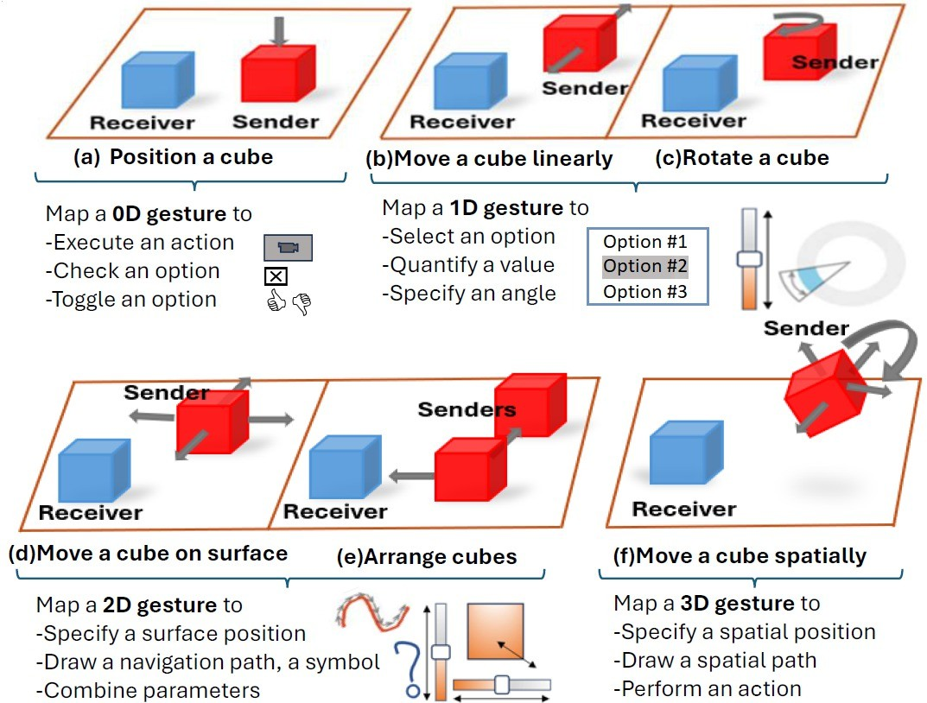
Burlingame, California, USA

Cubes, as a representative case of tangible user interfaces, bridge human motor action with digital interaction in various fields, such as education, ambient intelligence, and spatio-temporal data ex-ploration. A key question is how to map gestures performed with tangible cubes to commands in these interactive systems. Using intelligent wireless cubes that sense proximity, orientation, and motion, and communicate with software in real time, we categorize gestures in four families depending on their intrinsic number of di-mensions: 0D, 1D, 2D, and 3D. We demonstrate a set of mappings for gestures in each family for cube-based control, and show how tan-gible cubes support spatial, gestural, and collaborative interaction, in particular in music exploration.

CCS Concepts
- Human-centered computing → Human computer interac-tion (HCI); Interaction techniques.

Keywords
Cube, gesture input, gesture-to-command mapping, modular inter-faces, tangible user interface
ACM Reference Format:
Nacera Latreche and Bert Schiettecatte. 2026. Mapping Gestures Performed with Tangible Cubes to System Commands. In Companion Proceedings of the 18th ACM SIGCHI Symposium on Engineering Interactive Computing Systems (EICS Companion ’26), June 30-July 03, 2026, Patras, Greece. ACM, New York, NY, USA, 3 pages. https://doi.org/10.1145/3807968.3815996

Introduction
Tangible User Interfaces (TUIs) [8,21] enable end users to interact with digital information by manipulating physical objects, such as cubes [11], grounding interaction in spatial and motor skills [2]. Such TUIs support embodied cognition and social engagement in ways that traditional graphical user interfaces often do not [9]. Cube-based TUIs have demonstrated their suitable application in various fields, such as health management [3], home entertain-ment [4], making digital sound [19] or music [1], and navigating in 3D spaces [5,10,15] in mixed reality [13].
This work is licensed under a Creative Commons Attribution 4.0 International License.
EICS Companion ’26, Patras, Greece
© 2026 Copyright held by the owner/author(s). ACM ISBN 979-8-4007-2669-9/2026/06
https://doi.org/10.1145/3807968.3815996

Figure 1: Mapping gestures performed with tangible cubes to commands: (a) position a Sender cube with respect to a Receiver cube, (b) move a Sender cube linearly with respect to a Receiver cube, (c) rotate it, (d) move a Sender cube on a surface, (e) arrange Sender cubes together in a topology sensed by a Receiver, (f) move a Sender cube spatially.
Performing gestures on or with these physical objects raises the mapping problem [20]: how to adequately map various fami-lies of gestures to commands on the target interactive system. In electronic musical performance and related domains, end users ex-pect to match input parameters extracted from gestures to musical parameters correctly. Instead of individually manipulating many controls of a physical instrument or software controls of a Digital Audio Workstation (DAW), they expect to simultaneously operate several parameters by performing gestures with tangible objects.
However, this mapping is exposed to several challenges and limi-tations [6]. While the mapping between the controller and the target system completely changes the instrumental behavior and the feel to the performer, it should always be based on previous experience and preferred expectations [14]. Mappings should not be restricted to one-to-one correspondences, where one gesture controls multi-ple parameters or where algorithms generate sound/control data, leading to a misleading sense of simplicity; one should investigate many-to-many instances [6]. Classical mappings often imply fixed, stable correspondences between gestural input and instrument control, thereby ignoring how interactive applications and digital instruments can dynamically change mappings or how feedback loops back to alter gestures in a bidirectional way. This fosters dy-namic adaptation of such mappings with controllability. Guidelines for this purpose should also emerge [14] to become accessible [22].

EICS Companion ’26, June 30-July 03, 2026, Patras, Greece Latreche and SchieNecaNe

To address the mapping problem, this paper relies on AudioCubes [19], a set of small wireless cubes equipped with sensors that detect proximity, orientation, and motion, and which communicate spa-tial relationships to host software in real time, enabling expressive control through physical arrangement and gesture. Using them, we categorize gestures in four families depending on their number of spatial dimensions involved (Fig. 1) [16]: zero dimension (a), one-dimensional (b, c), two-dimensional (d, e), and three-dimensional (f) [24]. We demonstrate some mappings belonging to these families for cube-based control in musical expression, thus producing repro-ductible examples in other setups [23]. The system illustrates spatial control, collaborative interaction, and tangible system prototyping, therefore initiating design considerations relevant to practitioners and researchers in Human-Computer Interaction (HCI).

System Overview for Gestural Input with Tangible Cubes
Technical Description. An AudioCube is a 2.95 inches3 = 75𝑚𝑚3 1 acrylic-made cube TUI, weighing 800 g and containing an Inertial Measurement Unit (IMU) to capture the cube’s linear acceleration, angular velocity, and orientation, a Digital Signal Processor (DSP) with optical sensors and emitters (i.e., infrared, red, green, and blue LEDs). Each cube is powered by a Li-Poly rechargeable battery that can be charged via a special port and can be configured by software via a USB 2.0-compatible cable . Each lateral face is equipped with a sensor and an emitter. The sensors and emitters receive and send signals, generated or processed by the DSP in the cube. By posi-tioning the cubes relative to each other and moving them around, e.g., on a tabletop or another surface, a signal-processing network can be created that forms a cube topology (i.e., a physical arrange-ment of cubes interconnected). The minimum displacement that a AudioCube can detect is approximately 5 mm (0.19 inches) at a frequency of 60 Hz, thereby offering high speed. The response time falls within [0,01 s.; 0,1 s.], making the cube appear to respond in real time from the end user’s perspective with low latency. The min-imum distance between two cubes to interconnect them is about
0.5 cm (1.96 inches), and the maximum distance between them is about 50 cm (19.68 inches). When AudioCubes are arranged in a topology, they form a modular electronic musical instrument ini-tially introduced for creating music and visuals, but not restricted to this field of application.
How the AudioCubes Work. Each AudioCube senses the location and orientation of the other, as well as the distance to the hands, fingers, and other objects. Each face, except the bottom and top faces, has a communication port capable of transmitting and receiving digital or analog signals, using infrared light, to and from other AudioCube nearby. They can be arranged together in a topol-ogy that can be recognized in real time. AudioCubes communicate with each other through this port and can exchange sound or data signals, depending on the system running. AudioCubes operate in one of three modes:Sender-Receiver Mode ,Sensor mode and Topology mode.

1According to He et al.[13], a medium cube of this edge length located between 5 cm and 10 cm can still be held with one hand, while requiring the other hand to designate and orient areas of interest.

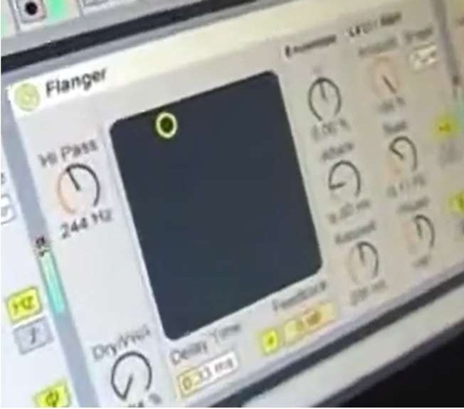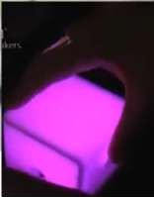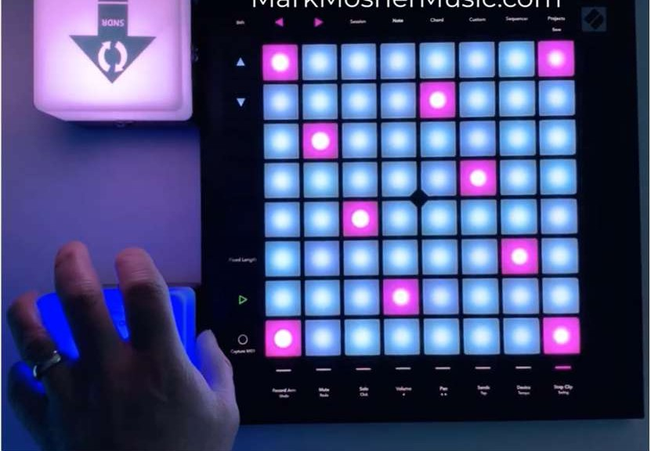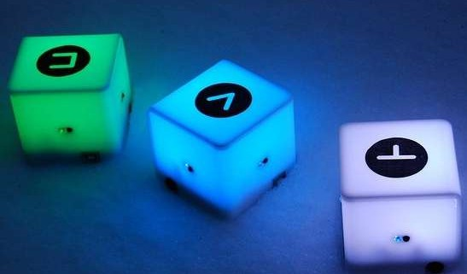
(a) Different functions attached to each cube
(b) Matrix positioning
(c) Potentiometer setting
Figure 2: Mappings: (a) a 0D gesture to execute a function, (b) a 1D gesture to position a cell in a row, (c) a 1D rotation for a potentiometer.

The Mapping Problem between Gestures on Tangible Cubes and System Commands
We illustrate how the configuration modes support explicit, param-eterizable, and adaptable mappings between gestures and system commands. Using an action+object mode [7] to represent a gesture, we can map system commands using a standard notation, such as canonical task types [12] or a taxonomy of tasks [17]:
  - 0D gestures: "Position a cube" or "Tap on a cube" executes a direct action associated to the cube. For example, different cubes can be associated to different functions (Fig. 2-a). Posi-
tioning a cube on a certain location checks/toggles an option and withdrawing it from this location unchecks/untoggles the option (Fig. 1-a).
  - 1D gestures: "Move a cube linearly" selects an option among a set of options or quantifies a numerical value (Fig. 1-b,c). For
example, moving a cube along a line positions a cell in a row (Fig. 2-b). Map continuous rotations to specify the value of a potentiometer (Fig. 2-c). Map single rotations (90° clockwise or counterclockwise) to basic commands like undo/redo. Use double rotations on the same line to trigger secondary or advanced actions.
  - 2D gestures: "Move a cube on a surface" (Fig. 1-d) to spec-ify a surface position or to draw a path. For example, bind
cube tilting (i.e., forward, backward, left, right) to navigation commands such as scrolling. Drawing a path (e.g., a letter, a symbol) on a surface requires a gesture recognizer that is independent from its location [18]. "Arrange cubes" (Fig. 1-e) to form a topology. Combine gestures on two or more cubes to access power-user commands, to form an input flow [14]. Use edge-to-edge rolls to cycle through layers.
  - 3D gestures: "Move a cube spatially" (Fig. 1-f) to perform an action (e.g., by shaking it to cancel an operation or reset the
current selection), specify a spatial position, or drawing any path in space. For example, map corner-down gestures to context-specific shortcuts or quick commands.

Conclusion
We presented a system of tangible cubes, using AudioCubes as a versatile way for mapping physical gestures to system commands. By structuring gestures according to their dimension (0D-3D) and framing cube-based gestures as modular interaction primitives, we demonstrated their applicability beyond musical expression to spatial control, collaboration, and tangible interaction.

Acknowledgments
Nacera Latreche is supported by the EU EIC Pathfinder-Awareness Inside challenge "Symbiotik" project under Grant no. 101071147.

Mapping Cubes-based Gestures to Commands EICS Companion ’26, June 30-July 03, 2026, Patras, Greece

References
- Miguel Bruns Alonso and David V. Keyson. 2005. MusicCube: making digital music tangible. In Proceedings of ACM International Conference on Human Factors in Computing Systems, Extended Abstracts (Portland, OR, USA) (CHI EA ’05). Association for Computing Machinery, New York, NY, USA, 1176–1179. https:
//doi.org/10.1145/1056808.1056870
- Leonardo Angelini, Denis Lalanne, Elise Van den Hoven, Omar Abou Khaled, and Elena Mugellini. 2015. Move, Hold and Touch: A Framework for Tangible Gesture Interactive Systems. Machines 3, 3 (2015), 173–207. https://doi.org/10. 3390/machines3030173
- David Bertolo, Stéphanie Fleck, Camille Lemiere, and Isabelle Pecci. 2025. Tangi-ble User Interface in Health: A Scoping Review. In Proceedings of the Nineteenth International Conference on Tangible, Embedded, and Embodied Interaction (TEI ’25). Association for Computing Machinery, New York, NY, USA, Article 32, 25 pages. https://doi.org/10.1145/3689050.3704951
- Florian Block, Albrecht Schmidt, Nicolas Villar, and Hans W. Gellersen. 2004. Towards a Playful User Interface for Home Entertainment Systems. In Proceedings of Second European Symposium on Ambient Intelligence, EUSAI 2004, Eindhoven, The Netherlands, November 8-11, 2004 (Lecture Notes in Computer Science, Vol. 3295), Panos Markopoulos, Berry Eggen, Emile Aarts, and James L. Crowley (Eds.). Springer Berlin Heidelberg, Berlin, Heidelberg, 207–217. https://doi.org/10.1007/ 978-3-540-30473-9_20
- Ken Camarata, Ellen Yi-Luen Do, Brian R. Johnson, and Mark D. Gross. 2002.
Navigational Blocks: Navigating Information Space with Tangible Media. In Proceedings of the 7th International Conference on Intelligent User Interfaces (San Francisco, California, USA) (IUI ’02). ACM, New York, NY, USA, 31–38. https:
//doi.org/10.1145/502716.502725
- Joel Chadabe. 2002. The limitations of mapping as a structural descriptive in electronic instruments. In Proceedings of the 2002 Conference on New Interfaces for Musical Expression (Dublin, Ireland) (NIME ’02). National University of Singapore,
SGP, 1–5. https://doi.org/10.5555/1085171.1085228
- Ylva Fernaeus, Jakob Tholander, and Martin Jonsson. 2008. Beyond representa-tions: towards an action-centric perspective on tangible interaction. Int. J. Arts Technol. 1, 3/4 (2008), 249–267. https://doi.org/10.1504/IJART.2008.022362
- Kenneth P. Fishkin. 2004. A taxonomy for and analysis of tangible interfaces.
Personal and Ubiquitous Computing 8, 5 (01 Sep 2004), 347–358. https://doi.org/
10.1007/s00779-004-0297-4
- George W. Fitzmaurice, Hiroshi Ishii, and William A. S. Buxton. 1995. Bricks: laying the foundations for graspable user interfaces. In Proceedings of the SIGCHI Conference on Human Factors in Computing Systems (Denver, Colorado, USA) (CHI ’95). ACM Press/Addison-Wesley Publishing Co., USA, 442–449. https:
//doi.org/10.1145/223904.223964
- Bernd Fröhlich and John Plate. 2000. The Cubic Mouse: A New Device for Three-dimensional Input. In Proceedings of the SIGCHI Conference on Human Factors in Computing Systems (The Hague, The Netherlands) (CHI ’00). ACM, New York,
NY, USA, 526–531. https://doi.org/10.1145/332040.332491
- Wooi Boon Goh, L. L. Chamara Kasun, Fitriani, Jacquelyn Tan, and Wei Shou. 2012. The i-Cube: Design Considerations for Block-based Digital Manipulatives and Their Applications. In Proceedings of the Designing Interactive Systems Conference (Newcastle Upon Tyne, United Kingdom) (DIS ’12). ACM, New York, NY, USA, 398–407. https://doi.org/10.1145/2317956.2318016
- Juan Manuel González-Calleros, Josefina Guerrero García, Jean Vanderdonckt, and Jaime Muñoz Arteaga. 2009. Towards Canonical Task Types for User Interface Design. In Proceedings of Joint Latin American Web Congress-Interaction Human Conference (Merida, Yucatan, Mexico) (LA-WEB/CLIHC ’09), Edgar Chávez, Eliza-beth Furtado, and Alberto L. Morán (Eds.). IEEE Computer Society, Piscataway,
NJ, USA, 63–70. https://doi.org/10.1109/LA-WEB.2009.33
- Shuqi He, Haonan Yao, Luyan Jiang, Kaiwen Li, Nan Xiang, Yue Li, Hai-Ning Liang, and Lingyun Yu. 2024. Data Cubes in Hand: A Design Space of Tangible Cubes for Visualizing 3D Spatio-Temporal Data in Mixed Reality. In Proceedings of the CHI Conference on Human Factors in Computing Systems (Honolulu, HI, USA) (CHI ’24). Association for Computing Machinery, New York, NY, USA, Article 209, 21 pages. https://doi.org/10.1145/3613904.3642740
- Andy Hunt, Marcelo M. Wanderley, and Matthew Paradis. 2003. The Importance of Parameter Mapping in Electronic Instrument Design. Journal of New Mu-sic Research 32, 4 (2003), 429–440. https://doi.org/10.1076/jnmr.32.4.429.18853 arXiv:https://www.tandfonline.com/doi/pdf/10.1076/jnmr.32.4.429.18853
- Yoshifumi Kitamura, Yuichi Itoh, and Fumio Kishino. 2001. Real-time 3D In-teraction with ActiveCube. In CHI ’01 Extended Abstracts on Human Factors in Computing Systems (Seattle, Washington) (CHI EA ’01). ACM, New York, NY,
USA, 355–356. https://doi.org/10.1145/634067.634277
- Nacera Latreche, Bert Schiettecatte, Paolo Roselli, Nuwan Attygalle, and Jean Vanderdonckt. 2026. User-Defined Gestures for Tangible Interaction with Cubes for Smart Home Control. In Proceedings of the ACM Int. Conf. on Designing Interactive Systems (Singapore, Singapore) (DIS ’26). Association for Computing Machinery, New York, NY, USA, 1–30. https://doi.org/10.1145/3800645.3813062

- David R. Lenorovitz, Mark D. Phillips, R.S. Ardrey, and Gregory V. Kloster. 1984. A taxonomic approach to characterizing human-computer interaction. In Human-Computer Interaction, Gabriel Salvendy (Ed.). Elsevier Science Publishers, Ams-terdam, 111–116.
- Nathan Magrofuoco, Paolo Roselli, and Jean Vanderdonckt. 2022. 𝜇V: An Articu-lation, Rotation, Scaling, and Translation Invariant (ARST) Multi-stroke Gesture Recognizer. Proc. ACM Hum. Comput. Interact. 6, EICS (2022), 150:1–150:25. https://doi.org/10.1145/3532200
- Bert Schiettecatte and Jean Vanderdonckt. 2008. AudioCubes: A Distributed Cube Tangible Interface Based on Interaction Range for Sound Design. In Proceedings of the 2Nd International Conference on Tangible and Embedded Interaction (Bonn, Germany) (TEI ’08). ACM, New York, NY, USA, 3–10. https://doi.org/10.1145/ 1347390.1347394
- Francisco Montero Simarro, Víctor López-Jaquero, Jean Vanderdonckt, Pascual González, María Dolores Lozano, and Quentin Limbourg. 2005. Solving the Mapping Problem in User Interface Design by Seamless Integration in IdealXML. In Proceedings of the 12th International Workshop on Design, Specification, and Verification of Interactive Systems, DSVIS 2005, Newcastle upon Tyne, UK, July 13-15, 2005 (Lecture Notes in Computer Science, Vol. 3941), Stephen W. Gilroy and Michael D. Harrison (Eds.). Springer, Berlin, 161–172. https://doi.org/10.1007/ 11752707_14
- B. Ullmer and H. Ishii. 2000. Emerging frameworks for tangible user interfaces.
IBM Sys. J. 39, 3.4 (2000), 915–931. https://doi.org/10.1147/sj.393.0915
- Jean Vanderdonckt. 1995. Accessing guidelines information with Sierra. In Pro-ceedings of IFIP TC13 International Conference on Human-Computer Interaction, INTERACT ’95, Lillehammer, Norway, 27-29 June 1995 (IFIP Advances in Informa-tion and Communication Technology), Knut Nordby, Per H. Helmersen, David J. Gilmore, and Svein A. Arnesen (Eds.). Chapman & Hall, London, UK, 311–316. https://doi.org/10.1007/978-1-5041-2896-4_52
- Jean Vanderdonckt and Radu-Daniel Vatavu. 2025. Context is Key for Re-producibility of Empirical Studies in Human-Computer Interaction. In Pro-ceedings of the 3rd ACM Conference on Reproducibility and Replicability (ACM REP ’25). Association for Computing Machinery, New York, NY, USA, 41–50. https://doi.org/10.1145/3736731.3746142
- Ryoichi Watanabe, Yuichi Itoh, Masatsugu Asai, Yoshifumi Kitamura, Fumio Kishino, and Hideo Kikuchi. 2004. The Soul of ActiveCube: Implementing a Flex-ible, Multimodal, Three-dimensional Spatial Tangible Interface. In Proceedings of the 2004 ACM SIGCHI International Conference on Advances in Computer Enter-tainment Technology (Singapore) (ACE ’04). ACM, New York, NY, USA, 173–180. https://doi.org/10.1145/1067343.1067364

