“Green” synthesized versus chemically synthesized zinc oxide nanoparticles: in vivo antihyperglycemic activity and pharmacokinetics
Espoir K. Kambale^{a,b}, Inês Dominguesª, Wunan Zhangª, Valentina Marottiª, Cheng Chenª, Kristelle Hughes^{c}, Joëlle Quetin-Leclercq^{c}, Patrick B. Memvanga^{b,d}, Ana Beloqui^{a,e}*
ª Advanced Drug Delivery and Biomaterials Group, Louvain Drug Research Institute, UCLouvain, Université catholique de Louvain, Avenue Mounier 73, B1.73.12, 1200 Brussels, Belgium
^{b} Laboratory of Pharmaceutics and Phytopharmaceutical Drug Development, Faculty of Pharmaceutical Sciences, University of Kinshasa, B.P. 212, Kinshasa XI, Democratic Republic of the Congo
^{c} Pharmacognosy Research Group, Louvain Drug Research Institute, UCLouvain, Université catholique de Louvain, Avenue Mounier 72, B1.72.03, 1200 Brussels, Belgium
^{d} Centre de Recherche et d’Innovation Technologique en Environnement et en Sciences de la Santé (CRITESS), University of Kinshasa, B.P. 212, Kinshasa XI, Democratic Republic of the Congo
^{e} WEL Research Institute, Avenue Pasteur 6, 1300 Wavre, Belgium

* Correspondence: ana.beloqui@uclouvain.be

ABSTRACT Zinc is one of the most studied trace elements, commonly used as supplement in diabetes treatment. By its involvement in the synthesis, secretion of insulin, promotion of insulin sensitivity and its multiple enzymatic functions it is known to contribute to reduce hyperglycemia. Researchers have shown that zinc administered under the form of zinc oxide nanoparticles (ZnONPs) is more effective than under its ionic form. Studies evaluating the antihyperglycemic activity of these nanocarriers include both ZnONPs synthesised using plants (i.e. green synthesized) or chemically synthesized. The present work aims to compare green synthesized ZnONPs with the marketed chemically synthesized ones. Green ZnONPs were synthesized using the aqueous extract of the stem bark of the medicinal plant Panda oleosa and zinc nitrate hexahydrate. Both nanocarriers were compared in terms of optical properties, morphology, composition, chemical functions, resistance to oxidation, in vivo antihyperglycemic activity via oral glucose tolerance test (OGTT) and pharmacokinetics in relation to zinc in C57BL/6J mice. A UV absorption peak was observed at 354 nm and 374 nm for the green and marketed ZnONPs, respectively. The shape and hydrodynamic diameters were anisotropic and of 228.8 ± 3.0 nm for the green ZnONPs and spherical and of 225.6 ± 0.9 nm for the marketed ZnONPs. Phenolic compounds accounted for 2.58 ± 0.04% of the green ZnONPs and allowed them to be more stable and unaffected by an oxidizing agent during the experiment, while the marketed chemically synthesized ZnONPs aggregated with or without contact with an oxidizing agent. No significant differences were observed on the amounts of zinc absorbed when comparing green ZnONPs, chemically synthesized ZnONPs and zinc sulfate in a pharmacokinetics study in normoglycemic mice. When evaluating the in vivo hypoglycemic activity of the nanocarriers in obese/diabetic mice, green synthesized ZnONPs displayed a significant hypoglycemic effect (p =0.0027) compared with the chemically synthesized nanoparticles following an OGTT. Altogether, these data indicate that phytocompounds, as catechin derivatives and polyphenols, attached to the green synthesized ZnONPs’ surface, could contribute to their hypoglycemic activity. The comparison thus demonstrated that green synthesized ZnONPs are significantly more efficient than chemically ones at reducing hyperglycemia regardless of their absorption.
Keywords: Zinc oxide nanoparticles, in vivo antihyperglycemic activity, pharmacokinetics, oxidation

- INTRODUCTION
Today, various cohort studies have shown that people suffering from diabetes develop altered homeostasis of trace elements, leading to their deficiency (Chehade et al., 2009; Terry, 2022). Researchers have demonstrated that trace elements such as copper, zinc, selenium, chromium, magnesium, vanadium, manganese and molybdenum have a positive effect on glucose metabolism, helping reduce high glucose levels (Ashrafizadeh et al., 2020; Praveeena et al., 2013). Deficiency in certain minerals including magnesium, potassium, zinc and chromium, can also predispose to hyperglycemia (Wolide et al., 2017). Trace elements are considered essential for the biochemical and molecular activities of cells and are involved in glycemia control at various levels, for example acting as cofactors or components of enzymes involved in glucose metabolism (Hassanin et al., 2020; Kruse-Jarres and Rükgauer, 2000; Wiernsperger and Rapin, 2010), or as cofactors of antioxidant enzymes that prevent tissue damage (Ashrafizadeh et al., 2020; Kruse-Jarres and Rükgauer, 2000). Thanks to their multiple actions, they can lower hyperglycemia in different ways and preserve tissue integrity, hence their particular interest. They are prescribed as a complement to anti-diabetic drugs to contribute to prevent issues linked to diabetes (e.g. cardiovascular disease, neuropathy), because current single-target anti-diabetic treatments, such as sulphonylureas, biguanides, meglinides and thiazolidinediones, are ineffective in the long term (Zeng et al., 2020).
Among these trace elements, zinc is one of the most studied and known (Jansen et al., 2009). Zinc contributes to the synthesis and secretion of insulin granules (Rutter et al., 2016), and enhances cells sensitivity to insulin. Zinc activates the insulin signalling cascade by causing phosphorylation of the beta subunit of the insulin receptor, including the serine/threonine kinase Akt. This leads to inhibition of glycogen synthase kinase 3 (GSK-3) and increases glucose transporter 4 (GLUT4) enzyme translocation and expression in both adipose and skeletal muscles (Ranasinghe et al., 2015). Moreover, zinc promotes glycogenesis and inhibits lipid peroxidation (Brand and Kleineke, 1996; Jansen et al., 2009; Olechnowicz et al., 2018). The superoxide dismutase (SOD), an efficient antioxidant enzyme, is an effective antioxidant that depends on zinc to function (Faure et al., 1992). In addition, zinc elevates cyclic guanosine monophosphate (cGMP) leading to inhibition of the proinflammatory cytokines IL-1β and TNF-α (von Bülow et al., 2005). Zinc supplementation has shown to improve the condition of both type 1 and type 2 diabetes and prevent complications of the disease (Dib et al., 2015; Ranasinghe et al., 2015; Yang et al., 2023). In addition, several recent in vitro and in vivo studies have shown that zinc administered in the form of nanoparticles (ZnONPs) is more effective against diabetes than zinc in ionic form (e.g., zinc sulfate) (Ashrafizadeh et al., 2020; Nazarizadeh and Asri-Rezaie, 2016; Rajakumar et al., 2018; Shaban et al., 2022). Other studies have shown that Zn in ZnONPs orally administered is absorbed under its ionic form (via transporters) and under nanoparticle forms (by endocytosis). The nanoparticle form absorbed is then gradually converted to zinc ions and can be released into circulation by zinc transporters (Chen et al., 2015; Paek et al., 2013). The acidic environment of lysosomes contributes to the production of zinc ions from ZnONPs (Cho et al., 2011). In our previous study, we used green synthesised ZnONPs to reduce hyperglycemia in mice fed a high-fat diet. We found that green synthesised ZnONPs could represent an alternative to the chemically synthesized ZnONPs used by other researchers, as they exhibited pronounced antihyperglycemic activity at low doses and were easy to prepare (Kambale et al., 2023). However, studies comparing green and chemically synthesized ZnONPs are lacking, making it impossible to establish a comparison between the efficacy of these two types of nanoparticles. The aim of this study was to compare green versus chemically synthesized ZnONPs in terms of antihyperglycemic effect.
In the present study, we carried out pharmacokinetic studies on green and chemically synthesized ZnONPs compared with zinc sulfate in order to understand if the antihyperglycemic effect is due to an increased zinc absorption, the antihyperglycemic effect of the plant derived capping agents or both altogether. Given that the physicochemical properties of nanoparticles can affect their activity, we also compared them to support the results of the in vivo studies. The antidiabetic activity of the green synthesized ZnONPs and chemically synthesized ZnONPs was evaluated in high-fat diet induced obese/diabetic mice.
- MATERIALS AND METHODS

  - Chemicals
Chemically synthesized ZnONPs (ZnO, 99.8% purity, size ~200 nm) were purchased from SkySpring Nanomaterials, Inc (Houston USA). Zinc nitrate hexahydrate (Zn(NO₃)₂⋅6H₂O, 98%), zinc sulfate heptahydrate (ZnSO₄⋅7H₂O, 99%), Tween® 80 (polysorbate 80) and sodium hydroxide (NaOH) were purchased from Sigma − Aldrich (St. Louis, MO, USA). Suprapur® Nitric acid (HNO₃) 65% and Hydrogen peroxide (H₂O₂ 30%), was acquired from Merck KGaA (Darmstadt, Germany). All other reagents utilized in this work were of analytical grade.
  - Preparation of Panda oleosa extract
Fifty grams of Panda oleosa stem bark powder was stirred and heated at 100 °C in 500 ml Milli-Q water for 15 min. The mixture was allowed to cool to room temperature and was then filtered through Whatman 1 filter paper (Whatman International Ltd, Maidstone, UK). The collected filtrate was frozen and freeze-dried for 48 h, then stored at 4 °C for subsequent experimental use.
  - Analysis of phytocompounds present in the plant extract
Composition of the crude plant extract was studied by identifying the main phytochemicals in the Panda oleosa extract. For this purpose, a 1% aqueous solution of the aqueous extract of Panda oleosa stem bark was prepared by dissolving the freeze-dried extract in Milli-Q water. The resulting mixture was diluted 100-fold. Then, the obtained solution was filtered using a 0.22 µm pore size filter. The mass spectra analyses were carried out by direct infusion-high resolution mass spectrometry (DI-HRMS) in tandem using a Thermoscientific Orbitrap Exploris mass spectrometer (Thermoscientific, Bremen, Germany). Full scan spectra were obtained in negative mode in a range of 100-800 m/z at a resolution of 60,000. The capillary temperature was set at 250°C and the sheath gas and auxiliary gas flow rates were set at 3 and 2 arbitrary units, respectively. Spray voltage was set to 2.3 kV. Chemcalc (http://chemcalc.org/) was used to determine the likeliest molecular formula and mass spectra databanks were consulted, such as Reaxys (https://www.reaxys.com/?#/search/quick), DNP (https://dnp.chemnetbase.com/), and Massbank EU (https://massbank.eu/) to compare MS/MS data and provide potential identifications.

  - Physicochemical analysis of nanoparticles and their phenolic content
To analyse the physicochemical properties of the green synthesized ZnONPs, different characterization techniques were used. They included UV-visible spectroscopy (UV-Vis), dynamic light scattering (DLS), scanning electron microscopy (SEM) and Fourier transform infrared spectroscopy (FTIR).
The UV-Vis spectrophotometry method was used to assess optical properties of the nanoparticles using a NanoDrop™ 2000 (Thermo Scientific/USA). In order to do this, equivalent aliquots of 8.8 mg of zinc oxide from green synthesized ZnONPs and chemically synthesized ZnONPs were separately dispersed in Milli-Q water to form 5 mL stock suspensions. These suspensions were sonicated for 3 min at a 20% amplitude using a digital sonifier 450 (Branson Ultrasonics Corporation USA) for homogenization. Then, aliquots were diluted to half of their concentration for analysis.
The size, polydispersity index (PDI) and the surface charge (zeta potential) were assessed using a Malvern Zetasizer Ultra instrument (Malvern Panalytical Ltd/UK). In order to accomplish this, 1.14 mL of the stock suspension was diluted to 5 mL with Milli-Q water, and 1 mL of the resulting suspension was analyzed. To investigate the morphology of nanoparticles, specimens for Field Emission Gun – Scanning Electron Microscope (FEG-SEM) analysis were mounted on stubs and coated with a 15 nm gold layer (Cressington sputter 208HR) to create a thin conductive layer, minimizing degradation and drift due to thermal expansion. FEG-SEM analysis was performed in a Jeol FEG-SEM 7600F (Japan) operating at 2 keV with a working distance of 8 mm.
The chemical functional groups present in samples of P. oleosa extract, green and chemically synthesized ZnONPs were investigated by the FTIR technique. The spectra were recorded on a Nicolet™ iN10 Infrared Microscope instrument (Thermo Fisher Scientific Inc. (NYSE: TMO USA)). Samples in potassium bromide (KBr) pellet form were analysed by microtransmission. 64 scans with a resolution of 16 cm⁻¹ were performed in the frequency range from 4000 cm⁻¹ to 400 cm⁻¹. The Mercury-Cadmium-Telluride (MCT) and deuterated-triglycine sulfate (DTGS) detectors were used.
To evaluate the phenolic fraction that remains after nanoparticle synthesis, the method outlined in the European Pharmacopoeia 10.8 was utilised, as previously described (Kambale et al., 2023). Both the marketed chemically ZnONPs and plant extract were also subjected to the same analysis in order to determine whether the result obtained was due to the presence of phytocompounds in the green synthesized nanoparticles.
  - Oxidation resistance and behaviour in aqueous media
The ability of the ZnONPs to resist against oxidation and their behaviour in aqueous media was assessed by the method using hydrogen peroxide (H₂O₂) according to Li et al., with slight modifications (Ii et al., 2012). Briefly, 5 mL of stock suspensions were prepared as described above (section 2.4). On the one side, 2 mL of Milli-Q water was mixed with 500 µL of each stock suspension and the nanoparticle size was measured immediately at time 0 and 15, 60 and 120 min after. The UV-visible absorbances were analysed at time 15 min. On the other side, 2 mL Milli-Q water and 50 µL H₂O₂ 30% were added to 500 µL of each stock suspension and the same measurements were performed.
  - In vivo studies
All animal experiments were performed in compliance with the animal and local ethics committee (2022/UCL/MD/035) and as recommended by the Belgian Law of 29 May 2013 on the protection of laboratory animals. C57BL/6J male mice (Janvier Laboratories, France) were housed in a ventilated room maintained at 22°C ± 2°C and 55% ± 5% relative humidity under a day/dark cycle of 12 h/12 h, with free access to food and water.
The formulations for in vivo studies were prepared by dispersing 10.5 mg green ZnONPs, 8.8 mg chemically synthesized ZnONPs and 31.1 mg zinc sulphate heptahydrate separately in 5 mL with water in vials to obtain the same concentration of Zn (1.408 mg/mL).
ZnONPs have shown higher antihyperglycemic activity in vitro or in diabetic rodents than zinc salt (e.g. zinc sulfate) at equivalent concentration of zinc (Ashrafizadeh et al., 2020; Nazarizadeh and Asri-Rezaie, 2016; Rajakumar et al., 2018; Shaban et al., 2022). Furthermore, considering our previous study (Kambale et al., 2023) which demonstrated that a large dosage of plant extract (400 mg) was necessary to achieve a noteworthy antihyperglycemic effect comparable to the one exerted by ZnONPs (10 mg), we did not introduce a physical mixture of extracts and zinc at equivalent concentrations in this experiment.
    - Oral glucose tolerance test in diabetic/obese mice
Mice were fed with control diet (AIN-93M mature rodent diet (D10012Mi Research Diets, USA) or high-fat diet (HFD) (60% fat and 20% carbohydrate (kcal per 100 g) diet (D12492i, Research Diets, USA)) for 9 weeks. Prior to the experiment, mice were fasted for 4 h, then weighed and divided into groups of 8 animals each, including a normal control group (CTL N), a HFD control group (CTL HFD), a HFD group receiving ZnONPs (ZnONPs P. oleosa) and a HFD group receiving chemically synthesized ZnONPs (ZnONPs Chem). Fifteen minutes before the glucose challenge (2g/kg), mice were orally administered with the following formulations: ZnONPs at a 10 mg (8.0 mg zinc)/kg dose (Umrani and Paknikar, 2014) and control groups (CTL N and CTL HFD) were orally gavaged with an equivalent volume of sterile Milli-Q water. Blood samples were withdrawn from the tail vein 30 min before and 15 min after the glucose administration to analyze plasma insulin concentrations using an ELISA kit (Mercodia ultrasensitive mouse kit, Uppsala, Sweden). Blood glucose was measured using a glucometer (Accu-check® Aviva Roche, Switzerland) at times -30, 0, 15, 30, 60, 90 and 120 min after glucose administration. The degree of insulin resistance developed by mice after this feeding period was assessed by analyzing the homeostasis model assessment of insulin resistance (HOMA-IR) index as previously described by Xu et al. (Xu et al., 2020) by using the following formula (2):
HOMA-IR = $\frac{fasting glucose (mg dL-1) X fasting insulin (µg/L)}{405}$ (2)
    - Pharmacokinetics study
Mice were fasted overnight with free access to sterile Milli-Q water prior to oral gavage. Then, they were weighed and randomly divided into 3 groups: green ZnONPs, chemically synthesized ZnONPs and zinc sulfate (16 mice per group). Each group was divided into 2 subgroups of 8 mice each in order to alternate blood sampling (2 capillaries) between time points. At the start of the experiment (e.g., at the 0h time point), 120 µL of blood was withdrawn from the tail vein of each mouse. Formulations were administered by oral gavage at a dose equivalent to 10 mg zinc oxide (8.0 mg zinc)/kg body weight. Blood samples were withdrawn at times 0, 0.5, 1, 2, 6 and 8 h after gavage in order to compare the oral absorption of zinc following administration of the formulations.
The collected blood was centrifuged at 4,000 rpm for 15 min at 4°C. The plasma was then collected and transferred to empty Eppendorf tubes. 25 µL of each plasma was mixed with 4,900 µL of 2% diluted suprapur nitric acid (HNO₃) and 100 µL of 30% H₂O₂. After 48 h of digestion at room temperature, the mixtures were centrifuged again at 4,000 rpm for 15 min at room temperature and 5 mL of supernatants were collected for quantification of zinc.
An inductively coupled plasma mass spectrometer (ICP-MS) (quadrupole ICP-MS: Thermo Fisher Scientific iCAP Q ICP-MS) instrument was used to quantify the zinc. The instrument was fitted with a collision cell (helium flow rate = 5 mL/min) to eliminate interference. The instrument was calibrated using 2% HNO₃ suprapur as blank and standards were prepared from Merck Certipur ICP zinc standard at 1 - 2 - 5 - 10 - 20 - 50 - 100 ppb zinc. The pharmacokinetic parameters were analyzed using PKSolver (Zhang et al., 2010).
  - Statistical analysis
GraphPad Prism 9.1.2 software (San Diego, CA, USA) was used to analyse the data. The Shapiro − Wilk test was run to check the normality. To assess the differences among groups, a one-way ANOVA followed by Tukey’s post hoc test was carried out. The t-test was used to make comparisons between two groups. For all the tests, a p value lower than 0.05 indicated statistical significance of difference. All tests were conducted in triplicate and are expressed as the mean ± standard error of the mean (SEM), unless otherwise stated.
- RESULTS AND DISCUSSION

  - Phytochemicals identification and phenolic content
The DI-HRMS investigations were conducted to identify the presence of previously reported phenolics in Panda oleosa extract. The full scan spectra of the aqueous extract of Panda oleosa stem bark revealed the absence of (epi)gallocatechin, rutin and (epi)gallocatechin gallate although the two first compounds had been identified previously by TLC (Thin Layer Chromatography) analysis (Katemo et al., 2018, 2017). Catechin (m/z 289.0716 [M-H]⁻) was observed, although at a low abundance, as well as 4’-O-methylepigallocatechin with m/z 319.0822 [M-H]⁻. Identifications were confirmed by comparison of MS/MS data with literature (Supplementary Figure S1 and Table S1). 4'-O-methyl-gallocatechin has already been isolated from the ethyl acetate extract of the stem bark of P.oleosa (Audi et al., 2004; Bokesch et al., 1994).
We also determined the total phenolic content of the green ZnONPs as already done previously (Kabale et al. 2023) and obtained values of 2.58 ± 0.04%, compared to the 11.58 ± 0.21% of the Panda oleosa aqueous extract. For chemically synthesized ZnONPs, a value of 0.60 ± 0.06% was obtained for the same amount of sample test analysed, confirming the presence of phenolic compounds from the plant extract in the green nanoparticles.
Given that plant compounds, including phenolics, are known to be responsible for zinc bioreduction and also play an essential role in nanoparticle capping, stability and biocompatibility (Bhardwaj et al., 2020; Naseer et al., 2020), these results show that the extract of the stem bark of P.oleosa could contribute to the green synthesis. In addition, in our previous paper we reported that ZnO accounted for about 84 % in the synthesized nanoparticle suggesting that the compounds derived from the plant extracts accounted for the remaining percentage (Kambale et al., 2023).
  - Nanoparticle characterization
To assess the influence of plant derived capping agents on the optical properties of the ZnONPs, UV-visible spectra of green synthesized ZnONPs and chemically synthesized ZnONPs were analyzed and compared. The UV-visible spectra of green ZnONPs as presented in Supplementary Figure S2, showed a maximum absorption peak at 354 nm. However, the chemically synthesized ZnONPs exhibited the maximum at 374 nm which was close to 378 nm, as previously reported by Pudukudy and Yaakob for bare ZnONPs (Pudukudy and Yaakob, 2015). This difference in absorption wavelengths between the green and chemically synthesized ZnONPs was attributed to the presence of phytochemicals linked to the green synthesized ZnONPs. The phytochemicals induced a blue shift i.e., relocation of the absorption peak from a high wavelength to a shorter wavelength. These findings are in accordance with previous research (Upadhyay et al., 2020). Moreover, no appreciable difference in absorbance values was observed between the two nanoparticle samples at the same concentration of zinc oxide, suggesting that the phytocompounds do not inhibit the UV-Vis absorption of zinc oxide. Additionally, naked eye observation of nanoparticles showed also differences in their appearance. The nanoparticle suspensions presented different colours. The green synthesized ZnONPs powder was eggshell coloured since they contained organic substances from plant extracts, whereas the chemically synthesized ZnONPs powder presented a white colour (Figure 1A and 1B, respectively).
The particle size analysis showed a size of 228.8 ± 3.0 nm with a PDI of 0.11 ± 0.02, negative zeta potential of -21.12 ± 0.48 for green ZnONPs (n=3), and 225.6 ± 0.9 nm with a PDI of 0.10 ± 0.01, positive zeta potential of +12.57 ± 1.08 for chemically synthesized ZnONPs (n=3).
Their morphology evaluation by SEM in Figure 2 showed differences in size and shape of the nanoparticles. On the one hand, an anisotropic shape with a diameter and length ranging from 107 nm to 451 nm for the green synthesized ZnONPs and an irregular and rough-like structure on the surface (Figure 2A). The chemically synthesized nanoparticles, on the other hand, exhibited an almost spherical shape with a minimum and maximum diameter of 44.2 nm and 225.0 nm, respectively (Figure 2B).
The reason for the size discrepancy between SEM and DLS could be due to difference in behaviour of these nanoparticles when in dried state or in water. According to Abraham et al., particles can have hydrodynamic diameters comparable to or slightly larger or lower than their electronic microscopic size (Abraham et al., 2020). The irregularity on the green ZnONPs surface was attributed to the presence of phytocompounds. These chemical compounds increase contact surface and can help avoid aggregation of the prepared nanoparticles. As previously reported, surface structures contribute to define both the physicochemical and biological characteristics of nanoparticles (Javed et al., 2020).

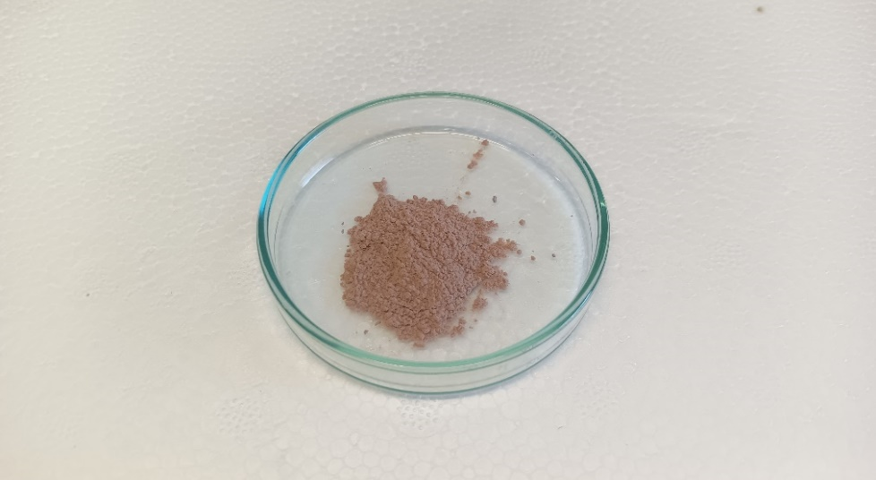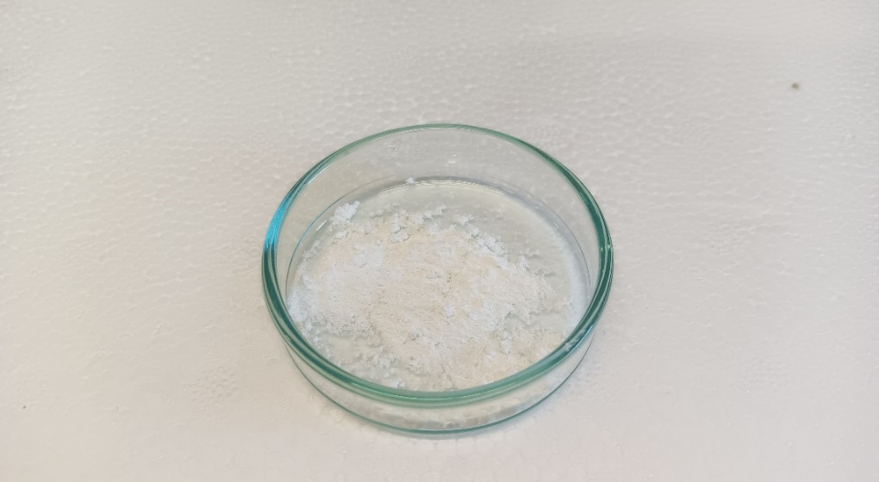
A
B
Figure 1. Photograph of (A) green synthesized ZnONPs and (B) chemically synthesized ZnONPs

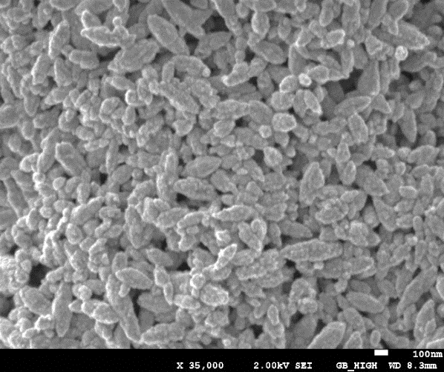
A
B

Figure 2. SEM images of (A) green synthesized ZnONPs and (B) chemically synthesized ZnONPs.
FTIR data were collected with a resolution of 16 cm⁻¹. The analysis was done after acquiring the spectrum of the background (ambient air). The vibrational band spectra of green synthesized ZnONPs was analysed to investigate similarity or differences with plant extract and with chemically synthesized ZnONPs. Identification of the functional groups associated with the formation of green ZnONPs revealed the presence of chemical functional groups derived from plant extracts. As shown in Figure 3, the bands around 3416.2, 2928.8 and 2852.4 cm⁻¹, 1614.0 and 1384.3 were common to all the samples and were assigned to the OH group from water (Abbas et al., 2017; Bala et al., 2015), asymmetric and symmetric stretching vibrations of C-H (Rajakumar et al., 2018), C=O groups of acids (Kazempour et al., 2021) and CH₃ symmetric bend (Jackson and Mantsch, 2010) respectively. At 1457.0 and 1446.4 cm⁻¹ bands of aromatic C=C stretching; 1254.5 and 1245.1 cm⁻¹can be due to the interaction of O-H deformation and C-O stretching vibrations of phenols. The stretching vibrations at 1115.7 to 1058.7 cm⁻¹ were attributed to C-C (phenyl-carbon) (Abbas et al., 2017) and were found in green ZnONPs and plant extracts, but not in chemically synthesized ZnONPs. The strong band at 472 cm⁻¹ corresponded to zinc oxide (Alamdari et al., 2020) and was not found in the extract. The present results are supported by previous reports on the phytochemical constituents of Panda oleosa aqueous extracts which include phenolic compounds and saponins (Muhoya et al., 2017) and the data we obtained above. The IR bands observed further justify the presence of these compounds.
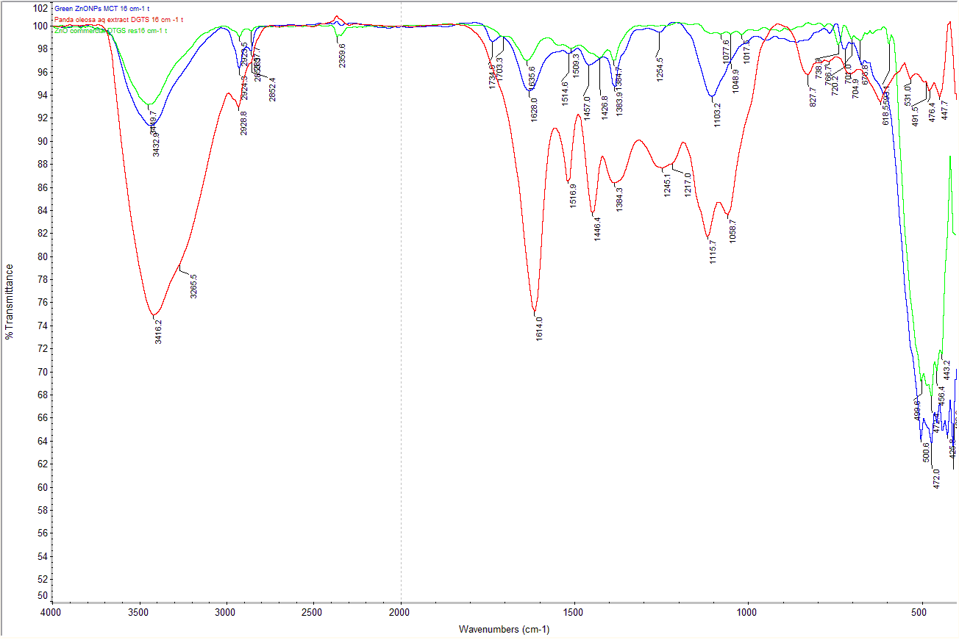
O-H, C-O of phenols
C-C (phenyl-carbon)
Aromatic
C=C
ZnO
Figure 3. FTIR spectra of green ZnONPs (blue), chemically synthesized ZnONPs (green) and Panda oleosa aqueous extract (red)
The study of the ability of ZnONPs to resist to oxidation and their behavior in aqueous media showed different results. The contribution of capping agents to the stability of nanoparticles with respect to ROS was remarkable. First, the study of the UV-visible absorbances of the green synthesized or chemically synthesized nanoparticles in aqueous medium recorded before and 15 min after the addition of H₂O₂ (oxidizing agent) showed no change in the height of the peaks (Supplementary Figure S3). However, a different result was observed for the size of nanoparticles in contact with H₂O₂. When H₂O₂ was added to the ZnONPs suspensions at time 0, a significant increase in the size of the chemically synthesized particles was observed. Indeed, the analysis of the size of the nanoparticles as a function of time, as presented in Supplementary Figure S4, showed that chemically synthesized nanoparticles aggregated significantly over time in suspension with or without the addition of H₂O₂. Moreover, H₂O₂ accelerated the aggregation process. In contrast, the green synthesized nanoparticles remained stable in the presence or absence of an oxidizing agent for a relatively long period (120 min). The stability of nanoparticles due to the presence of a capping agent from plants helping to avoid aggregation has been previously suggested (Javed et al., 2020). Our results herein confirm the ability of green synthesized ZnONPs to remain unaffected by oxidizing substances due to the presence of phytocompounds on their surface. Because it is known that increased ROS formation can exacerbate the damage caused by oxidative stress and can lead to aggregation of the particles in the intestine (Wang et al., 2020), this stability of green ZnONPs could be an advantage for their efficacy in diabetes. This is consistent with the results from our previous study in which we demonstrated that green synthesised ZnONPs were stable in vitro in four biomimetic gastrointestinal fluids notably fasted-state and fed-state simulated gastric or intestinal fluids (FaSSGF, FeSSGF, FaSSIF and FeSSIF, respectively) (Kambale et al., 2023).
  - Antihyperglycemic activity of green ZnONPs versus chemically synthesized ZnONPs
We compared the antihyperglycemic effect of green ZnONPs to that of chemically synthesized ZnONPs at an equivalent dose of ZnO (10 mg/kg) following one single oral administration. To this end, a series of parameters, including fasting glycemia, fasting insulinemia, glycemia after glucose administration and insulinemia after glucose administration, were monitored during the study. We first confirmed that mice under HFD regimen developed marked hyperglycemia and hyperinsulinemia in the fasted state as illustrated in Supplementary Figure S5A and S5B. The HFD-fed mice showed an increase in the HOMA IR index (~2.1) (Supplementary Figure S5C) indicating the onset of insulin resistance. This increase in the HOMA-IR index also confirmed the difference between the glycemic condition of these two groups of mice (CTL N and HFD-fed mice).
The profile of mice treated with the ZnONPs as illustrated in Figure 4A showed that these nanoparticles exerted an hypoglycemic activity. We observed that the blood glucose levels of the mice administered with these nanoparticles were lower than those of untreated CTL HFD mice throughout the oral glucose challenge, starting 15 min after glucose administration. Interestingly, among the two types of nanoparticles, only the green synthesized significantly lowered hyperglycemia (p=0.0027) throughout the overall oral glucose challenge. As illustrated in Figure 4A, the green ZnONPs decreased high blood glucose levels after glucose loading but the unique administration of nanoparticles did not normalize glycemia as the glycemia in CTL N mice was significantly lower than ZnONPs P. oleosa -mice (Figure 4A). Nevertheless, effects were not significantly different when comparing the glycemia between ZnONPs P. oleosa -mice and the ZnONPs chem -mice at each point. Importantly, a single oral dose of green ZnONPs significantly decreased hyperglycemia and the area under the curve (AUC) (*p<0.05) (Figure 4B) but the chemically synthesized ZnONPs did not (p>0.05).
No significant differences in insulin levels were observed between those observed 30 min before and 15 min after the glucose challenge (Supplementary Figure S6). On the basis of the present data, green synthesized zinc oxide nanoparticles were considered to be more effective against hyperglycemia than the chemically synthesized ones. These result are consistent with those of the study carried out after daily intraperitoneal injection of ZnONPs by Arvanag et al. (Mohammadi Arvanag et al., 2019). Our results also support the claims that phytocompounds attached to nanoparticles contribute to their activity (Javed et al., 2020). The green ZnONPs were synthesized using Panda oleosa extract which was shown to possess high antioxidant activity (Kambale et al, 2023). The reductive power of the plant extract allows the synthesis and capping of ZnONPs. We also observed that it contains flavonoid derivatives as catechin and 4’-O-methyl(epi)gallocatechin, well-known phytocompounds possessing antidiabetic and antioxidant properties (Shay et al., 2015; Wen et al., 2022). A better antihyperglycemic activity of green synthesised nanoparticles over chemically synthesised nanoparticles could be attributed to these phytocompounds and related compounds. We further evaluated the pharmacokinetics of these nanoparticles, compared with zinc sulfate, in order to confirm if part of the effect observed was due to increased plasmatic levels of zinc.

Figure 4. Antihyperglycemic effect of green synthesized ZnONPs (ZnONPs P. oleosa) and chemically synthesized ZnONPs (ZnONPs chem) in HFD-induced obese/diabetic mice. (A) Plasma glucose levels and (B) Glucose area under the curve. Data are presented as mean±SEM (n=8) (repeated measure). The significance of difference (*p<0.05) was evaluated according to (A) a two- way analysis of variance (ANOVA) followed by Tukey’s post hoc test. Different superscript letters in (A) at each time point indicate significant differences (*p<0.05) between groups. Data with different superscript letters in (B) are significantly different (*p<0.05) according to a one- way ANOVA followed by Tukey’s post hoc test.
  - Pharmacokinetic study
The pharmacokinetic study was conducted by measuring zinc blood levels in mice after oral administration of zinc sulfate, green ZnONPs and chemically synthesized ZnONPs. The results showed that zinc blood levels increased after their oral administration. We observed that the highest plasmatic levels of zinc were 1 h post-administration of each formulation (T_{max} =1 h) (Figure 5A). Overall, the quantification of zinc did not show significant differences between the levels of zinc absorbed regardless of the formulations (p>0.05). However, the only significant difference we observed was at 0.5 h post administration between mice receiving chemically synthesized ZnONPs and mice receiving zinc sulfate. This difference may be due to various factors which may slow down their absorption, such as the low stability of bare ZnONPs in aqueous media (as demonstrated in this study) and in simulated gastrointestinal fluids (Kambale et al., 2023). From time 1 h post administration, there was no significant difference between zinc levels among groups. The area under the curves of plasma zinc levels were not significantly different between formulations (p>0.05) (Figure 5B). These results suggest that zinc on a nanometric scale and at a low dose (equivalent to 10 mg ZnO (8.0 mg zinc)/kg) presents a similar zinc absorption than zinc sulfate. These results are consistent with previous studies which have stated that zinc oxide nanoparticles are absorbed under particles or ionic form and that the absorbed particulate form is gradually dissolved into an ionic form (Paek et al., 2013). The pharmacokinetic parameters following oral administration are summarized in Supplementary information Table S2.

Figure 5. (A) Plasma zinc profile µg L⁻¹ and (B) mean area under the curve (µg L⁻¹h⁻¹). Data are presented as mean±SEM (n=8) (repeated measure). The significance of difference (*p<0.05) was evaluated according to (A) a two- way analysis of variance (ANOVA) followed by Tukey’s post hoc test, and (B) a one- way ANOVA followed by Tukey’s post hoc test. * significant difference between plasma zinc levels of mice which received zinc sulfate solution and the ones which received chemically synthesized ZnONPs.
- CONCLUSION
In conclusion, our study compared the hypoglycemic activity and pharmacokinetics between green synthesized and chemically-prepared zinc oxide nanoparticles. We also compared their physicochemical properties. This study demonstrated that green synthesized ZnONPs are able to reduce significantly blood glucose levels following an OGTT compared to chemically synthesized nanoparticles. In the pharmacokinetic study, the zinc absorption was not significantly different between formulations. The enhanced effect obtained with green synthesised ZnONPs could be attributed to the contribution of capping agents derived from plant extracts. Additionally, this study validated the hypothesis according to which green synthesized ZnONPs are more resistant to oxidation than the chemically synthesized ones. Apart from their activity, green synthesised nanoparticles are of economic and ecological interest. Their synthesis is inexpensive, energy-efficient and requires no nanoparticle purification stage. Their production is environmentally friendly, as no potentially toxic or polluting products are used. All together, these advantages of green ZnONPs over chemically synthesized ones make green synthesised ZnONPs more promising for future use in the management of diabetes through zinc supplementation. Given that diabetes is a chronic condition, more research on the molecular markers associated with this pathology and tissue analysis is required throughout and after a long course of treatment.
Declaration of Competing Interests
The authors declare that they have no competing financial interests or personal relationships that could have appeared to influence the work reported in this paper.
CRediT authorship contribution statement
Espoir K. Kambale: Conceptualization, Data curation, Formal analysis, Investigation, Methodology, Resources, software, Visualization, Writing - original draft. Inês Domingues: Investigation, Methodology. Wunan Zhang: Methodology. Valentina Marotti: Methodology. Cheng Chen: Methodology. Kristelle Hughes: Investigation, Methodology, software. Joëlle Quetin-Leclercq: Conceptualization, Formal analysis, Methodology, Resources, Supervision, Validation, Writing - review & editing. Patrick B. Memvanga: Conceptualization, Formal analysis, Methodology, Supervision, Validation, Writing - review & editing. Ana Beloqui: Conceptualization, Data curation, Methodology, Funding acquisition, Project administration, Resources, Supervision, Validation, Writing - review & editing.
Acknowledgements
Authors are grateful to the Université catholique de Louvain/UCLouvain (coopération au dévelopment) for supporting this work with the PhD scholarship awarded to Espoir K. Kambale. Ana Beloqui is a research associate of the Belgian National Funds for Scientific Research (F.R.S.-FNRS) and a WELBIO investigator. CRITESS is the beneficiary of a grant from the Institut de la Francophonie pour le Développement Durable (IFDD/Canada)/Projet de Déploiement des Technologies et Innovations Environnementales (PDTIE), funded by the Organization Internationale de la Francophonie (OIF), the Organization of African, Caribbean and Pacific States (OACPS) and the European Union (EU) (FED/2020/421-370). Authors would like to thank Youzhong Liu from the Cellular Metabolism & Microenvironment research group for running mass spectrometry analyses. Authors would also like to thank Laurence Monin, Delphine Magnin and Sabine Bebelman for their excellent support and assistance at Earth and Life Institute Environmental Sciences (ELIE)-Mineral and Organic Chemical Analysis (MOCA) and at the Institute of Condensed Matter and Nanosciences (IMCN, Université Catholique de Louvain 1348 Louvain-la-Neuve, BELGIUM
Appendix A. Supplementary materials
References
Abbas, O., Compère, G., Larondelle, Y., Pompeu, D., Rogez, H., Baeten, V., 2017. Phenolic compound explorer: A mid-infrared spectroscopy database. Vib. Spectrosc. 92, 111–118. https://doi.org/10.1016/j.vibspec.2017.05.008
Abraham, J., Jose, B., Jose, A., Thomas, S., 2020. Characterization of green nanoparticles from plants, Phytonanotechnology. Elsevier Inc. https://doi.org/10.1016/b978-0-12-822348-2.00002-4
Alamdari, S., Ghamsari, M.S., Lee, C., Han, W., Park, H., Tafreshi, M.J., Afarideh, H., 2020. Applsci-10-03620.Pdf. Appl. Sci. 10, 1–19.
Ashrafizadeh, H., Abtahi, S.R., Oroojan, A.A., 2020. Trace element nanoparticles improved diabetes mellitus; a brief report. Diabetes Metab. Syndr. Clin. Res. Rev. 14, 443–445. https://doi.org/10.1016/j.dsx.2020.04.026
Audi, E.A., Mendes De Toledo, C.E., Solera Dos Santos, F., Bellanda, P.R., Alves-Do-Prado, W., Ueda-Nakamura, T., Nakamura, C.V., Sakuragui, C.M., Bersani-Amado, C.A., Palazzo De Mello, J.C., 2004. Biological activity and quality control of extract and stem bark from Stryphnodendron adstringens. Acta Farm. Bonaer. 23, 328–333.
Bala, N., Saha, S., Chakraborty, M., Maiti, M., Das, S., Basu, R., Nandy, P., 2015. Green synthesis of zinc oxide nanoparticles using Hibiscus subdariffa leaf extract: Effect of temperature on synthesis, anti-bacterial activity and anti-diabetic activity. RSC Adv. 5, 4993–5003. https://doi.org/10.1039/c4ra12784f
Bhardwaj, M., Yadav, P., Dalal, S., Kataria, S.K., 2020. A review on ameliorative green nanotechnological approaches in diabetes management. Biomed. Pharmacother. 127, 110198. https://doi.org/10.1016/j.biopha.2020.110198
Bokesch, H., Mckee, T., Cardellina, J., Boyd, M., 1994. ENT-4’-O-Methylgallocatechin from Panda oleosa. Nat. Prod. Lett. 4, 155–157. https://doi.org/10.1080/10575639408043898
Brand, I.A., Kleineke, J., 1996. Intracellular zinc movement and its effect on the carbohydrate metabolism of isolated rat hepatocytes. J. Biol. Chem. 271, 1941–1949. https://doi.org/10.1074/jbc.271.4.1941
Chehade, J.M., Sheikh-Ali, M., Mooradian, A.D., 2009. The role of micronutrients in managing diabetes. Diabetes Spectr. 22, 214–218. https://doi.org/10.2337/diaspect.22.4.214
Chen, W.Y., Cheng, Y.H., Hsieh, N.H., Wu, B.C., Chou, W.C., Ho, C.C., Chen, J.K., Liao, C.M., Lin, P., 2015. Physiologically based pharmacokinetic modeling of zinc oxide nanoparticles and zinc nitrate in mice. Int. J. Nanomedicine 10, 6277–6292. https://doi.org/10.2147/IJN.S86785
Cho, W.S., Duffin, R., Howie, S.E.M., Scotton, C.J., Wallace, W.A.H., MacNee, W., Bradley, M., Megson, I.L., Donaldson, K., 2011. Progressive severe lung injury by zinc oxide nanoparticles; the role of Zn2+dissolution inside lysosomes. Part. Fibre Toxicol. 8, 27. https://doi.org/10.1186/1743-8977-8-27
Dib, E., Olf, G., Msp, O., Lg, B., Ec, J., Junior, N., 2015. in adults with insulin resistance ( Review ). https://doi.org/10.1002/14651858.CD005525.pub3.www.cochranelibrary.com
European Pharmacopoeia 10.8. https://pheur.edqm.eu/app/10-8/search/
Faure, P., Roussel, A., Coudray, C., Richard, M.J., Halimi, S., Favier, A., 1992. Zinc and insulin sensitivity. Biol. Trace Elem. Res. 32, 305–310. https://doi.org/10.1007/BF02784615
Hassanin, N., Elkishki, M., Fawzy, L., 2020. Trace Elements and Their Relation to Diabetes Mellitus and Obesity . J. Recent Adv. Med. 0, 0–0. https://doi.org/10.21608/jram.2020.46094.1093
Ii, G.V.W., Kerscher, P., Brown, R.M., Morella, J.D., Mcallister, W., Dean, D., Kitchens, C.L., 2012. Green Synthesis of Robust , Biocompatible Silver Nanoparticles Using Garlic Extract 2012. https://doi.org/10.1155/2012/730746
Jackson, M., Mantsch, H.H., 2010. Medical Science Applications of IR. Encycl. Spectrosc. Spectrom. Second Ed. 1494–1502. https://doi.org/10.1016/B978-0-12-374413-5.00200-1
Jansen, J., Karges, W., Rink, L., 2009. Zinc and diabetes - clinical links and molecular mechanisms. J. Nutr. Biochem. 20, 399–417. https://doi.org/10.1016/j.jnutbio.2009.01.009
Javed, R., Zia, M., Naz, S., Aisida, S.O., Ain, N. ul, Ao, Q., 2020. Role of capping agents in the application of nanoparticles in biomedicine and environmental remediation: recent trends and future prospects. J. Nanobiotechnology 18, 1–15. https://doi.org/10.1186/s12951-020-00704-4
Kambale, E.K., Katemo, F.M., Quetin-Leclercq, J., Memvanga, P.B., Beloqui, A., 2023. “Green”-synthesized zinc oxide nanoparticles and plant extracts: A comparison between synthesis processes and antihyperglycemic activity. Int. J. Pharm. 635, 122715. https://doi.org/10.1016/j.ijpharm.2023.122715
Katemo, F.M., Kadima, J.N., Marini, R.D., 2018. Determination of in vitro antioxidant activity, acute toxicity in guinea-pig and TLC-fingerprint of Panda oleosa (Pierre) bark extract used to treat diabetes in folk medicine. Int. J. Pharm. Pharm. Res. 13, 38–50.
Katemo, F.M., Kadima, J.N., Marini, R.D., 2017. Comparative phytochemical composition and hypoglycaemic activity of some plants used by traditional healers to treat diabetes in Kisangani. Int. J. Pharm. Pharm. Res. 9, 312–321.
Kazempour, P., Yaghoubi, H., Mohammadi-Aloucheh, R., 2021. Green Synthesis of ZnO Nanoparticles using Eryngium billardieri Leaf Extract: Characterization and its Anti-Diabetic Properties. Biochem Mol Biol 7, 18.
Kruse-Jarres, J.D., Rükgauer, M., 2000. Trace elements in diabetes mellitus. Peculiarities and clinical validity of determinations in blood cells. J. Trace Elem. Med. Biol. 14, 21–27. https://doi.org/10.1016/S0946-672X(00)80019-X
Mohammadi Arvanag, F., Bayrami, A., Habibi-Yangjeh, A., Rahim Pouran, S., 2019. A comprehensive study on antidiabetic and antibacterial activities of ZnO nanoparticles biosynthesized using Silybum marianum L seed extract. Mater. Sci. Eng. C 97, 397–405. https://doi.org/10.1016/j.msec.2018.12.058
Muhoya, F.K., Kadima, J.N., Ranarivelo, N., Frédérich, M., Hubert, P., Djang’eing’a, R.M., 2017. Preliminary Phytochemical Content and Antidiabetic Potential Investigations of &lt;i&gt;Panda oleosa&lt;/i&gt; (Pierre) Used in Kisangani Areas. Am. J. Anal. Chem. 08, 564–581. https://doi.org/10.4236/ajac.2017.89041
Naseer, M., Aslam, U., Khalid, B., Chen, B., 2020. Green route to synthesize Zinc Oxide Nanoparticles using leaf extracts of Cassia fistula and Melia azadarach and their antibacterial potential. Sci. Rep. 10, 1–10. https://doi.org/10.1038/s41598-020-65949-3
Nazarizadeh, A., Asri-Rezaie, S., 2016. Comparative Study of Antidiabetic Activity and Oxidative Stress Induced by Zinc Oxide Nanoparticles and Zinc Sulfate in Diabetic Rats. AAPS PharmSciTech 17, 834–843. https://doi.org/10.1208/s12249-015-0405-y
Olechnowicz, J., Tinkov, A., Skalny, A., Suliburska, J., 2018. Zinc status is associated with inflammation, oxidative stress, lipid, and glucose metabolism. J. Physiol. Sci. 68, 19–31. https://doi.org/10.1007/s12576-017-0571-7
Paek, H.J., Lee, Y.J., Chung, H.E., Yoo, N.H., Lee, J.A., Kim, M.K., Lee, J.K., Jeong, J., Choi, S.J., 2013. Modulation of the pharmacokinetics of zinc oxide nanoparticles and their fates in vivo. Nanoscale 5, 11416–11427. https://doi.org/10.1039/c3nr02140h
Praveeena, S., Pasula, S., Sameera, K., 2013. Trace elements in diabetes mellitus. J. Clin. Diagnostic Res. 7, 1863–1865. https://doi.org/10.7860/JCDR/2013/5464.3335
Pudukudy, M., Yaakob, Z., 2015. Facile Synthesis of Quasi Spherical ZnO Nanoparticles with Excellent Photocatalytic Activity. J. Clust. Sci. 26, 1187–1201. https://doi.org/10.1007/s10876-014-0806-1
Rajakumar, G., Thiruvengadam, M., Mydhili, G., Gomathi, T., Chung, I.M., 2018. Green approach for synthesis of zinc oxide nanoparticles from Andrographis paniculata leaf extract and evaluation of their antioxidant, anti-diabetic, and anti-inflammatory activities. Bioprocess Biosyst. Eng. 41, 21–30. https://doi.org/10.1007/s00449-017-1840-9
Ranasinghe, P., Pigera, S., Galappatthy, P., Katulanda, P., Constantine, G.R., 2015. Zinc and diabetes mellitus: Understanding molecular mechanisms and clinical implications. DARU, J. Pharm. Sci. 23, 1–13. https://doi.org/10.1186/s40199-015-0127-4
Rutter, G.A., Chabosseau, P., Bellomo, E.A., Maret, W., Mitchell, R.K., Hodson, D.J., Solomou, A., Hu, M., 2016. Intracellular zinc in insulin secretion and action: A determinant of diabetes risk? Proc. Nutr. Soc. 75, 61–72. https://doi.org/10.1017/S0029665115003237
Shaban, E.E., Abd El-Aziz, M.E., Ibrahim, K.S., Nasr, S.M., Desouky, H.M., Elbakry, H.F.H., 2022. Effect of zinc oxide nanoparticles on diabetes development and complications in diabetic rats compared to conventional zinc sulfate and metformin. Biocatal. Agric. Biotechnol. 46, 102538. https://doi.org/10.1016/j.bcab.2022.102538
Shay, J., Elbaz, H.A., Lee, I., Zielske, S.P., Malek, M.H., Hüttemann, M., 2015. Molecular mechanisms and therapeutic effects of (-)-epicatechin and other polyphenols in cancer, inflammation, diabetes, and neurodegeneration. Oxid. Med. Cell. Longev. 2015. https://doi.org/10.1155/2015/181260
Terry, J., 2022. Vitamins & Minerals Impact of Minerals and Trace Elements on Insulin Resistance and Diabetes 11, 10–11. https://doi.org/10.37421/2376-1318.22.11.213
Umrani, R.D., Paknikar, K.M., 2014. Zinc oxide nanoparticles show antidiabetic activity in streptozotocin- induced Type 1 and 2 diabetic rats. Nanomedicine 9, 89–104. https://doi.org/10.2217/nnm.12.205
Upadhyay, P.K., Jain, V.K., Sharma, S., Shrivastav, A.K., Sharma, R., 2020. Green and chemically synthesized ZnO nanoparticles: A comparative study. IOP Conf. Ser. Mater. Sci. Eng. 798. https://doi.org/10.1088/1757-899X/798/1/012025
von Bülow, V., Rink, L., Haase, H., 2005. Zinc-Mediated Inhibition of Cyclic Nucleotide Phosphodiesterase Activity and Expression Suppresses TNF-α and IL-1β Production in Monocytes by Elevation of Guanosine 3′,5′-Cyclic Monophosphate. J. Immunol. 175, 4697–4705. https://doi.org/10.4049/jimmunol.175.7.4697
Wang, Y., Chen, Y., Zhang, X., Lu, Y., Chen, H., 2020. New insights in intestinal oxidative stress damage and the health intervention effects of nutrients: A review. J. Funct. Foods 75, 104248. https://doi.org/10.1016/j.jff.2020.104248
Wen, L., Wu, D., Tan, X., Zhong, M., Xing, J., Li, W., Li, D., Cao, F., 2022. The Role of Catechins in Regulating Diabetes: An Update Review. Nutrients 14. https://doi.org/10.3390/nu14214681
Wiernsperger, N., Rapin, J., 2010. Trace elements in glucometabolic disorders: An update. Diabetol. Metab. Syndr. 2, 1–9. https://doi.org/10.1186/1758-5996-2-70
Wolide, A.D., Zawdie, B., Alemayehu, T., Tadesse, S., 2017. Association of trace metal elements with lipid profiles in type 2 diabetes mellitus patients: A cross sectional study. BMC Endocr. Disord. 17, 1–7. https://doi.org/10.1186/s12902-017-0217-z
Xu, Y., Hul, M. Van, Suriano, F., Préat, V., Cani, P.D., Beloqui, A., 2020. Novel strategy for oral peptide delivery in incretin- ­ based diabetes treatment 911–919. https://doi.org/10.1136/gutjnl-2019-319146
Yang, H.-Y., Hung, K.-C., Chuang, M.-H., Chang, R., Chen, R.-Y., Wang, F.-W., Wu, J.-Y., Chen, J.-Y., 2023. Effect of zinc supplementation on blood sugar control in the overweight and obese population: A systematic review and meta-analysis of randomized controlled trials. Obes. Res. Clin. Pract. 17, 308–317. https://doi.org/10.1016/j.orcp.2023.06.003
Zeng, Z., Huang, S.Y., Sun, T., 2020. Pharmacogenomic Studies of Current Antidiabetic Agents and Potential New Drug Targets for Precision Medicine of Diabetes. Diabetes Ther. 11, 2521–2538. https://doi.org/10.1007/s13300-020-00922-x
Zhang, Y., Huo, M., Zhou, J., Xie, S., 2010. PKSolver : An add-in program for pharmacokinetic and pharmacodynamic data analysis in Microsoft Excel. Comput. Methods Programs Biomed. 99, 306–314. https://doi.org/10.1016/j.cmpb.2010.01.007

