In press in Current Psychology
This paper is not the copy of record and may not exactly replicate the final, authoritative version of the article. The final article is available via its DOI: https://doi.org/10.1007/s12144-021-01443-x

I Do Not Want to Smile! A Response to Customer Mistreatment

Nathan Nguyen¹ and Théo Besson²
¹Université catholique de Louvain, Psychological Sciences Research Institute, Belgium
²Université Paris Nanterre, Laboratoire Parisien de Psychologie Sociale EA 4386, France

Correspondence concerning this article should be addressed to Nathan Nguyen, Psychological Sciences Research Institute, Place Cardinal Mercier, 10, L3.05.01, 1348 Louvain-la-Neuve, Belgium. E-mail: nathan.nguyen@uclouvain.be. Phone: +32 10 47 30 76. Fax: +32 10 47 37 74.
Acknowledgments
The authors would like to thank Manea Neptina for her comments on the previous version of the manuscript.
Abstract
Building upon social exchange theory and personality models, this study aimed to examine why and to what extent experiencing customer incivility leads employees to engage in emotional deviance. More precisely, we argued that negative emotions would act as a mediator in this relationship and that employees’ resilience would moderate this mediation. A total of 419 frontline employees participated in this study. Using the latent moderated structural equations method, this research showed that negative emotions mediated the relationship between customer incivility and emotional deviance. Moreover, as expected, employees’ resilience moderated the indirect effect of customer incivility on emotional deviance through negative emotions. More specifically, the indirect effect emerged as weaker for resilient as compared to non-resilient individuals. Overall, this study offers several practical implications for managers and organizations. Specifically, it proposes that managers and organizations should offer training programs to improve stress management and emotion regulation, such as relaxation, mindfulness techniques, and resilience-building programs.
Keywords: Customer incivility; Negative emotions; Emotional deviance; Resilience.
I Do Not Want to Smile! A Response to Customer Mistreatment
Organizational norms are quite clear as to how emotional expressions should be handled in job-related interactions. In particular, it is common practice for frontline employees to smile as part of their jobs (Grandey, 2000). Research on emotional labor, i.e. the process by which workers manage their feelings and emotional expressions as an explicit part of their work role (Hochschild, 1983), reveals that surface acting and deep acting are important strategies for understanding how employees comply with the emotional display rules of the organization. In surface acting, workers handle the incongruence among their inner emotions and the required ones by either suppressing, faking, or amplifying them. While in deep acting, inner emotions are modified by either changing the focus of personal thoughts (attention deployment) or by appraisals of the external situation (cognitive change) to ensure that felt emotions match required ones (Grandey, 2000).
Then again, employees do not all (nor always) conform to the prescribed organizational display rules. That is, as literature suggests, one may also engage, at times, in emotional deviance, i.e. the expression of felt emotions that violate emotional display rules in interpersonal interactions (e.g., Goussinsky, 2015). Indeed, according to Barger (2009), emotional deviance is the counterproductive work behavior in which employees deliberately decide to express inadequate emotions (mainly negative) rather than those required (mainly positive) by the organization. As such, it represents a dysfunctional response triggered by negative emotions due to customer incivility (Barger, 2009; Goussinsky, 2015). Building upon Blau’s (1964) social exchange theory and Gouldner’s (1960) norm of reciprocity, in the current paper, we argued that employees experiencing customer incivility might develop a negative norm of reciprocity, leading them to engage in emotional deviance. Said otherwise, we expected that negative emotions induced by customer incivility would represent the starting point of a negative norm of reciprocity, which would eventually result in emotional deviance intended to harm the source of maltreatment (i.e., mediation model).
From a somewhat complementary perspective, although research on emotional deviance is limited, a corpus of evidence indicates that workers’ deviant responses to customer incivility are sensitive to individual differences (e.g., self-control, Barger, 2009; negative affectivity, Goussinsky, 2012). In line with this perspective, we further expanded the mediation model by exploring the moderating effect of the personality trait of resilience on the customer incivility-negative emotions relationship, along with its consequences on employees’ emotional deviance. In sum, we aimed to better understand why, and for whom, experiencing customer incivility might entail emotional deviance.
The present study brings new insights and contributes to the advancement of both workplace aggression and emotional deviance literature in several ways. First, we expand the limited literature on emotional deviance by exploring a new individual difference (i.e., individuals’ resilience). Secondly, by relying on both social exchange and the norm of reciprocity, we refine the literature by providing another theoretical framework for the processes underlying the relationship between customer incivility and emotional deviance, so far accounted for only by affective events theory (AET; Weiss & Cropanzano, 1996). Thirdly, this study responds to researchers’ call for a more generalizable framework of professional environment practices (e.g., Hershcovis, 2011) by considering dispositional characteristics as boundary conditions of the relationship between workplace aggression and workplace deviant behaviors. Finally, it contributes to the urgent need to broaden knowledge on the boundary conditions for reducing emotional deviance since such deviant behaviors have harmful consequences (e.g., Marcus et al., 2016).
Negative Emotions as a Mediator between Customer Incivility and Emotional Deviance
Customer incivility is defined as a “low-intensity deviant behavior [stemming from customers] with ambiguous intent to harm the target, in violation of workplace norms for mutual respect” (Andersson & Pearson, 1999, p. 457). This type of mistreatment refers to situations in which employees experience customer crudeness such as condescendence, insulting comments, disrespectful remarks, or mood swings (e.g., Burnfield et al., 2004; Sliter et al., 2012). Indeed, a host of evidence suggests that it is quite common for frontline employees to encounter customer incivility in the course of their daily work (e.g., Goussinsky, 2015; Hur et al., 2016). This counterproductive approach is largely due to the “the customer is always right” conception, which puts the client in a higher hierarchical position than the employee. Accordingly, Grandey et al. (2004) have found that call center employees may have up to ten customer incivilities per day. In a similar vein, scholars emphasized that flight attendants (e.g., Hochschild, 2003), nurses (e.g., Guidroz et al., 2010), and frontline employees in hospitality and tourism services (e.g., Garcia et al., 2019) have frequent interpersonal interactions with customers or patients who display such questionable behaviors. To no one’s surprise, customer incivility is an emotion-provoking experience that induces a variety of negative emotions (e.g., Adams & Webster, 2013; Junça-Silva & Lopes, 2020), including, but not limited to anger, sadness, or frustration (e.g., Barger, 2009; Sliter et al., 2015; Tremmel & Sonnentag, 2018; Zhou et al., 2015).
To explain why negative emotions resulting from customer incivility may subsequently lead to emotional deviance, we rely on social exchange theory, the most dominant conceptual framework pertaining to interactions between individuals in the organizational behavior literature (Cropanzano & Mitchell, 2005). Indeed, this theoretical framework suggests that interactions are shaped through the mutual exchange of valued resources and rewards (Blau, 1964). More specifically, it is the norm of reciprocity, which strikes at the core of social exchange theory, that defines the quality of this relationship of social exchange (Gouldner, 1960). According to this norm, individuals provide others with desired resources in the expectation that these resources will be returned to them. Importantly, although the norm of reciprocity was conceptualized to focus primarily on the positive aspect of the exchange relationship, Gouldner (1960) does not rule out the existence of a negative form of reciprocity in which “the emphasis is placed not on the return of benefits but on the return of injuries” (p. 172). As such, unlike previous research that had relied on affective events theory to explain why negative emotions resulting from mistreating situations lead to emotional deviance (e.g., Barger, 2009), we take a different perspective by drawing on social exchange theory and the negative norm of reciprocity. More precisely, we argue that negative emotions stemming from customer incivility are the trigger for emotional deviance. Said otherwise, we postulate that negative emotions are the starting point of a negative norm of reciprocity, whose goal is to harm back customers for their offense, by engaging in emotional deviance. Indeed, as literature suggests, the more individuals develop negative emotions, the more they engage in a negative norm of reciprocity that leads to deviant behaviors toward the source who treated them unfavorably (e.g., Eisenberger et al., 2004; Zhang et al., 2019). Accordingly, the present study tests this negative norm of reciprocity by examining the role of negative emotions in the relationship between customer incivility and emotional deviance. More specifically, we expect that:
Hypothesis 1: Negative emotions mediate the relationship between customer incivility and emotional deviance.
The Moderating Role of Resilience
Throughout our research, we treat resilience as a stable psychological trait -an individual ability to adapt efficiently and quickly to changing circumstances (Alessandri et al., 2011). Indeed, scholars have underlined that high-resilient individuals are “characterized by their ability to exert appropriate and dynamic self-regulation”, whereas low-resilient individuals “tend to rigidly under or over self-regulate” (p. 1032, Waugh et al., 2008). From this perspective, resilient people should have a greater ability to adapt to stressful situations than non-resilient individuals. Supporting this idea, several empirical evidence showed that high-resilient individuals adapt more successfully in response to stressful situations. For instance, Buckner et al. (2003) indicated that resilient individuals display higher levels of self-esteem or regulate their emotions more effectively in response to stressful life events (e.g., poverty) than non-resilient individuals. In addition, Tugade and Fredrickson (2004) found that resilient people tend to use positive emotions to cope with stressful experiences (e.g., threat appraisals), making recovery easier and more effective. Similarly, Waterschoot et al. (2020) showed that individuals high in resilience are more successful in recovering from feelings of failure resulting from stressful exposures (e.g., negative feedback) than individuals with low resilience. Yet, customer incivility is a stressful situation for frontline employees (e.g., Sliter et al., 2012). In line with past studies showing that resilient individuals regulate their emotions more efficiently in response to stressors, we argue that high-resilient employees adapt more effectively after an episode of customer incivility, by developing fewer negative emotions than their low-resilient counterparts. In short, we expect that resilience mitigates the positive relationship between customer incivility and negative emotions.
In view of the assumptions above, we thus postulate that the negative emotions caused by mistreatments stemming from customers mediate the interactive effect of customer incivility and employees’ resilience on emotional deviance so that this relationship is weaker for resilient individuals. In other words, we expect that employees’ resilience buffers the mediating effect of negative emotions in the customer incivility-emotional deviance relationship. Therefore, we suggest that:
Hypothesis 2: The effect of customer incivility on emotional deviance through negative emotions is weaker for resilient employees than for non-resilient ones.
The hypothesized model is displayed in Figure 1.
[Insert Figure 1 about here]
Method
Participants and Procedure
In line with Kline’s (1998) recommendations, which indicate that sample sizes in studies using structural equation modeling should 10 times the number of parameters to be estimated (i.e., around 400 participants in this study), the final sample represented 419 employees. Most of the participants were women (62.3%). On average, they were 38.94 years old (SD = 10.64), have been working in their current organization for 7.75 years (SD = 6.94). The majority of the participants held a bachelor's degree (47.3%) and worked in large organizations (60.5%). Participants were from diverse jobs (e.g., nurses, salespeople, waiters, and receptionists) and industries (e.g., health and social care, retail and sales, and public sector and administration). Table 1 displays participants’ demographic characteristics in more detail. All procedures contributing to this work comply with the ethical standards of the Helsinki Declaration of 1975, as revised in 2008. This study was approved by the institutional research ethics committee.
[Insert Table 1 about here]
Measures
Customer incivility
Incivility from customers was assessed using the 11 items of Burnfield and colleagues’ (2004) scale Customer Incivility. Participants indicated their frequency of customer incivility experienced on a 7-point scale ranging from never (1) to always (7). An example item was “Customers make personal verbal attacks against me”.
Resilience
Employees’ resilience was evaluated using the six items of Alessandri et al. (2011). Participants responded to these items through a 7-point scale ranging from strongly disagree (1) to strongly agree (7). An example included “I quickly get over and recover from being startled”.
Negative emotions
Negative emotions resulting from customer incivility were measured using five items of Watson, Clark, and Tellegen’s (1988) PANAS scale. Items included “Hostile, nervous, upset”. Participants were asked to indicate on a 7-point scale ranging from not at all (1) to extremely (7) the extent to which they felt these emotions after an experience of customer incivility.
Emotional deviance
Employees’ emotional deviance was assessed by adapting three items from Grandey et al. (2004). Participants indicated to what extent they engaged in emotional deviance when interacting with customers on a 7-point scale ranging from a small extent (1) to a large extent (7). A sample item was “I revealed my true feelings to customers when I was upset or angry”.
Control variables
Demographic variables (e.g., gender, age, level of education, organizational tenure, and organizational size; see Table 2) were included in the analyses as control variables as they might be associated with the variables of interest in the study (e.g., Barger, 2009; Goussinsky, 2015). Following Becker’s (2005) recommendations, we tested the moderated mediation model with and without these control variables. The inclusion of these demographic variables did not change the conclusion of the findings. Therefore, the results indicated below were free from any control variables for parsimonious purposes (Spector & Brannick, 2011).
[Insert Table 2 about here]
Statistical Analyses
Data were explored using SPSS and Mplus 8.4. We first performed a series of confirmatory factor analyses to investigate the distinctiveness of the four latent variables displayed in Figure 1. Prior to that, following Marsh, Wen, and Hau’s (2004) recommendations, we used the item-parceling strategy (i.e., the item-to-construct balance technique; Little et al., 2002) to create the same number of indicators for the independent (i.e., customer incivility) and moderating (i.e., resilience) variables to test their combined effect in a structural model. Accordingly, the number of indicators for customer incivility and resilience were reduced to three. We then examined our hypotheses by testing a structural equation model in which customer incivility, resilience, and their interaction were related to emotional deviance, both directly and indirectly through negative emotions. To create the latent interaction term, the indicators of customer incivility (i.e., the independent variable) and resilience (i.e., the moderating variable) were first centered to lessen the effects of multicollinearity (Marsh et al., 2004). The indicators of the latent interaction term were then created by multiplying the indicator of customer incivility displaying the lowest loading with the indicator of resilience displaying the lowest loading. This procedure was repeated for each subsequent pair of indicators. The mediation effect and the moderated mediation effect were examined using a bootstrapping procedure on latent variables (Cheung & Lau, 2008; Cheung and Lau, 2017).
Results
Measurement model
Table 3 indicates that the four-factor model fitted the data very well (χ² (71) = 209.72; RMSEA = .07; SRMR = .05; CFI = .96; TLI = .95) and was superior to all more constrained models. All the factor loadings of the indicators on their latent variables were significant, with standardized loadings ranging from .94 to .96 for customer incivility, from .68 to .74 for resilience, from .63 to .80 for negative emotions, and from .82 to .90 for emotional deviance.
[Insert Table 3 about here]
Moderated mediation model
The structural model indicated a good fit to the data (χ² (109) = 312.59; RMSEA = .07; SRMR = .05; CFI = .95; TLI = .94). The results also showed that customer incivility, resilience, and the interactive term were not related to emotional deviance. Consequently, an alternative model without these non-significant paths was performed (χ² (112) = 314.37; RMSEA = .07; SRMR = .05; CFI = .95; TLI = .94) and showed to be equivalent to the hypothesized model (Δχ² (3) = 1.78, p > .05). For the sake of parsimony, the alternative model was chosen as the final model. Figure 2 displays the standardized parameter estimates of the retained model.
[Insert Figure 2 about here]
The results showed that customer incivility and resilience were both significantly related to negative emotions (γ = .19, p < .001 and γ = -.59, p < .001, respectively). Furthermore, negative emotions were found to be positively associated with emotional deviance (β = .35, p < .001). To explore further the mediating role of negative emotions in the customer incivility-emotional deviance relationship, a bootstrapping analysis was performed on our latent variables (Cheung & Lau, 2008). The results indicated that the indirect effect of customer incivility on emotional deviance via negative emotions was significant (indirect effect = .12; BC 95% CI = [.07; .17]), while the direct effect of customer incivility on emotional deviance was no longer significant (direct effect = .07; BC 95% CI = [-.03; .17]). In line with Hypothesis 1, these results indicated that negative emotions fully mediated the relationship between customer incivility and emotional deviance.
The results also indicated that the interactive effect of customer incivility and resilience on negative emotions was significant (γ = -.24, p < .001). The moderating effect of resilience on the customer incivility-negative emotions relationship is represented in Figure 3. The simple slopes tests (Aiken & West, 1991) indicated that the relationship between customer incivility and negative emotions was only significant at -1 standard deviation below the mean of resilience (t(414) = 7.36, p < .001). In addition, the results also indicated that the slopes were significantly different from each other (t(414) = -3.29, p < .01). Overall, these results suggested that the relationship between customer incivility and negative emotions was weaker for resilient employees than non-resilient employees.
[Insert Figure 3 about here]
To further investigate the combined effect of customer incivility and resilience on emotional deviance through negative emotions, we used Cheung and Lau’s (2017) latent moderated structural equation procedure to test the moderated mediation model on the latent variables. The results showed that the indirect effect of customer incivility on emotional deviance through negative emotions was only significant at low (indirect effect = .13; BC 95% CI = [.07; .21]) levels of resilience. Furthermore, the index of moderated mediation was significant (index = -.09; BC 95% CI = [-.15; -.04]). In sum, these findings indicated that negative emotions mediated the combined effect of customer incivility and resilience on emotional deviance so that the relationship between customer incivility and emotional deviance through negative emotions was weaker for resilient employees than non-resilient employees, supporting Hypothesis 2.
Discussion
The purpose of the current study was to explore the relationship between customer incivility and emotional deviance. More particularly, we aimed at examining (a) whether negative emotions mediated the customer incivility-emotional deviance relationship, (b) the moderating (buffering) role of resilience in the relationship between customer incivility and negative emotions, and (c) its mitigating role in the indirect effects of customer incivility on emotional deviance via negative emotions.
Firstly, our results indicated that customer incivility entailed emotional deviance by inducing negative emotions. More particularly, we showed that employees who experience mistreatment from customers are more likely to develop negative emotions leading to emotional deviance toward the maltreating entity. More globally, our results corroborate prior research that has shown that experiences of maltreatment from customers are associated with feelings of anger that, in turn, lead to emotional deviance (e.g., Barger, 2009; Goussinsky, 2015). Moreover, as predicted, our findings are in line with social exchange theory (Blau, 1964) and in particular with the negative norm of reciprocity (Gouldner, 1960), which suggests that people seek to reciprocate by inflicting the same level of maltreatment on their offender. As such, our study is consistent with the idea that negative emotions may act as the starting mechanism of this negative norm of reciprocity (Eisenberger et al., 2004). Drawing on another theoretical framework to explain the relationship between customer incivility and emotional deviance, the current paper brings a new view of research on workplace aggression and emotional deviance and paves the way for future studies on the matter.
Secondly, our findings showed resilience buffering effect on the relationship between customer incivility and negative emotions. In addition, the indirect effect of customer incivility on emotional deviance through negative emotions was weaker among individuals with high levels of resilience. These results support the idea that highly resilient people adapt more efficiently and quickly to stressful situations given that they better regulate their emotions (Waugh et al., 2008). More broadly, our findings are in line with previous research that describes resilient individuals as more likely to develop positive emotions and affects and to recover more easily from maltreatment experiences (e.g., Buckner et al., 2003; Tugade & Fredrickson, 2004). Importantly, this research suggests that resilient individuals prefer conflict-avoidance behaviors to conflict-assertion ones, thereby supporting the mitigating effect of resilience within conflict situations (e.g., Waterschoot et al., 2020).
Limitations
Like any research, our study is not without limitations. First, the cross-sectional design does not allow causal links to be established. As such, our findings should be interpreted with caution. One way to strengthen our results would be to rely on more robust designs, such as longitudinal or experimental models. Second, the use of self-reported questionnaires and the assessment of variables at the same time renders our study sensitive to common method variance (CMV), which can be a serious threat to our results given than CMV might artificially amplify the strength of the links between our variables. However, in line with Podsakoff et al. (2003), both methodological and statistical remedies were considered to minimize the impact of CMV in this research. At the methodological level, we reduced method bias (e.g., social desirability, acquiescence bias, and individuals’ motivation) by guaranteeing participants’ anonymity, stating at the beginning of the questionnaire, “there were no right or wrong answers”, allowing participants to contact us for any question, and randomizing items on each scale. At the statistical level, we performed the one-factor Harman test by entering all observed variables into an exploratory factor analysis (i.e., principal axis factoring) in which the number of dimensions to be extracted was set to one. Results indicated that the one-factor model accounted only for 34.38%. It is therefore reasonable to suggest that CMV did not affect our findings, so one can be confident in our results. Nevertheless, it would be useful to corroborate our results by adopting a multi-wave data collection or using alternative measures. Similarly, one could equally assess employees’ negative emotions by using biological indicators such as salivary or capillary cortisol levels -a steroid hormone secreted in stressful situations- both known to be positively associated with negative emotions (e.g., Smyth et al., 1998).
Future Research
Several other research directions should also be interesting to investigate. For instance, our research indicated that employees reported moderately high levels of emotional deviance. Given the explicit items used (e.g., “I revealed my true feelings to customers when I was upset or angry” or “When I was in a bad mood, I did not hide those feelings from customers in the workplace”), these levels suggest that emotional deviance may be a common practice for frontline employees. Therefore, our study emphasizes that emotional labor research should also explore emotional deviance along with surface acting and deep acting. Future research should further refine emotional labor literature by exploring, for instance, the concrete conditions and the type of employees that choose to engage in one strategy rather than another.
In addition, our research focused on dispositional characteristics without considering situational ones. Yet, authors pointed out that situational factors might also moderate the effect of experiences of mistreatment on emotional deviance. In particular, Goussinsky (2015) found that job autonomy moderates the effect of customer incivility on emotional deviance, in the sense that this effect is stronger for employees having high levels of job autonomy. Therefore, it would be fruitful to explore dispositional characteristics along with situational ones to refine our understanding of the effect of experiences of mistreatment on emotional deviance.
Finally, it should be noted that emotional deviance was assessed via items reflecting an emotional expression in discordance with the organizational display rules toward the customer. Our results thus suggest that emotional deviance is an intentional and harmful response toward the source of the offense. However, scholars also argued that the source of the offense is not always the target of the mistreatment. For instance, Mitchell and Ambrose (2007) found that the more employees are mistreated by their supervisor, the more they engage in deviant behaviors toward their coworkers. Future research should find interest in further examining whether or not customer incivility would indeed also lead to emotional deviance toward other sources, such as coworkers or supervisors.
Practical Implications
This study indicated that when employees feel threatened by customers, they may engage in emotional deviance because of the feelings of negative emotions it results. Given the harmful consequences that emotional deviance may have on both employees and organizations (e.g., Marcus et al., 2016), our research is a source of important practical recommendations. First, the present paper highlights the need for organizations to prevent customer incivility. However, organizations have less control over mistreatment stemming from customers, so they should instead focus on helping their personnel cope with these stressful experiences. As such, organizations should instead provide services aimed at improving restoration after episodes of mistreatment. Hahn et al.’s (2011) recovery training program, for instance, consisting of four modules (i.e., detachment, relaxation, mastery, and control) that reduce perceived stress and negative affects of job stress, would appear as particularly promising.
Second, this study showed that high-resilient employees are less likely to develop negative emotions as a result of customer incivility and, implicitly, less likely to engage in emotional deviance. This suggests that organizations would benefit from providing programs designed to enhance the resilience of their staff. One promising practice would be to train employees in mindfulness techniques that focus on modifying thinking processes, situational and self-awareness, and emotional responsiveness. For instance, scholars have indicated that mindfulness-based stress reduction interventions help individuals to better regulate their emotions and improve their coping ability in stressful situations (e.g., Bamber & Schneider, 2020; Pillay & Eagle, 2019). Similarly, Hwang et al. (2018) have shown that an intensive mindfulness mediation training program (e.g., Templestay program) contributes to fostering individuals’ resilience and reducing stress through better regulation of emotions. Another way would be to rely on specific resilience-building programs. For instance, the “resilience and activity for every day” program, which targets five protective factors (i.e., social support, life meaning, positive emotions, active coping, and cognitive flexibility), helps employees to develop resilience and reduce stress through inducing positive emotions (Burton et al., 2010).
Declarations
Conflict of interest
On behalf of all authors, the corresponding author states that there is no conflict of interest.
Ethical approval
All procedures performed in studies involving human participants were in accordance with the ethical standards of the institutional and/or national research committee and with the 1964 Helsinki declaration and its later amendments or comparable ethical standards.
Informed consent
Informed consent was obtained from all individual participants included in the study.
Data availability
The datasets generated during and analyzed during the current study are available from the corresponding author on reasonable request.
References
Adams, G. A., & Webster, J. R. (2013). Emotional regulation as a mediator between interpersonal mistreatment and distress. European Journal of Work and Organizational Psychology, 22(6), 697-710. https://doi.org/10.1080/1359432X.2012.698057
Aiken, L. S., & West, S. G. (1991). Multiple regression: Testing and interpreting interactions. Sage.
Alessandri, G., Vecchione, M., Caprara, G., & Letzring, T. D. (2011). The ego resiliency scale revised. European Journal of Psychological Assessment, 28(2), 139-146. https://doi.org/10.1027/1015-5759/a000102
Andersson, L. M., & Pearson, C. M. (1999). Tit for tat? The spiraling effect of incivility in the workplace. Academy of Management Review, 24(3), 452-471. https://doi.org/10.5465/amr.1999.2202131
Bamber, M. D., & Schneider, J. K. (2020). College students’ perceptions of mindfulness-based interventions: A narrative review of the qualitative research. Current Psychology. Advance online publication. https://doi.org/10.1007/s12144-019-00592-4
Barger, P. B. (2009). Service without a smile?! Exploring the roles of customer injustice, anger, and individual differences in emotional deviance. Doctoral dissertation, Bowling Green State University.
Becker, T. E. (2005). Potential problems in the statistical control of variables in organizational research: A qualitative analysis with recommendations. Organizational Research Methods, 8(3), 274-289. https://doi.org/10.1177/1094428105278021
Blau, P. (1964). Exchange and power in social life. New York, NY: Wiley.
Buckner, J. C., Mezzacappa, E., & Beardslee, W. R. (2003). Characteristics of resilient youths living in poverty: The role of self-regulatory processes. Development and Psychopathology, 15(1), 139-162. https://doi.org/10.1017.S0954579403000087
Burnfield, J. L., Clark, O. L., Devendorf, S. A., & Jex, S. M. (2004, April). Understanding workplace incivility: Scale development and validation. Paper presented at the 19th Annual Conference of the Society for Industrial and Organizational Psychology, Chicago.
Burton, N. W., Pakenham, K. I., & Brown, W. J. (2010). Feasibility and effectiveness of psychosocial resilience training: A pilot study of the READY program. Psychology, Health & Medicine, 15, 266-277. https://doi.org/10.1080/13548501003758710
Cheung, G. W., & Lau, R. S. (2008). Testing mediation and suppression effects of latent variables: Bootstrapping with structural equation models. Organizational Research Methods, 11(2), 296-325. https://doi.org/10.1177/1094428107300343
Cheung, G. W., & Lau, R. S. (2017). Accuracy of parameter estimates and confidence intervals in moderated mediation models: A comparison of regression and latent moderated structural equations. Organizational Research Methods, 20(4), 746–769. https://doi.org/10.1177/1094428115595869
Cropanzano, R., & Mitchell, M. S. (2005). Social exchange theory: An interdisciplinary review. Journal of Management, 31(6), 874-900. https://doi.org/10.1177/0149206305279602
Eisenberger, R., Lynch, P., Aselage, J., & Rohdieck, S. (2004). Who takes the most revenge? Individual differences in negative reciprocity norm endorsement. Personality and Social Psychology Bulletin, 30(6), 787-799. https://doi.org/10.1177/0146167204264047
Garcia, P. R. J. M., Restubog, S. L. D., Lu, V. N., Amarnani, R. K., Wang, L., & Capezio, A. (2019). Attributions of blame for customer mistreatment: Implications for employees' service performance and customers' negative word of mouth. Journal of Vocational Behavior, 110, 203-213. https://doi.org/10.1016/j.jvb.2018.12.001
Gouldner, A. W. (1960). The norm of reciprocity: A preliminary statement. American Sociological Review, 25, 161-178. https://doi.org/10.2307/2092623
Goussinsky, R. (2012). Coping with customer aggression. Journal of Service Management, 23(2), 170-196. https://doi.org/10.1108/09564231211226105
Goussinsky, R. (2015). Customer aggression, felt anger and emotional deviance: The moderating role of job autonomy. International Journal of Quality and Service Sciences, 7(1), 50-71. https://doi.org/10.1108/IJQSS-04-2014-0027
Grandey, A. A. (2000). Emotional regulation in the workplace: A new way to conceptualize emotional labor. Journal of Occupational Health Psychology, 5(1), 95-110. https://doi.org/10.1037/1076-8998.5.1.95
Grandey, A. A., Dickter, D. N., & Sin, H. P. (2004). The customer is not always right: Customer aggression and emotion regulation of service employees. Journal of Organizational Behavior, 25(3), 397-418. https://doi.org/10.1002/job.252
Guidroz, A. M., Burnfield-Geimer, J. L., Clark, O., Schwetschenau, H. M., & Jex, S. M. (2010). The nursing incivility scale: Development and validation of an occupation-specific measure. Journal of Nursing Measurement, 18(3), 176-200. https://doi.org/10.1891/1061-3749.18.3.176
Hahn, V. C., Binnewies, C., Sonnentag, S., & Mojza, E. J. (2011). Learning how to recover from job stress: Effects of a recovery training program on recovery, recovery-related self-efficacy, and well-being. Journal of Occupational Health Psychology, 16(2), 202–216. https://doi.org/10.1037/a0022169
Hershcovis, M. S. (2011). “Incivility, social undermining, bullying… oh my!”: A call to reconcile constructs within workplace aggression research. Journal of Organizational Behavior, 32(3), 499-519. https://doi.org/10.1002/job.689
Hochschild, A. R. (1983). The managed heart: Commercialization of human feeling. University of California Press. http://dx.doi.org/10.1525/9780520930414
Hur, W. M., Moon, T., & Jun, J. K. (2016). The effect of workplace incivility on service employee creativity: The mediating role of emotional exhaustion and intrinsic motivation. Journal of Services Marketing, 30(3), 302-315. https://doi.org/10.1108/JSM-10-2014-0342
Hwang, W. J., Lee, T. Y., Lim, K. O., Bae, D., Kwak, S., Park, H. Y., & Kwon, J. S. (2018). The effects of four days of intensive mindfulness meditation training (Templestay program) on resilience to stress: A randomized controlled trial. Psychology, Health & Medicine, 23(5), 497-504. https://doi.org/10.1080/13548506.2017.1363400
Junça-Silva, A., & Lopes, R. R. (2020). Unfriendly customer behaviors and employees’ psychological capital: the role of health symptoms and positive humor events. Current Psychology. Advance Online Publication. https://doi.org/10.1007/s12144-020-01163-8
Little, T. D., Cunningham, W. A., Shahar, G., & Widaman, K. F. (2002). To parcel or not to parcel: Exploring the question, weighing the merits. Structural Equation Modeling, 9(2), 151-173. https://doi.org/10.1207/S15328007SEM0902_1
Marcus, B., Taylor, O. A., Hastings, S. E., Sturm, A., & Weigelt, O. (2016). The structure of counterproductive work behavior: A review, a structural meta-analysis, and a primary study. Journal of Management, 42(1), 203-233. https://doi.org/10.1177/0149206313503019
Marsh, H. W., Wen, Z., & Hau, K. T. (2004). Structural equation models of latent interactions: Evaluation of alternative estimation strategies and indicator construction. Psychological Methods, 9(3), 275-300. http://dx.doi.org/10.1037/1082-989X.9.3.275
Mitchell, M. S., & Ambrose, M. L. (2007). Abusive supervision and workplace deviance and the moderating effects of negative reciprocity beliefs. Journal of Applied Psychology, 92(4), 1159-1168. https://doi.org/10.1037/0021-9010.92.4.1159
Pillay, K., & Eagle, G. (2019). The case for mindfulness interventions for traumatic stress in high violence, low resource settings. Current Psychology. Advance Online Publication. https://doi.org/10.1007/s12144-019-00177-1
Podsakoff, P. M., MacKenzie, S. B., Lee, J. Y., & Podsakoff, N. P. (2003). Common method biases in behavioral research: a critical review of the literature and recommended remedies. Journal of Applied Psychology, 88(5), 879-903. https://doi.org/10.1037/0021-9010.88.5.879
Sliter, M., Sliter, K., & Jex, S. (2012). The employee as a punching bag: The effect of multiple sources of incivility on employee withdrawal behavior and sales performance. Journal of Organizational Behavior, 33(1), 121-139. https://doi.org/10.1002/job.767
Sliter, M., Withrow, S., & Jex, S. M. (2015). It happened, or you thought it happened? Examining the perception of workplace incivility based on personality characteristics. International Journal of Stress Management, 22(1), 24-45. http://dx.doi.org/10.1037/a0038329
Smyth, J., Ockenfels, M. C., Porter, L., Kirschbaum, C., Hellhammer, D. H., & Stone, A. A. (1998). Stressors and mood measured on a momentary basis are associated with salivary cortisol secretion. Psychoneuroendocrinology, 23(4), 353-370. https://doi.org/10.1016/S0306-4530(98)00008-0
Spector, P. E., & Brannick, M. T. (2011). Methodological urban legends: The misuse of statistical control variables. Organizational Research Methods, 14(2), 287-305. https://doi.org/10.1177/1094428110369842
Tremmel, S., & Sonnentag, S. (2018). A sorrow halved? A daily diary study on talking about experienced workplace incivility and next-morning negative affect. Journal of Occupational Health Psychology, 23(4), 568–583. https://doi.org/10.1037/ocp0000100
Tugade, M. M., & Fredrickson, B. L. (2004). Resilient individuals use positive emotions to bounce back from negative emotional experiences. Journal of Personality and Social Psychology, 86(2), 320-333. https://doi.org/10.1037/0022-3514.86.2.320
Waterschoot, J., van der Kaap-Deeder, J., & Vansteenkiste, M. (2020). The role of competence-related attentional bias and resilience in restoring thwarted feelings of competence. Motivation and Emotion, 44(1), 82-98. https://doi.org/10.1007/s11031-019-09776-8
Watson, D., Clark, L. A., & Tellegen, A. (1988). Development and validation of brief measures of positive and negative affect: The PANAS scales. Journal of Personality and Social Psychology, 54(6), 1063-1070.
Waugh, C. E., Fredrickson, B. L., & Taylor, S. F. (2008). Adapting to life’s slings and arrows: Individual differences in resilience when recovering from an anticipated threat. Journal of Research in Personality, 42(4), 1031-1046. https://doi.org/10.1016/j.jrp.2008.02.005
Weiss, H. M., & Cropanzano, R. (1996). Affective Events Theory: A theoretical discussion of the structure, causes and consequences of affective experiences at work. In B. M. Staw & L. L. Cummings (Eds.), Research in organizational behavior: An annual series of analytical essays and critical reviews (pp. 1-74). Elsevier Science/JAI Press.
Zhang, Y., Crant, J. M., & Weng, Q. (2019). Role stressors and counterproductive work behavior: The role of negative affect and proactive personality. International Journal of Selection and Assessment, 27(3), 267-279. https://doi.org/10.1111/ijsa.12255
Zhou, Z. E., Yan, Y., Che, X. X., & Meier, L. L. (2015). Effect of workplace incivility on end-of-work negative affect: Examining individual and organizational moderators in a daily diary study. Journal of Occupational Health Psychology, 20(1), 117–130. https://doi.org/10.1037/a0038167

Table 1
Characteristics of Participants
Variables |  | Values |  | M |  | SD |  | %
Gender |  | Male |  | - |  | - |  | 37.2
 |  | Female |  | - |  | - |  | 62.3
 |  | Other |  | - |  | - |  | 0.5
Age |  | - |  | 38.94 |  | 10.7 |  | -
Education |  | High school |  | - |  | - |  | 12.6
 |  | Some college |  | - |  | - |  | 23.6
 |  | Bachelor’s degree |  | - |  | - |  | 47.3
 |  | Master’s degree |  | - |  | - |  | 14.1
 |  | Ph.D. |  | - |  | - |  | 1.7
 |  | Other |  | - |  | - |  | 0.7
Organizational tenure |  | - |  | 7.75 |  | 6.9 |  | -
Organizational size |  | Small organizations |  | - |  | - |  | 6.3
 |  | Medium organizations |  | - |  | - |  | 33.2
 |  | Large organizations |  | - |  | - |  | 60.5
Sector |  | Teaching and education |  | - |  | - |  | 13.8
 |  | Health and social care |  | - |  | - |  | 11.2
 |  | Retail and sales |  | - |  | - |  | 10.5
 |  | IT and information services |  | - |  | - |  | 9.8
 |  | Public administration |  | - |  | - |  | 9.1
 |  | Banking and finance |  | - |  | - |  | 8.1
 |  | Manufacturing |  | - |  | - |  | 6.2
Note. Only the seven most frequent sectors are represented.
Table 2
Descriptive Statistics and Bivariate Correlations
 | M | SD | 1 | 2 | 3 | 4 | 5 | 6 | 7 | 8 | 9
1. Customer incivility | 2.50 | 1.31 | (.96)
2. Resilience | 5.19 | 0.90 | -.21** | (.77)
3. Negative emotions | 2.15 | 1.00 | .35** | -.46** | (.85)
4. Emotional deviance | 2.96 | 1.37 | .17** | -.18** | .30** | (.90)
5. Gender | 1.63 | 0.48 | .05 | -.07 | .11* | 0.5 | ---
6. Age | 38.94 | 10.64 | .00 | .15** | -.12** | -.10* | -.01 | ---
7. Education | 3.68 | 0.93 | -.06 | .05 | .06 | .05 | .03 | -.08 | ---
8. Organizational tenure | 7.75 | 6.94 | .01 | .11* | -.08 | -.06 | -.03 | .42** | -.07 | ---
9. Organizational size | 5.01 | 2.67 | .16** | -.04 | .01 | .02 | -.09 | .07 | .00 | .16** | ---
Note. Gender was coded 1 for male and 2 for women.
*p < .05. **p < .01.

Table 3
Fit Indices for Measurement Models
Model | χ² | df | RMSEA | SRMR | CFI | TLI | Δχ²
1. Four-factor model | 209.72 | 71 | .07 | .05 | .96 | .95 | ---
2. Three-factor model (CI and RE=1 factor) | 561.47 | 74 | .13 | .13 | .87 | .84 | 351.75***
3. Three-factor model (NE and ED=1 factor) | 930.35 | 74 | .17 | .11 | .78 | .72 | 720.63***
4. Two-factor model (CI and RE=1 factor, and NE and ED=1 factor) | 1315.89 | 76 | .20 | .20 | .67 | .61 | 1106.17***
5. One-factor model | 2458.20 | 77 | .27 | .16 | .37 | .26 | 2248.48***
Note. CI = customer incivility; RE = resilience; NE = negative emotions; ED = emotional deviance; df = degrees of freedom; RMSEA = root mean square error of approximation; SRMR = standardized root mean square residual; CFI = comparative fit index; TLI = Tucker-Lewis index.

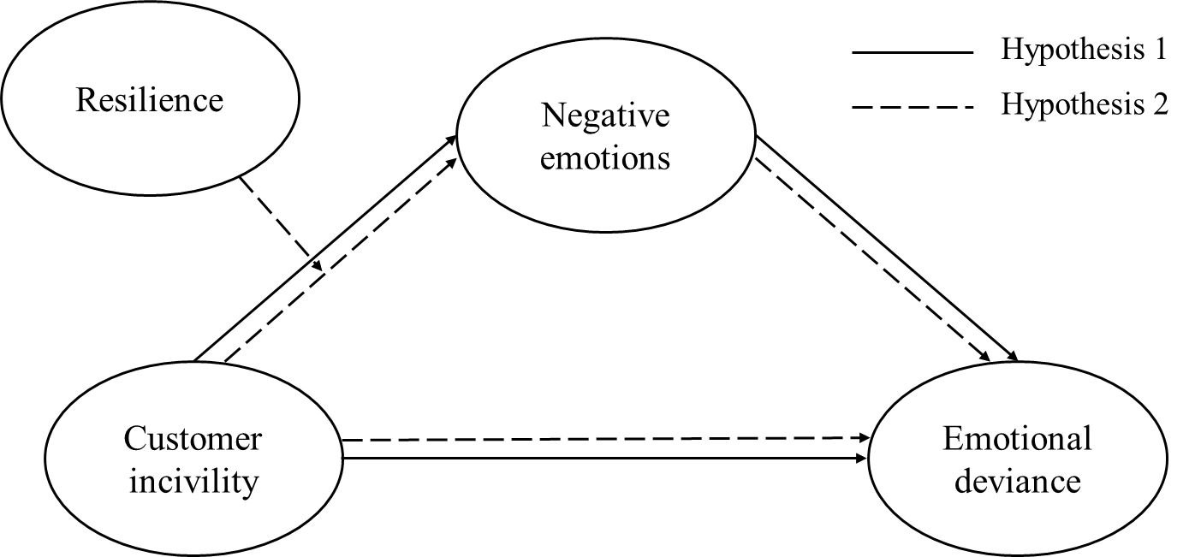
Figure 1. The hypothesized model.
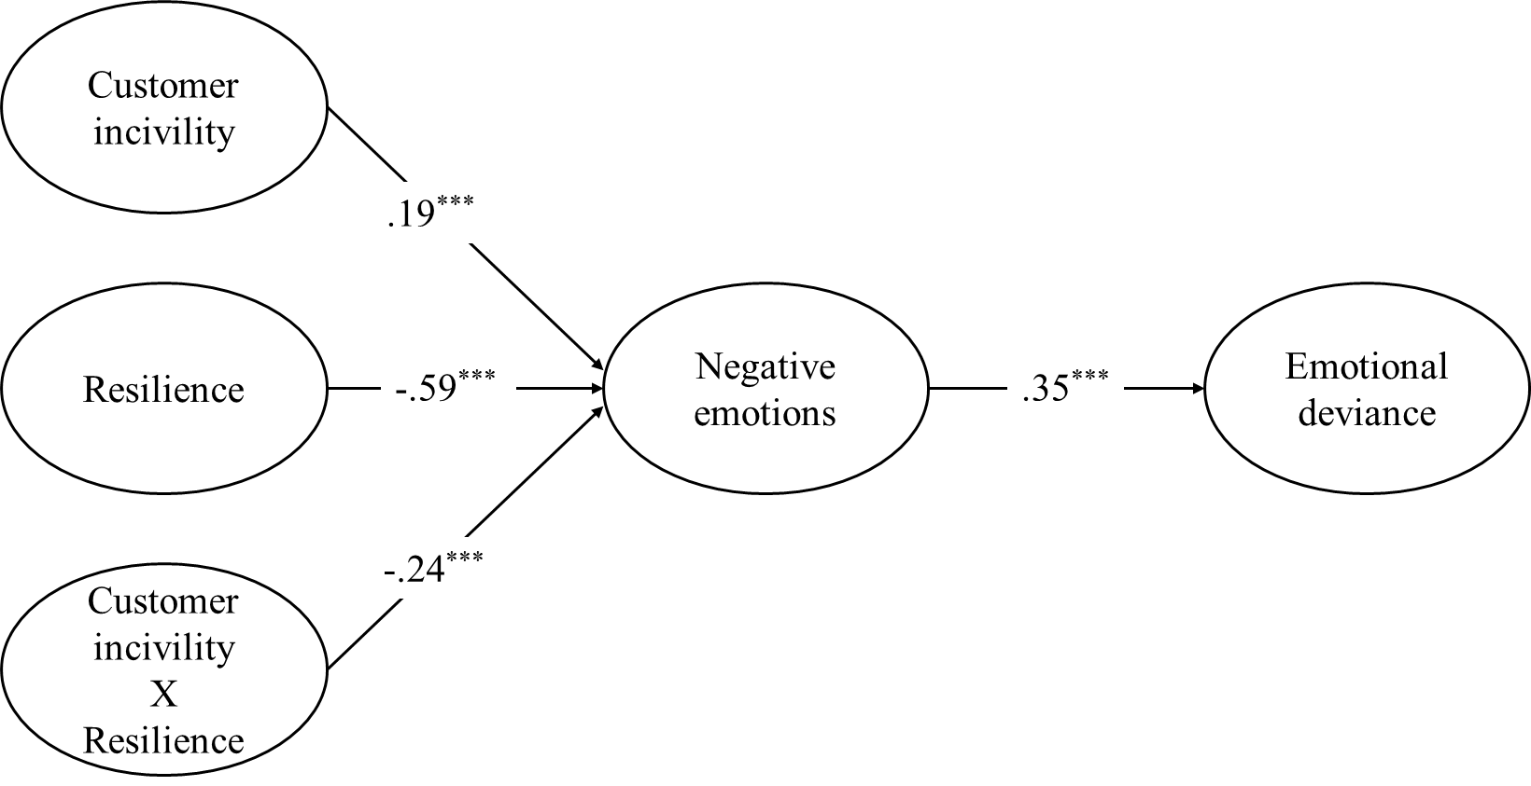
Figure 2. Standardized coefficients for the retained structural equation (N = 419).
***p < .001.
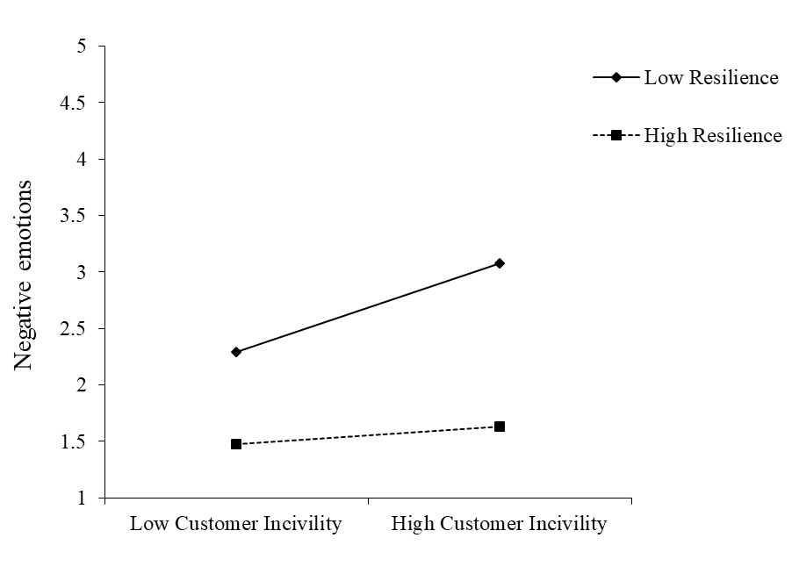
Figure 3. Relationship between customer incivility and negative emotions as a function of resilience.

