Optimization of microCT and contrast-enhanced microCT for cardiovascular applications

Lisa Leyssens (1,2), Maïté Pétré (1,2,3), Greet Kerckhofs (1,2,4,5)

1.iMMC, UCLouvain, Belgium; 2. IREC, UCLouvain, Belgium; 3. Dept. Mechanical Engineering, KU Leuven, Belgium; 4. MTM, KU Leuven, Belgium; 5. Prometheus, Division of Skeletal TE, KU Leuven, Belgium

Keywords: microCT; vasculature; structural characterization

To better understand and treat cardiovascular diseases, it is important to evaluate the changes in blood vessel wall microstructure during disease development and to link these microstructural changes to their functioning. Microfocus X-ray computed tomography (microCT) combined with contrast-enhancing staining agents (CESAs), i.e. contrast-enhanced microCT (CECT), allows non-invasive assessment of the 3D microstructure of soft tissues. The aim of this study was to show the potential of CECT for high-resolution analysis of the different vessel wall layers and their composition.
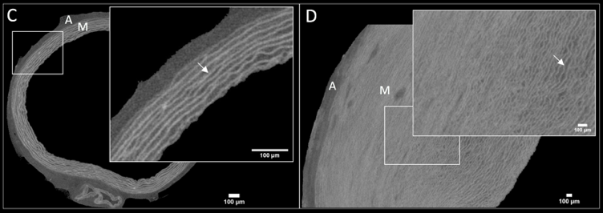
First, we screened Monolacunary and Hafnium-substituted Wells-Dawson polyoxometalates (Mono-WD and Hf-WD POM respectively) [1] as CESAs for vascular tissue staining. We first showed that staining porcine aorta tissue with both CESAs had a negligible effect on the tissue mechanical properties. Then, these CESAs were evaluated for their staining potential. Hf-WD POM stained the elastin laminae with higher intensity than Mono-WD POM, but the latter diffused faster in the tissue (Fig. 1, A-B). Hf-WD POM was then applied to other types of porcine blood vessels (elastic artery, muscular artery, and vein) and allowed to observe important differences in their 3D microstructure. We also showed species-related (porcine, rat, human) differences in the aorta wall microstructure (Fig. 1, C-D), which could have an important impact on their functional behavior, and hence this is important information to consider when running animal experiments to evaluate disease treatments. Importantly, 3D morphometrical parameters have been computed such as elastin volume fraction and elastic lamina waviness and separation, and this without altering the native structure of the tissue. Finally, healthy and atherosclerotic human femoral arteries were compared. Plaques and onsets of calcifications could be identified. The novelty of this study lies in the high-detailed comparison of the microstructure of different types of blood vessels (healthy and diseased) in different species, and this, in a non-destructive 3D manner.
Figure 1: Normalized gray value in function of time for different locations (x) inside the tissue and fitted with an exponential decay curve for (A) Hf-WD POM and (B) Mono-WD POM. CE-CT-based images of the rat aorta (C) and the porcine aorta (D) stained with Hf-WD POM. A=adventitia, M=media, arrow=elastic lamella.
References:
[1] de Bournonville et al, Acta Biomater., 105:253-62, 2020

- Session: Life Sciences
- Student

