The role of Ontology and Patterns in Information Systems Development and Design
  - On the use and reuse of design artifacts

Abstract
This paper advocates that the ambiguity of the word ontology is beneficial when the underlying concepts can be also identified individually. More precisely, the ambiguous interpretation of ontologies as (meta-) models and conceptualizations proves to be beneficial in the context of ontology-driven engineering, which is interpreted here as a special kind of model-driven engineering. Therefore, this paper addresses ontology weaving as a paradigm for the reuse of conceptualizations and model weaving as a paradigm for the reuse of modeling artifacts, integrating them in a framework that allows the creation of ad-hoc modeling and pattern languages that create interoperability via a shared ontology. This link between ontologies and (pattern and modeling) languages is also identified as a mechanism for reciprocal validation, which enables a continuous forward and backward engineering cycle that included validating ontologies with empirical evidence in pattern and modeling languages and evaluating language expressiveness vis-à-vis ontologies . Finally, a minimal pattern language for business is constructed from frequently occurring conceptualizations.

Keywords
Ontology, model transformation, pattern languages, modeling languages, model-driven engineering

Introduction
In the computer and information design science discipline, many authors seek for an increased reuse of design artifacts as it increases designer productivity (Antony, Batra, & Santhanam, 2005). This reuse paradigm, which is closely related to TRIZ that is a methodology for problem solving being based on the use of prior solutions to analogous problems to find proper solutions for specific problems, has resulted in pattern catalogues and pattern languages. These patterns, which specify conceptual solutions to conceptual problems, can be represented in platform specific languages (e.g. program code (Budd, 2002)) but are mostly represented in platform independent languages (e.g. UML or related formalizations (Fowler, 1997; Gamma, 1995; Hay, 1996)). Since these patterns are explicit specifications of a conceptualization, they are ontologies according to Gruber (1993, p. 199). Moreover, ontologies are linked with meta-models for computation-independent models (Jaap Gordijn, 2002; Yu, 1995) and computation-independent models (Garrido, Noguera, González, Hurtado, & Rodríguez, 2007). Additionally, all these ontology interpretations can be related to each other using model-driven architecture (MDA) (Mukerji & Miller, 2003), and each of these ontologies can be used in a TRIZ-like setting which uses ontologies for requirements elicitation (Haruhiko & Motoshi, 2006).
The model transformations in MDA imply that one conceptualization can be represented by multiple ‘ontologies’ or patterns, leading to a semantic mega-model. At the same time, identical syntactical structures can represent different ontologies as is shown by the type, subsequent transaction, strict hierarchy and plan pattern in Batra (2005) that all use the same syntactical structure (i.e. a one-to-many relation) to represent their individual meaning. This situation urges a discussion, which has been initiated by many authors (Assmann, Zchaler, & Wagner, 2006; C. Atkinson & Kuhne, 2003; Bézivin et al., 2006; Evermann & Wand, 2005; Hvalshagen & Khatri, 2008), on the relation between meaning and syntax in design and analysis patterns.
This paper presents a view on the relationship between patterns, (meta-)models and ontology that integrates the majority of the current views and adds a principle for the integration of ontologies (Guarino, 1997a) that enables the identification of analogous problems in separate problem domains, which is a pattern catalogue feature that has been coined by Fowler (1997, p. 9). This feature is valuable as it helps abstraction and increases the reuse and uniformity of solutions for problems across domains. Section 2 presents the ontology integration framework and applies this pattern weaving approach to a simplified set of ontologies to demonstrate the use of ontology abstraction. Subsequently, section 3 addresses the relation between ontologies and languages from a model-driven architecture (MDA) perspective. Section 4 identifies deficiencies in ontology-language mappings and section 5 construct a pattern language from a minimal set of validated ontological commitments to the ontological constructs in section 2. Sections 6 then addresses related work and section 7 presents conclusions and future research.

Ontology Weaving: Conceptualization reuse
The reuse of existing ontologies to construct new ontologies may involve merging existing ontologies to construct larger ones, which is analogous to the creation of pattern languages from pattern catalogues, and combining ontology constructs to create new mixed ontological constructs (i.e. the Cartesian product of ontologies). The first approach is a question of ontology granularity and scope, which is not considered in this paper. The latter approach is the one that applies the abstraction advocated by Fowler (1997, p. 9), for which the abstraction mechanism was formally presented by Guarino (Guarino, 1997a), who identify four types of ontologies that build upon each other, creating a structure that eases ontology integration.
This structure identifies top-level, domain, task and application ontologies. Top-level ontologies provide a generic construct repository, which describes a general world conceptualization, from which domain and task ontologies pick constructs that are further refined or extended to describe the problem domain irrespective of its inherent problems (i.e. domain ontology) or the problem irrespective of its domain (i.e. task ontology) in greater detail. Application ontologies then pick constructs from domain and task ontologies to refine and extend them for describing problems in a domain. Consequently, an application ontology refines the semantics of the Cartesian product of a domain and a task ontology of which the constructs refine top-level ontology constructs. The domain ontology then describes the domain-specific concepts and the domain specific axioms that apply to them, abstracting from the problems that need to be solved in application ontologies. The task ontology constructs, on the other hand, abstract from the domain-specific concepts and constraints (i.e. axioms) describing problems that occur in many application ontologies, using inference schemes (Guarino, 1997b). This structure enables the identification of the same domain construct in multiple application ontologies (and application specific inferences) and analogous applications of the same task (i.e. inference) to different domain ontology constructs (i.e. the same problem is solved (or inference conducted)) for different domain constructs that belong to the same or different domain ontologies).
Ontology can be interpreted as a language independent artifact called conceptualization or a language dependent artifact called ontological theory (Guarino & Giaretta, 1995). The application conceptualization in fig. 1, for which an ontological theory is presented in section 5, is the Cartesian product of a simple domain conceptualization that is derived from the REA ontology (Geerts & McCarthy, 2002) and a task conceptualization that consists of the data structuring conceptualization that was presented by Smith and Smith (1977), which identify generalization and aggregation as two important concepts in database structuring, and the sequence construct that is essential to control flow. The domain conceptualization discriminates the concepts resource (e.g. goods and services), event (e.g. resource acquisitions and conversion) and agent (e.g. employees, suppliers, customers), and specifies domain specific axioms to which all subsequent application ontologies should comply (e.g. every event should affect resources; every event should be controlled by an agent). These domain-specific axioms can also be seen as non-functional requirements for all applications in the domain, while the task conceptualization describes an abstract set of functional requirements. The resulting matrix is the conceptual equivalent of the periodic table of elements since it discriminates identified from unidentified or non-existing domain-task combinations.

Conceptualization | Domain
Task | Application | Resource | Event | Agent
Task | Generalization | Resource Type | Event Type | Agent Type
Task | Aggregation | Component-Whole | Process-SubProcess | Enterprise-Department, Parent-Subsidiary
Task | Sequence | Input-Output | Process | Predecessor-Successor
Fig. 1 A minimal application ontology
This structure is at the same time a creative technique for ontology and language designers (top-down approach) and a classification framework for language designers (bottom-up approach), which allows us to validate and refine ontologies by classifying existing language patterns in the provided structure as those patterns are models that belong to the set of intended models that is to be approximated by an ontology (Guarino, 1997a). Consequently, ontologies can be falsified by pattern or modeling languages that do not comply with the ontology prescription (e.g. urging for a relaxation of the ontology constraints) and ontologies can be refined by adding ontology constraints to the ontology axiomatization to make it approximate the empirically founded pattern catalogue of intended models as close as possible.

Model weaving: Ontology and the (re)use of Models in MDA
The patterns that provide solutions for the problem describing conceptualizations (i.e. top-level, domain, task and application) that were discussed in the preceding section are implemented as technology specific models (e.g. patterns or ‘ontological theories’), in an ontology-aware meta-pyramid (Assmann et al., 2006). According to the object management group (OMG), this meta-pyramid counts four technology layers (i.e. meta-meta model (M3), meta-model (M2), model (M1) and object model (M0)) and three kinds of models (i.e. computation independent model (CIM), platform independent model (PIM) and platform specific model (PSM)) that each have separate meta-models and a shared meta-meta-model that enables model transformations. These model transformations allow the creation of mega-models (Favre & Nguyen, 2005) that describe a set of models that are connected through model transformations. When these model transformations preserve ontological commitment (i.e. when they create semantically equivalent models), these mega-models connect models in different syntaxes and technologies that commit to the same conceptualization.
In MDA, models define the set of syntactically correct object models, which represent real-world objects. Since these models are developed to represent an intended set of real-world objects and not every syntactically correct expression is bound to represent a real-world object, they define an ontology that encloses a set of intended object models. One meta-level upwards, meta-models define a model ontology that describes the language for constructing a set of intended models. These intended models are part of the set of syntactically correct models for that particular language (i.e. ontology). Another meta-level higher, meta-meta-models prescribe a set of constructs for meta-model (and hence language) construction. Consequently, meta-meta-models define an ontology for language construction. The meta-level instantiation interpretation of ontology that is sketched in this paragraph is also known as the ‘linguistic instantiation’(C. Atkinson & Kuhne, 2003) that defines a strict model tree with an M3 root and M0 leafs.
‘Ontological instantiation’ (C. Atkinson & Kuhne, 2003) underlies a second interpretation of ontology. This interpretation relates model constructs (i.e. nodes in the syntax tree) across languages through model transformations, expressing semantic relations irrespective of syntax tree constraints. For example, constructs in an OWL ontology specification (i.e. an instance of the OWL language) are mapped into a UML model (Garrido et al., 2007). This model transformation describes the transformation of a CIM (e.g. OWL model) to a PIM (e.g. UML model) as a model transformation that defines a second model tree with a CIM root and PSM leafs, which are connected through PIMs via model transformations. However, other transformations describe CIM to CIM (e.g. i* to e3-value (J. Gordijn, Yu, & van der Raadt, 2006)) conversions. Since CIMs are roots for PIM and PSM transformation branches, this CIM to CIM transformations introduces the possibility of inter-ontology model tree transformations for PIMs and PSMs in addition to the inter-syntax model transformations that commit to only one CIM. These CIM ontology-root inter-tree transformations are the semantic equivalent of the M3 model-space syntax-root inter-tree transformations (e.g. MOF- space to BNF-space (Djuric, Gasevic, & Devedzic, 2006)).
 | CIM | PIM | PSM
CIM | CIM-to-CIM  (i.e. Inter-conceptualization model transformation) (e.g. i* to e3value) | CIM-to-PIM  (i.e. human readable forward engineering) | CIM-to-PSM  (i.e. machine readable forward engineering) (e.g. e3editor)
PIM | PIM-to-CIM  (i.e. human language reverse engineering) | PIM-to-PIM  (e.g. ERD to ORM) | PIM-to-PSM  (i.e. code generation preparation)
PSM | PSM-to-CIM  (i.e. machine language reverse engineering) | PSM-to-PIM  (i.e. syntax abstraction) | PSM-to-PSM  (i.e. Inter-syntax model transformation)
Fig. 2. model transformations classification
Fig. 2 identifies the different kinds of model transformations that can occur between the three kinds of models that are recognized in MDA (Mukerji & Miller, 2003). CIMs reflect conceptualizations, which are intentional, and therefore can be considered ontologies for the conceptualization model extensions (i.e. instances). These models can then be used to commit PIMs, which are syntactical extensions of the PIM language conceptualization model (i.e. meta-model), to the ontology that is represented by the CIM through CIM-to-PIM model transformations. Accordingly, PSMs can be committed to CIMs directly (i.e. through CIM-to-PSM transformations) or indirectly (i.e. through CIM-to-PIM and PIM-to-PSM transformations). The three syntax-focused transformations in the upper-right corner of fig. 2 are the primary concern of MDA. However, there is currently a lot of attention for the semantic transformations in the diagonal (i.e. CIM-to-CIM, PIM-to-PIM and PSM-to-PSM).
The semantic transformations in the diagonal differ from the other transformations in the diagonal because they commit to the same conceptualization, consequently being syntactic variations for the articulation of one conceptualization. For example, CIM models with a different meta-model that are related via a ontology-preserving model transformation, PIM models with a different meta-model that are related via model transformation and commit to the same CIM through one or two triangulating model transformations, and PSM models with a different meta-model that originate in the same PIM. The lower-left corner of fig. 2 shows abstraction or reverse-engineering (Gomez-Perez, Fernandez-Lopez, & Corcho, 2004, p. 154) operations that abstract from the syntax, revealing the conceptualization.
Fig. 2 abstracted from the meta-levels in MDA. These meta-levels are shown as orthogonal to the dimensions in fig. 2 in fig. 3. Since this paper allows ontological commitment in two dimensions (i.e. meta-level instantiation and semantic model transformation), meta-level crossing model transformations are needed. For example, when an information system is created from an requirements analysis in e3value, the e3value ontology (that is reflected in the CIM meta-model) obliges value interfaces to belong to an actor. When this requirement is transferred to an UML model, which is an instance of the UML meta-model and hence embedded in the UML ontology, it has to be included in the UML model since the standard UML meta-model does not embrace the notions value interface and actor. However, this need for meta-level crossing while creation PIMs from CIMs has been eliminated by stereotyping, which is extending the UML meta-model. For CIM-to-CIM (e.g. i* to e3value) and PIM-to-PIM (e.g. ERD to ORM) transformations however, these meta-level crossing transformations might still be required as ad hoc meta-model extensions are not always desirable (e.g. when the scope of the conceptualization differs).
Source to Target Ontology Model Transformations
M3 | Object-Oriented Platform Language
M2 | CIM/PIM/PSM-MM | Meta-Model Transformation | CIM/PIM/PSM-MM
M2 | CIM/PIM/PSM-MM | MM-to-M Transformation | CIM/PIM/PSM-MM
M1 | CIM/PIM/PSM | M-to-MM Transformation | CIM/PIM/PSM
M1 | CIM/PIM/PSM | Pattern Application | CIM/PIM/PSM
M0 | CIM/PIM/PSM-OM | Object-model Transformation | CIM/PIM/PSM-OM
Fig. 3 Model Transformations
Therefore, Fig. 3 identifies conventional meta-model transformations, meta-model to model transformations for semantics in the meta-model of the source ontology that are not supported by the meta-model of the target ontology and model to meta-model transformations for semantics that are supported by the meta-model of the target ontology and not by the meta-model of the source ontology. Additionally, pattern applications, which describe recurring semantics that are neither supported by the meta-model of the source ontology nor by the meta-model of the target ontology, are discriminated. Finally, object-model transformations should be fully automated and require no human interaction, as is shown by Assman et al. (2006) by representing M0 instances as instances of a CIM, PIM and PSM at the same time.

Ontological Commitment Quality
Not all model mappings across meta-levels (i.e. instantiation for M3, M2, M1, M0) or model kinds (i.e. model transformations for CIMs, PIMs, PSMs) are equally valid or valuable. Therefore, the interpretation of the MDA model transformation paradigm presented in the preceding section needs to be complemented with mapping quality measures. The mapping quality measures in this section asses the ‘syntactic quality’ of the ‘linguistic instantiation’ (C. Atkinson & Kuhne, 2003) in the M3-rooted instantiation trees and the ‘semantic quality’ of the ‘ontological instantiation’ (C. Atkinson & Kuhne, 2003) in the CIM-rooted transformation trees, abstracting from the ‘pragmatic’ and ‘social quality’ of ontologies (Burton-Jones, Storey, Sugumaran, & Ahluwalia, 2005). However, this section does not discuss the ontology quality (Rao & Osei-Bryson, 2007) measures or ontological quality (Haruhiko & Motoshi, 2006) measures for models themselves, as it addresses the notions that underlie these measures and guidelines for reverse and forward engineering when constructing models from other (ontology) models.
Fig. 4 organizes the ontological commitment deficiencies identified by Wand (1996). The mappings assessed are surrogates for ontological commitment as they use an existing ontological theory (i.e. source model), which is implicitly deemed to be a perfect representation of a conceptualization as a formalized substitute for the conceptualization, to evaluate the deficiencies of another ontological theory that is implicitly deemed to be imperfect (i.e. target model). The ideal mapping is identified as ‘ontological completeness’ (Wand, 1996) where every ontology (i.e. the ontological theory that is supposed to represent the conceptualization perfectly) construct (i.e. concept) is mapped on exactly one grammar (i.e. the ontological theory in a particular language) construct. The ‘ontological deficiencies’ ‘ontological incompleteness’ and ‘lack of ontological clarity’ (Wand, 1996) occur when this one-on-one mapping is violated. Ontological incompleteness or construct deficit occurs when an ontological concept, which is articulated in the source model, is not represented in the grammar that is elaborated in the target model. Lack of ontological clarity, on the other hand, comprises construct redundancy, overload and excess. Construct excess occurs when a grammar construct does not map to an ontology construct, meaning that the construct extends the grammar without adding to its expressiveness. Construct overload occurs when a single grammar construct maps into multiple ontology concepts, meaning that it is ambiguous. Construct redundancy occurs when several grammatical constructs represent one ontology construct, meaning that they are synonymous. When concepts or constructs exist that do not belong to the grammar neither to the ontology, they are probably out of scope. When the construct or concept is not out of scope, ontology and grammar extensions should be considered. When multiple ontology constructs are not represented in the grammar, they represent ontological incompleteness, whereas multiple grammar constructs that do not map to an ontology construct represent construct excess. When several ontology concepts map to multiple grammar constructs or vice versa, the mappings should be decomposed into construct overload and redundancy in the evolution toward a one-on-one mapping.

 | Source Model (i.e. Ontology)
Target Model (i.e. Grammar) |  | Not an Ontology Concept | Single Ontology Concept | Several Ontology Concepts
Target Model (i.e. Grammar) | Not a Grammar Construct | Irrelevant or Unknown | Ontological Incompleteness: Construct Deficit | Look for Construct Deficit while (de)composing concepts
Target Model (i.e. Grammar) | Single Grammar Construct | Lack of Ontological Clarity: Construct Excess | 1-on-1 mapping | Lack of Ontological Clarity: Construct Overload
Target Model (i.e. Grammar) | Several Grammar Constructs | Look for Construct Excess while (de)composing constructs | Lack of Ontological Clarity: Construct Redundancy | Look for Construct Overload and Redundancy while (de)composing concepts and constructs
Fig. 4 Ontological Commitment Quality for Model Transformations
Next to quality measures for ontological commitment summarized in fig. 4, quality requirements for meta-level instantiation exist. These quality requirements were partially identified by Atkinson and Kühne (2001) and organized in fig. 5. The ideal situation for meta-syntax to syntax mappings is called instantiation and describes the situation where one meta-syntax construct (e.g. class) relates to multiple syntax constructs (e.g. objects). When a single meta-syntax construct relates to exactly one syntax construct, the syntax mapping suffers replication of concepts, representing that the model and its meta-model convey the same semantics, creating a singleton ontology. A second model deficiency that is identified by Atkinson and Kühne (2001) is ambiguous classification, where one syntax construct relates to multiple meta-syntax constructs, blurring its meaning. Other syntax to meta-syntax mapping deficiencies might be ‘ad hoc syntax extension’, which represents the creation of syntax elements that are not supported by the syntax ontology that is defined by the meta-model. Ad hoc syntax extension might urge a meta-model extension. Incomplete models specification, on the other hand, indicates meta-syntax construct that do not occur in syntax models, denoting potentially superfluous syntax ontology constructs in the meta-model. When constructs occur that do not belong to the syntax, nor to its meta-syntax, they probably belong to a different syntax branch. When multiple meta-syntax construct do not map into syntax constructs, they probably denote incomplete model specification, whereas multiple syntax constructs that do not map into a meta-syntax construct possibly indicate ad hoc syntax extension. When multiple meta-syntax constructs map into several syntax constructs and vice versa, ambiguous classification should be recognized and eliminated.
 | Meta-Syntax M[n+1]
Syntax M[n] |  | Not a Meta-Syntax Construct | Single Meta-Syntax Construct | Several Meta-Syntax Constructs
Syntax M[n] | Not a Syntax Construct | Other Syntax | Incomplete Model Specification | Look for Incomplete Model Specification while (de)composing constructs
Syntax M[n] | Single Syntax Construct | Ad hoc Syntax Extension | Replication of Constructs | Ambiguous Classification
Syntax M[n] | Several Syntax Constructs | Look for Ad Hoc Syntax Extension while (de)composing constructs. | Instantiation | Look for Ambiguous Classification while (de)composing constructs
Fig. 5 Syntax Tree Quality (adopted from Atkinson & Kühne)

A Pattern Catalogue for a minimal Application Ontology
This section populates the minimal application ontology in fig. 1 with patterns in different PIM languages, validating the minimal ontology by showing some of its occurrences. For this operation the UML diagram (OMG, 2007) where chosen because of their omnipresence and domain-independent semantics (i.e. they do not incorporate constructs other than the ones needed for describing desired technology behavior).
Fig 1 constructs a small application ontology from a domain and a task ontology that count three constructs each. The three domain constructs provide a vocabulary (i.e. resource, event and agent) and grammar (i.e. the axioms) that are specific for all applications in the domain, while the three task constructs provide a vocabulary and grammar for applications in general that involve inference (i.e. reasoning). These generic task ontologies are often incorporated in language specification (i.e. meta-model) as they yield domain-independent inferences. Fig. 6 shows three representations that commit to the three task ontology constructs in fig. 1. The first representation column contains meta-models that define specific language constructs, which are shown in the second representation column. The third representation column shows UML Class Diagram patterns that convey the same meaning.

 | Meta-Model | Language Construct | Pattern
Generalization | (src: (OMG, 2007, p. 50)) | 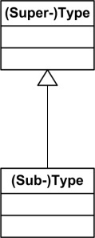 | 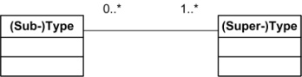  (adapted from  (Odell, 1998, p. 124))
Aggregation | (src: (OMG, 2007, p. 111)) | 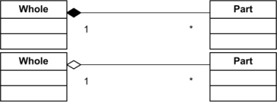 | 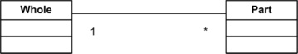  (adapted from  (Batra, 2005, p. 97))
Sequence | (src: (Evermann & Wand, 2005, p. 25)) | 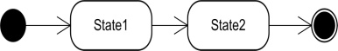 | 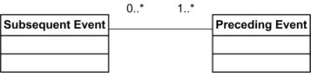  (adapted from  (Batra, 2005, p. 94))
Fig. 6 Task Ontologies in Meta-models and Models
After specifying ontologies in different languages for the same task conceptualization in fig. 6, fig. 7 shows a UML class diagram that models the simplified REA axioms as they were mentioned in section 2. Both the meta-model and the model (i.e. pattern) specify that every event should affect resources and every event should be controlled by an agent. The meta-model extends the UML meta-model to create a domain-specific stereotype-language. The pattern conveys the same semantics in a template for the creation of application ontologies.

 | Simplified REA Domain Ontology
Meta-Model | 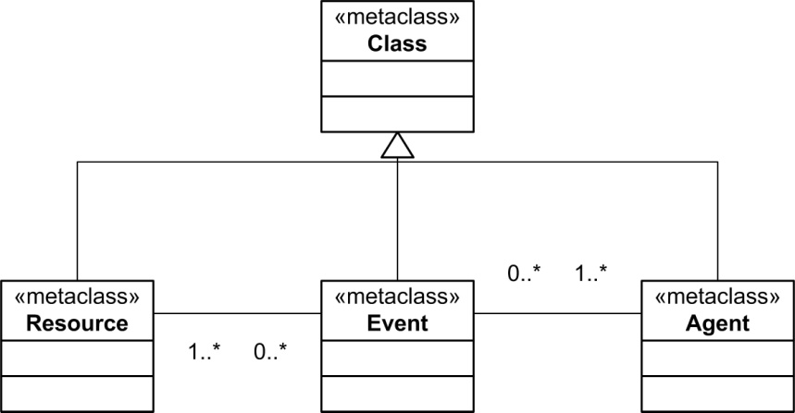
Pattern | 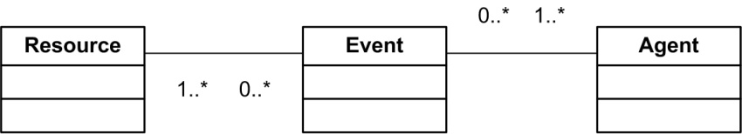
Fig. 7 Domain Ontologies in Meta-models and Models
Finally, fig. 8 combines the patterns fig. 6 and 7 into an application ontology articulated in patterns. The construction of a pattern application ontology is also a good metaphor for the construction of an application language from meta-model parts that commit to a certain domain or task ontology. Introducing the generalization task in the simplified REA domain ontology yields the extension of the domain ontology pattern with resource, event and agent types, whereas combining the domain ontology with aggregation results in the creation of resource bundles (i.e. resource aggregates), processes (i.e. event aggregates) and organizations (i.e. agent aggregates). Combining the domain ontology and the sequence construct then results in defining inputs (i.e. precondition resources) and outputs (i.e. post-condition resources), prior events (i.e. precondition events) and event (i.e. post-condition events) and predecessors (i.e. precondition agents) and successors (i.e. post-condition agents).

 | Simplified REA Application Ontology
Generalization | 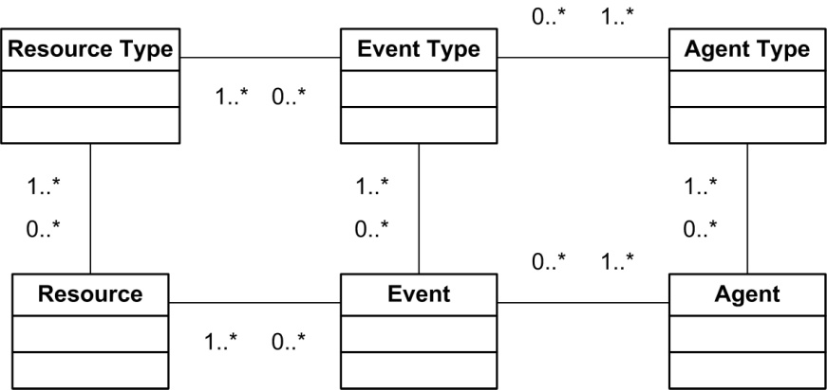
Aggregation | 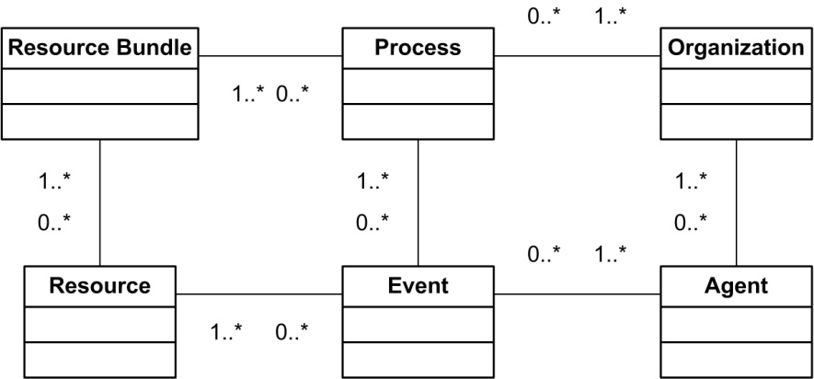
Sequence | 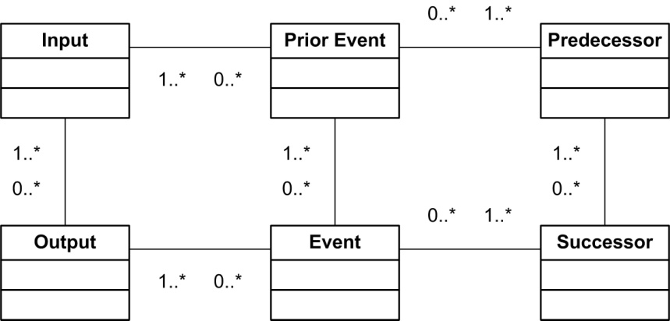
Fig. 8 Application Ontologies in Models

Conclusion and Future Research
This paper showed the creation of application ontologies (as models that represent an application conceptualization) from domain and task ontologies that respectively describe domain-specific constraints in axioms and task-specific inferences. Furthermore, this paper identified ontologies as models representing a conceptualization, which allows the identification of ontological commitment as an inherent part of MDA model transformations. Positioning ontologies within model-driven architecture and engineering enabled ontology- and model-weaving, in which ontology-weaving advocates the reuse of conceptualization models and model-weaving (Assmann et al., 2006) represents the conventional use of model transformations. Furthermore, the ontology weaving presented allows a semantic (de)composition of (meta-) models, easing semantic integration of modeling languages and models as was advocated by Fowler (1997). The established link between ontologies on the one hand and modeling and pattern languages on the other hand, elaborated the ontology for describing analysis patterns (Hvalshagen & Khatri, 2008) and reveals a link between empirically founded pattern and modeling languages and theoretically founded ontologies that enables mutual evaluation and validation. Consequently, this paper presents a unifying paradigm that incorporates most of the current forward and backward engineering approaches.
In the future, we would like to apply this ontology-weaving approach to fully-fledged task and domain ontologies, using this ontological structure to validate the ontological commitment of modeling languages (via their meta-model) and analysis, design and software patterns. This research should result in a structured pattern catalogue that identifies the conceptualization patterns and pattern and modeling languages commit to and categorized the patterns and languages that commit to a certain conceptualization (irrespective of the technology they use).

References.

Antony, S., Batra, D., & Santhanam, R. (2005). The use of a knowledge-based system in conceptual data modeling. Decision Support Systems, 41(1), 176-188.
Assmann, U., Zchaler, S., & Wagner, G. (2006). Ontologies, Meta-Models, and the Model-Driven Paradigm. In C. Calero, F. Ruiz & M. Piattini (Eds.), Ontologies for Software Engineering and Software Technology.
Atkinson, C., & Kuhne, T. (2001). The Essence of Multilevel Metamodeling. Paper presented at the Proceedings of the 4th International Conference on The Unified Modeling Language, Modeling Languages, Concepts, and Tools.
Atkinson, C., & Kuhne, T. (2003). Model-driven development: a metamodeling foundation. Software, IEEE, 20(5), 36-41.
Bahrami, A. (1999). Object oriented systems development. Boston, Mass. ; London: Irwin/McGraw-Hill.
Batra, D. (2005). Conceptual Data Modeling Patterns: Representation and Validation. Journal of Database Management, 16(2), 84-106.
Bézivin, J., Devedzic, V., Djuric, D., Favreau, J.-M., Gasevic, D., & Jouault, F. (2006). An M3-Neutral Infrastructure for Bridging Model Engineering and Ontology Engineering. In Interoperability of Enterprise Software and Applications (pp. 159-171).
Budd, T. (2002). An introduction to object-oriented programming (3rd ed.). Boston: Addison-Wesley.
Burton-Jones, A., Storey, V. C., Sugumaran, V., & Ahluwalia, P. (2005). A semiotic metrics suite for assessing the quality of ontologies. Data & Knowledge Engineering, 55(1), 84-102.
Chen, P. (1976). The Entity-Relationship model: toward a unified view of data. . ACM Transactions on Database Systems, 1(1), 9-36.
Djuric, D., Gasevic, D., & Devedzic, V. (2006). The Tao of Modeling Spaces. Journal of Object Technology, 5(8), 125-147.
Evermann, J., & Wand, Y. (2005). Toward formalizing domain modeling semantics in language syntax. Software Engineering, IEEE Transactions on, 31(1), 21-37.
Favre, J.-M., & Nguyen, T. (2005). Towards a Megamodel to Model Software Evolution Through Transformations. Electronic Notes in Theoretical Computer Science, 127(3), 59-74.
Fowler, M. (1997). Analysis patterns : reusable object models. Menlo Park, Calif.: Addison Wesley.
Gamma, E. (1995). Design patterns : elements of reusable object-oriented software. Reading, Mass.: Addison-Wesley.
Garrido, J. L., Noguera, M., González, M., Hurtado, M. V., & Rodríguez, M. L. (2007). Definition and use of Computation Independent Models in an MDA-based groupware development process. Science of Computer Programming, 66(1), 25-43.
Geerts, G. L., & McCarthy, W. E. (2002). An ontological analysis of the economic primitives of the extended-REA enterprise information architecture. International Journal of Accounting Information Systems, 3(1), 1-16.
Genesereth, M., & Nilsson, N. (1987). Logical foundations of artificial intelligence. Los Altos, CA: Morgan Kaufmann.
Gomez-Perez, A., Fernandez-Lopez, M., & Corcho, O. (2004). Ontological engineering : with examples from the areas of knowledge management, e-commerce and the semantic Web. London: Springer.
Gordijn, J. (2002). Value-based requirements Engineering: Exploring innovative e-commerce ideas. Free University of Amsterdam, Amsterdam.
Gordijn, J., Yu, E., & van der Raadt, B. (2006). E-service design using i* and e/sup 3/ value modeling. Software, IEEE, 23(3), 26-33.
Gruber, T. R. (1993). A translation approach to portable ontology specifications. Knowledge Acquisition, 5(2), 199-220.
Guarino, N. (1997a). Semantic Matching: Formal Ontological Distinctions for Information Organization, Extraction, and Integration. In SCIE (pp. 139-170).
Guarino, N. (1997b). Understanding, Building and Using Ontologies: A Commentary to "Using Explicit Ontologies in KBS Development" by van Heijst, Schreiber and Wielinga. INternational Journal of Human and Computer Studies, 46, 293-310.
Guarino, N., & Giaretta, P. (1995). Ontologies and Knowledge bases: towards a terminological clarification. In N. Mars (Ed.), Towards Very Large Knowledge Bases: Knowledge Building and Knowledge Sharing (pp. 314): IOS Press.
Halpin, T. A. (2001). Information modeling and relational databases : from conceptual analysis to logical design. San Francisco: Morgan Kaufman Publishers.
Haruhiko, K., & Motoshi, S. (2006). Using Domain Ontology as Domain Knowledge for Requirements Elicitation. Paper presented at the Proceedings of the 14th IEEE International Requirements Engineering Conference (RE'06).
Hay, D. C. (1996). Data model patterns : conventions of thought. New York: Dorset House Pub.
Hvalshagen, M., & Khatri, V. (2008). ODAP: an ontological approach for expressing the semantics of analysis patterns in conceptual modeling. Information Technology and Management, 9(2), 121-134.
Mukerji, J., & Miller, J. (2003). Overview and guide to OMG's architecture. MDA, from http://www.omg.org/cgi-bin/doc?omg/03-06-01
Nonaka, I., Umemoto, K., & Senoo, D. (1996). From information processing to knowledge creation: A Paradigm shift in business management. Technology in Society, 18(2), 203-218.
Odell, J. J. (1998). Advanced object-oriented analysis and design using UML. Cambridge: Cambridge University Press ; New York : SIGS.
OMG. (2007). OMG Unified Modeling Language (OMG UML), Infrastructure, V2.1.2.
Opdahl, A. L., Henderson-Sellers, B., & Barbier, F. (2001). Ontological analysis of whole-part relationships in OO-models. Information and Software Technology, 43(6), 387-399.
Rao, L., & Osei-Bryson, K.-M. (2007). Towards defining dimensions of knowledge systems quality. Expert Systems with Applications, 33(2), 368-378.
Smith, J. M., & Smith, D., C. P. . (1977). Database abstractions: aggregation and generalization. ACM Trans. Database Syst., 2(2), 105-133.
van der Aalst, W. M. P., ter Hofstede, A. H. M., Kiepuszewski, B., & Barros, A. P. (2003). Workflow Patterns. Distributed and Parallel Databases, 14(1), 5-51.
Wand, Y. (1996). Ontology as a foundation for meta-modelling and method engineering. Information and Software Technology, 38(4), 281-287.
Yu, E. S.-K. (1995). Modelling strategic relationships for process reengineering. University of Toronto.

Acronym for the Russian translation of ‘theory of inventor’s problem solving’
“a meaningful set of (objective) information articulated in clear (formal) language (that is not so difficult to process with computers )including numbers and diagrams” (Nonaka, Umemoto, & Senoo, 1996)
A conceptualization is the objects, concepts and other entities that are presumed to exist in some area of interest and the relationships that hold among them (Genesereth & Nilsson, 1987)
A mega-model (Favre & Nguyen, 2005) is a structure of models that are related with model transformations, allowing inter-model querying based on the individual construct transformations in the model transformation log.
The axioms convey the fundamental truths, concerning the constructs in a domain conceptualization, that are always observed to be valid and for which there is no counterexample in the domain (Bahrami, 1999)
A subtype requires (i.e. implies) a super-type
A part implies a whole. (For a more elaborate aggregation ontology, we refer to Opdahl et al. (2001))
A post-condition implies a precondition (For a more elaborate sequence ontology, we refer to van der Aalst et al. (2003)
The periodic table of elements discriminates impossible electron configurations as empty boxes and nuclear variations to an electron configuration as boxes that contain multiple isotopes
Under the open-world assumption that is essential to ontologies
Under the c:osed-world assumption
Creative techniques are one of the four problem solution techniques mentioned by Batra (2005)
http://www.e3value.com/tools/
Entity-Relationship Diagram (Chen, 1976)
Object-Role Model (Halpin, 2001)
Ontological commitment is the mapping between a language and the conceptualization it represents.

