(Initial page layout)

On-line optimization of biomethane production in continuous AD processes via model-based ESC approach*

G. Lara-Cisneros¹, D. Dochain², J. Álvarez-Ramírez³

¹ Unidad Juriquilla, Instituto de Ingeniería, Universidad Nacional Autónoma de México, Blvd. Juriquilla 3001, 76230, Querétaro, Mexico. E-mail: glaracis@gmail.com
² Mathematical Engineering department, ICTEAM, Université catholique de Louvain, 4-6 avenue G. Lemaitre 1348, Louvain-la-Neuve, Belgium. E-mail: denis.dochain@uclouvain.be
³ División de Ciencias Básicas e Ingeniería, Universidad Autónoma Metropolitana-Iztapalapa, Apdo. Postal 55-534, México, D.F., 09340, Mexico. E-mail: jjar@xanum.uam.mx

Abstract
This paper is aimed at designing a class of model based extremum-seeking feedback controllers (ESC) for the on-line optimization of biomethane production rate in continuous Anaerobic Digestion (AD) processes. The ESC scheme is based on the modelling error compensation approach coupled with a first-order gradient estimator. The feedback control law is able to keep the concentration of volatile fatty acids (VFAs) near the unknown optimal setpoint while the methane production rate is maximized. Unlike other ESC algorithms applied to AD processes, the proposed control scheme includes a continuous uncertain estimator and avoids excessive oscillations in the control action. Numerical simulations compare the performance of the proposed ESC controller with traditional perturbation-based and sliding mode based approaches.

Keywords: Continuous AD process; Extremum-seeking control (ESC); Model-based ESC; Biomethane production; On-line optimization.

Type of paper: Research Paper

*This work was presented at the 16th IWA World Conference on Anaerobic Digestion in the Session of Modelling, instrumentation and control.

Introduction
Anaerobic Digestion (AD) consists of a chain of parallel and sequential biochemical processes where organic matter is degraded into a methane-rich biogas in oxygen-free environment. The process is a well known wastewater treatment technology for rich organic matter effluents. Over the last decades AD has gained attention due to its high potential as a sustainable energy source [Zhang et al., 2016]. In fact, to privilege the biomethane production in a safe way is one of the targets for the optimization of AD performance [Weiland, 2010]. However, the implementation of large-scale biogas plants has been limited due to severe problems to achieve stable operating conditions [Zhang et al., 2016]. It is well known that the accumulation of Volatile Fatty Acids (VFAs) into the digester induces the inhibition of methanogenic bacteria growth rate and leads to the acidification of the process [Méndez-Acosta et al., 2008; Nguyen et al., 2015]. In this framework the control of the VFAs concentration is very important in order to maintain a good balance between the different stages of the process and to improve the methane production rate. The main issue is that the optimal value of the VFAs concentration is unknown and depends on different factors like the external disturbances of the AD process, e.g., fluctuations in the influent composition, pH and temperature [Nguyen et al., 2015]. One alternative to address this objective is to design robust control schemes able to reach unknown optimal set-points despite of the uncertainty in the mathematical model and external disturbances of the system. Extremum-seeking control techniques (ESC) are a class of real-time optimization tools aimed at finding operating set-points in order to maximize (or minimize) an uncertain objective function [Ariyur and Krstic, 2003; Dochain et al., 2011]. The design of ESC schemes for the on-line optimization of the AD process has been reported in the literature covering different approaches from conventional perturbation-based ESC to adaptive and sliding mode based schemes [Barbu et al., 2017; Caraman et al., 2017; Dochain et al., 2011; Lara-Cisneros et al., 2015; Meraz et al., 2016; Wang et al., 1999]. However, a common drawback in the implementation of existing ESC schemes is the excessive oscillations in the controlled system associated with supplementary effort of the command action (control input) and the actuator elements like valves and pumps of the process.
In this paper a model-based ESC scheme is designed for the real-time optimization of biomethane production in continuous AD process. The controller is based on a modelling error estimation technique coupled with a first-order gradient estimator. Unlike previous ESC approaches the proposed controller consists of a dynamical uncertain estimator that computes unknown terms ensuring robustness for the controlled system despite unmodelled dynamics and external disturbances, and does not make use of continuous perturbation signals for achieving closed-loop convergence around the optimal operating conditions. In the rest of the paper the control design methodology is presented and numerical simulations illustrate the performance of the proposed ESC scheme and compare it with traditional perturbation-based and sliding mode based approaches.

Controller Design
The control objective considered in this work is to keep the VFAs concentration close to an optimal unknown value while the methane production rate is maximized. For the control design purposes it is assumed that the concentration of the VFAs and the methane outflow rate are available for on-line measurement. The design of the ESC scheme proceeds in two steps. First, we assume that all terms and parameters of the mathematical model for the AD are well known; consequently an “ideal” ESC control law is derived. Next, the assumption of the perfectly known mathematical model is relaxed by design a modelling-error compensation and a first-order gradient estimator. Finally, a robust ESC scheme is presented.

AD is a complex bioprocess with a chain of parallel and sequential biochemical processes. For control design purposes it is common to use reduced order models. In this work the AD model from [Bernard et al. 2001] is considered.
$$\dot{S_{1}}=D\left(S_{1f}-S_{1}\right)-k_{1}μ_{1}\left(S_{1}\right)X_{1}$$
$\dot{X_{1}}=μ_{1}\left(S_{1}\right)X_{1}-αDX_{1}$ (1)
$$\dot{S_{2}}=D\left(S_{2f}-S_{2}\right)-k_{3}μ_{2}\left(S_{2}\right)X_{2}+k_{2}μ_{1}\left(S_{1}\right)X_{1}$$
$$\dot{X_{2}}=μ_{2}\left(S_{2}\right)X_{2}-αDX_{2}$$
where S₁ is the concentration of organic biodegradable substrate (total soluble Chemical Oxygen Demand COD except Volatile Fatty Acids) and S₂ represent the concentration of VFAs; X₁ and X₂ represents the concentration for the acidogenic and methanogenic microorganisms. The specific growth rates for the acidogenesis and methanogenesis stages are given by Monod and Haldane kinetic expressions, respectively. The dilution rate D is considered as the control action while S_{1f} and S_{2f} are the influent concentrations of S₁ and S₂, respectively. The k_{i} with i = 1,2,3,4 are yield coefficients and the parameter α∈[0,1] is related to the fraction of bacterial not-attached onto a support. The outflow rate of methane in the gaseous phase Q_{M} is proportional to the methanogenic population growth rate [Bernard et al. 2001]:
$Q_{M}=k_{4}μ_{2}\left(S_{2}\right)X_{2}$ (2)
Now, since the control objective is to keep the concentration of VFAs (S₂) at the optimal unknown set-point, we propose the following ideal feedback control law:
$D=\frac{1}{(S_{2f}-S_{2})}\left[k_{3}{}_{2}\left(S_{2}\right)X_{2}-k_{2}{}_{1}\left(S_{1}\right)X_{1}+K_{C}σ\right]$ (3)
where K_{C} is a positive control gain and σ is the gradient of the outflow rate of methane Q_{M} with respect to the VFAs concentration, defined as
$σ=\frac{dQ_{M}}{dS_{2}}$ (4)
The control law (3) is based on an input-output linearizing method, which means that the control law is designed such that the closed-loop dynamics is characterized by linear dynamics [Isidori 1995]. In this way, it is possible to shaow that the control law (3) is able to regulate the concentration of VFAs at the optimal set-point while the outflow rate of methane Q_{M} is maximized (see [Meraz et al. 2016; Lara-Cisneros et al. 2019]). However, the ESC control law (3) requires exact knowledge of the following:
- The growth kinetic expressions for the acetogenesis and methanogenesis processes and the yield coefficients (k_{i});
(ii) The gradient defined in (4) and,
(iii) The exact value for the influent concentration of VFAs (S_{2f}).
To relax these strong assumptions the modelling error estimation technique coupled with a first-order gradient estimator are proposed [Meraz et al. 2016; Lara-Cisneros et al. 2019]. First, we assume that the influent composition S_{2f} is an uncertain function varying around a nominal value, i.e. $S_{2f}=\overline{S_{f}}+∆S_{f}$, with $\overline{S_{f}}$ a known constant such that it provides a nominal value of the influent concentration, and $∆S_{f}$ an uncertain fluctuation in the composition of the influent feedstock. Now a function for grouping the uncertain terms in the control law (3) is defined as:
$η\left(t\right)=k_{2}{}_{1}\left(S_{1}\right)X_{1}-k_{3}{}_{2}\left(S_{2}\right)X_{2}+D∆S_{f}$ (5)
Based on the modelling-error compensation method the uncertain function (5) is assumed as a new state whose dynamics can be reconstructed from the on-line measurable signals [Álvarez-Ramírez 1999]. Hence, the new state η can be estimated by the following extended high-gain observer
$$\dot{\hat{S_{2}}}=D\left(\overline{S_{f}}-\hat{S_{2}}\right)+\hat{η}+κ_{1}L\left(S_{2}-\hat{S_{2}}\right)$$
$\dot{\hat{η}}=κ_{2}L^{2}(S_{2}-\hat{S_{2}})$ (6)
where $\hat{S_{2}} , \hat{η}$ denotes the estimate for VFAs concentration and the uncertainty function η, respectively. The observer parameters κ₁ and κ₂ are chosen such that the polynomial $P\left(λ\right)=λ^{2}+κ_{1}λ+κ_{2}$ is Hurwitz and L > 0 is a positive high-gain observer [Álvarez-Ramírez 1999].

On the other hand, in order to obtain an estimate of the gradient σ from the on-line measurable signals we consider the following. First, since the gradient is defined as $=\frac{dQ_{M}}{dS_{2}}$ then we can obtain a good approximation as $\hat{σ}=\frac{\dot{Q_{M}}}{\dot{S_{2}}}$ (see [Meraz et al. 2016; Lara-Cisneros et al. 2019]). Now, from the technique proposed in [Berghuis and Nijmeijer 1993] to get an estimate of the velocity using only the position measurements in electromechanical systems, the following gradient estimation scheme based on first-order compensators is proposed. In this sense, let us denote the time derivatives of S₂ and Q_{M} by δ S and δ Q, respectively. Then in the spirit of the works of [Berghuis and Nijmeijer 1993; Meraz et al. 2016] approximate values of the time derivatives for δ S and δ Q can be obtained as the output of the proper filtering as:
$$δQ=\left(\frac{D_{t}}{τ_{Q}D_{t}+1}\right)Q_{M}$$

$$δS=\left(\frac{D_{t}}{τ_{S}D_{t}+1}\right)S_{2}$$
where $D_{t}=\frac{d}{dt}$ is the time derivative operator and τ_{Q} and τ_{S} are filter time constants. The time domain realization of the above estimation expressions can be carried out using the auxiliary states ω_{Q} and ω_{S} as:
$$δQ=\frac{ω_{Q}+Q_{M}}{τ_{Q}}$$
$$δS=\frac{ω_{S}+S_{2}}{τ_{S}}$$
where
$\dot{ω_{Q}}=-\frac{ω_{Q}+Q_{M}}{τ_{Q}}$ (7)
$$\dot{ω_{S}}=-\frac{ω_{S}+S_{2}}{τ_{S}}$$
In this way the estimated value for the gradient (4) calculated as $\hat{σ}=\frac{\dot{Q_{M}}}{\dot{S_{2}}}$ is given by
$\hat{σ}=\frac{τ_{S}}{τ_{Q}}\frac{ω_{Q}+Q_{M}}{ω_{S}+S_{2}}$ (8)
For more details about the convergence of the above estimation gradient scheme see [Lara-Cisneros et al. 2019]. Hence the resulting robust ESC scheme is given by the feedback control law:
$D=\frac{1}{\overline{S_{f}}-S_{2}}\left[-\hat{η}+K_{C}\hat{σ}\right]$ (9)
where $\hat{η}$ and $\hat{σ}$ are computed by (6) and (7-8), respectively. It is important to remark that the control scheme given by (6-9) does not requires knowledge about the kinetic models for organic matter degradation and the exact influent composition in the AD process, only a nominal reference value for the VFAs feeding composition $\overline{S_{f}}$ is required.

Numerical simulations
Simulation results are shown in Fig. 1 and Fig. 3. The parameters of the AD model are the same as those reported in Bernard et al. 2001. The controller parameters for the ESC scheme (6-9) are set to the following values: K_{C} = 0.2, κ₁ = 1, κ₂ = 2, L = 2.5 and τ_{S} = τ_{Q} = 0.1. As we can see in Fig. 1 the control scheme (6-9) achieves the convergence of the AD process at the optimal operating conditions where the methane production rate Q_{M} is maximized. With respect to the issue of maximizing the degradation rate of organic matter in AD process, we know that it is of prime importance in the wastewater treatment plants context; but, on the other hand, it is known that one way to maximize the methane production rate is to maintain VFAs concentration at specific value in order to favour the methanization process and avoid the acidification of the digester [Méndez-Acosta et al. 2008; Nguyen et al. 2015]. It is important to remark that the control scheme is able to keep the AD process close to the optimal operating conditions despite un-modelled dynamics and fluctuations in the inlet composition (Fig. 2). In Fig. 3 acceptable performance of the ESC scheme (6-9) despite the fluctuation in the AD inlet composition is shown.

In order to compare the performance of the proposed ESC scheme with respect to the conventional perturbation-based ESC and sliding mode-based approaches [Barbu et al., 2017; Caraman et al., 2017; Dochain et al., 2011; Lara-Cisneros et al., 2015; Meraz et al., 2016; Wang et al., 1999], numerical simulations have been performed with same model parameters and conditions.
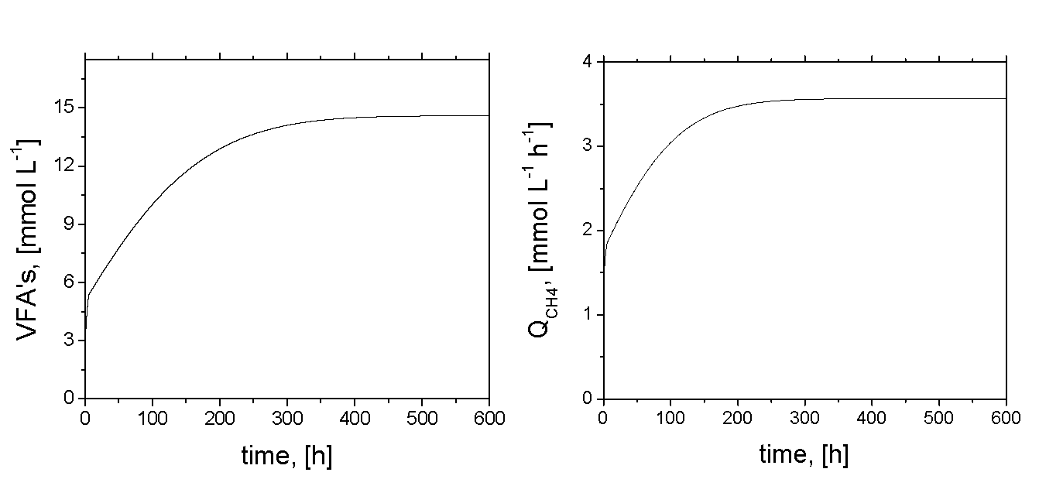
Figure 1. Controller performance of the ESC scheme (6-9) without fluctuation in the inlet composition, i.e. ΔS_{f} = 0.

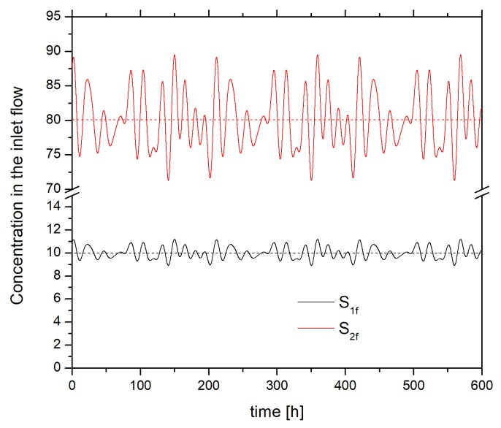
Figure 2. Fluctuation in the inlet composition around nominal values (dashed line).
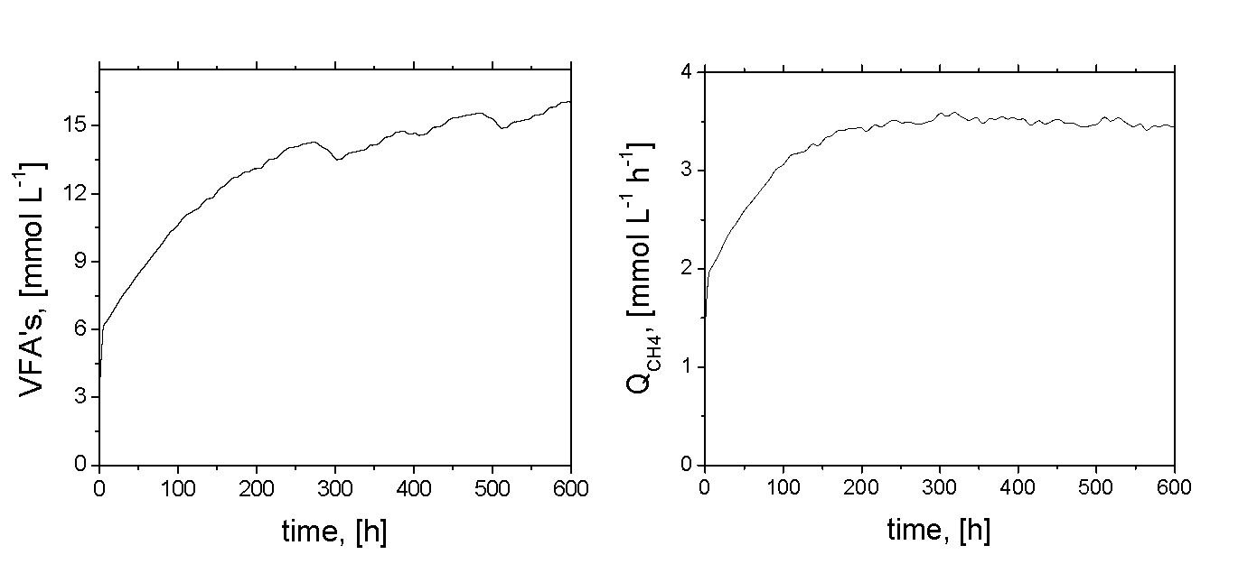
Figure 3. Controller performance of the ESC scheme (6-9) with fluctuation in the inlet composition, ΔS_{f} ≠ 0.

For the case of free-model perturbation-based ESC we use the basic structure studied in [Ariyur & Krstic 2003] that is based on a continuous perturbation in the control input in order to obtain information of the gradient by using a combination of one integrator with a high-gain filter. For the case of the AD process (1-2) we get to the following ESC control scheme
$$D=\hat{D}+Asin\left(ωt\right)$$
$\dot{\hat{D}}=K_{C}\left(Q_{M}-η_{AD}\right)\sin\left(ωt\right)$ (10)
$$\dot{η_{AD}}=-ω_{h}η_{AD}+ω_{h}Q_{M}$$
The control parameters for the perturbation-based ESC (10) were tuned as follows: K_{C} = 0.0003, A = 0.01, ω = 0.5 and ω_{h} = 0.4. For the sliding mode-based scheme we consider the same structure developed in [Lara-Cisneros et al., 2015] given by:
$$D=\frac{1}{\overline{S_{f}}-S_{2}}\left[-\hat{η}+λsgn\left(\sin\left(\frac{π}{α}z\right)\right)\right]$$$\dot{\hat{S_{2}}}=D\left(\overline{S_{f}}-\hat{S_{2}}\right)+\hat{η}+κ_{1}L\left(S_{2}-\hat{S_{2}}\right)$ (11)
$$\dot{\hat{η}}=κ_{2}L^{2}(S_{2}-\hat{S_{2}})$$
where $z\left(t\right)=Q_{M}(t)-g(t)$ with $\dot{g}=ρ$ and ρ,λ,α > 0.

We can see in Fig. 4 that the convergence rate to the maximal methane production does not have significant difference for the different ESC schemes. However, the response of the control action presents a clear advantage in terms of the smoothness for the proposed ESC scheme (6-9) with respect to (10) and (11) approaches (see Fig. 3 b). The simulations results show that the ESC approach proposed here is a good alternative to avoid the drawback of excessive oscillations in the control action due to the continuous external perturbation (dither signal) in traditional ESC schemes or sliding-mode ones. The advantage of smooth response in the control action is that it prevents excessive wear on the final actuator elements (valves and pumps) and guarantees low energy consumption. On the way to a practical implementation of the proposed ESC scheme, it is necessary to develop a tuning methodology in order to choose appropriate control parameters. Also a convergence analysis that includes the stability properties of the gradient estimation algorithm and its relation with the dynamical properties of the AD process will be addressed in a future contribution.
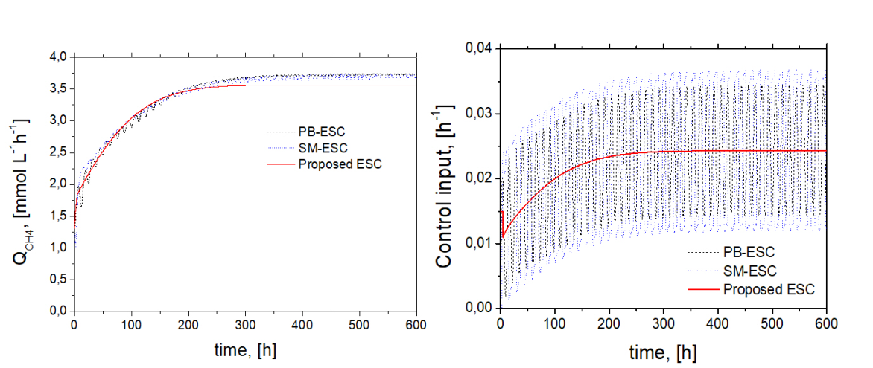
Figure 4. Comparison of the performance for the proposed ESC with perturbation-based and sliding mode based approaches; Perturbation-based ESC scheme (PB-ESC), sliding mode-based ESC (SM-ESC) and proposed Model-based approach (Proposed ESC).

Conclusions
In this paper a class of model-based extremum-seeking control scheme able to maximize the biomethane production rate in continuous AD processes has been proposed. The ESC controller is based on the modelling error compensation approach coupled with a first-order gradient estimator. Unlike the conventional ESC schemes the proposed control law is a model-based algorithm without using exogenous perturbation signals, which avoid the drawback of excessive oscillations in the control input. Numerical simulations showed that the ESC scheme is able to regularize the AD process close to the optimal operating conditions despite unmodelled dynamics and external disturbances.

Acknowledgements
This work was supported by the Sectorial Fund CONACYT-SENER-Energetic Sustainability Mexico through the project FSE-2015-07-279043 “Development of monitoring and control systems to maximize biogas production in wastewater treatment processes”.

References
Alvarez-Ramírez J. 1999 Adaptive control of feedback linearizable systems: A modelling error compensation approach. International Journal of Robust and Nonlinear Control, 9(6), 361-377.
Ariyur K.B. & Krstic M. 2003 Real-Time Optimization by Extremum-Seeking Control. Wiley & Sons., New Jersey.
Barbu, M., Ceanga E., Vilanova R., Caraman S. & Ifrim G. 2017 Extremum-Seeking control approach based on the influet variabilty for anaerobic digestion optimization. IFAC Papers On-Line 50-1, 12623-12628.
Berghuis H. & Nijmeijer H. 1993 Global regulation of robots using only position measurements, Systems & Control Letters, 21, 289-293.
Bernard O., Hadj-Sadok Z., Dochain D., Genovesi A. & Steler J.P. 2001 Dynamical model development and parameter identification for an anaerobic wastewater treatment plant. Biotechnology & Bioengineering, 75, 424-438.
Caraman S., Barbu M., Ifrim G., Titica M. & Ceanga E. 2017 Anaerobic digester optimization using extremum seeking and model-based algorithms. A comparative study. IFAC Papers On-Line 50-1, 12673-12678.
Dochain D. 2008 Automatic Control of Bioprocesses. Willey, CAM, U.K.
Dochain D., Perrier M. & Guay M. 2011 Extremum seeking control and its application to process and reaction systems: A survey. Mathematics and Computers in Simulation, 82, 369-380.
Isidori A. 1995 Nonlinear Control Systems. Springer-Verlag, Berlin.
Lara-Cisneros G., Aguilar-López R. & Femat R. 2015 On the dynamic optimization of methane production in anaerobic digestion via extremum-seeking control approach. Computers & Chemical Engineering, 75, 49-59.
Lara-Cisneros G., Dochain D. & Alvarez-Ramírez J. 2019 Model based extremum-seeking controller via modelling-error compensation approach. Journal of Process Control, 80, 193-201.
Méndez-Acosta H. O., Palacios-Ruiz B., Alcaraz-Gonzalez V., Steyer J-P., González-Alvarez V. & Latrille E. 2008 Robust control of volatile fatty acids in anaerobic digestion processes. Industrial & Engineering Chemistry Research, 47, 7715-7720.
Meraz M., Ibarra-Valdez C. & Alvarez-Ramírez J. 2016 Modelling-error compensation approach for Extremum-seeking control of a continuous stirred tank bioreactors with unknown growth kinets. Industrial & Engineering Chemistry Research, 55, 4071-4079.
Nguyen D., Gadhamshetty V., Nitayavardhana S. & Khanal S. 2015 Automatic process control in anaerobic digestion technology: A critical review. Bioresource Technology 193, 513–522.
Wang H.H., Krstic M. & Bastin G. 1999 Optimizing bioreactors by extremum-seeking. International Journal of Adaptive Control and Signal Processing, 13, 651-669.
Weiland P. 2010 Biogas production: Current state and perspectives. Applied Microbiology and Biotechnology, 85, 849-860.
Zhang Q., Hu J. & Lee D.J. 2016 Biogas from anaerobic digestion processes: Research updates. Renewable Energy, 98, 108-119.

