Testing crowdsourcing as a means of recruitment for the comparative judgement of L2 argumentative essays.

Abstract
Comparative judgement (CJ) is an assessment method in which a large number of pairwise comparisons between learner productions are used to generate scales ranking each item from strongest to weakest. Recent research has suggested that combining CJ with various approaches to judge recruitment, including community-driven and crowdsourcing methods, holds promise as a method of assessing L2 writing, especially for research purposes. However, the majority of studies to date have tested CJ only using relatively simple, easily evaluated sets of texts. There remains insufficient evidence of the method’s potential for assessing more complex texts, particularly when the comparisons are being conducted by crowdsourced assessors. This study seeks to address this problem by testing the reliability and validity of a crowdsourced form of CJ for the assessment of texts which are longer, more topically diverse, and more homogeneous in proficiency than those used in earlier studies. The results suggest that CJ can be conducted with crowdsourced judges to generate reliable assessments of L2 writing, and provide initial evidence of concurrent validity. However, there are drawbacks in terms of efficiency.

Introduction
Comparative judgement (CJ) is a measurement method in which participants (termed judges), are shown pairs of items (also called representations or performances) side-by-side and asked to choose which is better based on a simple task definition. Many such comparisons are collected from a range of judges; subsequently, statistical techniques related to Rasch analysis are used to generate a measurement scale which specifies the quality of each item relative to all others. The method was originally introduced by Louis Thurstone (1927, 1954), a pioneer in the field of psychometrics, to measure complex psychological values such as attitudes, beliefs and preferences. It was later introduced to the field of education, where it has been used to assess a wide range of hard-to-define educational constructs, including mathematical reasoning, critical thinking, essay writing, and creative performance (Jones & Davies, 2023). In applied linguistics, CJ offers significant potential as it can be used to address issues of construct definition and measurement through human perception (Thwaites & Paquot, 2024).
A number of recent studies have explored CJ as a potentially useful approach to L2 writing assessment (e.g. Paquot et al., 2022; Sims et al., 2020). These studies have generally shown the method to be highly reliable and to have strong concurrent validity, demonstrated through correlations with rubric-based grades. For example, Sims et al. (2020) used CJ to assess a set of L2 English essays and reported reliability levels in excess of .90, and correlations with rubric-based assessments of the same texts of .91 or greater.
CJ has a number of characteristics of potential value to the L2 writing assessment community, especially in research contexts. Firstly, since each comparison requires only a decision as to which of two texts is “better”, CJ tasks can be completed very quickly. Sims et al. (2020), for example, found CJ to be 51 seconds per text faster than rubric-based assessment. Secondly, CJ does not require a rubric, and therefore no lengthy process of rubric development or rater training. Instead, judges are asked to use their own experience and expertise to make their decisions. While this has led to the criticism that the method is opaque, since it is not known what criteria judges use to make their decisions (Jones & Inglis, 2015), the method’s advocates have countered this criticism by arguing that CJ allows judges to make full use of their expertise as they make decisions. This might represent an advantage over the use of rubrics, since by not imposing a “narrow and rigid [construct] definition” upon judges (Bisson et al., 2016), CJ allows the incorporation of a wide range of perspectives on the target construct.
Another of CJ’s advantages is its flexibility. L2 writing assessment studies have suggested that CJ can be performed equally effectively by judges from a variety of backgrounds. For example, the comparisons in Sims et al.’s (2020) L2 essay assessment study were conducted by two sets of judges – TESOL undergraduates and trained writing assessors – with the resulting scales showing very similar levels of reliability (SSR = .90 for the undergraduates and .93 for the trained raters) and concurrent validity (Spearman’s rho = .91 vs .94, respectively, with pre-existing rubric-based grades).
One particularly promising aspect of CJ’s flexibility is the potential to be combined with crowdsourced methods for judge recruitment. In the context of L2 writing research, crowdsourcing might facilitate access to reliable writing assessment in contexts where expert judges are hard to recruit. For researchers, it would also offer a reliable, efficient, “off the shelf” alternative to rubric-based assessment – the need for which has recently been underlined by Park et al. (2022), who reported on the widespread use of inaccurate and unreliable proficiency measurement practices in applied linguistic studies. In addition, CJ ranks can provide a numeric operationalization of proficiency in SLA research, addressing limitations associated with the traditional treatment of proficiency as a categorical variable, including issues such as lack of variance in observations (Ortega, 2012: 131).
One specific context to which such methods might be well-suited is learner corpus research, where the costs associated with rubric-based assessment have hindered progress on enriching learner corpora with reliable proficiency information (Carlsen, 2012). In order to explore this possibility, Paquot (Paquot et al., 2022; Thwaites, Vandeweerd, et al., 2024) initiated a project consisting of a series of studies testing CJ’s efficacy when used in tandem with various approaches to judge recruitment. The first of these studies took a “community-driven” approach, in which judges were recruited from the applied linguistic community using social media, mailing lists, and personal contacts. The judges performed CJ on a set of 50 argumentative essays from the ETS corpus of responses to TOEFL test questions. The study found that judges recruited in this way were able to provide comparisons of these essays with a reliability of SSR = .937. A linear model comparing the CJ-derived measurement scale with pre-existing CEFR assessments showed a significant relationship of .50.
This initial study was later replicated using a more traditional crowdsourcing approach to judge recruitment, in which judges were recruited using the crowdsourcing platform Prolific. They performed the same CJ task, rating the same 50 essays. The measurement scale which resulted from their comparisons had near-identical levels of reliability and concurrent validity to those achieved in the community-driven study (SSR = .944; linear model comparing the CJ scale with rubric-based CEFR grades R² = .53). The authors also noted that the change of recruitment approach led to greater efficiency.
While these studies suggest the reliability, validity, and efficiency of using both community-driven and crowdsourced approaches to L2 writing assessment with CJ, the evidence they provide is quite restricted. This is because the studies used a set of texts with quite a limited profile: argumentative essays with a length of around 250 words, covering a full proficiency range, and a single essay prompt. There are good reasons to believe that texts with these properties would be relatively easy to judge: shorter texts take less time to read; those which differ markedly in proficiency are easier to choose between; and those written in response to the same prompt are more easily compared. These features might therefore have contributed to the high levels of reliability and concurrent validity reported by the authors.
In order to test CJ’s efficacy for evaluating more complex sets of texts, Thwaites, Kollias, & Paquot (2024, Experiment 2) conducted a new study similar to the community-driven study above, except that the texts were replaced with 50 argumentative essays taken from the International Corpus of Learner English (ICLE; Granger et al., 2020). These texts had a more challenging profile: they were longer (610 words on average, rather than around 250), consisted of responses to five different prompts rather than only one, and had a narrower proficiency range than in earlier studies (largely around the B2 and C1 levels). The judges were again members of the applied linguistic community. The measurement scale produced in the study had a reliability of SSR = .82, and correlated with upper-moderate strength with a rank ordering of the same texts based on rubric-based grading with many faceted Rasch modelling (MFRM), conducted by trained raters (r = .677). The results suggested that while CJ can reliably be used to assess texts of the type found in the ICLE corpus, there was nevertheless an impact of the complexity of these texts.
Taken together, the above results suggest, firstly, that both community-driven and crowdsourced CJ offer promising approaches to L2 writing assessment. In the case of the community-driven approach, this potential extends to contexts in which quite challenging sets of texts have to be assessed. The community-driven approach is not without limitations, however. It requires drawing on the goodwill of an already very busy research community, making large-scale implementation nearly impossible. It is therefore important to also explore the performance of a crowdsourced approach to judge recruitment for assessing texts with challenging characteristics. The study presented below seeks to address these concerns.

The current study
The aim of this study is to test the reliability and validity of a crowdsourcing approach to the assessment of challenging sets of L2 written texts for research contexts. The study is a partial replication of the community-driven study described above (Thwaites, Kollias, & Paquot, 2024, Experiment 2); the 50 texts and the methods used in the two studies are the same, but the judges are different. Replicating this study facilitates comparison of the two approaches to judge recruitment, both with each other and with a rubric-based approach to assessment. There are three research questions:
- How reliably can a group of crowdsourced judges evaluate a set of relatively long L2 argumentative essays, which cover a narrow proficiency range and contain responses to multiple essay prompts?
- How strongly does the measurement scale produced by these crowdsourced judges correlate with a scale derived from rubric-based assessment conducted by trained raters?
- How strongly does the measurement scale correlate with that produced via a community-driven form of CJ conducted by linguists?

Participants, materials, and procedure
Seventy-five participants were recruited from the Prolific crowdsourcing platform (www.prolific.co). This platform provides filtering tools that which allow researchers to select participants based on their desired demographics. Since the goal of this study was to recruit participants reflective of a general crowdsourced population, we did not want to be too selective. We applied only one filter, requiring that English be the participants' first language to avoid introducing a confounding variable. This minimal filtering approach allowed for the possibility that some of the resulting participants might have expertise in writing assessment. To account for this, participants were asked to complete a short questionnaire concerning their writing assessment experience, enabling a comparison in order to facilitate their comparison with the judges in the original study. This revealed that a small number of participants in the Prolific group possessed some experience and training in writing assessment, but this was much less common than among the judges in original study (see Table 1).
Table 1: Judges' writing assessment experience in original and replication study
 | Original study | Replication
Experience as L2 examiner
Frequently
Experience as L2 examiner  Frequently | 26 (40%) | 1 (1.4%)
Occasionally | 12 (18%) | 5 (6.8%)
Rarely | 5 (7.7%) | 4 (5.4%)
Never | 22 (34%) | 64 (86%)
Experience as L2 instructor
Frequently
Experience as L2 instructor  Frequently | 37 (57%) | 3 (4.1%)
Occasionally | 9 (14%) | 7 (9.5%)
Rarely | 6 (9.2%) | 1 (1.4%)
Never | 13 (20%) | 63 (85%)
Experience as content instructor
Frequently
Experience as content instructor  Frequently | 21 (32%) | 2 (2.7%)
Occasionally | 13 (20%) | 6 (8.1%)
Rarely | 11 (17%) | 2 (2.7%)
Never | 20 (31%) | 64 (86%)
Training in writing evaluation | 48 (74%) | 8 (11%)

After completing the initial questionnaire, participants followed a link to the CJ platform No More Marking (www.nomoremarking.com). There, they were asked to read pairs of texts and decide “Which of the two texts is a more advanced piece of second-language writing?” (see Figure 1). Each of the 75 judges completed 10 comparisons, for a total of 750. This equates to an average of 30 comparisons per text. The original study used 602 comparisons at an average of 24 per text, with each judge completing an average of 8.9 comparisons. The larger number of comparisons collected in this replication was intended to compensate for the possibility that the crowdsourced judge group, having less expertise, would require a larger number of comparisons to reach a satisfactory level of reliability.

The 50 texts used in the study were the same as those used in the original study. They comprised ten responses to each of five prompts, covering the topics of feminism, money, television, the value of universities, and imagination. Texts were chosen to be representative of the ICLE corpus in terms of the popularity of the prompts (the five prompts were among the six most frequent in the corpus), the diversity of the L1 background of their writers (22 of the corpus’ 25 L1 groups were represented in the sample), and their length (ICLE mean = 598 words, study mean = 610). They were therefore longer and more topically diverse than the texts used in earlier CJ studies (e.g. Paquot et al., 2022; Sims et al., 2020; Thwaites, Vandeweerd, et al., 2024). They were also more homogeneous in terms of proficiency, since the texts in the ICLE typically cover a CEFR range of approximately B1+ to C2 and therefore lacked the lower proficiency texts found in earlier studies (see Table 2 for proficiency information).
Figure 1: An example comparison, illustrating the No More Marking platform (nomoremarking.com).
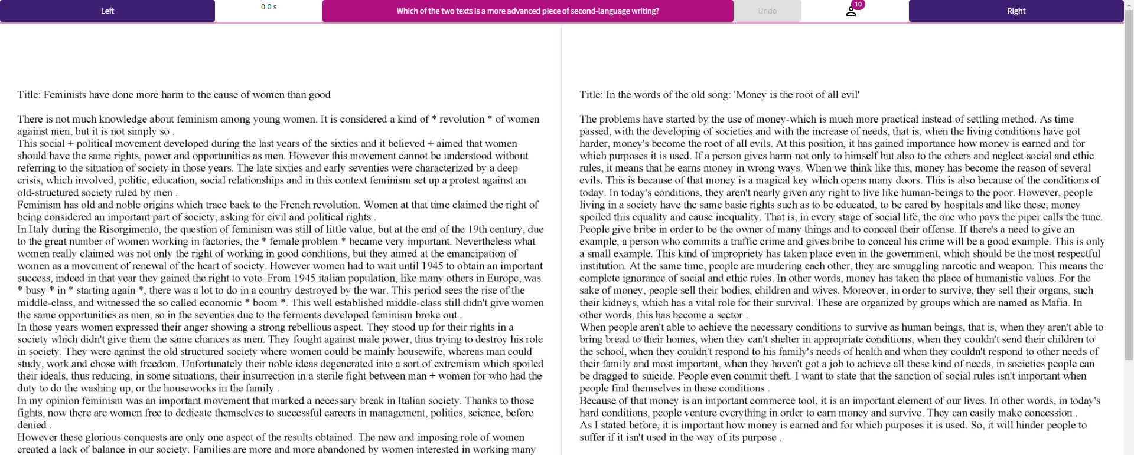

Data analysis
All data processing and analysis was done in R (R Core Team, 2023). An initial measurement scale was created using the sirt package (Robitzsch, 2023). The scale is generated using the Bradley-Terry model. Each item on the scale receives a score reflecting the probability that it will “win” a comparison with another item. The mean item score on the scale is zero, while the standard deviation is generally around 2.5 (Bramley, 2007).
Subsequently, checks were made to identify judges who showed signs of inattentive participation. As in the original study, crowdsourced judges were removed if they triggered at least two of three “red flags” of inattentive behaviour. Details of this scheme can be found in Thwaites, Kollias, & Paquot (2024). All judges passed these checks, so the initial measurement scale was treated as final.
To answer Research Question 1, we calculated the SSR of the scale. We also calculated infit data, which measures the extent to which each judge’s decisions are consistent with those of other judges. Where overall reliability is low, infit allows identification of any judges who behaved very differently from others.
To answer Research Question 2, the rank order of each item on the measurement scale was compared to a rank scale derived from rubric-based ratings. The rating process involved each text being assessed by three trained raters (i.e. triple rubric-based rating). The raters evaluated each text using a rubric derived from the C4 Writing descriptors which form part of the Council of Europe’s guidance on relating the CEFR scale to language examinations (Council of Europe, 2009). Final scores for each text were determined using many-faceted Rasch modelling (MFRM). Scores were then converted into interval-level measures (specifically logit-based theta parameters, which align with the comparative judgment framework based on the Bradley-Terry model; see Thwaites, Kollias, & Paquot, 2024, for a detailed description of the rubric-based rating process, and Table 2 for proficiency data).
Spearman correlation was used to calculate the similarity of the two scales, due to its compatibility with rank-ordered data. In addition, a linear model was created to test the extent to which texts rubric-rated at each CEFR level (B1+ to C2) had distinct CJ rank positions. CJ rank order was entered as the dependent variable and CEFR level as the independent variable. Tests of model assumptions were all within acceptable bounds. Paired contrasts were also conducted to explore whether the mean rank of texts at each CEFR level differed significantly. To answer Research Question 3, the same statistical method was used to compare the rank order of the crowdsourced scale with its location on the community-driven rank scale from the original study.
 | Experiment 2 texts
 | N = 50
CEFR level
B1+ | 7 (15%)
B2 | 8 (17%)
B2+ | 13 (28%)
C1 | 16 (35%)
C2 | 2 (4.3%)
Not graded | 4 (8.6%)
Table 2: CEFR levels for the 46 rubric-rated texts, generated via MFRM. Note that four texts could not be graded due to misfitting the MFRM model; see Thwaites, Kollias, & Paquot, 2024, for details.

Results

RQ1: How reliably can a group of crowdsourced judges evaluate a set of L2 argumentative essays?
The scale separation reliability (SSR) of the crowdsourced measurement scale was .81, after a total of 750 comparisons (30 judgements per text). This compares with a reliability of .82 after 602 comparisons conducted by the linguists in the original community-driven study (24 judgements per item). To make these values easier to compare, we also generated a model using only the first 24 judgements per item for the crowdsourced judges. The SSR level of this smaller model was .78. This confirms that the crowdsourced group required additional comparisons to reach the same level of reliability as the community-driven group. Analysis of judge infit data suggested that most judges performed in a consistent way, with only one judge returning an infit greater than two times the standard deviation.

RQ2: How strongly does the measurement scale correlate with a scale derived from rubric-based assessment?

A Spearman correlation between the crowdsourced judges’ CJ scale and the rubric-based assessments conducted by trained raters was statistically significant and in the upper-moderate range (r = .683, p < .001; see Figure 2). The corresponding correlation from the original study was very similar (r = .677, p < .001). This suggests that the two CJ rank scales were equally similar to the rubric-based assessments of trained raters.
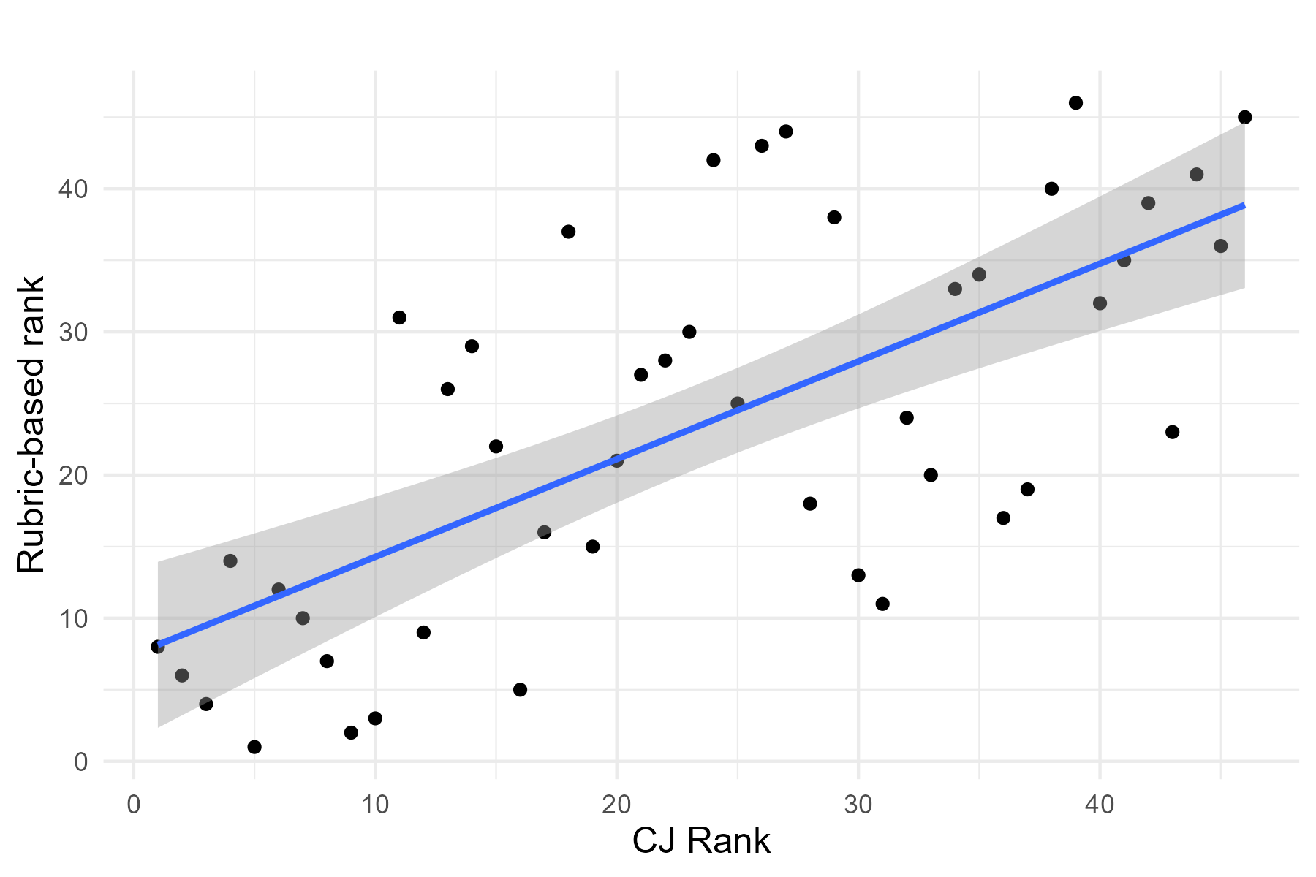
Figure 2: Spearman correlation between the CJ rank derived from Prolific judges, and the rubric-based rank from trained raters

A linear model was used to further test the relationship between the crowdsourced CJ rank scale and the rubric-based assessments, this time by comparing the rank order of each item with its categorical CEFR level. The model was statistically significant and accounted for a moderate amount of variance in rank orders (F(4, 41) = 10.3, p < .001, r² = .47).
Paired contrasts between texts at each CEFR level are presented in Table 3. Two observations can be made about this data. The first is that there is a general trend for rank scores to increase with each CEFR level, as would be expected from the correlation above. The second observation is that the differences in rank orders were only statistically significant for non-adjacent CEFR levels. For example, the contrast between B1+ and B2 was non-significant, but all other contrasts involving B1+ were significant. This pattern of results is essentially the same one reported in the original study, where the corresponding linear model was also significant but accounted for slightly less variance (F (4, 41) = 9.555, p < .001, r² = .43; see Table 4). Scatterplots illustrating the rank distribution of the texts by rubric-based CEFR level in the two studies are presented in Figure 3 [see attached file], which also highlights several texts whose CJ rank did not correspond to their rubric-based CEFR band. In the original study (see the right panel of Figure 3), but not in this replication (left panel), some of these texts were also statistical outliers, meaning that they had a CJ rank 1.5 times higher or lower than the median of other texts which received the same CEFR band. Six texts were categorised as non-adjacent in the replication study – one more than in the original study.
 |  |  | vs. B2 |  | vs. B2+ |  | Vs C1 |  | Vs C2
CEFR grade | n. | 95% CI | t | p | t | p | t | p | t | p
B1+ | 7 | .11-15.04 | -1.22 | 1 | -4.09 | <.01 | -5.22 | <.001 | -4.46 | .001
B2 | 8 | 6.77-20.73 |  |  | -2.86 | .07 | -4.0 | <.01 | -3.72 | <.01
B2+ | 13 | 20.83-31.78 |  |  |  |  | -1.20 | 1 | -2.18 | .35
C1 | 16 | 25.75-35.62 |  |  |  |  |  |  | -1.61 | 1
C2 | 2 | 28.54-56.46
Table 3: Summary of linear model comparing the mean crowdsourced CJ rank of texts at each CEFR level to those at other CEFR levels. Bonferroni correction has been applied to p values.
 |  |  | vs. B2 |  | vs. B2+ |  | Vs C1 |  | Vs C2
CEFR grade | n. | 95% CI | t | p | t | p | t | p | t | p
B1+ | 7 | 3.00-19.86 | -.43 | 1 | -2.96 | .05 | -4.74 | <.001 | -3.68 | <.01
B2 | 8 | 5.99-21.77 |  |  | -2.60 | .13 | -4.45 | <.001 | -3.45 | <.05
B2+ | 13 | 20.58-32.96 |  |  |  |  | -2.04 | .48 | -2.05 | .47
C1 | 16 | 29.61-40.77 |  |  |  |  |  |  | -1.06 | 1
C2 | 2 | 28.22-59.78
Table 4: Summary of linear model comparing mean community-driven CJ rank order of texts at each CEFR level to CEFR grades in the original study.

RQ3: How strongly does the measurement scale correlate with that produced via CJ conducted by linguists?
A Spearman correlation between the crowdsourced and the community-driven CJ ranking scales was strong and statistically significant (r = .74, p < .001; see Figure 4). This is slightly stronger than correlation of either CJ scales with the rubric-based grades. Nevertheless, as Figure 3 shows, there were also clear discrepancies between the two CJ scales. For example, texts Q041 and Q137 were ranked as non-adjacent to their CEFR bands by the Prolific group, but were ranked close to texts of the same CEFR band by the linguist group. The opposite pattern occurred for text Q030, and more marginally also for texts Q437 and Q464.

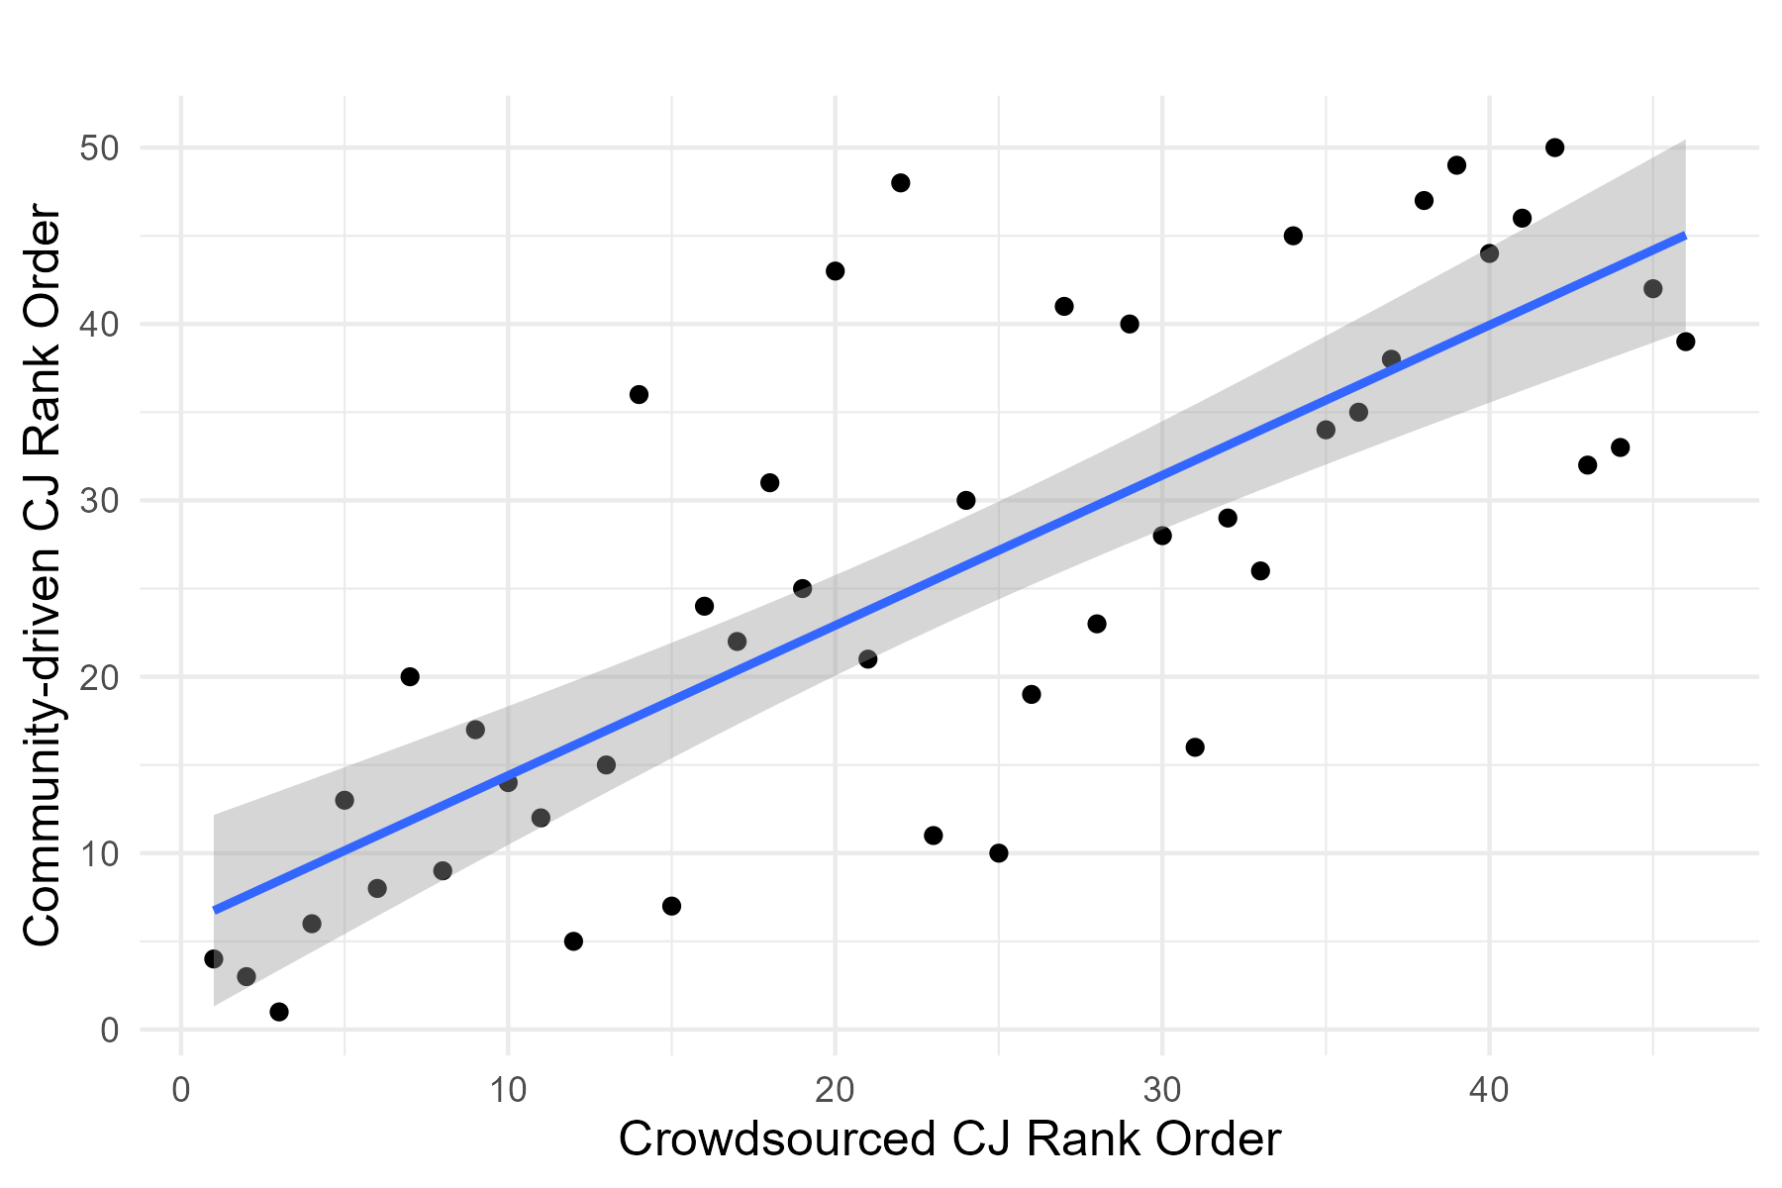
Figure 4: Spearman correlation between CJ rank orders derived from the Prolific and the Community-driven judges

Figure 4: Correlation between CJ rank orders produced by community-driven and Prolific judges

Discussion
This replication study compared the reliability and validity of a crowdsourced, CJ-based approach to L2 writing assessment with two alternative approaches presented in the original study: firstly a community-driven CJ approach in which members of the applied linguist community served as judges, and secondly triple rubric-rating with MFRM, conducted by trained raters. While an earlier study (Thwaites, Vandeweerd, et al., 2024) has suggested the feasibility of the crowdsourced approach, it did so only with relatively simple texts. By focusing on the evaluation of a more complex set of texts, the current study provides a more rigorous test of the use of crowdsourced CJ for L2 writing assessment in research contexts.
The results provide a mixed picture of the potential for crowdsourced CJ to be used for this purpose. On one hand, the measurement scale generated by the crowdsourced judges had a virtually identical reliability value, and very similar levels of correspondence with rubric-based assessments, to those produced by the linguists in the original study. On this basis, we can conclude that the crowdsourced judges generated reliableassessments of these complex texts, with some evidence of concurrent validity. On the other hand, the crowdsourced judges were less efficient than the community-driven group, requiring a larger number of comparisons per item to reach essentially the same level of reliability.
The likeliest explanation of this difference in efficiency is the lower level of expertise possessed by the crowdsourced judges. Only 11% of this group had any training in writing assessment, compared with 74% of the original study’s linguists (see Table 1). The results of meta-analysis conducted by Verhavert et al. (2019) suggest that this lower level of expertise is likely to have resulted in the larger number of comparisons required by the crowdsourced group. The study found that while “novice” judges – a category which would include the majority of the current study’s crowdsourced participants – could reach levels of reliability just as high as those achieved by peer or expert judges (which would include the original study’s participants), they required more comparisons per item to do so.
Since the goal of this study was to assess the feasibility of using crowdsourced CJ to assess L2 writing proficiency, particularly as a faster, cheaper, and more accessible alternative to rubric-based assessment in research contexts, it is worth expanding upon the effects of this reduced efficiency on CJ’s time and financial costs. Beginning with the former, the increased number of comparisons required by the crowdsourced judges did not lead to reduced time efficiency: the ease of recruiting participants via Prolific (and of setting up the task on NoMoreMarking) meant that the entire participant recruitment and data collection process was completed in less than 24 hours, and required no specialised expertise. By comparison, the original study took several months to complete due to the voluntary nature of judge participation, while collecting rubric-based ratings (including the steps of training raters, assigning and uploading scripts, and waiting for raters to complete their assigned ratings) took several weeks.
However, the low efficiency of the crowdsourced judges meant that collecting data this way was more expensive than expected. At a rate of 30 comparisons per item, the CJ approach cost €15 per script. This compares with a cost of around €10 per script for rubric-based assessment using three raters per script, including the cost of a two-hour rater training session. Taken together, these results suggest that this crowdsourced form of CJ was a time-efficient but not particularly cost-efficient approach to assessing this complex set of texts.
Moving on to the issue of validity, the present study has provided initial evidence of the concurrent validity of this crowdsourced, CJ-based approach to L2 writing assessment. The measurement scale produced by the crowdsourced group correlated strongly with the scale produced by the original study’s community-driven use of linguist judges (r = .74), and only slightly less strongly with rating produced by trained raters using rubric-based rating with MFRM (r = .683), suggesting that the crowdsourced judges made reasonable decisions regarding the proficiency of these L2 texts.
However, they also hint at divergences, both between the scales emerging from CJ and rubric-based rating, and between those created by the two judge groups in the two CJ studies. Each of these scales reflects a latent, group-level conceptualisation of the construct of L2 writing proficiency, formed from the decisions made by each judge/rater. The divergence between scales can therefore be assumed to reflect the extent to which these conceptualisations differ. Unfortunately, it is difficult to directly access the content of these conceptualisations; further research should explore them in more detail. One way of doing this, currently under investigation in our ongoing research (Thwaites et al., Submitted), is to ask different groups of judges, such as crowdsourced judges and trained raters, to provide comments on each decision they make while conducting CJ. This is the same approach taken in existing studies of the construct validity of using CJ for L1 writing assessment (e.g. Lesterhuis et al., 2018, 2022). The findings of these studies have generally suggested that CJ judges principally pay attention to higher order text features such as argumentation and organisation when making judgements, and vary in the attention they give to areas such as cohesion and accuracy. However, no study to date has compared comments made by different groups of judges; such an approach could shed much light on the content of the conceptualisations of L2 writing proficiency that underlie measurement scales such as those described in the present study.

Conclusion
This paper has reported on a replication study in which a group of judges recruited via the online crowdsourcing platform Prolific used comparative judgement to assess a set of L2 English essays which were longer, featured a wider range of topics, and were more homogeneous in proficiency than those used in earlier CJ studies. The results suggest that this approach can yield reliable assessments with acceptable concurrent validity for research purposes. However, achieving these results required a large number of comparisons per item. Though the approach was highly efficient in terms of time, its unexpectedly high financial costs suggest that it might only be cost-effective if the texts being evaluated are relatively simple to assess. The study also suggested a need for future research to explore CJ’s construct validity, both by investigating how judge demographics influence the construct underlying CJ measurement scales, and by exploring divergences between CJ and rubric-based rating scales. To maximise their usefulness in research contexts, and potentially in writing assessment contexts more generally, it will also be important to address an important limitation of CJ tasks. CJ scores are essentially norm-referenced (i.e. interpretable only in relation to the items included in the same task) unless additional steps are taken to align them with an external standard. Two promising solutions to this issue warrant further exploration: first, incorporating previously graded items representing grade boundaries into a CJ set to anchor CJ scores to these items (Marshall et al., 2020); and, second, conducting a standard-setting exercise where experts establish cut-off points for each level of the target standard (Fleckenstein et al., 2020).
Finally, given the significant expense involved, however, another potential avenue could be to explore whether CJ tasks could be delegated to a generative artificial intelligence tool, which might offer a more scalable and economically viable alternative for similar assessments. Future research should examine whether human judges offer distinct advantages in performing CJ tasks, or if generative AI tools could effectively handle challenging texts such as those used in this study.

Bibliography
Bisson, M.-J., Gilmore, C., Inglis, M., & Jones, I. (2016). Measuring Conceptual Understanding Using Comparative Judgement. International Journal of Research in Undergraduate Mathematics Education, 2(2), 141–164. https://doi.org/10.1007/s40753-016-0024-3
Bramley, T. (2007). Paired Comparison Methods. In P. Newton, J.-A. Baird, H. Goldstein, H. Patrick, & P. Tymms (Eds.), Techniques for monitoring the comparability of examination standards (pp. 246–300). Qualifications and Curriculum Authority. https://assets.publishing.service.gov.uk/government/uploads/system/uploads/attachment_data/file/487059/2007-comparability-exam-standards-i-chapter7.pdf
Carlsen, C. (2012). Proficiency Level—A Fuzzy Variable in Computer Learner Corpora. Applied Linguistics, 33(2), 161–183. https://doi.org/10.1093/applin/amr047
Council of Europe, N. (2009). Relating language examinations to the Common European Framework of Reference for Languages: Learning, teaching, assessment (CEFR): A Manual. Council of Europe Language Policy Division.
Granger, S., Dagneaux, E., Meunier, F., & Paquot, M. (2020). International corpus of learner English v3 (Vol. 2). Presses universitaires de Louvain Louvain-la-Neuve.
Jones, I., & Inglis, M. (2015). The problem of assessing problem solving: Can comparative judgement help? Educational Studies in Mathematics, 89(3), 337–355. https://doi.org/10.1007/s10649-015-9607-1
Lesterhuis, M., Bouwer, R., van Daal, T., Donche, V., & De Maeyer, S. (2022). Validity of Comparative Judgment Scores: How Assessors Evaluate Aspects of Text Quality When Comparing Argumentative Texts. Frontiers in Education, 7. https://www.frontiersin.org/articles/10.3389/feduc.2022.823895
Lesterhuis, M., van Daal, T., Van Gasse, R., Coertjens, L., Donche, V., & De Maeyer, S. (2018). When teachers compare argumentative texts: Decisions informed by multiple complex aspects of text quality. L1-Educational Studies in Language and Literature, 18, 1–22. https://doi.org/10.17239/L1ESLL-2018.18.01.02
Paquot, M., Rubin, R., & Vandeweerd, N. (2022). Crowdsourced Adaptive Comparative Judgment: A Community-Based Solution for Proficiency Rating. Language Learning, 72(3), 853–885. https://doi.org/10.1111/lang.12498
Park, H. I., Solon, M., Dehghan-Chaleshtori, M., & Ghanbar, H. (2022). Proficiency Reporting Practices in Research on Second Language Acquisition: Have We Made any Progress? Language Learning, 72(1), 198–236. https://doi.org/10.1111/lang.12475
R Core Team. (2023). R: A Language and Environment for Statistical Computing. R Foundation for Statistical Computing. https://www.R-project.org/
Robitzsch, A. (2023). sirt: Supplementary Item Response Theory Models. https://CRAN.R-project.org/package=sirt
Sims, M. E., Cox, T. L., Eckstein, G. T., Hartshorn, K. J., Wilcox, M. P., & Hart, J. M. (2020). Rubric Rating with MFRM versus Randomly Distributed Comparative Judgment: A Comparison of Two Approaches to Second-Language Writing Assessment. Educational Measurement: Issues and Practice, 39(4), 30–40. https://doi.org/10.1111/emip.12329
Thwaites, P., Kollias, C., & Paquot, M. (2024). Is CJ a valid, reliable form of L2 writing assessment when texts are long, homogeneous in proficiency, and feature heterogeneous prompts? Assessing Writing, 60, 100843. https://doi.org/10.1016/j.asw.2024.100843
Thwaites, P., Vandeweerd, N., & Paquot, M. (2024). Crowdsourced comparative judgement for evaluating learner texts: How reliable are judges recruited from an online crowdsourcing platform? Applied Linguistics, amae048.
Verhavert, S., Bouwer, R., Donche, V., & De Maeyer, S. (2019). A meta-analysis on the reliability of comparative judgement. Assessment in Education: Principles, Policy & Practice, 26(5), 541–562. https://doi.org/10.1080/0969594X.2019.1602027

Scale Separation Reliability is a Rach-based reliability metric comparable to Cronbach’s alpha
The information-weighted mean square value (infit) reflects the extent to which judges make unexpected decisions. For more details on infit measures in NoMoreMarking, see https://nmm.notion.site/What-is-infit-d83623b7c55040f3a59d306c343c4073 .

