Effect of PN Passivation on MOSFETs Performance in 28 nm FD-SOI
M. Vanbrabant¹, M. Rack¹, A. Cathelin², J.-P. Raskin¹, V. Kilchytska¹
¹Université catholique de Louvain, Louvain-la-Neuve, Belgium
²STMicroelectronics, Crolles, France

Abstract—This work investigates, for the first time, how the PN passivation introduced in the FDSOI substrate just below the BOX to improve substrate performance in 28 nm FD-SOI technology affects active MOSFET parameters. DC performance and low-frequency noise (LFN) of MOSFETs are studied for different substrate resistivities and implant parameters. It is demonstrated that PN passivation impacts the device performance via modification of the back-gate realization.

Introduction
Aiming for the best possible passives for RF and mm-wave applications, an alternative solution compatible with FD-SOI process, unlike trap-rich, was first introduced in [1] to improve the effective resistivity of the substrate. This solution called PN passivation was then applied to an industrial FD-SOI process [2] where optimal implant parameters/ substrates were found. In this work, we go further and investigate the impact of these implant variations (also used for the back-gate realization) on active nFETs performance.

Device Details
The device used in this study is an FD-SOI low threshold voltage (LVT) nMOSFET (Fig.1) from 28FDSOI technology of STMicroelectronics featuring a gate length of 30 nm, finger width of 1 μm and 64 fingers for a total width of 64 μm (layout dimensions). This device was tape-out on standard (Std) and high-resistivity (HR) wafers with variations in the implant conditions. It is important to note that N/P-type implantation used for n-well/back-gate realization in active nFET is the same as the one used for N/P-type implantation of PN junctions under passive devices. Wafers description is summarized in Table I, more details are available in [2]. “Ref.” refers to the usual implants (n- and p-wells) in the standard fabrication process when there is no PN passivation.

Results and Discussion

DC Characteristics
Fig. 2a shows I_{d}-V_{gs} characteristics in a linear regime for different wafer splits. For reference implants, moving from Std wafer (W23) to HR wafer (W15) does not affect IV curves. However, modifications of implants (W01| W09) result in an increase of the subthreshold slope (SS) from 82 mV/dec (W15|W23) to 89 mV/dec and a threshold voltage shift ΔV_{th} of 27 mV. In addition, V_{th} tunability with the back-gate voltage V_{bg} is reduced compared to “ref.” implants (Fig. 2b). W01 is particularly impacted, most probably due to lower energy and doses of implant making it more subjected to substrate depletion effect [3].

Analog Figures of Merit (FoM)
From analog figures of merit perspective, the maximum g_{m}/I_{d}, key FoM for baseband (high-gain, high-precision) applications, decreases by 7.1% for split runs (W01|W09) wrt “ref” ones (Fig. 3) which agrees with SS trends. For high-frequency applications where high current is required, I_{d} at g_{m}/I_{d} = 10 V⁻¹ is also reduced for W01|W09 (inset in Fig. 3). Maximum transconductance g_{m,max,} being similar for all wafers in linear regime (Fig. 4a), becomes a bit higher for split runs in saturation, while intrinsic voltage gain A_{v} is higher (with lower g_{m}) for “ref.” implants wafers (Fig. 4b).

LFN Characteristics
Fig. 5 exemplifies the noise power spectral density (PSD) S_{Id} at different fixed I_{d} for W23. Fig. 6 shows the normalized PSD S_{Id}/I_{d}² vs I_{d} at 10 Hz for different wafers, which for both “ref.” implants wafers is seen to be proportional to their corresponding (g_{m}/I_{d})², suggesting dominance of carrier number fluctuations (CNF) mechanism. For split wafers W01|09, it deviates from their (g_{m}/I_{d})² especially in weak inversion suggesting combination of different mechanisms.

Conclusion
The impact of substrate/implant variations, intended for PN passivation, on the FD-SOI nFETs performance was investigated. No significant degradation was observed and changes are suggested to be mainly related to modification of the back-gate realization.
- Wafers Description
Wafer  ID | Substrate | Implants.
W01 | HR | Split 1
W09 | HR | Split 2
W15 | HR | Ref.
W23 | Std | Ref.

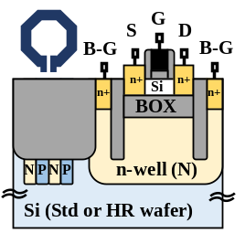
Fig. 1. Schematic of FD-SOI nFET.
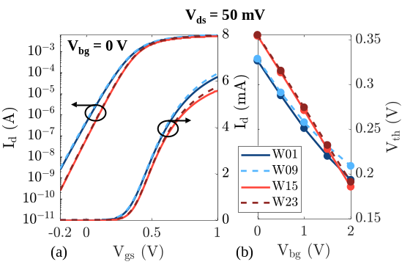
Fig. 2. (a) I_{d}-V_{gs} characteristics and (b) threshold voltage V_{th} vs back-gate voltage V_{bg} in linear regime (V_{ds} = 50 mV) for different wafers.
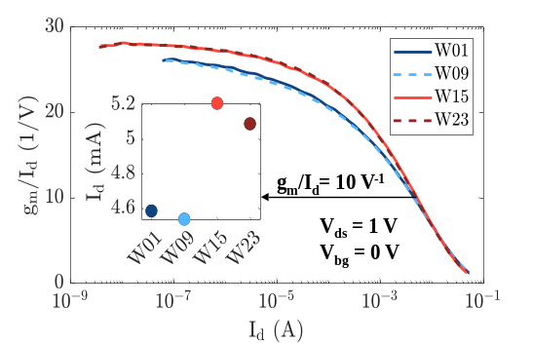
Fig. 3. g_{m}/I_{d} vs I_{d} at V_{ds} = 1 V and corresponding I_{d} at g_{m}/I_{d} = 10 V⁻¹ for different wafers.

Acknowledgment
The authors would like to thank STMicroelectronics for chip fabrication and research support. This work is partially supported by the Fonds de la Recherche Scientifique, via FNRS-PDR project and by KDT JU project “SOIL” (grant agreement No 101139785) via EU HORIZON and Walloon Region (Belgium) funding.

References
- M. Rack, et al, "Low-Loss Si-Substrates Enhanced Using Buried PN Junctions for RF Applications," IEEE EDL, vol. 40, no. 5, pp. 690-693, May 2019.
- M. Rack et al., “Low-Loss Silicon Substrates with PN Passivation in 28 nm FD-SOI,” SSE 2025.
- P. Kushwaha et al., ‘Modeling the impact of substrate depletion in FDSOI MOSFETs’, SSE, vol. 104, pp. 6–11, Feb. 2015.
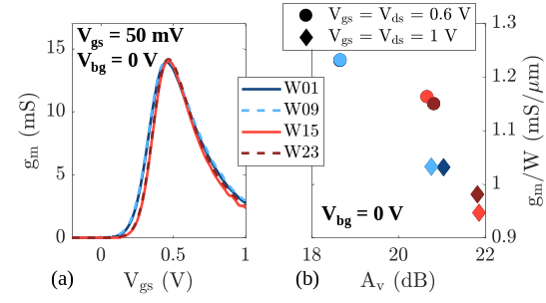
Fig. 4. (a) Transconductance g_{m} vs V_{gs} at V_{ds} = 50 mV and (b) g_{m}/W vs A_{v} at different V_{ds} = V_{gs}.
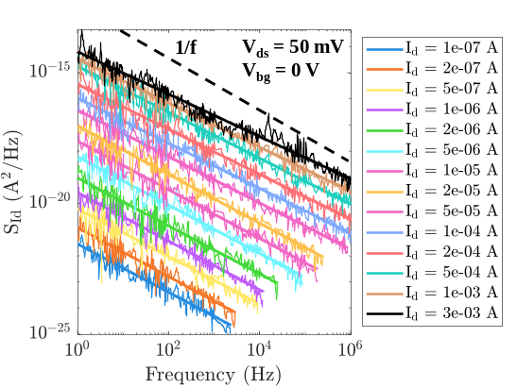
Fig. 5. Current noise power spectral density S_{Id} vs frequency at different fixed I_{d} for W23.
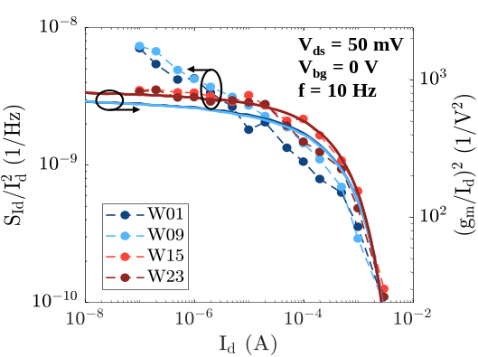
Fig. 6. Variation of normalized drain current noise S_{Id}/I_{d}² vs I_{d} at 10 Hz for different wafers.

