“INFLUENCE OF CRACKS ON THE STIFFNESS OF TIMBER STRUCTURAL ELEMENTS”

Elke Mergny, Raquel Mateo, Miguel Esteban, Thierry Descamps, Pierre Latteur

ABSTRACT: Cracks in timber structural elements lead users to downgrade them, while their influence on the mechanical properties is globally unknown. They are thus disadvantageous and responsible for an underutilization of timber in new constructions. The phenomenon also impacts constructions subjected to transformation or renovation that are most of the time fully replaced, simply because of the ignorance of their bearing capacity. The present paper investigates the influence of cracks on stiffness, by analytical and numerical developments. It proposes a classification of cracks in six types (+ composite types) and models real beams, randomly cracked. It shows that the presence of cracks seems to decrease the stiffness of the beam, although this decrease is quite low in most cases.

KEYWORDS: Cracks, Stiffness, Timber engineering, Numerical, Analytical X-ray tomography.

INTRODUCTION
Cracks in wood are well-known defects in timber beams. Their formation may be caused by various phenomena such as drying of the wood, growth stresses or environmental conditions.

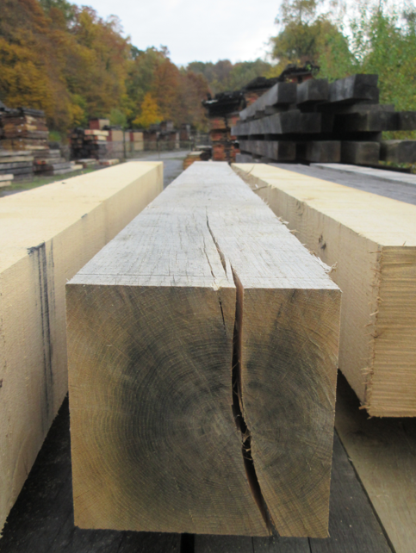 | 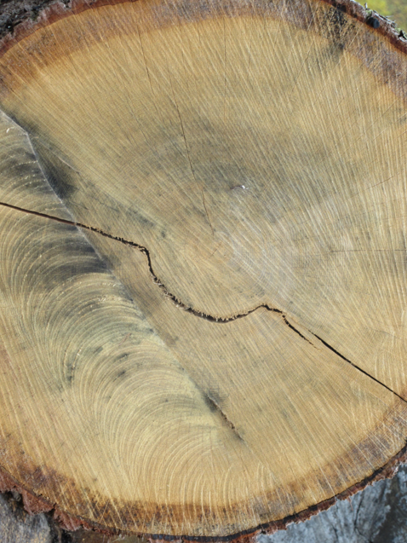
Figure 1: Drying cracks | Figure 2: Ring shake

Standards and rules of good practice consider mainly that cracks have a negative effect on the mechanical proprieties of timber beams. Consequences are serious for timber engineering. On the one hand, cracks oblige users to downgrade structural elements. This downgrading entails costs and even makes that some species are not used for building. On the other hand, in the field of retrofitting of structures, cracks sometimes lead project designers to proceed with a complete replacement of the existing structures. However, it seems that the influence of cracks on the mechanical behavior of timber beams is not yet completely understood. Further developments of this issue could be an opportunity for improving grading and safety, decreasing the waste of wood and making more attractive timber engineering.
The present paper investigates how cracks can affect the stiffness of timber beams by examining a batch of 71 cracked oak beams. The study is divided in four parts. Firstly, one will summarize the state of the art. This part will approach the terminology of the subject, standards and publications (Section 2, State of the art). Then, a classification of cracks will be proposed, on the basis of observations made on the set of oak beams (Section 4, Classification of cracks). Six main types of crack will be brought out. This step involves the analysis of images coming from a X-ray tomography scanner. Finally, one will investigate an analytical and a numerical approach in order to find how cracks (and which type(s) of cracks) can affect the stiffness of timber beams (Section 5, Analytical approach and Section 6, Numerical approach)

STATE OF THE ART
In this section, one will first define what the term “crack” covers in timber engineering. Then, one will discuss how practitioners have to deal currently with cracks, using standards. Finally, a few relevant scientific studies will be presented. They will tackle both experimental and numerical approaches.

HOW TO DEFINE A CRACK IN TIMBER ENGEENEERING?
Figure 9 shows a synthesis of all types of crack that can be met in a timber beam.
“Crack” is certainly a quite unclear word and it is important to define it accurately. The most comprehensive definition is given by Lamb (1992) in [1]: “Splits and cracks in wood are ruptures or separations in the grain of the wood which reduce the quality as measured by appearance, strength, or utility.” This definition includes cracks due to the wood quality, as well as the processing.
Four different terms usually refer to cracks in wood: shake, check, split and loosened grain. It is important to differentiate them. The hereunder definitions are based on [1] and [2].
- Shakes are separations or weaknesses of fiber bond, between (ring shake) or through (heart shake) annual rings and can extend lengthwise without limit. They occur in the standing tree.
- Checks are across the annual ring and due to drying or seasoning. They are rated by only the area of the opening.
- Splits are drying cracks, as checks, but through the section. They are usually located at the end of timber beams.
- Loosened grains appear in molders, planers and machines that use rotating knives. They are separations of the wood along the growth rings on the surface of the wood.
Among these four terms, cracks due to cutting down, imperfect design and mechanical damage are not included.
Lamb (1992) [1] suggests that cracks can appear at different stages of the life cycle of a piece of wood and considers four categories.
- Resource based cracks appear in the standing tree or log. They depend on environmental conditions (wind, frost), growth stresses and micro-organism. They are thus related to wood quality (ring shakes, heart shakes, frost cracks, star shakes).
- Processing based cracks are linked to conversion of green lumber into finished products. It includes the cracks due to cutting down, machining (loosened grain) and drying (surface checks, end checks, internal checks and split).
- Change of moisture content based cracks occur during the service life. They are similar to the drying cracks from the processing based cracks.
- Use based cracks appear in case of inadequate design and mechanical damage due to handling.

WHAT ARE THE CURRENT RECOMMENDATIONS ABOUT CRACKS?
International standards consider that cracks have a negative effect on the mechanical proprieties or are signs of a damaged structure. They give two types of size limitation. The first one is related to visual grading and the second one is related to the shear strength.

VISUAL GRADING
Throughout the European Union and since the 1st January 2012, all structural timber elements must be visually graded. The European standard NBN EN 14 081 [3] related to the grading of timber rectangular cross-section defines the criteria of grading and marking.
Rules can be summarized in this way: if cracks are “insignificant”, their impact on mechanical proprieties of the timber beam is not taken into account. However, what does “insignificant” mean? The answer depends on standards.
In Belgium, NBN 16-520 [4] allows drying cracks (splits and checks) in timber beams and limits their length from 1000 to 1500 mm. The British standard BS4978:2007+A1:2011 [5] gives similar rules but with other lengths. The German standard DIN 4074 [6] defines three qualities of fissured elements, graded according to the values of the f/b (ratio between the depth of the crack and the width of the section). The ratios are 2/5, 3/5 and 1/2, following the case. One can find something similar in the Spanish standard UNE 56544 [7].

SHEAR STRENGTH
In most cases, standards assume that cracks decrease only the shear strength of the element. Two trends are found in standards. In the Eurocode (EN 1995-1-1:2008), the width of the cross section is decreased by a factor k_{cr}:

 | $$k_{cr}≤1 :\frac{1.5V_{d}}{\left(k_{cr}b\right)h_{ef}}≤f_{v,d}$$ | (1)

In other standards (Switzerland, USA), the shear strength is decreased by a factor K_{red}:

 | $$K_{red}≤1 :\frac{1.5V_{d}}{bh_{ef}}≤K_{red}f_{v,d}$$ | (2)

Recommendations about $K_{red}$ can be found in SN 505 265:2012 (0.6 for solid wood or 0.8 glued-laminated wood). For $k_{cr},$ the value of 0.67 is often mentioned for solid wood or glued-laminated wood, but other rules exist (1.0 or 0.8 in the Netherlands).

It is quite surprising to see that standards are really different from a country to another. It seems that there is no common opinion over:
- The geometrical parameters that have to be taken into account for timber grading;
- The quantification of the effect of the cracks.

PAST SCIENTIFIC STUDIES RELATED TO CRACKS
There are very few scientific studies that assess the effect of cracks on the mechanical characteristics of structural timber elements.

EXPERIMENTAL INVESTIGATIONS
In 1933, a research led by Newlin et al. [8] showed that horizontal shear stresses are lower than usually assumed in cracked beams. The experiments were conducted with 200 beams made of 5 glued timber pieces affected by deep and artificially created cracks. It assessed that the upper and lower halves of the checked beams were acting as independent beams. Afterwards, American standards imposed a reduced factor $η_{Q}$ to the effective shear strength.
Shelling and Mölher [9] led several experimental tests in the 1970’s, about this subject. A first research involved beams with natural drying cracks near the neutral fiber, submitted to a concentrated load at the middle. A second project used two sets of GL beams with artificial cracks. For all these experiments, the shear resistance was tested, influence lines were given and another reduced factor $η_{Q}$was proposed.
A more recent study conducted in this field was led at the Madrid Polytechnic University in 2010, by Esteban et al. [10]. The authors carried out tests on 28 beams made of Scots pine that came from an 18th-century roof structure, and attempted to classify the cracks and their influence on the basis of easy-to-measure geometric parameters: their thickness, length, depth, the incline of the fibers and an “area index” calculated on the basis of the surface of the horizontal sections of the cracks. For each beam, the values of the maximum fracture stresses were analyzed according to the geometric parameters. However, the results of this experimental study are limited since it was not possible to demonstrate any correlation between a particular form of fracture and the geometric parameters considered for the cracks.
Afterwards, one can mention the study carried out by Mateo et al. [11] which involved a larger set of beams (40 samples). The cracks were measured and five parameters were calculated: the cracks area ratio (=ratio between the area of cracks and the total area in the neutral axis plane of the beam), the cracks volume ratio (=ratio between volume of cracks and the total volume of the beam), cracks average depth, fissures maximum depth and fissures depth in the broken zone of the beam. These parameters were compared with mechanical properties (tensile strength, Young modulus, and fracture energy). No satisfying relationship between these parameters was found.

For the experimental study of cracks, three hindrances have to be faced:
- The heterogeneity of the wood is a significant issue. Cracks share the place with knots, which often have a great influence. It is thus complicated to isolate the effect of cracks.
- The formation of cracks is random. For instance, drying cracks can appear everywhere and have several sizes, orientations, directions or length. All these parameters are non-predictable.
- Cracks are sometimes difficult to observe and even impossible to see when they are hided into the beams (e.g. internal checks)
These issues oblige researchers to work with a very high number of specimens (statistical approach) or with artificial cracks as in [8] and [9].

NUMERICAL MODELS
The advantage of a numerical approach is that it is possible to isolate the effect of cracks in timber beams and control their parameters.
It is difficult to numerically study cracks without considering the fracture mechanics.
A crack in a timber beam is a “singularity”. This involves a stress or strain concentration that cannot be treated with traditional stress- or strain-based methods.

Linear Elastic Fracture Mechanics (LEFM)
The failure criterion can be expressed in two equivalent ways:
- The strain energy release rate approach;
- The stress intensity factor approach.
LEFM is convenient for brittle materials such as glass and thus its application requires the following conditions [13]:
- A linear elastic material;
- A sharp crack;
- A small fracture process zone (in comparison with the dimensions of the studied body);
- A sudden fracture;
- The strain energy is directly used for the propagation of the crack and energy dissipation mechanisms are neglected;
- Toughening mechanisms are not assumed.
LEFM can be used for wood, especially when the effects of toughening and energy dissipation mechanisms are small.

Non-linear Fracture Mechanics
Non-linear Fracture Mechanics (NLFM) assesses a constitutive model that considers the strain softening of a material which allows [12]:
- A stress-transfer mechanism beyond the point where the maximum stress is reached;
- A decrease of this transmission capability when the fracture process area grows.
In this model, the material is characterized by two relationships [14]:
- A stress-strain relation up to maximum stress or strain;
- A linear softening relation characterized by the fact that stress is decreasing when the crack opening displacement is increasing.
Several models have been developed in order to model the fracture process zone:
- Fictitious cracks model (FCM) developed by Hillerborg et al. [15]: the tip of the cracks is replaced by a fictitious crack containing closing stresses with a non-constant distribution.
- Crack Tip Opening Displacement (CTOD) [16] which is used for ductile materials.
- Cohesive Zone Model (CMZ) [17]: the tip of the cracks is replaced by a cohesive element.
A relevant research was led by Magnière et al. [18], at the Bern University. This numerical investigation consisted in simulating a three-point bending test of a GL beam (Span=12 m, section 14/60 cm) presenting one initially opened crack with variable parameters (position, height, length and depth). The research showed that one “not-through” crack does not impact the global stiffness of the beam. A correlation was also found between the residual load-bearing capacity and two parameters of a through crack (the position into the cross section and the length of the crack). An analytic calculation of the reduced stiffness was finally provided for a beam presenting a through crack. However, it was not completely satisfying and further investigations are led.

METHODOLOGY
How does the present research extend the state of the art? The aim of this study is to extend the classification of cracks and evaluate their influence on the stiffness with both an analytical and a numerical approach. The project models real beams with all their cracks and tries to determine which “type of crack” has a relevant effect on the stiffness.
A set of 71 deeply cracked oak beams with several squared sections from 100x100 to 180x180mm and span 2.0m and 3,5m has been used.

Table 1
Number | Section [mm] | Span [mm]
10 | 100x100 | ~3500
9 | 120x120 | ~3100
18 | 150x150 | ~2500
12 | 160x160 | ~3000
11 | 170x170 | ~2000
10 | 180x180 | ~3000

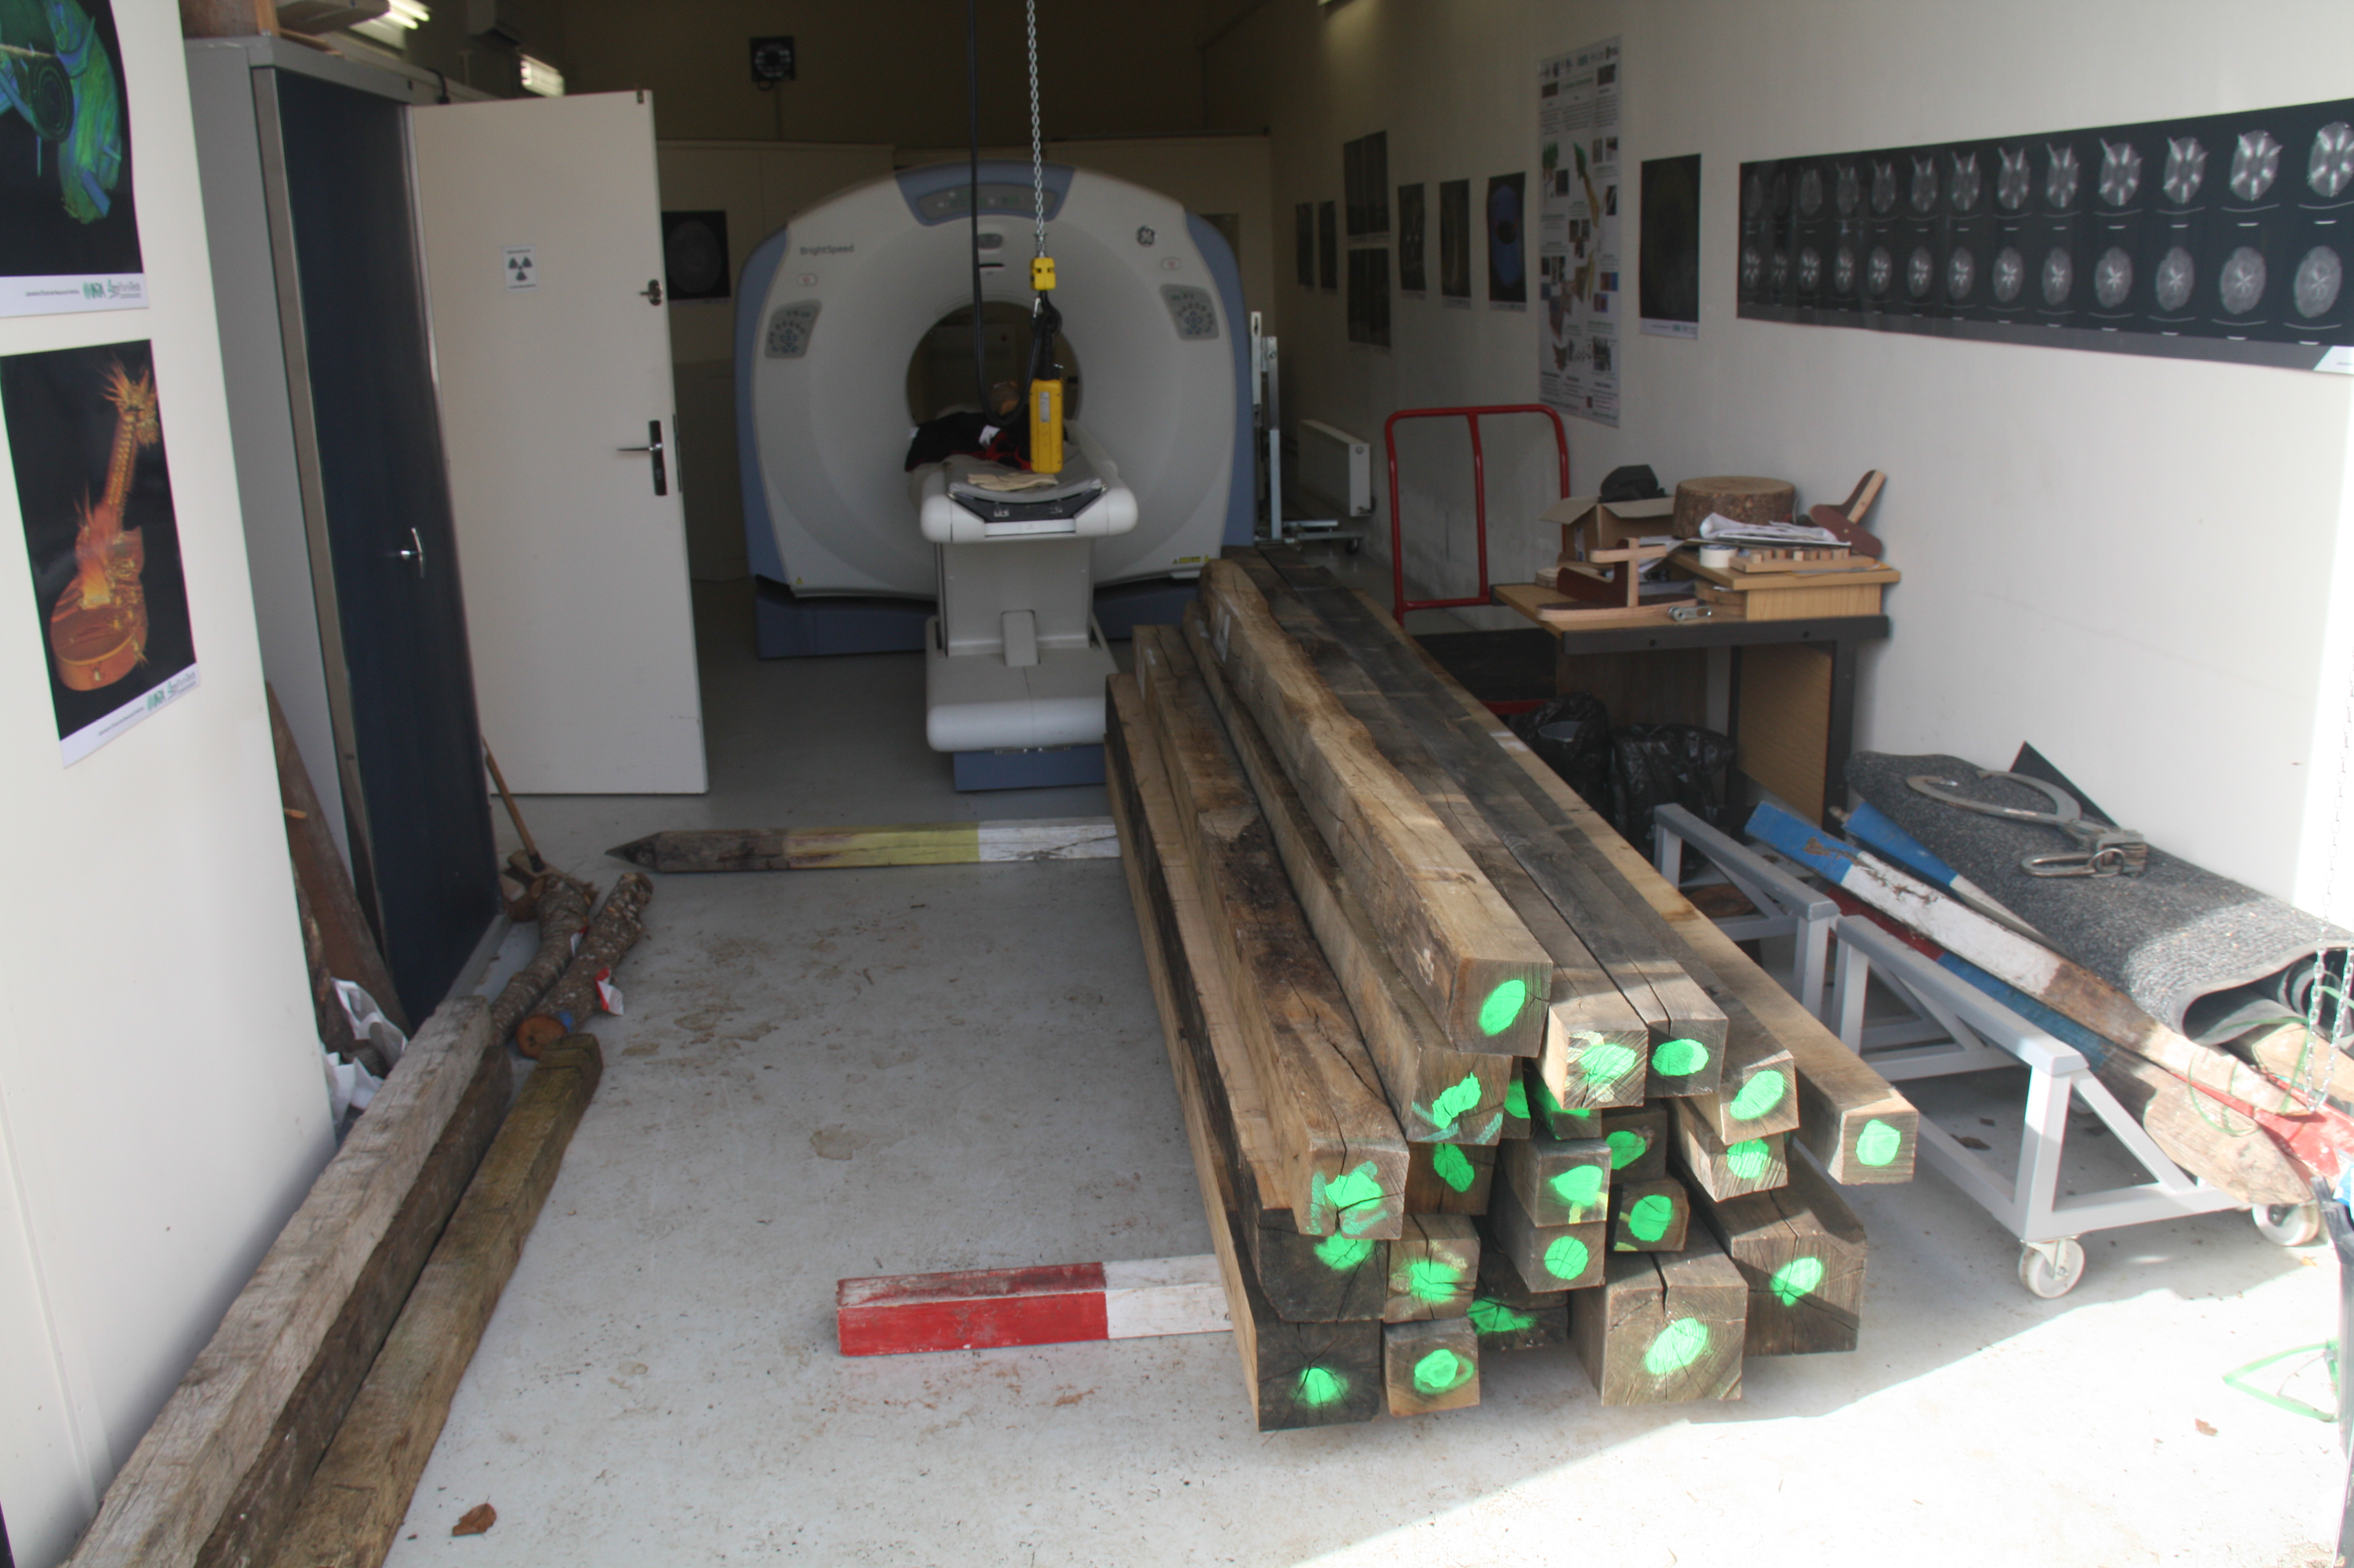
Figure 3

VISUAL ANALYSIS AND CLASSIFICATION OF CRACKS
The first step of this research aims at characterizing the cracks in the set of 71 beams according to the classification of figure 9. For this purpose, each beam was analysed by a tomographic X-ray scanner, at the National Institute for Agricultural Research (INRA) in Nancy. This approach gives a very accurate overview of the cracks in the beams.
Once this task achieved, a certain amount “f” of types of crack was highlighted for each beam of the set.

ANALYTICAL APPROACH
An analytical approach was conducted with 12 beams coming from the same set. It consisted in considering a cracked beam as a classical beam with a variable inertia (due to the presence of cracks), in submitting it to 3 different load cases, and in calculating the ratio between its stiffness and the one of the equivalent non-cracked beam (figure 4).
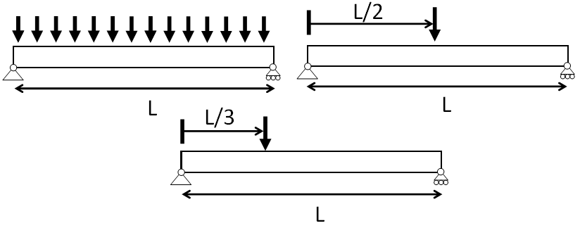
Figure 4

NUMERICAL APPROACH
The same 12 cracked oak beams were modeled on ABAQUS® using the Cohesive Zone Model. This numerical investigation consisted in simulating the three load cases in figure 4. Stiffness from cracked beams and corresponding non-cracked beams were compared.

CLASSIFICATION OF CRACKS

TOMOGRAPHIC X-RAY SCANNER
A "X General Electric BrightSpeed Exel" scanner was used, originally designed to medical use. It allows generating a 3-dimensional image of a wood sample by analyzing the attenuation of X-rays, which goes through a timber element. It provides a “picture” of the cross-section every 2.5 [mm]. This method provides extremely accurate results, without damaging beams (figures 5 and 6).

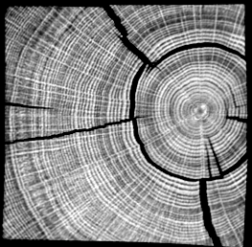 | 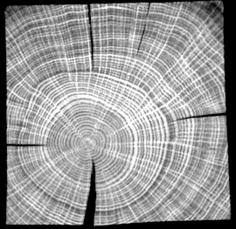
Figure 5 | Figure 6

CLASSIFICATION ACCORDING TO CAUSES OF CRACKS
On the basis of section 2.1, as far as causes of cracks are concerned, cracks can fall into the following categories [1]:
- Shakes: ring shakes, heart shakes (single heart shakes, double heart shakes, star shakes), frost shakes;
- Drying cracks: checks and splits;
- Loosened grains;
- Other: cutting down cracks.
Except the splits situated at the extremities of the beams, other cracks are generally randomly distributed in timber beams. Figure 7 shows a graph with the distribution of these types of crack in the set of 71 beams.
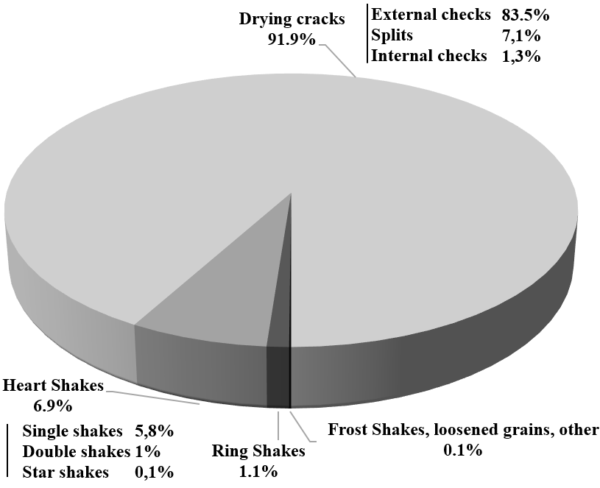
Figure 7

CLASSIFICATION BASED ON THE GEOMETRY OF CRACKS
Cracks can have two preferred directions:
- Radial (checks, heart shake, frost shake);
- Tangential (ring shake).
In case of cutting cracks or loosened grains, the direction can be variable but these cracks are not included in the analysis.
Then, cracks can have three different positions:
- Internal: the crack is in the beam and cannot be detected by visual analysis;
- Through: the crack divides the section in two or more pieces;
- External: the crack is visible at one face of the section.
Table 2 gives the different possible types of crack with this criteria, and abbreviation used in the paper.

Table 2
ERC | External radial cracks
TRC | Through radial cracks
IRC | Internal radial crack
ETC | External Tangential crack
TTC | Through Tangential crack
ITC | Internal tangential crack
CC | Composite cracks (e.g. ERC+ITC)

Figure 8 gives the distribution of these types of crack in the set of 71 beams. Figure 9 shows the two classifications related to each other, with images coming from the scanner.
For sections 5 and 6, one will use 12 beams coming from the set and given in table 3. These beams are affected by several types of crack.
Table 4 gives for each beams the number of each type of crack. One can notice that ERC are numerous.

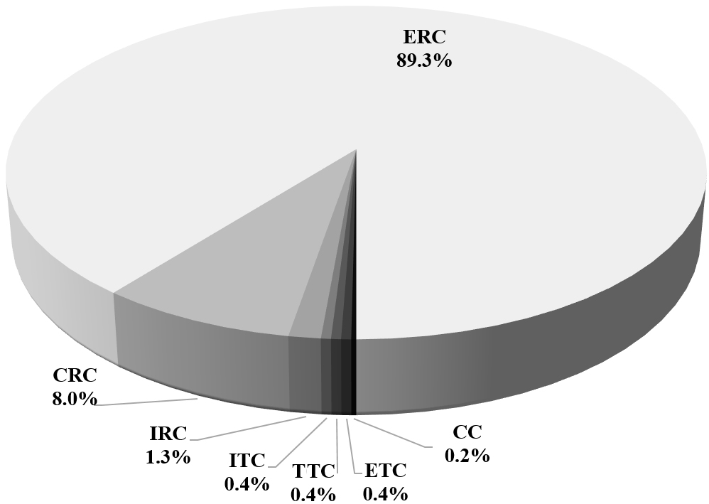

Figure 8
Table 3
Number of beams | Section [mm] | Span [mm]
10 | 150x150 | ~2500
2 | 170x170 | ~2000

Table 4
Beam | ERC | TRC | IRC | ETC | TTC | ITC | CC
1 | 53 | 1 | 0 | 0 | 0 | 0 | 0
2 | 17 | 0 | 0 | 0 | 0 | 0 | 0
3 | 64 | 0 | 0 | 0 | 0 | 0 | 0
4 | 32 | 0 | 0 | 0 | 0 | 0 | 0
5 | 58 | 0 | 0 | 0 | 0 | 0 | 0
6 | 10 | 1 | 0 | 0 | 0 | 0 | 0
7 | 17 | 2 | 0 | 0 | 0 | 0 | 1
8 | 57 | 1 | 0 | 0 | 0 | 0 | 0
9 | 31 | 1 | 0 | 0 | 0 | 1 | 3
10 | 40 | 1 | 0 | 0 | 0 | 0 | 0
11 | 41 | 0 | 10 | 0 | 0 | 6 | 3
12 | 58 | 1 | 0 | 0 | 0 | 0 | 0

ANALYTICAL APPROACH
A first approach for assessing the influence of cracks is to assume that cracks modify the inertia of the beam. A cracked beam is an equivalent classical beam with variable geometrical characteristics.
This assumption is easily justified by the fact that cracks can divide the section in two or more pieces (through cracks) or leave a hole in the beam (internal cracks). The effect of the previous types of crack (section 4) are summarized in table 5. TRC and TTC are interesting because they can change a lot the behavior of the beam.
In this section, one will study the effect of the cracks on the stiffness of the beam and separate the effect of internal (IRC+ITC), external (ERC+ETC) and through cracks (TTC+TRC).

Figure 9
Table 5
Type | Effect on the inertia
ERC  ETC | Modification of the section. Minor or major modification if the inertia following the size of the cracks
TRC  TTC | Division of the section in two or more pieces  High decreasing of the inertia
IRC  ITC | Hole in the section. Low/high decreasing of the inertia following the size of the cracks
CC | Variable

This analytical approach requires knowing the geometrical characteristics of each cross-section of the beam. Image processing is used at this purpose. Two orientations of the section will be considered. The first orientation (I_{x}) is the one where through cracks (or a maximum of external cracks) are horizontal. The second orientation (I_{y}) is the one where through cracks (or a maximum of external cracks) are vertical (figure 10).

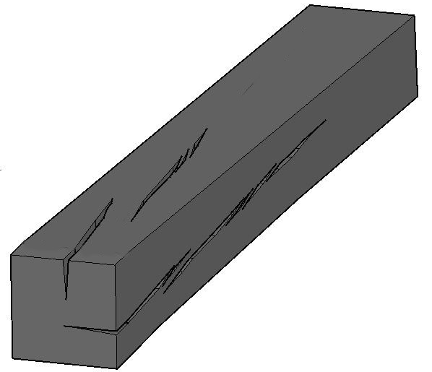  I_{x} | 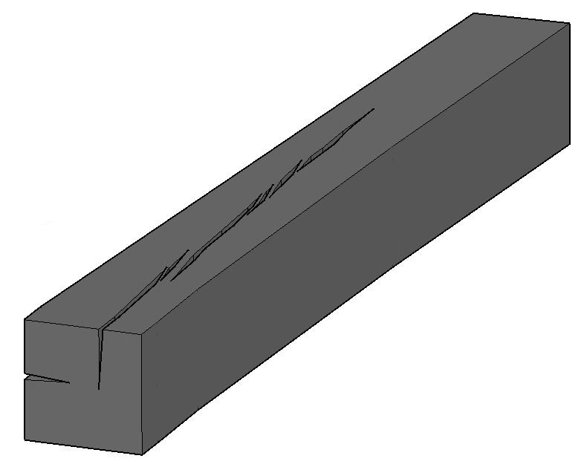  I_{y}
Figure 10
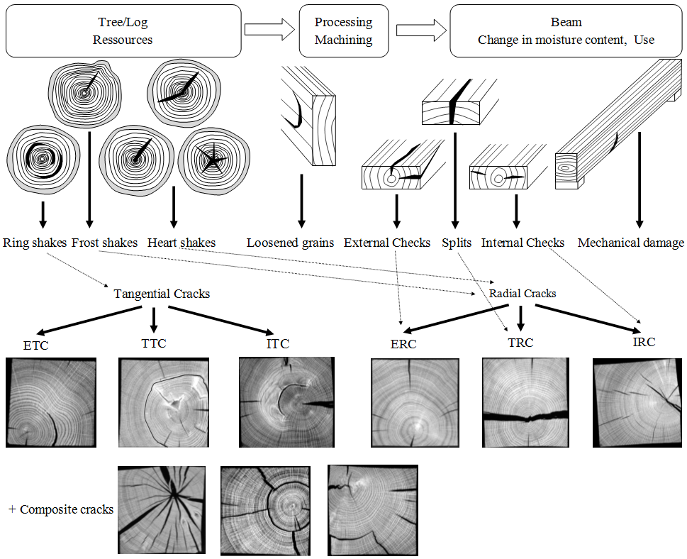

IMAGE PROCESSING
This analysis aims at determining the following geometrical characteristics from the medical scanner images:
- Area A
- Gravity centre coordinates x_{g} and y_{g}
- Inertia I_{x} and I_{y.}
The images are firstly cropped in order to suppress the useless parts (for instance, the trolley of the scanner). Then, they are analyzed by a Matlab® computing code, which consists of the following steps (figure 10):
- First, the Matlab® computing code transforms the image into a “RBG” matrix with dimensions a x b x 3, where “a” and “b” correspond to the dimensions (in pixels) of the image and “3” each component (red, green and blue) of the RGB code.
- The RBG matrix is converted into a grayscale matrix with dimensions a x b (values from 0 to 255).
- Each element of the matrix is then sorted so that value “1” (= white) is assigned to wood and “0” (= black) to empty space, considering the image brightness. A black and white image is obtained.
- From this binary matrix, the geometrical characteristics of the section (area, coordinates of the center of gravity, inertia) are calculated.
- Finally, the stiffness of the beam is calculated using these geometrical characteristics.
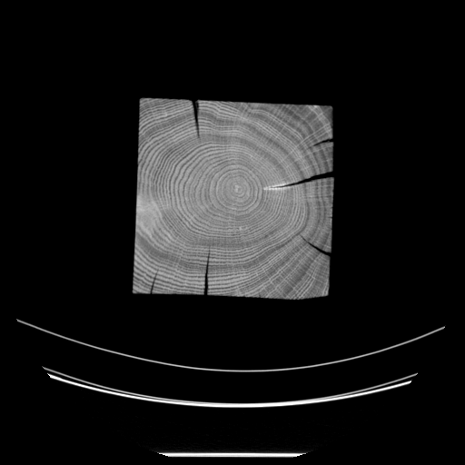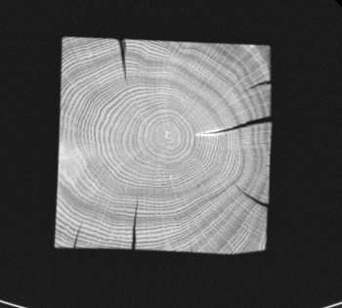
Matlab® computing code
A
x_{G}, y_{G}
I_{x}, I_{y}
RBG
matrix axbx3
Grayscale
matrix axbx1
White/black matrix axbx1
Figure 11
The deflection is calculated with these geometrical characteristics.

RESULTS
Figures 12 and 13 show the value of inertia (I_{x} and I_{y}) for beam 6 and beam 11 (figure 13). I_{ref} is the inertia of the beam without cracks.
Beam 6 has an inertia which is low at the right support because the cracks split the section in two parts. The difference is around 75% at this place.
Beam 11 is affected by numerous internal cracks (ITC and IRC), especially at the middle and near the right support. The maximum difference of inertia is around 13%.

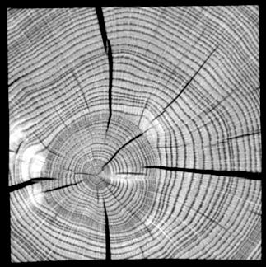 | 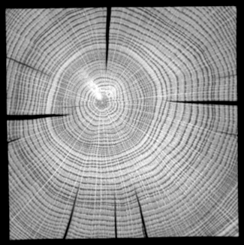 | 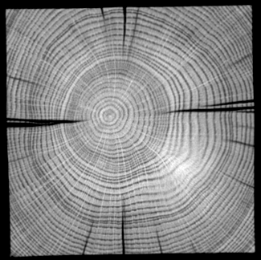 | 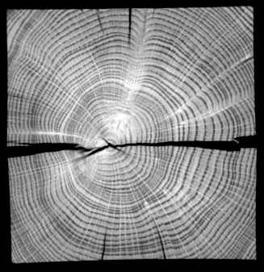 | 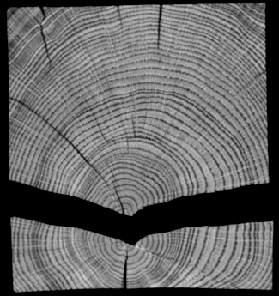

Figure 12 – Variable inertia of Beam 6
External cracks
External and through cracks

Figure 14
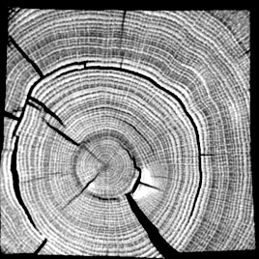 | 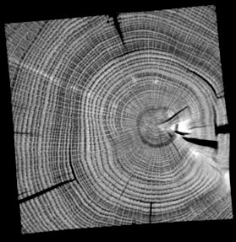 | 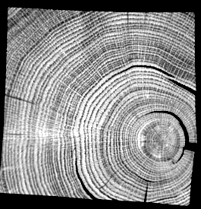 | 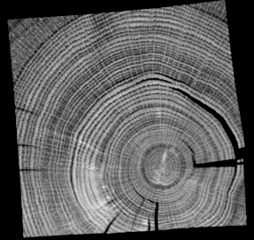 | 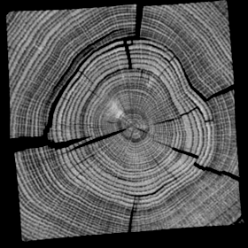

Figure 13 – Variable inertia of Beam 11

Figure 14 shows the difference of stiffness between the cracked beam (K) and the corresponding non-cracked beam (K_{ref}), submitted to a concentrated load at the middle. Results were similar for the other loadings. Figure 15a and 15b give the contributions of internal (In, IRC+ITC), external (Ex, ERC+ETC) and through cracks (Th, TTC+TRC), for orientation I_{x} and I_{y}.
One can conclude that:
- The stiffness difference is variable from a beam to another. In many cases, it is over 5%.
- Orientation I_{x} gives the highest differences. It would confirm the fact that horizontal cracks are more harmful for stiffness.
- Some high differences (Beam 6, 8, 9, 11) of stiffness are linked to the presence of horizontal through cracks, where they are horizontal. Figure 14 shows that the effect of the through cracks is over 86% for beam 6 and significant for beam 8 and 9.
- The length of the horizontal through cracks is an important parameter. Indeed, beam 6 have a through crack of 40 cm.
- One can notice that external cracks can bring an important contribution when they are quite deep (Beam 3) and can have a more significant contribution than through cracks (Beam 11).
- Internal cracks have no effects on the stiffness (or less than 1 %).
- One tried to hide external cracks one by one. However, one didn’t find any type external cracks that were especially responsible for this loss of stiffness.
External, internal and through cracks

a
b
Figure 15

NUMERICAL APPROACH
In this section, the beams were completely modelled in the software ABAQUS® and submitted to the same load cases (figure 4). The effect of the different types of cracks, as for the analytical approach, were separated.
Non-linear Fracture Mechanics (NLFM) was used for the modelling of the crack: the Cohesive Zone Model.

COHESIVE ZONE MODEL
The use of the Cohesive Zone Model (CMZ) [14] requires two types of material behavior:
- A stress-strain relationship for the material (e.g. linear elasticity);
- A stress-deformation relationship for the damaging in the fracture process zone.
A crack is divided in three parts [19]: the traction-free crack, the fracture zone process (a stress-deformation relationship) and the material (stress-strain relationship).
Figure 16 shows the stress distribution for the LEFM and the CMZ.
b
a
σ
σ
r
σ(ε)~1/√r
r
σ(ε)
σ(δ)
δ
Traction-free crack
Fracture process zone
(cohesive zone)
Crack

Figure 16 – (a) LEFM, (b) CMZ, [19]

For the damaging in the fracture process zone (figure 17), there are three successive phases: an elastic phase (phase A), a yielding phase (B) and a softening phase (phase C). During the phase C, the material outside the fracture zone is elastically unloaded. At the end of phase C, the crack is completely opened at the area considered and does not sustain any tension stress.

The fracture process zone is defined using pairs of zero thickness cohesive element.
σ
δ
A
B
C
Figure 17

MODEL
In the ABAQUS model, one will consider the following hypothesis
- The stress-strain relationship for the wood is linear elastic and one will consider the following value;

 | Table 8
σ₃₁  Longitudinal X, L, 1  σ₃₁  σ₃₃  σ₃₂  σ₁₃  σ₁₁  σ₁₂  σ₂₃  σ₂₁  σ₂₂  Tangantiel Z, T, 3  Radial Y, R, 2  Figure 18 | E₁ [MPa] | 12300
 | E₂ [MPa] | 2005
 | E₃ [MPa] | 886
 | G₂₃ [MPa] | 240
 | G₂₁ [MPa] | 1058
 | G₃₁ [MPa] | 996
 | ν₂₃ | 0.6
 | ν₂₁ | 0.1
 | ν₃₁ | 0.1

- The stress-deformation relationship for the damaging in the fracture process zone is a bilinear law;
- All the cracks are represented.

Figure 19 and 20 show the model of beam 6 and beam 12.

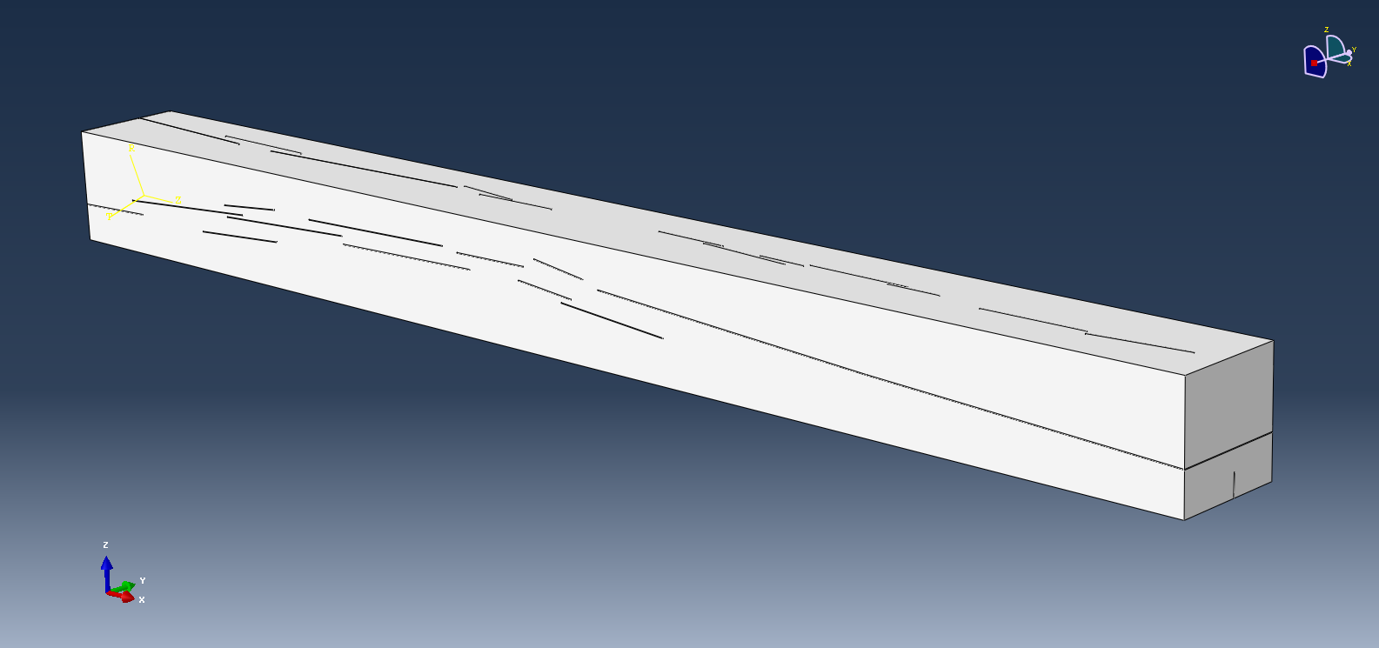
Figure 19 - Beam 6

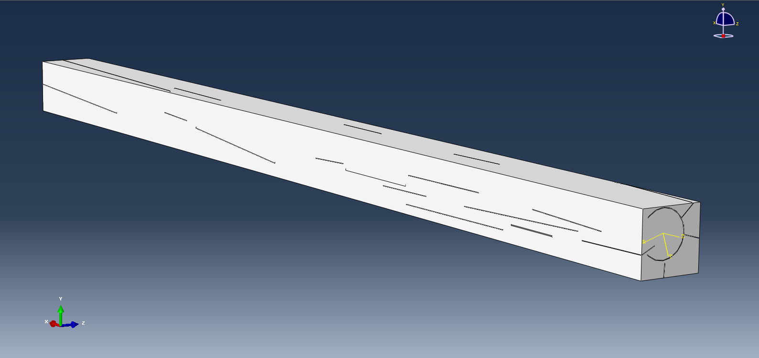
Figure 20 - Beam 12

RESULTS
One will show the results for the beams submitted to a concentrated load. The other load cases give similar results. Figure 21 shows the difference of stiffness between the cracked beam (K) and the corresponding non-cracked beam (K_{ref}).
The contributions of each type of crack are very close to figure 15a and 15b. The contribution of external cracks is higher in some cases (beam 6 and 8).
One can see that:
- Compared to the analytical approach, the results show a similar trend, although the values didn’t really correspond to each other. Beams affected by through cracks give significant differences, as beam 6, 8, 9 11 and 10.
- The differences of stiffness for beam 6 are higher than those of the analytical approach. This can be explained, on the one hand, by a higher contribution of the external crack, and, on the other hand, by the fact that the analytical approach is a 1D-2D one (not taking into account the 3rd dimension in the axis of the beam).
External, internal and through cracks
External and throught cracks
External cracks

Figure 21
- As in the analytical approach, external cracks played still an important role in the loss of stiffness (e.g. beam 1).
- It was impossible to detect a particular external crack which was responsible for the loss of stiffness.
- Internal cracks have almost no effects on the stiffness.

CONCLUSION
Cracks in timber beams is an important issue.
Both approaches (analytical, numerical) do not give the same absolute values of the “cracked stiffness”, even if a common trend is visible. However, the results of the numerical approach are certainly more relevant. In most cases, even for highly cracked beams, the reduction of stiffness is limited to 10%. However, for beam 6 with a very long through crack, the reduction of the stiffness reaches 25%.
Thus, through cracks can have a important effect on the stiffness: this was already shown in [18] by Magnière et al.

ACKNOWLEDGEMENT
We wish firstly to thank the Prof. Steffen Franke and Noëlie Magnière for their advice and explanations. We would also like to show our gratitude to Martin Patiny and Nicolas Gathon for their support in this research. Finally, we would like to express our deepest appreciation to Hontoir & Fils for providing us the oak beams for this experiment.

REFERENCES

- Lamb, F., 1992. Splits and cracks in wood. Reno, United States, s.n.
- Forest Products Laboratory, 2010. Wood Handbook - Wood as an Engineering Material. General Technical Report FPL-GTR-190. Madison, Wisconsin: United States Department of Agriculture, Forest Service, Forest Products Laboratory.
- NBN EN 14081-1+A1. “Structures en bois - Bois de structure à section rectangulaire classé pour sa résistance - Partie 1: Exigences générales. “
- NBN B 16-520. “Classement visuel du bois de structure à section rectangulaire“.

- BS 4978. “Visual strength grading of softwood. Specification for visual strength grading of softwood“.
- DIN 4074. “Sortierung von Holz nach der Tragfähigkeit“.
- UNE 56544. “Classificacion visual de la madera aserrada para uso structural : madera de coniferas“.
- Newlin, J.A., Heck, G.E., and March, H.W., 1934 New method of calculating longitudinal shear in checked wooden beams. Amer. Soc. Mech. Engin. Trans., 56: 739-744.
- Shelling K., Mölher K., 1972. “Forchungeaufgabe: Untersuchungen über den Einfluss der Laststellung bei Biergeträgern auf die Höhe der Schubbeanschpruchung aus Querkraft bei Brettschichtträgern, Bericht, Karlsruhe Istitue of Technology.“
- Esteban M., Arriaga F., Iniguez G., Bobadilla I., Mateo R., 2010. “The Effect of Fissures on the Strenght of Structural Timber“, Materiales de Construccion, Vol. 60, No. 299, 115-132.
- Mateo R., Montero M., Arriaga F., Iniguez G., Hermoso E., Esteban M., 2011. “Analysis of parameters for assessing drying fissures to estimate their influence on the mechanical properties of Pinus sylvestris L. wooden beams“ CIMAD 11 – 1º Congresso Ibero-Latino Americano da Madeira na Construção, 7-9 June 2011, Coimbra (Portugual).
- Serrano E., Gustafsson P. J., 2007. “Fracture mechanics in timber engineering – Strength analyses of components and joints”, Materials and Structures, Volume 40, Issue 1, pp 87-96.
- Pommier S., Gravouil A., Moës, N., Combescrure A., “La simulation numérique de la propagation des fissures : Milieux tridimensionnels, fonctions de niveau, éléments finis étendus et critères énergétiques“, 2010 European Journal of Computational Mechanics, Volume 19, Issue 8.
- Smith et al., 2003. Fracture and fatigue in wood. West Sussex: John Wiley & Sons Ltd.
- Hillerborg A., 1991. “Application of the fictitious crack model to different types of materials”, International Journal of Fracture, Volume 51, Issue 2, pp 95-102.
- Amstutz H., Seeger T., “Problems of Numerical CTOD Anlayses”, The Crack Tip Opening Displacement in Elastic-Plastic Fracture Mechanics, pp 21-44
- Elices M., Guinea G. V., Gómez J., Planas J., 2002. “The cohesive zone model: advantages, limitations and challenges”, Engineering Fracture Mechanics, Volume 69, Issue 2, Pages 137–163.
- Magnière N, Steffen F., Franke B., 2014. “Numerical investigation of the residual load-carrying capacity of cracked timber elements, Conference on experimental research with timber“, 21-23 May 2014, Prague (Pologne).
- Laverne J., “Notice d’utilisation des modèles de zones cohésives”. Code_Aster, Fascicule u2.05: Mécanique de la rupture et de l'endommagement, 2011.

Elke Mergny, Université catholique de Louvain-La-Neuve, Belgium, elke.mergny@uclouvain.be
Raquel Mateo, Universidad Politécnica de Madrid, Spain, raqmateo@gmail.com
Miguel Esteban, Universidad Politécnica de Madrid, Spain, miguel.esteban@upm.es
Thierry Descamps, Université de Mons, Belgium, thierry.descamps@umons.ac.be
Pierre Latteur, Université catholique de Louvain-La-Neuve, Belgium, pierre.latteur@uclouvain.be

