Youth Digital Practices: results from Belgian and French projects

Introduction
This article focuses on digital practices among young people, related to the way in which their contemporary language and relation to culture evolve, and how they handle their emotions. This research stems from current affairs in France, a country that recently banned the use of mobile phones in school. Numerous authors disagree with the hypothesis that phone usage is harmful, whether at school or at home (Zebroff, 2018; Maskens et al., 2015; Bernicot et al.,2014). This paper tries to deepen this counter hypothesis, specifically addressing three research questions: (1) Which current trends of digital practices at school do young people evolve in?; (2) What do children’s and teenagers' digital writing scholarly productions consist of?; (3) How do they represent their digital practices related to culture and emotions? Comparative results from international projects (sms4science and thumbs4science) are presented and originate from authentic textual data as well as from surveys concerning the daily use of digital devices, notably their relation to culture and emotion handling. A concluding section suggests possible future paths.

- Cultural context of digital use in France and Belgium
The following two subparagraphs aims at answering the initial research question: (1) Which current trends of digital practices at school do young people evolve in?.
  - Prohibition and innovation at school
During his presidential campaign in 2017, Macron announced that he would put a general ban on mobile phone usage in primary schools and junior high schools (collèges) if he were elected French president. The bill was indeed adopted in 2018 (vote: 62 for, 1 against), after the French Education Minister Blanquer had presented the measure to the French Assemblée nationale. Macron’s official tweet about the measure was: “The general ban on mobile telephones in schools and junior high schools was permanently adopted by the National Assembly today. Promise kept.”. This categorical position related to youth is out of step with social reality. Looking at a snapshot of the French National Assembly Chamber, one may notice that many political representatives are actually constantly using their mobile phones (or tablets/computers) during the debates. Mobile phones are now an integral part of everyday life, for leisure, training, work or family management. More than 91% of young people in the EU make daily use of the Internet (71% for the whole EU population) (Eurostat, 2016) and mobile phone users who are highly dependent (mainly young female adults) estimate their daily smartphone usage to be close to 6 hours (Lopez-Fernandez et al., 2017).
In order to understand the 2018 ban, we look into French and neighbouring Belgian scholar contexts. In 2010, the French education code introduced a clause that it was the responsibility of the school's pedagogical teams and management to regulate the use of mobile phones through internal regulations, in particular by specifying the places where phones were prohibited (playground, canteen, etc.). The official reason for this measure was in fact related to protecting pupils “from electromagnetic waves” in accordance with the Grenelle 2 law. However, in debates at the French Senate in 2011, it is apparent that politicians were already pushing for further and more radical measures in relation to a telephone ban, even though national public pedagogical (Educscol) and research (Heutte 2008) initiatives, private sector reports (Institut Montaigne 2016), international conferences and reports (Unesco Mobile Learning Week, Paris, December 2011, Dykes and Knight 2012), certain press articles (Panckhurst 2018a, 2018b) have indicated the benefits of digital technology in schools. This is true even if philosophical debates allow one to question age groups for screen usage introduction (Stiegler and Tisseron 2009). The 2018 law went a step further by applying an overall ban on the general use of mobile phones in school, yet permitting them for specific “exceptions” (disabilities, medical reasons, and pedagogical usages). At the same time, high schools (lycées) are under no obligation to implement the ban, so there seems to be a political reluctance linked to digital effects on younger pupils in France. Is this the result of political demagogy or a real awareness of negative effects? Things could well change at secondary level as school principals do have the option to locally ban cellphones if they wish. After a violent episode which took place in autumn 2018, Blanquer immediately seized the occasion to advocate a mobile-phone ban in high schools, but nothing has in fact been officially implemented since. On the contrary, in fact, a new French teaching qualification (CAPES) will see the light of day in 2020, entitled “Numérique et sciences informatiques” (Digital Technology and Computer Sciences). Also, primary and secondary schools are introducing many new courses and resources related to the “Le numérique au service de l’École de la confiance” (Digital technology at the service of the School of Trust). Is this not somewhat paradoxical given the 2018 French ban?
In French-speaking Belgium, contrary to France, there is no law on the prohibition of mobile phones. The use of the smartphone is determined by the general institutional rules and varies from one school to another. So, as in Canada and elsewhere, education establishments can easily follow the BYOD (Bring your own device) attitude. Some schools have banned mobile phones from playgrounds in order to “recreate the social bond” between peers and with teachers. This decision is generally welcomed by parents who often perceive the digital tool as a distraction. However, parents may also explain that they highly depend on mobile devices for family organisation. In many schools, smartphones have become educational tools used to illustrate, map, search for information, answer multiple-choice questions or play serious games.
Cougnon (2016) reviews various innovative classroom applications: one example of mobile and tablet usage in the classroom is the Twictée project from France (2013). The name is a contraction of “Twitter” and French word “dictée” (for “dictation”). Belgian teachers are also very happy to use this collaborative device for teaching spelling based on the Twitter application. Classes all around Francophone countries play together to win points through correct spelling exercises. The digital tool offers gamification techniques, thus introducing playfulness in a very theoretical and off-putting school subject. Another example Is the North American Classcraft engagement management system (2013), which makes it possible for pupils to study subjects (for example physics) and, at the same time, earn merit points that allow them to develop a game character. It also provides ludicization possibilities by being able to apply 'game principles to non-game situations’ i.e., game mechanics (rules/strategy/levels/avatars/points), and it also includes context (classroom situation) and collaboration (between students) which are paramount. The scholar divide in Belgium is not the same as in France: the importance of games in the learning process is particularly emphasised in Belgium during maternal and primary education and is devalued considerably when one grows up, as does the use of cell phone applications. Yet, we know that games stimulate and facilitate learning, even during adulthood (Romero et al., 2017).
  - Digital practices and higher education
In universities, digital initiatives exist and are even sometimes promoted, including online collaborative tools and mobile technology. (Panckhurst and Marsh 2011) adopted social networks within eLearning university courses in France over a three-year period (2007-2010) in order to explore and evaluate the relative advantages and challenges for the usage of such tools in higher education. Students were placed at the core of the learning process and were thus enabled to experience and reflect upon collaborative online learning while being engaged in specific practical projects. The authors argue that in a specific digital network environment, teacher-centric pedagogy is effectively replaced by peer-group management, collaborative sharing, flipped classrooms, autonomy and student responsibility.
Student/learner roles have of course changed perspective. For instance, amphitheatre lectures may be perceived as terribly boring by students and consequently the attention-span rather low. To reduce this effect, a Belgian product, Wooclap, has been used extensively (in the aforementioned situation and in others) and seems to be particularly effective for motivating student participation, since it includes collaborative functionalities which can then be immediately assessed and displayed. Indeed, Smartphone usage is practically compulsory in this context. So whether for University students or for secondary and elementary school pupils, in France and Belgium there seem to be fragmented practices and heterogeneous training directions. This pedagogical split seems to reflect the mitigated nature of common beliefs about digital effects, mostly on two subjects: linguistic capabilities and psychological balance. The following research results propose objective answers to this issue.
- Research context
  - sms4science and sud4science
The aim of the international project called sms4science (2004-2013, Cougnon, 2015) was to collect, through a call for volunteers, vast amounts of authentic SMS data from the general public all over the world, conduct analysis and disseminate results. This project was mainly — but not only — intended for linguistic research. Overall, 200,000 text messages were collected, including 70,000 in Belgium (Fairon et al. 2006a) and over 88,000 in France, where the sub-project was re-named sud4science (Panckhurst et al, 2013). After semi-automatic treatment using natural language processing techniques, anonymized text messages were made available to the research community and the general public as two distinct corpora (sms4science, Fairon et al. 2006b and 88milSMS, Panckhurst et al. 2014, 2016). It is the largest French SMS database ever built. The donors range in age from 11 to 66, with a high percentage of the donors under 24 (63%). 29% were minors.

2.2 thumbs4science
The thumbs4science project (Cougnon et al., 2017), emerged in 2016 from sms4science, and was shaped by a transdisciplinary approach, combining linguistics, psychology and sociology. It aimed at studying the skills of the population that uses modern forms of communication media. The hypothesis we wanted to test through the project was that the use of new media in younger and younger age groups does not lead to incompetency (lower spelling level, increased inhibition, impoverishment of social exchange, etc. ), but rather to a “pluricompetency” so that in actual fact it would enable each speaker to juggle his/her language, social and emotional code with each change of situation, change of interlocutor and change of communication medium. A call for volunteers was launched and volunteers were asked to “donate” their (Facebook Messenger, WhatsApp and Viber) messages and to answer two (sociolinguistic and psychological) questionnaires. The first questionnaire collected the participants’ sociodemographic data as well as some of their opinions and daily practices. The second questionnaire consisted of an emotional intelligence test, developed by psychologist colleagues (Mikolajczak et al., 2009). In parallel, an appeal was launched to French and Belgian school teachers in order to collect students’ language productions. The different parts of the project are summarised in Figure 1.
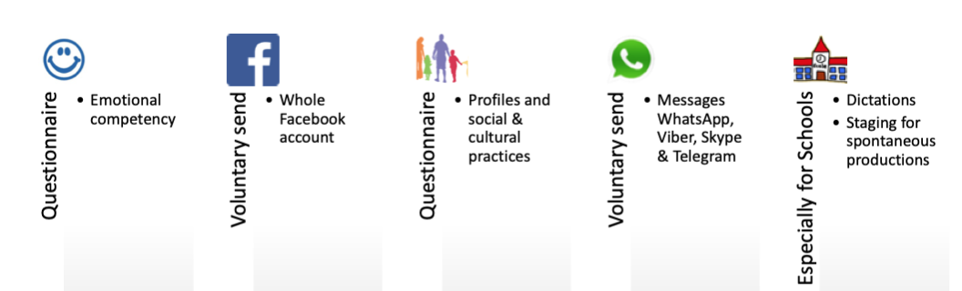
Figure 1: thumbs4science data collection stages

Figure 2 below indicates the vast amount of data which was collected over a 12-month period between 2016 and 2017. Since then, the data has mainly been analysed through a linguistic prism. Social and psychological aspects of digital practices were only considered for this paper. is still currently analysed.
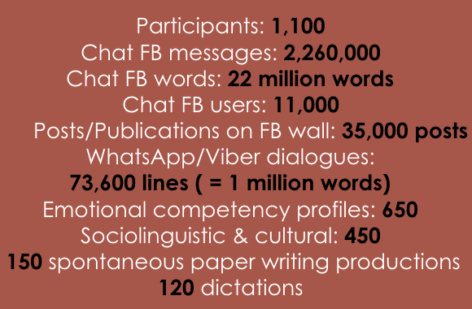
Figure 2: thumbs4science data collection numbers

- Youth digital practices
After having situated the context for the two research projects, we now present the different results that emerged from the two projects and that help us answer the initial research questions (cf. Introduction): (2) What do children’s and teenagers' digital writing scholarly productions consist of?; and (3) How do they represent their digital practices related to culture and emotions? The first part (3.1) summarises previous research about the influence of digital practices on linguistic competencies. The second part (3.2) maps the relation young people maintain with traditional culture in a society of mainly digitalised culture. The third part (3.3) presents results about young people’s emotion handling linked to digital practices.

Some general numbers emerge from the thumbs4science survey. Mainly young people under 25 responded to the survey (see Figure 3). Facebook is the dominant social network for 70% of the total surveyed population. However, for youngsters under 18, this drops to 54%, with Instagram and Snapchat also sharing the limelight (34%). For the 30-35 age range, Facebook increases to 84% of social network usage.
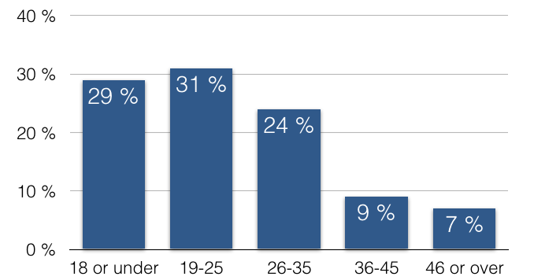
Figure 3: Respondents’ age
Beyond the frequency of social network usage, the psychological place these networks occupied was also investigated: social networks play an important part for only 25% of respondents, concerning their overall reputation, i.e. the way in which others perceive them. This percentage remains identical for under 25s. This is not a very high proportion, based on the observation of young people using their smartphones all-day-long. On the other hand, when asked about the role played by social networks in creating opportunities (such as linking people and finding jobs), this percentage increases to 33% and young people consider it to be very important.
  - Spelling
Young people maintain special relations to linguistic competencies and, in particular, towards spelling. The sms4science project enabled to highlight first results about spelling concerns: the research has shown that the use of SMS is not, contrary to popular belief, systematically abbreviating: the average message-reduction rate overall was only 9.4% in the Belgian corpus and this drops to 5% in a 1,000 text-message sample from the French corpus. The main reduction phenomena are:
- apocope: les appli sont pas encore a jour — appli instead of applications;
- aphaeresis: bon allez espère que ta flemme s'est arrangée un peu.. Un zou* — zou instead of bisou;
- semantic abbreviations, where words are reduced to initial characters (Roche et al. 2016): tu f koi ? (fais/feras/faisais/fous/foutais).
On the contrary, character repetition and addition is often used (suuuuppppeeerrrr (great), les zamours (loves), oki (ok)) and considerably extend the message space.
The study showed that very short messages, under 15 characters, are prevalent: 17.3% for the Belgian corpus, which we thought was logical, since it relates to 2004 when text-messages were chargeable and quite expensive. Unexpectedly, this rate remained very high (16.5%) in the French late (2011) collection, even with smartphones and monthly plan unlimited inclusion. André (2017) suggests that: “very short messages remain [...] one of the characteristics of SMS-writing, of the quasi-synchronous exchanges, simulating a conversation in co-presence”.
The sms4science results invalidated other popular beliefs such as the one whereby only young people write in very abbreviated forms. Cougnon (2015) showed that there was little difference between generations concerning linguistic practices; for example, there are no differences regarding words borrowed from other languages, or regionalisms. Cougnon and Draelants (2018) also showed that all generations find that respecting norms in writing conventions is very important. In terms of spelling and syntax, there are more subtle variations: verb tenses and modes are more often problematic for the young and informal question forms and negations which suppress the “ne” particle are also more apparent, which shows young people communicate in a more informal manner, but not in an incorrect one. Cougnon et al. (2017) compared dictations and writings over a 100-year period, and their study shows that today’s younger generations are in actual fact better at writing essays, using connectors and expressing ideas as compared to young people of yesteryear. These results confirm previous studies (Kemp & Bushnell 2011, Drouin and Davis 2009, Spooren 2009) that concluded on a positive influence of digital practices on language competencies and other studies which even revealed that young people can use a number of spelling variations in their text messages or other written CMC without repeating them in more formal situations (Aziz et al. 2013, Asmaak Shafie et al. 2010), making young people dual-skilled or digraphic (David and Goncalves 2007).

  - Culture
The following results emerged from the thumbs4science questionnaire. The place digital devices play in youth everyday life is an important question that can lead to anxiety among older people. Commonly, when asked about what this fear is mostly related to, parents, educators and journalists cite the decreasing role of culture and the increasing time allocated to screens. This is why the thumbs4science project also investigated these issues, and in particular, we looked into the transformations of cultural capital, the set of cultural resources available to an individual, in terms of proportions and nature of the cultural asset. We focus here on one aspect of the cultural capital: books and screens.

Figure 4: Book possession per age group (%)
Figure 4 Illustrates two interesting trends: first, there is a relatively comparable distribution of book possession between the two “under 18s” and “over 18s” groups. There is no salience of young people having fewer books when considering possession of 25 books or less (17% for 18- compared to 14% for 18+). Secondly, the graph shows a spike in an average book capital for youngsters (from 26 to 200 (56% for 18- compared to 45% for 18+) as older respondents largely declare a possession of more than 200 books (26% for 18- compared to 41% for 18+). The two trends show slight differences between age groups, but no major divide that could illustrate a disinterest of young people in book reading activities. Furthermore, Figure 5 confirms that even the youngest people (18-) feel more comfortable with paper than with a screen for a reading activity.

Figure 5: Which media is more “natural” for a reading activity? (18-)
Teenagers also answered questions regarding the time allocated for reading on different devices and their motivations towards the reading activity. Figure 6 shows the difference in everyday reading practices: 43% of young people declare everyday screen usage, whereas only 22% have a daily book contact.

Figure 6: Reading frequency on screen and books (18-%)
We could question the proportion (47% as a whole) of teenagers who declare reading books at least a few times a week or more. This is a relatively high rate and one initially wonders if they have included the contact with schoolbooks in this auto-evaluation. However, Figure 7 shows their motivations for reading activities more precisely. With reasonable certainty, we can eliminate the place of schoolbooks in most cases, as 69% of them declare reading often for their own pleasure, compared to 41% for school obligations.

Figure 7: What are your reading motivations? (18-%)
  - Emotion handling
The thumbs4science questionnaire also included questions about emotional handling in digital practices. For instance, psychological impact of social relations on social networks can be important, especially among teenagers. Therefore, we investigated different online emotional situations: harassment, embarrassment, sadness, oppression, anger and malaise. Firstly, as Figure 8 shows, only 2% of respondents suffered harassment often, 11% rarely and 87% never. The numbers are more or less the same for under 25s (1.5% often, 18% rarely, 80.5% never). However, what the figure does not show is that for minors under 18, the proportion of young people who often suffer from harassment online increases to 6%.

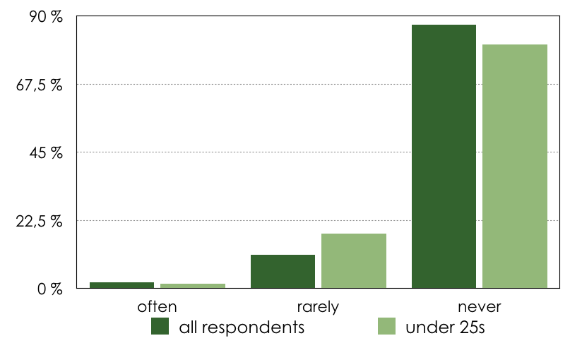
Figure 8: harassment
An open comment part of the questionnaire enabled donors to indicate freely, and in more detail, concrete cases of online threat and harassment (see Figure 9).
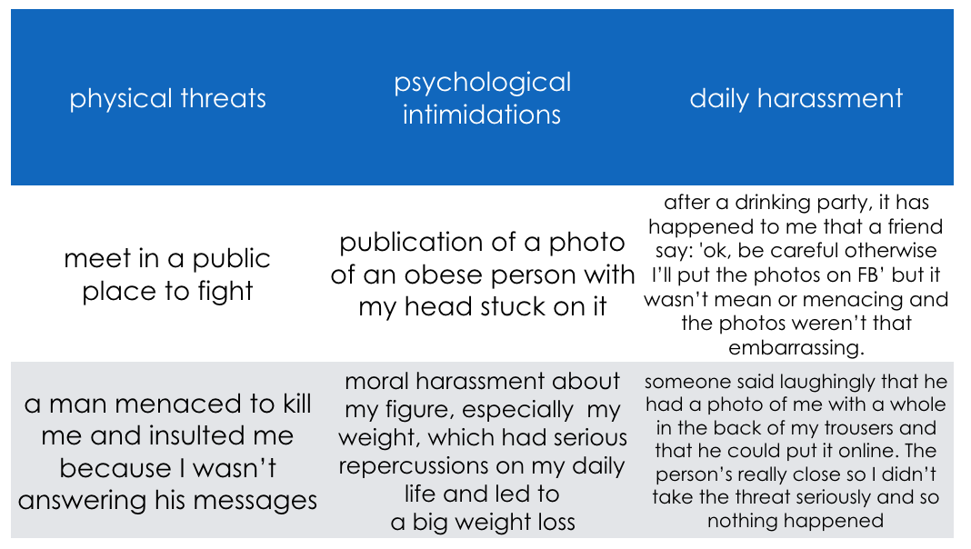
Figure 9: open comments
Some examples pertain more to physical threats, others to psychological intimidations and the survey also highlighted an interesting phenomenon of daily harassment that young people may experience and for which they say they do “relativize” (downplay), but for which one might wonder just what the true weight of the threat is.
Concerning the other emotions felt on social networks by school populations of under 18-year olds, the graph (Figure 10) summarises the main ones and their related frequencies. The question was: “On social networks, have you ever felt X after having received a post from one of your acquaintances?”, X corresponding to either: embarrassment, sadness, oppression, anger or malaise/uneasiness which then persisted in real life.
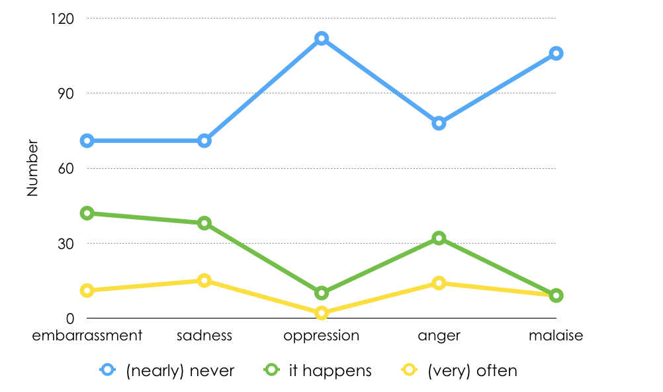
Figure 10: emotions of young people on social networks
In view of the tendencies expressed by the lines, we can conclude that oppression and malaise/uneasiness are the two least frequent emotions felt on social networks. On the contrary, anger and sadness are the most recurrent emotions felt by young people on social networks. New research perspectives will include a detail of different emotion handling through private qualitative interviews.
Conclusion
Young people evolve in different contexts in relation to digital practices at school across countries and from one establishment to another. We have seen that the French ban has had an impact on how mobiles are perceived in schools and that although pedagogical usage is allowed, this could be jeopardized by a formal law. Future diachronic research will shed light on this aspect. However, on a positive note, more and more formal, national, digital technology courses and projects are currently being introduced in France. In Belgium, young people are now encouraged in scholarly environments to use their mobiles for pedagogical projects, communication with staff and parents, etc. (§ 1).
The research projects sms4science and thumbs4science — which focus on (socio) linguistic and psychological analyses — point towards the important notion of “pluricompetency” (as opposed to incompetency) whereby pupils and students adapt their language, social and emotional code in various situations, with differing interlocutors and change of communication mediums (§ 2).
Children’s and teenagers' digital writing scholarly productions consist of a wide usage of linguistic practices, and sms4science results (Cougnon 2015) showed little variation between generations, apart from more informal (but not incorrect) spelling and syntax usage among the young. On the whole, there is a positive influence of digital practices on language competencies, in particular on skills related to semantics and pragmatics (§ 3.1).
As far as the thumbs4science project is concerned, digital practices related to culture (§ 3.2) don't show a disinterest of young people in book reading activities; trends show slight differences between age groups, but nothing as significant as is often mentioned in parents' and media discourse. Results also inform that under 18-year olds in fact prefer reading on paper rather than on screens, even though they tend to read more often on screens. A high percentage of youngsters read books for their own pleasure.
In terms of emotion handling (§ 3.3), psychological impact of social relations on social networks is important for teenagers. Emotional situations, including harassment, were considered in this study: only a small proportion, 2% of respondents of all ages, suffer harassment often, but for under 18s specifically, the proportion of online harassment increases to 6%. This may seem quite a small percentage but qualitative interviews mentioned a phenomenon of daily inconvenience that young people may not recognize as harassment, but which can play a crucial emotional role. The two most recurrent emotions felt on social networks are anger and sadness.
Finally, we believe that evolving forms of Mediated Digital Discourse (Panckhurst 2017) have a long life ahead of them and that their place at school and their influence on writing, culture and emotion handling needs to be monitored thanks to objective and scientific studies rather than to political beliefs and common sense. For instance, the linguistic analysis of the thumbs data has just commenced and will keep researchers occupied for a number of years to come, notably with more research on syntax and spelling based on up-to-date data, and with research on automatic emoji detection and cross-cultural/multilingual approaches. The psychological data analysis is in its infancy as well. An interdisciplinary future direction will be to statistically cross compare results between the emotional I.Q., the sociolinguistic questionnaire and the written productions. For instance, if a person complains about receiving aggressive messages, discourse analysis on the content could be conducted to check this. Another direction, as explained earlier, will be to explore qualitatively, through a semi-closed questions interview, the different types of emotions and their management.
A last very exciting aspect for researchers and linguists in particular, is that we now have the opportunity to analyse real interactions, ‘conversational messages’ as it were, and not just ‘isolated, unidirectional messages’, which was the case in sms4science (for legal reasons). There is no doubt that future research projects will investigate this currently rare written conversational aspect in more depth in years to come.

References
André F. (2017). Pratiques scripturales et écriture SMS : analyse linguistique d’un corpus de langue française. PhD, Université Paris-Sorbonne.
Asmaak Shafie, L., Azida Darus, N. and Osman, N. (2010). “SMS language and college writing: The language of the college texters”, in International Journal of EmergingTechnologies in Learning 5(1): 26–31.
Aziz, S., Shamim, M., Aziz, M. F. and Avais, P. (2013). “The impact of texting/SMSlanguage on academic writing of students – What do we need to panic about?”, in Linguistics and Translation 55: 12884–12890.
Bernicot, J., Goumi, A., Bert-Erboul, A. and Volckaert-Legrier, O. (2014). How do skilled and less-skilled spellers write text messages? A longitudinal study of sixth and seventh graders.Journal of Computer Assisted Learning 30 (6):559–576.
Cougnon, L.-A. (2015). Langage et sms. Presses universitaires de Louvain. ISBN: 978-2-87463-371-0 [PhD thesis publication].
Cougnon L.-A. (2016), “A peek into the classroom of tomorrow”, TEDx presentation
https://www.youtube.com/watch?v=3ite2Qw-U7g.
Cougnon, L.-A. and Draelants, H. (2018). "Language Ideologies and Writing Systems in CMC: a Sociolinguistic Approach". In Louise-Amélie Cougnon, Barbara De Cock and Cédrick Fairon (eds). Language and the new (instant) media, Cahiers du Cental 9, 88-99.
Cougnon, L.-A., Maskens, L., Roekhaut, S. and Fairon, C. (2017). "Social Media, Spontaneous Writing and Dictation. Spelling variation" in Journal of French Language Studies 27, 309-327, Cambridge University Press.
David, J. and Goncalves, H. (2007). « L’écriture électronique, une menace pour la maitrise de la langue ? » Le Français Aujourd’hui, 156:39–47.
Drouin, M. and Davis, C. (2009). "R u txting? Is the use of text speak hurting your literacy?", in Journal of Literacy Research 41(1):46–67.
Dykes G., Knight H.R. (2012), Mobile learning for teachers in Europe: exploring the potential of mobile technologies to support teachers and improve practice, UNESCO working paper series on mobile learning, https://unesdoc.unesco.org/ark:/48223/pf0000216167
Eurostat (2016). Being young in Europe today - digital world [online] https://ec.europa.eu/eurostat/statistics-explained/index.php/Being_young_in_Europe_today_-_digital_world
Fairon C., Klein J. R., Paumier S. (2006a). Le langage SMS. Étude d’un corpus informatisé à partir de l’enquête 'Faites don de vos SMS à la science'. Cahiers du Cental 1. Louvain-la-Neuve : Presses universitaires de Louvain. url : http://www.smspourlascience.be/
Fairon C., Klein J. et Paumier S. (2006b), Le Corpus SMS pour la science. Base de données de 30.000 SMS et logiciels de consultation, CD-Rom, Presses universitaires de Louvain, Louvain-la-Neuve. Cahiers du Cental, 3.2.
Heutte J. (2008) "Influence de l’habituation à l’usage de l’outil informatique sur l’apprentissage et les résultats scolaires d’élèves du cycles 3 de l’école primaire" - SPIRAL-e 2008 (31-47) : http://spirale-edu-revue.fr/spip.php?article845
Institut Montaigne (2016) ‘Le numérique pour réussir dès l’école primaire‘, 142p report, March 2016,
https://www.institutmontaigne.org/ressources/pdfs/publications/institut_montaigne_le_numerique_pour_reussir_des_l_ecole_primaire.pdf
Kemp, N. and Bushnell, C. (2011). "Children’s text messaging: Abbreviations, input methods and links with literacy", in Journal of Computer Assisted Learning 27(1):18–27.
Lopez-Fernandez O, Kuss DJ, Romo L, et al. (2017). "Self-reported dependence on mobile phones in young adults: A European cross-cultural empirical survey", in Journal of Behavioral Addictions, 6(2), 168–177.
Maskens, L., Cougnon, L.-A., Roekhaut, S. and Fairon, C. (2015). "Nouveaux médias et orthographe. Incompétence ou pluri-compétence ?". In Discours 16.
Mikolajczak M., Quoidbach J., Kotsou I., Nelis D. (2009). Les compétences émotionnelles. Dunod. 308 p.
Panckhurst R., Détrie C., Lopez C., Moïse C., Roche M. et Verine B. (2013). "Sud4science, de l'acquisition d'un grand corpus de SMS en français à l'analyse de l'écriture SMS", in Épistémè - revue internationale de sciences sociales appliquées, 9 : Des usages numériques aux pratiques scripturales électroniques, 107-138.
Panckhurst, R. (2017), « Entre linguistique et informatique. Des outils de traitement automatique du langage naturel écrit (TALNE) à l’analyse du discours numérique médié (DNM) ». French habilitation diploma, Comue Université Paris-Est.
Panckhurst R (2018a), « Le téléphone portable a toute sa place en classe », Tribune, Le Monde, 08/08/2018, https://www.lemonde.fr/series-d-ete-2018-long-format/article/2018/08/06/rachel-panckhurst-le-telephone-portable-a-toute-sa-place-en-classe_5339866_5325928.html
Panckhurst R (2018b), « Il faut encourager le téléphone portable en classe », Opinion, La Libre, 04/09/2018, https://www.lalibre.be/debats/opinions/il-faut-encourager-le-telephone-portable-en-classe-5b8d5384cd70f5387bde4c22
Panckhurst R., Détrie C., Lopez C., Moïse C., Roche M., Verine B. (2014), « 88milSMS. A corpus of authentic text messages in French », produced by the University Paul-Valéry Montpellier 3 and the CNRS, in collaboration with the Catholic University of Louvain, funded with support from the MSH-M and the Ministry of Culture (General Delegation for the French language and the languages of France) and with the financial participation of Praxiling, Lirmm, Lidilem, Tetis, Viseo. ISLRN : 024-713-187-947-8, http://88milsms.huma-num.fr
Panckhurst R., Détrie C., Lopez C., Moïse C., Roche M., Verine B. (2016). « 88milSMS. A corpus of authentic text messages in French”. (Ed) Thierry Chanier Banque de corpus CoMeRe. Ortolang : Nancy. https://hdl.handle.net/11403/comere/cmr-88milsms
Panckhurst R. Marsh D. (2011). “Using Social Networks for Pedagogical Practice in French Higher Education: Educator and Learner Perspectives”. In : “Globalisation and Internationalisation of Higher Education” [online monograph]. Revista de Universidad y Sociedad del Conocimiento (RUSC). Vol. 8, No 1. UOC. http://rusc.uoc.edu/rusc/ca/index.php/rusc/article/view/v8n1-panckhurst-marsh.html DOI: http://dx.doi.org/10.7238/rusc.v8i1.961
Roche M., Verine B., Lopez C., Panckhurst R., (2016), « La néographie dans un grand corpus de SMS français : 88milSMS », dans García Palacios J., De Sterck G., Linder D., Maroto N., Sánchez Ibáñez M. & Torres del Rey J. (éd.), La Neología en las lenguas románicas. Recursos, estrategias y nuevas orientaciones, Frankfort-sur-le-Main : Peter Lang, 279-302.
Romero, M., Ouellet, H. and Sawchuk, K. (2017). "Expanding the Game Design Play and Experience Framework for Game-Based Lifelong Learning (GD-LLL-PE)", in Game-Based Learning Across the Lifespan: Cross-Generational and Age-Oriented Topics, 1-11.
Spooren,W. (2009). "Bezorgde ouders ? De relatie tussen chat en schrijfkwaliteit", in W. Spooren and M. S. Onrust (eds), Studies in Taalbeheersing 3. Assen: Van Gorcum, pp.331–342.
Stiegler B., Tisseron S. (209), Faut-il interdire les écrans aux enfants ? Paris : Mordicus.
Zebroff, D. (2018). "Youth texting: Help or hindrance to literacy?" in Education and Information Technologies 23 (1), 341–356.

http://www.sms4science.org, http://www.sud4science.org
https://acougnon.wixsite.com/thumbs4science
Authors’ translation: « L’interdiction générale des téléphones portables dans les écoles et les collèges a été définitivement adoptée par l’Assemblée nationale aujourd’hui. Engagement tenu ».
« Dans les écoles maternelles, les écoles élémentaires et les collèges, l'utilisation durant toute activité d'enseignement et dans les lieux prévus par le règlement intérieur, par un élève, d'un téléphone mobile est interdite. » (In nursery schools, primary schools and lower secondary schools, the use of a mobile telephone by a pupil during any teaching activity and in areas indicated in the school’s internal regulations is prohibited). https://www.legifrance.gouv.fr
https://www.senat.fr/questions/base/2011/qSEQ11031235S.html (accessed 11/07/2019).
https://eduscol.education.fr/pid26435/enseigner-avec-le-numerique.html (accessed 11/07/2019)
On October 18th, a 15-year old high-school student in the Paris region pointed a fake gun at his teacher so that she would mark him present instead of absent.
https://www.education.gouv.fr/cid133192/le-numerique-service-ecole-confiance.html#Enseigner_au_XXIe_siecle_avec_le_numerique (accessed 11/07/2019)
https://www.twictee.org/
https://www.classcraft.com/
The Wooclap platform (http://www.wooclap.com) is developed with learning designers, digital pedagogy and neuroscience specialists and teachers around the world. One major advantage is that it is very simple to use. It can also be directly integrated into tools such as Powerpoint, Keynote, Google slides, and also LMS like Moodle, etc.
https://emotional-competence.co/en
Although there were 1,100 participants, there were many interlocutors, whether for Facebook Messenger, Viber, WhatsApp. This explains the high number (in millions) of words. The donors were to inform their interlocutors that their messages would also be sent in with their own, but for privacy reasons, Belgian law will not allow those messages to be publicly consulted. However, the participants’ ones can, which also includes their Facebook posts on their own walls. The corpus/data can be disseminated via the scientific network to: Belgium, France, Québec, Canada. Differences in numbers can be explained by the fact that donors were allowed to participate in one or more activities. There were less than 20 people who in fact participated in all activities.
“the apps aren’t up to date”
“Well I hope your laziness has settled abit.. A kiss”
“you are/will be/were doing what?”
Some examples: https://www.thedenverchannel.com/news/360/as-studies-suggest-excess-screen-time-can-damage-kids-brains-colorado-talks-how-much-is-too-much, https://www.washingtonpost.com/news/answer-sheet/wp/2015/04/29/why-kids-lose-interest-in-reading-as-they-get-older/?noredirect=on&utm_term=.95308062bdc3 (accessed 15 July 2019).
Examples in Figure 9 are translated from their original French version.
One needs to bear in mind that the collection finished in October 2017 and the anonymization process continued into 2018. So the data is very recent.

