Hitting the Right Note: The Impact of Lexical Complexity on Initial Coin Offering Success

ABSTRACT
This paper builds on credible signaling theory and proposes a novel approach to financial textual analysis by introducing lexical complexity (LC) as an informative signal of future venture performance. LC is measured by the sophistication, density, and diversity of vocabulary in a text and distinguishes itself from the widely used construct of readability. Analyzing 1,202 ICO white papers from 2015 to 2021, we find that higher LC positively influences the amount raised during ICOs, above and beyond the effect of white paper readability. This effect is amplified for more readable white papers. We also investigate the underlying mechanisms behind these results, suggesting that LC enhances perceptions of innovation and quality, attracts greater attention from institutional investors, and reduces information asymmetry. Our findings contribute to the entrepreneurial finance literature by highlighting how managers’ linguistic choices, particularly the use of LC, can significantly improve disclosure quality and influence investor behavior.

Keywords: Initial Coin Offerings, White Papers, Lexical Complexity, Readability.
JEL: G32, F30, G41, M20, O16.

Introduction
In today rapidly evolving financial landscape, effective communication is essential for fostering trust and attracting investment (Cumming & Johan, 2008; Thewissen et al., 2022). This is particularly true in the cryptocurrency sector, which is marked by high information asymmetry and constant innovation (Johan & Pant, 2018; Momtaz, 2021c). Consider evaluating two white papers for new cryptocurrency projects. The first one states: "Our crypto wallets are secure and easy to use." and the second one elaborates: "Our cryptographic repositories ensure impenetrable security and user accessibility." While both convey the same basic message, the two sentences distinguish themselves by conveying different levels of lexical complexity (henceforth LC), with the second one using more lexically complex language, potentially making the project appear more innovative and reliable. However, whether this difference in LC influences investor behavior and decision-making remains to be understood.
This study introduces LC, a construct borrowed from linguistics, as a distinct and complementary measure to other existing proxies used to date in prior literature, such as readability. LC measures the sophistication, density, and diversity of vocabulary in financial disclosures (Lu, 2012; Read, 2000). We propose that higher LC serves as a credible signal of innovation and professionalism, ultimately reducing information asymmetry and enhancing investor confidence. This statement aligns with credible signaling theory, which posits that high-quality firms differentiate themselves from lower-quality counterparts by offering observable signals that require effort and are not easily replicated (Connelly et al., 2011; Osburg et al., 2022; Spence, 1973), thereby impacting market dynamicity.
Unlike traditional readability, which can be easily replicated by individuals with access to advanced language tools or a broad vocabulary, crafting a lexically complex yet coherent white paper typically demands expertise and consideration with superior linguistic knowledge. High-quality firms may therefore be more likely to produce sophisticated, well-crafted documents that reflect their deeper knowledge, expertise and strategic thinking. In this sense, LC could serve as a signal of quality and help distinguish reputable ventures from less credible ones. On the other hand, excessive LC in financial communication could also risk alienating potential investors, especially those who may not be familiar with highly technical or jargon-heavy language. Financial documents need to hit the right note in terms of LC. If the complexity makes the message harder to understand or reduces accessibility, it could backfire, undermining the document effectiveness as a signal.
To date, the literature mostly focuses on the construct of readability and its impact on investor behavior. However, readability alone does not capture the full extent of linguistic sophistication. In this study, we emphasize that LC should not be confused with readability and present it as a novel construct for financial textual analysis. Readability, which focuses on the ease with which a text can be understood, is an appealing and widely used measure of textual communicative efficiency, particularly in financial textual analysis. Critics argue that readability may not fully capture the complexity of business texts, as it overlooks the quality and depth of vocabulary, which are crucial in professional financial communication (Li, 2008; Loughran & McDonald, 2014a). This paper addresses this gap by introducing LC as a distinct yet complementary construct that evaluates vocabulary quality, measured by lexical density, sophistication, and variety (Lu, 2012). While readability captures the accessibility of a text, LC focuses on the abundance and sophistication of the language, offering a more nuanced perspective on language quality. By borrowing this concept from linguistics, we introduce it to entrepreneurial finance, highlighting the potential for interdisciplinary cross-fertilization between the two fields. LC thus complements readability by providing a deeper understanding of how language complexity signals expertise and quality in financial communication.
Several operationalizations of LC exist in linguistics (see, e.g., Kyle et al., 2021). We adopt the LC framework developed by Lu (2012), which distinguishes between three interrelated sub-constructs: lexical density, lexical sophistication, and lexical diversity. Lexical density refers to the ratio of lexical words (i.e., content words such as verbs, nouns, adjectives, and adverbs) to the total number of words in a text. Lexical sophistication targets the proportion of rare, unusual, or advanced words in a text, specifically those not among the 2000 most frequent words in English as listed in the British National Corpus (BNC Consortium, 2007; Rayson et al., 2002). Lexical diversity refers to the range of vocabulary displayed in a text. We define our proxy for LC by aggregating these three components through Principal Component Analysis (PCA) and examine whether this proxy of LC influences the amount raised during Initial Coin Offering (ICO) campaigns, and if so, what underlying mechanisms explain this relationship and under which conditions.
The ICO market offers a unique context for exploring the influence of LC. ICOs have become a favored fundraising method for startups, allowing them to secure capital by issuing crypto-tokens directly to investors (Colombo et al., 2022; Fuchs & Momtaz, 2025). Although ICO activity has declined since its 2018 peak (Andrieu & Sannajust, 2023; Drobetz et al., 2025), research on ICOs remains strong thanks to the high levels of information asymmetry stemming from their unregulated nature and the opacity of their white paper. White papers are the main source of information for ICOs; however they often contain exaggerated claims (Momtaz, 2021b), vague information (Florysiak & Schandlbauer, 2022), and linguistic errors (Thewissen et al., 2022), eroding investor confidence (Florysiak & Schandlbauer, 2022; Momtaz, 2021c) and thus financial gains. Furthermore, the diverse backgrounds and varying English proficiency of ICO investors (Fisch et al., 2021; Thewissen et al., 2022) exacerbate communication barriers. Given this backdrop of high information asymmetry and limited disclosure quality, studying how LC influences the amount raised during ICO fundraising campaigns offers a novel perspective on financial communication and investor decision-making.
Analyzing a sample of 1,202 ICOs conducted between 2015 and 2021 and controlling for other linguistic aspects of white papers, in particular readability and sentiment, along with ICO-specific characteristics, regional factors, and year-quarter and industry fixed effects, we find a significant positive relationship between the level of LC in white papers and the amount raised in dollars during ICOs. Specifically, higher LC, characterized by denser, more sophisticated and varied vocabulary, is associated with a substantial increase in the funds raised during the ICO. Economically, a one-standard-deviation increase in the total level of LC is associated with a 1.2% rise in the absolute dollar value of ICO funding at the sample mean, equivalent to an increase of $104,558. Similarly, each LC sub-construct contributes to the absolute funding raised as follows: lexical density by 0.97% ($84,350), lexical sophistication by 1.81% ($158,016), and lexical diversity by 1.12% ($97,555). These findings are robust and consistent across various alternative dependent variable measures, including post-funding ICO performance, survival rates, ICO listing on secondary exchanges, and meeting the minimum funding requirement. Additionally, the results hold when accounting for a broad range of control variables, such as social media presence, multimedia content in the white paper and white paper sentiment.
We subsequently examine the mitigating impact of the ICO white paper readability on the relationship between LC and the amount raised during the ICO. We find that this relationship becomes more pronounced when the text is more readable, thereby further emphasizing that LC and readability constitute two complementary signals for investment decisions.
Signaling theory offers an appropriate framework for understanding a heterogeneous set of non-mutually exclusive channels through which LC can improve the amount raised during an ICO. The first channel is an innovation effect: ICOs that tend to incorporate technical content are characterized as more innovative (Holliman, 2023), which subsequently increases investor propensity to invest in the project (Chan & Parhankangas, 2017). The second channel is a cognitive effect: LC requires greater (but still manageable) cognitive effort from both the ICO manager and the investors to understand the content of ICO white paper, leading to higher perceived quality and professionalism from the team behind the ICO (Florysiak & Schandlbauer, 2022; Xia et al., 2024c). The third channel focuses on the role played by LC in reducing information asymmetry: the diversity and sophistication of information in a text have been shown to enhance the precision of content in white papers (Joenväärä et al., 2019), potentially reducing information asymmetry and increasing fundraising performance. Based on the mediation analysis framework of Baron & Kenny (1986) and Singh et al. (2022), we find that lexically complex language not only signals the technical innovation of an ICO but also enhances its perceived quality among investors (i.e., through ICO expert endorsements) and improves information dissemination, ultimately leading to increased funding.
Another significant result of this paper is that we identify which types of investors are influenced by the LC of ICO white papers. Since ICOs attract both retail and institutional investors, it is crucial to distinguish which investors respond to variations in LC, shedding light on how LC shapes investor behavior across different audiences. Our findings reveal a notable divergence in how different investor groups respond to LC. Specifically, higher LC is positively associated with greater interest from institutional investors, who are more likely to interpret sophisticated language as a credible signal of project quality. In contrast, retail investors tend to disengage from offerings with more complex disclosures, which is likely due to cognitive overload or skepticism toward overly intricate language. This asymmetry underscores the selective signaling power of LC: it primarily resonates with more sophisticated, financially literate investors who are better equipped to process nuanced, information-rich texts.
We next argue that the signal sent by LC is stronger when it is more difficult to imitate. To test this, we conduct three sensitivity tests: (i) the educational attainment in the ICO country of origin, (ii) the education level of the CEO of the ICO, and (iii) the ICO source code availability. We find strong evidence that the impact of LC on investors is more pronounced when the signal is more difficult to imitate. In particular, we find that LC is stronger for ICOs from a country with low educational attainment, when the CEO educational level is low and when the ICO does not disclose its source code.
Finally, we examine whether LC is an informative signal in predicting future token performance, beyond the fundraising stage. This long-run analysis helps rule out any self-fulfilling equilibrium, in which complex language influences investor perception without conveying substantive information (Lee et al., 2022). We find that LC predicts short-run and long-run token performance in the secondary market. LC is also associated with a lower chance of ICO delisting. However, it is not associated with token price volatility or the identification of fraudulent ICOs.
This study makes three key contributions to the literature on entrepreneurial finance and financial communication. First, it introduces LC as a novel and influential linguistic signal, revealing that entrepreneur vocabulary choices meaningfully shape investor perceptions of innovation, quality, and information asymmetry. By integrating credible signaling theory with linguistic constructs such as LC, we offer a fresh theoretical lens to understand how language can function as a strategic asset in the fundraising process. Crucially, we move beyond the predominant focus on readability in prior literature (Li, 2008; Loughran & McDonald, 2014a, 2014b), and instead highlight the distinct and complementary role of vocabulary sophistication in shaping investor decisions (Arslan-Ayaydin et al., 2016, 2020,2021; Zhang et al., 2019). Our findings show that readability alone does not capture the full dynamics of linguistic signaling in ICO white papers; rather, LC interacts with readability to jointly influence investor perceptions. This interplay refines our understanding of how linguistic cues drive investor trust and behavior, expanding the scope of signaling theory in entrepreneurial contexts.
Second, drawing on institutional theory, we demonstrate that the signaling effectiveness of LC is context-dependent. While prior research often assumes a uniform investor response to linguistic features (see, e.g., Karimi et al., 2017; Zhao et al., 2010), our study challenges this view by uncovering significant variation across cultural, educational, and ICO-specific dimensions (Bruton & Ahlstrom, 2003; Neira et al., 2017; Xia et al., 2024a). Specifically, we show that the interpretation of LC depends on factors such as national literacy levels, entrepreneurial education, and the technical sophistication of the ICO itself (e.g., presence of source code). This contribution deepens our understanding of how language-based signals operate across different institutional and cultural environments, which is largely overlooked in prior work (Colombo, 2020).
Third, within the ICO context, we position LC as a complementary signal alongside established cues such as tone, visuals, readability, and CEO traits. Prior studies have shown how factors like CEO attractiveness (Colombo et al., 2022), thematic content (Shrestha et al., 2023; Thewissen et al., 2022), tone (Akyildirim et al., 2024; Boudt & Thewissen, 2019), and crypto-related naming conventions (Xia et al., 2024b) influence funding success. Others have highlighted the role of visual elements, such as infographics, in reducing information asymmetry (Xia et al., 2024c). Building on this, we show that LC enhances the credibility and perceived professionalism of the project team, especially among more discerning investors. While readability continues to matter, overly simplistic language may backfire, reducing perceived credibility. LC thus emerges as a parallel and potent signal of expertise, enabling startups to differentiate themselves in highly competitive, information-scarce environments.
The rest of the paper is structured as follows. The following section presents the literature review, while Section 3 discusses the hypotheses development and Section 4 explains the research design. Section 5 provides the empirical results, while Section 6 includes the Post-ICO performance analysis. Section 7 tests the robustness of our results and Section 8 concludes.

Literature review
This study shows how vocabulary can be used as a tool to ensure investor attributions on a project and funding success. This approach strongly contrasts with prior research in finance, which overwhelmingly focuses on a text readability using inadequately specified readability formulas. We propose a novel paradigm in financial textual analysis by looking at LC and its role in influencing investor perceptions of the ICO project, impacting a venture ability to raise capital.

ICOs, information asymmetry and white papers
ICOs represent a rapidly growing entrepreneurial venture practice that allows startups to raise funds by directly selling blockchain-based digital assets (i.e., tokens) to investors (see, e.g., Amsden & Schweizer, 2018; Momtaz, 2020). The process of an ICO involves several stages. First, the issuing startup or project drafts a white paper outlining the details of the ICO, including its objectives, technological details, token allocation, and the proposed use of funds. The startup then announces the period of the ICO, during which interested investors can participate by paying with cryptocurrencies or fiat currencies in exchange for the newly created tokens. Once the ICO concludes, the tokens are distributed to investor digital wallets. After the ICO period ends, tokens may be listed on cryptocurrency exchanges, which enables secondary trading.
ICOs have gained attention in finance research due to their potential as an alternative fundraising method. However, the ICO market operates with limited regulation and is characterized by a high degree of information asymmetry. The absence of established financial statements regarding ICOs makes the white paper the only channel to convey information to investors (Thewissen et al., 2022). Entrepreneurs use it to describe and promote their projects in detail (e.g., value proposition, token allocation, technical features, and further prospects). White papers, therefore, matter to investors, as confirmed by a survey conducted by Fisch et al. (2021) showing that a large proportion of investors actually read them.
The nascent nature of ICO startups, together with their operation outside traditional regulatory and intermediation frameworks, give rise to significant levels of asymmetric information (Hornuf et al., 2022; Huang et al., 2022). A growing body of literature explores how the quality of disclosure and the use of signals can help mitigate this asymmetry and enhance ICO success. For example, Thewissen et al. (2022) use topic modeling to show that the thematic content of ICO white papers offers valuable insights for identifying successful ICOs. Samieifar & Baur (2021) find a positive correlation between the length and readability of white papers and ICO success. Regarding the use of signals, Shrestha et al. (2021) show that the institutional strength of the ICO issuing country serves as a heuristic for investors, while Momtaz (2021c) finds that CEO loyalty plays a critical role in mitigating agency problems, thereby increasing investor confidence and funding success.
Overall, while existing literature acknowledges the role of linguistic and visual features in reducing information asymmetry (Florysiak & Schandlbauer, 2022; Thewissen et al., 2022; Xia et al., 2024c), the impact of LC remains largely unexplored. This paper fills this gap and investigates how the vocabulary selection contained in ICO white papers influences investor trust and ICO success.

Readability and LC
While readability is an important construct, it is distinct from LC (Bulte & Housen, 2012; Lu, 2012; Read, 2000), which has not been studied or operationalized as we suggest here in the context of financial textual communication. In this section, we outline the differences between readability and LC, both in terms of their conceptual foundations and their measurement approaches.

Readability definition and measurement
Readability measurement in financial textual analysis primarily aims to capture the ease or difficulty with which information is linguistically presented and subsequently cognitively processed. Lahmar & Piras (2023) explain that readability formulas are "a quantitative methodology based on textual analysis, that makes it possible to estimate the degree of ease or difficulty an individual might face when reading a text." Readability equations predict how challenging the text is without involving the reader as there is no actual feedback from the readers themselves to judge the extent to which the text is understandable.
The three most frequently used readability measures in finance literature are the well-known Gunning Fog Index (FOG), the Flesch Reading Ease (FRE) and the Flesch-Kinkaid Grade Level (FKG) matrix. While practically appealing as a general gauge of textual understandability, each of these indices is imperfect (Loughran & McDonald, 2014a), therefore limiting their relevance in our study. For example, one component of the FOG Index is the count of complex words in a text, defined as words with more than two syllables. Thus, common financial terms such as "economy", "investment", "revenue" or "entrepreneur" are considered complex words despite being easily understood by people in and outside the field of finance. This rather simplistic definition of complex words is far removed from the more sophisticated operationalization proposed in this paper.
While traditional readability metrics such as the FOG and Flesch-Kincaid Index provide useful approximations of textual difficulty, they may not be entirely suitable for financial texts (Loughran & McDonald, 2014a). FKG, for instance, was initially developed to assess the reading grade level of a text for school-aged children, a setting quite far removed from that of financial communication. This raises concerns about the applicability of the FOG, FRE, and FKG formulas in evaluating the understandability of financial disclosures (Flesch, 1948; Gunning, 1952; Kincaid et al., 1975; Lahmar & Piras, 2023). Notably, these traditional readability models do not account for LC as we define it, focusing instead on surface-level features such as sentence length, syllable count, and total word count. Given these limitations, we question the relevance of depending solely on the conventional readability measures in financial disclosures (Loughran & McDonald, 2014a). We argue that readability and LC are distinct yet complementary constructs, each capturing different dimensions of textual effectiveness. Recognizing their interplay offers a more nuanced and accurate understanding of how language shapes investor perceptions in settings like ICOs.

LC conceptualization and measurement
We address the limitations of traditional readability formulas by introducing a novel linguistic concept: LC. While readability and LC both influence text comprehensibility, LC extends beyond conventional metrics such as average sentence length and syllable count, which are commonly used to assess readability (Flesch, 1948; Gunning, 1952; Kincaid et al., 1975). Unlike these surface-level measures, LC is a more holistic construct that captures the diversity and sophistication of information within a text, as well as the writer ability to communicate it effectively (Bulte & Housen, 2012; Joenväärä et al., 2019; Lu, 2012). This study advances financial textual analysis by shifting the focus from simplistic proxies, such as the number of multisyllabic words, to a vocabulary-based framework for measuring LC.
Our approach is structured around three key dimensions (Lu, 2012). The first dimension of this construct is lexical density, which is the ratio of content words (e.g., nouns, adjectives, verbs, and adverbs) to the total number of words in a text. This measure indicates how much information is packed into the text. For example, in the sentence "ICO papers in finance intricately delineate blockchain innovations and strategic tokenomics.", nine out of the eleven words are content words, resulting in a lexical density of over 80%. This high density makes the passage more demanding for the reader compared to less dense passages. The second dimension is lexical sophistication, which refers to the use of rare or less common words, defined as words that fall outside the 2000 most frequent English words. Specialized financial jargon is included in this category. In the example sentence, words like "ICO", "intricately", "delineate", "blockchain", and "tokenomics" are considered sophisticated, making up approximately 45% of the words in the sentence. The third dimension is lexical diversity, which refers to the range and variety of vocabulary used in a text (Kyle et al., 2021). This is often measured by a variant of the type-token ratio (ttr), which is the number of unique words (types) divided by the total number of words (tokens). In the sentence elaborated above, the ttr is 1, indicating that all words are unique with no repetitions, making it highly diverse. If the sentence is revised to "ICO papers in finance often discuss blockchain and tokenomics in detail, with blockchain innovations highlighted in their strategic tokenomics.", the ttr drops to approximately 0.79, reflecting more repetition and less diversity. It is important to acknowledge that text length plays a crucial role in studies of LC, particularly regarding lexical diversity. Longer texts provide more opportunities to use and repeat a wider range of vocabulary, which can lower measures of lexical diversity compared to shorter texts. Fortunately, existing lexical diversity measures account for text-length differences (Kyle et al., 2021).
In the financial literature, only a limited number of studies have explored the influence of vocabulary diversity on investor behavior, and none employ the specific operationalization of LC adopted in this study. For instance, Joenväärä et al. (2019) show that higher lexical diversity is positively associated with manager cognitive ability and can serve as a valuable signal in outperforming the market, particularly in the context of hedge funds. Their findings suggest that strong linguistic skills, especially the ability to use precise, nuanced, and contextually appropriate vocabulary, enhance manager capacity to generate investment ideas and effectively interpret corporate disclosures. While such studies underscore the relevance of lexical features, our work extends this line of research by applying a structured, multidimensional framework of LC to a new and understudied setting: ICOs.
The limited attention to LC in financial disclosure research may be attributed to its relative unfamiliarity, often eclipsed by the dominant focus on readability. Prior studies have emphasized the persuasive power of readable texts, particularly for retail investors. For example, Lawrence (2013) finds that retail investors are more likely to invest in firms with readable 10-K filings, while Miller (2010) shows that well-written documents are associated with heightened retail trading activity around disclosure dates. Similar findings have emerged in the ICO context: Samieifar & Baur (2021) report a positive association between white paper readability and funding outcomes, and Zhang et al. (2019) find that higher readability correlates with increased first-day returns. While this line of research underscores the importance of linguistic clarity, it leaves the role of vocabulary richness and sophistication unexplored. Addressing this gap, we leverage the unique characteristics of the ICO market, marked by high information asymmetry and uncertainty, to introduce a more advanced, robust operationalization of LC. Drawing on the multidimensional framework developed by (Lu, 2012), we investigate whether the level of LC in ICO white papers influences investor behavior and, in turn, contributes to fundraising success.

Hypotheses development
The ICO market operates with minimal regulation and is characterized by significant information asymmetry. Investors often have limited access to detailed information, relying primarily on white papers to inform their financial decisions. As a result, these documents must be crafted carefully, with a certain degree of LC to effectively convey the project potential to convince investors to invest in the ICO. We propose in this section that investors perceive LC as a credible signal of ICO quality, which can influence their decisions and ultimately lead to increased levels of funding. We next argue that readability and LC should not be seen as mutually exclusive but rather as distinct yet complementary dimensions of effective ICO disclosure.

Credible signaling theory and LC
Given the high degree of information asymmetry in ICO markets, investors must rely on alternative cues to assess project quality. Credible signaling theory provides a valuable framework for understanding ICO success factors. According to credible signaling theory, in markets with limited verifiable information, entrepreneurs must send signals to distinguish high-quality projects from lower-quality ones (Connelly et al., 2011). A signal is credible when it is difficult for low-quality firms to imitate. Prior research has shown that elements such as venture capital backing, founder expertise, and technical transparency (e.g., open-source code on GitHub) serve as strong signals in entrepreneurial finance (Colombo et al., 2022; Hsu, 2007). In an unregulated market rife with information asymmetry, every aspect of the white paper content and language can transmit signals about the venture quality.
In this paper, we argue that LC directly influences investor decision-making for several reasons. First, LC is associated with deeper cognitive processing, which enhances comprehension and recall, ultimately shaping investor behavior (Hayes-Roth, 1977; Liu et al., 2024). Second, complex language may signal innovation, especially when it emphasizes advanced technical solutions such as novel blockchain applications. Investors often perceive projects employing sophisticated vocabulary as more innovative, a known driver of success in entrepreneurial ventures (Chan & Parhankangas, 2017; Fisch, 2019; Lee et al., 2016; Mahmood et al., 2019). Third, LC conveys professionalism and expertise, enhancing the perceived credibility of the ICO team (Shardlow et al., 2021). Moreover, it contributes in reducing information asymmetry by providing clearer, more detailed insights into the project goals and implementation strategy, which increases investor confidence (Barraza, 2019; Joenväärä et al., 2019). Prior studies also suggest that sophisticated textual disclosures signal competence and thorough preparation, thereby boosting investor trust (Thewissen et al., 2022). In contrast, white papers that are vague or overly simplistic may trigger investor skepticism, making it harder to differentiate legitimate ventures from less credible ones (Florysiak & Schandlbauer, 2022). Therefore, a well-crafted white paper can credibly signal that the founders are serious, competent, and transparent, helping to attract investment despite the uncertainty inherent in ICO markets. Conversely, poorly written disclosures may reinforce doubts about the project quality, the team commitment, or even raise suspicions of fraud. Accordingly, we expect LC to serve as a signal of quality, innovation, and transparency, ultimately leading to higher levels of investor funding.
However, investors may not respond to LC in white papers at all, as the discretionary nature and lack of regulation around these documents often raise concerns about their credibility and reliability (El-Haj et al., 2019), potentially diminishing LC impact on fundraising success. Additionally, the global and decentralized nature of ICOs complicates the assessment of investor linguistic proficiency, specifically regarding their ability to characterize the LC of the English language. How well ICO investors grasp the lexical and semantic nuances of English therefore challenges this relationship and may significantly diminish the significance of the impact of LC on the amount raised during the ICO. Given this backdrop, it remains an open question whether LC plays a decisive role in shaping investor choices. This leads us to propose the following hypotheses:
Hypothesis 1A: The level of LC is positively associated with the dollar amount raised during the ICO fundraising.
Hypothesis 1B: The level of LC is not associated with the dollar amount raised during the ICO fundraising.

LC and the effect of the white paper readability
We argue that the effectiveness of LC as a credibility signal depends, in part, on investor ability to process linguistic information in disclosures. In this regard, readability likely plays a moderating role: for LC to be impactful, investors must be able to extract relevant insights from a complex text. We therefore examine whether the readability of ICO white papers moderates the relationship between LC and fundraising success.
While scholars have raised valid concerns about the appropriateness of traditional readability formulas in financial contexts (Loughran & McDonald, 2014b, 2014a), readability remains essential for providing investors with clear and transparent information. This is particularly true in the ICO market, where high levels of information asymmetry persist. Prior research supports this claim: Samieifar & Baur (2021) find a positive relationship between white paper readability and funding success, while Zhang et al. (2019) show that more readable white papers are associated with stronger first-day returns.
Although conventional metrics such as FOG and FKG may not fully capture the nuanced nature of financial discourse, their importance in the ICO setting cannot be dismissed. For instance, Burke et al. (2022) demonstrate that readability is positively associated with success, especially in white papers containing dense technical jargon. These findings suggest that readability and LC should be viewed as complementary rather than competing constructs: high readability can enhance the accessibility of lexically complex content, ensuring that key messages are effectively communicated. Conversely, overly simplistic language may undermine the perception of technical sophistication. As such, readability and LC are not just academic metrics; they actively shape investor perceptions of expertise, and effort. When an ICO team strikes the right balance, delivering a lexically complex, yet clear narrative, it reduces uncertainty for investors, thereby increasing trust. This trust can translate into higher participation in the ICO and better post-ICO outcomes. Accordingly, we posit the following hypothesis:
Hypothesis 2: The positive association between the level of LC in ICO white papers and the funding outcome is strengthened when the white paper is more readable.

Research design
This section presents the sample selection and construction steps, the variables definitions and the methods used to test the impact of LC on the amount raised during an ICO.

Sample construction and selection
As ICOs allow ventures to bypass intermediaries and rely on decentralization, collecting corresponding data for empirical analyses is a challenging task. This issue means that there exists no centralized repository containing detailed information about all (Lyandres et al., 2022; Thewissen et al., 2022). However, in response to the demands of both investors and researchers, third-party ICO aggregation websites have emerged to serve as intermediaries in the market (Howell et al., 2020; Lyandres et al., 2022). In this paper, we rely on the approach outlined by Thewissen et al. (2022) and utilize sources such as ICOHolder.com, ICOMarks.com, ICORatings.com, ICODrops.com, FoundICO.com, CoinMarketCap.com, and CryptoCompare.com to build the dataset. To ensure the accuracy and completeness of the data, we cross-reference official ICO websites and conduct web searches to manually fill in missing data and validate existing information. ICOs without available white papers or complete variables are removed from the sample. In addition, we exclude non-English white papers and corrupted files. Finally, we obtain a final sample of 1,202 observations from 2015 to 2021, which is in line with previous studies (see, e.g., Fuchs & Momtaz, 2025; Huang et al., 2020; Xia et al., 2024b, 2024a, 2024c)

Variables
We next describe the different dependent, independent and control variables we use to conduct our study.

Main variables
As our primary indicator of ICO success, we follow previous literature and use the natural logarithm of the amount of US dollars raised $(Amount raised)$ during the coin offering (Fisch, 2019; Thewissen et al., 2022; Xia et al., 2024b). The variable is winsorized at 1% and 99% to avoid potential biases driven by extreme values. To measure the readability level of a white paper, we use the Flesch Reading Ease Score ($Readability_Flesch$), a widely used readability metric that evaluates how easy a text is to understand based on average sentence length and the average number of syllables per word (Kincaid et al., 1975). A higher $Readability_Flesch$ score on this scale indicates more readable and accessible texts. Definitions of these variables are provided in Table 1.
[Insert Table 1 here.]

LC and principal component analysis
Based on Lu (2012), we quantify and extract the 25 metrics that represent the text LC level. These measurements define specific metrics addressing different components of LC, namely lexical density, sophistication, and diversity. All the 25 individual lexical metrics are detailed and defined in Table A1 in the Appendix.
Lexical density is estimated by only one variable named $ld$, representing the lexical density of the text. Lexical sophistication is measured using five variables. The $ls1$ variable determines the proportion of sophisticated words in the document. Based on Laufer (1995), Leech et al. (2001) and Lu (2012), words are labelled as sophisticated if they do not appear in the list of the 2000 most frequent words provided by the British National Corpus (BNC Consortium, 2007). Another type of sophistication measure is $ls2$, which measures the number of sophisticated word types. This means that different inflections of the same lemma are considered as one only type of word (e.g., "go","goes", "going", "went", and "gone"). Lexical diversity or variation is captured by 19 variables, which assess word diversity, verb diversity, and lexical word diversity. The measure $ndw$ depicts the number of different words in white papers. Since $ndw$ is dependent on the length of the language sample, there are two standardized measures, $ndw-erz$ and $ndw-esz$ (Malvern et al., 2004), allowing for comparison of samples of different length. Both procedures involve selecting two sub-samples of the same size as the sample and averaging out the expected $ndw$, $ndw-erz$ and $ndw-esz$ being the respective output of 10 random 50-word samples and 10 random sequences of 50 words with a random starting point. $ttr$ measures the proportion of word types to the total number of words. Considering lexical word diversity, $lv$ measures the number of word types, which are considered as lexical. Verb diversity is measured by $vv1$. Finally, nouns, adjectives, and adverbs diversity are also measured by $nv$, $adjv$, and $advv$ respectively. Please refer to Table A1 for detailed information of these variables.
There is a recognized correlation among various measures used in theLCA) tool (Norris & Ortega, 2009). To address this potential overlap and isolate variables that serve as distinct attributes of LC, we employ the PCA method, which aims to condense the dimensionality of the dataset, excising metrics that exhibit high correlation with one another. The PCA, by extension, divides the sample into multiple components that denote the directions of utmost variance within the data. Our PCA methodology first scrutinizes lexical density, sophistication, and diversity. We aggregate each measure from the LCA tool into their own category and extract their first components to build a measure of lexical diversity $(Diversity)$, lexical sophistication $(Sophistication)$ and lexical density $(Density)$. Lastly, we posit a composite measure of the total level of LC $(LC)$. This measure corresponds to the principal component of the total dataset composed of the 25 variables defined in the LCA tool and captures varying degrees of our sample variance. All four variables are winsorized at 1% and 99% to avoid potential biases driven by extreme values. This choice to prioritize the first dimension is predicated on its capacity to capture vital information within the dataset and provide an interpretable and relevant representation of the data. The decision to primarily focus on the first principal component was substantiated through a screen plot analysis, depicted in Figure 1. This plot illustrates the percentage of total variance represented by each component. First dimension accounts for a considerable proportion of the variance in the data, specifically 43.73%. This is highlighted by a significant drop when switching to the second dimension. Thus, we conclude that the first dimension adequately captures the critical characteristics of the data, making it the most suitable dimension for subsequent analysis.
[Insert Figure 1 here.]

Control variables
To mitigate the potential estimation bias of LC on the funding outcome, we select a wide array of control variables based on previous studies (Fuchs & Momtaz, 2025; Lyandres et al., 2022; Momtaz, 2021b, 2021c). First, we incorporate ICO features to control for the effect of ICOs design on the funding outcome, like the number of social media pages used by the venture for promotion $(Social media)$ or whether the ICO token is issued on the Ethereum platform $(Eth)$, if the ICO provides a descriptive video of its project $(Video)$, if the ICO specifies its token distribution $(Token distribution)$ and whether the ICO offers bonus schemes $(Bonus)$. Regarding the ICO financing information, we account for whether the ICO requires and specifies a minimum investment amount $(Minimum investment)$, whether the ICO accepts fiat currencies as means of payment $(Fiat)$, if the ICO restricts United States-based investors to participate in the project $(US restrict)$ and whether the ICO specifies funding caps $(Hardcap/Softcap)$. We also account for market conditions by controlling the Bitcoin price at the ICO issuance date $(PriceBit)$. To account for other linguistics features of white papers, we control for the document readability $(Readability_Flesch)$, a higher score represents a greater ease in comprehending the text. To account for the potential non-linear effects of readability (Bormuth, 1966; Hamby & Ickes, 2015) on reader engagement, we include the squared term of the Flesch reading ease score $(Readability_Flesch.square)$. This allows to control for the impact of both highly readable and less readable white papers, ensuring a nuanced effect of readability. We also control for the average sentiment of the white paper text $\left(Sentiment\right)$ and the variety of topics in white papers ($Topic diversity$) according to the Shannon diversity index (Shannon, 1948). We further account for country-specific variables such as institutional quality of the ICO issuing country $(Institution)$based on the Worldwide Governance Indicators (Kaufmann et al., 2010). Finally, we include year-quarter $(Year-Quarter)$, regional $(Region)$ and industry $(Industry)$ fixed effects to account for time, geographical and industrial varying effects on the ICO fundraising success. The control variables are defined in Table 1.

Methods

Model specification
To test the first hypothesis, we estimate the following model with an ordinary least squares (OLS) regression:
$$Amount raised= ⍺+β_{1}Complexity+Controls+ε,$$
$Complexity ∈\left\{LC, Density, Sophistication, Diversity\right\}$ (1)
where $Amount raised$ is the natural logarithm of the ICO funding outcome in US dollars and proxies for the success of the coin offering. It directly reflects the ICO valuation and captures investor collective behavior towards the coin offering (see, e.g., Fisch, 2019; Thewissen et al., 2022). $Complexity$ represents the specific level of complexity in the white paper and includes four different types of variables, each one being tested in a different regression model. $LC$ represents the total level of LC in the white paper. We then examine the impact on the ICO funding outcome for the three complexity components separately (Lu, 2012): lexical density ($Density)$, lexical sophistication $(Sophistication)$, and lexical diversity $(Diversity)$. $Controls$ represents the comprehensive set of control variables defined above, which have been shown to affect the success of the ICO. $ε$ is the Newey-West standard error corrected for auto-correlation and heteroskedasticity clustered at the ICO year-quarter level.
Hypothesis 2 predicts a strengthened relationship between LC and the funding amount when the white paper is more readable. To test Hypothesis 2, a split-sample analysis is conducted. We split the sample based on the median readability score of the white paper and estimate Equation (1) separately for each sub-sample. To verify our hypothesis, we expect the coefficient loading for $β_{1}$ to be significantly larger for ICOs with a high readability score. To test the statistical difference in coefficients across the two sub-samples, we follow Holzhacker et al. (2015) and test for the differences in coefficients based on Z-tests. The Z-statistic is calculated following Clogg et al. (1995) as follows:
$Z= \frac{{\hat{β}}_{12, high}- {\hat{β}}_{12, low} }{\sqrt{SE ({{\hat{β}}_{12, high})}^{2}+ SE ({{\hat{β}}_{12, high})}^{2}}}$, (2)
where $ε$ is the Newey-West standard error corrected for auto-correlation and heteroskedasticity clustered at the ICO year-quarter level.8

Econometrical approach
Our main analysis examines the relationship between the level of LC in the ICO white paper and the ICO funding success. Nonetheless, this causal relationship suggests that the utilization of a certain level of LC may depend on other factors that are hardly observable and quantifiable but could be correlated with the ICO amount raised. For example, entrepreneurial characteristics such as manager cognitive skills, such as memory, curiosity, and precision (Joenväärä et al., 2019), may explain the utilization of a high level of LC, leading to ICO success. Given that such characteristics are not easily measurable, our current economic interpretation may be driven by an omitted variable bias. In line with prior literature (Fisch & Momtaz, 2020), we employ the restricted control Function (rCF) to address this concern and control for potential endogeneity in our model.
We build on the formative work by Mansouri & Momtaz (2022) and perform a restricted control function (rCF) test to control for unobserved heterogeneity. Compared to matching methods such as the PSM, the rCF models omitted variables instead of assuming that a set of relevant covariates is sufficiently relevant (Heckmann & Navarro-Lozano, 2004). Furthermore, the generalized residuals extracted from the first stage of the rCF can be used as a clear test for endogeneity. The rCF approach mitigates the occurrence of endogeneity generated by reverse causality or spurious correlations, leading to the "experimental average treatment effect" of the utilization of LC on ICO success (Colombo & Grilli, 2010; Heckman, 1978; Thewissen et al., 2022). We conduct the rCF using a two-step approach. In the first step, we estimate an equation to obtain the generalized residuals. We first model the selection of ICO observations having a high level of LC based on the median level of white papers LC in our sample. We employ the following Probit model to estimate the probability that a given white paper contains a high level of LC:
${hiComplexity}_{i}={Φ(Ω}^{c}δ+ ξ_{i}),$ (3)
where ${hiComplexity}_{i}$ represents a dummy that takes the value of one if the ICO $i$ has a level of LC which is higher than the sample median, and zero otherwise. $Ω^{c}$ represents a set of set of exogeneous covariates. We then compute the generalized residuals $(GENRES)$ from the first-step model based on Gourieroux et al. (1987) and Mansouri & Momtaz (2022).
${\text{GENRES}}_{\text{i}} \text{=}{ \text{hi}\text{Complexity}}_{\text{i}}\text{× }\frac{\text{ϕ(}-Ω^{c}\text{δ)}}{\text{1}-Φ\text{(}-Ω^{c}\text{δ)}}+(1-{hiComplexity}_{i})× \frac{-\text{ϕ(}Ω^{c}\text{δ)}}{Φ\text{(}-Ω^{c}\text{δ)}}$ , (4)
where $ϕ(.)$ represents the probability density and $Φ(.)$ denotes the cumulative density functions (CDF) of the standard normal distribution. We then add $GENRES$ to our main model as an additional control for unobserved endogeneity to re-estimate it.

Empirical analysis

Summary statistics
Panel A of Table 2 offers descriptive statistics of the 25 metrics described in the LCA tool (Lu, 2012). We classify them according to the three LC sub-categories: lexical density ($Density)$, lexical sophistication ($Sophistication)$, and lexical diversity ($Diversity)$. On average, a white paper contains 56.2% of lexical words $(ld)$.9 We also observe that 40.1% of lexical words in a white paper are on average categorized as sophisticated $(ls1)$ (not belonging to the 2000 most frequent English words (BNC Consortium, 2007)), while an average of 43.7% of a white paper total lexical word types are sophisticated $(ls2)$.10 The average white paper contains 15.8% of sophisticated verbs relative to the total number of lexical words $(vs1)$ in a white paper.
Regarding lexical diversity metrics and the variety of the vocabulary used, we find that the average ICO white paper contains 1,175 words different words $(ndw)$. Our data also shows a relatively low ratio of 19.5% of the number of different words to the total number of words in the white paper $(ttr$). The table also highlights that 42.2% of the verbs used in an ICO white paper are different $(vv1)$, suggesting more variety in the use of verbs than total words in general. We also see a greater diversity of nouns $(nv)$ than adjectives $(adjv)$ and adverbs $(advv)$ with a mean of 27.6%, 6.6% and 1.3% respectively.
Panel B of Table 2 provides the descriptive statistics of the variables defined in Section 4.2.2. We observe an average LC level $(LC)$of 0.437 and a standard deviation of 2.962 in our sample. $Density$ has a mean of 0.038 and a standard deviation of 0.970, which are both lower compared to $LC.$ A similar pattern is observed for $Sophistication$, with a mean of 0.110 and a standard deviation of 1.657. Compared to the two other complexity components, $Diversity$ stands out as the most prominent measure of LC in our sample in terms of both mean (0.396) and standard deviation (2.715).
Panel C of Table 2 presents the summary statistics of our main variables. The mean value of the ICO funding $(Amount raised)$ is $8.72mil., which is in line with prior literature (Mansouri & Momtaz, 2022; Momtaz, 2021a). Regarding measures of readability, the average Flesch Reading Ease score $(Readability_Flesch)$ is 40.652, while the average Gunning FOG Index $\left(Readability_FOG\right)$is -15.516, meaning that white papers are in general difficult to understand and accessible on average by college graduates. The average number of pages in the white paper $(Readability_Size)$ is 34.631. Regarding other textual characteristics, we find an average sentiment score $(Sentiment)$ of 0.002, suggesting neutral sentiment in the white papers in our sample.
We further find an average score of 2.354 for the institutional strength of the ICO country $(Institution)$, which is similar to Shrestha et al. (2021). From project-specific attributes, we find that 45.3% of ICOs in our sample restrict investors from the US $(US restrict)$. Additionally, 88.8% of ICOs include an introductory video $(Video)$, and each project reaches, on average, 6.888 social media pages $(Social media)$, as well as 88.7% of the projects are issued on the Ethereum blockchain $(Eth)$.
Regarding token distribution, a significant proportion of ICOs, 97.1%, provides details on the number of tokens to be distributed $(Token distribution)$. Furthermore, we find that 52.2% of ICOs require a minimum investment amount $(Minimum investment)$. Finally, 92.3% and 82.9% of ICOs specify a hardcap and softcap amount, respectively $(Hardcap/Softcap),$72.1% publicize a bonus $(Bonus)$, and the average value of the ICO price on the issuance date is $7,678 $(PriceBit)$ (in absolute value).11
[Insert Table 2 here.]
Table 3 displays the Pearson correlations between ICO success, LC and the readability scores. We find a significantly positive correlation of 0.166 between $LC$ and the $Amount raised$, which is statistically significant at the 1%. The relationship between ICO funding and $Density$, $Sophistication$, and $Diversity$ is similar in terms of direction and significance. We also observe a positive correlation between the ICO white paper readability score and the ICO funding. In particular, the correlation between the $Readability_Flesch$ variable and $Amount raised$ is equal to 1.9%, which is statistically significant at the 10% level.12 Overall, these results provide initial evidence supporting Hypothesis 1A that the level of LC increases the funding outcome during the ICO.13
[Insert Table 3 here.]

The impact of LC on the amount raised during the ICO
Hypothesis 1 tests whether LC leads to a higher ICO funding. Table 4 introduces our main results regarding the impact of LC on the amount raised. We first test the impact of LC on the amount raised without the text readability score. Model (1) presents the regression results. We find a positive impact of LC of 0.137 (statistically significant at the 1% level), indicating that the level of LC disclosed in the white paper increases the funding outcome during the ICO. In Model (2) of Table 4, we then test whether the relationship sustains if we include the ICO white paper readability to control for the white paper readability effect ($Readability_Flesch$ and $Readability_Flesch.square)$. We find a similar relationship in terms of direction and significance, suggesting that the impact of LC on the ICO amount raised persists after accounting for readability.
In Panel A of Table 4, Model (3), (4), and (5) test the impact of lexical density, lexical sophistication and lexical diversity on the ICO amount raised, respectively. We find a positive coefficient of 0.211, 0.274, and 0.126 for $Density$, $Sophistication$, and $Diversity$, which are statistically significant at the 1% level. In line with Hypothesis 1A, our results are consistent and indicate a positive and significant association between the use of LC and ICO success.
We next examine the robustness of our results towards potential endogeneity concerns as discussed in Section 4.3.2. In Model (6), we report the results of the second stage of the rCF approach, and the coefficient of $LC$ is 0.111, which is statistically significant at the 1% level. From these results, we can observe a small decrease in the magnitude of the relationship. However, the statistical significance remains very high at the 1% level. Therefore, after addressing potential endogeneity concerns from unobserved factors, we conclude that the utilization of LC in ICO white papers is beneficial for fundraising success.
This result suggests that using lexically complex language can enhance ICO funding. However, excessive complexity or convoluted language may have the opposite effect. If a white paper is overly complex (e.g., jargon or buzzwords), investors may perceive it as intentional obfuscation or "window dressing". In the ICO landscape, where startups have an incentive to appear innovative, investors may become skeptical of an unnecessarily intricate text, suspecting it serves to obfuscate a lack of substance. While a certain level of complexity can signal expertise, an appropriate balance is likely to be a more effective signal for a broader investor base. Striking a balance in LC is therefore crucial: the goal is to provide detailed, informative content without resorting to excessive complexity that raises investor skepticism. To test this balance, we further investigate whether the relationship between $LC$ and $Amount raised$ is curvilinear. Intuitively, as the level of LC in ICO white papers increases, we expect its marginal impact to decrease. To account for this curvilinear relationship, we include in Equation (1), the squared terms of $LC$, $Density$, $Sophistication$ and $Diversity$. Table 4 also provides the regression results. From Model (7) to (11) in Panel B, we observe a significant and positive curvilinear relationship of LC measures with $Amount raised$, except for the variable $Density$. In Model (11), we further find that our conclusions are robust to potential endogeneity concerns. This result suggests that the impact of LC does not linearly influence ICO funding success, but that the positive impact of a text LC on ICO success marginally decreases as its complexity increases, except for lexical density.
[Insert Table 4 here.]
To illustrate the relationship between LC and the amount raised during the ICO, Figure 2 graphically illustrates curvilinear relationships for reasonable levels of (a) $LC$, (b) $Density$, (c) $Sophistication$ and (d) $Diversity$. We define reasonable levels of LC as the minimum and maximum values of these variables, as reported in Panel B of Table 2. We find clear curvilinear relationships between the level of LC, lexical sophistication and lexical diversity and the amount raised. Indeed, $LC$, $Sophistication$ and $Diversity$ show a clear curvilinear relationship with the ICO funding, with an optimal level of 6.13, 3.22 and 5.76, respectively. We also observe a clear curvilinear relationship in Figure 2(b) for lexical density, but this relationship is not significant.
[Insert Figure 2 here.]
Overall, our results support Hypothesis 1A and provide evidence of a causal relationship between the level of LC on the amount raised during the ICO. Furthermore, we find that this relationship tends to be non-linear, except for lexical density. This means that LC positively influences the amount raised during the ICO, but, beyond a specific threshold, an incremental increase in LC starts to negatively influence investor willingness to invest in the project.

The moderation effect of the white paper readability
Hypothesis 2 states that the impact of a text LC is more pronounced when the text is more readable (Burke et al., 2022; Florysiak & Schandlbauer, 2022). Using the Flesch Reading Ease Score as a proxy for readability, we divide our sample into two sub-samples with high and low readability based on the median of the readability score. In Table 5, we report the results of Equation (1) with below median Flesch scores in Model (1) and scores equal or above the median level in Model (2). While, we find both coefficients of LC to significantly impact the ICO funding (statistically significant at the 1% level), which is consistent with previous findings, we also observe the impact to be more prominent when the readability level $(Readability_Flesch)$ is above the median. The Z-statistic between coefficients of both sub-samples is statistically significant at the 1% level, indicating a statistical difference between both sub-groups (Holzhacker et al., 2015). This result provides support for Hypothesis 2 and indicates that, as the white paper is more readable, the positive association between the level of LC in ICO white papers and the amount raised during the ICO campaign is more pronounced.14 Overall, these results illustrate the dynamics between readability and LC and show that investors process both constructs together during their decision-making process.
[Insert Table 5 here.]

Channel analyses
This section focuses on the identification of the underlying mechanisms that drive this relationship. Specifically, we focus on four mechanisms through which a white paper complexity can affect fundraising: (i) enhancing the perceptions on ICO innovation, (ii) improving investor confidence in the ICO quality, (iii) reducing information asymmetry and (iv) increasing investor attention.15 We follow Baron & Kenny (1986) and Singh et al. (2022) to assess such indirect impacts and test serial mediation models. For each mechanism, we proceed in two steps. We first regress each $Mechanism$ on $LC$ to examine the relationship between the two variables:
$Mechanism = ⍺+β_{1}LC+ Controls+ε,$ (5)
The coefficient for $LC$ ($β_{1})$ indicates whether our assumptions regarding the impact of LC on the specific mechanism follows our expectations. In a second step, we regress $Amount raised$ on $LC$ and $Mechanism$ using Equation (6):
$Amount raised = ⍺+β_{1}LC+β_{2}Mechanism+ Controls+ε,$ (6)
a significant coefficient for $LC$ ($β_{1}$), alongside a significant coefficient for $Mechanism$($β_{2})$ indicates that the impact of LC on fundraising success persists, although we control for the channel.

The mediation effect of white paper innovation
We first test whether LC enhances the ICO perception of innovation, therefore leading to more funding (Jiménez-Jiménez & Sanz-Valle, 2011; Lee et al., 2016; Thewissen et al., 2022). Prior studies indicate that the technicality of a project or product is associated with the development of new technologies and products (Voncken et al., 2004), leading to a higher degree of innovation around these projects or products (Jiménez-Jiménez & Sanz-Valle, 2011; Lee et al., 2016). A product incorporating significant improvements in technical sophistication is seen as innovative (Lee et al., 2016), which is also a key driver of firm innovation (Dougherty & Hardy, 1996). Innovation has been related to performance in the context of crowdfunding and venture firms (Barraza, 2019; Thewissen et al., 2022). For instance, Howell et al. (2020) find that ICOs characterized by data computing and blockchain protocols obtain better performance, while Chan & Parhankangas (2017) find that incremental innovativeness results in more favorable funding outcomes in crowdfunding campaigns. We therefore propose that the degree of technicality in a white paper mediates the relationship between the level of LC in white papers and the ICO fundraising success.
To measure the technicality of a white paper $(Technicality)$, we rely on Thewissen et al. (2022) and Xia et al. (2024c) topic modeling approach by adding the sentences to technological-related topics in white papers. In their study, they identify 10 topic categories: "ICO", "Blockchain", "Mining", "Security", "People", "Product", "Profitability", "Network", "Innovation", and "Risk". We select topics under "Blockchain", "Mining", "Security", "Network", and "Innovation" as technology-related topics. The "Blockchain" topic describes blockchain development and smart contract design. The "Mining" topic specifies mining-related details. The "Security" topic discusses on-chain encryption and regulatory issues. The "Network" topic focuses on digital platforms building. The "Innovation" topic emphasizes research, data, and AI issues. For topics that are not considered technology-related, the "ICO" topic describes ICO details such as sale timelines and roadmaps. The "People" topic introduces team member expertise. The "Profitability" topic focuses on investment and market size. The "Risk" topic focuses on legal risk issues. The results for Equation (5) with $Technicality$ as a mechanism are reported in Model (1) of Table 6. We find a positive and significant relationship between $LC$ and $Technicality$, which is statistically significant (at the 1% level). This provides evidence that lexically complex white papers provide more technical content and are therefore more innovative.
The results for Equation (6) are reported in Model (2) of Table 6. The coefficients of both $LC$ and $Technicality$ remain positive and significant. We find that the relationship between $LC$ and $Amount raised$ is similar in terms of direction and significance, suggesting a partial mediation of $Technicality$. This result indicates that LC leads to higher perceptions of innovation from investors while they read the ICO white paper (Model (1)) (Jiménez-Jiménez & Sanz-Valle, 2011; Lee et al., 2016; Mahmood et al., 2019), which in turn contributes to greater funding outcome (Model (2)) (Chan & Parhankangas, 2017; Mahmood et al., 2019). However, the direct effect of $LC$ on the $Amount raised$ still holds even after controlling for $Technicality$.

The mediation effect of ICO quality
Prior marketing research has explored the role of product complexity in shaping perceived quality. Complex products, which incorporate a variety of heterogeneous and interrelated features (Fürst et al., 2024), are often associated with higher technical expertise, influencing consumer perceptions (Braun, 2015; Gong & Jiang, 2023; Mützel & Killian, 2016). These perceptions are shaped by consumer cognitive processing, with more complex products requiring greater cognitive involvement. This, in turn, leads to higher perceived value and quality (Horn, 2017). For example, Loureiro et al. (2020) find that complex products encourage consumers to engage in more detailed decision-making, thereby enhancing perceived quality. Similarly, Lafhaj et al. (2024) suggest that the complexity of a project enhances its quality by providing more integrated solutions. Consequently, lexically complex ICO projects are likely to be perceived as higher quality by ICO analysts, leading to more favorable reviews. We examine the indirect effect of the ICO quality, proxied by the average ratings provided by external analysts (Boreiko & Vidusso, 2019; Florysiak & Schandlbauer, 2022; Lee et al., 2022) in mediating the relationship between the level of LC and the ICO amount raised. The results of Equation (5) for $Rating$as a mechanism are reported in Model (3) of Table 6. We find a positive relationship between $LC$ and $Rating$, which is statistically significant at the 1% level. This provides evidence that lexically complex white papers positively impact expert ratings.
The results of Equation (6) are reported in Model (4) of Table 6. The coefficients of both $LC$ and $Rating$ are positive and significant. We also find that the relationship between $LC$ and $Amount raised$ is similar in terms of direction and significance, suggesting a partial mediation of $Rating$. This result indicates that LC leads to higher expert evaluations (Model (3)), which in turn contributes to greater funding outcome (Model (4)). However, the direct effect of LC on the ICO amount raised still holds even after controlling for $Rating$, suggesting a partial mediation (Model (4)). In line with prior literature (Boreiko & Vidusso, 2019; Florysiak & Schandlbauer, 2022; Lafhaj et al., 2024; Loureiro et al., 2020), we find that higher LC in an ICO white paper results in more favorable evaluations from external experts assessing the ICO quality, which in turn boosts fundraising success.

The mediation effect of ICO rating dispersion
We then assess the effect of LC in reducing information asymmetry across different ICO aggregators. We measure information asymmetry by the dispersion of expert ratings across the different data-aggregators platforms. Multiple ICO data aggregators exist, each with their proper rating systems, leading to inconsistencies across the different platforms (Boreiko & Vidusso, 2019; Rhue, 2018). This may be due to the fact that experts on the different platforms comprehend and analyze information in varying ways, leading to inconsistencies in different perceptions about the same ICO project. As LC represents the sophistication and range of the vocabulary used in a text (Bulte & Housen, 2012; Lu, 2012), it can help disseminate and convey information effectively to experts across platforms, mitigating information asymmetry and leading to more consistent ratings (Xia et al., 2024c).
The dispersion across ratings $(Rating dispersion)$ is measured as the standard deviation of standardized aggregated ratings for the ICO projects across different ICO aggregators as described in Section 4.1.16 We proceed in two steps. We first regress $Rating dispersion$ on $LC$ to examine the relationship between the two variables, using Equation (5). As reported in Model (5) of Table 6, we find a negative and significant relationship between $LC$ and $Rating dispersion$. The coefficient is negative (-0.001) and statistically significant at the 1% level. This provides evidence that lexically complex white papers reduce dispersion across experts, therefore mitigating information asymmetry. We further report the results of Equation (6) with $Rating dispersion$ as a mechanism. We find in Model (6) of Table 6 that the direct effect of $LC$ on the $Amount raised$still holds even after controlling for $Rating dispersion$, suggesting a partial mediation (Model (6)). This result aligns with our expectation that LC reduces information asymmetry across ICO experts, thereby reducing inconsistencies between ratings.

The mediation effect of investor attention – Retail vs. Institutional investors
LC can lead to higher investor attention, which in turn enhances ICO funding outcomes (Xia et al., 2024c). Complex language demands greater cognitive engagement, drawing investors into deeper scrutiny (Hayes-Roth, 1977; Liu et al., 2024). As attention increases, investors process more information, leading to greater confidence and a higher likelihood of investment. However, the effect of complexity on attention is not uniform across investor types (Baginski et al., 2018; Miller, 2010), making it crucial to distinguish between retail and institutional investors.
Retail investors often lack advanced analytical skills and may find complexity overwhelming, which can lead to disengagement or reliance on superficial cues, such as sentiment and visual elements (Drobetz et al., 2019; Xia et al., 2024c). In contrast, institutional investors, with their specialized expertise, can maintain attention and extract valuable insights, even if complexity slows their processing (Fisch & Momtaz, 2020). Thus, LC can be a double-edged sword: while it may attract institutional investors, it could have a limited impact on retail participation. Understanding how language shapes investor attention, and, ultimately, funding success, is essential. Since investor attention is not directly observable, we build several proxies (Lee et al., 2022). To estimate retail investor attention, we follow Lee et al. (2022) and track message board activity on BitcoinTalk.org, one of the most well-known cryptocurrency forums. ICO teams can announce projects on the "Announcement (Altcoins)" platform, where investors engage by commenting, expressing opinions, and discussing project details. We find that 58.53% of our sample made an announcement on BitcoinTalk.org. For each ICO, we collect the announcement, posts, and timestamps, measuring retail investor attention as the logarithmic growth rate of comment activity within a 7-days window before and after the ICO issuance. Regarding institutional investor attention, we follow Drobetz et al. (2025), Fisch & Momtaz (2020), and Momtaz (2024) to determine whether an ICO was backed by institutional investors. We construct a binary variable $(FundBacked)$, indicating whether an ICO had crypto fund backing before the public offering. Our sample contains 7.6% ICOs backed by institutional investors, allowing us to examine how LC influences institutional versus retail attention and, in turn, ICO funding success.
To test this attention mechanism, we analyze the indirect effect of investor attention on ICO funding success, distinguishing between retail and institutional attention proxies. First, we examine whether LC increases institutional investor attention following Equation (5) using a Probit model. We then assess whether institutional attention mediates the relationship between LC and ICO funding using Equation (6).
Our results are shown in Model (7) of Table 6. We find a positive and significant relationship between $LC$ and $FundBacked$, with a coefficient of 0.111, statistically significant at the 1% level. This confirms that LC increases the likelihood of an ICO being backed by institutional investors, thereby heightening institutional attention. Next, in Model (8) of Table 6, we find that the direct effect of $LC$ on $Amount raised$ remains significant even after controlling for $FundBacked$, suggesting a partial mediation effect. These findings confirm that LC attracts institutional attention, which increases the probability of ICO success.
Next, we examine retail investor attention by relying on Lee et al. (2022) and proxying it based on board activity on BitcoinTalk.org (Ahn & Kim, 2020; Canbaz, 2020). We define retail attention as the natural logarithm of the 7-days window growth rate $\left(7-days window growth rate\right)$ of comments issued by investors in reaction to the ICO announcement.
As reported in Model (9) of Table 6, we run Equation (5) with $7-days window growth rate$ as dependent variable. We find a negative relationship between $LC$ and $7-days window growth rate$, which is significant at the 1% level. This confirms that, contrary to institutional investors, higher LC reduces retail investor attention. Next, we examine whether reduced retail attention mediates the LC-funding relationship using Equation (6). Our findings in Model (10) of Table 6 indicate that, while LC remains significant for ICO funding, $7-days window growth rate$ does not significantly affect the amount raised. Overall, this result reinforces that institutional investors are the primary audience responding to LC. Retail investors, on the other hand, are deterred by complexity, reducing their attention without significantly impacting the total amount raised. These findings align with prior literature (Fisch et al., 2021; Fisch & Momtaz, 2020) and highlight the role of investor attention as a critical mechanism through which LC affects financial outcomes in the ICO context.
[Insert Table 6 here.]

Cross-sectional analyses
We next argue that the signal sent by LC is stronger when it is more difficult to imitate. For instance, if an ICO originates from a country with low literacy levels, or if the CEO has a limited educational background, or if the project code is not publicly available on development platforms, then producing a lexically complex white paper becomes more effortful and less likely for lower-quality projects. In such cases, LC is more likely to stand out as a credible and differentiating signal. Accordingly, we expect the effect of LC on fundraising to be more pronounced under the following conditions: (i) the ICO country has a low average literacy rate, (ii) the CEO has a lower level of education, and (iii) the project does not share its code on development platforms.
For each analysis, we do a split-sample analysis based on the (i) median of the sample educational level for country level of literacy, (ii) low education (i.e., no education or Bachelor’s degree) vs high education (i.e., Master’s or Ph.D. degrees) for CEOs and (iii) the absence vs. the presence of ICO source code on GitHub. For each analysis, we estimate Equation (1) accordingly. We then compare the coefficients of $LC$ using a Z-test to determine whether the differences across sub-samples are statistically significant.

Literacy – The ICO country of origin
Entrepreneurs do not operate in a vacuum when pursuing ICO opportunities. For example, Thewissen et al. (2022) find that linguistic errors in white papers have a more pronounced negative impact in countries with weaker institutional strength and in English-speaking countries, while Ahmad et al. (2023) show that the Hofstede culture dimensions influence the fundraising campaign presence and success of ICOs. Furthermore, Shrestha et al. (2021) find evidence that the impact of a country institutional strength decreases with the country regulation on ICOs. Given this evidence, we propose that the impact of LC is context-bound (Abdi Tabari et al., 2023; Bui, 2021; Ginting, 2018) and that it is interpreted differently depending on the ICO country of origin (Neira et al., 2017). This approach builds on existing research but extends it by examining the role of cross-country variation in the impact of LC, rather than focusing solely on individual countries as is often the case in prior literature (Antoncic et al., 2015; Karimi et al., 2017; Zhao et al., 2010).
In the context of LC, educational level of a country is likely to play a significant role, as financial literacy of investors influences how they perceive and interpret LC in white papers. In countries with higher education levels, investors are better equipped to evaluate sophisticated language, potentially viewing it as a baseline expectation rather than a signal of quality. In contrast, in countries with lower literacy rates, complex vocabulary is more likely to stand out as an indicator of competence. Based on this, we hypothesize that LC will have a greater impact on fundraising success in countries with lower education levels. To measure a country educational level, we rely on the ICO country adult literacy rate in a given country provided by the World Bank Group (2025)17 $(Literacy rate)$. Results are reported in Panel A of Table 7. Model (1) and (2) examine the impact of LC on ICO fundraising, distinguishing between countries with low and high literacy rates, respectively. We observe that LC has a stronger effect on the amount raised in countries with lower literacy rates. Specifically, in Model (1), for countries with low literacy rates, the coefficient of LC is 0.118, statistically significant at the 1% level. In contrast, for countries with high literacy rates (Model (2)), the LC coefficient is smaller (0.075) and is significant at the 10% level. The Z-test between both coefficients of LC confirm a statistically significant difference at the 10% level, reinforcing that the effect of LC differs based on a country literacy rate.
Overall, these findings align with our expectations, suggesting that LC in ICO white papers acts as a stronger credibility signal in countries with lower literacy rates, where investors may rely more on linguistic cues in the absence of advanced literacy.

CEO educational background
Extending on our country-level analysis, we draw on prior research exploring the essential role played by manager-specific characteristics (Amore et al., 2019; Bennedsen et al., 2007, 2020; Bennedsen & Nielsen, 2004; Hegde & Mishra, 2019; Huang et al., 2022; Momtaz, 2021a; Xia et al., 2024a) to examine the cross-sectional impact of the CEO educational background (e.g., Ph.D., Master’s, etc.) on the ICO success. We suggest that the educational background of ICO CEOs moderates the effect of LC on investor responses to their white papers. Specifically, we expect LC to have a greater impact on fundraising performance when the CEO has a lower educational background, and a lower effect when the CEO is highly educated. This is because investors may interpret the use of sophisticated language differently depending on the perceived expertise of the entrepreneur. When a highly educated CEO uses complex language, it may be seen as expected and therefore less remarkable, leading investors to view it as routine rather than an exceptional signal of innovation or quality. In contrast, when a CEO with less formal education uses higher LC, it may be a positive indicator of the project quality, signaling effort and skills exceeding expectations. We therefore expect the impact of LC to be more important for ICOs whose CEOs are less educated.
CEO education is measured based on the highest degree obtained by the ICO manager $(CEODegree)$. The variable takes values of one, two, or three, depending on whether the ICO CEO holds a Bachelor’s, Master’s, or Ph.D. degree, respectively, and is coded as zero otherwise. Results are reported in Panel B of Table 7. Model (3) and (4) examine the impact of LC on ICO fundraising, distinguishing between CEOs with lower and higher education levels, respectively. In Model (3), we observe a positive and significant effect of $LC$ on the $Amount raised$ for ICOs led by CEOs with lower education levels, with a coefficient of 0.210, statistically significant at the 1% level. In contrast, in Model (4), $LC$ is insignificant at conventional confidence levels, suggesting no strong evidence of an effect when the CEO holds a Master’s or a Ph.D. degree.
The Z-test between both coefficients of $LC$ confirms a statistically significant difference at a 1% level, reinforcing the finding that LC has a stronger effect on ICO fundraising when the CEO has a lower level of education. This result aligns with our expectations, suggesting that LC serves as a more credible signal to investors when the ICO is led by a CEO with lower formal education, as investors may rely more on the sophistication of the white paper to assess project legitimacy in the absence of strong educational credentials.

Code availability
High-quality source code can positively influence the amount raised in an ICO (Fisch, 2019). Publishing source code shows transparency and commitment to disclosure, allowing investors to assess the project technical integrity while enabling the identification of bugs and potential improvements (Howell et al., 2020). Howell et al. (2020) and Thewissen et al. (2022) support this relationship and find a positive association between publicly available source code and ICO fundraising success. Similarly, Belitski & Boreiko (2022) show that publishing code on platforms like GitHub before an ICO serves as a strong credibility signal, fostering investor confidence and increasing funding.
We therefore expect that when an ICO does not publish its source code, LC plays a more significant role in shaping investor perceptions. In the absence of a verifiable technical signal, LC may become a substitute credibility signal, helping investors assess the project legitimacy and sophistication. As a result, LC is likely to have a stronger effect on the amount raised in ICOs that lack publicly available source code, reinforcing its role as an alternative mechanism for signaling project quality.
To assess the availability of source code, we manually verify whether ICO projects have published their code on GitHub, the leading web-based code repository. Based on this, we construct a binary variable $(Code)$, which equals one if the source code is publicly available on GitHub, zero otherwise. Results are reported in Panel C of Table 7. Model (5) and (6) estimate the impact of LC on fundraising for ICOs without and with a code availability, respectively. In Model (5), we observe a slightly higher coefficient of $LC$ on the $Amount raised$ for ICOs without code (coefficient of 0.121), compared to ICOs with code (coefficient of 0.111). Both coefficients are statistically significant at a 1% level. The Z-test between both coefficients of LC confirms a statistically significant difference at the 5% level. This finding aligns with our expectations, suggesting that LC serves as a stronger credibility signal when an ICO project does not disclose its source code, as investors may rely more on linguistic cues in the absence of a verifiable technical signal.
[Insert Table 7 here.]

LC, Post-ICO performance and ICO survival
Since an ICO represents only the initial phase of a blockchain-based project development (Lee et al., 2022), its success should also be assessed based on how the venture progresses beyond the fundraising stage (Siegel et al., 2017). LC in white papers is likely to have a lasting impact in the post-ICO period, particularly as tokens become tradable on secondary exchanges (Amsden & Schweizer, 2018). Recent research highlights that greater transparency in communication and technical disclosures can enhance a firm long-term performance (Fisch, 2019; Howell et al., 2020). For instance, Amsden & Schweizer (2018) document a positive relationship between white paper length and the likelihood of tokens being tradable post-ICO, while (Xia et al., 2024b) find that the fluency of ICO project names correlates with stronger post-ICO performance. Given these findings, we next examine how LC in ICO white papers predicts post-offering token performance over extended time horizons.

LC and ICO post-funding performance
LC has been shown to be associated with long-term benefits for readers, including improved memory retention (Hayes-Roth, 1977). As such, we propose that a higher level of LC, by improving memory retention and reducing information asymmetry, increases investor willingness to engage in the project (Lyandres et al., 2022; Momtaz, 2021c). By conveying more efficient information to investors, lexically complex white papers may, therefore, sustain stronger performance, extending well beyond the immediate impact of the ICO issuance.
Given that ICO projects are not obligated to disclose financial information such as earnings and assets (Thewissen et al., 2022), direct measurements of a project post-ICO performance are unavailable. We follow previous literature and use token price as a proxy for performance (Amsden & Schweizer, 2018; Howell et al., 2020). In line with Momtaz (2021c, 2021d), we use market-adjusted abnormal return values for the first day $(InitialCAR)$ and over 180 days $(LongTermCAR)$ after the initial trading day to capture short-term and long-term post-ICO performance, respectively.18 In Panel A of Table 8, we summarize these returns and find an average and a median first-day CAR $(InitialCAR)$ of 8.4% and 2.5% respectively. We also find an average and a median 180-days CAR $(LongTermCAR)$ of −34.5% and −44.3%. These measures are consistent with prior literature (Thewissen et al., 2022). The statistics indicate that token returns over this relatively long horizon are highly skewed.
To investigate the relationship between LC and post-ICO performance, we estimate the following equation, using both OLS and quantile regressions, which rely on the median to alleviate potential outlier concerns (Lee et al., 2022):
${PostICOPerformance}_{i}= ⍺+β_{1}LC+Controls+ε,$
${PostICOPerformance}_{i}∈\left\{{InitialCAR}_{i} , {LongTermCAR}_{i} \right\}$ (9)
Panel B of Table 8 includes the results of the impact of LC in white papers on post-ICO performance. Model (1) and (2) report the results of $InitialCAR$ for the OLS and quantile regressions, respectively. Model (3) and (4) show the results for the $LongTermCAR$ for both the OLS and quantile regressions, respectively. Consistent across both models, the coefficient of LC is significantly positive, suggesting that higher LC in white papers is positively associated with post-ICO performance. These findings indicate that LC positively influences investor behavior both during the ICO issuance and in the post-ICO period.

LC and ICO survival
We next investigate whether LC serves as a useful tool for ICOs to survive in the long run. We define three different ICO survival metrics for ICOs: delisting, token return realized volatility and ICO fraud. We indicate whether an ICO is delisted on cryptocurrency market exchanges based on CoinMarketCap, indicating one if yes, zero otherwise $(Delisted)$ (see also Momtaz, 2020).19 We then estimate realized volatility by computing standard deviation of the 30-daily log returns $(Volatility)$20 (Howell et al., 2020; Lyandres et al., 2022). Furthermore, we estimate ICO fraud by determining whether an ICO is a scam or not. By relying on Cumming et al. (2023) and Hornuf et al. (2022) we conduct extensive searches on Google using the following terms: (1) "ICO name", (2) "ICO" and (3) the following fraud-related terms : "fraud" "scam", "phishing", "pump and dump" and "ponzi". We then construct a binary variable $(Scam)$, indicating one if the ICO is scammed, zero otherwise. In Panel A of Table 8, we observe summary statistics of the ICO survival indicators. We find that 35.6% of our ICOs are delisted from CoinMarketCap$,$that the average standard deviation of the 30-daily log return is 0.833 and that 33.4% of ICOs in our sample are considered as scams.
To estimate the impact of LC on ICO survival, we perform a regression following Equation (11):
$${ICOSurvival}_{i}= ⍺+β_{1}LC+Controls+ε,$$
${ICOSurvival}_{i}∈\left\{{Delisted}_{i},, {Volatility}_{i}, {Scam}_{i} \right\}$ (11)
Table 8 displays the results. In Model (5), we find a significant impact of LC in reducing the probability of an ICO being delisted $(Delisted)$, meaning that the level of LC in white papers increases chances of an ICO to stay listed on secondary exchanges. However, in Model (6) and (7), we find no significant impact of LC in impacting token volatility or the probability of being considered as a fraud.
[Insert Table 8 here.]

Robustness checks
Our main findings suggest that the level of LC in ICO white papers significantly impacts investor behavior by making the ICO project more innovative and reliable. However, we recognize that the precise quantification of this effect hinges on our dependent variables $(Amount raised$, $InitialCAR$, $LongTermCAR$) which may be subject to sample selection bias. In this section, we conduct several robustness tests in terms of alternative readability measures and dependent variables.
First, while we use the Flesch Reading Ease score to estimate white papers readability, the effect of LC may vary depending on our variable measurement. We therefore replicate our analysis in Section 5.3 by using alternative commonly used readability scores, such as the Gunning FOG Index $(Readability_FOG)$ and white paper size (measured as the number of white paper pages) $(Readability_Size)$. In Panel A of Table 9, we first present the results of the split-sample analyses. Model (1) and (2) report the results of Equation (1) with below median FOG scores in Model (1) and scores equal or above the median level in Model (2). Model (3) and (4) reports the results of Equation (1) with below median white paper size of pages in Model (3) and size equal or above the median level in Model (4). Our results remain qualitatively similar to our previous findings as we observe higher coefficients of LC when white papers are easier to read (for Model (2) and (4)). We then perform Z-tests to formally compare the coefficients of LC within sub-samples models. The test confirms a statistically significant difference at the 1% level for both analyses, reinforcing that the effect of LC differs based on white paper readability.
Second, while we test Hypothesis 2 using a split-sample approach, we also examine in Panel A of Table 9 the impact of readability on the relationship between LC and the amount raised, but using interaction terms instead. Model (5) to (7) show that our results remain consistent regarding the positive effect of LC on the amount raised. We also find a positive and significant interaction between LC and readability across all the readability proxy measures. These findings align with our previous results, indicating that the impact of LC on ICO fundraising is more pronounced when readability level increases.
Third, we use alternative measures of ICO success. Following Amsden & Schweizer (2018) and Lee et al. (2022), we first define ICO success based on whether the token is actively traded on a secondary exchange. We construct an alternative proxy, $Token traded$, which is a binary variable equal to one if the ICO was listed on an exchange by 2021, and zero otherwise. This measure is both relevant and unbiased, as issuers generally seek to have their tokens traded, regardless of the token type. Based on Lee et al. (2022), we then introduce $ICOCompletion$, a dummy variable that equals one if the ICO employs softcap amounts as the minimum fundraising threshold. We consider an ICO successful if it meets the softcap requirement for secondary exchange-listed ICOs, while for non-listed ICOs, we define success as raising at least $500,000 in funding. In Panel C of Table 2, our results show that 20.8% of ICOs are traded on secondary exchanges $(Token traded)$. Additionally, 31.1% of ICOs in our sample meet the success criteria defined by Lee et al. (2022). Panel C of Table 9 tests the impact of LC on ICO success ($Token traded, ICOCompletion$). We find that the relationship remains consistent with our main findings.21 Specifically, we report positive and significant coefficients of 0.08 and 0.05 for $Token traded$ and $ICOCompletion$, respectively, both at the 1% level. These findings further validate the robustness of our results, confirming that LC influences ICO success across different success definitions.
Finally, as described in Section 4.2.2, we measure LC using PCA (Lu, 2012), which aggregates a whole package of 25 different metrics. We have however not yet looked at the direct impact of each one of these 25 measures on the amount raised. Appendix B provides a detailed description of the individual impact of each LC metric on the amount raised. Overall, the appendix shows that all metrics of lexical sophistication contribute to the impact of LC on the ICO fundraising outcome, while a portion of lexical diversity metrics has a significant impact on the amount raised. Overall, these results confirm the robustness of our findings.
[Insert Table 9 here.]

Conclusion
This study represents a pioneering examination of how LC, a novel construct borrowed from linguistic literature, functions as a signal of credibility in financial decision-making, thereby reducing information asymmetry and enhancing investor willingness to engage in ICOs. By blending traditional readability metrics (e.g., Flesch Reading Ease Score) with cutting-edge linguistic constructs (Bulte & Housen, 2012; Lu, 2012; Read, 2000), we establish a new paradigm in financial textual analysis, asserting that LC is not merely a stylistic choice but a critical mechanism for conveying project quality to investors.
We define LC as the sophistication and range of vocabulary in a text (Lu, 2012; Read, 2000) and operationalize it through three sub-constructs: lexical density, lexical sophistication, and lexical diversity. Grounded in the credible signaling hypothesis, our findings reveal that LC in an ICO white paper serves as a powerful signal of higher project quality and sophistication, directly correlating with increased fundraising success.
Our analysis, based on a sample of 1,202 ICOs from 2015 to 2021, demonstrates that LC consistently impacts fundraising outcomes across all three sub-constructs. Interestingly, we uncover that the effect of LC is non-linear. While increased complexity generally leads to higher fundraising, there are diminishing returns as the white paper becomes more complex, particularly in terms of lexical density. Furthermore, we show that the impact of LC is amplified when the white paper is easier to read, suggesting that investors process both LC and readability as part of their decision-making process.
Building on Baron & Kenny (1986) and Singh et al. (2022), we provide further insights into the indirect pathways through which LC influences fundraising success, showing that the relationship is mediated by factors such as ICO innovation, perceived quality, information asymmetry, and institutional investor attention. Our results also underscore the importance of cultural context, revealing that the effect of LC is significantly diminished in countries and contexts with higher educational levels and greater institutional regulation, suggesting that LC influence is not universal but context-dependent (Neira et al., 2017).
In a further breakthrough, we assess the long-term impact of LC beyond the ICO stage, showing that projects with more complex language in their white papers are associated with higher post-ICO token returns and a lower likelihood of delisting, thereby improving the long-term survival of ICO ventures. These results remain robust across a range of endogeneity concerns, alternative readability measures, and additional control variables, reinforcing the validity and reliability of our findings.
While this study offers novel contributions to financial and entrepreneurial literature, it also opens avenues for future research. The ICO market has evolved with the rise of Security Token Offerings (STOs) and Initial Exchange Offerings (IEOs) (Andrieu & Sannajust, 2023; Bellavitis et al., 2021), and further exploration of how LC interacts with these new formats could yield valuable insights. Additionally, the growing role of artificial intelligence in standardizing language in financial documents warrants investigation, as AI-driven changes in LC could alter how investors perceive project quality (Cheng et al., 2024, Pretorius & Thewissen, forthcoming).
In conclusion, this study highlights the strategic importance of LC in the ICO process, offering a fresh lens through which to understand the dynamics between language, investor behavior, and funding success. Our findings underscore the need for entrepreneurs to carefully craft their white papers, leveraging the power of language to signal credibility and attract the investors.
Appendix A - Qualitative vocabulary analysis
Before we detail our results, we concretely exemplify the language behind the numbers in our empirical analyses. To do so, we select two ICO white papers: one (text 1, henceforth T1) that exhibits a low LC profile and poor investment performance, and a contrasting paper (text 2, T2) with a high LC profile and strong investment outcome. The objective is to compare the types of vocabulary used in both documents, thereby demonstrating the specific vocabulary that influences entrepreneurial communication and subsequent investment behavior. Using the Vocabulary Profiler available on the EAPfoundation.com page (EAP Foundation, 2024), the vocabulary profiles of the two ICO white papers are automatically generated, classifying words into their respective frequency bands (from 1k22 to 25k) according to the British National Corpus (BNC Consortium, 2007). This analysis thus provides qualitative insights into both vocabulary sophistication and diversity. Notably, T1 predominantly contains vocabulary within the 1k and 2k frequency bands (with a cumulative percentage of 80.6% for 1k and 2k vocabulary), whereas T2 demonstrates greater lexical sophistication, with vocabulary distributed across the 1k, 2k, and 3k bands (with a cumulative percentage of 73.8% for 1k and 2k vocabulary, and 87.3% when including 3k vocabulary).
Table A2 in the Appendix concretely illustrates what this means by providing the individual vocabulary items that the Vocabulary Profiler highlights within the k2 and k3 range for T1 and T2 (we disregard k1, which includes everyday terms and function words, such as "a", "about", "above", "business", "are", "back", etc.). T1 is notably a much shorter ICO white paper than T2, which accounts for the disparity in the word count. T1 arguably incorporates a number of performance-oriented vocabulary items, such as "advance", "available", "increasing", "development", "smart", "speed", "asset", "boost", "efficient", "revolution", etc. However, the overall tone remains relatively lexically neutral or "plain". Terms like "basis", "contract", "data", "economy", "email", "operation", "official", "period", "network", "modified", "participate", "currencies", "source", "profiles", "specified", etc., make up a large part of T1. These terms are straightforward and lack any substantial impact on the reader. This lexical plainness is even more apparent when contrasted with T2, which employs highly persuasive marketing language, a strategy that proves successful given the higher investment amount collected by T2. Many of the terms listed in the table for T2 can be categorized into several key semantic groups, each designed to convey that the company is well-managed, proactive, and poised for growth, presenting itself as a potentially lucrative investment opportunity. We identify several semantic categories below, along with representative vocabulary examples from the ICO itself (T2):
- Innovation and technological advancement: e.g., "advances", "brain", "clever", "create", "developers", "founders", "goals", "future", "giant", "generation"," increasing", "increasingly", "innovation", "inspiration", "skills", "produce", "scalable", "scales", "technological", "valuable", "novel", "smart", etc.
- Business management efficiency: e.g., "accessible", "adaptive", "availability", "challenges", "custom", "collaboration", "conditions", "connect", "connected", "current", "decisions", "delivering", "design", "directing", "efficient", "effort", "engage", "engineering", "enable", "fulfill", "fostering", "hire", "including", "increasing", "partners", "process", "produce", "purchase", "recovery", "successful", "smooth", "rapidly", etc.
- Talent management: e.g., "agent", "brain", "developers", "development", "directing", "efforts", "engage", "engineering", "hire", "hiring", "individuals", "managing", "operations", "organizing", "professionals", "skills", "society", etc.
- Legal, ethical, and regulatory vocabulary: e.g., "abuse", "behavior", "legal", "privacy", "private", "regulated", "regulating", "regulatory", "requirements", "respecting", "respects", "supervisory", etc.
[Insert Table A2 here.]
Overall, the vocabulary profile in T2 paints a picture of a dynamic, innovative, and well-managed company that is positioned to thrive and succeed, which is very appealing to potential business investors. It presents itself as flexible and adaptable (e.g., "adaptive", "scalable", "smooth", etc.), with broad market appeal (e.g., "community", "society", "organizations", "environment", "customers", etc.), and as accessible and inclusive (e.g., "available", "access", "benefits", "connect", etc.). In other words, T2 strikes all the right vocabulary notes. It effectively employs a strategic vocabulary that resonates well with its target audience, as evidenced by the substantial funding it secures. This aligns with our main findings below that linguistic knowledge, particularly the use of precise, yet subtle and nuanced vocabulary, enhances the development and articulation of investment ideas by equipping entrepreneurial communication with persuasive linguistic marketing power.
Importantly, the vocabulary used in T2 is diverse and sophisticated enough to convey a sense of innovation and trustworthiness, while still maintaining readability. In other words, the text is lexically sophisticated but still perfectly intelligible, which is really the balanced combination that ICO papers should aim for. The terms highlighted are not semantically obscure but are diverse and nuanced enough to capture the interest of investors. The qualitative analysis presented here clearly illustrates the semantic categories that ICO white papers should prioritize (e.g., language that reflects innovation, business management efficiency, talent management and an awareness of ethical concerns), providing first-hand evidence on the specific vocabulary choices that effectively resonate with potential investors.
Appendix B - The individual impact of individual LC measures
Throughout our analyses, we measure LC using PCA (Lu, 2012), which aggregates a whole package of 25 different metrics. We have however not yet directly looked at the direct impact of each one of these 25 measures on the amount raised. In this section, we are interested in identifying which variables from the LCA tool influence the fundraising performance. To do so, we test the sensitivity of our model (Equation (1)) to changes in the choice of each LC category and select the variables that maximize the adjusted R2 of our model.23 With this analysis, we provide a granular analysis of the impact of the different components of LC, therefore limiting the issue of multicollinearity by including too many predictors. We also reduce the risk of over-fitting and decreasing the degrees of freedom in the model.
Figure A1 plots the tables of the ten best models showing which metrics of LC, lexical sophistication and lexical diversity pertain to each model.24 The black (white) squares indicate that a variable is (not) included in the model. The results show that the maximum adjusted R2 possible given our set of predictors is 12.1%, 9.82% and 8.32% for LC, lexical sophistication and lexical diversity, respectively. We observe that the lexical sophistication metrics ($ls1$, $ls2$, $vs1$, $vs2$, $cvs1$) or ratios of advanced word, word types, verb types to the total number of lexical words are significant in predicting the ICO amount raised. By looking at lexical diversity, we can outline seven different variables, which are significantly predicting the ICO amount raised. Investors are therefore likely to react to the number of different words used in white papers $(ndw)$, as well as first 50 words diversity $(ndwz)$ and the type-token ratio $(ttr)$ and foremost to the variation of the different verbs and adverbs types ($lv$, $vv1$, $cvv1$, $adjv$). Overall, this analysis shows that all metrics of lexical sophistication contribute to the impact of LC on the ICO fundraising outcome, while a portion of lexical diversity metrics has a significant impact on the amount raised.
[Insert Figure A1 here.]

Figure A1: Model selection – ten best Adjusted R-squared models.
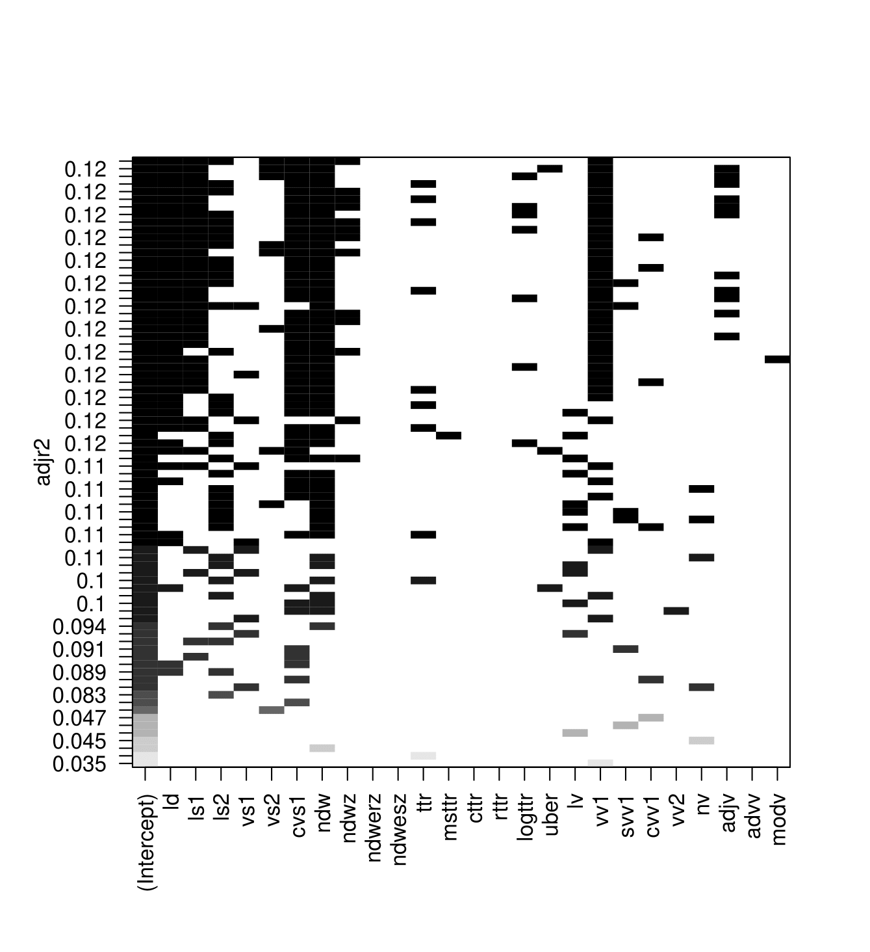 | 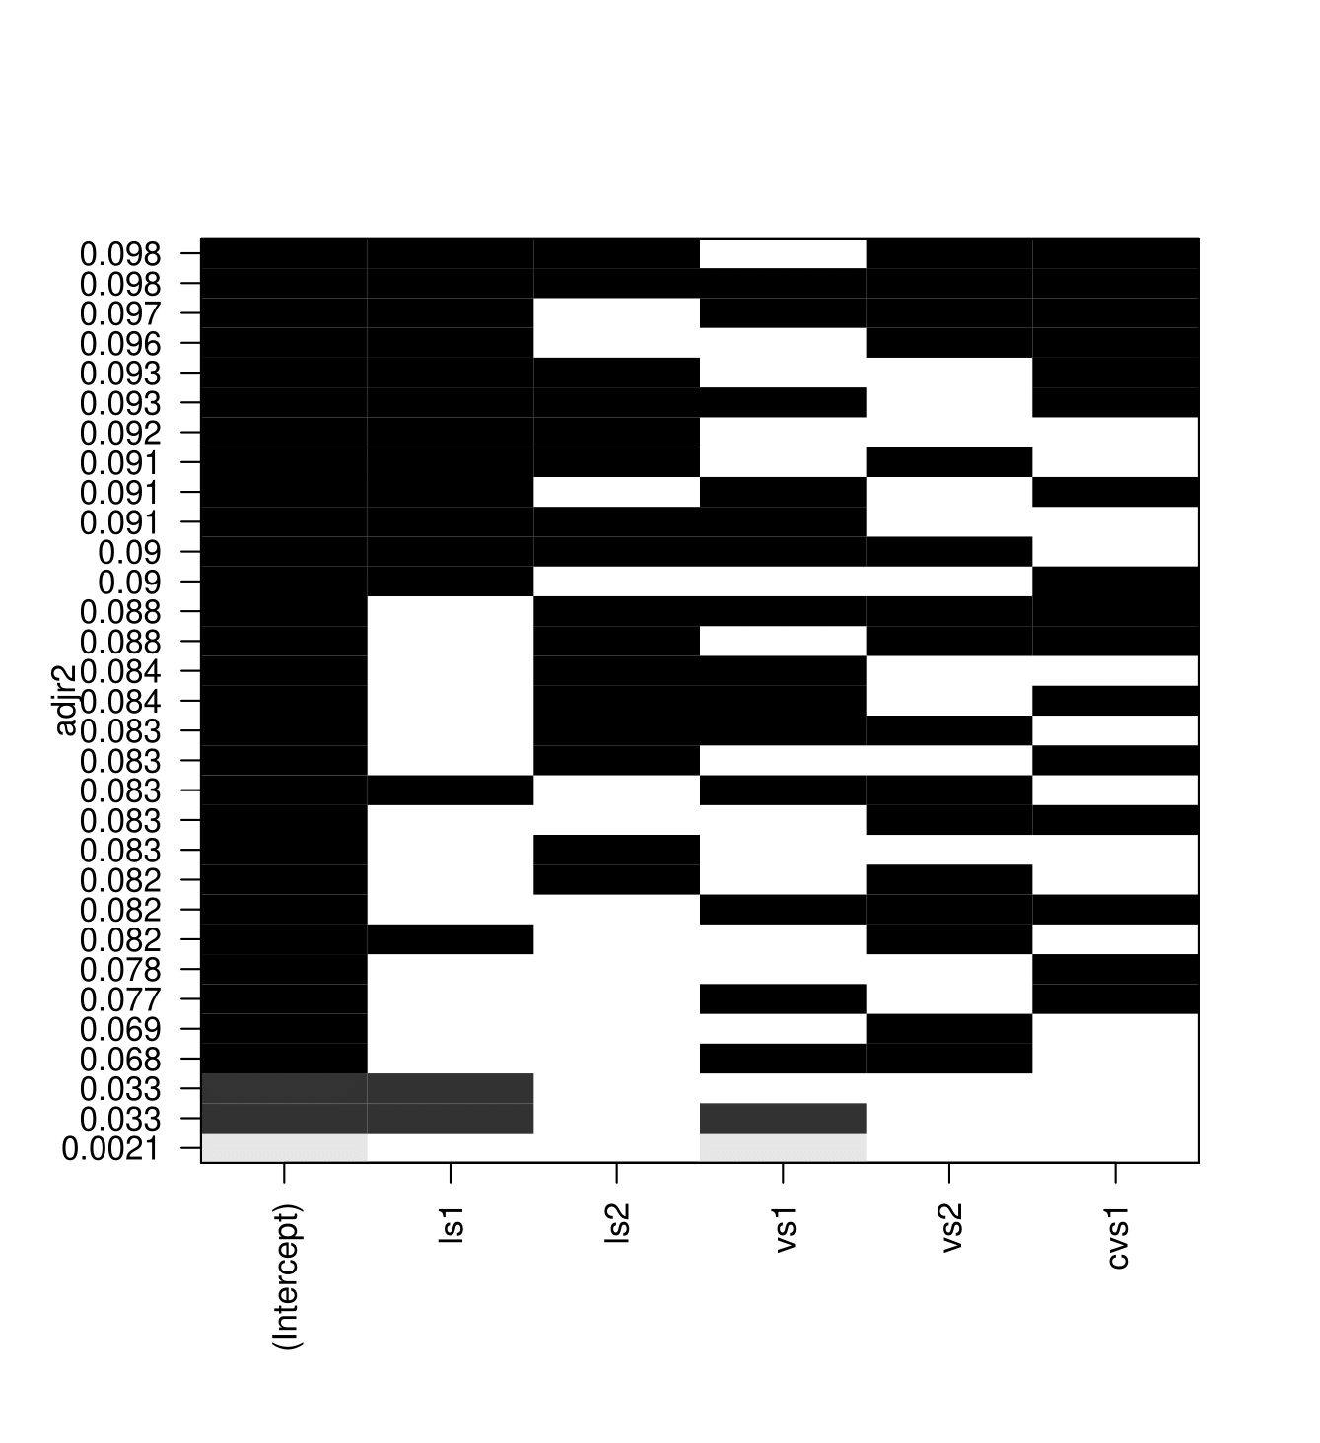
- LC | - Lexical sophistication
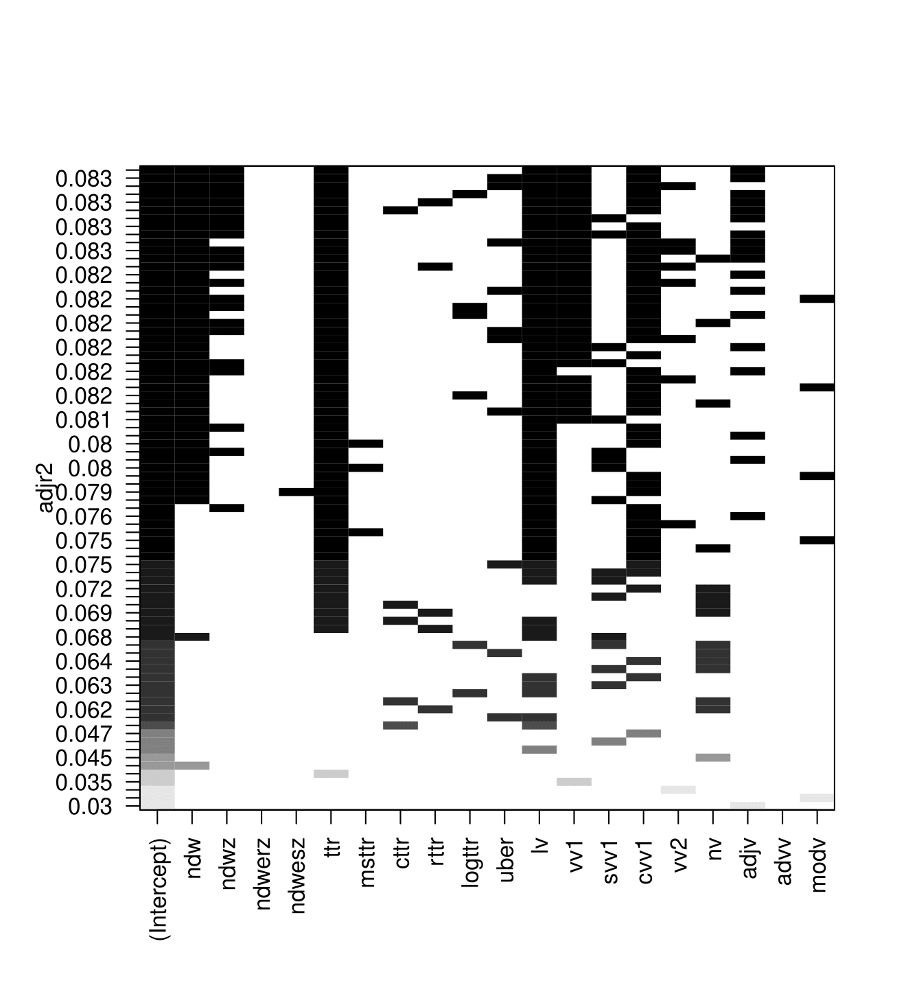
- Lexical diversity
Notes. This figure depicts tables of the ten best models of the LCA tool and its impact on the ICO amount raised, following the adjusted R2 criteria. The squares indicate which variables belong to the model. A black square means that a variable is included in the model and a white square means that they are not.

Table A1: Lexical Complexity Analyzer (LCA) tool.

LC sub-construct | Individual metric | Definition
Lexical density
Ld | Lexical density | Ratio of lexical words/total number of words in a text (nouns, verbs, adjectives and adverbs).
Lexical sophistication
ls1 | Lexical sophistication 1 | Ratio of advanced words/total lexical words.
ls2 | Lexical sophistication 2 | Ratio of advanced word types/total lexical word types.
vs1 | Verb sophistication 1 | Ratio of advanced verb types/total number of lexical verbs.
vs2 | Verb sophistication 2 | Same measure as vs1 but with a formula to reduce the sample size effect of the count.
cvs1 | Corrected verb sophistication 1 | Same measure as vs1 but with a formula to reduce the sample size effect of the count.
Lexical diversity
Ndw | Number of different words | Number of different unique words.
Ndwz | Number of different words – first 50 words | Number of different word types in the first fifty words of sample.
ndw-erz | Number of different words – expected random 50 | Mean of the number of different words of 10 random 50-word samples.
ndw-esz | Number of different words – expected sequence 50 | Mean word types of 10 random 50-word sequences.
Ttr | Type/token ratio | Ratio of different words/total number of words.
Msttr | Mean segmental ttr | Divides a sample into successive segments of a given length and then calculates the average ttr of all segments.
Cttr | Corrected ttr | Transformation of the ttr.
Rttr | Root ttr | Transformation of the ttr.
Logttr | Bilogarithmic ttr | Transformation of the ttr.
Uber | Uber Index | Transformation of the ttr.
vv1 | Verb variation 1 | Ratio of the number of verb types to the total number of verbs.
svv1 | Squared vv1 | Transformed formula for vv1 which controls for effect size of sample.
cvv1 | Corrected vv1 | Transformed formula for vv1 which controls for sample size effect.
Lv | Lexical word variation | Ratio of the number of lexical word types/total number of lexical words.
vv2 | Verb variation 2 | Ratio of the number of verb types/total number of lexical words in a text.
Nv | Noun variation | Number of noun types/total number of lexical words.
Adjv | Adjective variation | Number of adjective types/total number of lexical words.
Advv | Adverb variation | Number of adverb types.
Modv | Modifier variation | Total number of lexical words.
Notes. This table displays the 25 lexical metrics of complexity from the study of Lu (2012). Measures are separated into three sub-constructs representing lexical density, sophistication and diversity.

Table A2: Vocabulary profiles of two ICO white papers - 2k & 3k vocabulary examples.

T1: ICO topic: Creating a liquidity pool for ICO investments | T2: ICO topic: Creating an open-source protocol for a decentralized market of coordinated AI services
Low LC profile | Low investment result
2k words | 2k words
advanced, announced, available, basis, cash, community, compared, conditions, contracts, created, creating, creation, delivery, destroyed, development, economy, email, entire, exchanges, existence, finance, flows, funded, funds, future, grade, including, income, increase, increased, increasing, instructions, loss, models, official, operation, performed, period, pool, preventing, prevents, process, professional, project, provide, provider, provides, quoting, reserve, risk, sale, smart, speed, spreads, stable, traded, trading, traditional, value, various | access, accessed, accessible, according, activities, adaptive, advanced, advances, advised, agent, agents, applications, armies, availability, benefit, benefits, brain, broad, broadly, capabilities, capability, challenges, clever, cloud, combination, community, conditions, connect, connected, containing, contract, contracts, create, created, creating, creation, creations, creators, current, currently, customers, decision, decisions, delivering, demand, design, designed, detailed, developers, developing, development, directing, economic, economies, economy, effort, efforts, encourages, encouraging, engage, engineering, eventual, exchange, exist, existing, financial, firm, future, generation, giants, goals, hire, hiring, include, including, increasing, increasingly, individuals, intended, internet, legal, manner, match, minor, model, operate, operation, operational, operations, ordinary, organization, organizations, organizing, partners, path, percentage, pool, positive, practical, practice, prevent, privacy, private, process, produce, products, professionals, project, projects, provide, provides, providing, purchase, purely, rapidly, rarely, recovery, reducing, regarding, require, requirements, researchers, respecting, respects, results, role, sales, scalable, scales, series, shelf, similar, skills, smart, smooth, society, species, specific, standard, successful, successfully, supply, tech, technological, technologies, technology, tool, tools, valuable, varying
3k words | 3k words
achieved, adopters, aim, asset, assets, boost, currencies, currency, data, decrease, destruction, digital, distributed, effective, efficient, executed, generated, injected, institutional, investors, liquid, liquidity, modified, network, participate, potential, profiles, promote, published, relatively, revolution, source, specified, transaction | abuse, academics, accelerate, accelerating, agencies, agency, analysis, appropriate, architecture, behavior, chairman, characteristics, code, collaboration, complexity, concept, concepts, conceptualize, consultancy, consulting, contemporary, context, cooperative, core, corporation, corporations, critical, critically, custom, data, decades, democratic, democratically, democratizing, device, devices, digital, distinguished, distributed, dominant, effectively, efficient, emergence, emergent, emerging, emphasizes, enable, enabled, enabling, ensure, essentially, estimate, evolve, evolves, executive, expert, experts, explicitly, external, facilitate, factor, failure, flexible, formal, foster, fostering, foundation, founders, founding, framework, fulfill, generate, global, goods, grad, gravity, host, hostile, incorporated, independent, initial, initiatives, insert, insertion, inspiration, inspired, install, institutions, intelligence, interact, interaction, interactions, launches, launching, logic, mechanism, mechanisms, methods, mode, modifying, modularity, monitored, monitoring, multiple, network, nonprofit, novel, numerous, obtain, organic, phases, platform, potential, principles, prior, profit, pursues, radically, regulated, regulating, request, resource, significant, software, solely, solution, solutions, sophisticated, source, sovereignty, structure, structures, sufficient, supervising, supervisory, task, tasks, theoretical, theory, transaction, transactions, transition, undertaking, unprecedented, via, vision
Notes. This table displays the different vocabulary profiles for a white paper with a low-level of LC compared with a high-level of LC.

Table A3: Correlations table.

Variables | (1) | (2) | (3) | (4) | (5) | (6) | (7) | (8) | (9) | (10) | (11) | (12)
Amount raised (1)
Token traded (2) | 0.319***
ICOCompletion (3) | 0.300*** | 0.749***
LC (4) | 0.166*** | 0.155*** | 0.087**
Density (5) | 0.112*** | 0.061* | 0.068* | 0.093**
Diversity (6) | 0.142*** | 0.148*** | 0.083** | 0.973*** | 0.022
Sophistication (7) | 0.227*** | 0.173*** | 0.101*** | 0.786*** | 0.252*** | 0.648***
Readability_Flesch (8) | 0.019* | -0.048 | -0.056 | -0.218*** | -0.346*** | -0.140*** | -0.355***
Readability_FOG (9) | 0.012* | -0.032 | -0.034 | -0.226*** | -0.172*** | -0.168*** | -0.315*** | 0.894***
Readability_Size (10) | 0.011* | -0.061* | -0.010 | -0.706*** | -0.085** | -0.686*** | -0.528*** | 0.124*** | 0.133***
Sentiment (11) | -0.061* | -0.046 | 0.000 | -0.121*** | 0.149*** | -0.106*** | -0.137*** | 0.012 | 0.011 | 0.048
Institution (12) | 0.125*** | 0.098*** | 0.061* | 0.115*** | 0.109*** | 0.084** | 0.183*** | -0.044 | -0.032 | -0.048 | -0.059*
US restrict (13) | -0.017 | 0.041 | -0.055 | 0.141*** | 0.015 | 0.142*** | 0.110*** | -0.018 | -0.043 | -0.145*** | -0.014 | 0.099***
Social media (14) | -0.055 | 0.069* | -0.031 | 0.148*** | 0.068* | 0.146*** | 0.100*** | -0.010 | 0.008 | -0.144*** | -0.020 | -0.002
Eth (15) | -0.023 | -0.031 | -0.095** | 0.064* | 0.050 | 0.079** | 0.002 | -0.020 | -0.012 | -0.054 | -0.080** | 0.018
Video (16) | 0.039 | 0.085** | 0.040 | 0.198*** | 0.066* | 0.189*** | 0.173*** | -0.040 | -0.038 | -0.164*** | -0.002 | 0.021
Token distribution (17) | -0.011 | 0.052 | -0.044 | 0.072* | -0.013 | 0.067* | 0.060* | 0.004 | 0.005 | -0.078** | -0.044 | 0.010
Minimum investment (18) | -0.032 | -0.019 | -0.088** | 0.092** | 0.027 | 0.095** | 0.057* | 0.016 | -0.006 | -0.111*** | -0.080** | 0.050
Fiat (19) | 0.038 | -0.058* | -0.059* | 0.131*** | 0.019 | 0.123*** | 0.097*** | -0.046 | -0.070* | -0.165*** | 0.045 | 0.026
Hardcap (20) | 0.008 | -0.028 | -0.162*** | 0.089** | 0.075** | 0.086** | 0.066* | -0.043 | -0.043 | -0.112*** | 0.002 | 0.092**
Softcap (21) | -0.016 | 0.003 | -0.488*** | 0.114*** | 0.007 | 0.110*** | 0.093** | 0.004 | -0.003 | -0.106*** | -0.054 | 0.041
Bonus (22) | -0.037 | -0.056 | -0.139*** | 0.083** | -0.021 | 0.089** | 0.028 | 0.049 | 0.026 | -0.111*** | 0.023 | 0.013
TopicDiversity (23) | -0.017 | -0.030 | -0.031 | 0.295*** | -0.018 | 0.262*** | 0.244*** | -0.176*** | -0.183*** | -0.285*** | -0.031 | 0.049
PriceBit (24) | 0.154*** | 0.031 | 0.094** | 0.059* | 0.013 | 0.066* | 0.012 | 0.027 | 0.025 | -0.092** | 0.026 | -0.055

Variables |  | (13) | (14) | (15) | (16) | (17) | (18) | (19) | (20) | (21) | (22) | (23)
Social media (14) | 0.251***
Eth (15) | 0.050 |  | 0.113***
Video (16) | 0.133*** |  | 0.305*** | 0.006
Token distribution (17) | 0.108*** |  | 0.157*** | 0.016 | 0.079**
Minimum investment (18) | 0.223*** |  | 0.208*** | 0.100*** | 0.061* | 0.102***
Fiat (19) | 0.022 |  | 0.090** | -0.006 | 0.089** | 0.012 | 0.061*
Hardcap (20) | 0.151*** |  | 0.131*** | 0.054 | 0.035 | 0.209*** | 0.178*** | 0.028
Softcap (21) | 0.177*** |  | 0.193*** | 0.103*** | 0.077** | 0.158*** | 0.173*** | 0.050 | 0.324***
Bonus (22) | 0.136*** |  | 0.201*** | 0.065* | 0.149*** | 0.146*** | 0.112*** | 0.040 | 0.146*** | 0.162***
TopicDiversity (23) | 0.055 |  | 0.055 | 0.029 | 0.047 | 0.128*** | 0.078** | 0.100*** | 0.103*** | 0.059* | 0.124***
PriceBit (24) | -0.085** |  | -0.093** | 0.030 | 0.034 | -0.030 | -0.042 | -0.057* | -0.032 | -0.062* | 0.048 | 0.040
Notes. This table presents Pearson correlations between variables in our sample. Variables are defined in Table 1. Significance levels: * indicates p<0.1, ** indicates p<0.05, *** indicates p<0.01.

References
Abdi Tabari, M., Lu, X., & Wang, Y. (2023). The effects of task complexity on lexical complexity in L2 writing: An exploratory study. System, 114, 103021.
Ahmad, M. F., Kowalewski, O., & Pisany, P. (2023). What determines initial coin offering success: A cross-country study. Economics of Innovation and New Technology, 32(5), 622–645.
Ahn, Y., & Kim, D. (2020). Sentiment disagreement and bitcoin price fluctuations: A psycholinguistic approach. Applied Economics Letters, 27(5), 412–416.
Akyildirim, E., Aysan, A. F., Cepni, O., & Serbest, Ö. (2024). Sentiment matters: The effect of news-media on spillovers among cryptocurrency returns. The European Journal of Finance, 30(14), 1577–1613.
Amore, M. D., Bennedsen, M., Larsen, B., & Rosenbaum, P. (2019). CEO education and corporate environmental footprint. Journal of Environmental Economics and Management, 94, 254–273.
Amsden, R., & Schweizer, D. (2018). Are Blockchain Crowdsales the New “Gold Rush”? Success Determinants of Initial Coin Offerings. SSRN Electronic Journal.
Andersen, T. G., Bollerslev, T., Diebold, F. X., & Labys, P. (2003). Modeling and Forecasting Realized Volatility. Econometrica, 71(2), 579–625.
Andrieu, G., & Sannajust, A. (2023). ICOs after the decline: A literature review and recommendations for a sustainable development. Venture Capital, 1–19.
Antoncic, B., Bratkovic Kregar, T., Singh, G., & Denoble, A. F. (2015). The Big Five Personality–Entrepreneurship Relationship: Evidence from Slovenia. Journal of Small Business Management, 53(3), 819–841.
Arslan-Ayaydin, Ö., Bishara, N., Thewissen, J., & Torsin, W. (2020). Managerial career concerns and the content of corporate disclosures: An analysis of the tone of earnings press releases. International Review of Financial Analysis, 72, 101598.
Arslan-Ayaydin, Ö., Boudt, K., & Thewissen, J. (2016). Managers set the tone: Equity incentives and the tone of earnings press releases. Journal of Banking & Finance, 72, 132–147.
Arslan-Ayaydin, Ö., Thewissen, J., & Torsin, W. (2021). Disclosure tone management and labor unions. Journal of Business Finance & Accounting, 48(1–2), 102–147.
Baginski, S. P., Campbell, J. L., Hinson, L. A., & Koo, D. S. (2018). Do Career Concerns Affect the Delay of Bad News Disclosure? The Accounting Review, 93(2), 61–95.
Baron, R. M., & Kenny, D. A. (1986). The moderator–mediator variable distinction in social psychological research: Conceptual, strategic, and statistical considerations. Journal of Personality and Social Psychology, 51(6), 1173–1182.
Barraza, B. (2019). The Worth of Words: How Technical White Papers Influence ICO Blockchain Funding. MIS Quarterly Executive, 18(4), 281–286.
Belitski, M., & Boreiko, D. (2022). Success factors of initial coin offerings. The Journal of Technology Transfer, 47(6), 1690–1706.
Bellavitis, C., Fisch, C., & Wiklund, J. (2021). A comprehensive review of the global development of initial coin offerings (ICOs) and their regulation. Journal of Business Venturing Insights, 15, e00213.
Bennedsen, M., & Nielsen, K. (2004). The Family behind the Family Firm: Evidence from CEO Transitions (Nos. 3–2004). Working paper.
Bennedsen, M., Perez-Gonzalez, F., & Wolfenzon, D. (2007). Do CEOs Matter? (Nos. 13–2007). Working paper.
Bennedsen, M., Pérez‐González, F., & Wolfenzon, D. (2020). Do CEOs Matter? Evidence from Hospitalization Events. The Journal of Finance, 75(4), 1877–1911.
BNC Consortium (2007). British National Corpus.
Boreiko, D., & Vidusso, G. (2019). New Blockchain Intermediaries: Do ICO Rating Websites Do Their Job Well? The Journal of Alternative Investments, 21(4), 67–79.
Bormuth, J. R. (1966). Readability: A New Approach. Reading Research Quarterly, 1(3), 79–132.
Boudt, K., & Thewissen, J. (2019). Jockeying for position in CEO letters: Impression management and sentiment analytics. Financial Management, 48(1), 77-115.
Braun, A. M. (2015). The Influence of Design Complexity on Perceived Quality: The Moderating Role of Price and Brand Familiarity [Master’s thesis, Auburn University].
Bruton, G. D., & Ahlstrom, D. (2003). An institutional view of China’s venture capital industry: Explaining the differences between China and the West. Journal of Business Venturing, 18(2), 233–259.
Bui, G. (2021). Influence of learners’ prior knowledge, L2 proficiency and pre-task planning on L2 lexical complexity. International Review of Applied Linguistics in Language Teaching, 59(4), 543–567.
Bulte, B., & Housen, A. (2012). Defining and operationalising L2 complexity. 1–317.
Burke, Q., Li, B., Wan, C., & Wang, Y. (2022). Disclosure Readability in Unregulated Capital Markets: Evidence from Initial Coin Offerings. SSRN Electronic Journal.
Canbaz, A. G. (2020). Can investor’s sentiment from forum posts predict bitcoin return? [Master’s thesis, Sabancı University].
Chan, C. S. R., & Parhankangas, A. (2017). Crowdfunding Innovative Ideas: How Incremental and Radical Innovativeness Influence Funding Outcomes. Entrepreneurship Theory and Practice, 41(2), 237–263.
Cheng, Y., Zeng, Y., & Zou, J. (2024). Harnessing ChatGPT for predictive financial factor generation: A new frontier in financial analysis and forecasting. The British Accounting Review, 101507.
Clogg, C. C., Petkova, E., & Haritou, A. (1995). Statistical Methods for Comparing Regression Coefficients Between Models. American Journal of Sociology, 100(5), 1261–1293.
Colombo, M. G., Fisch, C., Momtaz, P. P., & Vismara, S. (2022). The CEO beauty premium: Founder CEO attractiveness and firm valuation in initial coin offerings. Strategic Entrepreneurship Journal, 16(3), 491–521.
Colombo, M. G., & Grilli, L. (2010). On growth drivers of high-tech start-ups: Exploring the role of founders’ human capital and venture capital. Journal of Business Venturing, 25(6), 610–626.
Colombo, O. (2020). The Use of Signals in New-Venture Financing: A Review and Research Agenda. Journal of Management, 47(1), 237–259.
Connelly, B. L., Certo, S. T., Ireland, R. D., & Reutzel, C. R. (2011). Signaling Theory: A Review and Assessment. Journal of Management, 37(1), 39–67.
Cumming, D., Hornuf, L., Karami, M., & Schweizer, D. (2023). Disentangling Crowdfunding from Fraudfunding. Journal of Business Ethics, 182(4), 1103–1128.
Cumming, D., & Johan, S. (2008). Information asymmetries, agency costs and venture capital exit outcomes. Venture Capital, 10(3), 197–231.
Dougherty, D., & Hardy, C. (1996). Sustained Product Innovation in Large, Mature Organizations: Overcoming Innovation-to-Organization Problems. Academy of Management Journal, 39(5), 1120–1153.
Drobetz, W., Hornuf, L., Momtaz, P. P., & Schermann, N. (2025). Token-Based Crowdfunding: Investor Choice and the Optimal Timing of Initial Coin Offerings. Entrepreneurship Theory and Practice, 49(1), 232–282.
Drobetz, W., Momtaz, P. P., & Schröder, H. (2019). Investor Sentiment and Initial Coin Offerings. The Journal of Alternative Investments, 21(4), 41–55.
El-Haj, M., Rayson, P., Walker, M., Young, S., & Simaki, V. (2019). In search of meaning: Lessons, resources and next steps for computational analysis of financial discourse. Journal of Business Finance & Accounting, 46(3–4), 265–306.
EAP Foundation (2024). Vocabulary profiler. EAP Foundation.com.
Fisch, C. (2019). Initial coin offerings (ICOs) to finance new ventures. Journal of Business Venturing, 34(1), 1–22.
Fisch, C., Masiak, C., Vismara, S., & Block, J. (2021). Motives and profiles of ICO investors. Journal of Business Research, 125, 564–576.
Fisch, C., & Momtaz, P. P. (2020). Institutional investors and post-ICO performance: An empirical analysis of investor returns in initial coin offerings (ICOs). Journal of Corporate Finance, 64, 101679.
Flesch, R. (1948). A new readability yardstick. Journal of Applied Psychology, 32(3), 221–233.
Florysiak, D., & Schandlbauer, A. (2022). Experts or charlatans? ICO analysts and white paper informativeness. Journal of Banking & Finance, 139, 106476.
Fuchs, J., & Momtaz, P. P. (2025). Token governance in initial coin offerings: Implications of token retention and resale restrictions for ICO success. Small Business Economics, 64(3), 1321–1359.
Fürst, A., Pecornik, N., & Hoyer, W. D. (2024). How product complexity affects consumer adoption of new products: The role of feature heterogeneity and interrelatedness. Journal of the Academy of Marketing Science, 52(2), 329–348.
Ginting, S. A. (2018). Lexical Complexity on Descriptive Writing of Indonesian Male and Female EFL Learners. International Journal of English Linguistics, 8(3), 297.
Gong, X., & Jiang, X. (2023). Understanding consumer impulse buying in livestreaming commerce: The product involvement perspective. Frontiers in Psychology, 14, 1104349.
Gourieroux, C., Monfort, A., Renault, E., & Trognon, A. (1987). Generalised residuals. Journal of Econometrics, 34(1), 5–32.
Gunning, R. (1952). The technique of clear writing.
Hamby, T., & Ickes, W. (2015). Do the Readability and Average Item Length of Personality Scales Affect Their Reliability? Some Meta-Analytic Answers. Journal of Individual Differences, 36(1), 54–63.
Hayes-Roth, B. (1977). Evolution of cognitive structures and processes. Psychological Review, 84(3), 260–278.
Heckman, J. J. (1978). Simple Statistical Models for Discrete Panel Data Developed and Applied to Test the Hypothesis of True State Dependence against the Hypothesis of Spurious State Dependence. ANNALES DE L’INSÉÉ, 30/31, 227–269.
Heckman, J., & Navarro-Lozano, S. (2004). Using matching, instrumental variables, and control functions to estimate economic choice models. Review of Economics and statistics, 86(1), 30-57.
Hegde, S. P., & Mishra, D. R. (2019). Married CEOs and corporate social responsibility. Journal of Corporate Finance, 58, 226–246.
Holliman, A. ′Freddie′. (2023). DIMENSIONS OF PRODUCT COMPLEXITY FROM DESIGNERS’ PERSPECTIVES. Proceedings of the Design Society, 3, 1495–1504.
Holzhacker, M., Krishnan, R., & Mahlendorf, M. D. (2015). The Impact of Changes in Regulation on Cost Behavior. Contemporary Accounting Research, 32(2), 534–566.
Horn, K. (2017). Consumer values and product perception. Consumer Perception of Product Risks and Benefits, 283-299.
Hornuf, L., Kück, T., & Schwienbacher, A. (2022). Initial coin offerings, information disclosure, and fraud. Small Business Economics, 58(4), 1741–1759.
Howell, S. T., Niessner, M., & Yermack, D. (2020). Initial Coin Offerings: Financing Growth with Cryptocurrency Token Sales. The Review of Financial Studies, 33(9), 3925–3974.
Hsu, D. H. (2007). Experienced entrepreneurial founders, organizational capital, and venture capital funding. Research Policy, 36(5), 722–741.
Huang, W., Meoli, M., & Vismara, S. (2020). The geography of initial coin offerings. Small Business Economics, 55(1), 77-102
Huang, W., Vismara, S., & Wei, X. (2022). Confidence and capital raising. Journal of Corporate Finance, 77, 101900.
Jiménez-Jiménez, D., & Sanz-Valle, R. (2011). Innovation, organizational learning, and performance. Journal of Business Research, 64(4), 408–417.
Joenväärä, J., Karppinen, J., Teo, M., & Tiu, C. I. (2019). The Vocabulary of Hedge Funds. SSRN Electronic Journal.
Johan, S., & Pant, A. (2018). Regulation of the Crypto-Economy: Securitization of the Digital Security. SSRN Electronic Journal.
Karimi, S., Biemans, H. J., Naderi Mahdei, K., Lans, T., Chizari, M., & Mulder, M. (2017). Testing the relationship between personality characteristics, contextual factors and entrepreneurial intentions in a developing country. International Journal of Psychology, 52(3), 227-240.
Kaufmann, D., Kraay, A., & Mastruzzi, M. (2010). Response to ‘What do the Worldwide Governance Indicators Measure?’ The European Journal of Development Research, 22(1), 55–58.
Kincaid, J., Fishburne, R., Rogers, R., & Chissom, B. (1975). Derivation of New Readability Formulas (Automated Readability Index, Fog Count And Flesch Reading Ease Formula) For Navy Enlisted Personnel. Institute for Simulation and Training.
Kyle, K., Crossley, S. A., & Jarvis, S. (2021). Assessing the Validity of Lexical Diversity Indices Using Direct Judgements. Language Assessment Quarterly, 18(2), 154–170.
Lafhaj, Z., Rebai, S., AlBalkhy, W., Hamdi, O., Mossman, A., & Alves Da Costa, A. (2024). Complexity in Construction Projects: A Literature Review. Buildings, 14(3), 680.
Lahmar, O., & Piras, L. (2023). Making sense and transparency in finance literature: Evidence from trends in readability. Research in International Business and Finance, 64, 101900.
Laufer, B. (1995). Beyond 2000. The current state of interlanguage: Studies in honor of William E. Rutherford, 265.
Lawrence, A. (2013). Individual investors and financial disclosure. Journal of Accounting and Economics, 56(1), 130–147.
Lee, H., Cha, S., & Park, H. (2016). The effect of technology-exploration on product innovation: an analysis based on Korean manufacturing SMEs. International Journal of Quality Innovation, 2, 1-15.
Lee, J., Li, T., & Shin, D. (2022). The wisdom of crowds in fintech: Evidence from initial coin offerings. The Review of Corporate Finance Studies, 11(1), 1-46.
Leech, G., Rayson, P., & Wilson, A. (2001). Word Frequencies in Written and Spoken English: Based on the British National Corpus.
Li, F. (2008). Annual report readability, current earnings, and earnings persistence. Journal of Accounting and Economics, 45(2), 221–247.
Liu, Y., Sheng, J., & Wang, W. (2024). How Do Investors Value Technology in Cryptocurrency? Evidence from Textual Analysis. SSRN Electronic Journal.
Loughran, T., & McDonald, B. (2011). When Is a Liability Not a Liability? Textual Analysis, Dictionaries, and 10-Ks. The Journal of Finance, 66(1), 35–65.
Loughran, T., & McDonald, B. (2014a). Measuring Readability in Financial Disclosures. The Journal of Finance, 69(4), 1643–1671.
Loughran, T., & McDonald, B. (2014b). Regulation and financial disclosure: The impact of plain English. Journal of Regulatory Economics, 45, 94-113.
Loureiro, G. B., Ferreira, J. C. E., & Messerschmidt, P. H. Z. (2020). Design structure network (DSN): A method to make explicit the product design specification process for mass customization. Research in Engineering Design, 31(2), 197–220.
Lu, X. (2012). The Relationship of Lexical Richness to the Quality of ESL Learners’ Oral Narratives. The Modern Language Journal, 96(2), 190–208.
Lyandres, E., Palazzo, B., & Rabetti, D. (2022). Initial coin offering (ICO) success and post-ICO performance. Management Science, 68(12), 8658-8679.
Mahmood, A., Luffarelli, J., & Mukesh, M. (2019). What’s in a logo? The impact of complex visual cues in equity crowdfunding. Journal of Business Venturing, 34(1), 41–62.
Malvern, D., Richards, B., Chipere, N., & Durán, P. (2004). Lexical diversity and language development (pp. 16-30).
Mansouri, S., & Momtaz, P. P. (2022). Financing sustainable entrepreneurship: ESG measurement, valuation, and performance. Journal of Business Venturing, 37(6), 106258.
Miller, B. P. (2010). The Effects of Reporting Complexity on Small and Large Investor Trading. The Accounting Review, 85(6), 2107–2143.
Momtaz, P. P. (2020). Initial Coin Offerings. PLOS ONE, 15(5), e0233018.
Momtaz, P. P. (2021a). CEO emotions and firm valuation in initial coin offerings: An artificial emotional intelligence approach. Strategic Management Journal, 42(3), 558–578.
Momtaz, P. P. (2021b). Entrepreneurial Finance and Moral Hazard: Evidence from Token Offerings. Journal of Business Venturing, 36(5), 106001.
Momtaz, P. P. (2021c). Initial coin offerings, asymmetric information, and loyal CEOs. Small Business Economics, 57(2), 975–997.
Momtaz, P. P. (2021d). The Pricing and Performance of Cryptocurrency. The European Journal of Finance, 27(4–5), 367–380.
Momtaz, P. P. (2024). Decentralized finance (DeFi) markets for startups: Search frictions, intermediation, and the efficiency of the ICO market. Small Business Economics, 63(4), 1415–1447.
Mützel, L. M. A., & Kilian, T. (2016). Product complexity in consumer research: Literature review and implications for future research. In Rediscovering the Essentiality of Marketing: Proceedings of the 2015 Academy of Marketing Science (AMS) World Marketing Congress (pp. 645-661).
Neira, I., Calvo, N., Fernández, L., & Portela, M. (2017). Entrepreneur: Do social capital and culture matter? International Entrepreneurship and Management Journal, 13(2), 665–683.
Norris, J. M., & Ortega, L. (2009). Towards an organic approach to investigating CAF in instructed SLA: The case of complexity. Applied linguistics, 30(4), 555-578.
Osburg, V.S., Yoganathan, V., McLeay, F., & Diallo, M. F. (2022). (In)compatibilities in sustainable luxury signals. Ecological Economics, 196, 107430.
Pretorius, M. & Thewissen, J. (forthcoming). Mediating L2 Writing Revision: The Impact of ChatGPT Feedback on L2 Accuracy and Lexical Diversity. Submitted to Journal of Second Language Writing.
Rayson, P., Wilson, A., & Leech, G. (2002). Grammatical word class variation within the British National Corpus Sampler in: New Frontiers of Corpus Research (pp. 295-306).
Read, J. (2000). Assessing Vocabulary.
Rhue, L. (2018). Trust is All You Need: An Empirical Exploration of Initial Coin Offerings (ICOs) and ICO Reputation Scores. SSRN Electronic Journal.
Richard, G., Fischer, R., & Van Staden, C. (2015). Readability and thematic manipulation in corporate communications: A multi-disclosure investigation.
Samieifar, S., & Baur, D. G. (2021). Read me if you can! An analysis of ICO white papers. Finance Research Letters, 38, 101427.
Shannon, C. E. (1948). A mathematical theory of communication. The Bell System Technical Journal, 27(3), 379–423.
Shardlow, M., Evans, R., Paetzold, G. H., & Zampieri, M. (2021). Semeval-2021 task 1: Lexical complexity prediction, arXiv:2106.00473.
Shrestha, P., Arslan-Ayaydin, Ö., Thewissen, J., & Torsin, W. (2021). Institutions, regulations and initial coin offerings: An international perspective. International Review of Economics & Finance, 72, 102–120.
Shrestha, P., Thewissen, J., Arslan‐Ayaydin, Ö., & Parhankangas, A. (2023). A sense of risk: Responses to crowdfunding risk disclosures. Strategic Entrepreneurship Journal, 17(4), 925-970.
Siegel, D., Gramatke, M. R., Paulsen, J. H., Giessen, W. A., Brosig, M., Heinzelmann, S., & Kumar, S. S. (2017). ICOs—The New IPOs? How to fund innovation in the crypto age. (Monito Deloitte).
Singh, H., Sultana, N., Islam, A., & Singh, A. (2022). Busy auditors, financial reporting timeliness and quality. The British Accounting Review, 54(3), 101080.
Spence, M. (1973). Job Market Signaling. The Quarterly Journal of Economics, 87(3), 355–374.
Thewissen, J., Shrestha, P., Torsin, W., & Pastwa, A. M. (2022). Unpacking the black box of ICO white papers: A topic modeling approach. Journal of Corporate Finance, 75, 102225.
Thewissen, J., Thewissen, J., Torsin, W., & Arslan-Ayaydin, Ö. (2022). Linguistic errors and investment decisions: The case of ICO white papers. The European Journal of Finance, 29(7), 826–868.
Voncken, R. M., Broekhuis, A. A., Heeres, H. J., & Jonker, G. H. (2004). The Many Facets of Product Technology. Chemical Engineering Research and Design, 82(11), 1411–1424.
World Bank. (2025). Literacy rate, adult total (% of people ages 15 and above) [Data set]. World Bank Open Data.
Xia, F., Thewissen, J., Huang, W., & Yan, S. (2024a). Founder-CEO Extraversion and Sustainability Orientation in Initial Coin Offerings. Entrepreneurship Theory and Practice, 48(4), 941–980.
Xia, F., Thewissen, J., Shrestha, P., & Yan, S. (2024b). The power of a name: Exploring the relationship between ICO name fluency and investor decision making. International Review of Financial Analysis, 93, 103142.
Xia, F., Thewissen, J., Barrio Herrezuelo, D., Arslan-Ayaydin, Ö., & Yan, S. (2024c). Picturing success: The informational role of visual cues in initial coin offerings. The British Accounting Review, 101503.
Zhang, S., Aerts, W., Lu, L., & Pan, H. (2019). Readability of token white paper and ICO first-day return. Economics Letters, 180, 58–61.
Zhao, H., Seibert, S. E., & Lumpkin, G. T. (2010). The relationship of personality to entrepreneurial intentions and performance: A meta-analytic review. Journal of management, 36(2), 381-404.

Figures
Figure 1: Contribution of dimensions to dataset variance.
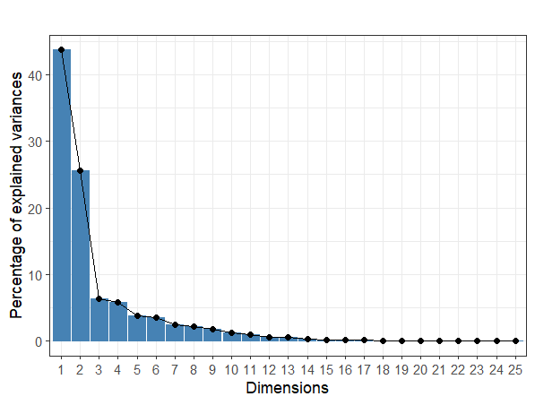
Notes. This figure represents the percentage of variance explained by each component, using the PCA. The first component is used to estimate the level of LC within ICO white papers and explain 43.73% of the dataset variability.

Figure 2: The curvilinear impact of LC on the ICO amount raised.
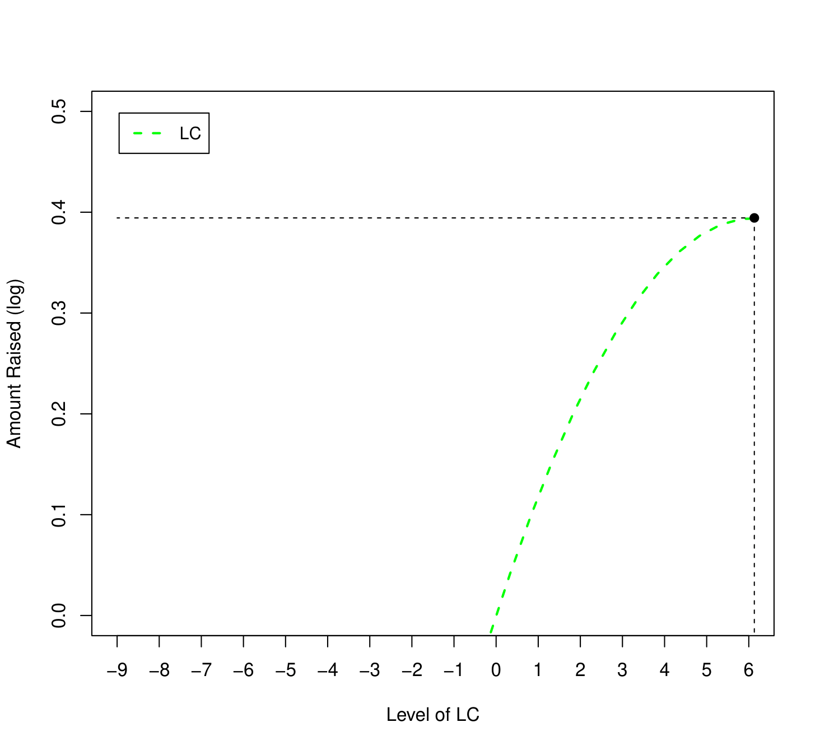 | 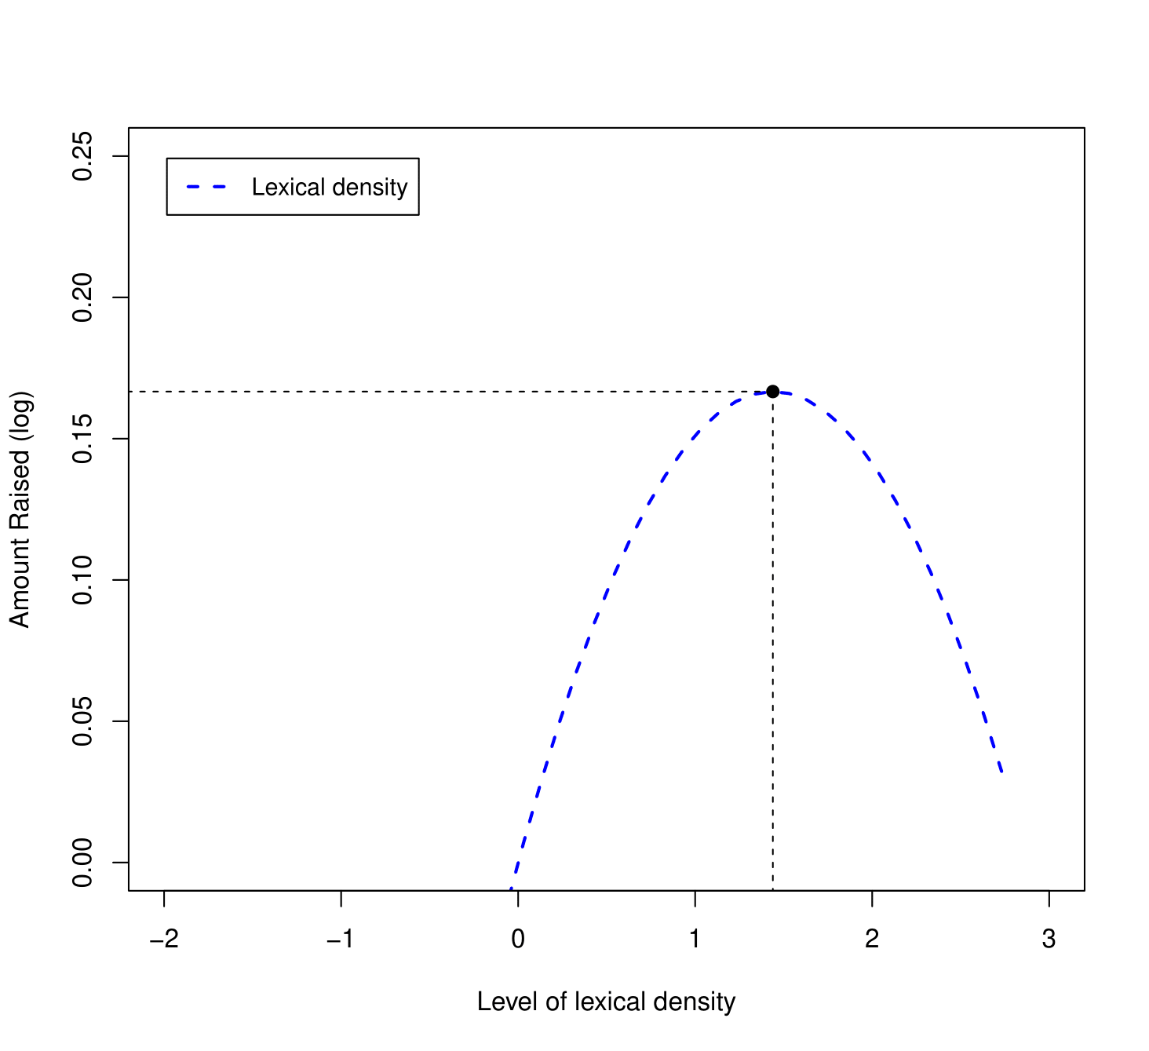
(a) LC | (b) Lexical density
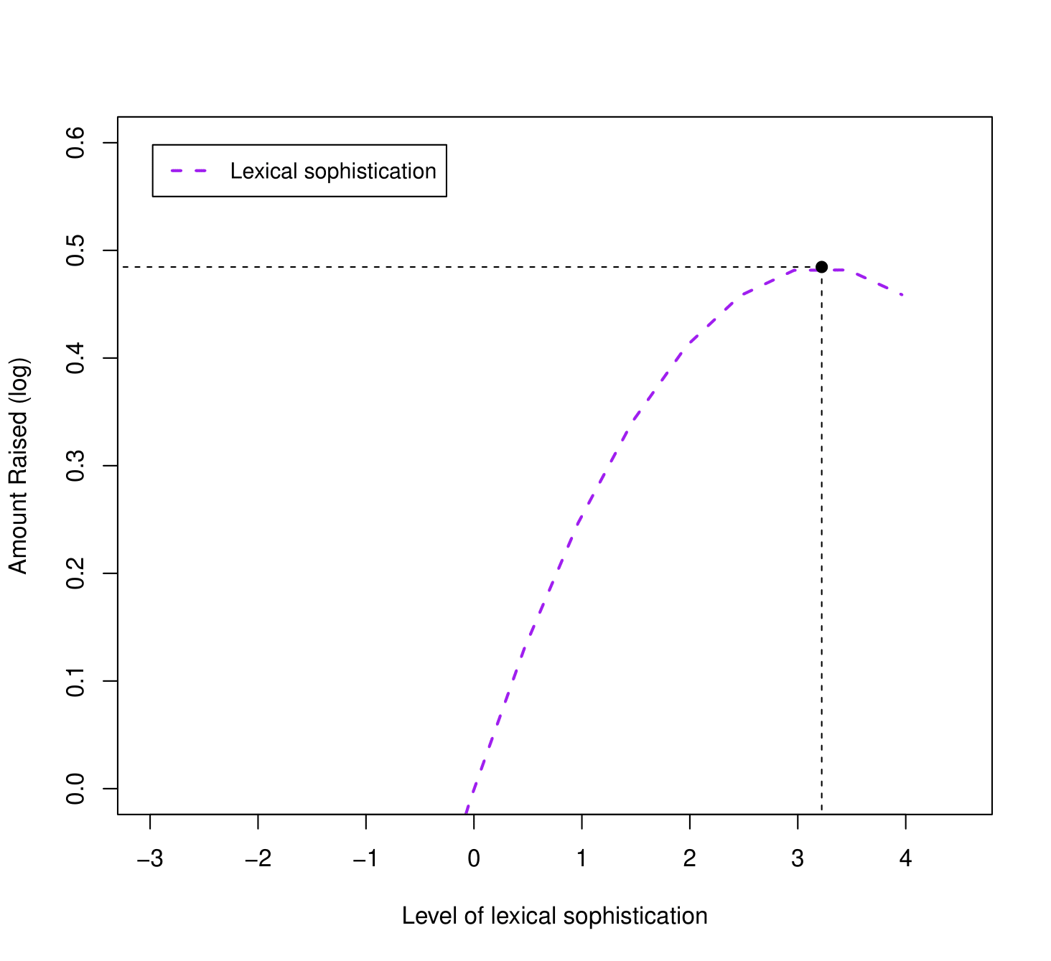 | 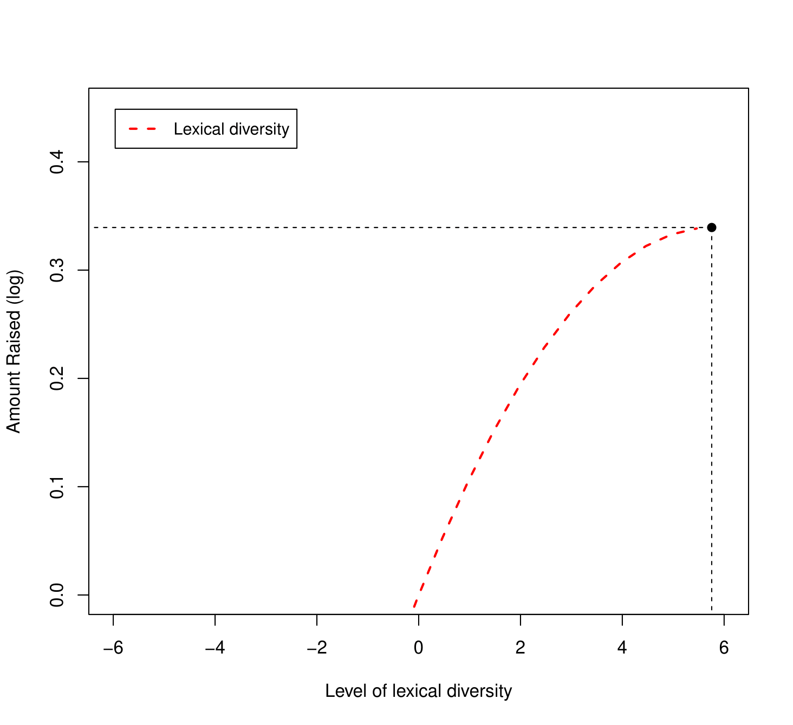
(c) Lexical sophistication | (d) Lexical diversity
Notes. This figure reports the curvilinear impact of LC on the ICO amount raised. The impacts of $LC$, $Density$, $Sophistication$ and $Diversity$ are reported in Figures A2(a), A2(b), A2(c) and A2(d) respectively. Black points represent optimal levels of complexity to reach highest funding possible.

Tables
Table 1: Variables description.

Variables | Description | Data Source
Amount raised | The natural logarithm of the US dollar amount raised during the coin offering period. | ICO aggregators
Bonus | Indicates if a bonus scheme was offered to investors during the ICO. | ICO aggregators
Code | Indicates whether the ICO code is published. | GitHub
CEODegree | Indicates the level of the ICO CEO education. | ICO aggregators
Delisted | Indicates whether the token is delisted. | CoinMarketCap
Density | The level of lexical density in ICO white papers Lu (2012). | ICO white paper
Diversity | The level of lexical diversity in ICO white papers Lu (2012). | ICO white paper
Eth | Indicates whether the project blockchain is built on the Ethereum platform. | ICO aggregators
Fiat | Indicates whether the ICO accepts fiat currencies. | ICO aggregators
FundBacked | Indicates whether the ICO is backed by crypto funds prior to fundraising. | CryptoFundResearch
Hardcap | Indicates whether a hard cap is specified. | ICO aggregators
ICOCompletion | Indicates whether secondary exchange-listed ICOs reach their soft cap and non-secondary exchange-listed ICOs reach a minimum of $500,000 in funding, based on Lee et al. (2022). | ICO aggregators
Industry | Indicates the industry in which operates the ICO. | ICO aggregators
InitialCAR | Market-adjusted price returns on the first day the token is traded. | CoinMarketCap
Institution | Aggregated institution score based on Worldwide Governance Indicators (Kaufmann et al., 2010) | Shrestha et al. (2021)
LC | The level of lexical complexity in ICO white papers Lu (2012). | ICO white paper
Literacy rate | Percentage of people aged 15 and above who can both read and write a short, simple statement about their everyday life. | World Bank Group
LongTermCAR | Market-adjusted buy-and-hold price returns during the first 180 days since the token starts trading. | CoinMarketCap
Minimum investment | Indicates whether a minimum investment amount is specified. | ICO aggregators
PriceBit | The natural logarithm of the Bitcoin price on the ICO issuance date. | CoinMarketCap
Rating | Average of the source-specific ratings in standardized values. | ICO aggregators
Rating dispersion | Standard deviation of the source-specific ratings (in standardized values) for ICOs with more than one rating. | ICO aggregators
Readability_Flesch | Flesch reading ease score of the white paper text (Kincaid et al., 1975). | ICO white paper
Readability_FOG | Gunning FOG Index (Gunning, 1952). | ICO white paper
Readability_Size | The number of pages in the ICO white paper. | ICO white paper
Region | Indicates the world region in which the ICO is issued. | ICO aggregators
Scam | Indicates whether an ICO is considered a scam. | ICO aggregators
Sentiment | Proportion of positive minus negative words in the white paper text based on the dictionaries provided by Loughran & McDonald (2011). | ICO white paper
Social media | Number of different social media channels used by the ICO project. | ICO aggregators
Softcap | Indicates whether a soft cap is specified. | ICO aggregators
Sophistication | The level of lexical sophistication in ICO white papers Lu (2012). | ICO white paper
Technicality | Proportion of technology-related topics in ICO white papers (Thewissen et al., 2022). | ICO white paper
Token distribution | Indicates whether the token distribution structure is specified. | ICO aggregators
Token traded | Indicates whether the token is eventually traded on a currency exchange. | CoinMarketCap
Topic diversity | Variety of information in white papers according to the Shannon diversity index (Shannon, 1948). | ICO white paper
US restrict | Indicates if US-based investors are restricted from participating in the ICO. | ICO aggregators
Video | Indicates whether the project provided a descriptive video. | ICO aggregators
Volatility | Realized volatility in the token price during the first 30 days the token is traded. | CoinMarketCap
Year-Quarter | Indicates the year and quarter of the ICO issuance. | ICO aggregators
7-days window growth rate | Measures the natural logarithm of the growth rate of community engagement over a 7-days window. | ICO aggregators
Notes. This table reports the description of the main variables used in the regression analyses as well as their corresponding data sources.

Table 2: Summary statistics.

Panel A: LC metrics
Variable | N | Mean | St/Dev | Min | Median | Max
Density
Ld | 1,202 | 0.562 | 0.028 | 0.480 | 0.560 | 0.700
Sophistication
ls1 | 1,202 | 0.401 | 0.034 | 0.290 | 0.400 | 0.550
ls2 | 1,202 | 0.437 | 0.055 | 0.260 | 0.440 | 0.600
vs1 | 1,202 | 0.158 | 0.029 | 0.010 | 0.160 | 0.280
vs2 | 1,202 | 18.251 | 8.925 | 0.500 | 17.045 | 53.700
cvs1 | 1,202 | 2.925 | 0.756 | 0.500 | 2.920 | 5.180
Diversity
ndw | 1,202 | 1,175 | 408 | 87 | 1,149 | 2,863
ndwz | 1,202 | 36.360 | 3.670 | 17 | 37 | 45
ndwerz | 1,202 | 40.222 | 1.331 | 34.900 | 40.300 | 43.600
ndwesz | 1,202 | 37.332 | 1.530 | 31.300 | 37.300 | 42.000
ttr | 1,202 | 0.195 | 0.051 | 0.010 | 0.190 | 0.490
msttr | 1,202 | 0.746 | 0.021 | 0.650 | 0.750 | 0.800
cttr | 1,202 | 10.274 | 1.225 | 2.280 | 10.330 | 14.280
rttr | 1,202 | 14.529 | 1.732 | 3.230 | 14.610 | 20.200
logttr | 1,202 | 0.809 | 0.019 | 0.610 | 0.810 | 0.890
uber | 1,202 | 19.770 | 1.182 | 12.040 | 19.805 | 25.390
lv | 1,202 | 0.305 | 0.071 | 0.020 | 0.295 | 0.640
vv1 | 1,202 | 0.422 | 0.093 | 0.030 | 0.410 | 0.840
svv1 | 1,202 | 116.314 | 30.963 | 5.390 | 116.055 | 215.240
cvv1 | 1,202 | 7.552 | 1.063 | 1.640 | 7.620 | 10.370
vv2 | 1,202 | 0.085 | 0.019 | 0.010 | 0.080 | 0.170
nv | 1,202 | 0.276 | 0.064 | 0.020 | 0.270 | 0.590
adjv | 1,202 | 0.066 | 0.015 | 0.010 | 0.060 | 0.140
advv | 1,202 | 0.013 | 0.005 | 0.000 | 0.010 | 0.030
modv | 1,202 | 0.080 | 0.017 | 0.010 | 0.080 | 0.150
Panel B: Lexical sub-constructs
Variable | N | Mean | St/Dev | Min | Median | Max
LC | 1,202 | 0.437 | 2.962 | -6.169 | 0.685 | 6.517
Density | 1,202 | 0.038 | 0.970 | -2.169 | -0.041 | 2.796
Sophistication | 1,202 | 0.110 | 1.657 | -3.535 | 0.100 | 4.279
Diversity | 1,202 | 0.396 | 2.715 | -7.537 | 0.691 | 5.524
Panel C: Dependent, additional interest and control variables
Variable | N | Mean | St/Dev | Min | Median | Max
ICO Success proxies
Amount raised | 1,202 | 8,720 | 11,697 | 5,009 | 3,783 | 54,990
Token traded | 1,202 | 0.208 | 0.406 | 0 | 0 | 1
ICOCompletion | 1,202 | 0.311 | 0.463 | 0 | 0 | 1
Readability variables
Readability_Flesch | 1,202 | 40.652 | 8.416 | 8.013 | 40.739 | 67.849
Readability_FOG | 1,202 | -15.516 | 2.114 | -22.912 | -15.452 | -9.045
Readability_Size | 1,202 | -34.631 | 17.113 | -167 | -32 | -3
Mechanism variables
Rating | 1,202 | 0.372 | 0.688 | -1.920 | 0.426 | 2.218
Technicality | 1,202 | 0.357 | 0.247 | 0.040 | 0.279 | 1.133
Rating dispersion | 1,202 | 0.035 | 0.023 | 0.0001 | 0.033 | 0.112
FundBacked | 1,202 | 0.076 | 0.265 | 0 | 0 | 1
7-days window growth rate | 462 | 3.549 | 32.210 | 0.017 | 1.267 | 689
Conditional variables
Literacy rate | 315 | 95.475 | 7.734 | 43.020 | 97.345 | 99.889
CEODegree | 793 | 1.288 | 0.863 | 0 | 1 | 3
Code | 1,202 | 0.256 | 0.437 | 0 | 0 | 1
Control variables
Sentiment | 1,202 | 0.002 | 0.006 | -0.025 | 0.003 | 0.030
Institution | 1,202 | 2.354 | 1.851 | -3.847 | 3.081 | 4.448
US restrict | 1,202 | 0.453 | 0.498 | 0 | 0 | 1
Social media | 1,202 | 6.888 | 1.899 | 0 | 7 | 12
Eth | 1,202 | 0.887 | 0.317 | 0 | 1 | 1
Video | 1,202 | 0.888 | 0.316 | 0 | 1 | 1
Token distribution | 1,202 | 0.971 | 0.168 | 0 | 1 | 1
Minimum investment | 1,202 | 0.522 | 0.500 | 0 | 1 | 1
Fiat | 1,202 | 0.258 | 0.438 | 0 | 0 | 1
Hardcap | 1,202 | 0.923 | 0.267 | 0 | 1 | 1
Softcap | 1,202 | 0.829 | 0.376 | 0 | 1 | 1
Bonus | 1,202 | 0.721 | 0.449 | 0 | 1 | 1
PriceBit | 1,202 | 7,678 | 2,845 | 231 | 7,276 | 37,108
Topic diversity | 1,202 | 2.246 | 0.382 | 0.000 | 2.318 | 3.030
Notes. This table reports the summary statistics of the variables used in our study. Variables are defined in Table 1. Panel A reports the statistics for the 25 individual lexical metrics defined in (Lu, 2012). Panel B reports the statistics for the variables computed using PCA (see Section 4.2.2.) and Panel C reports statistics for other dependent, interest variables, mechanism, conditional and control variables.

Table 3: Correlations table.

Variables | (1) | (2) | (3) | (4) | (5) | (6) | (7) | (8) | (9)
Amount raised (1)
Token traded (2) | 0.319***
ICOCompletion (3) | 0.300*** | 0.749***
LC (4) | 0.166*** | 0.155*** | 0.087**
Density (5) | 0.112*** | 0.061* | 0.068* | 0.093**
Diversity (6) | 0.142*** | 0.148*** | 0.083** | 0.973*** | 0.022
Sophistication (7) | 0.227*** | 0.173*** | 0.101*** | 0.786*** | 0.252*** | 0.648***
Readability_Flesch (8) | 0.019* | -0.048 | -0.056 | -0.218*** | -0.346*** | -0.140*** | -0.355***
Readability_FOG (9) | 0.012* | -0.032 | -0.034 | -0.226*** | -0.172*** | -0.168*** | -0.315*** | 0.894***
Readability_Size (10) | 0.011* | -0.061* | -0.010 | -0.706*** | -0.085** | -0.686*** | -0.528*** | 0.124*** | 0.133***
Notes. This table presents Pearson correlations between the ICO success, LC and readability variables. Variables are defined in Table 1. Significance levels: * indicates p<0.1, ** indicates p<0.05, *** indicates p<0.01.

Table 4: The impact of LC on the ICO funding outcome.

Dependent variable | Amount raised
 |  | Panel A: Linear impact |  |  |  |  |  | Panel B: Curvilinear impact
 |  |  |  |  |  | rCF |  |  |  |  |  | rCF
Model | (1) | (2) | (3) | (4) | (5) | (6) |  | (7) | (8) | (9) | (10) | (11)
Constant | 11.152*** | 12.395*** | 10.690*** | 11.605*** | 12.238*** | 12.156*** |  | 12.785*** | 11.223*** | 11.983*** | 12.503*** | 12.460***
 | (3.016) | (2.043) | (1.866) | (2.110) | (1.996) | (2.037) |  | (2.110) | (1.931) | (1.966) | (2.018) | (2.062)
LC | 0.137*** | 0.129*** |  |  |  | 0.111*** |  | 0.129*** |  |  |  | 0.101***
 | (0.027) | (0.025) |  |  |  | (0.030) |  | (0.025) |  |  |  | (0.029)
Density |  |  | 0.211*** |  |  |  |  |  | 0.232***
 |  |  | (0.040) |  |  |  |  |  | (0.043)
Sophistication |  |  |  | 0.274*** |  |  |  |  |  | 0.301***
 |  |  |  | (0.039) |  |  |  |  |  | (0.044)
Diversity |  |  |  |  | 0.126*** |  |  |  |  |  | 0.118***
 |  |  |  |  | (0.027) |  |  |  |  |  | (0.025)
LC.square |  |  |  |  |  |  |  | -0.010* |  |  |  | -0.012*
 |  |  |  |  |  |  |  | (0.006) |  |  |  | (0.006)
Density.square |  |  |  |  |  |  |  |  | -0.081
 |  |  |  |  |  |  |  |  | (0.055)
Sophistication.square |  |  |  |  |  |  |  |  |  | -0.047***
 |  |  |  |  |  |  |  |  |  | (0.013)
Diversity.square |  |  |  |  |  |  |  |  |  |  | -0.010*
 |  |  |  |  |  |  |  |  |  |  | (0.005)
Readability_Flesch |  | 0.052 | 0.080* | 0.065* | 0.054 | 0.055 |  | 0.049 | 0.066 | 0.053 | 0.053 | 0.053
 |  | (0.045) | (0.043) | (0.036) | (0.046) | (0.047) |  | (0.044) | (0.042) | (0.036) | (0.045) | (0.047)
Readability_Flesch.square |  | -0.001* | -0.001** | -0.001** | -0.001* | -0.001* |  | -0.001* | -0.001** | -0.001* | -0.001* | -0.001*
 |  | (0.001) | (0.001) | (0.0004) | (0.001) | (0.001) |  | (0.001) | (0.001) | (0.0004) | (0.001) | (0.001)
Sentiment | 2.805 | -0.084 | -11.184 | 1.938 | -1.361 | -0.802 |  | 0.156 | -10.386 | 2.176 | -1.320 | -0.920
 | (11.112) | (11.196) | (10.431) | (11.334) | (11.010) | (11.299) |  | (11.102) | (10.838) | (11.169) | (11.027) | (11.177)
Institution | 0.155*** | 0.171*** | 0.179*** | 0.148*** | 0.179*** | 0.173*** |  | 0.172*** | 0.177*** | 0.143*** | 0.180*** | 0.175***
 | (0.014) | (0.016) | (0.015) | (0.015) | (0.016) | (0.016) |  | (0.016) | (0.014) | (0.013) | (0.016) | (0.016)
US restrict | 0.067 | 0.210*** | 0.273*** | 0.215*** | 0.211*** | 0.218*** |  | 0.220*** | 0.265*** | 0.227*** | 0.218*** | 0.233***
 | (0.095) | (0.060) | (0.054) | (0.058) | (0.060) | (0.058) |  | (0.060) | (0.055) | (0.052) | (0.061) | (0.058)
Social media | -0.0005 | 0.012 | 0.018 | 0.012 | 0.014 | 0.014 |  | 0.011 | 0.016 | 0.011 | 0.014 | 0.014
 | (0.045) | (0.043) | (0.044) | (0.045) | (0.043) | (0.042) |  | (0.043) | (0.044) | (0.042) | (0.043) | (0.042)
Video | 0.248* | 0.270** | 0.409** | 0.262** | 0.291** | 0.293** |  | 0.252** | 0.410** | 0.233* | 0.285** | 0.285***
 | (0.128) | (0.122) | (0.178) | (0.133) | (0.126) | (0.117) |  | (0.111) | (0.183) | (0.126) | (0.121) | (0.110)
Eth | -0.121 | -0.211 | -0.207 | -0.141 | -0.227 | -0.206 |  | -0.235 | -0.216 | -0.146 | -0.249 | -0.229
 | (0.165) | (0.173) | (0.187) | (0.178) | (0.174) | (0.170) |  | (0.162) | (0.186) | (0.163) | (0.165) | (0.157)
Token distribution | -0.091 | -0.036 | -0.031 | -0.042 | -0.032 | -0.038 |  | -0.028 | -0.031 | -0.016 | -0.023 | -0.031
 | (0.573) | (0.572) | (0.544) | (0.561) | (0.564) | (0.566) |  | (0.574) | (0.543) | (0.571) | (0.558) | (0.565)
Minimum investment | -0.170 | 0.009 | 0.010 | 0.017 | 0.007 | 0.008 |  | 0.009 | 0.030 | 0.012 | 0.011 | 0.008
 | (0.182) | (0.153) | (0.170) | (0.152) | (0.157) | (0.154) |  | (0.156) | (0.172) | (0.157) | (0.160) | (0.157)
Fiat | 0.331*** | 0.474*** | 0.562*** | 0.485*** | 0.486*** | 0.487*** |  | 0.475*** | 0.552*** | 0.472*** | 0.492*** | 0.497***
 | (0.102) | (0.122) | (0.116) | (0.119) | (0.120) | (0.129) |  | (0.117) | (0.110) | (0.114) | (0.118) | (0.125)
Hardcap | -0.012 | 0.160 | 0.129 | 0.182 | 0.153 | 0.163 |  | 0.150 | 0.110 | 0.201 | 0.142 | 0.154
 | (0.294) | (0.216) | (0.214) | (0.215) | (0.214) | (0.214) |  | (0.219) | (0.212) | (0.209) | (0.216) | (0.216)
Softcap | -0.069 | 0.092 | 0.141 | 0.078 | 0.102 | 0.097 |  | 0.087 | 0.140 | 0.060 | 0.100 | 0.094
 | (0.128) | (0.180) | (0.191) | (0.184) | (0.182) | (0.178) |  | (0.181) | (0.189) | (0.186) | (0.186) | (0.179)
Bonus | -0.017 | -0.016 | -0.011 | 0.002 | -0.020 | -0.016 |  | -0.011 | -0.015 | -0.012 | -0.019 | -0.011
 | (0.141) | (0.120) | (0.108) | (0.119) | (0.119) | (0.120) |  | (0.117) | (0.112) | (0.113) | (0.118) | (0.116)
TopicDiversity |  | -0.295 | -0.014 | -0.267 | -0.253 | -0.262 |  | -0.312 | -0.037 | -0.303 | -0.269 | -0.263
 |  | (0.204) | (0.225) | (0.202) | (0.206) | (0.194) |  | (0.194) | (0.226) | (0.185) | (0.197) | (0.186)
PriceBit | 0.418 | 0.738* | 0.758* | 0.679 | 0.760* | 0.750* |  | 0.732* | 0.737* | 0.658 | 0.760* | 0.749*
 | (0.324) | (0.429) | (0.426) | (0.456) | (0.422) | (0.422) |  | (0.431) | (0.430) | (0.443) | (0.426) | (0.421)
Region fixed effect | Yes | Yes | Yes | Yes | Yes | Yes |  | Yes | Yes | Yes | Yes | Yes
Year-Quarter fixed effect | Yes | Yes | Yes | Yes | Yes | Yes |  | Yes | Yes | Yes | Yes | Yes
Industry fixed effect | Yes | Yes | Yes | Yes | Yes | Yes |  | Yes | Yes | Yes | Yes | Yes
GENRES | No | No | No | No | No | Yes |  | No | No | No | No | Yes
Observations | 1,202 | 1,202 | 1,202 | 1,202 | 1,202 | 1,202 |  | 1,202 | 1,202 | 1,202 | 1,202 | 1,202
Adjusted R2 | 0.098 | 0.152 | 0.131 | 0.162 | 0.148 | 0.152 |  | 0.154 | 0.133 | 0.167 | 0.149 | 0.154
Notes. This table shows OLS regression results. Variable definitions are provided in Table 1. Model (1) conducts multivariate regression test and looks at the impact of $LC$, excluding readability effects. Panel A and B test linear and curvilinear relationships between LC and the ICO funding, including readability effects. Model (2) to (5) and (7) to (10) test linear and curvilinear impacts of LC, lexical density, sophistication and diversity on the ICO funding, respectively. Model (6) and (11) report the second stage of rCF approach. Standard errors are clustered at the year-quarter level. Significance levels: * indicates p<0.1, ** indicates p<0.05, *** indicates p<0.01.

Table 5: Readability and LC.

Dependent variable | Amount raised
 | < median | ≥ median
Model | (1) | (2)
Constant | 7.326** | 11.571***
 | (2.952) | (3.617)
LC | 0.099*** | 0.173***
 | (0.025) | (0.042)
Readability_Flesch | 0.280*** | 0.109
 | (0.061) | (0.236)
Readability_Flesch.square | -0.005*** | -0.001
 | (0.001) | (0.002)
Sentiment | 2.052 | -3.543
 | (12.107) | (13.149)
Institution | 0.128*** | 0.207***
 | (0.039) | (0.028)
US restrict | 0.144** | 0.257**
 | (0.073) | (0.123)
Social media | 0.037 | -0.035
 | (0.066) | (0.055)
Video | 0.165 | 0.398**
 | (0.221) | (0.181)
Eth | -0.004 | -0.344
 | (0.202) | (0.223)
Token distribution | -0.300 | 0.358
 | (0.491) | (1.057)
Minimum investment | 0.046 | 0.034
 | (0.190) | (0.160)
Fiat | 0.329 | 0.610**
 | (0.271) | (0.243)
Hardcap | 0.163 | 0.019
 | (0.146) | (0.506)
Softcap | -0.025 | 0.211
 | (0.251) | (0.278)
Bonus | 0.074 | -0.184
 | (0.130) | (0.138)
TopicDiversity | -0.139 | -0.295
 | (0.185) | (0.300)
PriceBit | 0.875* | 0.656
 | (0.499) | (0.540)
Region fixed effect | Yes | Yes
Year-Quarter fixed effect | Yes | Yes
Industry fixed effect | Yes | Yes
Observations | 601 | 601
Adjusted R2 | 0.127 | 0.145
Z-test |  | 2.961*
Notes. This table reports the OLS regression results. Variable definitions are provided in Table 1. Model (1) and (2) show the results of a split-sample analysis, dividing the sample at the median value of white paper readability $(Readability_Flesch)$. Model (1) focuses on observations with low readability, while Model (2) examines those with high readability. We conduct a Z-test on the coefficients across each sub-sample to assess whether the effect of LC is statistically different. Standard errors are clustered at the year-quarter level. Significance levels: * indicates p<0.1, ** indicates p<0.05, *** indicates p<0.01.

Table 6: Mechanism analysis.

Dependent variables | Technicality | Amount raised |  | Rating | Amount raised |  | Rating dispersion | Amount raised |  | FundBacked | Amount raised | 7-days window growth rate | Amount raised
 | Panel A : Innovation |  |  | Panel B :Quality |  |  | Panel C : Information asymmetry |  |  | Panel D: Investor attention
Model | (1) | (2) |  | (3) | (4) |  | (5) | (6) |  | (7) | (8) | (9) | (10)
Constant | 1.131*** | 11.418*** |  | 0.526 | 12.112*** |  | 0.029 | 13.310*** |  | 2.825 | 11.402*** | 1.498*** | 6.458
 | (0.187) | (1.898) |  | (0.624) | (2.094) |  | (0.027) | (2.147) |  | (3.301) | (2.078) | (0.465) | (4.075)
LC | 0.014*** | 0.117*** |  | 0.041*** | 0.107*** |  | -0.001*** | 0.134*** |  | 0.111*** | 0.111*** | -0.026*** | 0.136***
 | (0.002) | (0.024) |  | (0.003) | (0.025) |  | (0.0002) | (0.028) |  | (0.026) | (0.024) | (0.007) | (0.037)
Technicality |  | 0.863***
 |  | (0.161)
Rating |  |  |  |  | 0.537***
 |  |  |  |  | (0.060)
Rating dispersion |  |  |  |  |  |  |  | -7.930***
 |  |  |  |  |  |  |  | (2.739)
FundBacked |  |  |  |  |  |  |  |  |  |  | 1.339***
 |  |  |  |  |  |  |  |  |  |  | (0.081)
7-days window growth rate |  |  |  |  |  |  |  |  |  |  |  |  | 0.153
 |  |  |  |  |  |  |  |  |  |  |  |  | (0.218)
Readability_Flesch | 0.008 | 0.045 |  | 0.0002 | 0.052 |  | 0.0003 | 0.020 |  | -0.006 | 0.053 | -0.012 | 0.112
 | (0.006) | (0.046) |  | (0.013) | (0.046) |  | (0.001) | (0.050) |  | (0.050) | (0.042) | (0.011) | (0.081)
Readability_Flesch.square | -0.0001 | -0.001 |  | -0.00002 | -0.001* |  | -0.00000 | -0.001 |  | -0.00001 | -0.001* | 0.0002 | -0.002*
 | (0.0001) | (0.001) |  | (0.0001) | (0.001) |  | (0.00001) | (0.001) |  | (0.001) | (0.001) | (0.0002) | (0.001)
Sentiment | -5.210*** | 4.413 |  | 1.706 | -1.000 |  | 0.184** | 1.576 |  | -10.440* | 2.228 | 1.260 | 14.195
 | (1.037) | (11.594) |  | (1.707) | (11.567) |  | (0.093) | (11.078) |  | (5.861) | (11.041) | (2.679) | (13.667)
Institution | 0.010*** | 0.163*** |  | 0.018** | 0.162*** |  | -0.0004 | 0.155*** |  | 0.055** | 0.165*** | 0.019** | 0.205***
 | (0.003) | (0.017) |  | (0.008) | (0.016) |  | (0.0004) | (0.019) |  | (0.026) | (0.015) | (0.010) | (0.033)
US restrict | -0.001 | 0.211*** |  | 0.022 | 0.198*** |  | 0.0004 | 0.199*** |  | 0.253** | 0.175*** | -0.093*** | 0.186*
 | (0.013) | (0.052) |  | (0.027) | (0.064) |  | (0.002) | (0.074) |  | (0.118) | (0.045) | (0.029) | (0.098)
Social media | -0.005 | 0.016 |  | 0.180*** | -0.085** |  | 0.002*** | 0.015 |  | 0.001 | 0.012 | 0.029 | 0.015
 | (0.006) | (0.044) |  | (0.012) | (0.041) |  | (0.0003) | (0.047) |  | (0.043) | (0.042) | (0.020) | (0.053)
Video | 0.020 | 0.253** |  | 0.222*** | 0.151 |  | 0.001 | 0.224* |  | 0.190 | 0.247** | 0.112 | 0.814***
 | (0.020) | (0.109) |  | (0.036) | (0.120) |  | (0.001) | (0.133) |  | (0.144) | (0.120) | (0.078) | (0.263)
Eth | -0.026 | -0.189 |  | -0.049 | -0.185 |  | 0.005*** | -0.041 |  | 0.044 | -0.214 | -0.060 | 0.007
 | (0.024) | (0.163) |  | (0.048) | (0.170) |  | (0.001) | (0.170) |  | (0.185) | (0.156) | (0.171) | (0.231)
Token distribution | -0.028 | -0.011 |  | 0.219 | -0.153 |  | 0.010*** | 0.191 |  | 0.399 | -0.113 | 0.0004 | 0.136
 | (0.049) | (0.557) |  | (0.134) | (0.553) |  | (0.002) | (0.711) |  | (0.412) | (0.573) | (0.140) | (0.620)
Minimum investment | 0.030*** | -0.017 |  | 0.023 | -0.003 |  | 0.002*** | 0.037 |  | 0.051 | -0.002 | -0.079 | 0.167
 | (0.010) | (0.158) |  | (0.034) | (0.146) |  | (0.001) | (0.140) |  | (0.081) | (0.146) | (0.092) | (0.148)
Fiat | -0.050*** | 0.517*** |  | 0.001 | 0.473*** |  | -0.002** | 0.494*** |  | -0.290** | 0.514*** | 0.089* | 0.334**
 | (0.015) | (0.125) |  | (0.035) | (0.120) |  | (0.001) | (0.125) |  | (0.120) | (0.123) | (0.046) | (0.158)
Hardcap | -0.035 | 0.190 |  | 0.243*** | 0.030 |  | 0.001 | 0.221 |  | -0.156 | 0.204 | 0.078 | 0.230
 | (0.035) | (0.202) |  | (0.067) | (0.222) |  | (0.001) | (0.197) |  | (0.161) | (0.204) | (0.131) | (0.314)
Softcap | 0.030** | 0.066 |  | 0.030 | 0.076 |  | -0.001 | 0.173 |  | 0.268* | 0.046 | 0.028 | 0.290
 | (0.014) | (0.180) |  | (0.040) | (0.170) |  | (0.001) | (0.160) |  | (0.139) | (0.168) | (0.090) | (0.300)
Bonus | -0.041*** | 0.019 |  | 0.034 | -0.034 |  | 0.005*** | 0.001 |  | -0.823*** | 0.136 | 0.003 | -0.231
 | (0.015) | (0.120) |  | (0.025) | (0.115) |  | (0.002) | (0.099) |  | (0.084) | (0.102) | (0.024) | (0.180)
TopicDiversity | -0.216*** | -0.109 |  | -0.055*** | -0.266 |  | 0.0003 | -0.330 |  | -0.454*** | -0.198 | -0.052 | -0.408
 | (0.023) | (0.209) |  | (0.015) | (0.204) |  | (0.002) | (0.243) |  | (0.173) | (0.190) | (0.067) | (0.259)
PriceBit | 0.006 | 0.733* |  | -0.029 | 0.753* |  | -0.006 | 0.680 |  | 0.726 | 0.628 | -0.042 | 1.092
 | (0.032) | (0.425) |  | (0.075) | (0.438) |  | (0.004) | (0.497) |  | (0.468) | (0.406) | (0.074) | (0.664)
Region fixed effect | Yes | Yes |  | Yes | Yes |  | Yes | Yes |  | Yes | Yes | Yes | Yes
Year-Quarter fixed effect | Yes | Yes |  | Yes | Yes |  | Yes | Yes |  | Yes | Yes | Yes | Yes
Industry fixed effect | Yes | Yes |  | Yes | Yes |  | Yes | Yes |  | Yes | Yes | Yes | Yes
Observations | 1,202 | 1,202 |  | 1,202 | 1,202 |  | 1,137 | 1,137 |  | 1,202 | 1,202 | 462 | 462
Adjusted R2 | 0.202 | 0.160 |  | 0.455 | 0.170 |  | 0.090 | 0.161 |  |  | 0.180 | -0.00002 | 0.211
Log Likelihood |  |  |  |  |  |  |  |  |  | -249.246
Akaike Inf. Crit. |  |  |  |  |  |  |  |  |  | 604.492
Notes. This table shows the OLS regression results. Variable definitions are provided in Table 1. $Rating dispersion$ is measured as the standard deviation of expert evaluations for the same ICO project across different aggregator platforms. Model (7) and (8) explore the attention channel relevant to institutional investors, while Model (8) and (9) focus on retail investor attention. Standard errors are clustered at the year-quarter level. Significance levels: * indicates p<0.1, ** indicates p<0.05, *** indicates p<0.01.

Table 7: Cross-sectional analysis.

Dependent variable | Amount raised
 | Panel A: Literacy rate |  |  | Panel B: CEODegree |  |  | Panel C: Code
 | < median | ≥ median |  | Low education | High education |  | Code absence | Code presence
Model | (1) | (2) |  | (3) | (4) |  | (5) | (6)
Constant | -1.146 | 8.288*** |  | 14.210*** | 13.930*** |  | 13.887*** | 6.100***
 | (1.678) | (1.995) |  | (2.513) | (3.156) |  | (1.847) | (0.737)
LC | 0.118*** | 0.075* |  | 0.210*** | 0.007 |  | 0.121*** | 0.111***
 | (0.034) | (0.038) |  | (0.035) | (0.057) |  | (0.005) | (0.003)
Readability_Flesch | 0.133 | -0.108 |  | 0.020 | 0.029 |  | 0.015 | 0.103**
 | (0.154) | (0.126) |  | (0.109) | (0.125) |  | (0.025) | (0.049)
Readability_Flesch.square | -0.002 | 0.001 |  | -0.001 | -0.001 |  | -0.001** | -0.001***
 | (0.002) | (0.002) |  | (0.001) | (0.002) |  | (0.0003) | (0.0004)
Sentiment | 43.848 | 4.471 |  | -2.296 | -8.973 |  | 6.023 | -15.270***
 | (48.407) | (22.710) |  | (18.011) | (25.098) |  | (6.868) | (1.580)
Institution | 0.135 | 0.330*** |  | 0.144** | 0.293*** |  | 0.223*** | 0.060***
 | (0.191) | (0.039) |  | (0.062) | (0.082) |  | (0.055) | (0.018)
US restrict | 0.540 | 0.563 |  | 0.287*** | -0.094 |  | 0.068*** | 0.815***
 | (0.875) | (0.379) |  | (0.078) | (0.152) |  | (0.026) | (0.053)
Social media | 0.170*** | -0.039 |  | -0.070 | 0.171*** |  | -0.037** | 0.219***
 | (0.059) | (0.032) |  | (0.045) | (0.059) |  | (0.015) | (0.021)
Video | -0.363 | 0.239 |  | 0.368* | -0.292 |  | 0.287 | 0.297*
 | (0.893) | (0.252) |  | (0.195) | (0.538) |  | (0.243) | (0.171)
Eth | 0.093 | -0.723*** |  | -0.230 | -1.197*** |  | -0.058 | -0.584***
 | (0.309) | (0.207) |  | (0.277) | (0.245) |  | (0.072) | (0.027)
Token distribution | -0.094 | 0.764 |  | -0.131 | 0.051 |  | -0.329*** | 1.308
 | (1.063) | (1.617) |  | (0.390) | (0.317) |  | (0.099) | (1.434)
Minimum investment | -0.305 | -0.242 |  | 0.091 | -0.141 |  | 0.061 | 0.037
 | (0.349) | (0.174) |  | (0.249) | (0.265) |  | (0.057) | (0.096)
Fiat | 0.718 | 0.009 |  | 0.312 | 0.256 |  | 0.484*** | 0.356***
 | (0.532) | (0.135) |  | (0.202) | (0.440) |  | (0.156) | (0.017)
Hardcap | -0.443 | 0.364*** |  | -0.282 | -0.019 |  | 0.143** | 0.323*
 | (0.733) | (0.044) |  | (0.202) | (0.411) |  | (0.061) | (0.177)
Softcap | 0.247 | -0.777 |  | -0.089 | 0.710 |  | 0.023 | 0.055
 | (0.235) | (1.070) |  | (0.336) | (0.490) |  | (0.146) | (0.087)
Bonus | 0.665*** | -0.294** |  | -0.060 | -0.253 |  | 0.016 | -0.146*
 | (0.215) | (0.119) |  | (0.141) | (0.177) |  | (0.049) | (0.075)
TopicDiversity | -0.038 | -0.676** |  | -0.513** | -0.268 |  | -0.113 | -0.641***
 | (0.255) | (0.302) |  | (0.204) | (0.201) |  | (0.195) | (0.062)
PriceBit | 1.774*** | 1.108* |  | 0.774 | 0.373 |  | 0.583*** | 1.110***
 | (0.196) | (0.592) |  | (0.522) | (0.523) |  | (0.127) | (0.062)
Region fixed effect | Yes | Yes |  | Yes | Yes |  | Yes | Yes
Year-Quarter fixed effect | Yes | Yes |  | Yes | Yes |  | Yes | Yes
Industry fixed effect | Yes | Yes |  | Yes | Yes |  | Yes | Yes
Observations | 112 | 203 |  | 471 | 322 |  | 894 | 308
Adjusted R2 | 0.219 | 0.246 |  | 0.163 | 0.187 |  | 0.165 | 0.175
Z-test |  | 3.006* |  |  | 8.200*** |  |  | 4.304**
Notes. This table presents OLS regression results. Variable definitions are provided in Table 1. We estimate Equation (1) and split the sample based on three criteria: the median literacy rate of the ICO country (Panel A), the education level of the ICO CEO (Panel B), and whether the ICO source code is publicly available on GitHub (Panel C). Model (3) captures the impact of LC on fundraising for ICOs led by CEOs without a degree or with only a Bachelor’s degree, while Model (4) includes those led by CEOs holding a Master’s or Ph.D. degree. We conduct a Z-test on the coefficients across each sub-sample to assess whether the effect of LC differs significantly within each split. Significance levels: * indicates p<0.1, ** indicates p<0.05, *** indicates p<0.01.

Table 8: Token returns and ICO survival.

Panel A: Summary statistics
Variable | N | Mean | St/Dev | 25th Percentile | Median | 75th Percentile
InitialCAR | 248 | 0.084 | 0.302 | -0.028 | 0.025 | 0.112
LongTermCAR | 292 | -0.345 | 2.865 | -0.954 | -0.443 | -0.180
Delisted | 388 | 0.356 | 0.479 | 0 | 0 | 1
Volatility | 310 | 0.833 | 0.463 | 0.525 | 0.706 | 1.035
Scam | 1202 | 0.334 | 0.472 | 0 | 0 | 1
Panel B: Regression results
Dependent variables | InitialCAR |  | LongTermCAR |  | Delisted | Volatility | Scam
 | OLS | Quantile regression | OLS | Quantile regression
Model | (1) | (2) | (3) | (4) | (5) | (6) | (7)
Constant | -0.927** | -0.637* | 11.648* | -0.786 | -12.101*** | 1.069 | -3.694**
 | (0.466) | (0.331) | (6.196) | (1.921) | (2.275) | (1.191) | (1.811)
LC | 0.021* | 0.008* | 0.147* | 0.047** | -0.137** | -0.007 | -0.028
 | (0.011) | (0.004) | (0.081) | (0.024) | (0.067) | (0.008) | (0.027)
Controls | Yes | Yes | Yes | Yes | Yes | Yes | Yes
Region fixed effect | Yes | Yes | Yes | Yes | Yes | Yes | Yes
Year-Quarter fixed effect | Yes | Yes | Yes | Yes | Yes | Yes | Yes
Industry fixed effect | Yes | Yes | Yes | Yes | Yes | Yes | Yes
Observations | 248 | 248 | 292 | 292 | 388 | 310 | 1,202
Adjusted R2 | 0.033 |  | 0.103 |  |  | 0.078
Log Likelihood |  |  |  |  | -209.696 |  | -690.962
Akaike Inf. Crit. |  |  |  |  | 515.393 |  | 1,487.924
Pseudo R2 |  | 0.277 |  | 0.621
Notes. This table presents the regression results. Variable definitions are provided in Table 1. Model (1) and (2) use the 1-day market abnormal return $(InitialCAR)$ as the dependent variable in OLS and quantile regressions, respectively. Model (3) and (4) use the 180-days market abnormal return $(LongTermCAR)$ as the dependent variable in OLS and quantile regressions, respectively. Standard errors are clustered at the year-quarter level. Significance levels: * indicates p<0.1, ** indicates p<0.05, *** indicates p<0.01.

Table 9: Additional robustness checks.

Dependent variable | Amount raised
Panel A: Alternative readability metrics
 | Readability_FOG |  |  |  | Readability_Size
 | < median | ≥ median |  | < median |  | ≥ median
Model | (1) | (2) |  | (3) |  | (4) |  |  | (5) |  |  |  | (6) |  |  |  | (7)
Constant | -3.425 | 18.166** |  | 9.417*** |  | 15.074*** |  |  | 13.113*** |  |  |  | 12.830*** |  |  |  | 12.600***
 | (10.202) | (8.950) |  | (2.477) |  | (2.958) |  |  | (2.218) |  |  |  | (2.283) |  |  |  | (2.353)
LC | 0.089*** | 0.190*** |  | 0.051 |  | 0.234*** |  |  | 0.096*** |  |  |  | 0.088*** |  |  |  | 0.075***
 | (0.034) | (0.034) |  | (0.032) |  | (0.038) |  |  | (0.019) |  |  |  | (0.027) |  |  |  | (0.022)
Readability_FOG | -1.383 | 0.455
 | (1.117) | (1.695)
Readability_FOG.square | -0.038 | 0.019
 | (0.031) | (0.064)
Readability_Size |  |  |  | 0.008 |  | 0.042
 |  |  |  | (0.014) |  | (0.081)
Readability_Size.square |  |  |  | 0.0001 |  | 0.001
 |  |  |  | (0.0001) |  | (0.002)
LC*Readability_Flesch |  |  |  |  |  |  |  |  | 0.079**
 |  |  |  |  |  |  |  |  | (0.035)
LC*Readability_FOG |  |  |  |  |  |  |  |  |  |  |  |  | 0.095***
 |  |  |  |  |  |  |  |  |  |  |  |  | (0.027)
LC*Readability_Size |  |  |  |  |  |  |  |  |  |  |  |  |  |  |  |  | 0.156***
 |  |  |  |  |  |  |  |  |  |  |  |  |  |  |  |  | (0.045)
Controls | Yes | Yes |  | Yes |  | Yes |  |  | Yes |  |  |  | Yes |  |  |  | Yes
Region fixed effect | Yes | Yes |  | Yes |  | Yes |  |  | Yes |  |  |  | Yes |  |  |  | Yes
Year-Quarter fixed effect | Yes | Yes |  | Yes |  | Yes |  |  | Yes |  |  |  | Yes |  |  |  | Yes
Industry fixed effect | Yes | Yes |  | Yes |  | Yes |  |  | Yes |  |  |  | Yes |  |  |  | Yes
Observations | 601 | 601 |  | 586 |  | 616 |  |  | 1,202 |  |  |  | 1,202 |  |  |  | 1,202
R2 | 0.204 | 0.204 |  | 0.177 |  | 0.240 |  |  | 0.186 |  |  |  | 0.186 |  |  |  | 0.185
Adjusted R2 | 0.135 | 0.131 |  | 0.107 |  | 0.171 |  |  | 0.149 |  |  |  | 0.150 |  |  |  | 0.149
Z-test |  |  |  |  |  |  |  |  | 10.872** |  |  |  |  |  |  |  | 15.476***
Dependent variables | Token traded | ICOCompletion
Panel B: ICO success proxies
Model | (1) | (2)
Constant | 5.139** | 5.056***
 | (2.036) | (1.831)
LC | 0.080*** | 0.050***
 | (0.024) | (0.007)
Controls | Yes | Yes
Region fixed effect | Yes | Yes
Year-Quarter fixed effect | Yes | Yes
Industry fixed effect | Yes | Yes
Observations | 1,202 | 1,202
Log Likelihood | -535.301 | -660.966
Akaike Inf. Crit. | 1,176.603 | 1,423.933
Notes. This table reports the OLS regression results. Variable definitions are provided in Table 1. Panel A introduce readability splitsample and interaction analyses using $Readability_FOG$ (Models (1) and (2)) and $Readability_Size$ (Models (3) and (4) respectively. We conduct a Z-test for coefficients of in each splitsample analysis and which confirm statistical difference of $LC$ within each splitsample. Panel B introduces alternative ICO success proxies as dependent variables. Model (1) includes a dummy variable indicating whether the ICO has been listed on a secondary exchange, while Model (2) uses a softcap reached threshold variables ($Hardcap$ and $Softcap$ control variables are ommited in this model). Standard errors are clustered at the Year-Quarter level. Significance levels: * indicates p<0.1, ** indicates p<0.05, *** indicates p<0.01.

Please see, among others, Li (2008), Loughran & McDonald (2014a, 2014b), and Zhang et al. (2019) on the limitations of the measurements of readability.
They claim that existing readability formulas evaluate the degree of difficulty of a written text based on "its linguistic, semantic, and grammatical characteristics, without involving the human reader."
We investigate alternative dependent variables in additional analyses and robustness checks. Our results remain qualitatively similar and available upon request.
We use two alternative measures of readability to show the robustness of LC effects on ICO fundraising success, such as the Gunning FOG Index $(Readability_FOG)$ and the number of white paper pages $(Readability_Size)$ as a measure of a white paper size (Gunning, 1952; Loughran & McDonald, 2014a; Richard et al., 2015). To ensure consistent interpretation across all readability variables, $Readability_FOG$ and $Readability_Size$ are multiplied by -1, such that higher values on all three measures indicate greater readability. Variable definitions are presented in Table 1.
Before we detail our results, the reader may be interested in reading Appendix A to concretely exemplify the language behind the numbers in our empirical analyses.
By using a bag-of-words approach based on Loughran & McDonald (2011), we identify positive and negative words in white papers to calculate the sentiment index, by taking the spread in proportion of positive and negative words in the text divided by the total number of words.
Our results remain qualitatively similar if we do not cluster at the year and quarter level. The results are available upon request.
8 The robustness section shows that tests based on interaction variables provide qualitatively similar results.
9 Lexical words include nouns, verbs, adjectives and adverbs.
10 A word type is a unique word form in a text, counted only once regardless of repetition.
11 The similarity in designs among the ICOs in our sample can be explained by the selection criteria, which includes only ICOs that had complete white papers and disclosed funding amounts. ICOs meeting these criteria likely represent those of higher quality (Howell et al., 2020).
12 The correlation scores are similar if we rely on alternative readability definitions. For instance, the correlation scores between $Readability_FOG$ and $Readability_Size$and the ICO amount raised are equal to 1.2% and 1.1%, respectively. All correlation scores are statistically significant at the 10% level.
13 Table A3 in Appendix provides the full correlation table with all the control variables. The correlations follow prior literature and have the expected sign.
14 Additional robustness checks investigate the alternative method of interaction variables and find qualitatively similar results.
15 For example, Mahmood et al. (2019) demonstrate that the complexity of logos on equity crowdfunding platforms influences backer perceptions of venture innovativeness, thereby increasing funding decisions indirectly rather than directly affecting funding amounts. Braun (2015) also investigates the influence of product factors such as complexity on perceptions of quality and finds that a product perceived quality by consumers is enhanced by its design complexity, which in turn leads to greater purchasing intentions. Furthermore, prior ICO literature identifies a series of signals, such as the institutional strength of an ICO country of origin (Shrestha et al., 2021) or the white paper name (Xia et al., 2024b), which help mitigate information asymmetry, thereby enhancing greater funding (Momtaz, 2021c; Samieifar & Baur, 2021; Thewissen et al., 2022). Lee et al. (2022) further find that ICO signals can drive investor attention, which improves ICO success on secondary exchange markets.
16 We use a sample of ICOs that have more than one rating from different ICO aggregators, which is smaller with 1,137 observations.
17 Adult literacy rate is the percentage of people aged 15 and above in a given country who can both read and write with understanding a short simple statement about their everyday life.
18 We follow Momtaz (2021c, 2021d), and correct for market capitalization-weighted market returns to account for the influence of market fluctuations on token returns. The measure of $InitialCAR$ and $LongTermCAR$ are formulated as follow: ${InitialCAR}_{i}= \frac{P_{i,t=1}- P_{i,t=0}}{P_{i,t=0}}- \sum_{j=1, j≠1}^{n}{\frac{{MC}_{j,1}}{\sum_{j=1, j≠1}^{n}{{MC}_{j,1}}}} . \frac{P_{j,t=1}- P_{j,0}}{P_{j,0}}$ (7) ${LongTermCAR}_{i}= \frac{P_{i,t=180}- P_{i,t=0}}{P_{i,t=0}}- \sum_{j=1, j≠1}^{n}{\frac{{MC}_{j,180}}{\sum_{j=1, j≠1}^{n}{{MC}_{j,180}}}} . \frac{P_{j,t=180}- P_{j,0}}{P_{j,0}}$ (8)
19 For a detailed list of CoinMarketCap delisting criteria, see CoinMarketCap Listings Criteria.
20 We compute $Volatility$ by relying on Andersen et al. (2003), as follows: ${Volatility}_{i}=\sqrt{\sum_{t=1}^{30}{{[log⁡(\frac{P_{i,t}}{P_{i, t-1}})]}^{2}}}$ (10)
21 To avoid multicollinearity issues, $Hardcap$ and $Softcap$ controls are removed when testing the impact of $LC$ on $ICOCompletion$ variable.
22 1k = 1000 most frequent words using the BNC as a reference.
23 The advantage of the adjusted R2 is that it adjusts the R2 for the number of explanatory terms relative to the number of data points.
24 Lexical density only includes one variable, its impact is therefore reported in Model (3) of Table 4.

