Exploring Polyoxometalates as Non-invasive Staining Agents for Contrast-Enhanced Microfocus Computed Tomography of Biological Tissues

Sébastien De Bournonville^{1,2}*, Sarah Vangrunderbeeck^{1,3}*, Hong Giang T. Ly^{3,4}, Carla Geeroms^{1,5}, Wim M. De Borggraeve³, Tatjana N. Parac-Vogt³⁺, Greet Kerckhofs^{1,6,7,8+&},

(1) Prometheus, Division of Skeletal Tissue Engineering, KU Leuven, Leuven, Belgium
(2) Biomechanics Section, Department of Mechanical Engineering, KU Leuven, Leuven, Belgium
(3) Molecular Design and Synthesis, Department of Chemistry, KU Leuven, Leuven, Belgium
(4) Department of Chemistry, College of Natural Sciences, Can Tho University, Can Tho, Vietnam
(5) Skeletal Biology and Engineering Research Center, Department Development and Regeneration, KU Leuven, Leuven, Belgium
(6) Biomechanics lab, Institute of Mechanics, Materials, and Civil Engineering, UCLouvain, Louvain-la-Neuve, Belgium

(7) IREC, Institute of Experimental and Clinical Research, UCLouvain, Woluwé-Saint-Lambert, Belgium

(8) Department Materials Engineering, KU Leuven, Leuven, Belgium

* These authors have contributed equally and join the first authorship.
⁺ These authors have contributed equally and join the last authorship.

Abstract
3D bioprinting is a promising development in regenerative medicine, which aims to replace/regenerate tissues and organs. To further optimize and validate this technique, more detailed knowledge is required on the 3D microstructure and spatial interrelationships of the different biological tissues within organs. Despite being destructive, conventional histology is still the gold standard for structural analysis of biological tissues. Although having a high discriminative power, histology is limited by 2D sections of a 3D object, prohibiting full 3D structural analysis. X-ray microfocus computed tomography (microCT) can provide 3D structural analysis of mineralized tissues. However, the intrinsic low X-ray absorption of soft tissues requires contrast-enhancing staining agents (CESAs). In a previous study, we showed that hafnium-substituted Wells-Dawson polyoxometalate (Hf-WD POM) allows simultaneous contrast-enhanced microCT (CE-CT) visualization of mineralized bone, marrow vascularization and marrow adiposity. In this study, other POM species were examined for their potential as soft tissue CESAs. Four Wells-Dawson POMs, differing in structure and overall charge, were used to stain murine long bones and kidneys. Their staining potential and diffusion rate were compared to those of Hf-WD POM and phosphotungstic acid (PTA), a frequently used but invasive CESA. Monolacunary Wells-Dawson POM (Mono-WD POM) showed similar soft tissue enhancement as Hf-WD POM and PTA. Moreover, Mono-WD POM is less invasive, shows a better diffusion than PTA, and its synthesis requires less time and cost than for Hf-WD POM. Finally, the solubility of Mono-WD POM was improved by addition of LiCl to the staining solution, enhancing further the contrast of soft tissues.
Keywords: polyoxometalates; contrast-enhanced computed tomography; soft tissue imaging; virtual 3D histology

Introduction
To advance regenerative medicine, novel biomaterial approaches are needed that are able to capture the 3D complex and heterogeneous composition and structure of the tissue or organ to be regenerated or replaced. 3D bioprinting is a recent field of research aiming at creating a functional 3D regenerated tissue or organ. To further optimize and validate 3D bioprinting, more detailed knowledge of the full 3D microstructure is required and, importantly, the spatial interrelationships of the different biological tissues within organs. Given the complexity and heterogeneous structure of biological tissues, imaging tools that enable precise and quantitative structural analyses of such materials are of high importance. Histological sectioning and staining, along with histomorphometry, are standard techniques for evaluating biological tissues. They have a high discriminative power, both at the tissue and at the cellular level. However, these techniques show limitations in quantifying the structural parameters of heterogeneously distributed interconnected 3D tissues, such as the blood vessel network, and in identifying the spatial interrelationship between different tissues within one sample. Indeed, in standard settings they only allow assessment of the tissue distribution in 2D, they present a restricted sectioning orientation and they have a limited depth resolution, all leading to loss of information in 3D. Moreover, samples often need to be decalcified and/or embedded before sectioning, which can cause tissue deformation and thus limits quantitative and spatial structural tissue analysis.
X-ray micro- and nanofocus computed tomography (micro- and nanoCT) could provide a solution, as they are standard techniques for 3D quantitative imaging of mineralized tissues [1-3]. For soft tissue visualization, however, the use of a contrast-enhancing staining agent (CESA) is required when phase contrast imaging is not available; this is often referred to as contrast-enhanced microCT (CE-CT) [4-20]. Recent studies have focused on the use of X-ray opaque agents for CE-CT imaging of soft tissue [21-23]. Most of these CESAs are, however, destructive [24-26] or toxic [16-18], preventing subsequent (immuno)-histological assessment. Moreover, several of these have been discovered by trial-and-error screening of commercially available chemical compounds containing an X-ray opaque element [19, 27], consequently lacking knowledge about the exact binding mechanism.
Polyoxometalates (POMs) represent a group of clusters consisting of early transition metals (typically V, Mo, W) in their highest oxidation state that are bridged by oxide anions. Besides the Keggin structure, the Wells-Dawson POM is among the best studied phosphotungstate POM. Under mildly alkaline conditions, a controlled removal of one tungsten-oxygen unit from the Wells-Dawson POM structure can be achieved, resulting in a lacunary isomer, which can be substituted with various metals (e.g. Hafnium, Zirconium).
In a previous study, we have tested and validated the hafnium-substituted Wells-Dawson POM [Hf(α₂‐P₂W₁₇O₆₁)₂]¹⁶⁻ (Hf-WD POM) as a novel X-ray attenuating CESA for soft skeletal tissue visualization [28]. Hf-WD POM was compared with phosphotungstic acid (PTA), which has often been reported for 3D visualization of multiple soft biological tissues using CE-CT [13, 19, 25, 27]. Because of its strongly acidic nature [29], PTA affects the tissue integrity [6, 25]. Hf-WD POM-based CE-CT, however, allows simultaneous 3D multi-tissue visualization and characterization in murine long bones of the mineralized bone, bone marrow vasculature and adipose tissue, while precluding tissue shrinkage. Indeed, phosphate-buffered saline (PBS) solutions of Hf-WD POM are characterized by a nearly neutral pH. Alterations of the tissue integrity of the stained samples were not observed, enabling subsequent (immuno)-histological processing and staining, as well as assessment of the spatial distribution of the different tissues and their interrelationship.
The multistep synthesis of the Hf-WD POM involves different intermediates. The latter in turn could be interesting CESA candidates for soft skeletal tissues since they are more cost-effective, and more straightforward and less time-consuming to synthesize. In this work, four different Wells-Dawson POM species were evaluated as CESAs using murine long bones and kidneys. The kidneys were used to assess of the rate of diffusion. Phosphorus nuclear magnetic resonance (³¹P NMR) spectroscopy was used to study the effect of the buffer solution, staining time, and the presence of long bones or kidneys on the stability of the POMs.

Materials and Methods

Contrast agents
The 1:2 hafnium(IV)-substituted Wells-Dawson POM K₁₆[Hf(α₂-P₂W₁₇O₆₁)₂]•19H₂O (α₂-HfP₂W₁₇ or Hf-WD POM)[30], parent Wells-Dawson POM α-/β-K₆P₂W₁₈O₆₂•14/19H₂O (α/β-P₂W₁₈ or Parent-WD POM)[31], monolacunary Wells-Dawson POM α₂-K₁₀P₂W₁₇O₆₁•20H₂O (α₂-P₂W₁₇ or Mono-WD POM) and trilacunary Wells-Dawson POM Na₁₂[α-P₂W₁₅O₅₆] •24H₂O (α-P₂W₁₅ or Tri-WD POM) were synthesized as described in literature [31]. The structures of these POMs are illustrated in Table 1. Phosphotungstic acid H₃PW₁₂O₄₀ (PTA) (Sigma Aldrich, USA) and all other chemicals were purchased from commercially available sources. Staining solutions were prepared by dissolving 35.0 mg/mL (3.5%) POM in PBS. The PBS buffer containing KH₂PO₄, NaCl and Na₂HPO_{4,} helps to maintain a physiological pH of 7.32 and is widely used in biological research. The pH of the POM solutions was measured in PBS.

Tissue samples
The different POMs were tested as CESAs on long bones (tibiae and femurs) and kidneys of C57Bl/6 mice with an age between 15 and 28 weeks (n=3 per POM species). As a negative control, samples kept in PBS (n=3) were used. All animal experiments were performed in accordance with the Belgian legislation and were approved by the Ethical Committee of the Faculty of Biomedical Sciences of the KU Leuven. All animals were euthanized and the long bones (tibiae and femurs) and kidneys were harvested, fixed in a 4% paraformaldehyde solution (Sigma Aldrich, USA) for 16 hours and stored in PBS at 4°C. Before POM-staining, the distal end of the long bones was removed to allow better diffusion of the CESA into the bone marrow compartment. Samples were immersed in the staining solution for different time periods at 4°C while shaking gently: 48 hours for the long bones, 4 and 10 days for the kidneys. After staining, samples were scanned using CE-CT, and the remaining staining solution was collected and used for ³¹P NMR spectroscopy.

NMR spectroscopy
³¹P NMR spectroscopy was used to study the effect of the buffer solution, staining time, and the presence of long bones or kidneys on the stability of the POMs. Solutions containing 35.0 mg of POM in 1 mL PBS with 10% D₂O were used for recording ³¹P NMR spectra on a Bruker Avance 400 spectrometer directly after dissolution and after different time increments. ³¹P NMR spectra of the solutions after staining of long bones and kidneys were also recorded. As an external standard, 25% H₃PO₄ in D₂O in a sealed capillary was used. All spectra were processed and analysed using Bruker TopSpin software (ver. 4.0.6). From this software spectra were exported (using the command convbin2asc) and plotted using Matlab (Mathworks, Natick, US), to generate the figure.

Contrast-enhanced microCT (CE-CT) - acquisition
Prior to scanning, samples were first wrapped in parafilm, and were then imaged using a Phoenix NanoTom M (GE Measurement and Control Solutions, Germany) [3, 32]. Because of the relatively high X-ray attenuation of the POM-stained samples, a diamond-coated tungsten target was applied. For the long bones the system was operated at a voltage of 60 kV and a current of 140 µA, and a 0.2 mm filter of aluminium was used to reduce beam hardening during the acquisition. The exposure time was 500 ms, and 1800 images were acquired over 360° using the fast scan mode (frame averaging = 1; image skip = 0), resulting in a scan time of 15 minutes [3, 32]. The proximal long bones were examined at 2 µm isotropic voxel size to assess the trabecular bone as well as the bone marrow tissue and adipocytes in the metaphysis. For the kidneys, a voltage of 60 kV, a current of 170 µA and a 0.1 mm filter of aluminium were used. The exposure time was 500 ms, and 2400 images were acquired over 360° using the fast scan mode (frame averaging = 1; image skip = 0). A 5.5 µm isotropic voxel size was selected. During reconstruction (Datos|x, GE Measurement and Control Solutions), we applied a beam hardening correction of 8 and 7 for the long bones and kidneys respectively, and a Gaussian filter with a radius of 3 voxels.

Contrast-enhanced microCT (CE-CT) – image processing and analysis
For each sample, greyscale profile lines were drawn and analysed within the structures of interest using the software tools DataViewer (Bruker Micro-CT, Kontich, Belgium) and Matlab (Mathworks, Natick, US). These profile lines were as long as possible, but still covering the same structure of interest, to average out the inherent image noise. For the long bones, profile lines were selected within the cortical bone, bone marrow tissue, adipocytes, air and parafilm. For the kidneys, profiles lines in the cortex (outer part of the kidney), the renal pelvis (central part of the kidney), air and parafilm were selected. The methodology for drawing the profile lines in the long bones is illustrated in Figures 1A-D. More precisely, for bone and bone marrow tissue, the profile lines were drawn in the middle of the reconstructed volumes, along the longitudinal orientation of the long bone. The bone profile lines were drawn in the cortical bone and the bone marrow tissue profile lines were indicated in the middle of the bone marrow cavity, excluding trabecular bone. For the adipocytes, the profile lines were selected in the middle of the bone marrow cavity covering five different adipocytes for each sample.

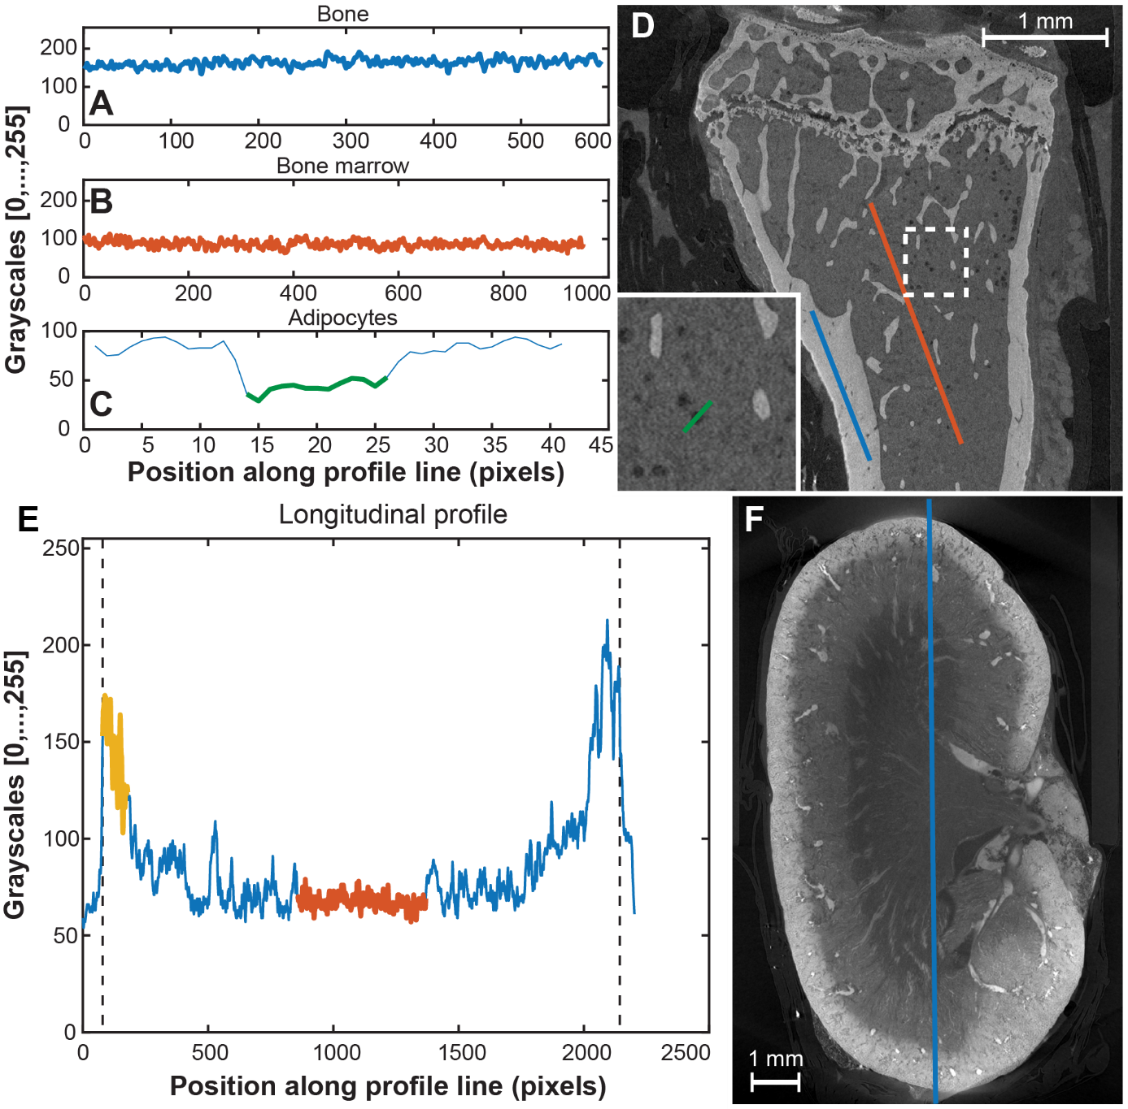
Figure 1. Typical profile lines drawn on a long bone (A-D) stained with Hf-WD POM and on a kidney (E-F) stained with Parent-WD POM. A: Greyscale profile line for cortical bone, corresponding to the blue line in D. B: Greyscale profile line for the bone marrow tissue, corresponding to the orange line in D. C: Profile line drawn through the bone marrow compartment covering an adipocyte, corresponding to the green line in the insert in D. The green, thicker line in C corresponds to the grey values of the adipocyte only. D: Longitudinal CT image of a long bone stained with Hf-WD POM. Insert = a magnification of the dotted white rectangle. The coloured lines are the different profile lines. E: Longitudinal greyscale profile line corresponding to the blue line in F. The yellow and orange thick lines represent the grey values for the cortex and the renal pelvis of the kidney respectively. The vertical dotted lines represent the edges of the kidney, used to measure the kidney length. F: Longitudinal CT image slice of a kidney stained with Parent-WD POM. The blue line is the profile line in E. Scale bar is 1 mm, voxel size is 2 µm for the long bone and 5.5 µm for the kidney.

For the kidneys, the methodology to draw the profile lines is illustrated in Figures 1E-F. Briefly, longitudinal profile lines were drawn from the top of the kidney to the bottom, passing through the renal pelvis. A region of 550 µm from the top was selected to generate the cortex grey values and the middle region was manually selected for the renal pelvis grey values.
For each CE-CT dataset, the reconstruction software offsets the grey values within the images to the less dense voxels detected and normalizes them to the densest ones. Therefore, to make all our scans comparable in terms of greyscale, the grey values of each dataset were normalized to the average greyscale value of air and parafilm. These two known materials served as greyscale references. Let $G_{X,i}$ be the average grey value of a tissue X in sample i. The normalized grey value associated to that tissue was noted and calculated as follows:
$$g_{X,i}=\frac{G_{X,i}-G_{A,i}}{G_{P,i}-G_{A,i}}$$
where $G_{P,i}$ and $G_{A,i}$ represent the average grey values of parafilm and air, respectively, measured within sample i.
For the long bones, the contrast difference between cortical bone and bone marrow tissue, and between bone marrow tissue and adipocytes, were calculated as the absolute differences between the normalized grey values of the respective tissues. For the kidneys, the extent of diffusion through the tissue was determined by calculating the normalized contrast difference between the cortex and the renal pelvis (as previously explained). This value was then divided by the half-length of the kidney (measured from the scans).

Statistical analysis
For the comparison in terms of contrast difference between the different POM species and PBS, a one-way ANOVA test was performed. For the extent of diffusion, we only compared similar POM species with each other for the different staining times using a one-way ANOVA test. The statistical analysis was performed using GraphPad Prism 8 software. The graphs represent the individual data points per experimental condition, along with their mean and standard deviation. Significance is indicated as following P-values: *: 0.01 to 0.05, **: 0.001 to 0.01, and ***: 0.0001 to 0.001 and ****< 0.0001 (significance level α=0.05).

Results and discussion

Properties of POMs
The structures of the POMs that were evaluated as CESAs are shown in Table 1. The table also summarizes the pH values measured of the different POMs upon dissolution of 35.0 mg/mL in PBS. The pH of all the POM solutions showed to be much closer to physiological pH (or were significantly less acidic) than the pH of the PTA solution. The PBS solutions of Parent-WD POM and Hf-WD POM were slightly acidic, while the Tri-WD POM solution was slightly basic. The Mono-WD POM solution was the closest to physiological pH, and hence is assumed to be the least harmful to biological samples.

Table 1. Chemical structure, charge and pH of the POM species dissolved in PBS (35.0 mg/ml).
POM |  | Hf-WD POM | Parent-WD POM | Mono-WD POM | Tri-WD POM | PTA
Structure |  | 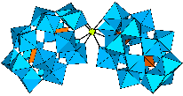 | 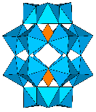 |  | 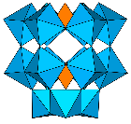 | 
Charge | POM | -20 | -6 | -10 | -12 | -3
Charge | Metal | +4 | 0 | 0 | 0 | 0
Charge | Net | -16 | -6 | -10 | -12 | -3
pH |  | 6.73 | 6.42 | 7.15 | 8.18 | 1.82

CE-CT imaging
To assess the staining potential of the different POMs, we determined the contrast difference between different types of tissue in murine long bones after 48 hours of staining by immersion, as well as the extent of diffusion within murine kidneys at different staining times (4 days and 10 days). Representative CE-CT images of the long bones and kidneys are given in Figure 2, while Figure 3 presents the quantification of the contrast difference between the features in the cortical bone and bone marrow compartment of the long bone, and the extent of diffusion through the kidneys. Samples in PBS were used as a negative control for contrast enhancement (but not for diffusion). Samples stained with PTA were used as a positive control, since the potential of this CESA for soft tissue staining has been shown in the literature [19, 33]. Low contrast differences between cortical bone and bone marrow tissue indicates good staining of the bone marrow tissue by the CESA (Figure 3A). High contrast differences between bone marrow tissue and adipocytes indicates good staining of the bone marrow tissue (since the POMs are repelled by the adipocytes) (Figure 3B) [28]. Low contrast differences between the edge and the middle of the kidneys (Figure 3C) indicates good diffusion of the CESA through the tissue and, therefore a more homogeneous staining.

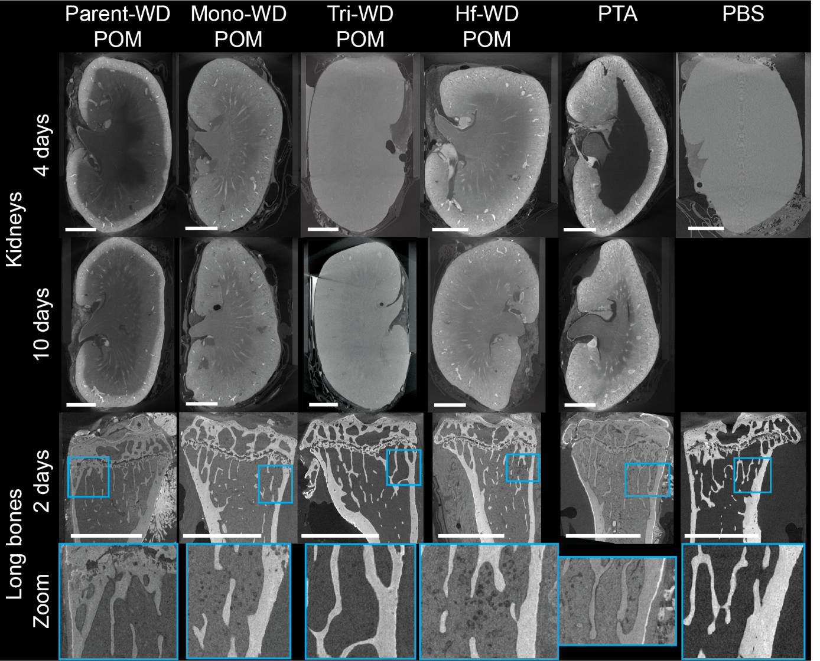
Figure 2. CE-CT images of murine tibiae and kidneys stained with the different POMs. Typical longitudinal CE-CT slices of kidneys (rows 1 and 2) and tibiae (row 3 and 4) stained with different POM species (columns: Parent WD POM, Mono-WD POM, Tri-WD POM, Hf-WD POM and PTA (positive control)) and PBS (negative control) for different staining times. Scale bar = 1 mm.

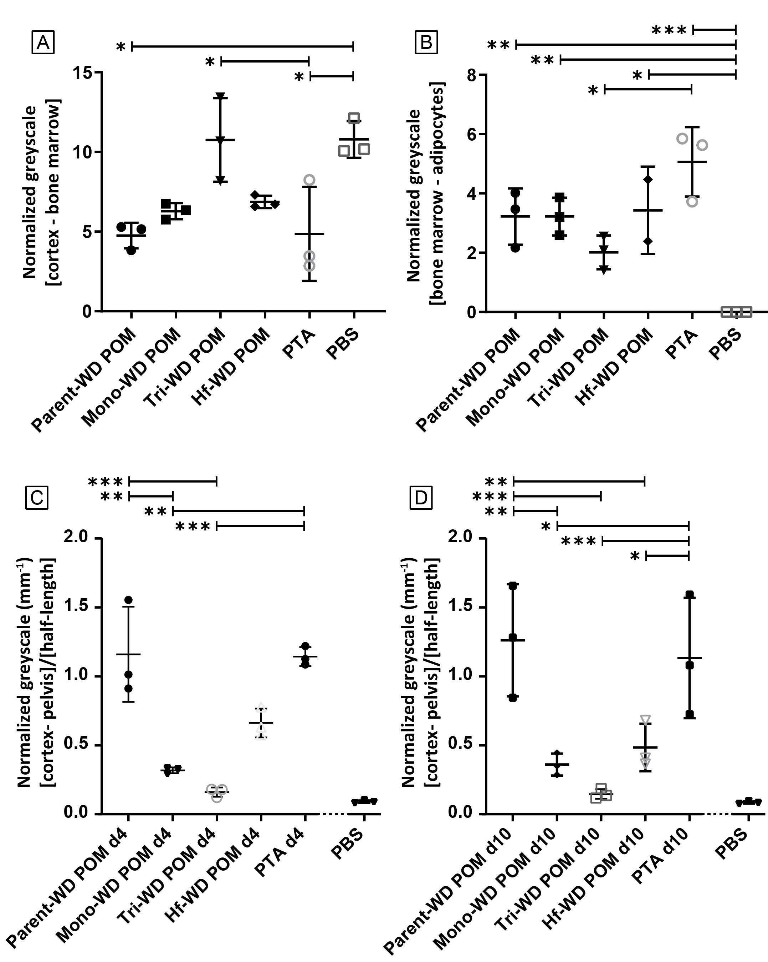
Figure 3. Quantitative assessment of the contrast difference in the CE-CT images of tibiae and kidneys stained with different POMs for different staining times; values are given in normalized grey values. A: Quantification of the contrast difference between cortical bone and bone marrow tissue for all tibiae. B: Quantification of the contrast difference between bone marrow tissue and adipocytes for all tibiae. C: Quantification of the contrast difference between the renal cortex and the renal pelvis (middle) of the kidneys, divided by half the length of the kidney, for all the kidneys; values are given in normalized grey values per millimetre.

A clear contrast enhancement of both bone marrow and kidney tissue was observed for most of the CESAs compared to the unstained reference material (PBS). Tri-WD POM showed the worst contrast enhancement, as qualitatively confirmed on the reconstructed CE-CT images (Figure 2), and quantitatively determined in Figures 3A and 3B. Distinct structures within the bone marrow of the long bone (bone marrow tissue or adipocytes) or within the kidney tissue (i.e. blood vessels, porosities, etc.) were difficult to identify. On the contrary, long bones stained with Parent-WD POM, Mono-WD POM, and Hf-WD POM performed similarly to PTA in terms of contrast enhancement (Figures 3A and 3B). Reconstructed CE-CT images of the long bones stained with these CESAs provided the differentiation of distinct skeletal tissues: mineralized bone, bone marrow adipose tissue and vasculature. Similarly, substructures of kidneys could be revealed, such as: renal pelvis, papilla, inner and outer medulla and cortex. Related to the diffusion dynamics, Parent-WD POM behaved similarly to PTA, which is known to have a relatively slow diffusion through soft tissues (Figures 2 and 3C-D) [19]. These, both non-lacunary, POMs failed to diffuse inside the core of the kidneys. In contrast, Mono-WD POM and Hf-WD POM showed a faster diffusion within the tissue. Therefore, we hypothesize that diffusion is improved due to the presence of a lacuna in the POM structure. Because of the small difference in grey values at the renal cortex and renal pelvis, Tri-WD POM seemed to show a very good diffusion (Figure 3C-D). However, the negative control PBS also shows a small difference. As noted above, Tri-WD POM was not able to increase the contrast of soft tissues (Figure 3A-B), which is reflected in about the same grey values at the renal pelvis and renal cortex. In addition, tissue shrinkage was only observed for PTA-stained samples, and this due to the acidic nature of PTA. Tissue shrinkage strongly affects tissue integrity and prevents structural and volumetric analyses [33].

In general, excellent results, both in terms of contrast enhancement and tissue penetration, were achieved with Mono-WD POM and Hf-WD POM. Whereas tissues stained with Mono-WD POM and Hf-WD POM give rise to about the same degree of contrast enhancement, a lower solubility was observed in PBS for Mono-WD POM compared to Hf-WD POM. Therefore, we decided to further improve the solubility of Mono-WD POM in PBS. This is worthwhile since Mono-WD POM is an intermediate in the synthesis of Hf-WD POM, hence it is easier to prepare. The synthesis of MonoWD-POM is more cost-efficient and less time-consuming, making it the preferred CESA. Addition of lithium chloride (LiCl) to the staining solution increased the solubility of Mono-WD POM because of the presence of the added Li⁺ ions [34, 35]. Since Mono-WD POM was synthesized as a potassium salt, the effect of the presence of Li⁺ ions was studied for an increasing molar ratio of lithium to potassium, using PBS as the solvent. In the presence of 35.0 mg/mL Mono-WD POM, three conditions were selected based on a molar ratio of lithium to potassium of 1:1, 1:3 and 1:13, corresponding to a LiCl concentration of 3.0 mg/mL, 9.1 mg/mL and 39.5 mg/mL respectively. A sample immersed in a PBS solution solely containing 39.5 mg/mL LiCl was used as a negative control. Representative CE-CT images of the long bones are given in Figures 4A-D, while Figures 4E-F present the quantification of the contrast difference between the features in the cortical bone and bone marrow compartment.
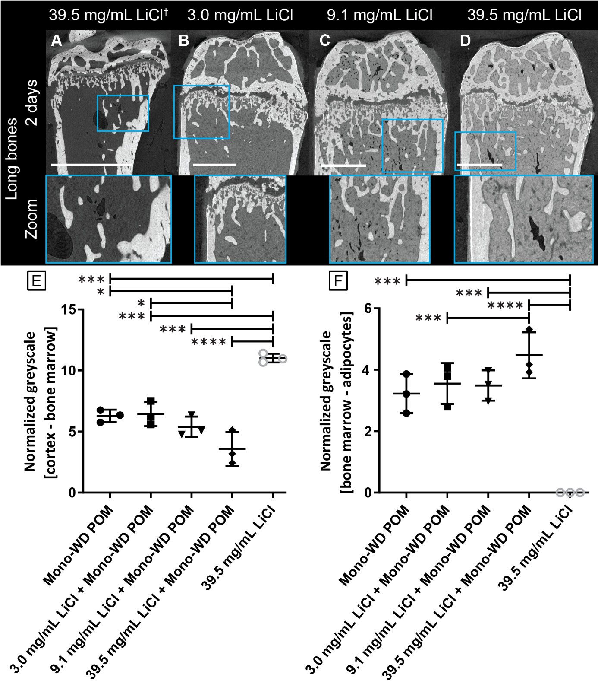Figure 4. CE-CT images and quantitative assessment of murine long bones stained with Mono-WD POM dissolved in PBS in the presence of LiCl. A-D: CE-CT images of murine long bones stained for 48 hours with Mono-WD POM (35.0 mg/mL) in PBS in the presence of variable concentrations of LiCl. † = Control sample, absence of Mono-WD POM. Scale bar = 1 mm. E: Quantification of the contrast difference between cortical bone and bone marrow tissue for all the long bones; values are given in normalized grey values. F: Quantification of the contrast difference between bone marrow tissue and adipocytes for all the long bones; values are given in normalized grey values.

Table 2. pH and calculated osmolarity of Mono-WD POM solutions containing LiCl, dissolved in PBS.
 | 3.0 mg/mL LiCl  + Mono-WD POM | 9.1 mg/mL LiCl  + Mono-WD POM | 39.5 mg/mL LiCl  + Mono-WD POM
pH | 6.78 | 6.73 | 6.37
Calculated osmolarity in PBS (mOsm/L) | 553 | 841 | 2275

The CE-CT cross-sections of the long bones stained with Mono-WD POM in Figures 4A-D appear to indicate an increased contrast of the bone marrow with increasing LiCl concentrations, which was quantitatively validated in Figures 4E-F. Indeed, the lower contrast difference between cortical bone and bone marrow for the sample stained with Mono-WD POM in the presence of 39.5 mg/mL LiCl, compared to the samples stained with a lower LiCl concentration, confirms the improved bone marrow staining. Likewise, the improved staining is also reflected in the higher contrast difference between bone marrow and adipocytes for increased LiCl concentrations.
Despite the increased bone marrow contrast, shrinkage was observed as cavities in the bone marrow tissue for samples stained with Mono-WD POM and high LiCl concentrations (Figures 4A, 4C and 4D). The observed tissue shrinkage is caused by dehydration of the soft tissue, which we hypothesize is due to the hypertonicity of these staining solutions [36-38]. PBS buffer, which is isotonic, was used to prepare the staining solutions. Addition of Mono-WD POM and LiCl increases the ionic strength, resulting in hypertonic staining solutions (> 312 mOsm/L), justified by the calculated osmolarities in Table 2 [39]. The degree of tissue shrinkage and the correlated harm of tissue integrity is an important consideration for morphometric and volumetric analyses. Therefore, we selected Mono-WD POM with 3.0 mg/mL LiCl dissolved in PBS as the preferred condition for long bone staining as the contrast of bone marrow was increased without the observation of tissue shrinkage. The development of isotonic staining solutions, e.g. through replacement of PBS by a solution of lower ionic strength, will be the focus of future studies.

Stability and speciation of POMs
The structural integrity of POMs in aqueous solution is highly dependent on pH, temperature, time and concentration [40-43]. Therefore, apart from their staining potential, their stability under the experimental conditions used for the staining experiments was also investigated. Due to the presence of phosphorus atoms in POMs, ³¹P NMR spectroscopy is a powerful technique for their characterization in solution.
The ³¹P NMR spectrum of PTA dissolved in PBS showed a singlet at -14.98 ppm (Supplementary Figures 1A-B) at low pH values (Table 1). Indeed, after dissolution of PTA in PBS, the pH of the solution reached 1.82 (Table 1), and resulted in a partial decomposition of PTA as indicated by the additional singlets at -12.27 ppm, -12.75 ppm and -12.86 ppm [44, 45]. After staining of a kidney, the ³¹P NMR spectrum of the staining solution showed disappearance of the singlet at -14.98 ppm and appearance of a broad singlet at -10.73 ppm (Supplementary Figures 1C-D), which could be attributed to the base decomposition of PTA to monolacunary α-Keggin type POM [41, 46] After long bone staining only a singlet at -11.52 ppm was detected in the ³¹P NMR spectrum of the staining solution (Supplementary Figure 1E), which could be most likely attributed to monolacunary α-Keggin type POM that is coordinated to Ca²⁺ ions in the mineralized bone (vide infra).

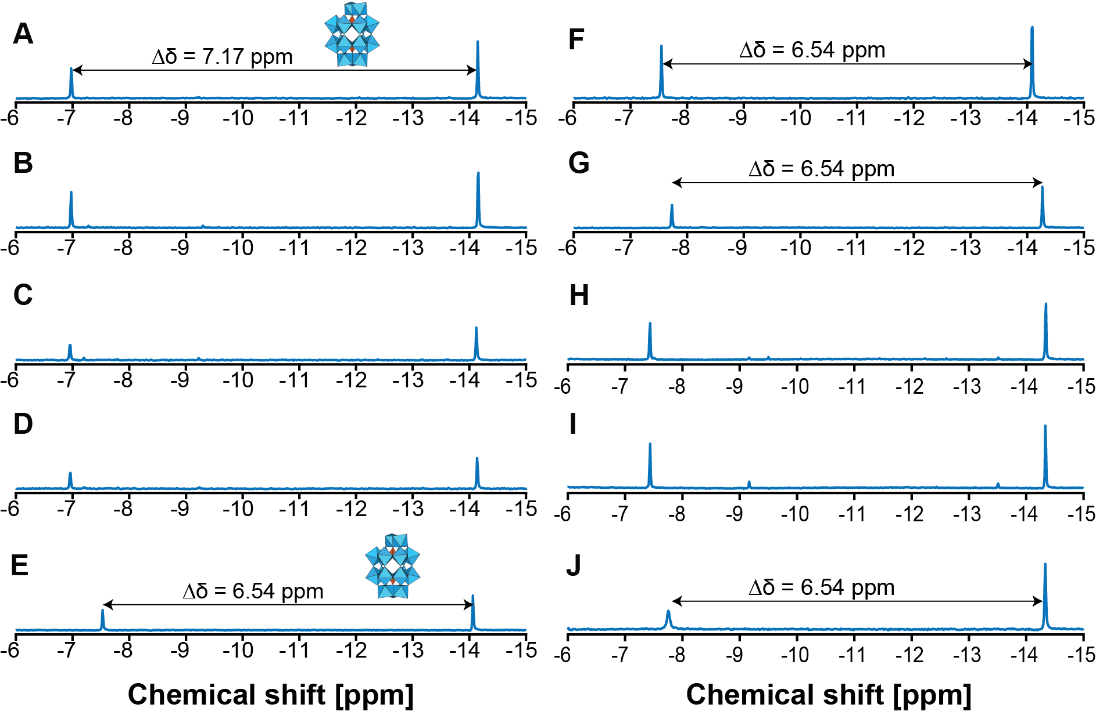
Figure 5. ³¹P NMR spectra of Mono-WD POM in PBS, before and after staining of kidney or bone and in the presence of 3.0 mg/mL LiCl. Spectrum of a Mono-WD POM solution in PBS A: after dissolution. B: after 17 days. C: after 4 days of staining a kidney. D: after 10 days of staining a kidney. E: after 2 days of staining a tibia. F-G: in the presence of Ca(NO₃)₂ (F) and CaCl₂ (G). Spectrum of a Mono-WD POM with 3.0 mg/mL LiCl solution in PBS H: after dissolution. I: after 17 days. J: after 2 days of staining a femur.

Mono-WD POM (showing singlets at -6.97 ppm and -14.14 ppm in the ³¹P NMR spectrum, ∆δ = 7.17 ppm) was stable in PBS both in the absence and presence of a kidney or a long bone (Figures 5A-E) [31]. After 4 days of staining a kidney and 2 days of staining a long bone, the amount of Mono-WD POM in the staining solution decreased in both cases (Figures 5C and 5E). In the presence of the bone, the difference in chemical shift (∆δ) between two phosphorus atoms was reduced from 7.17 ppm to 6.54 ppm (Figure 5E). The shift of the ³¹P NMR singlets of Mono-WD POM after long bone staining could be attributed to the presence of Ca²⁺ ions in the mineralized bone. We hypothesized that Ca²⁺ ions in the mineralized bone interact with the open lacunary site in the POM, thereby influencing the chemical shift of the ³¹P NMR singlets [47]. To confirm this, ³¹P NMR spectra of 1 mL-samples containing 35.0 mg Mono-WD POM and 0.2 M Ca(NO₃)₂ or CaCl₂ were recorded (Figures 5F-G). As expected, when Ca²⁺ ions were added to the staining solution the chemical shift of the ³¹P NMR singlets of Mono-WD POM changed in the same way as in Figure 5E. This change in chemical shift indicates that Ca²⁺ ions indeed interact with Mono-WD POM, most likely via coordination to its open lacunary site.
Mono-WD POM in the presence of 3.0 mg/mL LiCl was stable in PBS, exhibiting singlets at -7.43 ppm and -14.34 ppm in the ³¹P NMR spectrum (∆δ = 6.91 ppm, Figures 5H-I). The decrease in both the chemical shift of the ³¹P singlets and the distance between these singlets in the presence of LiCl, compared to the solution without LiCl, could be attributed to the increased ionic strength of the solution [48]. After long bone staining, the ³¹P NMR spectrum of the staining solution showed a further reduction of the difference in chemical shift between the two characteristic singlets to 6.54 ppm, which is the same as in Figures 5E-G (Figure 4J). Again, the decrease in the difference in chemical shift could be attributed to the coordination of Mono-WD POM with Ca²⁺ ions of the mineralized bone.

Dissolved in PBS, Hf-WD POM showed singlets at -9.40 ppm and -14.02 ppm in the ³¹P NMR spectrum (∆δ = 4.62 ppm, Supplementary Figure 2A-B) [31]. In addition, singlets at -7.17 ppm and -14.33 ppm (∆δ = 7.17 ppm) were observed, which could be attributed to the dissociation of the 1:2 Hf-WD POM into Mono-WD POM and 1:1 Hf-WD POM in PBS. After 4 days of kidney staining, the integrated values of the singlets corresponding to 1:2 Hf-WD POM decreased (Supplementary Figure 2C), and decreased even more when staining was prolonged for six additional days, albeit only slightly (Supplementary Figure 2D). The singlets at -7.17 ppm and -14.33 ppm were still observed in the staining solution after kidney staining. After long bone staining, the ³¹P NMR spectrum of the staining solution solely showed singlets at -7.73 ppm and -14.27 ppm (∆δ = 6.54 ppm), which could be ascribed to the presence of Mono-WD POM (Supplementary Figure 2E). Similarly to other cases discussed above, the chemical shift change due to the presence of Ca²⁺ ions in mineralized bone was observed.
The ³¹P NMR spectrum of Parent-WD POM dissolved in PBS showed singlets at -12.96 (α-Parent-WD POM), -11.46 ppm (β-Parent-WD POM) and -12.23 ppm (β-Parent-WD POM) [31]. Moreover, singlets at -7.17 ppm and -14.34 ppm (∆δ = 7.17 ppm) were also detected, which could be explained by the conversion of Parent-WD POM into Mono-WD POM (Supplementary Figures 3A and 3B). The ³¹P NMR spectrum of the staining solution after kidney staining only showed singlets that are most likely originating from Mono-WD POM (Supplementary Figure 3C); signals corresponding to Parent-WD POM disappeared. After long bone staining, the singlets corresponding to Parent-WD POM were not observed in the ³¹P NMR spectrum of the staining solution. Nonetheless, singlets at -7.74 ppm and -14.28 ppm (∆δ = 6.54 ppm) appeared in the ³¹P NMR spectrum, which probably results from the presence of Ca²⁺-coordinated Mono-WD POM.

Finally, PBS solutions containing Tri-WD POM were analysed by ¹³P NMR. Characteristic resonance signals of Tri-WD POM were not observed, indicating that Tri-WD POM is not stable in PBS. Since contrast enhancement was observed neither for kidney, nor for long bone, Tri-WD POM was not considered as a suitable CESA.

In general, the ³¹P NMR spectra of the different Wells-Dawson POMs indicate Mono-WD POM to be the most stable species in PBS. Indeed, PBS solutions of Parent-WD POM and Hf-WD POM were shown to partially convert and dissociate, respectively, into Mono-WD POM. The CE-CT images (Figures 2 and 4) showed effective soft tissue contrast enhancement for these three WD species, while almost no contrast enhancement was observed for Tri-WD POM. Taken together the data obtained from the CE-CT images and ³¹P NMR experiments, 35.0 mg/mL Mono-WD POM in combination with 3.0 mg/mL LiCl is concluded to be the most suitable CESA for imaging soft tissue as it is the most stable in PBS and shows high contrast enhancement.

Conclusions
In this work, four Wells-Dawson POM species were screened for their potential as CESAs for soft tissue visualization using CE-CT. The different Wells-Dawson POMs were compared to PTA, which is a commonly used histological and CE-CT stain. The POMs were dissolved in PBS at equal concentrations and subsequently used to stain murine long bones and kidneys for CE-CT imaging. Quantification of the contrast enhancement of soft tissue due to the POM staining implied that Tri-WD POM was not a suitable CESA. ³¹P NMR measurements of the staining solutions performed before and after staining revealed that: (1) calcium ions interact with lacunary POM structures and induce a shift in the ³¹P NMR resonance signals, (2) Mono-WD POM is the most stable POM species in PBS since Parent-WD POM and Hf-WD POM convert and dissociate, respectively, to it. Finally, Mono-WD POM and Hf-WD POM species showed the best diffusion and overall staining of soft tissues. Therefore, we concluded that Mono-WD POM is the most suitable CESA of the screened POM species in terms of (1) contrast-enhancement, (2) diffusion rate through the tissue, (3) non-destructiveness (physiological pH), (4) chemical stability, and (5) ease of synthesis, leading to a lower production cost in comparison with Hf-WD POM. This work was further strengthened by improving the staining properties of Mono-WD POM through addition of LiCl to the staining solution in order to increase its solubility. We conclude that Mono-WD POM (35.0 mg/mL) with 3.0 mg/mL LiCl, dissolved in PBS, results in high contrast enhancement of soft tissue without inducing tissue shrinkage. Although improving the contrast, tissue shrinkage was observed for long bones that were stained with Mono-WD POM solutions containing a higher concentration of LiCl ( > 3.0 mg/mL). Therefore, the development of isotonic staining solutions containing CESAs that match the pH levels of biological tissues will be the focus of future research.
CE-CT using Mono-WD POM with LiCl demonstrates the potential of virtual 3D histology of biological tissues, as it provides additional spatial information, compared to standard histomorphometry. Given the complexity of biological tissues, precise imaging and the additional 3D information could provide novel insights in tissue development and disease, which is valuable for both basic research and disease diagnosis. Furthermore, our improved virtual 3D histology method could provide an important contribution for the optimization of biomaterial design and 3D bioprinting strategies for regenerative medicine purposes.

Acknowledgements
We are grateful to Jens Moons for the assistance with the design of experiment. S.d.B. was supported by a PhD grant of the Research Foundation Flanders [FWO, Grant No. 1S67217N]. H.G.T.L. acknowledges funding from the FWO (Research Foundation − Flanders) for the postdoctoral fellowship. This research project was funded by a research project of the Research Foundation Flanders FWO; Grant no. G088218N]. The CE-CT images have been generated at the X-ray computed tomography facilities of the Department of Development and Regeneration of the KU Leuven, financed by the Hercules Foundation (project AKUL 13/47). This work is part of Prometheus, the Leuven Research & Development Division of Skeletal Tissue Engineering of the KU Leuven: www.kuleuven.be/prometheus.

Disclosures
The authors declare no conflicts of interest.

Author contributions statement
G.K., S.d.B. and S.V. conceived the design of the experiments. C.G. and S.V. performed the CE-CT imaging. NMR experiments were conducted by H.G.L.T. and S.V.. W.M.D.B. and T.P.V. contributed to the discussion about the NMR experiments. Data interpretation was done by S.d.B., S.V., G.K., W.M.D.B. and T.P.V.. S.d.B., S.V., H.G.L.T., and G.K. drafted the manuscript. All authors critically reviewed and approved the final manuscript.

References
[1] I. Kallai, O. Mizrahi, W. Tawackoli, Z. Gazit, G. Pelled, D. Gazit, Microcomputed tomography-based structural analysis of various bone tissue regeneration models, Nature protocols 6(1) (2011) 105-10.
[2] M.L. Bouxsein, S.K. Boyd, B.A. Christiansen, R.E. Guldberg, K.J. Jepsen, R. Muller, Guidelines for assessment of bone microstructure in rodents using micro-computed tomography, Journal of bone and mineral research : the official journal of the American Society for Bone and Mineral Research 25(7) (2010) 1468-86.
[3] G. Kerckhofs, Y.C. Chai, F.P. Luyten, L. Geris, Combining microCT-based characterization with empirical modelling as a robust screening approach for the design of optimized CaP-containing scaffolds for progenitor cell-mediated bone formation, Acta Biomater. 35 (2016) 330-340.
[4] D.P. Cormode, P.C. Naha, Z.A. Fayad, Nanoparticle contrast agents for computed tomography: a focus on micelles, Contrast Media Mol Imaging 9(1) (2014) 37-52.
[5] H. Lusic, M.W. Grinstaff, X-ray-computed tomography contrast agents, Chemical reviews 113(3) (2013) 1641-66.
[6] M. Sonnaert, G. Kerckhofs, I. Papantoniou, S. Van Vlierberghe, V. Boterberg, P. Dubruel, F.P. Luyten, J. Schrooten, L. Geris, Multifactorial Optimization of Contrast-Enhanced Nanofocus Computed Tomography for Quantitative Analysis of Neo-Tissue Formation in Tissue Engineering Constructs, PLoS One 10(6) (2015) e0130227.
[7] L. Xie, A.S.P. Lin, R.E. Guldberg, M.E. Levenston, Nondestructive assessment of sGAG content and distribution in normal and degraded rat articular cartilage via EPIC-mu CT, Osteoarthr. Cartil. 18(1) (2010) 65-72.
[8] B.A. Lakin, D.J. Grasso, S.S. Shah, R.C. Stewart, P.N. Bansal, J.D. Freedman, M.W. Grinstaff, B.D. Snyder, Cationic agent contrast-enhanced computed tomography imaging of cartilage correlates with the compressive modulus and coefficient of friction, Osteoarthritis Cartilage 21(1) (2013) 60-8.
[9] T.S. Silvast, J.S. Jurvelin, V. Tiitu, T.M. Quinn, J. Töyräs, Bath Concentration of Anionic Contrast Agents Does Not Affect Their Diffusion and Distribution in Articular Cartilage In Vitro, Cartilage 4(1) (2013) 42-51.
[10] G. Kerckhofs, J. Sainz, M. Marechal, M. Wevers, T. Van de Putte, L. Geris, J. Schrooten, Contrast-Enhanced Nanofocus X-Ray Computed Tomography Allows Virtual Three-Dimensional Histopathology and Morphometric Analysis of Osteoarthritis in Small Animal Models, Cartilage 5(1) (2014) 55-65.
[11] R.C. Stewart, P.N. Bansal, V. Entezari, H. Lusic, R.M. Nazarian, B.D. Snyder, M.W. Grinstaff, Contrast-enhanced CT with a High-Affinity Cationic Contrast Agent for Imaging ex Vivo Bovine, Intact ex Vivo Rabbit, and in Vivo Rabbit Cartilage, Radiology 266(1) (2013) 141-150.
[12] L.N. Hayward, C.M. de Bakker, L.C. Gerstenfeld, M.W. Grinstaff, E.F. Morgan, Assessment of contrast-enhanced computed tomography for imaging of cartilage during fracture healing, J Orthop Res 31(4) (2013) 567-73.
[13] S.S. Karhula, M.A. Finnila, M.J. Lammi, J.H. Ylarinne, S. Kauppinen, L. Rieppo, K.P. Pritzker, H.J. Nieminen, S. Saarakkala, Effects of Articular Cartilage Constituents on Phosphotungstic Acid Enhanced Micro-Computed Tomography, PLoS One 12(1) (2017) e0171075.
[14] H.J. Nieminen, H.K. Gahunia, K.P.H. Pritzker, T. Ylitalo, L. Rieppo, S.S. Karhula, P. Lehenkari, E. Haeggstrom, S. Saarakkala, 3D histopathological grading of osteochondral tissue using contrast-enhanced micro-computed tomography, Osteoarthritis Cartilage 25(10) (2017) 1680-1689.
[15] H.J. Nieminen, T. Ylitalo, S. Karhula, J.P. Suuronen, S. Kauppinen, R. Serimaa, E. Haeggstrom, K.P. Pritzker, M. Valkealahti, P. Lehenkari, M. Finnila, S. Saarakkala, Determining collagen distribution in articular cartilage using contrast-enhanced micro-computed tomography, Osteoarthritis Cartilage 23(9) (2015) 1613-21.
[16] M. Styner, W.R. Thompson, K. Galior, G. Uzer, X. Wu, S. Kadari, N. Case, Z.H. Xie, B. Sen, A. Romaine, G.M. Pagnotti, C.T. Rubin, M.A. Styner, M.C. Horowitz, J. Rubin, Bone marrow fat accumulation accelerated by high fat diet is suppressed by exercise, Bone 64 (2014) 39-46.
[17] E.L. Scheller, C.R. Doucette, B.S. Learman, W.P. Cawthorn, S. Khandaker, B. Schell, B. Wu, S.Y. Ding, M.A. Bredella, P.K. Fazeli, B. Khoury, K.J. Jepsen, P.F. Pilch, A. Klibanski, C.J. Rosen, O.A. MacDougald, Region-specific variation in the properties of skeletal adipocytes reveals regulated and constitutive marrow adipose tissues, Nat Commun 6 (2015) 7808.
[18] E.L. Scheller, N. Troiano, J.N. Vanhoutan, M.A. Bouxsein, J.A. Fretz, Y. Xi, T. Nelson, G. Katz, R. Berry, C.D. Church, C.R. Doucette, M.S. Rodeheffer, O.A. Macdougald, C.J. Rosen, M.C. Horowitz, Use of osmium tetroxide staining with microcomputerized tomography to visualize and quantify bone marrow adipose tissue in vivo, Methods Enzymol 537 (2014) 123-39.
[19] B.D. Metscher, MicroCT for comparative morphology: simple staining methods allow high-contrast 3D imaging of diverse non-mineralized animal tissues, BMC Physiol 9 (2009) 11.
[20] M.D. Wong, A.E. Dorr, J.R. Walls, J.P. Lerch, R.M. Henkelman, A novel 3D mouse embryo atlas based on micro-CT, Development 139(17) (2012) 3248-3256.
[21] H. Lusic, M.W. Grinstaff, X-ray-Computed Tomography Contrast Agents, Chem. Rev. 113(3) (2013) 1641-1666.
[22] M.M. Koc, N. Aslan, A.P. Kao, A.H. Barber, Evaluation of X-ray tomography contrast agents: A review of production, protocols, and biological applications, Microsc. Res. Tech. 82(6) (2019) 812-848.
[23] S. de Bournonville, S. Vangrunderbeeck, G. Kerckhofs, Contrast-Enhanced MicroCT for Virtual 3D Anatomical Pathology of Biological Tissues: A Literature Review, Contrast Media Mol. Imaging (2019).
[24] P. Vickerton, J. Jarvis, N. Jeffery, Concentration-dependent specimen shrinkage in iodine-enhanced microCT, J Anat 223(2) (2013) 185-93.
[25] J. Buytaert, J. Goyens, D. De Greef, P. Aerts, J. Dirckx, Volume shrinkage of bone, brain and muscle tissue in sample preparation for micro-CT and light sheet fluorescence microscopy (LSFM), Microscopy and microanalysis : the official journal of Microscopy Society of America, Microbeam Analysis Society, Microscopical Society of Canada 20(4) (2014) 1208-17.
[26] T. Schulz-Mirbach, M. Hess, B.D. Metscher, Sensory epithelia of the fish inner ear in 3D: studied with high-resolution contrast enhanced microCT, Frontiers in zoology 10(1) (2013) 63.
[27] E. Pauwels, D. Van Loo, P. Cornillie, L. Brabant, L. Van Hoorebeke, An exploratory study of contrast agents for soft tissue visualization by means of high resolution X-ray computed tomography imaging, Journal of microscopy 250(1) (2013) 21-31.
[28] G. Kerckhofs, S. Stegen, N. van Gastel, A. Sap, G. Falgayrac, G. Penel, M. Durand, F.P. Luyten, L. Geris, K. Vandamme, T. Parac-Vogt, G. Carmeliet, Simultaneous three-dimensional visualization of mineralized and soft skeletal tissues by a novel microCT contrast agent with polyoxometalate structure, Biomaterials 159 (2018) 1-12.
[29] D. Farcasiu, J.Q. Li, Acidity Measurements on a Heteropolyacid Hydrate in Acetic-Acid Solution - a Case of 3 Hydrons Ionizing Independently, Rather Than Consecutively, J Catal 152(1) (1995) 198-203.
[30] C.N. Kato, A. Shinohara, K. Hayashi, K. Nomiya, Syntheses and X-ray crystal structures of zirconium(IV) and hafnium(IV) complexes containing monovacant wells-Dawson and Keggin polyoxotungstates, Inorg Chem 45(20) (2006) 8108-19.
[31] A.P. Ginsberg, Inorganic Syntheses, Wiley1990.
[32] G. Kerckhofs, M. Durand, R. Vangoitsenhoven, C. Marin, B. Van der Schueren, G. Carmeliet, F.P. Luyten, L. Geris, K. Vandamme, Changes in bone macro- and microstructure in diabetic obese mice revealed by high resolution microfocus X-ray computed tomography, Scientific reports 6 (2016) 35517.
[33] J. Buytaert, J. Goyens, D. De Greef, P. Aerts, J. Dirckx, Volume Shrinkage of Bone, Brain and Muscle Tissue in Sample Preparation for Micro-CT and Light Sheet Fluorescence Microscopy (LSFM), Microsc. Microanal. 20(4) (2014) 1208-1217.
[34] J.F. Kirby, L.C.W. Baker, Effects of counterions in heteropoly electrolyte chemistry. 1. Evaluations of relative interactions by NMR on Kozik salts, Inorg. Chem. 37(21) (1998) 5537-5543.
[35] M. Sadakane, A. Ostuni, M.T. Pope, Formation of 1 : 1 and 2 : 2 complexes of Ce(III) with the heteropolytungstate anion alpha(2)- P2W17O61 (10-), and their interaction with proline. The structure of Ce-2(P2W17O61)(2)(H2O)(8) (14-), Journal of the Chemical Society-Dalton Transactions (1) (2002) 63-67.
[36] K. Degenhardt, A.C. Wright, D. Horng, A. Padmanabhan, J.A. Epstein, Rapid 3D Phenotyping of Cardiovascular Development in Mouse Embryos by Micro-CT With Iodine Staining, Circulation-Cardiovascular Imaging 3(3) (2010) 314-U138.
[37] P. Vickerton, J. Jarvis, N. Jeffery, Concentration-dependent specimen shrinkage in iodine-enhanced microCT, J. Anat. 223(2) (2013) 185-193.
[38] M.J. West, Tissue Shrinkage and Stereological Studies, Cold Spring Harbor Protocols 2013(3) (2013) pdb.top071860.
[39] 5 - Disturbances of Free Water, Electrolytes, Acid-Base Balance, and Oncotic Pressure, in: P.D. Constable, K.W. Hinchcliff, S.H. Done, W. Grünberg (Eds.), Veterinary Medicine (Eleventh Edition), W.B. Saunders2017, pp. 113-152.
[40] G. Absillis, T.N. Parac-Vogt, Peptide bond hydrolysis catalyzed by the Wells-Dawson Zr(alpha2-P2W17O61)2 polyoxometalate, Inorg Chem 51(18) (2012) 9902-10.
[41] H.G. Ly, G. Absillis, T.N. Parac-Vogt, Amide bond hydrolysis in peptides and cyclic peptides catalyzed by a dimeric Zr(IV)-substituted Keggin type polyoxometalate, Dalton Trans 42(30) (2013) 10929-38.
[42] C. Boglio, B. Hasenknopf, G. Lenoble, P. Remy, P. Gouzerh, S. Thorimbert, E. Lacote, M. Malacria, R. Thouvenot, Sensing the chirality of Dawson lanthanide polyoxometalates [alpha1-LnP2W17O61]7- by multinuclear NMR spectroscopy, Chemistry 14(5) (2008) 1532-40.
[43] N. Dupre, P. Remy, K. Micoine, C. Boglio, S. Thorimbert, E. Lacote, B. Hasenknopf, M. Malacria, Chemoselective catalysis with organosoluble Lewis acidic polyoxotungstates, Chemistry 16(24) (2010) 7256-64.
[44] B.J. Smith, V.A. Patrick, Quantitative Determination of Aqueous Dodecatungstophosphoric Acid Speciation by NMR Spectroscopy, Australian Journal of Chemistry 57(3) (2004) 261-268.
[45] Z. Zhu, R. Tain, C. Rhodes, A study of the decomposition behaviour of 12-tungstophosphate heteropolyacid in solution, Canadian Journal of Chemistry 81(10) (2003) 1044-1050.
[46] M.N. Sokolov, E.V. Chubarova, E.V. Peresypkina, A.V. Virovets, V.P. Fedin, Complexes of Zr-IV and Hf-IV with monolacunary Keggin- and Dawson-type anions, Russ. Chem. Bull. 56(2) (2007) 220-224.
[47] D.K. Lyon, W.K. Miller, T. Novet, P.J. Domaille, E. Evitt, D.C. Johnson, R.G. Finke, Highly oxidation resistant inorganic-porphyrin analog polyoxometalate oxidation catalysts. 1. The synthesis and characterization of aqueous-soluble potassium salts of .alpha.2-P2W17O61(Mn+.cntdot.OH2)(n-10) and organic solvent soluble tetra-n-butylammonium salts of .alpha.2-P2W17O61(Mn+.cntdot.Br)(n-11) (M = Mn3+,Fe3+,Co2+,Ni2+,Cu2+), Journal of the American Chemical Society 113(19) (1991) 7209-7221.
[48] J.K.M. Roberts, N. Wadejardetzky, O. Jardetzky, INTRACELLULAR PH MEASUREMENTS BY P-31 NUCLEAR MAGNETIC-RESONANCE INFLUENCE OF FACTORS OTHER THAN PH ON P-31 CHEMICAL-SHIFTS, Biochemistry 20(19) (1981) 5389-5394.

Supplementary Figures

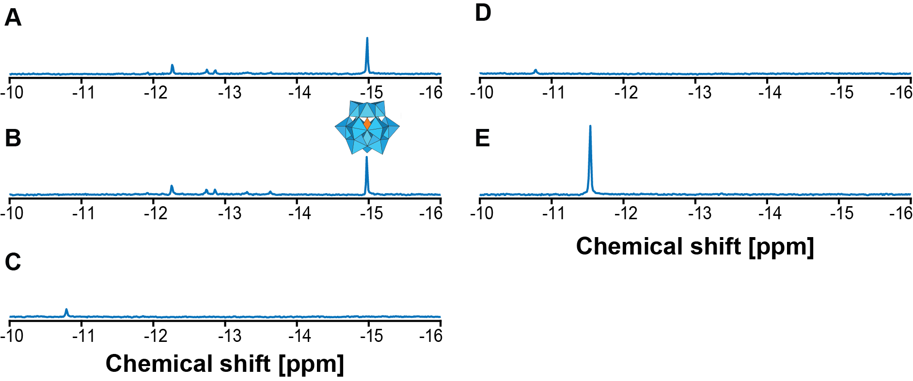

Supplementary Figure 1. ³¹P NMR spectra of PTA in the absence and presence of a kidney or tibia in PBS for different staining times. Spectrum of a PTA solution in PBS A: after dissolution. B: after 17 days in PBS. C: after 4 days of staining a kidney. D: after 10 days of staining a kidney. E: after 2 days of staining a tibia.

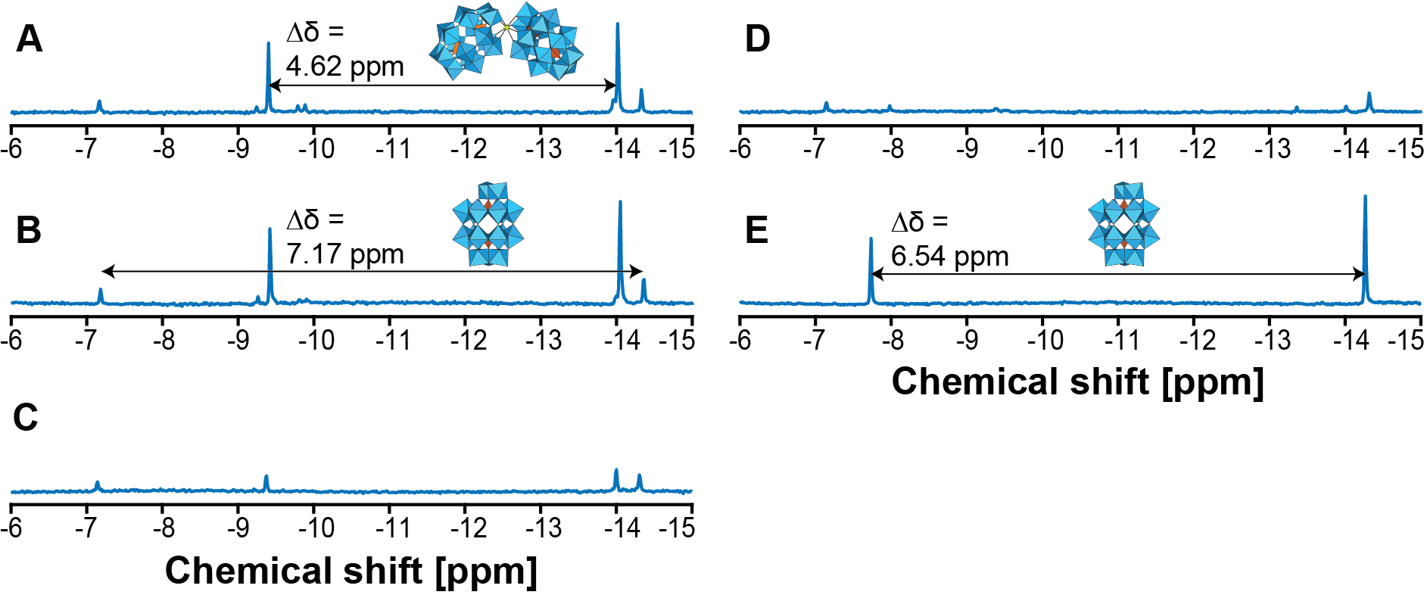

Supplementary Figure 2. ³¹P NMR spectra of Hf-WD POM in the absence and presence of kidney or a tibia in PBS. Spectrum of an Hf-WD POM solution in PBS A: after dissolution. B: after 17 days in PBS. C: after 4 days of staining a kidney. D: after 10 days of staining a kidney. E: after 2 days of staining a tibia.

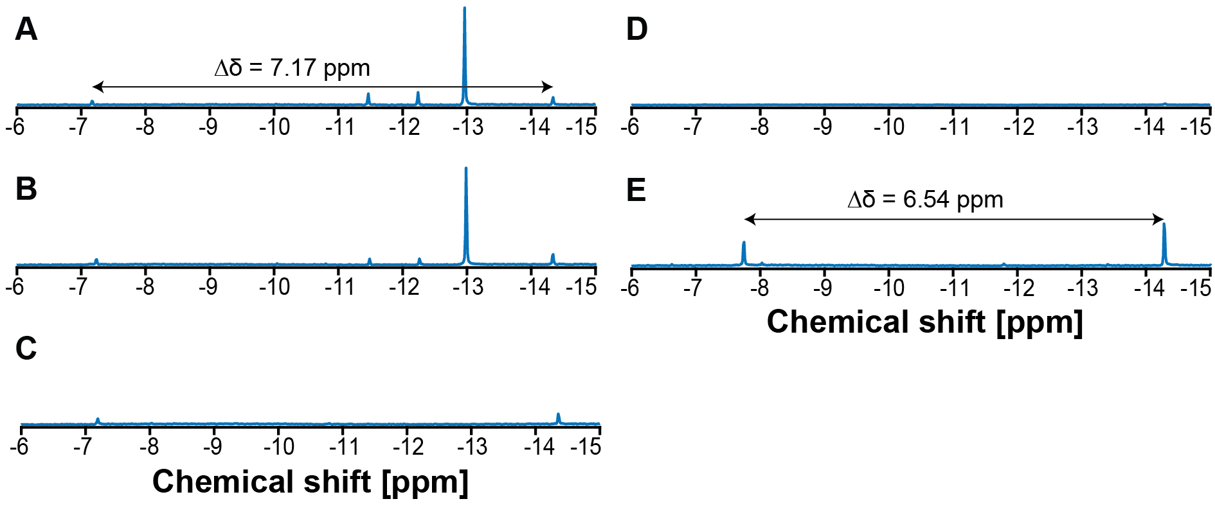

Supplementary Figure 3. ³¹P NMR spectra of Parent-WD POM in the absence and presence of kidney or tibia in PBS. Spectrum of a Parent-WD POM solution in PBS A: after dissolution. B: after 17 days in PBS. C: after 4 days of staining a kidney. D: after 10 days of staining a kidney. E: after 2 days of staining a tibia.

