Author's note

This is the post-print version (i.e., peer-reviewed including revisions) of the following article: Masson, N., Andres, M., Carneiro Pereira, S., Vandenberghe, A., Pesenti, M., & Vannuscorps, G. (2021). Shifting attention in visuospatial short-term memory does not require oculomotor planning: Insight from congenital gaze paralysis. Neuropsychologia, 161, 107998. The published version of the article is available via its DOI : https://doi.org/10.1016/j.neuropsychologia.2021.107998.

Shifting attention in visuospatial short-term memory does not require oculomotor planning: insight from congenital gaze paralysis

Nicolas MASSON _{a, c}, Michael ANDRES _{a, b}, Sarah CARNEIRO PEREIRA _{a}, Antoine VANDENBERGHE _{a}, Mauro PESENTI _{a, b}, & Gilles VANNUSCORPS _{a, b}
_{a} Psychological Sciences Research Institute, Université catholique de Louvain, Belgium
_{b} Institute of Neuroscience, Université catholique de Louvain, Belgium
_{c}Institute of Cognitive Science and Assessment (COSA), Research Unit Education, Culture, Cognition and Society (ECCS), Faculty of Language and Literature, Humanities, Arts and Education (FLSHASE), University of Luxembourg, Luxembourg

Submitted to the Special Issue “VSI: Unique cases & cohorts”
Abstract: 214 words
main text: 4245 words (abstract not included)

Declaration of interest:
The authors have no conflict of interest to declare

Correspondence should be addressed to:
Nicolas Masson or Gilles Vannuscorps
Institut de Recherche en Sciences Psychologiques
Université catholique de Louvain
Place Cardinal Mercier, 10
B-1348 Louvain-la-Neuve (Belgium)
E-mail: nicolas.masson@uclouvain.be; gilles.vannuscorps@uclouvain.be
Tel.: +32 10 47 38 39
Fax.: +32 10 47 38 79

Abstract:
Attention allows pieces of information stored in visuospatial short-term memory (VSSTM) to be selectively processed. Previous studies showed that internal shifts of attention in VSSTM in response to a retro-cue are accompanied by eye movements in the direction of the position of the memorized item although there is nothing left to look at. This finding raises the possibility that internal shifts of attention in VSSTM are underpinned by mechanisms originally involved in the planning and control of eye movements. To explore this possibility, we investigated the ability of an individual with congenital horizontal gaze paralysis (HGP2) to shift her attention horizontally or vertically toward a memorized item within VSSTM using a retro-cue paradigm. As efficient oculomotor programming is not innate but requires some trial and error learning and adaptation to develop, congenital paralysis prevents this development. Consequently, if shifts of attention in VSSTM rely on the same mechanisms as those supporting the programming of eye movements, then horizontal congenital gaze paralysis should necessarily prevent typical retro-cueing effect in the paralyzed axis. At odds with this prediction, HGP2 showed a typical retro-cueing effect in her paralyzed axis. This original finding indicates that selecting an item within VSSTM is not made by saccade programming and that it does not depend on the ability to program it.
Keywords: Working memory; Eye movements; Retro-cue; Gaze paralysis; Focus of attention

- Introduction
Attention allows pieces of information stored in visuospatial short-term memory (VSSTM) to be selectively processed. Hence, cueing the position of an item within a memorized visual array during the retention period facilitates the retrieval of this item over the others in a subsequent memory test: participants are faster and more accurate to make a judgement on the cued item in comparison with trials in which no cue is provided or in which the cue is uninformative or misleading (Griffin & Nobre, 2003; Landman, Spekreijse, & Lamme, 2003; Zokaei, Board, Manohar, & Nobre, 2019). This effect is called the retro-cueing effect as the cue is displayed after the offset of the items to memorize (for a review, see Gressmann & Janczyk, 2016; Souza & Oberauer, 2016).
The mechanisms supporting attentional shifts within VSSTM in response to a retro-cue remain unclear. One possibility is that shifting attention in VSSTM to focus on an item in response to a retro-cue is underpinned by the same oculomotor mechanisms as those involved in planning and controlling eye movements (van Ede, Chekroud, & Nobre, 2019). According to this view, shifting one’s attention in VSSTM would be achieved by “looking at” or “looking toward” the place where the relevant item was previously located, as it would actually be done if it were still present in the environment. Three main types of findings are usually considered to support this view. First, forcing participants to execute saccades during the retention period significantly impacts memory retrieval performance: items located at a position incongruent with the saccade target location are remembered less accurately than those located at the saccade target location (Ohl & Rolfs, 2017; 2018; 2020). Second, merely preparing a saccade toward a location improves memory performance for items located at that position (Hanning, Jonikaitis, Deubel, & Szinte, 2016; Hanning & Deubel, 2018). Hence, in trials in which participants had to inhibit a prepared saccade, better retention was observed for the item located at the position of the programmed saccade. In contrast, in blocks in which eye movements were never authorized, asking participants to shift their attention covertly toward the congruent location of the to-be-recalled item had no impact on memory performance (Hanning et al., 2016). This was taken as evidence that internal selection of the item in VSSTM was supported by mechanisms specific to oculomotor planning – not covert attention – independently of saccade execution. Third, even more basically, a retro-cue presented during the retention period elicits small gaze biases in the direction of the retro-cued memorized item location despite there being nothing to look at, and this even when participants are asked keep their eyes on a central fixation cross (van Ede, Chekroud, & Nobre, 2019). However, these findings are also compatible with the possibility that attentional shifts in VSSTM and oculomotor programming are distinct processes, but that oculomotor programming automatically elicits a subsequent attention shift that may interfere with VSSTM. As a matter of fact, involuntary gaze shifts induced by a displacement of the fixation cross toward or away from the memorized location does not impact memory accuracy (van Ede et al., 2019), which is difficult to reconcile with the hypothesis of a functional expansion of the oculomotor system to the internal space of memory. In sum, while working memory and gaze control may be highly connected functions, the nature on that connection remains to be discovered (Jonikaitis & Moore, 2019).
The study reported here was designed to constrain the space of hypothesis about the nature of this association. We assessed whether the retro-cueing effect in the horizontal plane is impaired in HGP2, an individual born with congenital horizontal oculomotor paralysis in the context of Moebius syndrome – an extremely rare congenital disorder characterized by a non-progressive horizontal oculomotor paralysis caused by hypoplasia of the lower brain stem (Carta, Mora, Neri, Favilla, & Sadun, 2011; Verzijl, Van der Zwaag, Cruysberg & Padberg, 2003). This provided a direct test of the causal role of oculomotor programming in the ability to shift attention in VSSTM. Indeed, two main arguments support the assumption that congenital oculomotor paralysis caused by nerve hypoplasia prevents oculomotor programming. First, evidence suggests that the motor cortex does not contain representations of disconnected muscles (e.g., Reilly & Sirigu, 2011). Instead, both congenital output deprivation and acquired output loss, such as peripheral nerve hypoplasia or damage, are followed by a massive takeover of the sensorimotor network originally devoted to representing the disconnected muscles by the adjacent muscles (Funk et al., 2008; Hahamy & Makin, 2019; Kaas, 2000; Kaas, Merzenich & Killackey, 1983; Makin, Scholtz, Henderson Slater, Johansen-Berg, & Tracey, 2015; Stoeckel, Seitz, & Buethefish, 2009; Striem-Amit, Vannuscorps & Caramazza, 2017). Second, motor programs emerge and are maintained through trial and error learning and adaptation (e.g., Miall & Wolpert, 1996; Diedrichsen et al., 2010; Shadmehr et al., 2010). Therefore, like other motor skills, the programming of eye movements starts with unspecified motor plans that are progressively updated, refined and then maintained, through numerous exposures to mismatches between the goal of the motor command and the sensory result of the movement (Cassanello, Ostendorf & Rolfs, 2019; Noto & Robinson, 2001; Wong & Shelhamer, 2012). In this context, it seems reasonable to assume that individuals with congenital paralysis are deprived of oculomotor programming.
In light of these considerations, we reasoned that if the oculomotor programming contributes to the retro-cueing effect, HGP2 should benefit from retro-cues in the non-paralyzed vertical axis, but not on items located in the right or left side of her mental space. At odds with these predictions, HGP2 showed a retro-cueing effect in both the non-paralyzed and the paralyzed axis, as strong as typically-developed (hereafter TD) control participants.
- Methods
2.1 Participants
HGP2 is a 43-year-old right-handed woman with congenital horizontal gaze paralysis caused by cranial nerve dysplasia in the context of Moebius Syndrome. She shows orthotopia in primary position (i.e., her eyes are in the typical central position) with a complete absence of horizontal (both abduction and adduction) ocular movements, but normotypical vertical ocular movements. She has a mild vision loss with best corrected acuity of 5/10. She shows no psychiatric history or additional neurological issues. For further information regarding her case, HGP2 had previously participated in several studies assessing the role of oculomotor programming on attentional shifts in the external space (Masson, Andres, Carneiro Pereira, Pesenti, & Vannuscorps, 2020) and the role of facial motor simulation on action perception (under the acronym: IMS4 in Vannuscorps, Andres & Caramazza, 2020; Vannuscorps, Andres, Carneiro Pereira, Rombaux & Caramazza, 2021). We also tested 22 TD control participants (20 females; 2 males; 3 left-handed; all college students or graduates with normal or corrected-to-normal vision and no history of psychiatric or neurological disorder; Mean age ± SD: 20 ± 1 years). The study was approved by the Ethics committee of the Cliniques Universitaires Saint-Luc, Brussels, Belgium (Registration # B403201629166) and all participants gave written informed consent prior to the study.
2.2 Task, material & procedure
We used a retro-cue task to assess attentional shifts in VSSTM along the vertical and horizontal axes. Participants had to memorize the orientation and color of two bars (items) in order to determine whether a third bar (target), presented after a delay, was similar (in color and orientation) to one of the items by pressing a response key. In each trial, two items were presented simultaneously at an eccentricity of 6.5° from the central fixation dot (0.5° diameter) on the left and on the right (horizontal blocks) or up and down (vertical blocks) in separated blocks, and were 3.2° in length and 0.5° in width. In each trial, one item was green and the other one was blue. The two items differed by 30°, 40°, 50°, 60°, 70°, or 80°. Item orientation and color were independent of item location; participants were never questioned about item locations. The target was presented centrally. Participants had unlimited time to respond but were instructed to respond as fast and accurately as possible. They had to press an up/left response key (for the horizontal/vertical blocks, respectively) of a keyboard when they thought the target matched (i.e., same color and orientation) one item and a down/right response key (for the horizontal/vertical display, respectively) when they thought the target differed from the items.
At the beginning of each trial, a fixation dot was presented in the center of the screen for 1000 ms. The items were then briefly displayed for 200 ms. After a 1000 ms-delay, three possible scenarios could happen with equiprobability and randomly intermixed within blocks (Valid Cue; Neutral Cue; No Cue; see Figure 1). In the Valid Cue condition, a green or blue dot appeared for 200 ms and the target was displayed after another 1000 ms delay. Green/Blue dot predicted with 100 % validity the color of the target. Participants were aware of the predictive value of the Valid Cue and were thus expected to prioritize the corresponding memorized item. In the Neutral Cue condition, a gray dot appeared for 200 ms in the center of the screen and was followed 1000 ms later by the display the target. The Neutral Cue was uninformative as the gray color did not allow the subject to anticipate the color of the target. In the No Cue condition, no retro-cue was presented and the target appeared immediately after a 1000 ms delay following the display of the two items. In the two latter conditions, it was expected that participants would not shift their attention within VSSTM because the retro-cue or absence of retro-cue made both items equally relevant. As shown on Figure 1, the Neutral Cue condition allowed us to match the retention duration of the Valid Cue condition, and the No Cue condition to control for the time-based forgetting up until the presentation of the Valid Cue. Participants performed 8 experimental blocks of 72 trials each, switching between horizontal and vertical conditions in a fixed order (i.e., HVVHHVVH).
The experiment was run on a PC equipped with a 19-inch LCD screen (1280x1024 pixels; refresh rate: 60Hz). Participants sat at a distance of 57 cm in front of a computer screen and fixated the center of the screen for the whole trial. Stimulus presentation and response recording were controlled by Opensesame (Mathôt, Schreij, & Theeuwes, 2012). An Eyelink 1000 Duo eye tracker was used to record eye movements (SR Resarch, Canada; sampling rate: 1000Hz; average accuracy range: 0.25° angle to 0.5° angle; gaze tracking range of 32° angle horizontally and 25° angle vertically). Head movements were prevented by chin and forehead stabilizers. Prior to each block, the eyetracker was calibrated to the screen using a built-in nine-point protocol. For HGP2, calibration was made with the head free configuration to allow her horizontal gaze displacements (i.e., with neck rotations); her head was placed on the chin-rest after she performed the calibration phase.
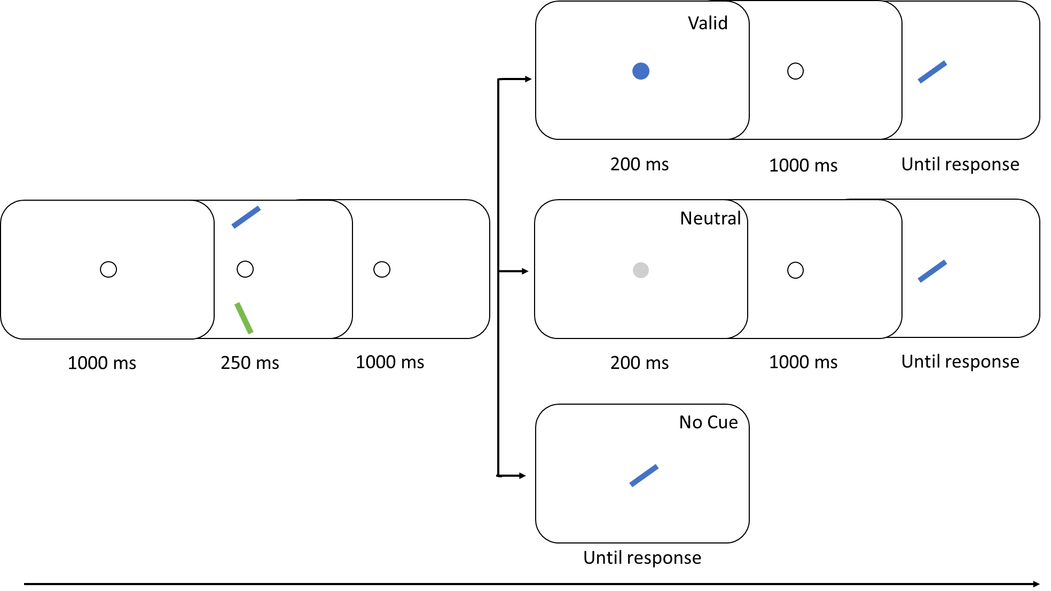
Figure 1. Time course of a trial for the three conditions of trials (Valid cue; Neutral cue; No cue) for the vertical version of the task.
- Results
Trials in which a participant made a gaze displacement of more than 2° during the period between the onset of the array and the response (3.3%; 435/13248) were excluded from the analyses. In the TD sample, we excluded 230 trials in the Vertical axis (10.45 ± 11.53 trials) and 204 in the Horizontal axis (9.27 ± 11.43 trials). We only excluded one trial in the Vertical axis for HGP2.
We first conducted a series of analyses to ensure that our task elicited the ocular drifts in response to the cue onset previously reported by van Ede and colleagues (2019). Spatial and temporal parameters of eye movements were extracted using Eyelink Data Viewer (SR Research Ltd., Mississauga, Canada). We analyzed the horizontal and vertical coordinates of the eye position between the onset of the cue (Valid or Neutral) and the onset of the target, resulting into a period of 1200 ms; data were aggregated into 60 bins of 20 ms. In each trial, missing data due to blinks were removed. Then, for each bin or each trial, we computed the deviation in visual angle towards the position in which the target was displayed: positive values indicate that the gaze was drifting towards the location where the target was previously displayed during the encoding phase and negative values indicate that the gaze was drifting away (as in van Ede et al., 2020). Hereafter, this variable was labelled “Towardness”.
For the TD group, we performed a series of t-tests to compare mean Towardness for Valid and Neutral trials within each axis. As shown in Figure 2, Towardness was significantly larger in the Valid than in the Neutral condition in the vertical axis, from 400 to 440 ms and from 480 ms after the onset of the cue until the onset of the target (all ps < .05). This was also observed in the horizontal axis, 460 ms after the onset of the cue until the onset of the target (all ps < .05).
In HGP2, we used a series of independent t-tests to compare Towardness of Valid and Neutral trials in each axis for every bin. In the non-paralyzed vertical axis, we observed significantly more positive Towardness in the Valid trials than in the Neutral trials between 400 ms and 500 ms and from 680 ms after the onset of the cue to the onset of the target (all ps < .05). As expected, in the paralyzed horizontal axis, no bins showed significant larger Towardness for the Valid cue (all ps > .4). In sum, as expected, the results of these analyses showed the typical ocular drifts in response to cue onset (van Ede et al., 2020) in both axis in the TD participants, and only in the non-paralyzed (vertical) axis in HGP2.
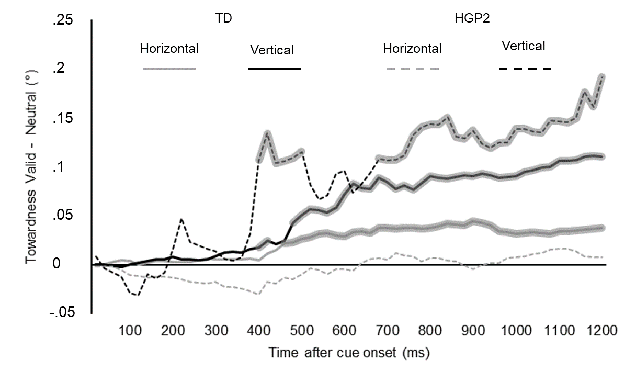
Figure 2: Gaze bias in degrees of visual angle as a function of time after the cue onset for HGP2 and TD sample in the Horizontal and Vertical axis. Gaze bias is represented as the difference between the Towardness for condition with a Valid Cue and the Towardness for condition with a Neutral Cue. Bold segments of the lines represent the time windows during which Towardness is significantly larger for Valid than for Neutral Cues.

We then examined the behavioral performance of the participants. Response latency (RL) analyses were carried out over correct responses only, after trials considered as outliers for each participant and each trial category (Cue Type x Axis) were removed (i.e., any RL smaller or larger by more than 2.5 median absolute deviation (MAD) than the individual’s median RL in a given condition; 6.2%; 824/13248; Leys, Ley, Klein, Bernard, & Licata, 2013). An inverse efficiency score (IES) was also computed for each participant and each trial category (Cue Type x Axis) by dividing the mean RL by the proportion of correct responses in a given condition (thus, the higher the score the poorer the performance). This score allows combining the measures of accuracy and speed into a single measure of processing efficiency, and thereby allows between-group comparisons unbiased by potential speed-accuracy tradeoffs (Townsend & Ashby, 1978, 1983; Vandierendonck, 2007). Individual scores for RL, Accuracy and IES are provided in Table S1.
We performed a series of analyses to compare HGP2 and TD group's performance across all conditions and axes in order to ensure that HGP2 could process (i.e., encode, maintain, and recall from memory) items displayed in the paralyzed axis, irrespective of the retro-cue condition. To this end, we applied modified t-tests for single-case vs. group comparison (Crawford & Howell, 1998) on IES. HGP2 performed as well as the TD participants in the horizontal and vertical conditions (for both t-tests: ts<1; ps >.2). We then applied the Bayesian standardized difference test (BSDT; Crawford & Garthwaite, 2007) on IES to test the possibility that HGP2’s performance could differ more between the two axes than in the TD group (i.e., we tested for a Group x Axis interaction). Her performance in the horizontal and vertical conditions did not differ more than in the TD group (P=.219).
We then assessed the presence of retro-cueing effects in the TD participants and in HGP2’s non-paralyzed axis. This was the case: TD participants were faster, more accurate and more efficient in the Valid cue than in the two control conditions for both axes (all twelve paired t-tests: ts (21) > 3.5; ps<.003, d > 1). In HGP2, independent samples t-tests on her RLs showed that she was significantly faster in the Valid cue condition than in the two control conditions for the non-paralyzed axis (both t-tests: ts> 10.1; ps<.001). Z-tests for two proportions on her accuracy showed that she made significantly less errors in the Valid Cue condition than in the two control conditions for the vertical non-paralyzed axis (both ps <.001).
Then, we performed a series of analyses to test whether HGP2’s horizontal gaze paralysis impaired her ability to displace her attention horizontally on a memorized visual space.
First, we tested for the presence of significant retro-cueing effect in her horizontal paralyzed axis (Figure 3). We used independent samples t-tests to assess whether her RLs were significantly faster in the Valid cue condition than in the two other conditions, and Z-tests for two proportions to test whether her accuracy was significantly higher in the Valid cue condition than in the two other conditions. All tests showed that HGP2 had significant retro-cueing effects in her paralyzed axis (RLs: both t-tests; ts>9.9 ps<.001; Accuracy, both Z tests ps <.001). Second, we tested the possibility that the horizontal retro-cueing effect found in HGP2 may nevertheless be smaller than in the TD participants. To do so, we applied the modified t-test (Crawford & Howell, 1998) on the IES to compare the retro-cueing effects of HGP2 and of the TD group for the (paralyzed) horizontal axis. These analyses revealed that the magnitude of the retro-cueing effects was not significantly different in HGP2 and in the TD group (both t-tests: ts<1.4; ps >.25). In fact, HGP2 had a larger horizontal retro-cueing effect than almost 75% of the TD sample (Valid cue vs. Neutral cue :74% ;95% CI: 59-88%; Valid cue vs. No cue: 73% 95% CI: 57-87%). Third, we applied the BSDT (Crawford & Garthwaite, 2007) on IES to test whether the discrepancy of retro-cueing effects between the two axes in HGP2 was significantly different from the discrepancy between the two axes in the TD group (i.e., we tested for a Group x Axis interaction). No particularity was observed in HGP2 as the discrepancy between her horizontal and vertical retro-cueing effects was not significantly different from those in the TD sample for both Neutral-Valid (P=.434) and No Cue-Valid (P=.481) retro-cueing effects. In the TD sample, 24 % (95%CI: 7-42%) of the participants showed a larger discrepancy in the same direction as HGP2.
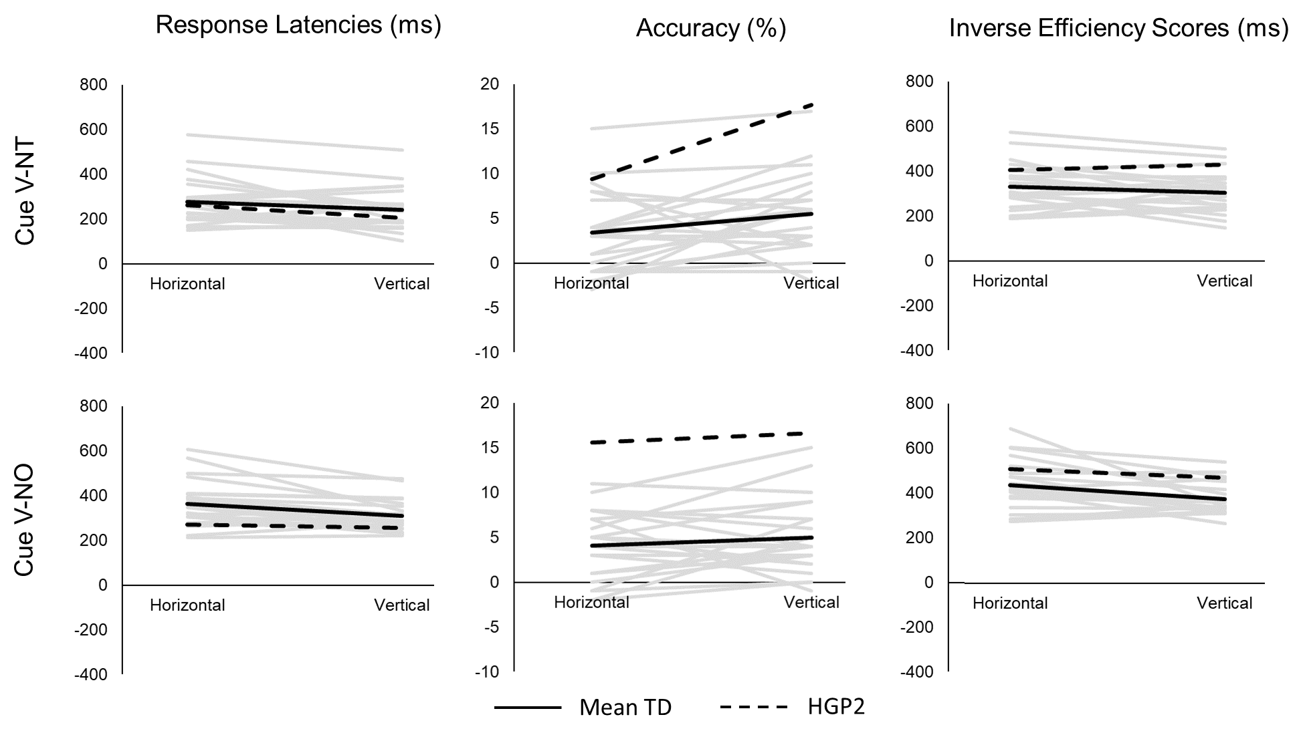
Figure 3. Difference between each participant’s mean response latency, accuracy and IES between the Valid cue and either the Neutral cue (Cue V-NT) or the No Cue condition (Cue V-NO). Black dashed lines represent the retro-cueing effects in HGP2. Black continuous lines represent the mean retro-cueing effects of the TD sample. Gray lines represent the retro-cueing effects of each TD individual.
- Discussion
Recent behavioral studies have shown that internal shifts of attention in VSSTM in response to a retro-cue are accompanied by eye movements in the direction of the position of the memorized item despite there is nothing left to look at. This finding raised the possibility that internal shifts of attention in VSSTM may be achieved through the planning of an eye movement “at” or “toward” the item stored in VSSTM as if it would actually be done in the external environment (e.g., van Ede et al., 2019; Hanning, et al., 2016; Ohl & Rolfs, 2020). To explore this possibility, we investigated the ability of an individual with congenital horizontal gaze paralysis (HGP2) to shift her attention horizontally or vertically toward a memorized item within VSSTM using a retro-cue paradigm, and compared her to TD participants. As congenital horizontal gaze paralysis prevents the development of horizontal oculomotor programming, if oculomotor programming is necessary for shifting attention in VSSTM, HGP2 should not show typical attentional shifts in VSSTM as indexed by the retro-cueing effect.
We observed that Valid cues elicited short gaze biases towards the position where the cued item was displayed in TD individuals and in HGP2 along her non-paralyzed axis, as observed by van Ede and colleagues (2019), but not in HGP2’s paralyzed axis. However, at odds with the hypothesis that oculomotor programming is necessary for shifting attention in VSSTM, we found the typical speed, accuracy and efficiency advantage for the retro-cued items in HGP2’s paralyzed axis. In addition, the retro-cueing effect found in HGP2’s paralyzed axis was as strong as the one observed in TD participants, and as strong as in her non-paralyzed axis. This finding implies that the ability to voluntarily shift attention to select an item in VSSTM does not rely on the mechanisms involved in planning or executing eye movements.
Our findings suggest that spontaneous eye movements shown to accompany retro-cues (van Ede et al., 2019) are not essential to shift attention in VSSTM. As such, this confirms that analyzing eye position is an interesting and sensible way to study the content of the focus of attention in typical individuals, but that it should not be taken as evidence of a functional role of eye movements to shift attention in VSSTM. Along the same lines, the finding that programming a saccade toward a portion of space associated with a memorized item ends up with an automatic prioritization of this item (Hanning et al., 2016; Ohl & Rolfs, 2020) should not be interpreted as evidence that shifts of attention in VSSTM are supported by saccade programming, but rather as evidence that saccade programming automatically triggers a subsequent mechanism of internal shift of attention to prioritize an item in VSSTM.
Alternatively, one might want to interpret the present results as showing that shifts of attention depend on gaze planning by means of any effector, that is not only eyes, but also the head, or the body. In this view, selecting items in VSSTM without eye movements could be supported by the programming of head movements as a compensatory mechanism. It was previously reported that an individual with gaze congenital paralysis developed head movements akin to saccades (Gilchrist, Brown, & Findlay, 1997) that even gain some properties typically ascribed to ocular saccades, such as saccadic suppression (Gilchrist, Brown, Findlay, & Clarke, 1998). Further studies should investigate whether planning head movements constitutes a compensatory mechanism in individuals with gaze paralysis or a complementary mechanism as efficient as ocular programming in TD individuals. As HGP2’s head was immobilized by a chin rest, it could be, for instance, that HGP2 programmed neck rotations toward the cued location that she did not execute. If so, any other body parts that may be used to shift gaze should be considered as a being potentially functional to mechanisms responsible for selecting an item within VSSTM.
Finally, our study focused on the mechanisms related to the retro-cue paradigm and it is worth noting that our conclusion is not incompatible with the possibility that oculomotor processes may play an important role in other aspects of VSSTM. One of these aspects could be the ability to remember sequences of positions. It has been shown, for instance, that patients with degenerative impairment of vertical eye movements but relatively spared horizontal eye movements have shorter memory spans for spatial sequences presented in their paralyzed axis than in their non-paralyzed axis (Smith & Archibald, 2018). In line with the possibility of a fundamental distinction between these two aspects of VSSTM, it has been shown that disrupting the ability to prepare and execute saccadic eye movements in TD participants with the eye abduction paradigm, a technique that is supposed to prevent oculomotor execution and preparation by presenting stimuli outside of oculomotor range (Craighero, Nascimben, Fadiga, 2004; Smith, Ball, Ellison, & Schenk, 2010), reduced the ability to memorize spatial sequences but not visual patterns (Ball, Pearson, Smith, 2013; Pearson, Ball, Smith, 2014). Altogether, these studies in conjunction with HGP2’s results support the idea of dissociable mechanisms for remembering different properties in visual spatial working memory (e.g., Klauer & Zhao, 2004).
Oculomotor mechanisms are also believed to underlie several other mental activities such as the exploration of a visual scene retrieved from long term memory (for a review, see Ferreira, Apel, & Henderson, 2008). Previous behavioral studies using interference paradigms have provided evidence that constraining or manipulating eye movements may impact the performance of participants (e.g., Bays & Husain, 2008; Hale, Myerson, Rhee, Weiss, Abrams, 1996; Johansson, Holsanova, Dewhurst, & Holmqvist, 2012; Johansson & Johansson, 2014; Laeng & Teodorescu, 2002; Lawrence, Myerson, & Abrams, 2004; Lawrence, Myerson, & Oonk, 2001). Moreover, eye movements are also known to accompany the manipulation of abstract concepts, such as numbers, because they would require to be spatialized within a mental space (e.g., Loetscher, Bockish, Nicholls, & Brugger, 2010; Masson, Letesson, & Pesenti, 2018; Salvaggio, Masson & Andres, 2019). Whether these mechanisms rely on oculomotor programming remains unknown. The investigation of individuals with gaze paralysis thus opens new avenues for the investigation of the functional role of eye movements in mental activities.
To conclude, we report typical retro-cueing effects in the paralyzed axis of an individual with congenital gaze paralysis. This observation demonstrates that shifts of attention in VSSTM to select a memorized item do not depend on the ability to program an eye movement toward the position where this item was displayed. We suggest that programming eye movements and shifts of attention in VSSTM in response to a retro-cue are two distinct mechanisms, but that initiating the first could automatically launch the latter.

Acknowledgements
The authors have no conflict of interest to declare. M.A. is a research associate and M.P. a senior research associate at the Fonds National de la Recherche Scientifique (FRS-FNRS, Belgium). M.A. was supported by grant PDR-T.0245.16 and N.M. by grant PDR-T.0047.18 from the Fonds National de la Recherche Scientifique (FRS-FNRS, Belgium) and grant FNR-INTER/FNRS/17/1178524 from the National Research Fund of Luxembourg (FNR, Luxembourg) to M.P. We wish to thank the association Syndrome Moebius France (http://moebius-france.org/en) for their support.
References:
Ball, K., Pearson, D. G., & Smith, D. T. (2013). Oculomotor involvement in spatial working memory is task-specific. Cognition, 129(2), 439-446. https://doi.org/10.1016/j.cognition.2013.08.006
Bays, P. M., & Husain, M. (2008). Dynamic shifts of limited working memory resources in human vision. Science, 321(5890), 851-854. DOI: 10.1126/science.1158023
Carta, A., Mora, P., Neri, A., Favilla, S., & Sadun, A. A. (2011). Ophthalmologic and systemic features in Möbius syndrome: An Italian case series. Ophthalmology, 118(9), 1518-1523. https://doi.org/10.1016/j.ophtha.2011.01.023
Cassanello, C. R., Ostendorf, F., & Rolfs, M. (2019). A generative learning model for saccade adaptation. PLoS Computational Biology, 15(8), e1006695. https://doi.org/10.1371/journal.pcbi.1006695
Craighero, L., Nascimben, M., & Fadiga, L. (2004). Eye position affects orienting of visuospatial attention. Current Biology, 14(4), 331-333.
Crawford, J. R., & Howell, D. C. (1998). Comparing an individual's test score against norms derived from small samples. The Clinical Neuropsychologist, 12(4), 482-486. https://doi.org/10.1076/clin.12.4.482.7241
Crawford, J. R., & Garthwaite, P. H. (2007). Comparison of a single case to a control or normative sample in neuropsychology: Development of a Bayesian approach. Cognitive Neuropsychology, 24(4), 343-372. https://doi.org/10.1080/02643290701290146
Diedrichsen, J., White, O., Newman, D., & Lally, N. (2010). Use-dependent and error-based learning of motor behaviors. Journal of Neuroscience, 30(15), 5159-5166. DOI: https://doi.org/10.1523/JNEUROSCI.5406-09.2010
Ferreira, F., Apel, J., & Henderson, J. M. (2008). Taking a new look at looking at nothing. Trends in Cognitive Sciences, 12(11), 405-410. https://doi.org/10.1016/j.tics.2008.07.007
Funk, M., Lutz, K., Hotz-Boendermaker, S., Roos, M., Summers, P., Brugger, P., … Kollias, S. S. (2008). Sensorimotor tongue representation in individuals with unilateral upper limb amelia. NeuroImage, 43(1), 121–127. https://doi.org/10.1016/j.neuroimage.2008.06.011
Gilchrist, I. D., Brown, V., Findlay, J. M., & Clarke, M. P. (1998). Using the eye–movement system to control the head. Proceedings of the Royal Society of London. Series B: Biological Sciences, 265(1408), 1831-1836. https://doi.org/10.1098/rspb.1998.0509
Gilchrist, I. D., Brown, V., & Findlay, J. M. (1997). Saccades without eye movements. Nature, 390(6656), 130-131. https://doi.org/10.1038/36478
Gressmann, M., & Janczyk, M. (2016). The (un) clear effects of invalid retro-cues. Frontiers in Psychology, 7, 244. https://doi.org/10.3389/fpsyg.2016.00244
Hahamy, A., & Makin, T. R. (2019). Remapping in cerebral and cerebellar cortices is not restricted by somatotopy. Journal of Neuroscience, 39(47), 9328-9342. DOI: https://doi.org/10.1523/JNEUROSCI.2599-18.2019
Hale, S., Myerson, J., Rhee, S. H., Weiss, C. S., & Abrams, R. A. (1996). Selective interference with the maintenance of location information in working memory. Neuropsychology, 10(2), 228. https://doi.org/10.1037/0894-4105.10.2.228
Hanning, N. M., & Deubel, H. (2018). Independent effects of eye and hand movements on visual working memory. Frontiers in systems neuroscience, 12, 37. https://doi.org/10.3389/fnsys.2018.00037
Hanning, N. M., Jonikaitis, D., Deubel, H., & Szinte, M. (2016). Oculomotor selection underlies feature retention in visual working memory. Journal of Neurophysiology, 115(2), 1071-1076. https://doi.org/10.1152/jn.00927.2015
Johansson, R., Holsanova, J., Dewhurst, R., & Holmqvist, K. (2012). Eye movements during scene recollection have a functional role, but they are not reinstatements of those produced during encoding. Journal of Experimental Psychology: Human perception and performance, 38(5), 1289. https://doi.org/10.1037/a0026585
Johansson, R., & Johansson, M. (2014). Look here, eye movements play a functional role in memory retrieval. Psychological Science, 25(1), 236-242. https://doi.org/10.1177/0956797613498260
Jonikaitis, D., & Moore, T. (2019). The interdependence of attention, working memory and gaze control: behavior and neural circuitry. Current opinion in psychology, 29, 126-134. https://doi.org/10.1016/j.copsyc.2019.01.012
Kaas, J. H. (2000). The reorganization of somatosensory and motor cortex after peripheral nerve or spinal cord injury in primates. Progress in Brain Research, 128, 173-179. https://doi.org/10.1016/S0079-6123(00)28015-1
Kaas, J. H., Merzenich, M. M., & Killackey, H. P. (1983). The Reorganization of Somatosensory Cortex Following Peripheral Nerve Damage in Adult and Developing Mammals. Annual Review of Neuroscience, 6(1), 325–356. https://doi.org/10.1146/annurev.ne.06.030183.001545
Klauer, K. C., & Zhao, Z. (2004). Double dissociations in visual and spatial short-term memory. Journal of Experimental Psychology: General, 133(3), 355. https://doi.org/10.1037/0096-3445.133.3.355
Laeng, B., & Teodorescu, D. S. (2002). Eye scanpaths during visual imagery reenact those of perception of the same visual scene. Cognitive Science, 26(2), 207-231. https://doi.org/10.1207/s15516709cog2602_3
Landman, R., Spekreijse, H., & Lamme, V. A. F. (2003). Large capacity storage of integrated objects before change blindness. Vision Research, 43, 149–164. doi:10.1016/S0042-6989(02)00402-9
Lawrence, B. M., Myerson, J., Oonk, H. M., & Abrams, R. A. (2001). The effects of eye and limb movements on working memory. Memory, 9(4-6), 433-444. https://doi.org/10.1080/09658210143000047
Lawrence, B. M., Myerson, J., & Abrams, R. A. (2004). Interference with spatial working memory: An eye movement is more than a shift of attention. Psychonomic Bulletin & Review, 11(3), 488-494. https://doi.org/10.3758/BF03196600
Loetscher, T., Bockisch, C. J., Nicholls, M. E., & Brugger, P. (2010). Eye position predicts what number you have in mind. Current Biology, 20(6), R264-R265. https://doi.org/10.1016/j.cub.2010.01.015
Masson, N., Andres, M., Carneiro Pereira, S., Pesenti, M., & Vannuscorps, G. (2020). Typical exogenous covert shift of attention without the ability to plan eye movements. Current Biology, 30 (18), R1032-R1033. https://doi.org/10.1016/j.cub.2020.07.074
Masson, N., Letesson, C., & Pesenti, M. (2018). Time course of overt attentional shifts in mental arithmetic: Evidence from gaze metrics. Quarterly Journal of Experimental Psychology, 71(4), 1009-1019. https://doi.org/10.1080/17470218.2017.1318931
Mathôt, S., Schreij, D., & Theeuwes, J. (2012). OpenSesame: An open-source, graphical experiment builder for the social sciences. Behavior research methods, 44(2), 314-324. https://doi.org/10.3758/s13428-011-0168-7
Makin, T. R., Scholz, J., Henderson Slater, D., Johansen-Berg, H., & Tracey, I. (2015). Reassessing cortical reorganization in the primary sensorimotor cortex following arm amputation. Brain, 138(8), 2140–2146. https://doi.org/10.1093/brain/awv161
Miall, R. C., & Wolpert, D. M. (1996). Forward models for physiological motor control. Neural Networks, 9(8), 1265-1279. https://doi.org/10.1016/S0893-6080(96)00035-4
Noto, C. T., & Robinson, F. R. (2001). Visual error is the stimulus for saccade gain adaptation. Cognitive Brain Research, 12(2), 301-305. https://doi.org/10.1016/S0926-6410(01)00062-3
Ohl, S., & Rolfs, M. (2017). Saccadic eye movements impose a natural bottleneck on visual short-term memory. Journal of Experimental Psychology: Learning, Memory, and Cognition, 43(5), 736. https://doi.org/10.1037/xlm0000338
Ohl, S., & Rolfs, M. (2018). Saccadic selection of stabilized items in visuospatial working memory. Consciousness and cognition, 64, 32-44. https://doi.org/10.1016/j.concog.2018.06.016
Ohl, S., & Rolfs, M. (2020). Bold moves: Inevitable saccadic selection in visual short-term memory. Journal of Vision, 20(2), 1-14. doi:https://doi.org/10.1167/jov.20.2.11
Pearson, D. G., Ball, K., & Smith, D. T. (2014). Oculomotor preparation as a rehearsal mechanism in spatial working memory. Cognition, 132(3), 416-428. https://doi.org/10.1016/j.cognition.2014.05.006
Reilly, K. T., & Sirigu, A. (2011). Motor cortex representation of the upper-limb in individuals born without a hand. PLoS ONE, 6(4). https://doi.org/10.1371/journal.pone.0018100
Salvaggio, S., Masson, N., & Andres, M. (2019). Eye position reflects the spatial coding of numbers during magnitude comparison. Journal of Experimental Psychology: Learning, Memory, and Cognition, 45(10), 1910. https://doi.org/10.1037/xlm0000681
Shadmehr, R., Smith, M. A., & Krakauer, J. W. (2010). Error correction, sensory prediction, and adaptation in motor control. Annual Review of Neuroscience, 33, 89-108. https://doi.org/10.1146/annurev-neuro-060909-153135
Smith, D. T., & Archibald, N. (2018). Spatial working memory in progressive supranuclear palsy. Cortex, 122, 115-122. https://doi.org/10.1016/j.cortex.2018.07.004
Smith, D. T., Ball, K., Ellison, A., & Schenk, T. (2010). Deficits of reflexive attention induced by abduction of the eye. Neuropsychologia, 48(5), 1269-1276. https://doi.org/10.1016/j.neuropsychologia.2009.12.028
Stoeckel, M. C., Seitz, R. J., & Buetefisch, C. M. (2009). Congenitally altered motor experience alters somatotopic organization of human primary motor cortex. Proceedings of the National Academy of Sciences of the United States of America, 106(7), 2395–2400. https://doi.org/10.1073/pnas.0803733106
Striem-Amit, E., Vannuscorps, G., & Caramazza, A. (2018). Plasticity based on compensatory effector use in the association but not primary sensorimotor cortex of people born without hands. Proceedings of the National Academy of Sciences of the United States of America, 115(30), 7801–7806. https://doi.org/10.1073/pnas.1803926115
Vandierendonck, A. (2017). A comparison of methods to combine speed and accuracy measures of performance: A rejoinder on the binning procedure. Behavior Research Methods, 49(2), 653-673. https://doi.org/10.3758/s13428-016-0721-5
van Ede, F., Chekroud, S. R., & Nobre, A. C. (2019). Human gaze tracks attentional focusing in memorized visual space. Nature Human Behaviour, 3(5), 462-470. doi: 10.1038/s41562-019-0549-y
Vannuscorps, G., Andres, M., & Caramazza, A. (2020). Efficient recognition of facial expressions does not require motor simulation. Elife, 9, e54687. DOI: 10.7554/eLife.54687
Vannuscorps, G., Andres, M., Carneiro Pereira, S., Rombaux, E. & Caramazzza, A. (2021). Typical efficient lipreading without motor stimulation. Journal of Cognitive Neuroscience. doi: https://doi.org/10.1162/jocn_a_0166
Wong, A. L., & Shelhamer, M. (2012). Using prediction errors to drive saccade adaptation: the implicit double-step task. Experimental Brain Research, 222(1-2), 55-64. DOI 10.1007/s00221-012-3195-4
Zokaei, N., Board, A. G., Manohar, S. G., & Nobre, A. C. (2019). Modulation of the pupillary response by the content of visual working memory. Proceedings of the National Academy of Sciences of the United States of America, 116(45), 22802-22810. https://doi.org/10.1073/pnas.1909959116

