Course on Genome Instability and Human Disease- 5th edition
October 2-8, 2023 – Institut Curie, Paris, France

SPEAKER FORM
(to return as soon as possible to ana-rita.furtado@curei.fr or c.genomeinstability2023@curie.fr )

- SPEAKER INFORMATION (for Badge):

FIRST Name LAST Name | Anabelle DECOTTIGNIES
AFFILIATION (Institution) | de Duve Institute, UCLouvain
CITY - COUNTRY: | Brussels, Belgium

To advertise your talk within Institut Curie :
- TITLE OF YOUR TALK:

TRF1 and telomerase dosage is crucial to face replication stress at telomeres

- ABSTRACT

Telomeres are hard-to-replicate regions where fork progression is hampered by many obstacles, such as G-quadruplexes, RNA-DNA hybrids or the T-loop, and cannot be rescued by a converging fork. Many proteins help preventing telomere fragility and ensuring efficient telomere replication. Our project aims to further investigate how cells deal with replication stress at telomeres. We took advantage of a set of isogenic post-crisis survivors from E6/E7-immortalized human fibroblasts that spontaneously activated telomerase at various levels to investigate the genetic requirements of telomere replication. Evidences exist in mouse and yeast that telomerase can act on reversed forks at telomeres experiencing replication stress and new data suggest that telomerase can elongate reversed telomeric forks from a mini-chromosome introduced in human cells. Our data suggest that telomerase acts on the leading strand of naturally-occurring reversed forks provoking lagging strand fragility.
We propose a model in which TRF1 and telomerase dosage is crucial to allow efficient replication of telomeres experiencing replication stress.

- Your PICTURE (tif, png or jpeg format):

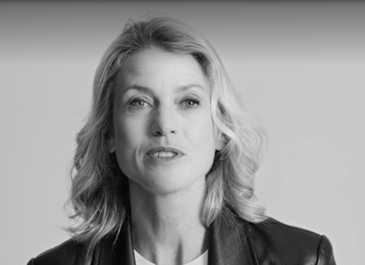

- TRAVEL & HOTEL
 | Arrival | Departure | Number of nights in the hotel
Date | October 5 | October 6 | 1
To ease the organization and reimbursement procedure, please buy your tickets yourself. Institut Curie will reimburse your travel expenses or your institution directly (please read the reimbursement conditions send in the same email). Hotel accommodation for up to 2 nights in charge of the course.
- DIETARY RESTRICTION (cross option below)
NONE | X
Vegetarian
Allergy

- QUESTIONS AND SPECIAL REQUESTS
==============================================================================
COURSE VENUE
Institut Curie, Paris, France

