
Factsheet for decision makers

1) Title of the Factsheet

Participatory monitoring of river flows

- 2) Key words :

Citizen science
Participatory approach
Water resources monitoring
- 3) Field of interest:

Water resources management

- 4) Topic

Water resources monitoring

- 5) Type de mesure d’adaptation choisir 1 de l’annexe I

Green solution
 | Climate change challenge addressed
Water users in northwestern Tunisia, like the Medjerda watershed, are increasingly withdrawing water from hydro-systems. This is a response to the effects of climate change that are causing strong variability. These water withdrawals result in an increase in the state of stress over time (Fehri et al., 2020). The involvement of citizens, in a participatory manner, is likely to help raise awareness among water users. The use of Mobile application has been validated in the region of Medjez El Bab by the involvement of different citizen groups (Fehri et al., 2020a; Fehri, 2021). The objective of this sheet is to capitalize on these achievements and to be used in the north-west of Tunisia for monitoring droughts or floods.
 |  |  | Description of the adaptation approach, technology or strategic management for adaptation
The involvement of citizens in the process of collecting water-related data, as a source of additional information complementary to official observations, is likely to improve the spatial and temporal resolution of water resources monitoring. It will also make stakeholders and users aware of the constraints weighing on the water sector. The participatory monitoring approach improves the integrated management of water resources. Citizens can contribute to the collection of flow data through mobile applications. In times of drought, this is likely to make them aware of the state of the resource and to better understand, and even adhere to, water management programs. During periods of high water and flooding, participants in the program will be alerted at the appropriate time. The technical services of the Ministry of Agriculture as well as educational and research institutions could create the sites, perform training sessions for the volunteers, establish, and maintain a platform to host observations. Members collect data through mobile devices and will benefit from the information.

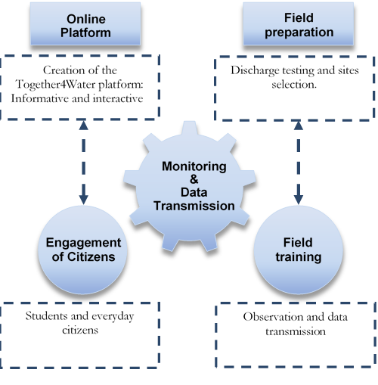
Figure 1. Implementation of the participatory flow collection approach according to Fehri et al. (2020b).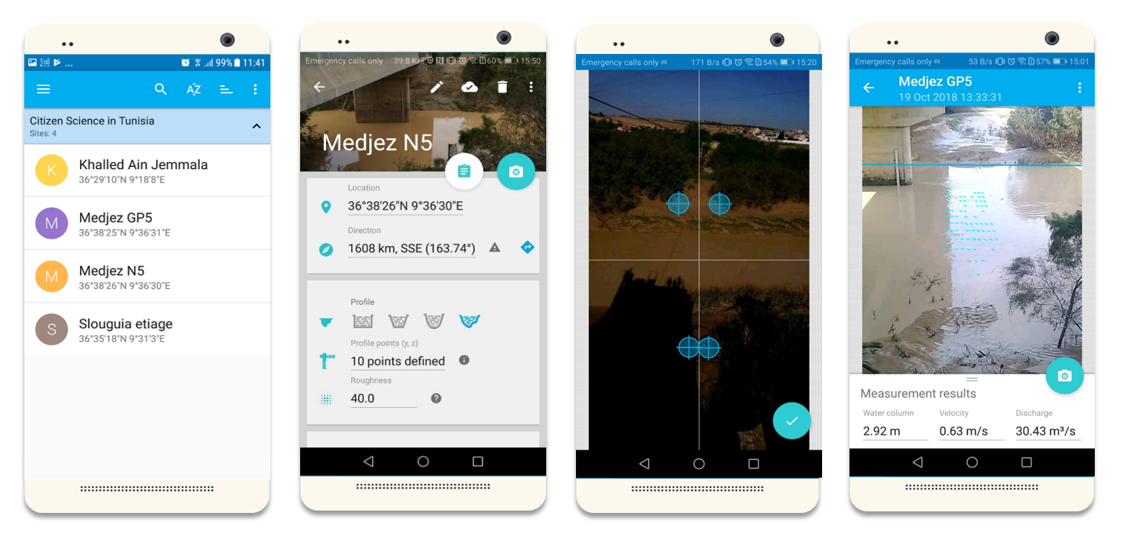
Figure 2: Flow measurement by at the Medjez el Bab station (Raed et al., 2020a).
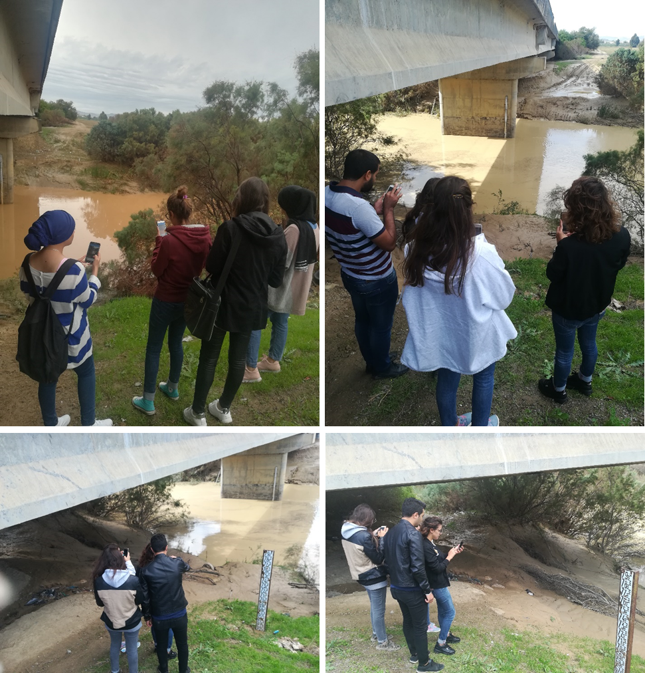
Figure 3: Volunteer training session at Medjez el Bab N5 station (October 2018).

 |  | Expected Impacts to tackle the climate change related challenge
The proposed solution is innovative for the water sector for Tunisia. The participatory approach should be involved in integrated water resources management programs, especially in the context of water scarcity associated with climate change. Indeed, the stakeholder engagement and commitment approach (water users, technicians, researchers, decision-makers, and civil society) contribute to a better understanding of the vulnerability of the hydrological system and therefore their greater responsibility. This is an essential aspect in the context of transition that Tunisia is going through (Fehri et al., 2017). The actions related to the water management program would be better applied and therefore could better achieve its purpose, especially during periods of increasingly severe water scarcity. Another oucome is the flood warning and announcement of floods through the strengthening and densification of official hydrometric stations and access to information from all stakeholders.

YES |  |  | NO | = | Approach proposed:
Low | Medium | High
 |  | X |  |  | Causes a transformation (societal, economic, institutional, etc.)
 | X |  |  |  | Reduces water demand
 | X |  |  |  | Improve sanitary conditions and ecosystem functionality (resilience)
 |  | X |  |  | Adopts a multisectoral approach (integration)
 |  | X |  |  | flexible
 |  | X |  |  | robust
 |  |  |  |  | TOTAL


Actors et Roles
Here you can list the concrete actors, institutions or others who need to be involved to develop or implement the action and their role in developing the political approach or strategy.
Example:
Involved actor: Ministry of Agriculture
Role: to promote the integration of current legislation
Acteur engagé | Rôle
Technical directories of Ministry of Agriculture | Adoption of the solution  Implementation of platform to collect data and announcement (draught and flood)  Plateform management
Regional technical services of Ministry of Agriculture (CRDA) | Data collection  Sites’ implementation
Stakholders (Sociaties for Agricultural Develpemnt (GDA), farmers, civil society) | Data collection  Data access related to the hydro-systems
Tunisian Agriculture and Fishing Union at regional and local level | Sites’ implementation  Sites’ management
Academics and researchers | Data valorization  Data collection

Authors of the factsheet

Slaheddine Khlifi (ESIM)
Raed Fehri (UC Louvain)
Marnik Vanclooster (UC Louvain)
Oussama Rhouma (ESIM)
Khalifa Riahi (ESIM)
Safa Chaabene (ESIM et CITET)
Makram Bouzidi (INAT et INRGREF)
Jawaher Gasmi (ESIM)
Amani Belhaj Kilani(ESIM)

Bibliographical references

Fehri, R. (2021). Participatory approaches to monitor water-related Sustainable Development Goal (SDG 6) in Tunisia. PhD dissertation. Doctoral thesis in Sciences agronomiques et ingénierie biologique, UCLouvain, Belgium
Fehri, R., Bogaert, P., Khlifi, S., Vanclooster, M. (2020a). Data fusion of citizen-generated smartphone discharge measurements in Tunisia. Journal of Hydrology, (590), 125518. doi:10.1016/j.jhydrol.2020.125518.
Fehri R., Khlifi S., Vanclooster M. (2020b). Testing a Citizen Science water monitoring approach in Tunisia. Environmental Science and Policy 104 (Water Innovation in Africa): 67 – 72 DOI: 10.1016/j.envsci.2019.11.009.
Fehri R., Khlifi S., Vanclooster M. 2019.Desaggregating SDG-6 water stress indicator at different spatial and temporal scales in Tunisia. Science of the Total Environment 694, 133766 DOI: 10.1016/j.scitotenv.2019.133766
Fehri R., Vanclooster M., Khlifi S. 2017. Scientific and participatory approaches to monitor water related SDG (SDG-6) in Tunisia. Revue des Régions Arides 41 : 321 – 326p

- ANNEX I –FILLING ELEMENTS OF THE FACTSHEET

3) Select a field of interest :
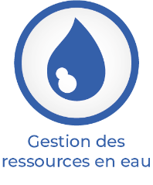





4) Select a topic (order of the list is random):

1. Soil fertility,
2. Water saving,
3. Forest exploitation
4. Plant protection,
5. Soil erosion
6. Water governance,
7. Forest management,
8. Genetic improvement.
9. Land use
10. Water quality,
11. Forest conservation
12. Floods,
13. Sylvopastoralism,
14. Drought
15. Procurement and infrastructure
16. Livestock management,
17. Fishing for invasive species,
18. Collection of runoff water
19. Etc….

5) Select the type of adaptation measure:

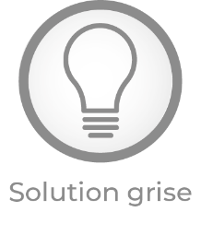

The action takes into account current knowledge but can be modified according to unforeseen conditions, i.e. generally refers to adaptation processes, to an incremental set of transformative actions. The development of an adaptation strategy or the evolution of cultures are flexible actions, the construction of a water transfer infrastructure is not.
The action maintains the expected impact under a wide range of possible climate change scenarios. That is, the restoration of wetlands or the ban on building houses in a floodplain.

