THE CONTENT OF THERAPEUTIC EDUCATION FOR PATIENTS WITH TEMPOROMANDIBULAR DISORDERS:
A SYSTEMATIC SCOPING REVIEW

Timothée CAYROLa , Alice Masquelier a, Marie Remacle a, Laurent Pitance a, b

a Institute of Experimental and Clinical Research (IREC), UCLouvain, Brussels, Belgium
b Oral and Maxillofacial Surgery unit, Cliniques Universitaires Saint-Luc, Brussels, Belgium
Presenting author’s contact details:
Place Pierre de Coubertin 1/L8.10.01. 1348 Louvain-la-Neuve. Belgium.
Tel.: +32 (0)478.21.13.43. Email address: Timothee.cayrol@uclouvain.be
Background and aims: Therapeutic education has an important role in the treatment of temporomandibular disorders (TMD)¹. However, there is no consensus about the content of this therapeutic education. The aim of this scoping review was to extract the contents of therapeutic education for TMD in the scientific literature in order to develop a therapeutic education protocol specific to TMD.

Methods: A preferred Items for Systematic reviews and Meta-Analyses extension for Scoping Reviews (PRISMA) approach was followed². A systematic search was developed and applied to Pubmed, Scopus, Psychinfo and Cochrane databases to identify studies discussing the content of therapeutic education applied to TMD. All stages of the review were completed independently in duplicate and were peer-reviewed. The content of therapeutic education was extracted, mapped, narratively synthesized and utilized to develop a specific therapeutic education protocol for patients with TMD.

Results: 21 studies out of 552 were included and analyzed for this review. The following themes of therapeutic education were identified (in order of frequency at which they were reported in studies): ‘specific advises about TMD’, ‘lifestyle factors’, ‘dealing with parafunctional activity’, ‘relaxation techniques’, ‘temporomandibular joint anatomy’, ‘the benign nature of TMD’, ‘etiological factors of TMD’, ‘cognitive behavioral dimension’, ‘stress’ and ‘pain physiology’ (figure 1 and 2). The professional providing the therapeutic education was rarely specified but included researchers, psychologists, dentists and infrequently physiotherapists. Therapeutic education of TMD was mainly delivered in oral form.

Conclusion: Based on the findings of this study, therapeutic education should be individualized, biopsychosocial, and delivered orally by a healthca re professional (possibly with a booklet to take home). Therapeutic education for patients with TMD should include specific information concerning TMD as well as general education regarding relaxation, stress, cognitive-behavioral dimension of TMD and pain physiology.

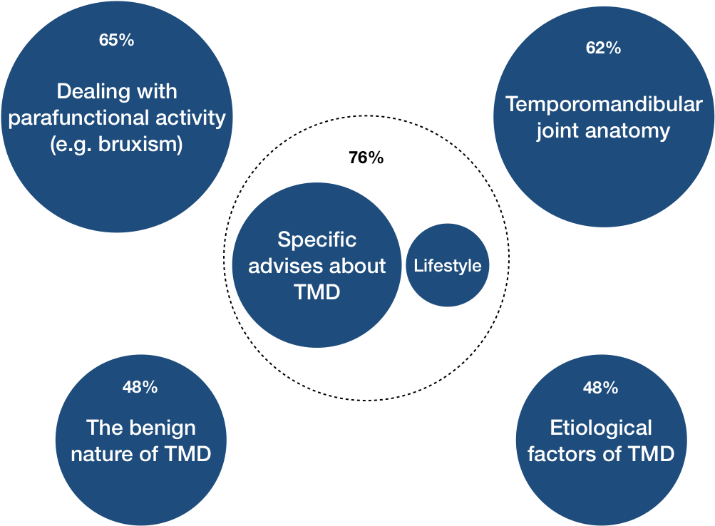

Figure 1. Mapping of the main themes of therapeutic education specific to TMD. The bubble sizes represent the frequency (%) with which the themes are reported in studies.

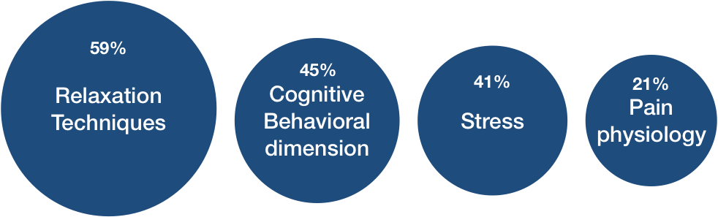

Figure 2. Mapping of the main themes of therapeutic education non-specific to TMD. The bubble sizes represent the frequency (%) with which the themes are reported in studies.

References:
- J Oral Rehabil. 2013 Nov;40(11):864-74. doi: 10.1111/joor.12098. Epub 2013 Sep 18. Counselling and self-management therapies for temporomandibular disorders: a systematic review. de Freitas RF, Ferreira MÂ, Barbosa GA, Calderon PS.
- Peters, M. D., Godfrey, C. M., Khalil, H.,Mc Inerney, P., Parker, D., Soares, C.B. (2015). Guidance for conducting systematic scoping reviews. International Journal of Evidence Based Healthcare, 13(3), 141-146.

