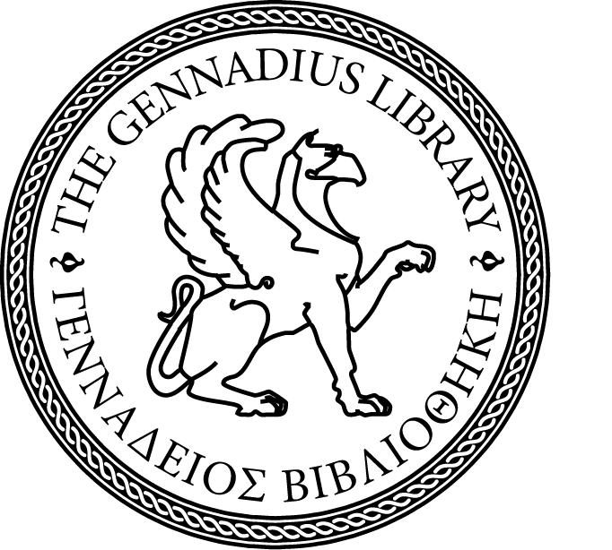
THE GENNADIUS LIBRARY
OF THE AMERICAN SCHOOL OF CLASSICAL STUDIES AT ATHENS

Gennadeion Seminar

presents

Illia Kovalenko
Ph.D. Candidate in Religious Studies,
École Pratique des Hautes Études – PSL / UCLouvain
Scholarship holder of the École française d’Athènes

Agapios Landos and the History of the Book:
Orthodox Spirituality in Print

(the presentation will be in English)

fEBRUARY 27, 2025, 4.00pm

The Pia Zombanakis Seminar Room

For more information please contact: Maria Smali <msmali.genn@ascsa.edu.gr>, 210 – 72.10.536 (ext. 301)

