(In)stability of the Professional Trajectories of Asylum Seekers and Refugees in Belgium
Natacha Zimmer
Abstract: Ensuring a stable employment situation is crucial for asylum seekers, as it not only provides them with economic resources but also facilitates their active integration into the life of the host country and adaptation to a new environment. However, the course and (in)stability of employment trajectories of asylum seekers and refugees remain little explored in Belgium. We aim to describe how those trajectories are shaped for a cohort of asylum-seeking migrants who arrived in Belgium between 2004 and 2007. The concept of (in)stability is further examined by looking at whether individuals stay for long in specific activity sectors. Using data from administrative sources, we rely on sequence analysis to describe employment trajectories. Then, we use logistic regressions to explore the determinants of employment stability. Results suggest that employment careers among asylum migrants are unstable, with short and fragmented periods of employment. The sectors "Hotel, Catering and Trade", "Building and Industry" and "Health and Social" present career paths that show a certain continuity, by remaining in a single activity sector over the observed period after arrival. Our study also indicates the existence of an ethnic stratification across these activity sectors which groups people with the same origins. We argue that this is in favour of the stabilisation of employment situations. Finally, this research suggests that economic integration policies for asylum migrants should not only address entry into employment but also long-term career stability. They should leverage benefits of the social networks while promoting access to diverse sectors to avoid marginalisation.
Keywords: sequence analysis, asylum seekers, Belgium, employment trajectories, stability, activity sectors

Introduction
Over the last 30 years, Belgium has received a substantial number of migrants seeking international protection, as defined by the 1951 Geneva Convention (Ouali, 2004). Between 1999 and 2014, more than 320,000 asylum applications were submitted to the Aliens Office (CGRS, 2019a). Asylum migrants live in Belgium for different lengths of time and are involved in the country’s socio-economic life. However, migration for international protection is often carried out on an emergency basis, and individuals do not have the opportunity to choose their destination based on job opportunities that they will find there (Brell et al., 2020; Cheung & Phillimore, 2014; Kubiciel–Lodzińska et al., 2024; Leitner, 2023). Rather, the experience of forced migration is often traumatic, putting the migrant at a disadvantage when integrating into the destination country (Heidinger, 2023; Lens et al., 2018). Also, socio-economic integration is more difficult than for other migrants, as they are often disadvantaged by their weak local social networks and lower language skills (Lens et al., 2018). Yet, having a stable professional situation proves to be crucial as it not only provides the asylum applicants with economic resources but also allows them to actively integrate into the life of the host country and adapt to a new environment (Blom, 2004; Jackson & Bauder, 2013). Moreover, various studies, not necessarily focused on immigrants, have examined the impacts of unstable career paths on many domains of the life course (going from the labour market integration itself (Schmitt, 2012) to health (He et al., 2006), the fertility (Kreyenfeld, 2010), or the life at older ages (Fournier et al., 2011)). Employment instability is characterised by several elements: unemployment and repeated periods without a job (He et al., 2006; Kreyenfeld, 2010), non-permanent positions (Schmitt, 2012), discontinuity in the career (Fournier et al., 2011), or having precarious incomes (Fournier et al., 2011; Schmitt, 2012).
This paper examines the access to a stable employment career for applicants and beneficiaries of international protection in Belgium. To understand how the employment trajectories are shaped, we first present a brief overview of existing research. The prevailing perspective in the literature often focuses on entry into employment and typically examines individuals who have already been granted protection, highlighting the factors that hinder their labour market insertion. Thus, we propose to focus on the duration of employment and continuous career paths, looking at whether there is regular mobility in and out of employment. Our long-term approach also accounts for the period of the asylum procedure to complement existing work.
We then explain the administrative context in Belgium and its implications regarding the employment of asylum migrants. Next, we describe our data, which consists of a sample of migrants who applied for international protection in Belgium. Individuals’ socio-demographic and economic information is retrieved from the Belgian National Register coupled with the Crossroads Bank of Social Security (CBSS). The following section explains the sequence analysis method used to build and describe a typology of employment careers. Binomial and multinomial logistic regressions are also conducted to identify the determinants of the (in)stability of employment trajectories. We primarily focus on the effects of the protection status granted and the sector of employment. The results are presented in two sections. First, we describe the employment trajectories. We found that they are unstable and not frequent among asylum-seeking migrants in Belgium. Second, we explore the stratification of the labour market across activity sectors and highlight that trajectories in some sectors present greater stability. By taking a long-term perspective on career paths, this research provides relevant insights for policy measures focused on the integration of asylum migrants. It underscores the importance of considering factors that enhance employment stability when making decisions about the long-term settlement and economic integration of asylum migrants.

Labour Market Stratification and Job Stability
In Belgium and other destination countries, immigrants face less favourable employment situations than natives. This is often referred to as a segmentation of the labour market (Colic-Peikser & Tilbury, 2006; Kogan, 2004) or an ethnic stratification (Adam, 2006, 2007; Gracia et al., 2016). These concepts encompass two main dimensions. First, immigrants perform less well in the labour market than locals. For example, unemployment rates are higher among immigrants in host countries (Blom, 2004; Krahn et al., 2000) and opportunities are limited to precarious jobs with short contracts or poor working conditions (Adam, 2007). For the Belgian case, the Organisation for Economic Co-operation and Development (OECD) also points to differences in employment rates: in 2014, the employment rate was 63.8% among the Belgian-born compared to 52.8% for the foreign-born (OECD, 2024). Second, the accessibility to various jobs and activity sectors differs across origin groups. Research in Canada and Switzerland found that asylum seekers were mainly concentrated in less skilled sectors of work (Söhn, 2019), such as hotels, cleaning, agriculture, and building (in Canada: Jackson & Bauder, 2013; in Switzerland: Piguet & Wimmer, 2000). In Belgium, studies conducted on data from the Crossroads Bank for Social Security (Verhoeven & Martens, 2000) and the Labour Force Surveys (Okkerse & Termotte, 2004) similarly show that immigrants are more present in the hotel and catering (hereafter Horeca), trade, industry, and agriculture sectors (Okkerse & Termotte, 2004; Verhoeven & Martens, 2000).
Among asylum-seeking migrants, the obstacles to rapid access and stable professional careers are as numerous or even more important compared to other immigrants (Jackson & Bauder, 2013). They fare worse than other immigrants in the labour market (Backman et al., 2021) and their employment rates are lower (Herman & Rea, 2017) due to language deficiencies (Brell et al., 2020) or uncertain legal status (Bertrand, 2019). In Belgium, the median duration between arrival in the country and first job is 4 years for cohorts of refugees who arrived between 2001 and 2014 (Carpentier & Schoumaker, 2018). On the other hand, other factors could contribute to securing employment trajectories. For example, an analysis of Swiss administrative registers found that having a more stable residence status, i.e. that allows a longer stay (Bertrand, 2019), helps the migrant and/or the employer to plan for the long term and to secure the employment situation. Thus, the conditions governing access to employment significantly vary depending on the legal status of the migrant (Bertrand, 2019). However, in Belgium, few asylum applications result in a protection status. Also, asylum seekers and refugees experience complex and lengthy administrative procedures, which hinder their entry into the labour market (Wets & Rea, 2014). The following section presents the specific context of Belgium regarding the legal permits and the implications on access to employment and social welfare.

Belgian Context: Legal Status, Access to the Labour Market, and Social Assistance
In Belgium, international protection statuses are defined according to the 1951 Geneva Convention. Asylum seekers first apply to the Aliens Office and the asylum procedure then considers their eligibility for refugee or subsidiary protection status (CGRS, 2019c). A recognised refugee is a person who is granted an unlimited right of residence in the country at the end of this procedure. Subsidiary protection is granted when the criteria for refugee status are not fully met but returning to the country of origin still entails significant risks. Regarding labour market access, refugees benefit from direct access to the labour market. This is not the case for beneficiaries of the subsidiary protection who only obtain a limited right of residence (one year, renewable) and must obtain a work permit to undertake a professional career in Belgium. This work permit covers one year, renewable. It is also accessible to asylum seekers whose procedure is underway, provided they have been present in Belgium for more than 6 months (Carpentier & Schoumaker, 2018) .
In addition to access to the labour market, economic and social integration into Belgian society also relies on access to various social security benefits, which may be a springboard to employment or, on the contrary, may lead to situations of 'social dependence' (Herman & Rea, 2017). Three types of allowances are distinguished: unemployment benefits, integration income, and social assistance. Eligibility for unemployment benefits relies on the legal right of residence as well as on professional activity: one must be granted a protection status and have already worked in Belgium (Lens et al., 2017). The integration income, which corresponds to a monthly allowance, 'allowing the applicant to lead a life in accordance with human dignity' (Burniaux, 2015: 5), is only granted to recognised refugees. Finally, social assistance is a monthly or occasional financial allowance, available to anyone who arrived in Belgium before June 2007 (Dupont, 2007).‬ ‬‬‬
These different legal situations outline the administrative and legal complexity of the life course in Belgium and already partly explain the difficulties encountered during the migrant’s professional careers. Among other things, the uncertainty linked to short residence permits makes employers reluctant to hire these workers or extend their contracts (Bertrand, 2019; Jackson & Bauder, 2013; Söhn, 2019). Differences in access to unemployment or social assistance benefits create disparities in the socio-economic pathways of those who have or have not obtained a protection status (Herman & Rea, 2017). ‬‬‬‬‬‬‬‬‬‬‬‬‬‬‬‬‬‬‬‬‬‬‬‬‬‬‬‬‬‬‬‬‬‬‬‬‬‬‬‬‬‬‬‬‬‬‬‬‬‬‬‬‬‬‬‬‬‬‬‬‬‬‬‬‬‬‬‬‬‬‬‬‬‬‬‬‬‬‬‬‬‬‬‬‬‬‬‬‬‬‬‬‬‬‬‬‬‬‬‬‬‬‬‬‬‬‬‬‬‬‬‬‬‬‬‬

Research Objectives
Numerous elements, both favourable and unfavourable to professional insertion, have been identified in the literature, but the course and (in)stability of employment trajectories of asylum seekers and refugees remain little explored, particularly in Belgium. Existing literature often focuses on examining the initial stages of labour market integration among refugees and/or relies on cross-sectional data. Although entry into employment is a crucial step in economic integration, we argue that the way the professional situation evolves is of equal importance. Long-term approaches are needed to complement existing studies and help understand whether challenges faced upon entry into the labour market hold in the long term and what other barriers might occur. An innovative aspect of this paper is thus its comprehensive study of the employment trajectories of refugees and asylum seekers in the host country, similarly to the research by Bertrand (2019) in Switzerland and Herman and Rea (2017) in Belgium. However, the latter do not consider migrants before they receive international protection, whereas our contribution studies migrants from the moment they file an asylum application. By shifting the focus from simple entry into the labour market to encompass the longitudinal nature of individuals' career paths, our central questions are as follows: how are their employment trajectories shaped, are they more or less stable, and what factors influence their (in)stability?

Data

Studying Employment Trajectories using Administrative Registers
Data from the Belgian National Register and the Crossroads Bank of Social Security (CBSS) are used to study the career paths of asylum seekers and refugees. The register includes socio-demographic information along with a detailed record of administrative procedure and residence permits obtained, dated to the day. It is an administrative data collection tool whose primary function is to identify persons present on Belgian territory (Poulain & Herm, 2013). Registration in the register depends on the legal right of residence obtained: Belgian citizens and foreigners with an unlimited right of residence are registered in the population register; foreigners who have received permission to stay in the territory for more than three months are registered in the foreigners' register; asylum seekers whose administrative procedure is ongoing are registered in the waiting register (Rea et al., 2014).
The CBSS data gathers information provided by all the social security institutions in Belgium. It provides quarterly information on the socio-economic position in the labour market at the end of each three months. When an individual is working, it describes the type of employment (employee, self-employed, complementary activity) as well as the activity sector (NACE code). When a person is not working, the CBSS records his/her socio-economic position according to whether he/she is receiving social assistance (unemployment benefits, social security benefits, pension, etc.). These longitudinal data make it possible to know the social and economic situation of individuals over time and are therefore suitable for the analysis of evolving social processes and the description of trajectories (Beauchemin & Schoumaker, 2016).
The information is comprehensive and detailed about legal status, employment situations, and social assistance benefits. National Register data is more reliable than those from retrospective surveys (Billari, 2001). However, this data does not provide insights into educational attainment, language skills, or social capital. It also has the disadvantage of considering only formal situations of residence or work, and thus hides periods when people work informally or remain on the territory regardless of the final rejection of their asylum application. In the latter case, they are generally removed from the administrative registers. Despite this, formal work situations are important to analyse because they allow access to unemployment benefits, among other things.

Study Sample
This article uses an extract from these administrative databases. We have a simple random sample of a quarter of the individuals registered in the National Register, who immigrated to Belgium between 1999 and 2014 and were at least 18 years old at arrival. Our analyses focus on individuals who applied for international protection in Belgium between 2004 and 2007 and were aged between 18 and 65 years at arrival (which corresponds to the active ages), i.e. 9,550 individuals. The choice of this cohort was made for several reasons: first, a major change in the CBSS nomenclatures complicates comparisons between the data available before and after 2003; second, it allows the examination of the evolution of professional careers in Belgium in the short and medium term. Indeed, the slow access to employment mentioned earlier implies the need to observe individuals over long periods to study their professional trajectories. This cohort was monitored during the 7 years after arrival in the country, a period that allows us to observe both professional integration and professional development in the first years of employment. Observations are recorded at the end of every quarter, resulting in the creation of sequences of 28 consecutive states: the 28 quarters that make up the 7 years of observation following arrival in Belgium. Persons who died during this observation period were not considered in the analyses. As for those who leave Belgium during the period, they are kept in the analyses by considering the socio-economic information available until they are removed from the registers and then indicating their exit. This allows us to consider the many situations where applicants do not ultimately remain in the host country.

Methods

A Descriptive and Explanatory Research Strategy
A sequence analysis method is used to describe typical trajectories experienced by applicants and beneficiaries of international protection in the Belgian labour market. It allows for a graphical visualisation, offering a nuanced understanding of career paths in their longitudinal dimension, shedding light on patterns of stability and change over time. Compared to survival methods, sequence analysis enables a holistic approach to individuals’ trajectories rather than examining the occurrence of isolated events over time (Backman et al., 2021). As it was already used in previous studies in Belgium (Herman & Rea, 2017) and elsewhere (e.g. Bertrand, 2019), it gives a robust framework to answer our research questions, leveraging the register data at our disposal.
However, as sequence analysis is a primarily descriptive method, the resulting classification of employment trajectories is then used as a dependent variable in logistic regressions (binomial and multinomial) to identify the factors associated with the different clusters and support the descriptive results from the sequence analyses. The independent variables included are gender, age group at arrival, and region of birth. The type of protection status granted by the end of the observation period is also included to account for the impact of administrative situations.

Operationalising the Method
Applying sequence analysis involves two phases: first, comparing individual trajectories with each other and, second, classifying them according to their (dis)similarities.
Optimal matching (Abbott & Tsay, 2000) is used to compare career paths. This method measures the dissimilarity between pairs of sequences, by computing the effort that is required to transform one into the other (Billari, 2001; Robette, 2011). A cost is assigned to each elementary operation required (insertion, deletion, or substitution of states) and the total cost should be as small as possible. Substitution costs are computed using transition costs: the lower the probability of transitioning from one state to the other, the higher the substitution cost (Robette, 2011). Deleting and then inserting a state (indel) implies alterations in the temporal structure of the sequences. In the context of a study on the construction of professional careers, this temporal structure is particularly important to preserve. Therefore, a higher value than the substitution costs is assigned to this indel indicator. In this way, the deletion and insertion operations are less utilised when computing the distances between sequences (Robette, 2011).
The resulting distance matrix is then used to create meaningful typologies with a hierarchical ascending classification. It aggregates the sequences that are most similar to each other (Lesnard & de Saint Pol, 2006). The choice of the number of clusters is made based on Ward's criterion, which minimises intra-class heterogeneity and maximises inter-class heterogeneity (Robette, 2011). Once the categories of typical trajectories have been created, graphs such as state distribution plots and sequence index plots, as well as descriptive tables, allow the description of these clusters (Gabadinho et al., 2011). We also compute the mean number of transitions per sequence in each cluster. It is the average number of changes from one state to another during a single sequence. We consider this measure as an indicator of the stability of the trajectories (Robette, 2011): the higher the number of transitions, the less stable the trajectory.

Implementing the Sequence Analysis: Statuses on the Labour Market
To reconstruct the employment trajectories, we define two groups of states, leading to the creation of two typologies through a primary and a secondary sequence analysis. The first analysis is carried out to highlight the trajectories mostly involved in employment. Based on the nomenclature of the socio-economic positions of the CBSS, we create six distinct states showing the situation of individuals in each quarter: "employed", "unemployment benefits", "integration income", "social assistance", "other" and "exit from the register". The "other" category groups situations of inactivity in the Belgian labour market: in particular, students, homemakers, people who work without being affiliated with the Belgian social security system, etc. The "exit from the register" status covers all the quarters in which individuals are no longer present in the National Register and CBSS data, either because they have emigrated or because they have been deregistered.
For the second sequence analysis, we used the activity sector in which individuals work. This second typology focuses only on individuals who experience the predominantly employed careers identified in the first typology. Based on an original use of the Statistical Classification of Economic Activities in the European Community (NACE), we grouped the activities into 14 main sectors. The numerous activities are classified into broad sectors with similar qualification levels and themes. The purpose of this distinction is to identify sectors that do or do not provide greater stability of professional trajectories and test our hypothesis of the ethnostratification of the labour market. Through the lens of activity sectors, the measure of stability relies on whether a trajectory occurs in a single activity sector and in a relatively continuous way or not (few or many transitions and changes of sectors in one sequence).

Results

Trajectories in Employment
The first sequence analysis results in 6 clusters, that summarize the typical socio-economic paths among asylum seekers and refugees in Belgium. The graphs and descriptive statistics of this typology are provided in appendices 1 and 2. Because of the questions raised in this paper, only cluster 1, “Trajectories towards employment”, is considered here since it groups the socio-economic pathways with the largest proportion of time spent in employment. The clusters of the typology that are not discussed in this article concern trajectories outside the formal labour market (cluster 2, 33.8%), trajectories of benefit from social welfare (cluster 3, 5.5% and cluster 4, 4.1%), and finally trajectories exiting from the administrative data (cluster 5, 28.9% and cluster 6 8.7%). In these clusters, individuals spend on average less than 6 months in employment during the entire observation period.
For cluster 1 (19.0%) on the other hand, individuals spend an average of 3 years in employment over the 7 years of observation (Figure 1). It includes the highest mean number of transitions between states per individual sequence, i.e. 5.6 state changes (compared to a range of 1.1 to 3.6 in all other clusters). Employment periods are fragmented and interspersed with periods outside the formal labour market (red lines on the sequence index plot) or periods of unemployment (light beige). Moreover, this type of trajectory represents a minority in the sample studied, illustrating the low employment rate of asylum seekers and refugees (see Appendix 2). Men (72%), of relatively young ages (73.4% between 20 and 34 years old) are overrepresented in comparison with the other clusters. Individuals born in Sub-Saharan African countries are also strongly represented (52.8% of the cluster). French is often one of the official languages in these countries, which may favour professional integration in Belgium. Furthermore, 42.4% of the cluster was granted refugee protection before the end of observation and 5.2% were granted subsidiary protection. Those who did not get any protection status over the observation period are also present in cluster 1 but to a lesser extent in comparison with the other clusters (Appendix 2).
Fig. 1 Trajectories towards employment: state distribution and sequence index plot (N=1,818, 19% of the total sample of 9,550 individuals)
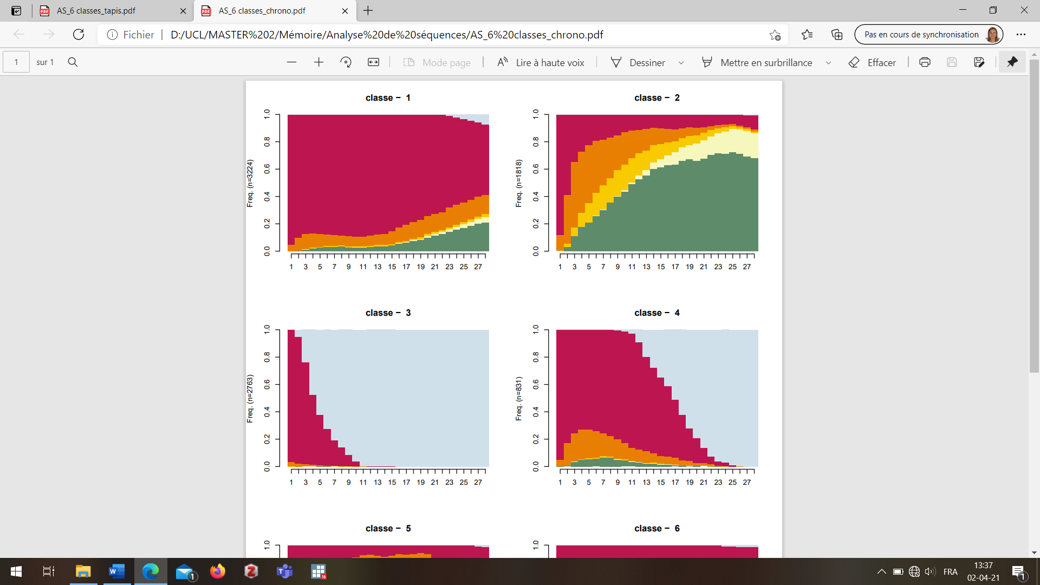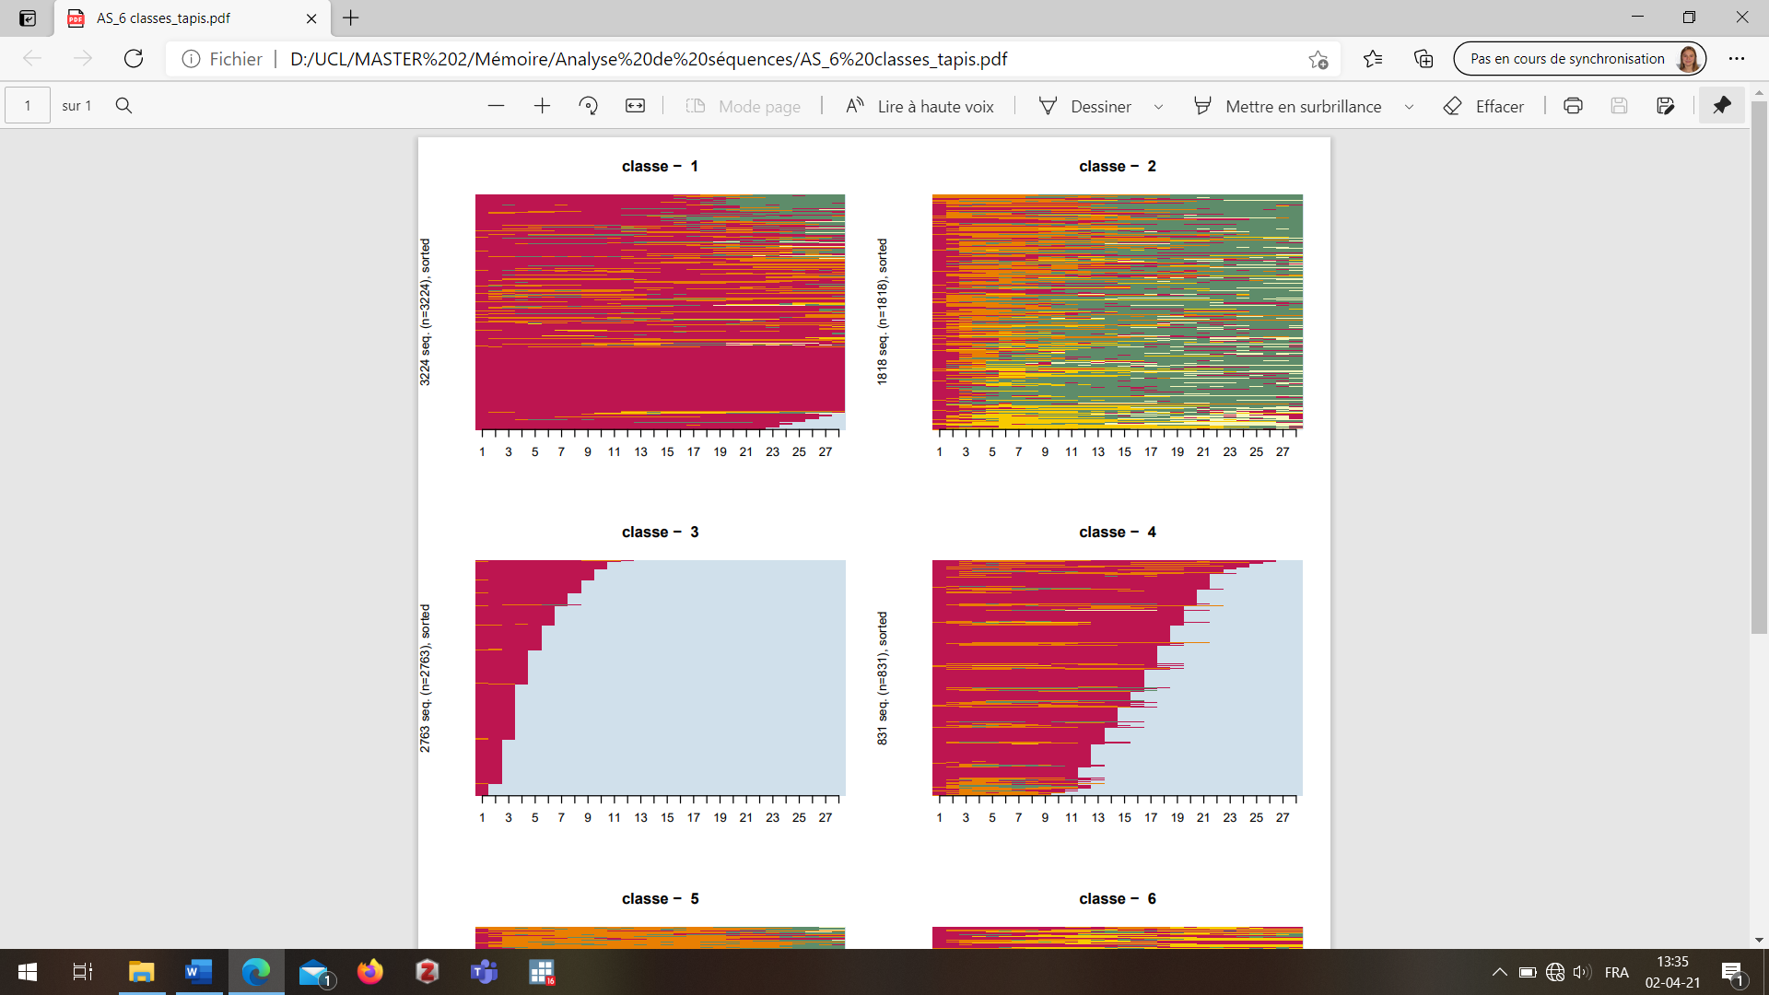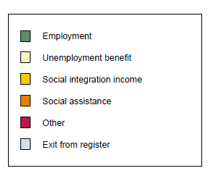
Time post-arrival (in quarters)
Frequency
Time post-arrival (in quarters)
Reading: The state distribution plot (left) shows the proportion of the population in each state at each quarter. The sequence index plot (right) shows all individual trajectories (each line being an individual trajectory). It thus keeps the longitudinal dimension. Each trajectory is represented by a succession of states recorded at the end of each quarter (i.e. a succession of 28 states per individual, presenting the 28 quarters of the 7-year observation period). The horizontal axis presents the time since arrival in Belgium, measured in quarters.
Data: applicants for international protection, arrived between 2004 and 2007
Source: National Register and CBSS
We conducted a binomial logistic regression to understand which factors are associated with a significant probability of belonging to this cluster 1, “Trajectories towards employment”. The results are presented in odd ratios (Table 1). They express whether the likelihood of being in cluster 1 is higher for a specific category of the explanatory variable compared to a reference category. The findings indicate that women are less likely to be in cluster 1 and, conversely, the age groups at arrival 25-29 and 30-34 are more likely to be in this cluster rather than in another. This is consistent with previous research findings showing that women generally have lower employment rates (Backman et al., 2021; Brell et al., 2020) and people between 26 and 40 (intermediary ages) are more likely to have more active working careers (Backman et al., 2021; Herman & Rea, 2017).‬‬‬‬‬‬‬‬‬‬‬‬ The regression also highlights the benefit of being granted refugee protection: asylum seekers and beneficiaries of subsidiary protection are much less likely to be in this cluster of trajectories towards employment. This is also consistent with the existing literature on the benefits of having a stable residence permit (Bertrand, 2019). Regarding the region of birth, individuals born in Sub-Saharan Africa and in Eastern Asia have significantly higher odds of being in the trajectories towards employment compared to those born in non-EU European countries.‬ ‬‬‬‬‬‬‬‬‬This result is consistent with an ethnic stratification of the labour market as it shows higher access to employment careers for specific origins.‬‬‬‬‬‬‬‬‬‬‬‬‬‬‬‬‬‬‬‬‬‬‬‬‬‬‬‬‬‬‬‬‬‬‬‬‬‬‬‬‬‬
‬‬‬‬‬‬‬‬‬‬‬‬‬‬‬‬‬‬‬‬‬‬‬‬‬‬‬‬‬‬‬‬‬‬‬‬‬‬‬‬‬‬‬‬Table 1 Logistic regression model on the main socio-demographic characteristics for cluster 1, compared to the other clusters (N = 9,550)

 | Odd Ratio |  | 95% confidence interval
Gender
Male | Ref.
Female | 0,51 | *** | 0,45 | 0,58
Age at arrival
18-24 | Ref.
25-29 | 1,25 | *** | 1,07 | 1,45
30-34 | 1,21 | ** | 1,02 | 1,43
35-39 | 1,11 |  | 0,92 | 1,36
40-49 | 0,91 |  | 0,73 | 1,13
50 and over | 0,35 | *** | 0,23 | 0,53
Region of birth
European Union | 0,32 | *** | 0,16 | 0,61
Europe non-EU | Ref.
Western Asia | 1,22 | ** | 1,02 | 1,45
Eastern Asia | 1,65 | *** | 1,14 | 2,39
North Africa | 0,88 |  | 0,59 | 1,32
Subsaharan Africa | 3,23 | *** | 2,80 | 3,72
Latin America and the Carribeans | 2,55 | ** | 1,06 | 6,17
Protection status
Subsidiary protection | 0,50 | *** | 0,37 | 0,98
Refugee | Ref.
No protection | 0,10 | *** | 0,91 | 0,12
R²: 0.18
*** p<0.01 ; ** p<0.05 ; * p<0.1
Reading: The odds of being in the class of employment trajectories, rather than in any other class, are halved for women compared to men, the reference category (odds ratio of 0.51).
Data: applicants for international protection, arrived between 2004 and 2007
Source: National Register and CBSS
This first part of the analysis shows that the “Trajectories towards employment” regroup less than a fifth of the sample studied and are characterised by a relatively late entry into employment and interspersed periods of work, confirming our hypothesis. Employment is not very stable among asylum seekers and refugees as few individuals remain in the same situation for long. To understand which factors may influence this (in)stability, an in-depth analysis is carried out among individuals from cluster 1 by constructing a second typology of trajectories based on the sectors of professional activity.

(Un)stable Employment Trajectories and Activity Sectors
The second sequence analysis based on activity sectors allows us to distinguish between 5 main trajectories (Figure 2). For the first three clusters (a, b, and c, 35.5% of cluster 1 together), career paths essentially take place in one main sector: Horeca and Trade for the cluster (a); Building and Industry for (b); Health and Social for (c). For the three clusters, we also observe the presence of the Temporary work sector and the Agriculture sector at the beginning of many individual sequences (Figure 2). These sectors appear to be useful for insertion into a first job even if work situations are more precarious in these sectors (seasonal work, less qualified jobs, short-term contracts, etc.). For the three clusters, half of the observation period or more is spent in employment (4.7 years for (a) and (b); and 3.5 years for (c)). Moreover, clusters (a), (b) and (c) show the fewest transitions between states among trajectories of this second analysis, they are the most stable. In contrast, the other two clusters (d and e) are characterised by a high degree of heterogeneity of activity sectors within the sequences. They group the largest shares of individuals with 44.2% and 20.3% of cluster 1, respectively. For cluster (d), individuals spend less time in employment (on average 2.4 years out of 7), whereas in cluster (e), the average time spent in employment is longer (4.4 years). Despite this difference, they both show a lower stability of the career paths: they have an average number of transitions between states respectively of 4.5 and 4.9, which is higher than in other clusters (Appendix 3). The careers are not continuous in a single activity sector.
The socio-demographic composition of the second typology (Appendix 3) shows that cluster (a), Horeca and Trade trajectories, has a high share of men (84.5%), often born in Asian countries, such as Nepal or Afghanistan. The Building and Industry trajectories in the cluster (b) also gather more men (94.0%), but more often born in European countries outside the European Union, mainly from the former USSR or the former Yugoslavia. As for cluster (c), whose careers are in the Health and Social sector, women are overrepresented (61.4%), often born in Sub-Saharan African countries. Cluster (d) and (e) have similar socio-demographic composition. Most individuals experiencing these turbulent trajectories are men. Cluster (d) has the highest number of individuals who are granted protection before the end of observation: 50.3% were granted refugee protection and 5.1% were granted subsidiary protection. Conversely, in clusters (a, b, c), there is a low representation of individuals who are granted international protection before the end of the 7-year observation period: about 60% of individuals are not granted protection in each of these clusters.

Fig. 2 Graphical representations of the sequence analysis by sector (state distribution and sequence index plot)
Cluster a: Trajectories in the Horeca and Trade sector
(N = 251, 13.8% of the 1,818 individuals in cluster 1)
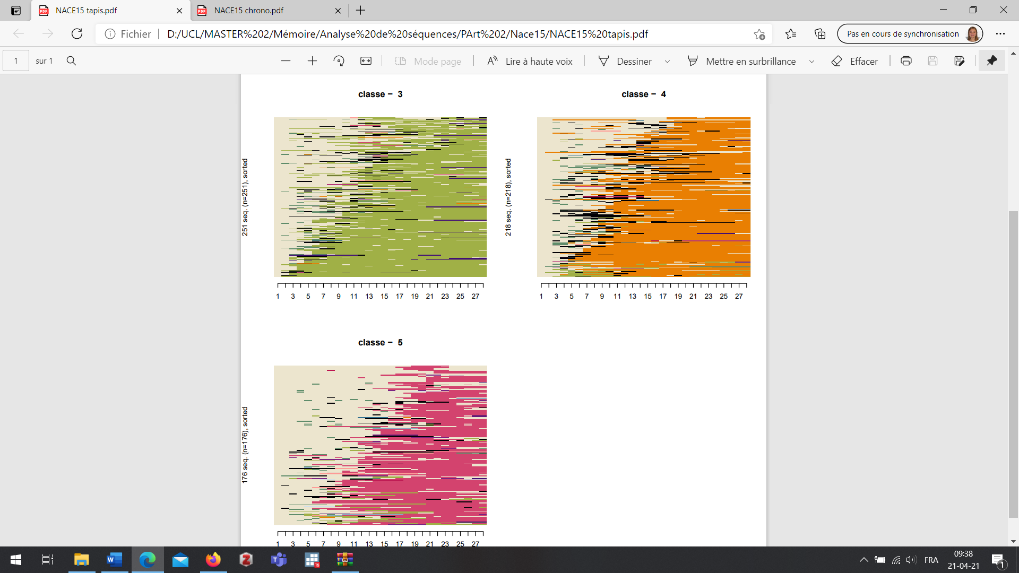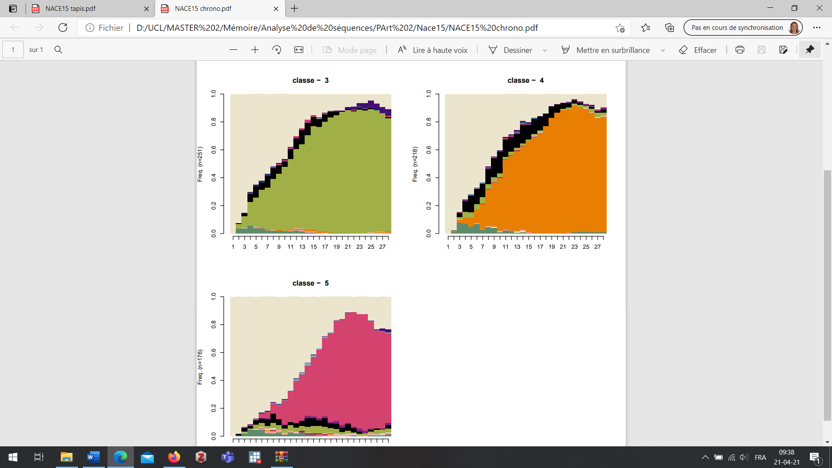
Frequency
Time post-arrival (in quarters)
Time post-arrival (in quarters)
Cluster b: Trajectories in the Building and Industry sectors
(N = 218, 12% of 1,818 individuals in cluster 1)
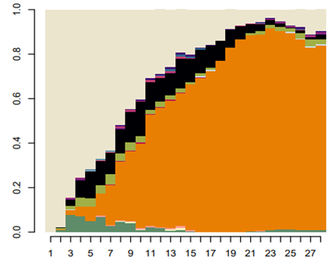
Frequency
Time post-arrival (in quarters)
Time post-arrival (in quarters)
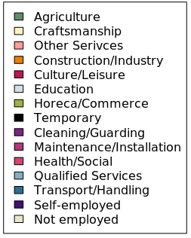

Cluster c: Trajectories in the Health and Social sector
(N = 176, 9.7% of 1,818 individuals in cluster 1)
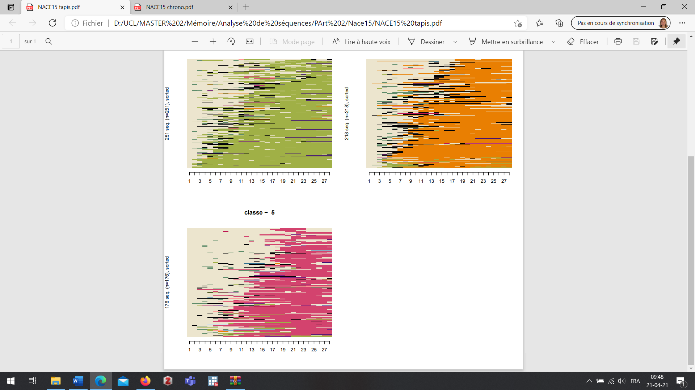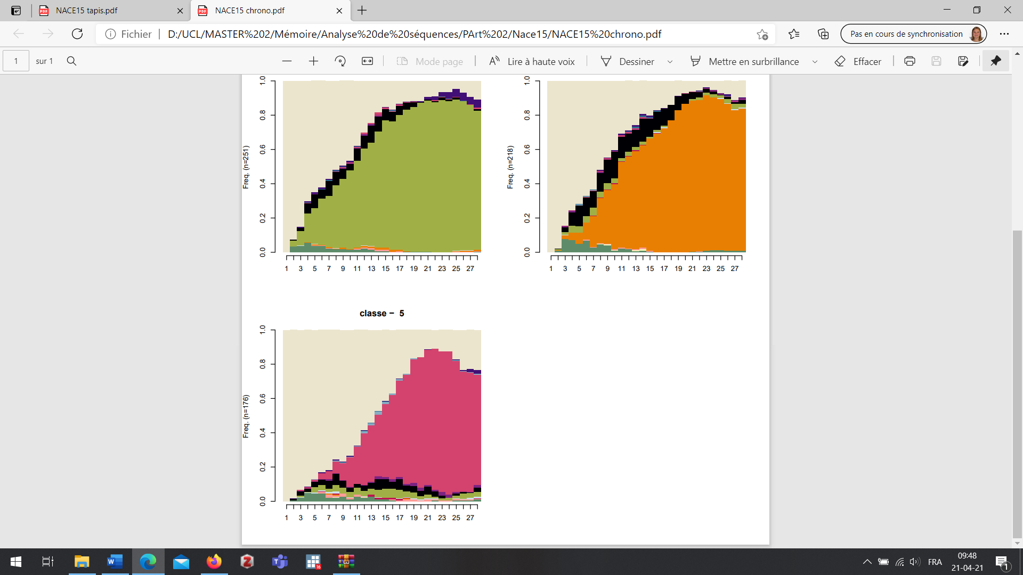
Frequency
Time post-arrival (in quarters)
Time post-arrival (in quarters)
Cluster d: Low employment trajectories and multiple sectors
(N = 804, 44.2% of 1,818 individuals in cluster 1)
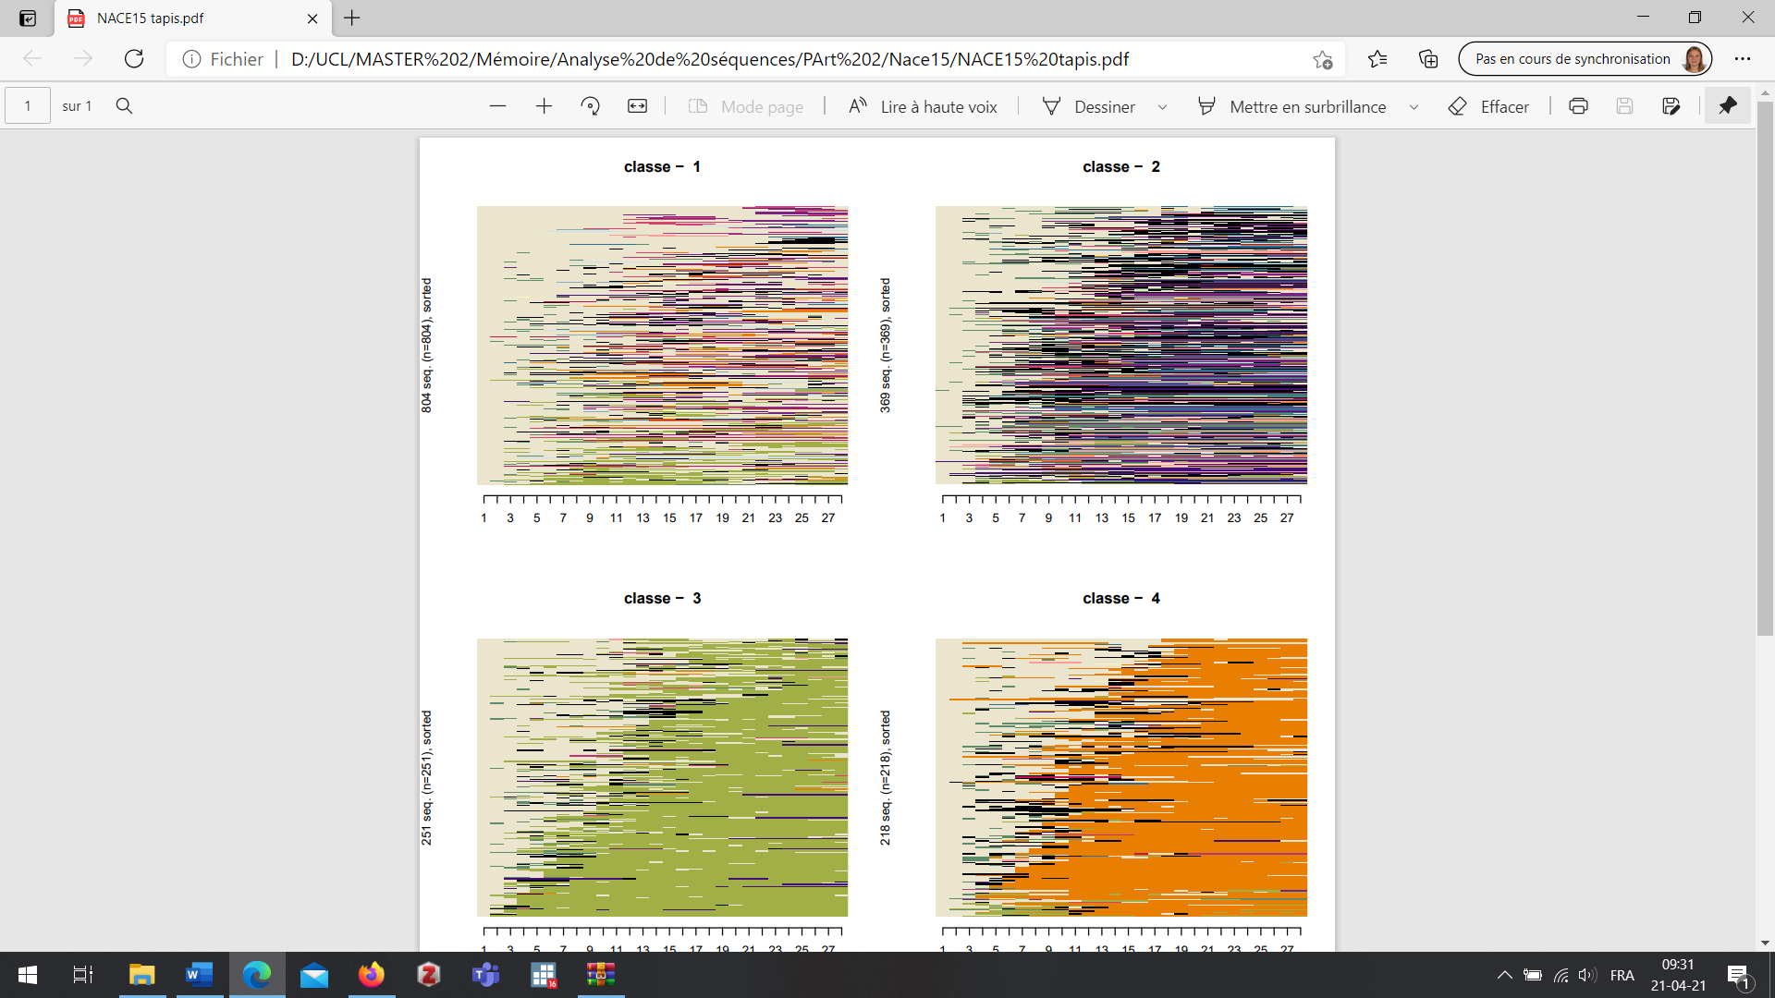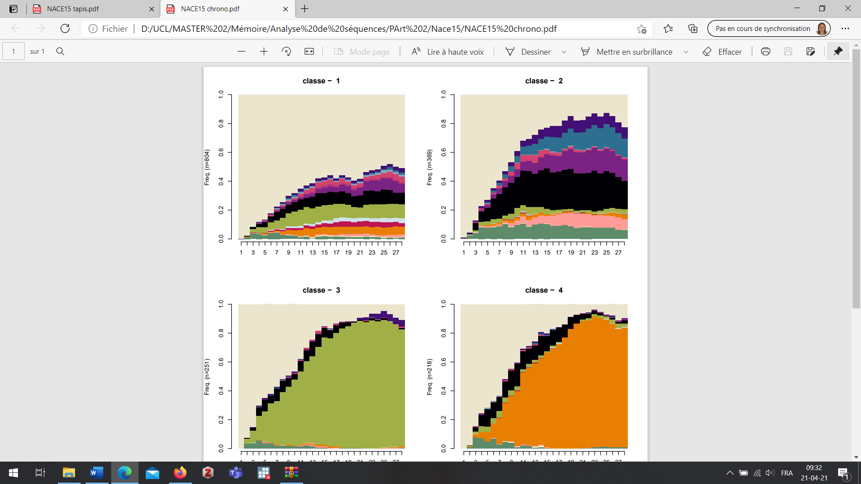
Frequency
Time post-arrival (in quarters)
Time post-arrival (in quarters)
Cluster e: employment trajectories and multiple sectors
(N = 369, 20.3% of 1,818 individuals in cluster 1)
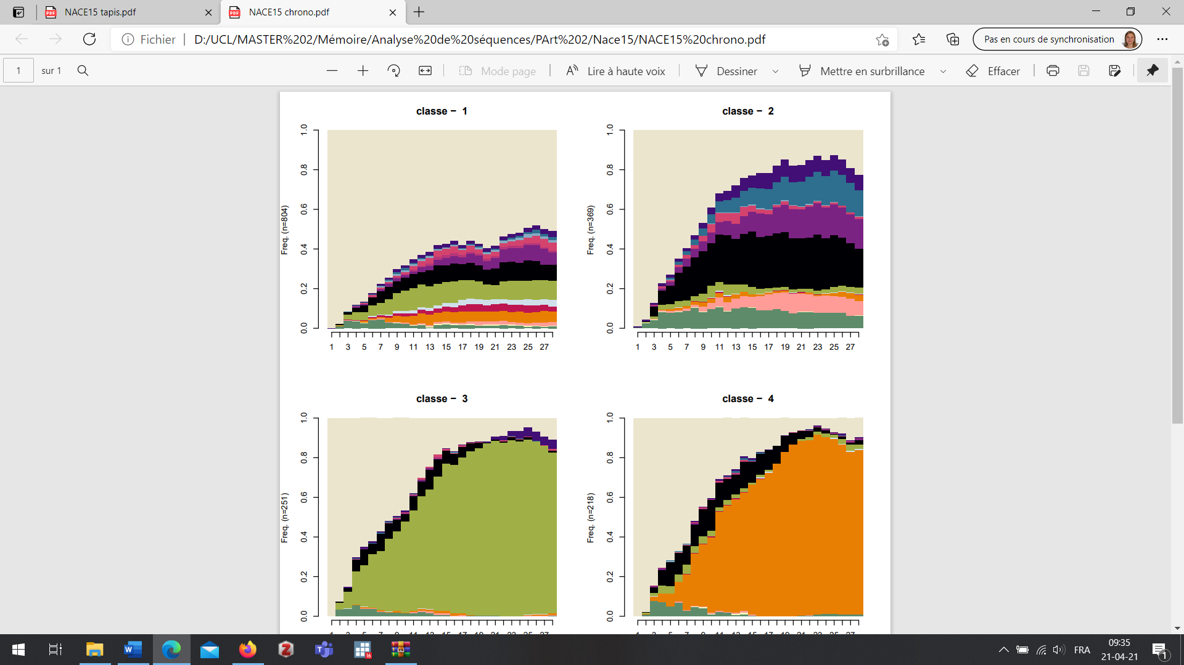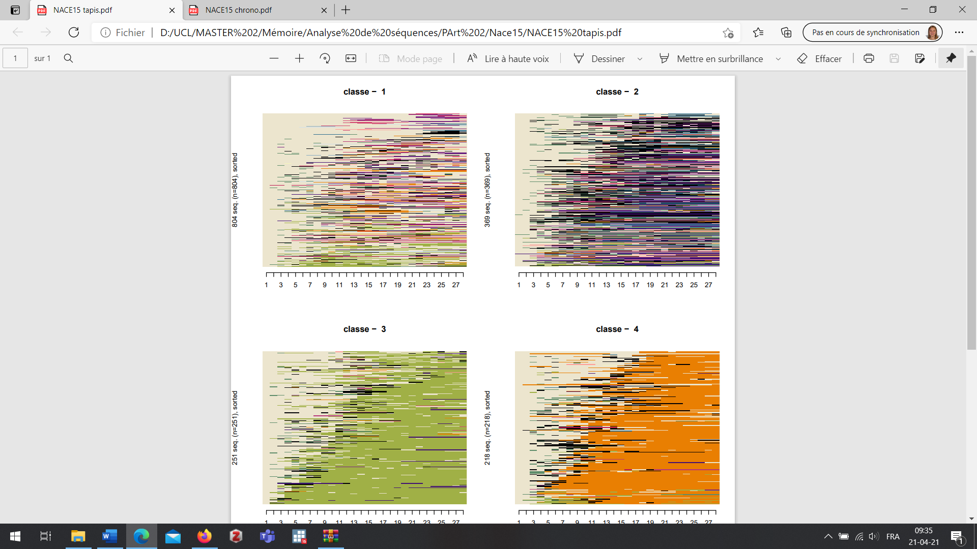
Frequency
Time post-arrival (in quarters)
Time post-arrival (in quarters)
Reading: The state distribution plot (left) shows the proportion of the population in each state at each quarter. The sequence index plot (right) shows individual trajectories (each line being an individual trajectory). Each trajectory is represented by a succession of states recorded at the end of each quarter. The horizontal axis presents the time since arrival in Belgium, measured in quarters.
Data: individuals who applied for international protection in Belgium between 2004 and 2007, who were between 18 and 65 years old at arrival and belong to cluster 1 of the first typology.
Source: National Register and CBSS
To identify factors influencing the belonging to each cluster, we compute a multinomial regression model, which is presented in Table 2 through the predicted probabilities. The results are consistent with the descriptive findings. They highlight a stratification according to the region of birth: individuals born in Asia have greater probabilities compared to others of being in the cluster (a); individuals from Europe non-EU have higher probabilities of being in the cluster (b); while individuals born in Sub-Saharan Africa have a higher probability of being in the cluster (c) than in another cluster, compared to other regions of birth. Furthermore, differences across genders also appear: women are more likely than men to experience the trajectories (c) in the Health and Social sector. Men on the other hand have significantly higher probabilities of being in clusters (a) or (b). Moreover, the predicted probabilities indicate that those who are not (yet) granted protection have a significantly higher probability of being in clusters (a) and (b) compared to refugees. Those who are not (yet) granted protection have a significantly lower probability of being in the cluster (d).
Table 2 Predicted probabilities of the multinomial regression model for the clusters in the sector analysis, according to the main socio-demographic determinants (N = 1,818)
 | Cluster a  Horeca & Trade | Cluster b  Building & Industry | Cluster c  Health & Social | Cluster d  Low employment & heterogenous sectors | Cluster e  Employment & heterogenous sectors | Total  (Cluster 1)
Gender | *** | *** | *** | ***
Male | 15.0 | 15.1 | 5.1 | 43.6 | 21.3 | 100
Female | 7.3 | 2.5 | 20.1 | 51.1 | 19.0 | 100
Age at arrival | n.s. | *** | n.s. | n.s. | *
18-19 | 14.9 | 13.6 | 7.6 | 48.2 | 15.8 | 100
20-24 | 12.8 | 10.5 | 7.7 | 49.7 | 19.2 | 100
25-29 | 13.2 | 11.4 | 7.1 | 47.3 | 20.9 | 100
30-34 | 14.1 | 9.4 | 9.4 | 42.8 | 24.2 | 100
35-39 | 8.7 | 9.9 | 7.9 | 45.1 | 28.5 | 100
40-44 | 13.8 | 4.2 | 6.9 | 57.3 | 17.7 | 100
45-49 | 13.0 | 4.0 | 6.2 | 53.1 | 23.6 | 100
50 + | 13.7 | 3.1 | 7.7 | 60.9 | 14.7 | 100
Region of birth | *** | *** | *** | ** | ***
Sub-Saharan Africa | 11.8 | 8.4 | 10.5 | 44.8 | 24.5 | 100
Europe non-EU | 7.5 | 14.0 | 5.9 | 51.7 | 20.9 | 100
Western Asia | 21.2 | 7.0 | 5.3 | 49.6 | 16.9 | 100
East Asia | 45.5 | 13.3 | 2.5 | 32.2 | 6.5 | 100
North Africa | 20.2 | 15.3 | 3.8 | 39.6 | 21.1 | 100
Protection status | *** | *** | n.s. | *** | n.s.
Refugee | 9.9 | 7.0 | 7.0 | 55.7 | 20.3 | 100
Subsidiary protection | 7.1 | 9.3 | 16.6 | 43.5 | 23.6 | 100
No protection granted | 16.4 | 12.2 | 7.7 | 41.6 | 22.0 | 100
R² : 0.0685
n.s. Non-significant, *** p<0.01; ** p<0.05; * p<0.1
Reading: The predicted probabilities of women being in class (a) are significantly lower than those of men (7.3% vs. 15.0%); the other determinants being fixed at their mean. The p-values of each variable indicate the statistical significance of differences observed between the predicted probabilities across categories.
Data: individuals who applied for international protection in Belgium between 2004 and 2007, who were between 18 and 65 years old at arrival and belong to cluster 1 of the first typology (N=1,818).
Source: National Register and CBSS
Regarding stability, the trajectories of clusters (a), (b), and (c), where an ethnostratification is observed, are more stable as careers remain in a single activity sector. Few activity sectors are accessible for asylum-seeking migrants (so-called "refugee jobs" (Jackson & Bauder, 2013)). Our results suggest that some sectors are more accessible depending on the region of birth. Although we are not able to measure it in this study, we argue that entering employment in these sectors is probably supported by co-ethnic networks. Other authors have already demonstrated the positive impact of networks with co-ethnic communities on obtaining employment (e.g. Cheung & Phillimore, 2014; Colic-Peisker & Tilbury, 2006; Leitner, 2023). These relationships would also support the continuity of the career in the same sector. Another possible reason for the observed continuity in these sectors is that jobs may be less attractive for locals (Colic-Peikser & Tilbury, 2006; Kogan, 2004) and it is easier for refugees to stay in these activity sectors.
Conversely, instability of employment careers is observed in clusters (d) and (e): those trajectories showcase a succession of different activity sectors and non-continuous spells in employment. The most represented sectors in trajectories (d) and (e) are the sectors of Temporary work, Agriculture or Horeca, and Trade. These are often associated with precarious employment situations (short-term contracts and/or less qualified work).
Looking at the impact of protection status, clusters (a) and (b) underline the possibility for asylum seekers to experience employment trajectories in a single sector. Cluster (d), on the other hand, shows that recognised refugees often experience trajectories where employment careers are unstable and of short duration despite the security offered by their legal status. A possible explanation for this phenomenon is that individuals who do not yet have legal status in Belgium face a greater disadvantage in the labour market and rely more on acquaintance networks to access employment and stabilise their situation, hence their representation in clusters (a) to (c).

Discussion
Our study of professional trajectories using sequence analysis and typologies goes beyond the study of integration through a first job. Unlike the predominant focus in the existing literature on entry into the labour market, our research provides a comprehensive examination of individuals' career paths, revealing previously unexplored dimensions of employment stability. We show that employment trajectories remain rare among applicants for international protection who arrived in Belgium between 2004 and 2007 (less than 20% of the cohort studied). Moreover, these trajectories are fragmented with many changes in the economic position throughout the observation period. These trajectories are experienced both by individuals who have obtained asylum and by those awaiting a more secure right of residence. Our results thus complement previous works conducted notably in Belgium, that were mainly focused on the employment of recognised refugees (Herman & Rea, 2017).
Using precise register data, we were able to reconstruct the employment trajectories by activity sectors. As expected, an ethnostratification of the activity sectors emerges, pointing in particular to the sectors of "Horeca and Trade", "Building and Industry" and "Health and Social" as being sectors that gather individuals with the same origins. However, a more original result of this research is that this stratification of the market is associated with a stabilisation of professional trajectories. The sectors mentioned are those in which we find continuous trajectories, with the least transitions between different sectors. Our interpretation of this phenomenon is that individuals rely on co-ethnic social networks to enter the job market (Cheung & Phillimore, 2014; Heidinger, 2023; Leitner, 2023). On the one hand, those co-ethnic networks give access to specific resources and information that encourage access to certain jobs, but, on the other hand, they might also prevent from accessing sectors in which co-ethnics are less represented (Bontenbal et al., 2024; Heidinger, 2023; Leitner, 2023). The stay in a certain sector could be interpreted as a long-term consequence of this reliance on co-ethnic social networks. We are unfortunately unable to verify this hypothesis with the register data at hand. Complementary to this, the long-term stay in certain sectors could reflect other well-known barriers to labour market integration among immigrants: experience of downward mobility (Jackson & Bauder, 2013), lack of skills recognition (Kubiciel–Lodzińska et al., 2024), access restricted to low-skilled jobs and/or jobs with poor working conditions, etc. On another note, our results show that the Temporary work or Agriculture sectors are not conducive to stability in the same sector of activity: they often appear at the beginning of trajectories and only concern short periods of employment. These sectors sometimes act as a springboard for entry into a first job. The degree of employment stability in the same sector thus varies from one sector to another, due to the types of contracts or the social networks used when entering employment.
It is essential to nuance these results regarding two elements. Firstly, the analysis carried out shows stability in one sector of activity but does not exclude the possibility that the individual regularly changes jobs while remaining in this sector. Secondly, results suggest that instability remains the norm. Our first classification shows that trajectories toward employment are turbulent. The second classification shows that almost 65% of employment trajectories are constructed in a heterogeneous way, comprising a succession of periods of employment in various sectors of activity (clusters e and d). The stability of certain trajectories, observed in a stratified labour market, is, therefore, relative and concerns only 35% of the employment trajectories studied and thus less than 10% of all the trajectories. Also, stability in activity sectors is only one dimension of professional careers, and other dimensions, such as upward/downward mobility or working conditions, could be studied.
Additionally, our findings highlight disparities in employment opportunities between asylum seekers awaiting protection and beneficiaries of international protection, underscoring the importance of legal status in shaping labour market outcomes. People waiting for international protection encounter more difficulties, particularly administrative ones, but this does not mean that they are excluded from employment. Their presence is not negligible in the trajectories toward employment (Cluster 1). However, the results of the logistic regression show that they remain less likely than beneficiaries of international protection to be in these employment trajectories. This finding is in line with previous research stating that the more stable the administrative situation, the higher the chances of economic integration (Bertrand, 2019).

Conclusion
This research’s findings are relevant in Belgium as well as in other countries hosting substantial numbers of asylum seekers and refugees. The longitudinal approach adopted in this paper highlights various possible pathways for asylum seekers and beneficiaries of international protection. This research focused on the trajectories predominantly in employment, which only concern a small percentage of applicants for international protection. The other trajectories resulting from the first sequence analysis could be exploited to see what other socio-economic pathways are possible for these individuals. This would allow us to understand to what extent they compete with employment trajectories in the formal labour market. Sequence analysis is relevant here as part of an overall approach to economic integration in the host country. Nevertheless, it would be worthwhile to update it to more recent periods. For instance, it would be interesting to explore the recent case of Ukrainian refugees and see how their employment trajectories unfold differently or not, given the specific legal provisions they benefit from. Another important note is the lack of consideration for informal jobs in this study. Additional (qualitative) research is necessary to explore this element further, as register data does not permit its examination. Similarly, qualitative research could explore in greater depth the role of social networks in the long-term economic integration of asylum migrants.
Finally, this study has some relevant policy implications concerning the labour market integration of asylum migrants. As employment trajectories are more accessible to recognized refugees, asylum policies should ensure a reduction of the procedures’ length. Also, integration policies should not exclusively focus on entry into employment but preferably adopt a long-term strategy. The paper shows the importance of taking into consideration the sectors of professional activity given their impact on the employment trajectories of asylum migrants. Understanding the underlying mechanisms of ethnic stratification could help in the development of effective integration policies. The resulting stability we found may be viewed as a positive outcome of the labour market segmentation because a secure economic position is proven to support integration in the host society. However, it also has downsides as it maintains individuals in low-skilled sectors and contributes to the marginalisation of ethnic groups. Policies should consider these nuanced results by acknowledging the importance of networks in labour market integration while contributing to improving the accessibility of other activity sectors.

References
Abbott, A., & Tsay, A. (2000). Sequence Analysis and Optimal Matching Methods in Sociology: Review and Prospect. Sociological Methods & Research, 29(1), 3-33. https://doi.org/10.1177/0049124100029001001
Adam, I. (2006). La discrimination ethnique à l’embauche à l’agenda politique belge. Formation emploi. Revue française de sciences sociales, 94, 11-25. https://doi.org/10.4000/formationemploi.2169
Adam, I. (2007). Les immigrés et leurs descendants sur le marché de l’emploi. Qu’en savons-nous en Belgique francophone (1989-2004) ? In M. Martiniello, A. Rea & F. Dassetto (Eds.), Immigration et intégration en Belgique francophone. Etat des savoirs (pp. 223-236). Academia Bruylant.
Backman, M., Lopez, E., & Rowe, F. (2021). The occupational trajectories and outcomes of forced migrants in Sweden. Entrepreneurship, employment or persistent inactivity? Small Business Economics, 56(3), 963-983. https://doi.org/10.1007/s11187-019-00312-z
Beauchemin, C., & Schoumaker, B. (2016). Micro Methods: Longitudinal Surveys and Analyses. In M.J. White (Ed.), International Handbook of Migration and Population Distribution (pp.175-204). Springer.
Bertrand, A.-L. (2019). Refugees’ trajectories in Switzerland: Impact of residence permits on labour market integration. Revue Quetelet, 7(1), 71-99. https://doi.org/10.14428/rqj2019.07.01.03
Billari, F. (2001). Sequence Analysis in Demographic Research. Canadian Studies in Population, 28(2), 439-458. https://doi.org/10.25336/P6G30C
Blom, S. (2004). Labour market integration of refugees in Norway under changing macro-economic conditions. Journal of International Migration and Integration, 5(1), 1-31. https://doi.org/10.1007/s12134-004-1000-3
Bontenbal, I., Riikonen, R., & Kosonen, J. (2024). Examining the Impact of Conscript Service on the Labour Market Integration of Migrants. Journal of International Migration and Integration. https://doi.org/10.1007/s12134-024-01140-1
Brell, C., Dustmann, C., & Preston, I. (2020). The Labor Market Integration of Refugee Migrants in High-Income Countries. The Journal of Economic Perspectives, 34(1), 94-121. https://doi.org/10.1257/jep.34.1.94
Burniaux, J.-C. (2015). Revenu d’intégration sociale—Catégories de bénéficiaires. Bulletin juridique et social, 553, 5.
Carpentier, S., & Schoumaker, B. (2018). Socio-demographic profile and socio-economic careers of people granted international protection in Belgium, 2001-2014. EMN Thematic Studies. Retrieved February 2, 2023, from https://emnbelgium.be/sites/default/files/publications/Socio-economic%20integration%20of%20beneficiaries%20of%20international%20protection.pdf
Cheung, S. Y., & Phillimore, J. (2014). Refugees, Social Capital, and Labour Market Integration in the UK. Sociology, 48(3), 518-536. https://doi.org/10.1177/0038038513491467
Colic-Peikser, V., & Tilbury, F. (2006). Employment Niches for Recent Refugees: Segmented Labour Market in the Twenty-first Century Australia. Journal of Refugee Studies, 19(2), 203-229. https://doi.org/10.1093/jrs/fej016
Office of the Commissioner General for Refugees and Stateless Persons (CGRS). (2015). Statistiques d’asile : Bilan 2014. Retrieved March 12, 2021, from https://www.cgra.be/sites/default/files/statistiques_asile_decembre_2014_externe.pdf
Office of the Commissioner General for Refugees and Stateless Persons (CGRS). (2019a). Demandes ultérieures. Retrieved April 12, 2021, from https://www.cgra.be/fr/asile/demandes-ulterieures
Office of the Commissioner General for Refugees and Stateless Persons (CGRS). (2019b). La procédure d’asile. Retrieved May 7, 2020, from https://www.cgra.be/fr/asile
Office of the Commissioner General for Refugees and Stateless Persons (CGRS). (2019c). Statistiques d’asile : Bilan 2018. Retrieved November 30, 2019, from https://www.cgra.be/fr/actualite/statistiques-dasile-bilan-2018
Dupont, C. (2007). Circulaire relative à la nouvelle procédure d’asile et à son impact sur le droit à l’aide sociale, SPP Intégration sociale. Retrieved April 6, 2021, from www.mi-is.be
Eurostat. (2016). Glossary: Statistical classification of economic activities in the European Community (NACE). Retrieved May 30, 2022, from https://ec.europa.eu/eurostat/statistics-explained/index.php?title=Glossary:Statistical_classification_of_economic_activities_in_the_European_Community_(NACE)/fr
Fournier, G., Zimmermann, H., & Gauthier, C. (2011). Instable career paths among workers 45 and over: Insight gained from long-term career trajectories. Journal of Aging Studies, 25(3), 316-327. https://doi.org/10.1016/j.jaging.2010.11.003
Gabadinho, A., Ritschard, G., Müller, N. S., & Studer, M. (2011). Analyzing and Visualizing State Sequences in R with TraMineR. Journal of Statistical Software, 40(4), 1-37. https://doi.org/10.18637/jss.v040.i04
Gracia, P., Vázquez-Quesada, L., & Van de Werfhorst, H. G. (2016). Ethnic penalties? The role of human capital and social origins in labour market outcomes of second-generation Moroccans and Turks in the Netherlands. Journal of Ethnic and Migration Studies, 42(1), 69-87. https://doi.org/10.1080/1369183X.2015.1085800
He, Y. H., Colantonio, A., & Marshall, V. W. (2006). The relationship between career instability and health condition in older workers: A longitudinal analysis. In L. O. Stone (Ed.), New Frontiers of Research on Retirement (pp. 321-342). Statistics Canada.
Heidinger, E. (2023). Overcoming Barriers to Service Access: Refugees’ Professional Support Service Utilization and the Impact of Human and Social Capital. Journal of International Migration and Integration, 24(1), 271-312. https://doi.org/10.1007/s12134-022-00939-0
Herman, B., & Rea, A. (2017). La longue et sinueuse route vers l’emploi : Les carrières d’insertion professionnelle des réfugiés sur le marché du travail en Belgique. Revue européenne des migrations internationales, 33(4), 109-134. https://doi.org/10.4000/remi.9467‬‬‬‬‬‬‬‬‬‬‬‬‬‬‬‬‬‬‬‬‬‬‬‬‬‬‬‬‬‬‬‬‬‬‬‬‬‬‬‬‬‬
Jackson, S., & Bauder, H. (2013). Neither Temporary, Nor Permanent: The Precarious Employment Experiences of Refugee Claimants in Canada. Journal of Refugee Studies, 27(3), 360-381. https://doi.org/10.1093/jrs/fet048
Kogan, I. (2004). Labour Market Careers of Immigrants in Germany and the United Kingdom. Journal of International Migration and Integration, 5(4), 417-447. https://doi.org/10.1007/s12134-004-1022-x
Krahn, H., Derwing, T., Mulder, M., & Wilkinson, L. (2000). Educated and underemployed: Refugee integration into the Canadian labour market. Journal of International Migration and Integration, 1(1), 59-84. https://doi.org/10.1007/s12134-000-1008-2
Kreyenfeld, M. (2010). Uncertainties in Female Employment Careers and the Postponement of Parenthood in Germany. European Sociological Review, 26(3), 351-366. https://doi.org/10.1093/esr/jcp026
Kubiciel–Lodzińska, S., Golebiowska, K., Pachocka, M., & Dąbrowska, A. (2024). Comparing pre-war and forced Ukrainian migrants in Poland: Challenges for the labour market and prospects for integration. International Migration, 62(1), 236-251. https://doi.org/10.1111/imig.13213
Leitner, S. M. (2023). Occupational Trajectories Among Refugees in Austria: The Role of Co-ethnic and Austrian Social Networks in Job Search (Working Paper 232). Vienna Institute for International Economic Studies.
Lens, D., Marx, I., & Vujic, S. (2017). Integrating (former) asylum seekers into the Belgian labour market: What can we learn from the recent past? CSB Working Paper. Retrieved February 13, 2024, from https://medialibrary.uantwerpen.be/oldcontent/container2453/files/CSB%20WP%202017/CSB_WP_17_10.pdf
Lens, D., Marx, I., & Vujic, S. (2018). Is Quick Formal Access to the Labor Market Enough? Refugees’ Labor Market Integration in Belgium. IZA Discussion Paper n°11905. Retrieved May 31, 2023, from https://papers.ssrn.com/abstract=3286164
Lesnard, L., & de Saint Pol, T. (2006). Introduction aux méthodes d’appariement optimal (Optimal Matching Analysis). Bulletin de méthodologie sociologique, 90, 5-25.
Organisation for Economic Co-operation and Development (OECD). (2024). Taux d’activité des allochtones. (indicator). Retrieved February 13, 2024, from https://doi.org/10.1787/d9fa2cd3-fr
Okkerse, L., & Termotte, A. (2004). Singularité des Etrangers sur le Marché de l’Emploi. A propos des Travailleurs Allochtones en Belgique. Institut National de Statistique. Retrieved April 4, 2022, from https://doc.statbel.fgov.be/publications/A000.01/A000.01F_Etude_stat_2004_111.pdf
Ouali, N. (2004). Contexte économique et analyse des données démographiques et des demandes d’asile. In P. Desmarez, P. Van der Hallen, N. Ouali, V. Degraef, & K. Tratsaert (Eds.), Minorités ethniques en Belgique : Migration et marché du travail (pp. 5-34). Politique scientifique & Academia press.
Piguet, E., & Wimmer, A. (2000). Les nouveaux « Gastarbeiter » ? Les réfugiés sur le marché du travail suisse. Journal of International Migration and Integration, 1(2), 233-257. https://doi.org/10.1007/s12134-000-1003-7
Poulain, M., & Herm, A. (2013). Le registre de population centralisé, source de statistiques démographiques en Europe. Population, 68(2), 215-247. https://doi.org/10.3917/popu.1302.0215
Rea, A., Wets, J., Callier, L., Schepers, W., & Vanduynslager, L. (2014). Legislative, Institutional and Economic contexts. In J. Wets & A. Rea (Eds.) The Long and Winding Road to Employment: An analysis of the labour market careers of asylum seekers and refugees in Belgium (p. 11-56). Academia Press.
Robette, N. (2011). Explorer et décrire les parcours de vie : Les typologies de trajectoires. CEDEP.
Schmitt, C. (2012). Labour market integration, occupational uncertainties, and fertility choices in Germany and the UK. Demographic Research, 26(12), 253-292. https://doi.org/10.45054/DemRes.2012.26.12
Söhn, J. (2019). Initial employment pathways of immigrants in Germany. Why legal contexts of reception matter – an analysis of life-course data. Transfer: European Review of Labour and Research, 25(1), 43-62. https://doi.org/10.1177/1024258918818069
Verhoeven, H., & Martens, A. (2000). Arbeidsmarkt en diversiteit...over de vreemde eend in de bijt. Steunpunt Werkgelegenheid, Arbeid en Vorming. Retrieved April 4, 2022, from https://publicaties.vlaanderen.be/view-file/34451
Wets, J., & Rea, A. (2014). The long and winding road to employment: An analysis of the labour market careers of asylum seekers and refugees in Belgium. Academia Press.

***

Appendix 1 Graphical representations of the first typology
State distribution and sequence index plots
Cluster 2: Trajectory outside the formal labour market (N = 3,224, 33.8% of the total sample of 9,550)
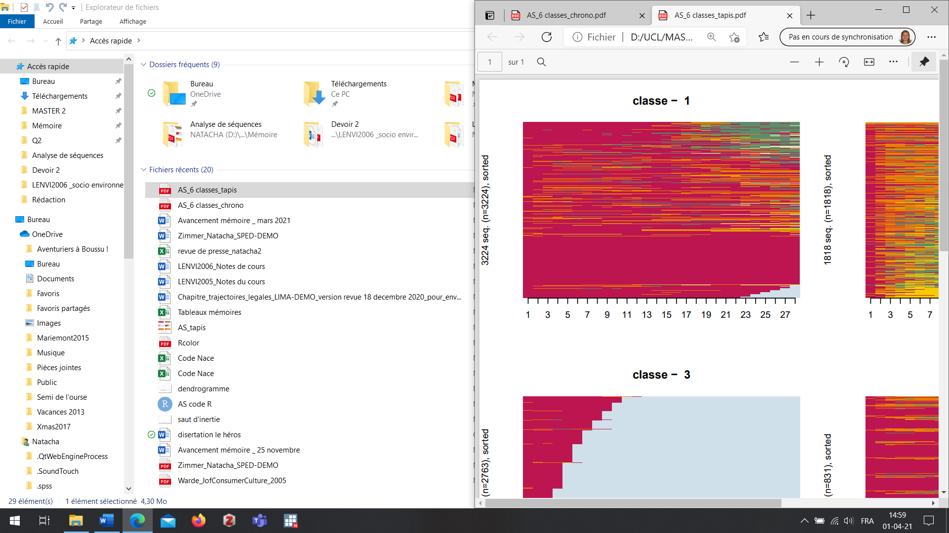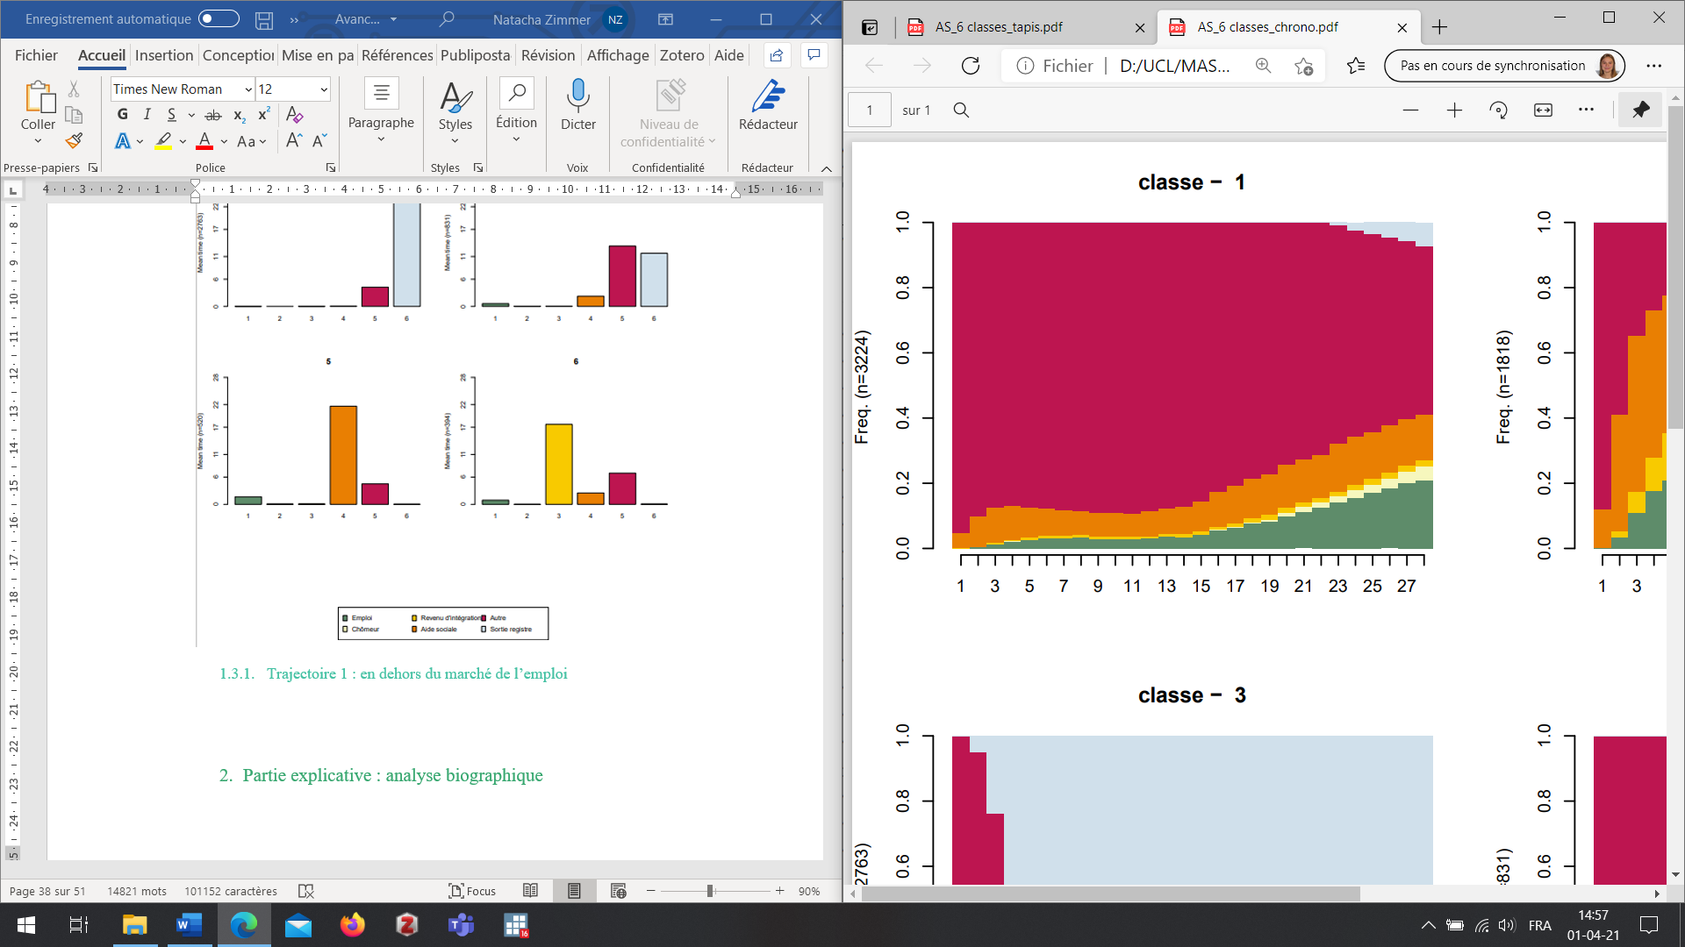
Frequency
Time post-arrival (in quarters)
Time post-arrival (in quarters)
Cluster 3: Trajectory of benefit from social assistance (N = 520, 5.5% of the total sample of 9,550)
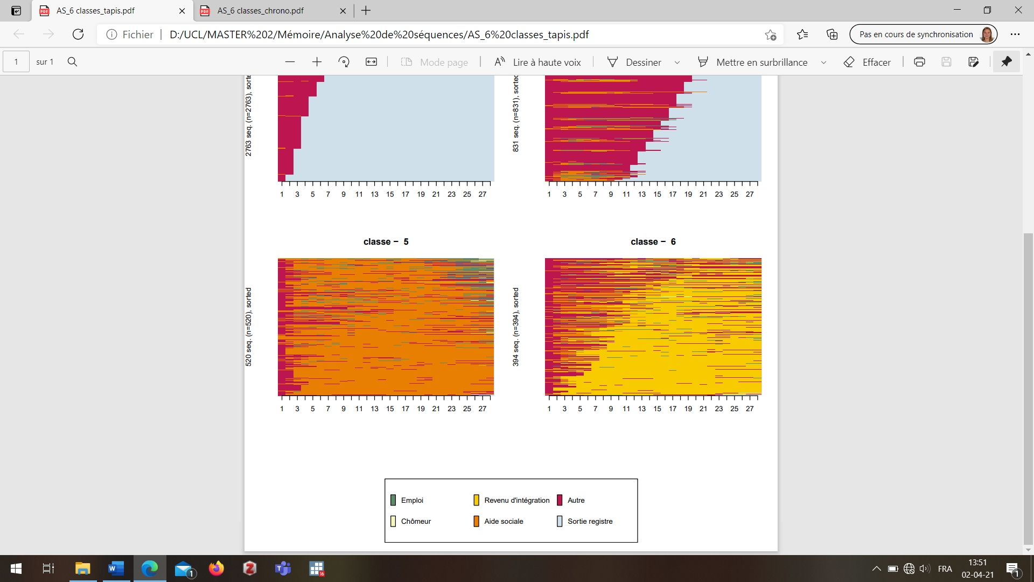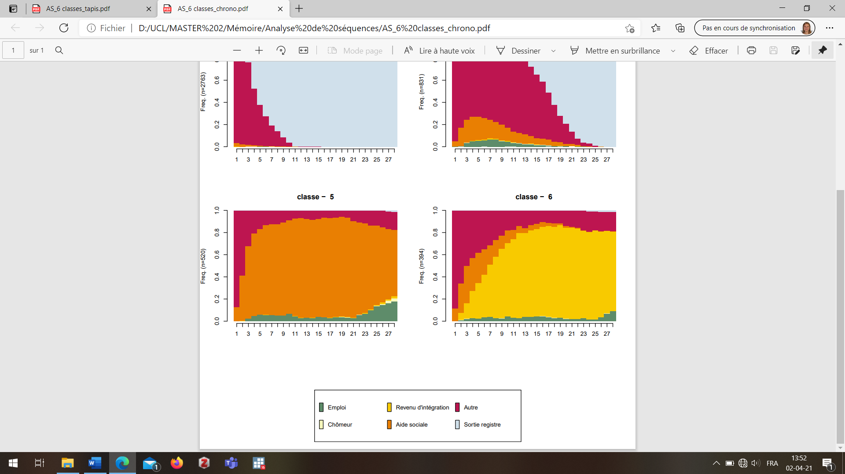
Frequency
Time post-arrival (in quarters)
Time post-arrival (in quarters)
Cluster 4: Trajectory of benefit from integration income (N = 394, 4.1% of the total sample of 9,550)
Frequency
Time post-arrival (in quarters)
Time post-arrival (in quarters)

Cluster 5: Trajectory of rapid exit from the Register (N = 2,763, 28.9% of the total sample of 9,550)
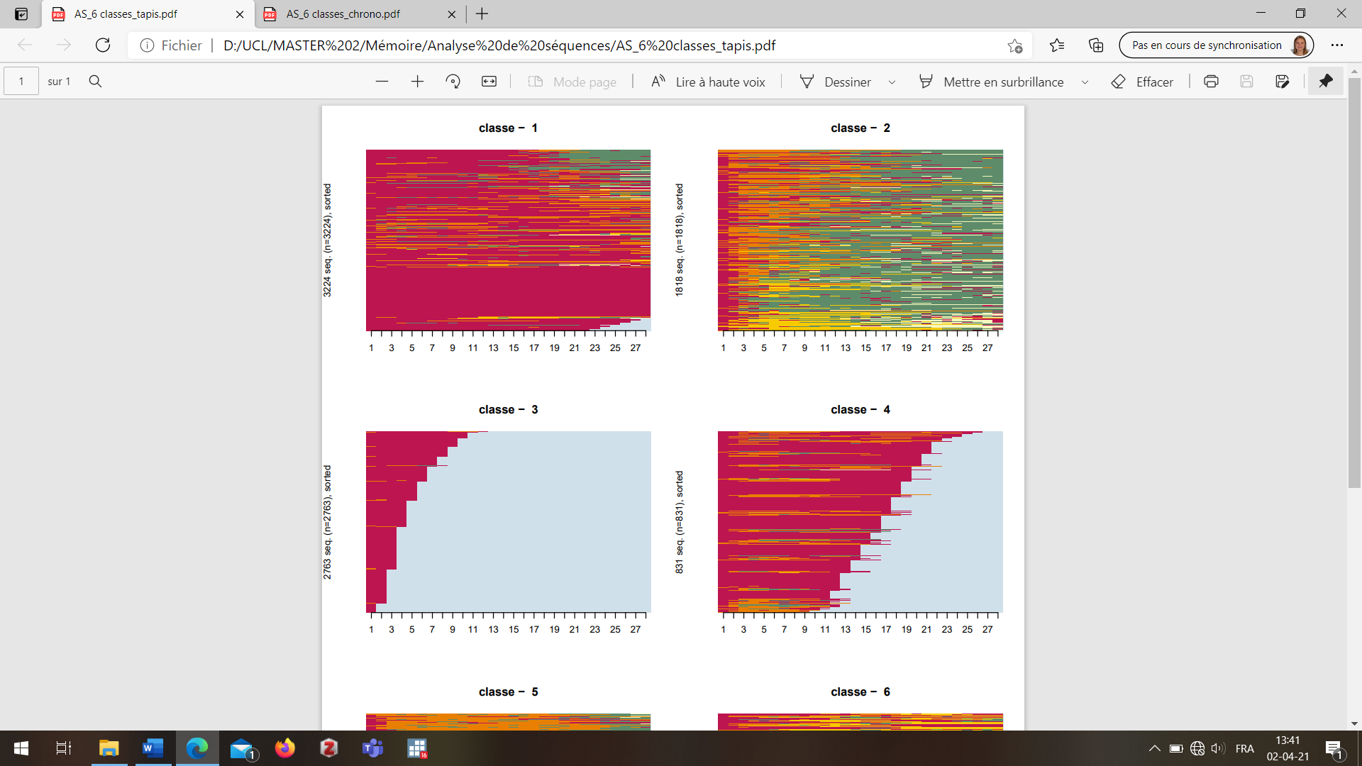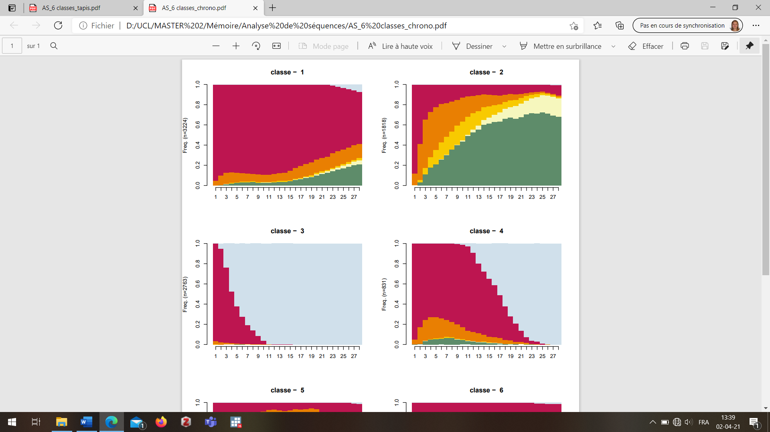
Frequency
Time post-arrival (in quarters)
Time post-arrival (in quarters)
Cluster 6: Trajectory of progressive exit from the Register (N = 831, 8.7% of the total sample of 9,550)
Frequency
Time post-arrival (in quarters)
Time post-arrival (in quarters)
Note: N=9,550: applicants for international protection, arriving between 2004 and 2007. The horizontal axis presents the time since arrival in Belgium, measured in quarters.
Source: National Register and CBSS

Appendix 2 Distribution of individuals by clusters from the first typology and by socio-demographic characteristics
 | Cluster 1  Towards employment | Cluster 2  Outside the formal labour market | Cluster 3  Benefit from social assistance | Cluster 4  Benefit from integration income | Cluster 5  Rapid exit from the Register | Cluster 6  Progressive exit from the Register | Total
N | 1,818 | 3,224 | 520 | 394 | 2,763 | 831 | 9,550
% | 19.0 | 33.8 | 5.5 | 4.1 | 28.9 | 8.7 | 100.0
Gender (%)
Male | 72.0 | 57.9 | 54.2 | 40.1 | 74.9 | 75.8 | 66.1
Female | 28.1 | 42.1 | 45.8 | 59.9 | 25.2 | 24.2 | 33.9
Mean age at arrival | 29.5 | 30.2 | 32.4 | 33.1 | 30.4 | 30.1 | 30.4
Age at arrival (%)
18-24 | 27.4 | 28.2 | 26.2 | 26.9 | 30.3 | 29.5 | 28.5
25-29 | 29.5 | 28.0 | 18.3 | 20.6 | 25.3 | 25.8 | 26.5
30-34 | 20.6 | 18.3 | 22.3 | 12.4 | 16.5 | 18.4 | 18.2
35-39 | 12.2 | 11.4 | 11.0 | 11.7 | 12.6 | 13.0 | 12.0
40-49 | 8.7 | 10.5 | 13.9 | 17.2 | 11.0 | 9.3 | 10.7
50 + | 1.7 | 3.6 | 8.4 | 11.2 | 4.3 | 4.1 | 4.0
Region of birth (%)
European Union | 0.5 | 3.5 | 0.2 | 3.4 | 9.0 | 3.5 | 4.3
Europe outside the EU | 22.7 | 35.8 | 25.4 | 45.3 | 41.2 | 33.0 | 34.4
West Asia | 18.7 | 21.6 | 15.2 | 13.2 | 21.4 | 24.4 | 20.5
East Asia | 3.3 | 1.6 | 0.2 | 1.3 | 2.3 | 2.4 | 2.1
North Africa | 1.7 | 3.0 | 1.9 | 0.3 | 5.4 | 4.0 | 3.3
Sub-Saharan Africa | 52.8 | 34.3 | 57.1 | 36.4 | 20.4 | 32.3 | 35.0
Latin America | 0.4 | 0.3 | 0.0 | 0.3 | 0.5 | 0.5 | 0.4
Protection status (%)
Subsidiary protection | 5.2 | 3.1 | 9.0 | 0.3 | 0.1 | 1.9 | 2.7
Refugee | 42.4 | 9.4 | 2.7 | 89.1 | 0.4 | 2.3 | 15.4
Not protection granted | 52.5 | 87.5 | 88.3 | 10.7 | 99.5 | 95.8 | 81.9
Type of exit of the register (%)
Emigration | 0.1 | 0.7 | 0.2 | 0.0 | 7.0 | 4.8 | 2.7
Deregistered | 3.4 | 16.7 | 6.0 | 5.1 | 93.0 | 95.2 | 42.0
No exit | 96.5 | 82.6 | 93.9 | 94.9 | 0.0 | 0.0 | 55.3
Mean number of transitions between states | 5.6 | 2.1 | 3.6 | 3.5 | 1.1 | 2.1 | 3.0
Note: the cells highlighted in grey are those where there is an overrepresentation or under-representation in comparison with to the total sample value.
Data: individuals who applied for international protection in Belgium between 2004 and 2007 and who were between 18 and 65 years old at arrival (N=9,550).
Source: National Register and CBSS

Appendix 3 Distribution of individuals by clusters of the second typology and by socio-demographic characteristics
 | Cluster a  Horeca/  Trade | Cluster b  Building  /Industry | Cluster c  Health/  Social |  | Cluster d  Low employment/  Multiple sectors | Cluster e  Employment/Multiple sectors | Total  (Cluster 1)
N | 251 | 218 |  | 176 | 804 | 369 | 1,818
% | 13.8 | 12.0 |  | 9.7 | 44.2 | 20.3 | 100
Gender (%)
Male | 84.5 | 94.0 |  | 38.6 | 68.7 | 73.4 | 72.0
Female | 15.5 | 6.0 |  | 61.4 | 31.3 | 26.6 | 28.1
Age at arrival (%)
18-24 | 26.3 | 28.5 |  | 29.5 | 28.4 | 24.4 | 27.4
25-29 | 30.7 | 34.9 |  | 26.1 | 29.0 | 28.5 | 29.5
30-34 | 24.7 | 20.6 |  | 22.2 | 17.9 | 22.8 | 20.6
35-39 | 8.4 | 11.9 |  | 12.5 | 11.8 | 15.7 | 12.2
40-49 | 8.8 | 3.7 |  | 8.0 | 10.5 | 7.6 | 8.7
50 + | 1.2 | 0.5 |  | 1.7 | 2.3 | 1.1 | 1.7
Region of birth (%)
European Union | 0.4 | 0.9 |  | 0.6 | 0.4 | 0.8 | 0.5
Europe non-EU | 12.0 | 30.7 |  | 14.8 | 26.0 | 21.7 | 22.7
West Asia | 29.5 | 16.5 |  | 10.2 | 19.3 | 15.2 | 18.7
East Asia | 9.2 | 3.2 |  | 1.1 | 2.9 | 1.1 | 3.3
North Africa | 2.8 | 3.2 |  | 0.6 | 1.2 | 1.6 | 1.7
Sub-Saharan Africa | 46.2 | 45.4 |  | 72.2 | 49.6 | 59.4 | 52.8
Latin America | 0.0 | 0.0 |  | 0.6 | 0.6 | 0.3 | 0.4
Protection status (%)
Subsidiary protection | 4.8 | 5.5 |  | 5.7 | 5.1 | 5.2 | 5.2
Refugee | 35.1 | 31.7 |  | 36.9 | 50.3 | 39.0 | 42.4
No protection granted | 60.2 | 62.8 |  | 57.4 | 44.7 | 55.8 | 52.5
Mean number of years in employment | 4.7 | 4.7 |  | 3.5 | 2.4 | 4.4 | 3.5
Mean number of transitions between states | 4.1 | 3.8 |  | 3.8 | 4.5 | 4.9 | 4.2

Data: individuals who applied for international protection in Belgium between 2004 and 2007, who were between 18 and 65 years old at arrival and belong to cluster 1 of the main sequence analysis (N=1,818).
Source: National Register and CBSS

Centre for Demographic Research, UCLouvain, natacha.zimmer@uclouvain.be
Counting first applications as well as multiple applications, i.e. new applications submitted after the first one when new elements can be added to the file and allow the procedure to be re-evaluated (CGRS, 2019b).
In 2014, 36.6% of asylum decisions granted refugee status, and 10.2% subsidiary protection status, while the remaining 47.8% of decisions resulted in the denial of one of these statuses (CGRS, 2015).
This section describes the rules in force during the 10-year observation period considered for this article, covering individuals who arrived between 2004 and 2007, and monitored until 2014. Some legal changes occurred, notably from 2015 onwards, which modified the duration of residence permits obtained or the length of time required before a work permit could be obtained.
Statistical classification of economic activities in the European Community. This nomenclature is extremely detailed, with hundreds of different codes, describing precisely the categories of employment (Eurostat, 2016).
For individuals who arrive aged over 60, employment trajectories will certainly be restricted as they will leave the active ages during the observation period. However, this only concerns a small proportion: less than 1% of the cohort studied was between 60 and 65 years old upon arrival in Belgium.
The "employed" category includes all quarters when the individual is registered by social security institutions as having a work situation. The status "unemployed" distinguishes situations when individuals are available on the labour market and receive unemployment benefits. The "integration income" is available under different conditions. In the observation period of this study, only beneficiaries of refugee status were eligible for this income. "Social assistance" refers to monthly or occasional financial support and is available for any person residing in Belgium.
Deregistration corresponds here to the automatic deletion that occurs when an individual has changed his or her main residence and the municipality can not find the new main residence. An investigation is carried out and deletion is decided when it is assumed that the person has left the territory. However, people may be wrongly deregistered.
The 15 resulting states are: 1) Agriculture, 2) Craft Industry, 3) Other Services, 4) Building & Industry, 5) Culture, Art & Leisure, 6) Education, 7) Horeca & Trade, 8) Temporary work, 9) Cleaning & Guarding, 10) Repairing, installation & maintenance of machines, 11) Health & Social, 12) Skilled Services, 13) Transport & Handling, 14) Self-employed, 15) Not in employment.
This regression uses the belonging to clusters (a) to (e) as the dependent variable. We computed the predicted probabilities, i.e. the probability of being in a class according to a certain socio-demographic characteristic, knowing that all other independent variables are fixed at their mean.

