Abstract:
Atherosclerosis is still a leading cause of death worldwide. To better understand and treat this disease, it is important to evaluate the changes in blood vessel wall microstructure during disease development and to link these microstructural changes to changes in mechanical properties. Microfocus X-ray computed tomography (microCT) combined with contrast-enhancing staining agents (CESAs), a technique referred to as contrast-enhanced microCT (CE-CT), allows non-invasive assessment of the 3D microstructure of soft tissues. Monolacunary and Hafnium-substituted Wells-Dawson polyoxometalate (Mono-WD and Hf-WD POM respectively) have shown their potential for non-destructive staining of kidney and soft skeletal tissues [1]. The aim of this study was to show the potential of CE-CT for high-resolution analysis of the different vessel wall layers and their composition.
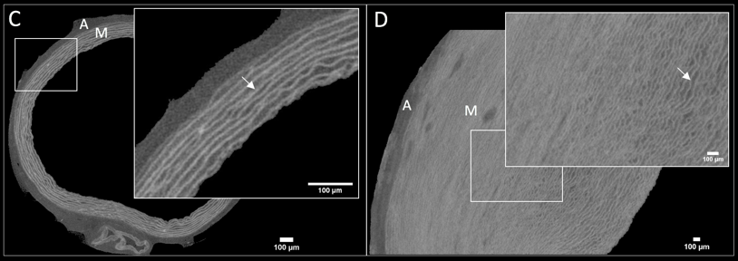
First, we have shown with planar biaxial testing that Mono-WD and Hf-WD POM have a negligible effect on the mechanical properties of the tissue. Then, these CESAs were evaluated for their staining potential of the porcine aorta. It was concluded that Hf-WD POM stains with much higher intensity while Mono-WD POM stains less bright and more homogeneously but diffuses much faster than Hf-WD POM (Fig. 1, A-B). The optimized staining parameters were then applied to other types of porcine blood vessels (elastic artery, muscular artery, and vein) and allowed to observe the differences in the 3D microstructure of different tissue constituents (i.e. elastin and collagen) of the vessel wall in these tissues. We also showed important species-related (porcine, rat, human) differences in the vessel wall microstructure of the aorta (Fig. 1, C-D), which could have an important impact on their functional behavior, and hence this is important information when running animal experiments to evaluate disease treatments. From the data mentioned above, 3D morphometrical parameters have been computed such as elastin volume fraction and elastic fiber waviness and separation, and this without altering the native structure of the tissue. Finally, healthy and atherosclerotic human femoral arteries were compared. Plaques and onsets of calcifications could be identified and parameters such as calcification volume fraction could be quantified. The novelty of this study lies in the high-detailed comparison of the microstructure of different types of blood vessels (healthy and diseased) in different species, and this, in a non-destructive 3D manner.
Figure Caption: Fig. 1: Normalized gray value in function of time for different locations (x) inside the tissue and fitted with an exponential decay curve for (A) Hf-WD POM and (B) Mono-WD POM. CE-CT-based images of the rat aorta (C) and the porcine aorta (D) stained with Hf-WD POM. A=adventitia, M=media, arrow=elastic lamellae.

Acknowledgments: /
References:
[1] de Bournonville et al, Acta Biomater., 105:253-62, 2020
[2] Balint et al, PloS One, 11(4):e0153552, 2016

