Redesigning discussion forums to increase learner participation and post quality in a MOOC on Corporate Social Responsibility

Dennis Rivera¹, Mariane Frenay¹, Pauline de Montpellier² & Valerie Swaen^{2, 3}

¹ Psychological Science Research Institute (IPSY), UCLouvain, Belgium
² Louvain Research Institute in Management and Organisations (LOURIM), UCLouvain, Belgium
³ IESEG School of Management (LEM-CNRS), Univ. Lille, France

Introduction
Discussion forums in massive open online courses (MOOCs) can provide a venue for learners to interact and co-construct knowledge. Such interactions are crucial to learning corporate social responsibility (CSR) because individual perspectives on CSR vary based on cultural and sociodemographic characteristics (Gond & Moon, 2011). Thus, discussing different perspectives can enrich understanding of CSR. However, learner interactions in MOOC forums rarely occur (Tawfik et al., 2017). Instead, learners tend to post messages containing similar titles, which impairs navigation through the forums as relevant information cannot be easily found (Almatrafi & Johri, 2019). Thus, instructors need to design MOOC discussion forums aligning the technological affordances of the forums with a learner-centred pedagogy (Sergis et al., 2017; West & Allman, 2021). This study empirically explores the effects of a learning design intervention on the forums of the edX MOOC “Communicating Corporate Social Responsibility (CSR)”. The intervention addresses the issues of low learner interactions and forum navigation difficulty. We provide theoretical and practical guidance to help MOOC instructors design open online discussions for a massive number of learners.

Method
We conducted design-based research to evaluate the effectiveness of our learning design intervention in increasing learner interactions (number of messages that receive a response), and easing navigation in the forums (through relevant message titles). Before the intervention, the CSR MOOC released 5 editions of the course (from 2015 to 2019) and contained 40 forums. The first iteration of our intervention comprised the following 2 editions of the course (from 2020 to 2021) and reduced the number of forums to 25.
We modified the forum instructions based on Gibbons’ (2014) layered approach and Van Merriënboer et al.’s (2003) 4C/ID model. We designed instructions to provide support and guidance that informed learners about the type and amount of engagement required in the forums (message layer) and helped them harness the technological affordances of the forum (control layer). We used mixed-methods to analyse the total number of learner interactions and improved the quality of the titles in forum messages.

Results
The initial learning design triggered, on average, 13.11% (SD = 2.86%) interactions (messages with responses). The learning design we implemented triggered an average of 28.35% interactions (SD = 4.74%). The total number of forum messages posted per course edition before and after our intervention, as well as the total number of interactions can be seen in Table 1.

Table 1
Distribution of forum messages per course edition.

MOOC forum messages | Ed15 | Ed16 | Ed17 | Ed18 | Ed19 |  | Ed20 | Ed21
Total messages | 329 | 297 | 716 | 1153 | 718 |  | 82 | 100
Messages without responses | 281 | 264 | 612 | 967 | 652 |  | 56 | 75
Messages with responses | 48 | 33 | 104 | 186 | 66 |  | 26 | 25
Percentage of messages without responses | 14,58% | 11,11% | 14,52% | 16,13% | 9,19% |  | 31,70% | 25,00%
Note. Ed+# refers to the course edition and the year. E.g., Ed15 = Edition 2015 of the MOOC.

Before the intervention, forum instructions did not provide any guidance concerning message titles. As a result, in the forum intended to discuss the purpose of companies, the title “purpose of a/the company/companies” was found in 127 of the 292 messages (43.49%). Our intervention guided learners to write meaningful titles (specific company names they wanted to discuss). Consequently, the aforementioned title occurred 3 times in 53 messages (5.66%). This allowed a better organisation of the messages (see Figure 1).

Figure 1
Forum message titles before (B) and after (A) the intervention.
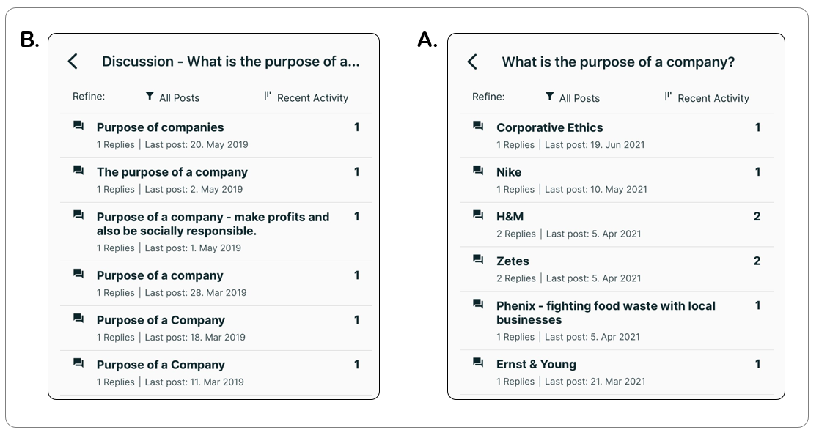

Discussion
Theoretically, this study outlines the need to understand the learning design of MOOC discussion forums as composed of technological and pedagogical layers (and sub-layers). This can help MOOC instructors focus on specific layers and design forum instructions that foster the cognitive, social, and technical competences of the learners. In practice, promoting learner interactions and improving forum navigation can arguably help learners find relevant information and engage in CSR discussions. However, further research is necessary to understand how those discussions help MOOC learners socially construct knowledge of CSR.

References
Almatrafi, O. & Johri, A. (2019). Systematic review of discussion forums in massive open online courses (MOOCs). In IEEE Transactions on Learning Technologies, 12(3), 413–428.
Gibbons, A. (2014). An architectural approach to instructional design. Routledge.
Gond, J-P., & Moon, J. (2011). Corporate social responsibility in retrospect and prospect: Exploring the life-cycle of an essentially contested concept. In J-P. Gond, & J. Moon (Eds.), Corporate social responsibility: A reader (Vol. 1, pp. 1-28). Routledge.
Sergis S., Sampson D., Pelliccione L. (2017) Educational design for MOOCs: design considerations for technology-supported learning at large scale. In Jemni M., Kinshuk, Khribi M. (Eds) Open Education: from OERs to MOOCs. Lecture Notes in Educational Technology. Springer.
Tawfik, A., Reeves, T., Stich, A., Gill, A., Hong, C., McDade, J., Pillutla, V., Zhou, Z., & Giabbanelli, P. (2017). The nature and level of learner–learner interaction in a chemistry massive open online course (MOOC). Journal of Computing in Higher Education, 29(3), 411–431.
Van Merriënboer, J., Kirschner, P., & Kester, L. (2003). Taking the load off a learner’s mind: Instructional design for complex learning. Educational Psychologist 38, 5–13.
West, R., & Allman, B. (2021). Designing Technology-Enhanced Learning Experiences. https://open.byu.edu/id/designing_technology

