Tau burden in the rhinal cortex is associated with the ability to discriminate conceptually confusable objects
Lara Huyghe¹, Lisa Quenon^{1,2}, Yasmine Salman¹, Lise Colmant^{1,2}, Thomas Gérard^{1,3}, Emma Delhaye⁴, Gabriel Besson⁴, Vincent Malotaux¹, Emilien Boyer^{1,2}, Quentin Dessain⁵, Laurence Dricot¹, Renaud Lhommel^{1,3}, Adrian Ivanoiu^{1,2}, Christine Bastin⁴, Bernard Hanseeuw^{1,2,6}

- Institute of Neuroscience (IoNS), UCLouvain, Brussels, Belgium
- Neurology Department, Saint-Luc University Hospital, Brussels, Belgium
- Nuclear Medicine Department, Saint-Luc University Hospital, Brussels, Belgium
- GIGA-Cyclotron Research Centre-In Vivo Imaging, University of Liège
- ICTEAM, UCLouvain, Louvain-La-Neuve, Belgium
- Radiology Department, Massachusetts General Hospital, Harvard Medical School, Boston, USA
Background: Alzheimer's disease (AD) starts with a preclinical stage during which amyloid (Aβ) and tau pathologies develop in the brain while patients remain cognitively normal (CN). The first cortical region affected by tau pathology is the anterolateral entorhinal cortex and (peri)rhinal cortex (RC). This region is implicated in discriminating conceptually confusable objects, evaluated using the Conceptual-Matching-Task (CMT, Frick et al., 2023). In functional MRI studies, CMT solicits the Medial Temporal Lobe (MTL), specifically the RC. However, performance on this task in CN individuals characterized for amyloid and tau burden has not yet been evaluated.
Method: Eighty-two older adults underwent [F¹⁸]-MK6240 tau-PET, [F¹⁸]-Flutemetamol amyloid-PET or CSF analysis, 3D-T1 MRI, a standard neuropsychological assessment, and the CMT. In CMT, a word and a picture from the same semantic category are presented simultaneously. The participant must determine in a maximum of three seconds whether they represent the same concept or not. The task consists of 120 items for which the distance between concepts varies: Close-Concepts (CC) vs. Distant-Concepts (DC). We calculated the Accuracy Score (AS) and the mean Reaction Time (RT). Participants were classified in three groups based on Aβ status and standard neuropsychological assessment: Aβ- CN (n=46); Aβ+ CN (or preclinical AD, n=20); and Aβ+ MCI patients (n=16).
Results: Total AS and AS for CC was lower in Aβ+CN than in Aβ-CN participants, while Aβ+CN and Aβ+MCI did not differ in these conditions. The Aβ+CN group performed slower than Aβ-CN subjects on average and for DC (Fig.1). Considering the whole sample, total AS and RT were significantly predicted by RC and MTL tau burden. The relation for RC but not for MTL tau remains significant (marginally for RT) after controlling for age, sex and Flutemetamol Centiloids (Tab.1). In CN participants only, similar results are observed for AS. There was an interaction between RC tau and group: tau burden was more strongly associated with AS and RT in Aβ+ CN (Fig.2).

Discussion: Deficits in the ability to distinguish between concepts can be detected in preclinical AD, specifically in those individuals with RC tau.

Figure 1: Boxplot of accuracy scores (AS) and reaction times (RT) between groups
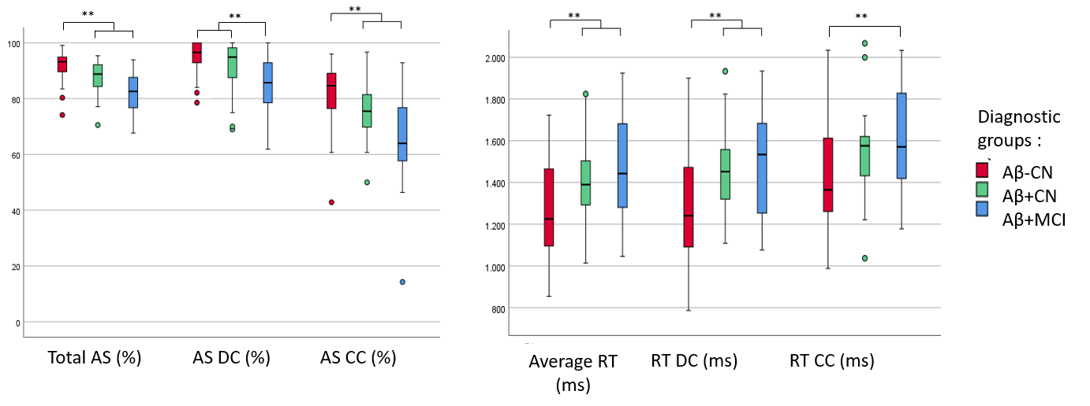
Legend: AS = Accuracy Score; DC = Distant Concept; CC = Close Concept; RT = Reaction Time, Aβ= Amyloid-Beta; CN = Cognitively Normal; MCI = Mild Cognitive Impairment.

Table 1: Effect of Rhinal (RC) tau burden on Accuracy Score and on Reaction Time when considering the whole sample
 | Total Accuracy Score |  | Total Accuracy Score + age + sex + amyloid
 | p-val | η² | η² RC tau (p-val) | η² AB (p-val) | η² age (p-val) | η² sex (p-val)
RC tau | <0.001 | 0.316 | 0.086 (0.047) | 0.028 (0.270) | 0.029 (0.261) | 0.111 (0.024)
MTL tau | 0.019 | 0.076 | 0.001 (0.846) | 0.052 (0.099) | 0.048 (0.115) | 0.084 (0.036)
 | Average Reaction Time |  | Average Reaction Time + age + sex + amyloid
RC tau | <0.001 | 0.180 | 0.076 (0.064) | 0.047 (0.146) | 0.063 (0.091) | 0.012 (0.470)
MTL tau | 0.024 | 0.071 | 0.018 (0.344) | 0.046 (0.125) | 0.066 (0.63) | 0.029 (0.220)

NB: Each line represents a different model. Columns 2 and 3 show the results when the predictor is included alone in the model. Columns 4 to 7 highlight results when controlling for the effect of age, sex and amyloid (Flutemetamol SuVR).

Figure 2: Effects of RC Tau burden on AS and on average RT by groups
