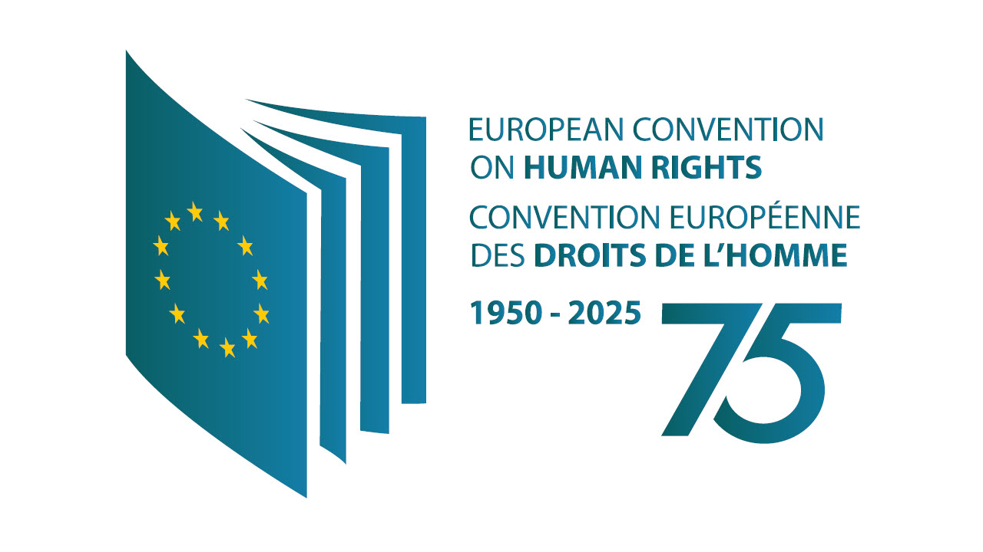
SAFEGUARDING RIGHTS AND CHANGING WORLD:
75 YEARS OF THE EUROPEAN CONVENTION ON HUMAN RIGHTS

International Conference
PROGRAMME

10 November 2025, Kampus Hybernská
Hybernská 998/4, 110 00 Nové Město

9:00 - 9:30 | Registration
9:30 – 9:45 | Veronika Bílková: Welcoming Address
Panel I
Moderator: Veronika Bílková
9:45 – 10:00 | Ivana Jelić: The Court's replay on the crisis of the rule of law in Europe
10:00 – 10:15 | Frédéric Krenc: Current challenges facing the European System of Human Rights Protection
10:15 – 10:35 | Discussion
10:35 – 11:05 | Coffee break
Panel II
Moderator: Vladimír Janoušek Pysk
11:05 – 11:20 | Kateřina Šimáčková: Sexual violence against women in the case law of the ECHR
11:20 – 11:35 | Armen Harutyunyan: The coping mechanisms at the disposal of the ECtHR against current challenges of democracies
11:35 – 11:55 | Discussion
11:55 – 12:00 | Summary / Transition to Lunch
12:00- 13:30 | Lunch
Panel III
Moderator: Alla Tymofeyeva
13:30 – 13:45 | Petr Konůpka: Implementation of the ECtHR judgments: achievements and challenges
13:45 – 14:00 | Petr Válek: Council of Europe response to the Russian aggression against Ukraine
14:00 – 14:15 | Vít Alexander Schorm: Reflections on two decades of reforming the Convention’s control mechanism
14:15 – 14:35 | Discussion
14:35 – 14:45 | Closing remarks

