BIOMARKERS AND CLINICAL CHARACTERISTICS ASSOCIATED WITH NONALCOHOLIC STEATOHEPATITIS FIBROSIS PROGRESSION IN THE CENTAUR STUDY
Nicolas Lanthier,¹ Johannes Kluwe,² Andrew J. Fowell,³ Maciej Jablkowski,⁴ Vincent Wai-Sun Wong,⁵ Jiacheng Yuan,⁶ Sean Muthian,⁷ Jean Paul Nicandro,⁸ Star Seyedkazemi,⁷ Eduardo Bruno Martins,⁷ Laurent Fischer,⁷ Rohit Loomba⁹
¹Cliniques Universitaires Saint-Luc, Brussels, Belgium; ²Hamburg University Medical Center, Hamburg, Germany; ³Portsmouth Hospitals NHS Trust, Queen Alexandra Hospital, Portsmouth, UK; ⁴Medical University of Lodz, Lodz, Poland; ⁵The Chinese University of Hong Kong, Hong Kong, the People’s Republic of China; ⁶Allergan plc, Irvine, CA, USA; ⁷Allergan plc, South San Francisco, CA, USA; ⁸Former employee of Allergan plc, Irvine, CA, USA; ⁹University of California, San Diego, La Jolla, CA, USA
Background: Cenicriviroc (CVC) is an oral C-C chemokine receptor type 2/5 antagonist currently being evaluated for the treatment of liver fibrosis in adults with nonalcoholic steatohepatitis (NASH). In the Phase 2b CENTAUR study, CVC treatment resulted in a significant, durable antifibrotic benefit compared with placebo. The aims of this CENTAUR analysis were to characterize the subpopulation of fibrosis progressors (FPs) initially treated with placebo during Year 1 compared to fibrosis non-progressors (FNs), and to evaluate the effect of CVC in FPs on histology and biomarkers of fibrosis during Year 2.
Methods: Adults with histologically confirmed NASH, nonalcoholic fatty liver disease activity score (NAS) ≥4, and liver fibrosis Stages 1–3 (NASH Clinical Research Network) received CVC 150 mg once daily (Arm A) or placebo (Arm C), respectively, for 2 years; Arm B received placebo in Year 1 and crossed over to CVC in Year 2. FPs were defined as subjects who experienced worsening in fibrosis by ≥1 stage from baseline to Year 1 and were identified from the placebo-treated modified intent-to-treat population (N=126) in Year 1 (Arms B and C). Clinical characteristics and serum biomarkers were analyzed at baseline and over time. Histology was assessed by a central pathologist blinded to treatment assignment. The effect of CVC (Arm B) vs. placebo (Arm C) on FPs was assessed during Year 2.
Results: Of Year 1 placebo-treated subjects in Arms B and C (N=126), 29% (n=37) were identified as FPs (mean age: 52.1 years; mean body mass index: 34.1 kg/m²; NAS ≥5: 89%; type 2 diabetes mellitus: 46%). A greater proportion of FPs compared to FNs at baseline were female (62% vs. 49%), Hispanic/Latino (89% vs. 78%), and had higher disease activity (NAS ≥5: 89% vs. 71%; hepatocellular ballooning grade 2: 65% vs. 51%). Considerably more FPs vs. FNs had fibrosis Stage 1 (65% vs. 20%) and aspartate aminotransferase >30 U/L (89% vs. 74%) at baseline. During Year 1, increases in serum transforming growth factor-beta (TGF-β) and tissue inhibitor of metalloproteinase-1 (TIMP-1), and liver biopsy alpha-smooth muscle actin (α-SMA) staining and collagen proportionate area were observed for FPs vs. FNs. During Year 2, CVC treatment was associated with a lesser decrease in collagen area, increased TIMP-1, and reduced α-SMA staining and attenuated serum TGF-β concentrations compared to placebo (Figure).
Conclusion: The unique study design of CENTAUR enabled characterization of NASH FPs during Year 1 and evaluation of the antifibrotic effect of CVC in Year 2. Female sex, ethnicity, and inflammatory disease activity are key characteristics of FPs. In those FPs, CVC treatment was associated with a reduction of some biomarkers of fibrosis (TGF-β and α-SMA) vs. placebo in Year 2. These findings warrant further investigation.
Writing assistance by Complete HealthVizion.
Character count (2900 max): 2876/2900
Clinical trials registry number: NCT02217475
Presentation type: AASLD Oral or Poster
Category: NAFLD and NASH; S02 Experimental – Clinical
Science type: Clinical
Disclosures: Nicolas Lanthier is a consultant for Promethera Biosciences and Gilead and has been a speaker for Fresenius Kabi and Dr Falk Pharma; he has received grant/research support from AbbVie, Norgine, and MSD.
Figure. Changes in α-SMA and TGF-β during Year 2 for FPs with PBO and CVC treatment
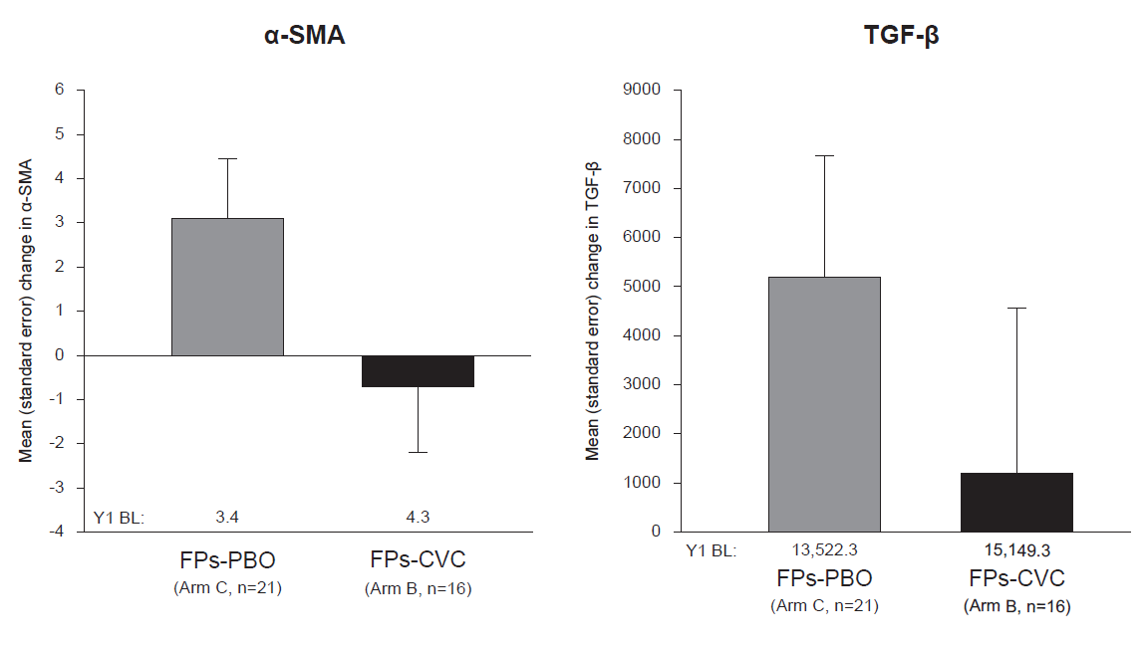
α-SMA, alpha-smooth muscle actin; BL, baseline; CVC, cenicriviroc; FP, fibrosis progressor; PBO, placebo; TGF-β, transforming growth factor-beta

