Controversies and Brands: A Study on Digital Rhetorical Arenas

Damien Renard
Professor
Université catholique de Louvain
Ruelle de la lanterne magique 4, 1340 Louvain-La Neuve
E-mail : damien.renard@uclouvain.be

INTRODUCTION
Brand storytelling has become an essential component of marketing communication, allowing companies to establish a consistent image and differentiate themselves from their competitors (Dessart & Pitardi, 2019). However, these narratives need to be carefully crafted, as they can be challenged by stakeholders who use social media platforms to express their dissatisfaction and launch boycott campaigns. As brands are increasingly exposed to controversies on social media, it is essential to understand how they can manage them. The research question therefore focuses on how controversies surrounding brands can create digital rhetorical arenas. Using a mixed-methods approach combining content analysis of tweets (n = 29 466 messages related to the #boycottLeclerc hastag) and social network analysis, we examine the discursive practices and tactics employed by various actors in the digital rhetorical arena. Our results reveal that the digital rhetorical arena surrounding the French hypermarket chain E. Leclerc has been highly contested, with multiple stakeholders engaging in a range of discursive practices to promote their agendas. Overall, our study contributes to the literature on crisis communication and digital media by providing a detailed analysis of the rhetorical dynamics of digital rhetorical arenas surrounding brand controversies. The first part of our research presents several concepts from the relevant literature, the second part presents the results of the mixed-method study, while the final part concludes with the limitations of the study and the future research directions it opens up.
LITTERATURE REVIEW
Building brand identity through storytelling: a multi-stakeholder approach
The brand is a socially constructed object, shared by the organization and its stakeholders. It has long since gone beyond the market context and has imposed itself in our political and social space as a cultural reference (Holt, 2004). It gives meaning to a group of actors (consumers, citizens, employees, distributors, etc.) by providing a vision (a direction), meaning (a content) and emotions. The brand is an object characterized by an identity that is expressed through three dimensions: communication, symbols and employees' actions/attitudes (Cornelissen, 2004). However, in order to define brand identity, it is necessary to go beyond a simple list of characteristics. It can be viewed through the lens of narrative, which is described in the literature as a sequence of diverse events that come together to form a coherent and understandable whole over time. From this perspective, brand storytelling is not just the result of a spokesperson's strategy to define what the organization is or what it should do. It is a narrative process that results from interactions between the organization's stakeholders (Michel, 2017). Thus, just as the organization tells its story and, through it, its identity, consumers develop their understanding of what it is and what it should do. These stories can be the same as what the organization's representatives say or different, mobilizing other actors and other narrative motifs. From this perspective, digital social networks are spaces of expression for consumers, allowing everyone to participate in the construction of the brand's narrative. While there are many opportunities, platforms are also places of expression that can encourage misinformation and controversy. While the literature has long focused on the role of consumers in co-creating the brand identity (e.g. Black and Veloutsou, 2017; Renard et al., 2022; Zhao et al., 2016), the role of controversies that arise within digital rhetorical arenas needs to be further explored.
Brands Face Rising Boycott Risks in digital rhetorical arenas
A controversy for a brand refers to a situation in which a company or its products/services become the subject of public disagreement, dispute or boycott. The marketing literature has long been interested in the phenomenon of brand boycotts (Klein and Smith, 2004), which have multiple motivations, but which can lead organizations to crisis situations. In recent years, with the development of social networks, calls for brand boycotts have multiplied, leading brands to media crises. Coombs (2015) defines a crisis as "the perception of an unlikely event that threatens stakeholder expectations." Crisis is considered an unpredictable event and generally characterized by an acceleration of time, the existence of a sense of ambiguity and uncertainty (Seeger et al., 2003). Frandsen and Johansen (2017) defend the idea of a multivocal approach to crisis, characterized by the presence of voices that communicate with each other, with or against the organization in question. In this research, we are interested in the formation of a digital rhetorical arena and seek to better understand how the brand, through its identity and the narrative it carries, can constitute a boundary object (Star and Griesemer, 1989) between different stakeholders.
METHODOLOGY
The research focuses on the #BoycottLeclerc hashtag, which was created after the CEO of Leclerc appeared on TV to discuss the company's efforts in fighting Covid-19. The initial goal was to enhance the company's brand narrative in several ways. Firstly, it emphasizes Leclerc's ability to manage the health crisis, strengthening its reputation as a responsible and dedicated company to its customers. Additionally, the interview presents the CEO as a proactive figure who advocates for consumers, enhancing the brand's ethos and positive image. Finally, by taking a stance on the vaccination issue and suggesting a ban on entry to stores for unvaccinated individuals, Leclerc positions itself as a socially responsible company committed to combating the pandemic and addressing public health concerns. In the context of this research, we are interested in messages created and/or disseminated via the hashtag #boycottLeclerc. Using the Netlytic collection tool, we collected 29,466 messages between January 6 and March 13, 2022, posted by 12,701 people. The analysis of message publication reveals a three successive waves of tweets. The first wave is triggered by statements made by the leader, with the second wave occurring four weeks after the initial one, showing the ephemeral nature of the controversies.
Figure 1. Temporal analysis of posts
To study controversies, we rely on the method of social network analysis. In this research, the nodes are platform users who have performed at least one action on the platform. We consider a user to be linked to another when he or she has performed one of four actions (tweet, retweet, quote, reply). Finally, we arrive at a network of 12,700 nodes and 21,496 links. For each participant, we calculate a set of measures, namely the number of actions (tweets, retweets, replay, quote) and the number of incoming and outgoing links. The number of outgoing links corresponds to actions directed towards others. The number of incoming links corresponds to community members' actions directed towards a user, such as retweeting another member's message. To finalize this analysis, we use the IRAMUTEQ software to conduct a discourse analysis. The objective is to categorize the tweets according to their thematic content and the extent of ethos, pathos, and logos they conveyed. Ethos refers to the credibility or authority of a person, and in the context of tweets, it may include the reputation or status of the organization. Pathos relates to the use of emotion to persuade, and in the context of tweets, it may involve the use of emotional words or images to elicit an emotional response. Lastly, logos pertains to the use of rational arguments.

Message | Logos | Ethos | Pathos
#BoycottLeclerc ! https://t.co/kmOrN1Yqhn | 0 | 0 | 1
"Leclerc wants to inject our children, we need to set an example and boycott massively. https://t.co/yVXoL21Lp6" | 0 | 0 | 1
"Leclerc has opened vaccination centers for children!!! I think that #BoycottLeclerc has never been more relevant. #TouhezPasAuxEnfants https://t.co/8izpBguKJD" | 0 | 0 | 1
"BAGUETTE #BoycottLeclerc Good poisoning to all!!!😂 https://t.co/yKWAJOZAUw" | 0 | 0 | 1
"After the health pass that Michel Édouard Leclerc had no problem imposing to buy food in his stores, now he directly sponsors and implements vaccination centers in his galleries!🤮🤮🤮 #BoycottLeclerc https://t.co/0DT2okZRik" | 1 | 1 | 1
"After threatening to require the #VaccinePassport, #Leclerc sells baguettes at a loss for 29 cents to destroy small businesses. #boycottLeclerc" | 1 | 1 | 0
"The 29-cent baguette from Leclerc isn't bread, it's cardboard... it's crap! #boycottLeclerc I'm continuing the #boycottLeclerc, and you?" | 0 | 0 | 1
"As Michel-Édouard Leclerc wants to starve our children through the #VaccinePassport, I took the liberty of creating a resume for his father, who had a tendency to talk a lot in 1940. And I invite people to #BoycottLeclerc #PengamTo watch the full video: https://t.co/bcrbnElp9e https://t.co/f8p2ZfA03L" | 1 | 1 | 1
Table 1. Examples of coding

RESULTS
The call for a boycott and the aggregation of multiple voices
In accordance with the literature on boycotts (Friedman 1999; Smith 1990), participation is motivated by the conviction that the company has engaged in conduct that is manifestly bad and has negative and potentially harmful consequences. In the context of this boycott, the hashtag allows the creation of a digital space that enables users to engage in discursive practices, form communities, and circulate ideas and messages through online debates. The use of a specific hashtag allows users to aggregate their content around a common topic and participate in online debates. The analysis shows that 2% of actors have disseminated 46.7% of the messages (tweets, retweets, replies, quotes). It is also interesting to note that 67.1% of the messages are retweets and 19% are original tweets. This call for boycott resembles an assemblage (Delanda, 2012) of individual actions and thus corroborates previous research that highlights the difficulty of emerging collectives within boycotts. Indeed, the results show that the degree of reply is low, indicating a low level of interaction between actors. Additionally, their infrequent and irregular tweeting activity suggests a lack of commitment towards the call for boycott. Finally, the #boycottLeclerc hashtag bring together many people who share a common goal of expressing their disapproval of E.Leclerc's decision. However, it does not necessarily signify a cohesive collective with clear objectives or coordinated plans of action. Instead, it appears to be a digital arena where individuals can engage in rhetorical competition to defend their interests and promote their positions.
Harnessing emotional appeal in digital rhetoric
Within the arena, it is possible to observe different rhetorical dynamics. To analyze them, we conduct a discourse analysis that reveals a weak use of modes of persuasion based on logic and reasoning (logos) or challenging the credibility of the organization itself (ethos). Messages belonging to this category are often directed towards the leader's ethos rather than the organization. Additionally, to expand the boycott appeal, stakeholders adopt a reframing strategy aimed at criticizing the organization's marketing strategy more broadly. For example, challenging the price reduction of bread aims to demonstrate how the organization is detrimental to the interests of local artisans and businesses. This broader scope of controversy, based on rational arguments, aims to mobilize more opponents seeking support from a wider range of actors beyond just the unvaccinated, including defenders of local crafts and commerce. However, the analysis highlights the importance of pathos in the digital rhetorical arena, in particular in the second step of the boycott (week 4). The dissemination of a message about vaccinating children in a vaccination center located in a Leclerc shopping center is the starting point of a the most important controverse related to the #boycottLeclerc hashtag. The message seems focused on appealing to emotions.
The emergence of a multi-vocal rhetoric arena
Hilgartner and Bosk (1988) consider the struggle for power and influence as a central element of the dynamics of arenas, where actors compete to influence public policies. In our case, the brand is associated with mandatory COVID-19 vaccination policy, drawing the attention of political organizations that perceive this controversy as a way to promote their own causes. In this perspective, the hashtag #boycottLeclerc becomes a space of contestation where actors compete to impose their point of view. Figure 2 illustrates this arena during the last step, with an illustration (colors) of the main clusters. We observe that few nodes on the periphery exhibit a high level of authority even if they are not engaged in a collaborative dynamic with a low level of centrality degree. While their content production investment is relatively limited, it is observed that their messages are widely disseminated by their community. The boycott call appears here as an object that they adapt according to their pursued goals.
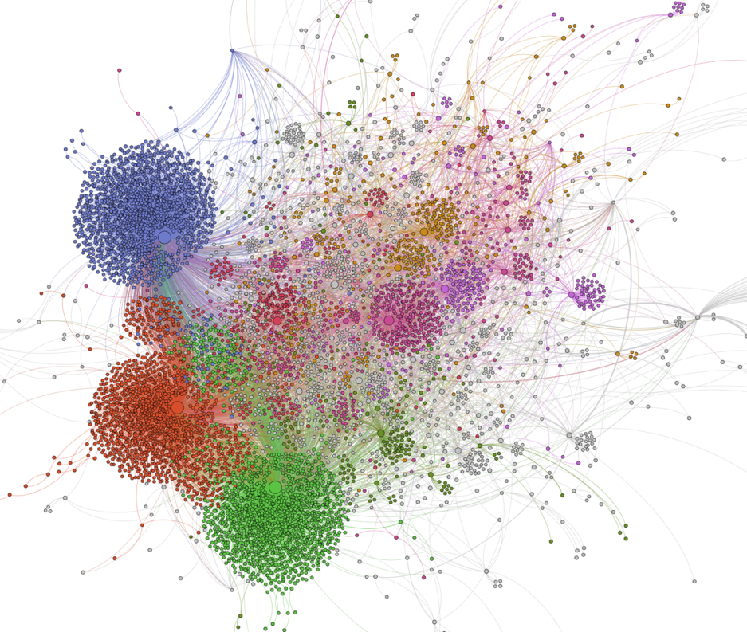
Figure 2. Visualization of social interactions
DISCUSSION
This study sheds light on how the use of specific hashtags can create boycott that enable users to engage in discursive practices, form communities, and circulate ideas and messages through online debates. However, we observe the difficulties in creating a collective due to the fragmented audience and the proliferation of contradictory discourses. Additionally, the use of emotionally-charged arguments can often lead to a competition to attract user attention, rather than fostering genuine constructive dialogue. From a theoretical standpoint, this study illustrate how contreverses against a brand can serve as the starting point for the construction of a digital rhetorical arena. The controversy surrounding the #BoycottLeclerc hashtag is an example of a multivocal approach to crisis, characterized by the presence of different voices (consumers, politicians, journalists, etc.) that communicate with each other, expressing their interpretations of the Leclerc brand's messaging and actions during the COVID-19 pandemic. Moreover, it emphasizes the importance of emotional appeal (pathos) in digital rhetoric. From a managerial perspective, this study provides valuable insights into how brand narratives can be shaped and contested in the digital age, particularly during a crisis, and suggests potential strategies for companies to manage their brand narratives in such situations. However, our study has limitations, such as the focus on a single case study. Future research can build on our findings by exploring the dynamics of digital rhetorical arenas in different contexts.

REFERENCES

Black, I. & Veloutsou, C. (2016). Working consumers: Co-creation of brand identity, consumer identity and brand community identity. Journal of Business Research, 70, 416-429.
Coombs, W. T. (2015). Ongoing crisis communication: Planning, managing, and responding. Sage Publications.
Cornelissen J. (2004). Corporate communication: theory and practices, Sage Ed.
Delanda, M. (2016). Assemblage Theory, Edinburgh University Press.
Dessart L, & Pitardi V. (2019), How stories generate consumer engagement: An exploratory study,, Journal of Business Research,Volume 104, 183-195.
Frandsen, F., & Johansen, W. (2016). Organizational Crisis Communication: À Multivocal Approach. SAGE.
Friedman, M. (1999). Consumer Boycotts: Effecting Change Through the Market-
place and the Media. Routledge, New
Hilgartner, S., & Bosk, C.L. (1988). The Rise and Fall of Social Problems: A Public Arenas Model. American Journal of Sociology, 94, 53 - 78.
Holt, D. (2004), How Brands Become Icons: The Principles of Cultural Branding, Boston: Harvard Business School Press.
Klein, J. G., Smith, N. C., & John, A. (2004). Why We Boycott: Consumer Motivations for Boycott Participation. Journal of Marketing, 68(3), 92–109.
Michel, G. (2017), « From Brand Identity to Polysemous Brands: Commentary on “Performing Identities: Processes of Brand and Skakeholder Identity Co-Construction” », Journal of Business Research, 70, 453-455.
Renard D, Zhao Z, Balagué C, Elmoukhliss M. (2016). Crowdsourcing collective intelligence through coopetition. In: Collective Intelligence Conference 2016.
Renard D., (2022). La justification des pratiques de co-création sur les plateformes de crowdsourcing, Réseaux, nº 231, vol. 1, p. 197-224.
Seeger, M. W., Sellnow, T. L., & Ulmer, R. R. (2003). Communication and organizational crisis. Greenwood Publishing Group.
Smith, N. C. (1990). Morality and the Market; Consumer Pressure for Corporate Accountability. Routledge, London.
Star S.L., Griesemer J. (1989). Institutionnal ecology, ‘Translations’ and Boundary objects: amateurs and professionals on Berkeley’s museum of vertrebate zoologie”, Social Studies of Science. 19(3), p. 387-420.

