Traversing between the arcs of environmental collaboration:
Implications for dyadic environmental performance

1. Introduction
Supply chain environmental collaboration (SCEC) describes the development of deep and long-term partnerships with upstream and downstream partners to alleviate negative environmental impacts (Cao and Zhang, 2011, Vachon and Klassen, 2006).We see more and more exemplary international firms proactively collaborating with their supply chain partners to address sustainability issues. For example, Ford collaborates with its suppliers to build environmental capacity through its Partnership for A Cleaner Environment (PACE) program (Ford, 2022); Johnson & Johnson provides their suppliers with a cohesive curriculum of webinars covering various sustainability topics involving human rights, climate emissions, and employee health and safety (Johnson & Johnson, 2022); Starbucks equips its farmers with precision agronomy tools to decrease carbon emissions in its supply chain and ensures farmers can access more sustainable machines in order to conserve water (Starbucks, 2021).
As established by these exemplary cases, firms can improve their environmental performance substantially through SCEC (de Sousa Jabbour et al., 2017, Gölgeci et al., 2019, Kumar et al., 2018, Tachizawa et al., 2012, Vachon and Klassen, 2008). Studies have confirmed that the broader the scope of collaboration, the more firms can benefit from their supply chains (Frohlich and Westbrook, 2001, Schoenherr and Swink, 2012, Humphreys et al., 2011). Nevertheless, a greater proportion of firms still seem to underutilize the potential of partnerships due to various internal or external reasons (Nonet et al., 2022). Against this backdrop, an important question arises: “Which environmental collaboration strategies involving upstream and downstream partners are most effective in enhancing environmental performance along the supply chain?” With this goal in mind, we depart from extant literature that seems to focus only on a focal firm’s environmental performance (Arora et al., 2020, Blome et al., 2014b, Gölgeci et al., 2019, Paulraj, 2011, Paulraj and Blome, 2017, Paulraj et al., 2014, Vachon and Klassen, 2008). By “focal firm,” we mean the firm within the particular supply chain represented in our study (i.e., from whom we collected our survey data). Specifically, we focus on the environmental collaboration activities of the focal firm spanning its immediate upstream (suppliers) and downstream (customers) partners. With the belief that the performances of other business partners along the supply chain also need attention, we go a step further and consider the environmental outcomes of both the focal firm and its key supplier, termed herein as the dyadic environmental performance. While we study environmental collaboration along upstream (supplier) and downstream (customer) relationships, we limit our examination to upstream dyadic environmental performance, given the belief that the focal firm can have a significant bearing on the output of its upstream partners instead of its downstream partners. We draw on the “arcs of integration” framework to investigate the outcomes of different SCEC strategies.
Furthermore, as environmental degradation is becoming a serious issue, firms’ and consumers’ sustainability priorities are expected to increase in importance. A recent survey found that consumers across all generations would be willing to spend more on environmentally sound products (Petro, 2022). Product stewardship is an advanced sustainability initiative that concerns the ‘life cycle’ of the environmental impacts of a product from its design to its disposal (Pujari et al., 2003). A high level of product stewardship represents a firm’s strong orientation to address environmental problems, and it requires firms to collaborate and collect environment-related information from both upstream and downstream supply chain partners (Bhupendra and Sangle, 2018, Khor and Udin, 2013). Since product stewardship embraces a broader strategic perspective in terms of managing the environmental impact of a product throughout its entire lifecycle, it is logical to expect that it may help shape the outcomes of other environment-related strategies as well. Therefore, we identify product stewardship as a key contingency and study its interaction with different SCEC strategies to influence the environmental benefits that firms may reap. Consequently, another research question that we want to explore is, “What are the differential moderating effects of product stewardship when it comes to the effect of different environmental collaboration strategies involving upstream and downstream partners on the environmental performance along the supply chain?”
As for the contributions of our study, it first extends the original “arcs of integration” framework (Schoenherr and Swink, 2012, Frohlich and Westbrook, 2001) to the sustainability domain by empirically studying the arcs of environmental collaboration. Using the natural resource-based view (NRBV) and the relational view, as well as a novel polynomial regression along with the response surface approach, we confirm that outward-facing environmental collaboration results in the highest dyadic environmental performance. Second, as opposed to current studies that mainly focus on the joint effect of supplier and customer environmental collaboration (Blome et al., 2014b, Vachon and Klassen, 2008, Wong, 2013), our research fills the void left by extant studies by uncovering the differential environmental performance benefits of collaborating with supply-side and demand-side partners. Third, we advance the understanding of product stewardship and identify its critical role in moderating the main hypothesized relationships, thus echoing the call of Schoenherr and Swink (2012) and Jayaram et al. (2010) who propose the necessity to explore more potential contingencies within the purview of the “arcs of integration” framework. More importantly, our findings also offer some important practical implications for improving a firm’s environmental performance.

2. Literature Review

2.1. Arcs of environmental collaboration
While supply chain integration emphasizes formal control and ownership, supply chain collaboration is hybrid governance emphasizing informal means (Nyaga et al., 2010). Supply chain collaboration spans several distinct aspects, such as the sharing of information and resources, congruence in goals and incentives, synchronization of decisions, and joint creation of knowledge (Cao and Zhang, 2011, Um and Oh, 2020). Just like integration, collaboration also yields significant benefits such as cost reduction, reduced delivery time, enhanced product innovation, shorter time-to-market (Liao et al., 2017), improved organizational responsiveness (Cai et al., 2016), and various financial improvements (Cao and Zhang, 2011), thereby providing collaborative advantage that could benefit all supply chain partners (Dyer and Singh, 1998). Therefore, we contend that supply chain collaboration could be a more appropriate construct to capture the mutual relationship that exists between supply chain partners (Cao and Zhang, 2011). Based on the “arcs of integration” framework, we propose the “arcs of environmental collaboration” framework. The “arcs of environmental collaboration” framework is similarly defined as comprising five different collaboration strategies concerning both the direction and degree of environmental collaboration with upstream and downstream partners: inward-, periphery-, customer-, supplier-, and outward-facing collaborations (Childerhouse and Towill, 2011).
Extant research has tried to cross-validate and extend the original “arcs of integration” framework proposed by Frohlich and Westbrook (2001) and, in doing so, developed a more fine-grained theoretical rationale around this concept. The missing focus of internal integration in the original “arcs of integration” research has been considered, and the relationship between supply chain integration and operational performance, as well as business performance, has been further empirically tested (Flynn et al., 2010, Schoenherr and Swink, 2012). It is specifically argued that internal integration enables firms to better exploit the information and knowledge gained from outside, thus making external integration more beneficial (Schoenherr and Swink, 2012). An 8-year field study conducted by Childerhouse and Towill (2011) also found that firms would first integrate internally and then make efforts to integrate externally with key suppliers and customers. Thun (2010) expanded the “arcs of integration” principle by exploring the fit between IT and supply chain integration strategies. In contrast to the “arcs of integration” framework, which considered integration direction and degree, Jayaram et al. (2010) found empirical support for the idea that the scope of integration is positively linked with a firm’s supply chain management efforts. Finally, unlike previous studies that focused on a single industry, Wong et al. (2017) extended the knowledge of the performance impacts of different arcs of integration by empirically verifying the differences in supply chain integration strategies across three different industries.

2.2. Supply chain environmental collaboration
As sustainability is a vital part of firms’ strategies, more and more firms are trying to actively integrate sustainability priorities into their business (Bonini, 2012, Longoni and Cagliano, 2015, Ivory and Brooks, 2018, Silvestre et al., 2022, Zharfpeykan and Akroyd, 2022, Burritt et al., 2020, Martin-de Castro, 2021). Internally, firms are tending to integrate sustainability-related aspects with other core processes and functions (Wagner, 2007). There is evidence that the integration of environmental management with the core functions of the firm is conducive to economic performance (Wagner, 2007), and subsequently, creating more opportunities for competitive advantage (Hart, 1995, Hart and Dowell, 2011). Across firm boundaries, firms collaborate for sustainability since whether a product is sustainable or not depends on the design, material, production, and technology decisions made by a diverse set of firms along the supply chain as well as the product life cycle (Nilsson‐Lindén et al., 2019). Consequently, a supply chain perspective that entails the development and management of interdependent relationships among supply chain partners is of paramount importance if firms want to achieve their sustainability objectives (Tachizawa et al., 2012, Green Jr et al., 2012, Cheng and Sheu, 2012, Lacoste, 2016).
As more and more firms start to collaborate for the purpose of sustainability, there is also a growing interest among researchers in exploring the antecedents, underlying practices, and outcomes of SCEC (Chen et al., 2017). Furthermore, while the initial focus of SCEC studies was on economic impacts, this has been subsequently broadened to incorporate environmental impacts as well (Chen et al., 2017, Sudusinghe and Seuring, 2022). Since sustainability cannot be achieved in isolation, SCEC has been recognized as an important strategy for achieving the sustainability outcomes of the focal firms and their supply chains (Kumar et al., 2018, Sudusinghe and Seuring, 2022). It ensures that supply chain partners work together and share knowledge and resources, as well as risk, in designing sustainable products (Cao and Zhang, 2011, Vachon and Klassen, 2006). These underlying collaborative activities also signal the focal firm’s inclination to commit their resources to helping suppliers and customers realize their sustainability goals (Paulraj, 2011, Blome et al., 2014b).
Being a relational supply chain mechanism (Paulraj and Blome, 2017), environmental collaboration is more focused on developing sound operations and processes in the long run (Vachon and Klassen, 2006, Vachon and Klassen, 2008). A representative literature review of papers on SCEC has focused predominantly on supply-side environmental collaboration (SEC) (i.e., environmental collaboration between the focal firm and its suppliers) and its influence on focal firm performances (Arora et al., 2020, Gölgeci et al., 2019, Paulraj et al., 2014, Paulraj, 2011, Paulraj and Blome, 2017). Barring a few notable studies like Vachon and Klassen (2008), Wong (2013) and Blome et al. (2014b), there appears to be no significant research that has explored demand-side environmental collaboration (DEC) (i.e., environmental collaboration between the focal firm and its customers) or its impacts on focal firm performances. Although industry leaders suggested that firms must simultaneously manage SEC and DEC to gain sustainability and strategic benefits (Blome et al., 2014b), research has rarely investigated the coalignment of SEC and DEC and linked their combined impacts on firm performance. Additionally, extant research has operationalized performance only from the perspective of the focal firms (Arora et al., 2020, Gölgeci et al., 2019, Blome et al., 2014b, Paulraj, 2011, Paulraj and Blome, 2017, Paulraj et al., 2014, Vachon and Klassen, 2008); investigation of performance from the perspective of suppliers has been lacking, and researchers have rightly responded to the need to study this perspective (Gimenez and Sierra, 2013). Echoing the call of previous studies, our research proposes the “arcs of environmental collaboration” framework based on the original “arcs of integration” developed by Frohlich and Westbrook (2001) and investigates the coexistence of SEC and DEC and their impacts on dyadic environmental performance.

2.3. The natural resource-based view and the relational view

The proposed relationships are based on the tenets of the NRBV and the relational view. Basically, the NRBV posits that environmental challenges are not merely constraints on business activities but also opportunities for competitive advantage, and firms that proactively address these issues can distinguish themselves from their competitors (Hart, 1995, Hart and Dowell, 2011). The NRBV highlights three different strategic capabilities involving pollution prevention, sustainable development, and product stewardship; each of these components offers distinct avenues for integrating environmental sustainability into business strategies (Hart, 1995, Hart and Dowell, 2011). Through environmental collaborations, firms can develop the necessary capabilities to better address environmental issues. In addition, since we focus on the resources/capabilities derived from inter-firm relationships (through collaborations) and examine the environmental performance of both the focal firm and its key supplier, we also rely on the tenets of the relational view (Dyer and Singh, 1998).

Among the three components stressed by the NRBV, pollution prevention concerns proactive activities to minimize waste and reduce emissions rather than controlling them after occurring. Sustainable development aims at long-term strategies that align business growth with environmental sustainability. Product stewardship involves taking responsibility for the environmental impact of a product throughout its entire lifecycle (Hart, 1995). While the first two strategic capabilities have more focused aspects in terms of sustainability, product stewardship encompasses life-cycle analysis, which quantitatively assesses the environmental impacts of a product through its entire life-cycle, involving manufacture, storage, packaging, use, and disposal (Bok et al., 2022, Pujari et al., 2003). Since product stewardship takes a more holistic perspective, it has the unique ability to condition the success of other environment-related strategies. Many firms tend to invest in product stewardship since they may be held responsible for environmental damages even when the damages are not directly caused by their actions (Snir, 2001). Specifically, under product stewardship, firms can assist their suppliers and customers in improving environmental practices, thus mitigating their own liability (Snir, 2001). Product stewardship cannot be successful if firms do not collaborate with both upstream and downstream partners on environmental issues (Bhupendra and Sangle, 2018). Therefore, it is undeniable that the level of product stewardship is very relevant to the scope and depth of SCEC. With this belief, we consider product stewardship to be a key moderator and study how product stewardship could interact with different arcs of environmental collaboration strategies to impact dyadic environmental performance.

3. Hypotheses Development

In this study, we are interested in the coexistence of SEC and DEC as personified by the arcs of environmental collaboration. Therefore, we use the response surface approach to hypothesize the coexistence of SEC and DEC, as this approach can help us understand the underlying synergies (Please refer to Figure 1). Our hypotheses are focused on symmetry and asymmetry lines as the five configurations of environmental collaboration are located along these lines of the response surface. As we move along the symmetry line, we traverse from inward-facing configuration to periphery-facing and then to outward-facing configurations. Alternatively, as we move along the asymmetry line, we traverse from customer-facing configuration to periphery-facing and then to supplier-facing configurations. Our hypotheses concentrate on the different arcs of environmental collaboration as well as the paths along the different arcs of integration.
-- Insert Figure 1 about here –

3.1. Dyadic environmental performance
Along the symmetry line, we propose that dyadic environmental performance will be comparatively lower when the levels of SEC and DEC are both low. As we move along the symmetry line, dyadic environmental performance will be medium (high) when the levels of SEC and DEC are both medium (high). Under the theoretical tenet of the NRBV, as both SEC and DEC increase, they can contribute to the development of environment-related capabilities and resources that hold greater potential for enhancing and sustaining a firm’s environmental performance (Hart, 1995). Additionally, as envisioned by the relational view, the increase in SEC and DEC can help the partners to identify as well as evaluate environment-related complementary resource endowments that could have a significant impact on the environmental performance across the supply chain (Dyer and Singh, 1998).
Specifically, when firms adopt an inward-facing environmental collaboration, namely when SEC and DEC are both low, the tenets of the relational view suggest that the lack of interaction between the involved parties implies that the focal firm will have a limited exchange of environment-related information and resources with its customers and suppliers, limiting the impact on their environmental performances (Dyer and Singh, 1998, Hart and Dowell, 2011). From the perspective of the NRBV, the inward-facing strategy could tend to be ineffective in enabling pollution prevention as well as the firm’s efforts toward sustainable development (Hart, 1995). Specifically, the lack of collaboration will hinder firms’ green product innovation processes (Hofman et al., 2020, Melander, 2018) as well as expose firms to more sustainability-related risks due to a lack of transparency along the supply chain (Hofmann et al., 2014, Kashmanian, 2017), thereby limiting improvements in the dyadic environmental performance. Taken together, we hold that with this strategy, the exchange partners will not be able to benefit significantly given the lack of the development of complementary idiosyncratic resources and knowledge-sharing routines (Dyer and Singh, 1998).
On the contrary, higher implementations of either SEC or DEC mark a firm’s proactive environmental strategy that aims at long-term sustainable development (Hart, 1995). Specifically, increased DEC could help firms acquire environmental information regarding new customer requirements as well as new environmental standards and regulations (Wong, 2013); also, environmental information exchange with customers goes a long way when it comes to a firm’s green product innovation (Hofman et al., 2020, Melander, 2018). These can all help the focal firm to quickly adapt to the changing external environment, identify more opportunities to prevent emissions and reduce waste (Wong, 2013, Hart and Dowell, 2011). Accordingly, DEC can not only improve focal firms’ environmental performance but also lessen their suppliers’ environmental impacts. This occurs because suppliers will need to find appropriate sustainability solutions to cater to focal firms’ environmental requests, leading to mutual coevolution in environmental sustainability practices (Dyer and Singh, 1998).
Also, the SEC is associated with higher levels of firms’ environmental performance (Arora et al., 2020, Gölgeci et al., 2019, Le et al., 2021, Paulraj, 2011, Paulraj and Blome, 2017, Paulraj et al., 2014, Vachon and Klassen, 2008, Zahoor and Gerged, 2021). Increased SEC not only drives supply chain transparency (Brun et al., 2020, Kashmanian, 2017) but also enables firms to conduct joint environmental planning and goal-setting with suppliers (Vachon and Klassen, 2008). Using the reasoning from the NRBV, these activities could ultimately contribute to not only minimizing waste and emissions but also creating opportunities for competitive advantage (Hart, 1995). Supplier environmental performance can also be improved through SEC activities such as green supplier development involved (Blome et al., 2014a, Lee et al., 2018), where suppliers receive support and feedback by working with the focal firms on sustainability issues. As such, suppliers’ lack of environmentally oriented capabilities can be overcome by the formation of idiosyncratic interaction routines (Lorenzoni and Lipparini, 1999, Paulraj et al., 2014).
As firms move from an inward-facing collaboration towards periphery-facing and, subsequently, outward-facing environmental collaboration strategies (i.e., when both SEC and DEC increase simultaneously), the focal firm along with its customers and suppliers can increasingly make the most out of the collaboration by obtaining complementary idiosyncratic environment-related knowledge and resources to improve their environmental performances (Dyer and Singh, 1998, Hart and Dowell, 2011). In the case of an outward-facing collaboration, the potential idiosyncratic and complementary resources and capabilities that are identified and developed collaboratively could pave the way for superior environmental as well as financial benefits for the involved partners (Hart and Dowell, 2011, Dyer and Singh, 1998). Particularly, firms will have a good command of customer preferences, environmental regulations, and market knowledge (Priem and Swink, 2012); they can leverage the environmentally innovative ideas from supply chain partners (Melander, 2018) as well as cultivate a better understanding of possible environmental problems facing each part of the supply chain (Busse et al., 2017), thus improving the dyadic environmental performance significantly (Hart, 1995, Dyer and Singh, 1998). Therefore,
H_{1a}: As both SEC and DEC increase (i.e., as we traverse from inward-facing periphery-facing outward-facing), dyadic environmental performance will increase.

Along the asymmetry line, we propose that dyadic environmental performance will be low in the case of periphery-facing environmental collaboration, and it will increase as we move towards either supplier-facing or customer-facing collaboration. When firms implement a periphery-facing collaboration, namely when SEC and DEC are both at medium levels, the focal firm and its suppliers can, to some extent, gain valuable environment-related resources and capabilities through collaboration (Dyer and Singh, 1998, Hart and Dowell, 2011). However, as espoused by the NRBV and the relational view, under the medium level of collaboration, the lack of tacit relevant knowledge sharing may limit the accessibility of the potential idiosyncratic resources embedded in the relationships (Dyer, 2000, Dyer and Singh, 1998), thus significantly hindering the ultimate improvement of dyadic environmental performance (Hart, 1995).
Though not ideal, under either supplier-facing or customer-facing environmental collaboration, firms aim for adequate sustainable development and accordingly tend to utilize the full knowledge potential and leverage the tacit knowledge from either side of their supply chains (Dyer, 2000, Dyer and Singh, 1998, Hart, 1995). Therefore, first, we propose that in comparison to the periphery-facing collaboration, supplier-facing collaboration can lead to a higher dyadic environmental performance. Specifically, as advocated by the relational view, when firms implement a supplier-facing environmental collaboration, both the focal firm and its suppliers could gain as much environment-related knowledge and capabilities as possible from each other (Dyer and Singh, 1998, Hart and Dowell, 2011), and, in doing so, benefit from less exposure to sustainability-related risks in the upstream supply chain (Hofmann et al., 2014). In addition, high levels of SEC can facilitate the exchange of tacit knowledge (Parente et al., 2022), which is found to be particularly useful in environmental management activities involving pollution source identification, emergency situation management, and preventive solution development (Boiral, 2002). While the lower level of DEC may prevent firms from gaining a comprehensive and timely update on changing customer preferences and new environmental regulations (Wong, 2013), we argue that the limitation caused by a lower level of DEC can be negated, to an extent, by the tacit knowledge and valuable capabilities gained from supply-side collaboration.
Similarly, we also argue that a customer-facing collaboration can lead to higher dyadic environmental performance in comparison to a periphery-facing environmental collaboration. A high level of collaboration with customers could enable focal firms to be well-informed of the updated market knowledge and environmental requirements (Wong, 2013), making it easier for them to generate feasible ideas for green product innovation (Melander, 2018) in collaboration with the customers. This will also subsequently stimulate their suppliers to use sustainable raw materials, thus compensating for the lack of SEC. Therefore, based on the tenets of the relational view, we purport that a high level of collaboration with either the upstream or downstream partners can improve dyadic environmental performance through the development of idiosyncratic resources and routines more than collaborating with both at only moderate levels (Dyer and Singh, 1998).
H_{1b}: As SEC increases and DEC decreases (i.e., traversing from customer-facing periphery-facing supplier-facing, and vice versa), dyadic environmental performance will initially decrease, then it will increase.

Past research findings indicate that firms engaging in more comprehensive collaboration regimes seem to have the greatest rates of performance improvement (Childerhouse and Towill, 2011, Frohlich and Westbrook, 2001, Schoenherr and Swink, 2012). In addition to the fact that firms are impacted by their surrounding networks, especially in the sustainability domain (Chen and Paulraj, 2004), we argue that in comparison to other types of collaboration, outward-facing environmental collaboration could make the most use of the idiosyncratic and complementary environmental resources that could be derived through strong partnerships with both suppliers and customers, thus leading to collaborative advantage in terms of superior dyadic environmental performance (Hart, 1995, Dyer and Singh, 1998). Drawing on the tenets of the relational view, we can envision that when focal firms fully collaborate with both their customers and suppliers on sustainability issues, they can not only increase transparency but also facilitate access to relevant environmental knowledge from both sides of the supply chain through appropriate knowledge-sharing routines (Blome et al., 2014b) which could eventually broaden their range of environmental opportunities (Gutierrez et al., 2022). Particularly, firms with an outward-facing strategy benefit from high levels of tacit knowledge sharing, which can facilitate advanced pollution reduction as well as prevention practices that could result in superior environmental performance as well as other performance benefits (Blome et al., 2014b, Vachon and Klassen, 2007, Dyer and Singh, 1998, Hart, 1995). Accordingly, in this case, dyadic environmental performance will reach a peak since the focal firm and its supplier firm can both leverage the full knowledge potential of the supply chain. Moreover, the direct involvement of both the focal firm and its supplier firm on sustainability issues is more likely to drive the successful management of sustainability risks in the supply chain, thus alleviating the negative impacts on the environment (Hofmann et al., 2014). Therefore, we hypothesize the following:

H_{1c}: Outward-facing collaboration will result in the highest dyadic environmental performance when compared to customer-facing or supplier-facing collaborations.

3.2. Moderating effect of product stewardship

Firms focusing on product stewardship tend to pay particular attention to the sustainability of their products. Given its ambition to embrace “the voice of the environment,” firms must exhibit more care for products’ reuse, recycle, and recovery, and whether the products are made of environmentally friendly materials (Hart, 1995, Snir, 2001). Product stewardship also focuses on minimizing the environmental impact throughout the product’s entire useable life (Hart, 1995, Liu et al., 2017). Accordingly, in their quest for achieving product stewardship, firms will need continuous information inputs from, and careful coordination between, multiple supply chain partners to minimize the total negative environmental consequences throughout the products’ cradle-to-grave stages (Matos and Hall, 2007, Fuller and Ottman, 2004). Given that it mandates the need for closer relationships with various stakeholders, including the suppliers and customers, product stewardship has the unique ability to condition the efficacy of other environment-related strategies due to its holistic view across the whole supply chain (Hart, 1995).

In the upstream supply chain, firms may be concerned with the sustainability issues of material extraction and material manufacturing; in the downstream supply chain, firms may be concerned with customer consumption activities such as product final disposal (Fuller and Ottman, 2004). Based on the tenets of the NRBV and the relational view, by collaboratively harnessing the complete environment-related knowledge potential from upstream and downstream supply chain partners, firms will be able to produce more sustainable products and minimize environmental impact, meeting the demands of high product stewardship (Dyer and Singh, 1998, Hart, 1995). Therefore, under the condition of high product stewardship, an outward-facing collaboration facilitates closer working relationships with, and accumulation of knowledge resources from, both the customers and suppliers, thereby yielding higher dyadic environmental performances in comparison to either supplier-facing or customer-facing strategies (Hart, 1995).

Conversely, when product stewardship is low, firms pay only limited attention to the sustainability issues of their products. In such a scenario, life cycle analysis is not a priority as the firms need not assess the complete environmental burden created by their products; in other words, focal firms may feel less required to either gain valuable environmental knowledge from both supplier and customer sides or coordinate their environmental activities for implementing product stewardship. We draw on the tenets of the relational view and conjecture that a high level of collaboration with either side could be enough for the focal firms to meet the requirements of lower levels of product stewardship initiatives (Dyer and Singh, 1998). In other words, we argue that when product stewardship is low, the consequent dyadic environmental outcome of a supplier-facing or a customer-facing strategy would be no different than that of an outward-facing strategy. Therefore,

H2a: When product stewardship is high, outward-facing collaboration will perform better than customer-facing or supplier-facing collaborations when it comes to dyadic environmental performance.

H2b: When product stewardship is low, customer-facing or supplier-facing collaborations could perform equally to that outward-facing collaboration when it comes to dyadic environmental performance.

4. Methodology

4.1. Data collection
The sampling frame consisted of 3,000 Institute for Supply Management (ISM) members who worked in U.S. firms. The respondents were senior executives with titles such as VP/Director of purchasing and supply chain management. The instrument was pre-tested using eight supply chain practitioners as well as professors. A few changes were made to the survey instrument based on the suggestions provided by these experts (Dillman, 2007). All items were measured on a 5-point Likert scale. In the case of supplier-related indicators, the respondents were asked to answer them based on key suppliers; these suppliers were responsible for a higher spend and/or important purchased materials/components. Similarly, in the case of customer-related indicators, the key customers were instructed to be selected based on the total value of the product sold and/or the strength of the relationship.

Given that ISM does not provide member email addresses, we conducted the survey in two stages. Initially, a consent form along with a project description was mailed to the 1,500 respondents who were randomly selected from the sampling frame. While 30 surveys were returned undelivered, a total of 580 consent forms were returned (response rate = 580/[1500-30] = 39.50%). Only 305 of these 580 respondents consented to participate in the study; 275 respondents did not provide consent owing to either company policy and/or lack of experience in sustainable supply chain practices (resulting in an effective sample size of 1470 – 275 = 1195). The participants (i.e., 309) had the option to choose how the survey instrument was delivered to them (i.e., online or paper-based). Eventually, 241 surveys were returned, resulting in a 20.17% response rate.

To address the key respondents' issues, we asked respondents two questions to assess their knowledge and confidence about the topics covered in the survey. An average of 3.97 and 4.04 was found for these two questions; these values demonstrate the appropriateness of the respondents. Furthermore, 65% of the respondents held senior positions in their company. Additionally, approximately 57% of the respondents had 20 or more years of experience, implying that they were knowledgeable as well as experienced in answering the questions regarding their sustainable supply chain practices and performance. As for the firm profile, our final sample primarily included medium to large firms, with nearly 58% of the firms employing 1,000 employees or more. Alternatively, when it came to annual sales income, the final sample was quite evenly distributed; while 23% of the firms made less than $100 million, nearly 18% made more than $10 billion.

4.2. Measures
The measurement items were developed from extant literature. SEC focused on the collaboration between the focal firm and its key suppliers on sustainability issues. The measures were adapted from Bowen et al. (2001), (Vachon and Klassen, 2006), and (Zhu and Sarkis, 2004). DEC reflects the extent of collaboration between the focal firm and its key customers on sustainability issues. The measurement items for this construct came from Vachon and Klassen (2008). We followed the classification scheme of supply chain integration strategies that was proposed by Frohlich and Westbrook (2001). Using quartiles, five different integration strategies in relation to SEC and DEC were identified, including inward-facing, periphery-facing, outward-facing, supplier-facing, and customer-facing (Frohlich and Westbrook, 2001). Product stewardship focuses on the focal firm’s design of environmentally friendly products as well as the environmental impact of their products through life cycle analysis (Walton et al., 1998, Zhu and Sarkis, 2004). The focal firm’s and the supplier’s environmental performance covered improvements along different aspects, including emission, waste, and other environmental impacts (Zhu and Sarkis, 2004); the average of the focal firm’s performance and the supplier’s performance was used to operationalize dyadic environmental performance. Since all the constructs are measured from the perspective of the focal firm, their corresponding suppliers’ environmental performances are measured in a more generic way to ensure that we receive trusted data with quality.

4.3. Bias assessment

We assessed non-response bias by separating our sample into early and late respondent groups (Armstrong and Overton, 1977); the early group included 131 responses, and the late group included 110 responses. We conducted group comparison tests for company size as well as a set of randomly selected indicators; these were not statistically different (p < 0.05). As an additional test, we compared the responding firms to the overall population. For this purpose, we combined our final sample of 241 with 200 randomly selected non-responding firms. Demographic data on annual sales volume and employee count was collected by contacting these 200 firms and was then combined with our sample of 241 to get the population mean. The two demographic variables were found to be not significant across the sample and population (at p < 0.05), thereby suggesting that non-response is a non-issue. Harman’s single-factor test was used to assess common method variance (Podsakoff et al., 2003). The single-factor model fit was considerably weak in comparison to our hypothesized model (Sanchez and Brock, 1996). Second, we conducted the marker variable technique (Malhotra et al., 2006); the second-smallest positive correlation among variables was the marker variable. All zero-order correlations were still statistically significant after partialing out this correlation (Lindell and Whitney, 2001). Overall, these results suggest that common method variance is not a problem.

4.4. Assessment of psychometric properties

Construct validity was assessed using the confirmatory factor analysis (CFA). The results are provided in Tables 1 and 2. Based on the model fit indices (NNFI = 0.98; CFI = 0.98; RMSR = 0.037; RMSEA = 0.062) as well as standardized coefficients (all coefficients significant at the 99% confidence level), we can conclude that our measurement items exhibit construct validity and unidimensionality. Discriminant validity was assessed using the Fornell and Larcker (1981) approach. The correlation coefficients presented in comparison to the average variance extracted (AVE) values in Table 2 suggest that our indicators pass the test. Finally, we used the HTMT (heterotrait-monotrait) approach recommended by Henseler et al. (2015). All HTMT values were below the recommended value of 0.85 (between 0.228 and 0.652). During this instrument development process, one indicator was deleted (marked with an asterisk in Table 1). We used coefficient alpha (Nunnally and Bernstein, 1994), coefficient omega (Deng and Chan, 2017), and composite reliability (CR) (Bagozzi and Yi, 1988) to assess reliability. As evident from Table 1, all constructs had coefficient alpha (0.865 to 0.960), coefficient omega (0.869 to 0.961), and CR values (0.867 to 0.963) that were greater than 0.80. Additionally, we also assessed the confidence interval of both coefficients alpha and omega (Raykov and Shrout, 2002); the lower limit of coefficient alpha (0.825 to 0.949) and omega (0.833 to 0.948) for all constructs were above 0.80. Scholars also suggest reporting robust coefficient alpha and robust coefficient omega values as they account for the influence of outliers and missing data (Zhang and Yuan, 2016). The robust coefficient alpha (0.883 to 0.979) and robust coefficient omega (0.887 to 0.979) values of all constructs were also above 0.80.
-- Insert Tables 1 and 2 about here –

4.6. Hypothesis tests
Table 2 presents the summary statistics and the correlation matrix. A polynomial regression analysis was used to test our hypotheses. SEC and DEC were scale-centered before creating the higher-order terms; this approach ensured that our models were free of multicollinearity. Specifically, since the variance inflation factor (VIF) values were lower than 5 for all the terms, we do not have multicollinearity concerns. We used multiple control variables in our regression analysis. We used firm size as a control variable as it reflects the availability of resources within the focal firm (Paulraj et al., 2008). Focal firm size was measured using the number of employees as a measure of firm size; it was log-transformed before being included in the regression analysis. Second, market share held by the focal firm with respect to its competition was included as a control; market share also reflects resource availability when it comes to improving a firm’s environmental practices as well as performance (Boulding and Staelin, 1993). Market share was captured using the question, “When compared to our firm’s largest competitor, our market share is”. The answer to this question was captured using a 5-point Likert scale with anchors of “1 – much smaller”, “3 – similar”, and “5 – much larger”. Finally, the extent of environmental collaboration between the supply chain partners, as well as the ensuing superior dyadic environmental performance, could be dependent on the extent of assets that have been invested in a supplier relationship. Accordingly, we used the “extent of specific assets” as a control variable in our analysis; this was measured using the question “The extent of specific assets involved in our relationship with this supplier.”
We evaluated the characteristics of the response surfaces instead of looking at the significance of SEC and DEC individually, (Edwards, 1994, Edwards and Cable, 2009, Lambert et al., 2003). In general, studying response surfaces involves a quadratic equation such as:
P = b₀ + b₁ SEC + b₂ DEC + b₃ SEC² + b₄ SEC * DEC + b₅ DEC² + e (1)
In this equation, P represents dyadic environmental performance. The unstandardized coefficients of SEC, DEC, squared SEC term, SEC * DEC (interaction term), and squared DEC were used to assess the hypotheses. The significance of the symmetry line’s slope (denoted by b₁ + b₂) and curvature (denoted by b₃ + b₄ + b₅) as well as the asymmetry line’s slope (denoted by b₁ – b₂) and curvature (denoted by b₃ – b₄ + b₅) were evaluated to closely study the effect of different SCEC configuration on the outcome variable.

4.7. Results
The results of the polynomial regression analysis on the joint effects of SEC and DEC on dyadic environmental performance are presented in Table 3 (Model 1). Hypothesis H_{1a} predicted that as SEC and DEC both increased (i.e., as we traverse from inward-facing configuration to periphery-facing and then to outward-facing configurations), dyadic environmental performance will continue to increase. As evident from Table 4, the symmetry line’s slope is positive and significant (0.411; CI = [0.163, 0.435]), while its curvature is insignificant (0.105; CI = [-0.009, 0.216]). In general, these results provide adequate support for Hypothesis H_{1a}. Alternatively, a U-shaped (positive) curvature along the asymmetry line was predicted by hypothesis H_{1b}. Though the sign of the curvature (0.101; CI = [-0.217, 0.237]) was positive, it was found to be insignificant. Additionally, the asymmetry line’s slope (0.126; CI = [-0.146, 0.314]) was also found to be insignificant. The insignificance of the curvature along the asymmetry line indicates that hypothesis H_{1b} was not supported. Figure 2 presents the surfaces; as evident from Figure 2, the highest point of the response surface occurs when both SEC and DEC are high (i.e., outward-facing collaboration). Though not significant, the positive curvature and positive slope along the asymmetry line suggest that while the second highest point occurs when SEC is high and DEC is low (supplier-facing collaboration), the third highest point occurs when DEC is high and SEC is low (customer-facing collaboration). In other words, hypothesis H_{1c} was supported by our analysis.
-- Insert Tables 3 and 4 and Figure 2 about here –
Hypotheses H_{2a} and H_{2b} focused on the contingent effect of product stewardship. Specifically, hypothesis H_{2a} proposed a significant positive slope along the symmetry line when product stewardship was high. As evident from Table 3, the symmetry line’s slope (0.287; CI = [0.107, 0.476]) was significant. Additionally, the curvature (0.018; CI = [-0.135, 0.155]) was insignificant. While Hypothesis H_{2a} was supported by these results, supplier-facing collaboration seems to perform much better than customer-facing collaboration. In other words, when product stewardship is high, outward-facing and supplier-facing collaborations lead to better dyadic environmental performance than a customer-facing collaboration. The response surface for hypothesis H_{2a} is presented in Figure 3 (right side). Hypothesis H_{2b} predicted that supplier-facing and customer-facing collaborations will perform like an outward-facing collaboration. While the curvature (-0.139; CI = [-0.472, 0.212]) along the asymmetry line was insignificant, the slope (-0.346; CI = [-0.682, -0.022]) was found to be negative and significant. This result does not support hypothesis H_{2b}. Instead, as evident from Figure 3 (left side), it is intriguing to notice that customer-facing collaboration’s performance is far superior to supplier-facing collaboration when product stewardship is low. Additionally, dyadic environmental performance in customer-facing collaboration is only slightly lower than in outward-facing collaboration. When compared to the previous results, customer-facing collaboration seems to be more appropriate whenever product stewardship is not that high.
-- Insert Figure 3 about here –

4.8. Post-hoc Analysis
We also tested the effects of the five configurations of environmental collaboration on the supplier’s environmental performance and the focal firm’s environmental performance separately to assess how the effects are different. The results are presented in Table 5. In the case of the focal firm’s environmental performance, both the slope (0.214; CI = [0.103, 0.325]) and curvature (0.149; CI = [0.062, 0.245]) along the symmetry line were found to be significant. On the contrary, in the case of the supplier’s environmental performance, only the slope (0.408; CI = [0.194, 0.598]) along the symmetry line was found to be significant. When taken together, these results suggest that in the case of the focal firm’s environmental performance, inward-facing collaboration is better than periphery-facing collaboration. On the contrary, periphery-facing collaboration is better than inward-facing collaboration when it comes to the supplier’s environmental performance. However, outward-facing collaboration seems to be the best configuration when it comes to both the focal firm’s and the supplier’s environmental performance outcomes. The response surface for this analysis is presented in Figure 4.
-- Insert Table 5 and Figure 4 about here --

5. Discussion and Concluding Remarks
The differential benefits of SEC and DEC on environmental performance and the mechanisms therein are rather underexplored in current literature. Extant literature focuses mainly on the joint effect of supplier and customer environmental collaboration (Blome et al., 2014b, Vachon and Klassen, 2008, Wong, 2013), yet they fail to distinguish and highlight the mechanisms of how SEC and DEC could impact dyadic environmental performances differently. Accordingly, in this study, we draw upon the “arcs of integration” framework to investigate the effect of different SCEC strategies on dyadic environmental performance. While some of our hypotheses were supported, others were not. Specifically, our analysis did not find support for the U-shaped relationship along the asymmetry line (H_{1b}). Interestingly, we found that while outward-facing collaboration performs the best when it comes to dyadic environmental performance, supplier-facing collaboration ranks as the second-best strategy, followed by customer-facing collaboration. Referring to the findings of Grekova et al. (2016), one plausible reason for this finding might be that SEC seems to improve the firm’s environmental performance more directly, especially while considering dyadic environmental performance.

When adding the moderating effect of product stewardship, the results are quite intriguing. First, the results support that outward-facing collaboration always yields the best dyadic environmental outcome irrespective of the levels of product stewardship. As purported, our results show that a higher level of product stewardship requires a deeper SEC rather than DEC to drive superior dyadic environmental performance. This might be explained by the fact that the raw materials used by the suppliers are the key determinant of environmentally-friendly product design (Eppinger, 2011). Although DEC can help with specifying environmentally friendly product characteristics in the design stage (Andalib Ardakani et al., 2022), firms might need more SEC to ensure the green design and production of their products.

5.1. Theoretical Implications
First, our study extends the original “arcs of integration” framework proposed by Frohlich and Westbrook (2001) by (1) applying the framework to an exclusive sustainability context by investigating the “arcs of environmental collaboration,” (2) using a novel polynomial regression and response surface approach to better visualize the environmental outcomes of different environmental collaboration configurations. Second, the results of our study provide empirical support for the conjecture that outward-facing environmental collaboration could lead to the highest dyadic environmental performance. These findings adhere to the tenets of both NRBV and the relational view by showing that the unique value generated through environmental collaborations fosters sustainable competitive advantages for both buyer and supplier firms (Hart, 1995, Dyer and Singh, 1998). Third, the findings uncover the differential performance benefits of SEC and DEC. Although both SEC and DEC represent valuable and inimitable external resources, our findings empirically demonstrate that they are not equally beneficial when it comes to dyadic environmental performance. This echoes the findings of Grekova et al. (2016) and Heirati and Siahtiri (2019) that environmental collaboration with suppliers and customers are two different mechanisms when it comes to improving firm performance. Specifically, our findings adhere to the tenets of the relational view in demonstrating that if focal firms collaborate more with the suppliers than the customers, then they could achieve superior dyadic environmental performance. We empirically distinguish these two and, in doing so, fill the research void by exploring the differential benefits of SEC and DEC.
Third, we contribute to studies that advance our understanding of product stewardship. Given that products impact the natural environment at many stages of the supply chain – raw materials selection, packaging, waste management, etc. (Pujari et al., 2003), we rightly acknowledge the critical role of product stewardship within the purview of SCEC. Our findings support the ideology behind the NRBV and the relational view in that they support our claim that an outward-facing collaboration, wherein both SEC and DEC are high, can facilitate closer working relationships as knowledge flows between the exchange partners, thereby ensuring superior collaborative advantage in terms of environmental performance (Hart, 1995, Dyer and Singh, 1998). More importantly, by revealing that the differential benefits of SEC and DEC can be further amplified or attenuated under different product stewardship conditions, our findings also add nuanced insights to both NRBV and the relational view. Specifically, in the case of resource constraints that could limit collaboration with both supply-side and demand-side partners, the requirements of a higher level of product stewardship could be sufficiently met through increased environmental collaboration with suppliers rather than customers. As mentioned by Stitzhal (2011), a product’s upstream environmental footprint may be larger than its downstream footprint. Specifically, our findings, in line with the juxtaposition of both NRBV and the relational view, adhere to the notion that firms may need a deeper supplier environmental collaboration to tackle production-phase impacts rather than disposal impacts. Overall, we empirically confirm that product stewardship can play a crucial role in the selection and deployment of different environmental collaboration strategies.

5.2. Practical Implications
As our results demonstrate, environmental collaboration with both upstream and downstream supply chain partners can improve not only the focal firms’ but also their suppliers’ environmental performance. The extent to which a firm can advance its environmental performance appears to largely hinge on the scope of its environmental collaboration with upstream and/or downstream partners. Therefore, when addressing environmental issues, managers are advised to take a supply chain perspective and proactively engage in relationship development activities with business partners across both sides of their supply chain. Although outward-facing environmental collaboration is the best configuration as it ensures superior environmental practices along both upstream and downstream sides of the supply chain, this might involve significant resource and time commitments from the supply chain managers of the focal firm. In reality, firms do not always have abundant resources to implement an outward-facing strategy spanning both suppliers and customers due to a lack of time, resources, and skills (Journeault et al., 2021). For example, renowned for its environmental commitment to sustainable practices, Patagonia invests heavily in sustainable sourcing. However, even as a successful and sustainability-focused firm, it still faces challenges in balancing and allocating resources for collaboration with both its suppliers and customers (Alonso, 2023). Our findings suggest that managers need not always commit resources to enhance the environmental prowess of their suppliers and customers. Instead, they could take into account the level of product stewardship when making decisions about their environmental collaboration strategy. Our results suggest that managers should focus on creating the most suitable sustainability collaboration configuration based on their specific needs and the availability of resources. Specifically, managers could focus more on SEC (i.e., environmental collaboration with suppliers) when product stewardship practices in their firm are dominant. Alternatively, when the extent of product stewardship is low, managers could pay closer attention to DEC (environmental collaboration with customers).

5.3. Limitations and Future Research Agenda
Notwithstanding these significant implications, our study is not without limitations. In this section, we discuss the various limitations with the ambition of paving the way for future research. First, we use data collected only from US firms; this may limit the generalizability of our findings. Future research could replicate and test our research model using data collected from other developed as well as developing nations. Second, although we consider the environmental performance of both the focal firms and their suppliers, we use cross-sectional data collected from a single respondent from the focal firm. Future researchers are encouraged to adopt a longitudinal research design and collect dyadic data to overcome the weaknesses inherent in our research design. Third, while we consider upstream and downstream environmental collaboration, we included the environmental performance of only the focal firm and its key supplier in our hypothesized model due to the belief that the focal firm might not have much of a say when it comes to its customer’s performance. Yet, we understand that it would be quite interesting to consider environmental performance that covers both the upstream and downstream sides of a focal firm. Fourth, our study focuses only on external environmental collaborations and the outcome of the different arcs of environmental collaborations. Though we conjecture that product stewardship could be a strong indicator of the internal environmental prowess of a firm, we believe that it would be interesting to investigate the specific role of internal environmental collaboration. Additionally, future researchers can try to identify factors other than product stewardship and study their potential influence on the relationship between the different SCEC strategies and performance outcomes; among others, future research could consider sustainability factors, national culture (Schoenherr and Swink, 2012), as well as other organizational characteristics (Jayaram et al., 2010). It would also be interesting to study the contingent role of a firm’s digital capability, given the documented mixed findings on the impact of digital technologies on firms’ environmental performance (Li et al., 2020). Finally, as suggested by Mariani et al. (2022), collaboration plays a vital part in solving environmental sustainability problems, especially within inter-firm partnerships. Thus, future research can consider the role played by multi-stakeholders such as governments and NGOs in alleviating the environmental impacts of firms.

Figure 1: Response Surface – symmetry and asymmetry lines

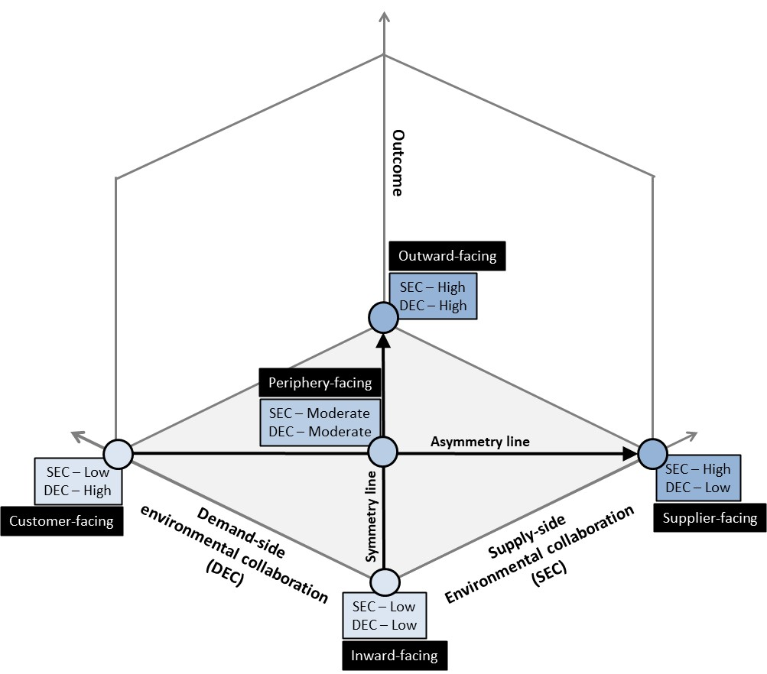

Figure 2: Joint effects of SEC and DEC on dyadic environmental performance
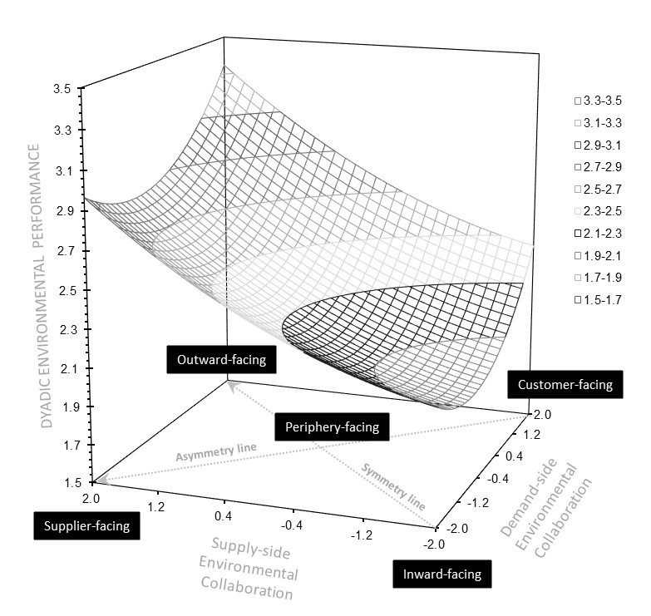

Figure 3: Joint effects of SEC and DEC on dyadic environmental performance
(moderating effect of product stewardship)

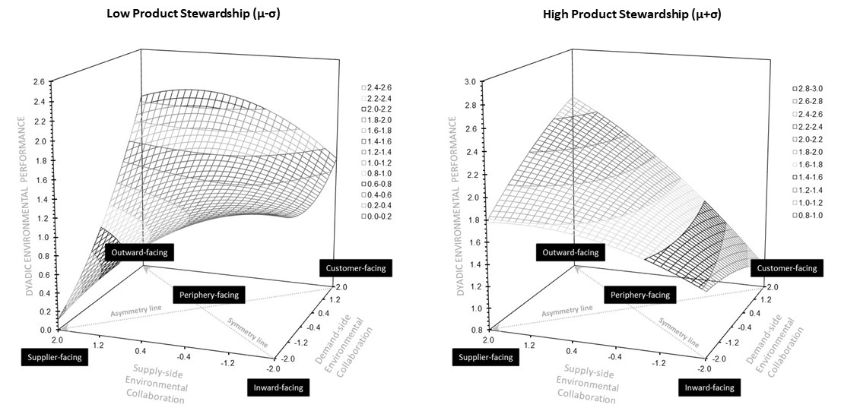

Figure 4: Joint effects of SEC and DEC on focal firm and supplier environmental performance

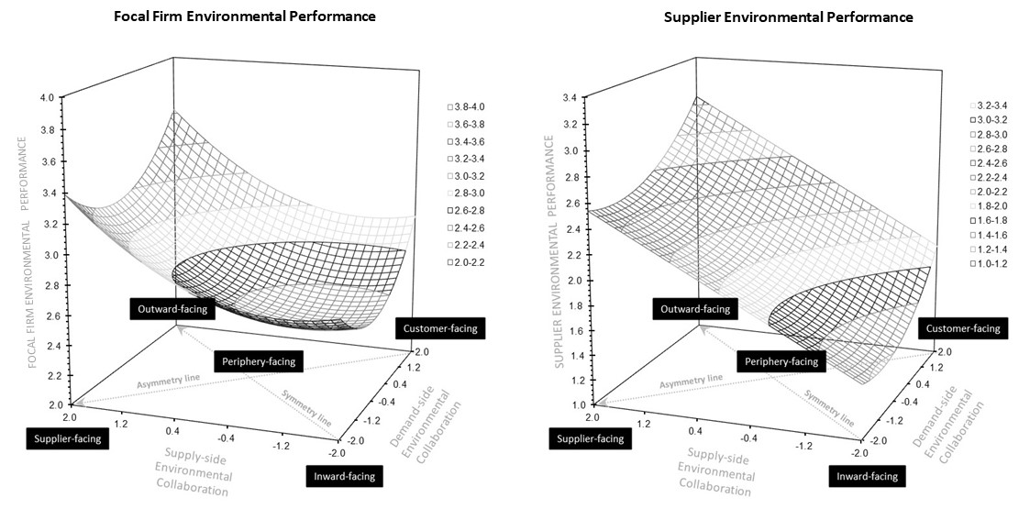

Table 1: Measurement Model

`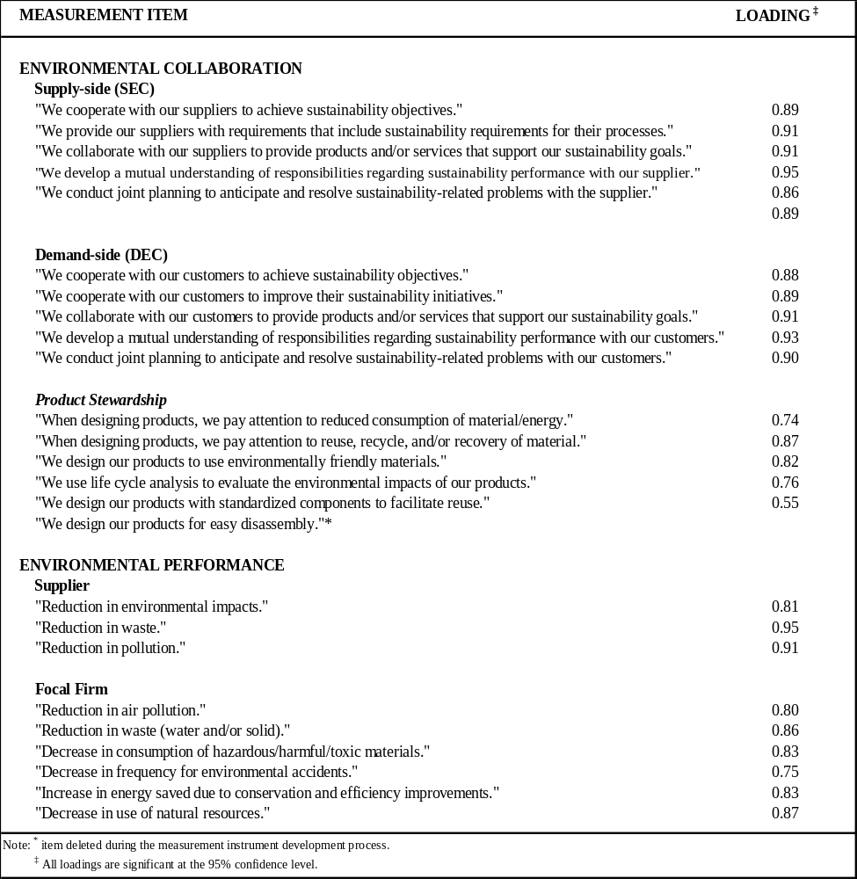
Table 2: Descriptive statistics and correlation

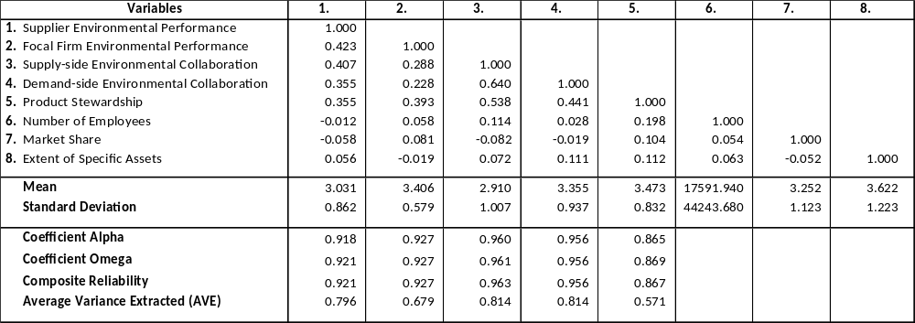

Table 3: Regression results
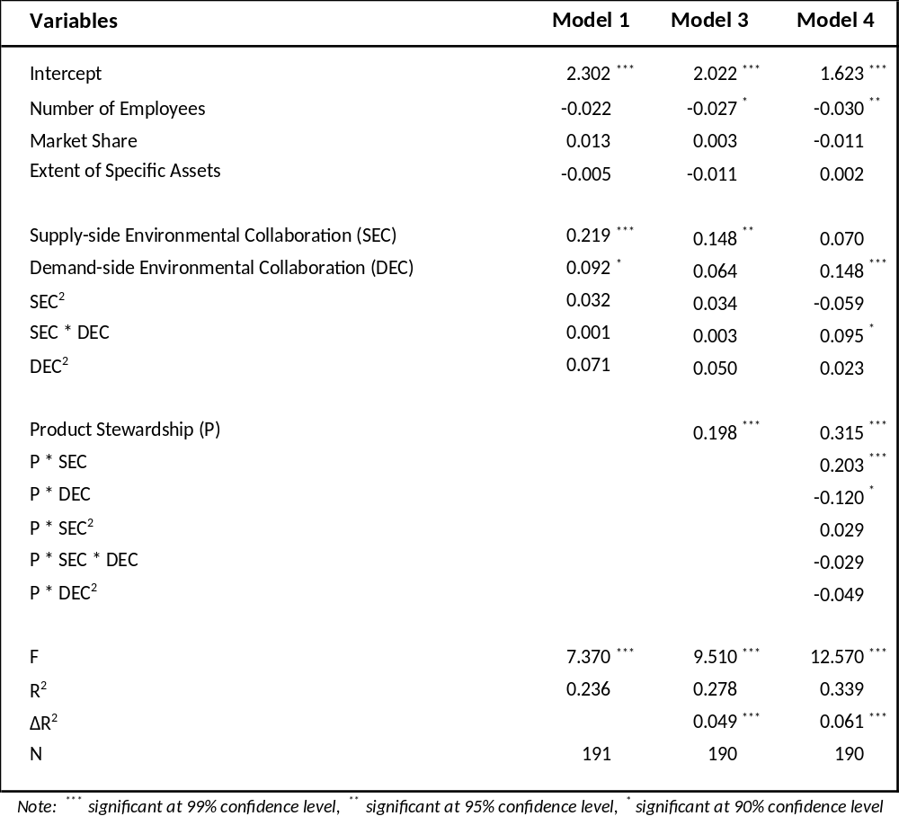

Table 4: Response Surface
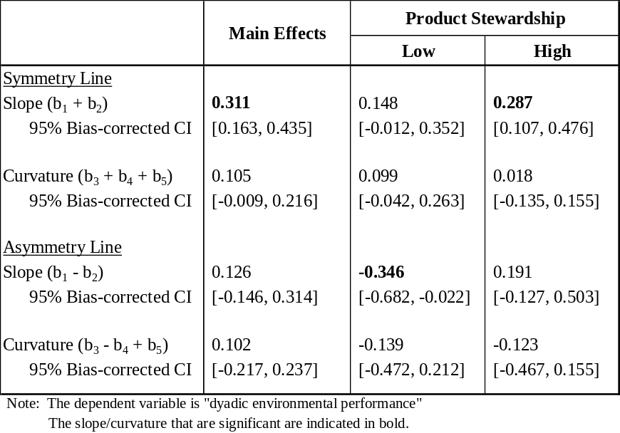

Table 5: Post-hoc Analysis
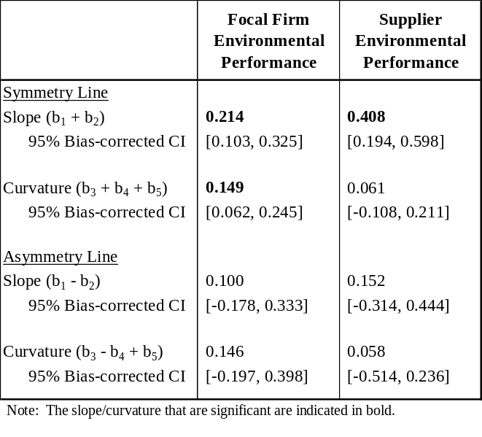

REFERENCES
ALONSO, T. 2023. How Patagonia Became The Benchmark In Sustainable Clothing [Online]. Available: https://www.cascade.app/studies/patagonia-strategy-study [Accessed 1st July 2024].
ANDALIB ARDAKANI, D., SOLTANMOHAMMADI, A. & SEURING, S. 2022. The impact of customer and supplier collaboration on green supply chain performance. Benchmarking: An International Journal.
ARMSTRONG, J. S. & OVERTON, T. S. 1977. Estimating nonresponse bias in mail surveys. Journal of Marketing Research, 14, 396-402.
ARORA, A., ARORA, A. S., SIVAKUMAR, K. & BURKE, G. 2020. Strategic sustainable purchasing, environmental collaboration, and organizational sustainability performance: the moderating role of supply base size. Supply Chain Management: An International Journal, 25, 709-728.
BAGOZZI, R. P. & YI, Y. 1988. On the evaluation of structural equation models. Journal of the Academy of Marketing Science, 16, 74-94.
BHUPENDRA, K. V. & SANGLE, S. 2018. Product stewardship strategy: A study of Indian firms. Corporate Social Responsibility and Environmental Management, 25, 124-134.
BLOME, C., HOLLOS, D. & PAULRAJ, A. 2014a. Green procurement and green supplier development: Antecedents and effects on supplier performance. International Journal of Production Research, 52, 32-49.
BLOME, C., PAULRAJ, A. & SCHUETZ, K. 2014b. Supply chain collaboration and sustainability: A profile deviation analysis. International Journal of Operations and Production Management, 34, 639-663.
BOIRAL, O. 2002. Tacit knowledge and environmental management. Long Range Planning, 35, 291-317.
BOK, C. H., LIM, C. H., NGAN, S. L., HOW, B. S., NG, W. P. Q. & LAM, H. L. 2022. Life cycle assessment and life cycle costing analysis for uncertified and Malaysia sustainable palm oil-MSPO-certified independent smallholders. Journal of Cleaner Production, 379, 134646.
BONINI, S. 2012. The business of sustainability. McKinsey Report New York, NY.
BOULDING, W. & STAELIN, R. 1993. A look on the cost side: Market share and the competitive environment. Marketing Science, 12, 144-166.
BOWEN, F. E., COUSINS, P. D., LAMMING, R. C. & FARUKT, A. C. 2001. The role of supply management capabilities in green supply. Production and Operations Management, 10, 174-189.
BRUN, A., KARAOSMAN, H. & BARRESI, T. 2020. Supply chain collaboration for transparency. Sustainability, 12, 4429.
BURRITT, R. L., CHRIST, K. L., RAMMAL, H. G. & SCHALTEGGER, S. 2020. Multinational enterprise strategies for addressing sustainability: The need for consolidation. Journal of Business Ethics, 164, 389-410.
BUSSE, C., SCHLEPER, M. C., WEILENMANN, J. & WAGNER, S. M. 2017. Extending the supply chain visibility boundary: Utilizing stakeholders for identifying supply chain sustainability risks. International Journal of Physical Distribution and Logistics Management, 47, 18-40.
CAI, Z., HUANG, Q., LIU, H. & LIANG, L. 2016. The moderating role of information technology capability in the relationship between supply chain collaboration and organizational responsiveness: Evidence from China. International Journal of Operations and Production Management, 36, 1247–1271.
CAO, M. & ZHANG, Q. 2011. Supply chain collaboration: Impact on collaborative advantage and firm performance. Journal of Operations Management, 29, 163-180.
CHEN, I. J. & PAULRAJ, A. 2004. Towards a theory of supply chain management: the constructs and measurements. Journal of Operations Management, 22, 119-150.
CHEN, L., ZHAO, X., TANG, O., PRICE, L., ZHANG, S. & ZHU, W. 2017. Supply chain collaboration for sustainability: A literature review and future research agenda. International Journal of Production Economics, 194, 73-87.
CHENG, J.-H. & SHEU, J.-B. 2012. Inter-organizational relationships and strategy quality in green supply chains—Moderated by opportunistic behavior and dysfunctional conflict. Industrial Marketing Management, 41, 563-572.
CHILDERHOUSE, P. & TOWILL, D. R. 2011. Arcs of supply chain integration. International Journal of Production Research, 49, 7441-7468.
DE SOUSA JABBOUR, A. B. L., VAZQUEZ-BRUST, D., JABBOUR, C. J. C. & LATAN, H. 2017. Green supply chain practices and environmental performance in Brazil: Survey, case studies, and implications for B2B. Industrial Marketing Management, 66, 13-28.
DENG, L. & CHAN, W. 2017. Testing the difference between reliability coefficients alpha and omega. Educational and Psychological Measurement, 77, 185-203.
DILLMAN, D. A. 2007. Mail and internet surveys: The tailored design method, John Wiley & Sons.
DYER, J. H. 2000. Collaborative advantage: Winning through extended enterprise supplier networks, Oxford University Press.
DYER, J. H. & SINGH, H. 1998. The relational view: Cooperative strategy and sources of interorganizational competitive advantage. Academy of Management Review, 23, 660-679.
EDWARDS, J. 1994. The study of congruence in organizational behavior research: Critique and a proposed alternative. Organizational Behavior and Human Decision Processes, 58, 51-100.
EDWARDS, J. & CABLE, D. 2009. The value of value congruence. Journal of Applied Psychology, 94, 654.
EPPINGER, S. 2011. The fundamental challenge of product design. Journal of Product Innovation Management, 28, 399-400.
FLYNN, B. B., HUO, B. & ZHAO, X. 2010. The impact of supply chain integration on performance: A contingency and configuration approach. Journal of Operations Management, 28, 58-71.
FORD 2022. Integrated Sustainability and Financial Report.
FORNELL, C. & LARCKER, D. 1981. Evaluating structural equation models with unobservable variables and measurement error. Journal of Marketing Research, 18, 39-50.
FROHLICH, M. T. & WESTBROOK, R. 2001. Arcs of integration: An international study of supply chain strategies. Journal of Operations Management, 19, 185-200.
FULLER, D. A. & OTTMAN, J. A. 2004. Moderating unintended pollution: The role of sustainable product design. Journal of Business Research, 57, 1231-1238.
GIMENEZ, C. & SIERRA, V. 2013. Sustainable supply chains: Governance mechanisms to greening suppliers. Journal of Business Ethics, 116, 189-203.
GÖLGECI, I., GLIGOR, D. M., TATOGLU, E. & ARDA, O. A. 2019. A relational view of environmental performance: What role do environmental collaboration and cross-functional alignment play? Journal of Business Research, 96, 35-46.
GREEN JR, K. W., WHITTEN, D. & INMAN, R. A. 2012. Aligning marketing strategies throughout the supply chain to enhance performance. Industrial Marketing Management, 41, 1008-1018.
GREKOVA, K., CALANTONE, R. J., BREMMERS, H. J., TRIENEKENS, J. H. & OMTA, S. 2016. How environmental collaboration with suppliers and customers influences firm performance: Evidence from Dutch food and beverage processors. Journal of Cleaner Production, 112, 1861-1871.
GUTIERREZ, L., MONTIEL, I., SURROCA, J. A. & TRIBO, J. A. 2022. Rainbow Wash or Rainbow Revolution? Dynamic Stakeholder Engagement for SDG-Driven Responsible Innovation. Journal of Business Ethics, 180, 1113-1136.
HART, S. 1995. A natural-resource-based view of the firm. Academy of Management Review, 20, 986-1014.
HART, S. L. & DOWELL, G. 2011. Invited editorial: A natural-resource-based view of the firm: Fifteen years after. Journal of Management, 37, 1464-1479.
HEIRATI, N. & SIAHTIRI, V. 2019. Driving service innovativeness via collaboration with customers and suppliers: Evidence from business-to-business services. Industrial Marketing Management, 78, 6-16.
HENSELER, J., RINGLE, C. & SARSTEDT, M. 2015. A new criterion for assessing discriminant validity in variance-based structural equation modeling. Journal of the Academy of Marketing Science, 43, 115-135.
HOFMAN, P. S., BLOME, C., SCHLEPER, M. C. & SUBRAMANIAN, N. 2020. Supply chain collaboration and eco‐innovations: An institutional perspective from China. Business Strategy and the Environment, 29, 2734-2754.
HOFMANN, H., BUSSE, C., BODE, C. & HENKE, M. 2014. Sustainability‐related supply chain risks: Conceptualization and management. Business Strategy and the Environment, 23, 160-172.
HUMPHREYS, P., CADDEN, T., WEN-LI, L. & MCHUGH, M. 2011. An investigation into supplier development activities and their influence on performance in the Chinese electronics industry. Production Planning and Control, 22, 137-156.
IVORY, S. B. & BROOKS, S. B. 2018. Managing corporate sustainability with a paradoxical lens: Lessons from strategic agility. Journal of Business Ethics, 148, 347-361.
JAYARAM, J., TAN, K.-C. & NACHIAPPAN, S. 2010. Examining the interrelationships between supply chain integration scope and supply chain management efforts. International Journal of Production Research, 48, 6837-6857.
JOHNSON & JOHNSON 2022. Onward and upward: Procurement’s training program prepares suppliers to advance Johnson & Johnson’s sustainability priorities.
JOURNEAULT, M., PERRON, A. & VALLIÈRES, L. 2021. The collaborative roles of stakeholders in supporting the adoption of sustainability in SMEs. Journal of environmental management, 287, 112349.
KASHMANIAN, R. M. 2017. Building greater transparency in supply chains to advance sustainability. Environmental Quality Management, 26, 73-104.
KHOR, K. S. & UDIN, Z. M. 2013. Reverse logistics in Malaysia: Investigating the effect of green product design and resource commitment. Resources, Conservation and Recycling, 81, 71-80.
KUMAR, G., SUBRAMANIAN, N. & MARIA, A. R. 2018. Missing link between sustainability collaborative strategy and supply chain performance: Role of dynamic capability. International Journal of Production Economics, 203, 96-109.
LACOSTE, S. 2016. Sustainable value co-creation in business networks. Industrial Marketing Management, 52, 151-162.
LAMBERT, L. S., EDWARDS, J. R. & CABLE, D. M. 2003. Breach and fulfillment of the psychological contract: A comparison of traditional and expanded views. Personnel Psychology, 56, 895-934.
LE, A. N. H., NGUYEN, T. T. & CHENG, J. M.-S. 2021. Enhancing sustainable supply chain management performance through alliance portfolio diversity: The mediating effect of sustainability collaboration. International Journal of Operations and Production Management, 41, 1593-1614.
LEE, A. B. S., CHAN, F. T. & PU, X. 2018. Impact of supplier development on supplier’s performance. Industrial Management and Data Systems, 118, 1192-1208.
LI, Y., DAI, J. & CUI, L. 2020. The impact of digital technologies on economic and environmental performance in the context of industry 4.0: A moderated mediation model. International Journal of Production Economics, 229, 107777.
LIAO, S.-H., HU, D.-C. & DING, L.-W. 2017. Assessing the influence of supply chain collaboration value innovation, supply chain capability and competitive advantage in Taiwan's networking communication industry. International Journal of Production Economics, 191, 143-153.
LINDELL, M. K. & WHITNEY, D. J. 2001. Accounting for common method variance in cross-sectional research designs. Journal of Applied Psychology, 86, 114-121.
LIU, Y., ZHU, Q. & SEURING, S. 2017. Linking capabilities to green operations strategies: The moderating role of corporate environmental proactivity. International Journal of Production Economics, 187, 182-195.
LONGONI, A. & CAGLIANO, R. 2015. Environmental and social sustainability priorities: Their integration in operations strategies. International Journal of Operations and Production Management, 35, 216-245.
LORENZONI, G. & LIPPARINI, A. 1999. The leveraging of interfirm relationships as a distinctive organizational capability: A longitudinal study. Strategic Management Journal, 20, 317-338.
MALHOTRA, N. K., KIM, S. S. & PATIL, A. 2006. Common method variance in IS research: A comparison of alternative approaches and a reanalysis of past research. Management Science, 52, 1865-1883.
MARIANI, L., TRIVELLATO, B., MARTINI, M. & MARAFIOTI, E. 2022. Achieving sustainable development goals through collaborative innovation: Evidence from four European initiatives. Journal of Business Ethics, 180, 1075-1095.
MARTIN-DE CASTRO, G. 2021. Exploring the market side of corporate environmentalism: Reputation, legitimacy and stakeholders' engagement. Industrial Marketing Management, 92, 289-294.
MATOS, S. & HALL, J. 2007. Integrating sustainable development in the supply chain: The case of life cycle assessment in oil and gas and agricultural biotechnology. Journal of Operations Management, 25, 1083-1102.
MELANDER, L. 2018. Customer and supplier collaboration in green product innovation: External and internal capabilities. Business Strategy and the Environment, 27, 677-693.
NILSSON‐LINDÉN, H., ROSÉN, M. & BAUMANN, H. 2019. Product chain collaboration for sustainability: A business case for life cycle management. Business Strategy and the Environment, 28, 1619-1631.
NONET, G. A.-H., GÖSSLING, T., VAN TULDER, R. & BRYSON, J. 2022. Multi-stakeholder Engagement for the Sustainable Development Goals: Introduction to the Special Issue. Journal of Business Ethics, 180, 945-957.
NUNNALLY, J. & BERNSTEIN, I. 1994. Psychometric theory, New York, NY, McGraw-Hill.
NYAGA, G. N., WHIPPLE, J. M. & LYNCH, D. F. 2010. Examining supply chain relationships: Do buyer and supplier perspectives on collaborative relationships differ? Journal of Operations Management, 28, 101-114.
PARENTE, R., MURRAY, J. Y., ZHAO, Y., KOTABE, M. & DIAS, R. 2022. Relational resources, tacit knowledge integration capability, and business performance. Journal of Knowledge Management, 26, 805-823.
PAULRAJ, A. 2011. Understanding the relationships between internal resources and capabilities, sustainable supply management and organizational sustainability. Journal of Supply Chain Management, 47, 19-37.
PAULRAJ, A. & BLOME, C. 2017. Plurality in environmental supply chain mechanisms: Differential effects on triple bottom line outcomes. International Journal of Operations and Production Management, 37, 1010-1030.
PAULRAJ, A., JAYARAMAN, V. & BLOME, C. 2014. Complementarity effect of governance mechanisms on environmental collaboration: does it exist? International Journal of Production Research, 52, 1-18.
PAULRAJ, A., LADO, A. A. & CHEN, I. J. 2008. Inter-organizational communication as a relational competency: Antecedents and performance outcomes in collaborative buyer–supplier relationships. Journal of Operations Management, 26, 45-64.
PETRO, G. 2022. Consumers demand sustainable products and shopping formats. Forbes.
PODSAKOFF, P. M., MACKENZIE, S. B., LEE, J.-Y. & PODSAKOFF, N. P. 2003. Common method biases in behavioral research: A critical review of the literature and recommended remedies. Journal of Applied Psychology, 88, 879-903.
PRIEM, R. L. & SWINK, M. 2012. A demand‐side perspective on supply chain management. Journal of Supply Chain Management, 48, 7-13.
PUJARI, D., WRIGHT, G. & PEATTIE, K. 2003. Green and competitive: Influences on environmental new product development performance. Journal of Business Research, 56, 657-671.
RAYKOV, T. & SHROUT, P. E. 2002. Reliability of scales with general structure: Point and interval estimation using a structural equation modeling approach. Structural Equation Modeling: A Multidisciplinary Journal, 9, 195-212.
SANCHEZ, J. I. & BROCK, P. 1996. Outcomes of perceived discrimination among Hispanic employees: Is diversity management a luxury or a necessity? Academy of Management Journal, 39, 704-719.
SCHOENHERR, T. & SWINK, M. 2012. Revisiting the arcs of integration: Cross-validations and extensions. Journal of Operations Management, 30, 99-115.
SILVESTRE, W. J., FONSECA, A. & MORIOKA, S. N. 2022. Strategic sustainability integration: Merging management tools to support business model decisions. Business Strategy and the Environment, 31, 2052-2067.
SNIR, E. M. 2001. Liability as a catalyst for product stewardship. Production and Operations Management, 10, 190-206.
STARBUCKS 2021. Starbucks announces coffee-specific environmental goals.
STITZHAL, D. 2011. Product stewardship: Can it drive green design? Environmental Quality Management, 20, 25-41.
SUDUSINGHE, J. I. & SEURING, S. 2022. Supply chain collaboration and sustainability performance in circular economy: A systematic literature review. International Journal of Production Economics, 245, 108402.
TACHIZAWA, E. M. M., THOMSEN, C. G. & MONTES-SANCHO, M. J. 2012. Green supply management strategies in Spanish firms. IEEE Transactions on Engineering Management, 59, 741-752.
THUN, J. H. 2010. Angles of integration: An empirical analysis of the alignment of internet‐based information technology and global supply chain integration. Journal of Supply Chain Management, 46, 30-44.
UM, K.-H. & OH, J.-Y. 2020. The interplay of governance mechanisms in supply chain collaboration and performance in buyer–supplier dyads: Substitutes or complements. International Journal of Operations and Production Management.
VACHON, S. & KLASSEN, R. D. 2006. Extending green practices across the supply chain: The impact of upstream and downstream integration. International Journal of Operations and Production Management.
VACHON, S. & KLASSEN, R. D. 2007. Supply chain management and environmental technologies: The role of integration. International Journal of Production Research, 45, 401-423.
VACHON, S. & KLASSEN, R. D. 2008. Environmental management and manufacturing performance: The role of collaboration in the supply chain. International Journal of Production Economics, 111, 299-315.
WAGNER, M. 2007. Integration of environmental management with other managerial functions of the firm: Empirical effects on drivers of economic performance. Long Range Planning, 40, 611-628.
WALTON, S. V., HANDFIELD, R. B. & MELNYK, S. A. 1998. The green supply chain: Integrating suppliers into environmental management processes. International Journal of Purchasing and Materials Management, 34, 2-11.
WONG, C. W. 2013. Leveraging environmental information integration to enable environmental management capability and performance. Journal of Supply Chain Management, 49, 114-136.
WONG, C. Y., WONG, C. W. & BOON-ITT, S. 2017. Do arcs of integration differ across industries? Methodology extension and empirical evidence from Thailand. International Journal of Production Economics, 183, 223-234.
ZAHOOR, N. & GERGED, A. M. 2021. Relational capital, environmental knowledge integration, and environmental performance of small and medium enterprises in emerging markets. Business Strategy and the Environment, 30, 3789-3803.
ZHANG, Z. & YUAN, K.-H. 2016. Robust coefficients alpha and omega and confidence intervals with outlying observations and missing data: Methods and software. Educational and Psychological Measurement, 76, 387-411.
ZHARFPEYKAN, R. & AKROYD, C. 2022. Factors influencing the integration of sustainability indicators into a company's performance management system. Journal of Cleaner Production, 331, 129988.
ZHU, Q. & SARKIS, J. 2004. Relationships between operational practices and performance among early adopters of green supply chain management practices in Chinese manufacturing enterprises. Journal of Operations Management, 22, 265-289.

