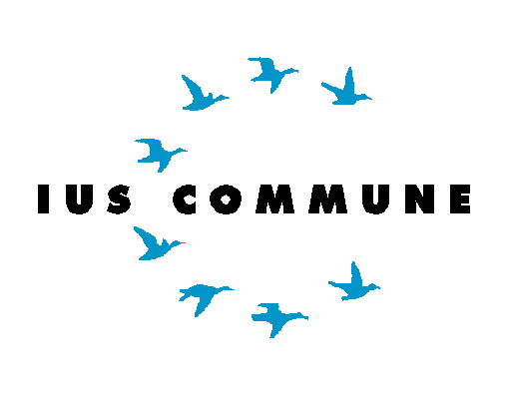

Masterclass Leuven

23 May 2025
PROGRAMME IUS COMMUNE MASTERCLASS LEUVEN

Thursday 22 May
Pre-masterclass dinner for participants
Time: 19u00
Venue: Restaurant De Valck, Tiensestraat 10, Leuven

Friday 23 May
Welcome and introduction
9u00-9u30 Welcome & introduction (prof. Tom Vos and prof. Elise Muir)
Venue: Bronnenlokaal (DV1 03.27), Tiensestraat 41, Leuven

Presentations and discussions
After the welcome and introduction, the presentations and discussions will take place in three groups.

Group 1:  - Mélanie Massant  - Pauline Van Belle  - Maria Breskaya  - Henk Verstraete  - Sanne Liefers  - Chrisi Charisi  - Cato Deprez | Group 2:  - Qi Zhang  - Kaili Jiang  - Felix Peerboom  - Guido Bellenghi  - Nora Vissers  - Alessio Devis
Group 3:
- Tessa Rotscheid
- Mart van Esterik
- Maaike Huijzer
- Dianthe Verhoef
- Edo Schoone
- Sharleen Quarem

Group 1
Venue: Bronnenlokaal (DV1 03.27)

9u30-10u20 Mélanie Massant - The role of economic substance under the PPT.
Expert: prof. Filip Debelva
Discussant: Chrysi Charisi

10u20-11u10 Pauline Van Belle - The role of corporate legal personality in tax law.
Expert: prof. F. Debelva
Discussant: Henk Verstraete

11u10-12u00 Chrysi Charisi - Composite administrative procedures in European administrative law and the quest for effective judicial protection: the case of Protected Destinations of Origin and Protected Geographical Indications.
Expert: prof. Piet Van Nuffel (online)
Discussant: Sanne Liefers

Group 2
Venue: Kleine vergaderzaal (DV1 Poorthuis 00.46)

9u30-10u20 Presentation cancelled – longer coffee break

10u20-11u10 Qi Zhang - Can competition law address the panacea of exclusive music licensing? - Policy approaches in the EU, US and China.
Expert: Prof. Jozefien Vanherpe
Discussant: Kaili Jiang

11u10-12u00 Kaili Jiang - New genomic techniques and intellectual property law: from the perspective of food security.
Expert: Dr. Daria Kim
Discussant: Qi Zhang
Group 3
Venue: Meeting room International House (Internationaal huis 04.27)

9u30-10u20 Mart Van Esterik - Nature-based solutions: negatieve emissies en herstel van biodiversiteit.
Expert: Prof. Marjan Peeters
Discussant: Sharleen Quarem
10u20-11u10 Tessa Rotscheid - Improving the quality of our waters - Strengthening the implementation of the objectives of article 4 of the Water Framework Directive.
Expert: Prof. Isabelle Larmuseau
Discussant: Dianthe Verhoef

11u10-12u00 Maaike Huijzer - Improving the legal position of informal cohabitants.
Expert: Prof. Elise Goossens
Discussant: N/A

At 12:00, there will be a joint lunch break (Inkomhal Nieuwe Valk, outside if the weather allows it). After the lunch break, all groups will continue the presentations and discussions at their respective locations.

Group 1
Venue: Bronnenlokaal (DV1 03.27)

13u30-14u20 Cato Deprez - Qualitative healthcare services in hospitals: In search of a solid legal framework.
Expert: Prof. Tom Goffin
Discussant: Maria Breskaya
14u20-15u10 Maria Breskaya - The Place of Smart Contracts within the Architecture of Commercial Agreements in Global Trade.
Expert: Prof. Maarten Herbosch
Discussant: Mélanie Massant

15u10-16u00 Henk Verstraete - The temporal effects of tax jurisprudence.
Expert: Prof. Thijs Vancoppernolle
Discussant: Pauline Van Belle
16u00-16u50 Sanne Liefers - The social enterprise and its investor.
Expert: Prof. Tineke Lambooy
Discussant: Cato Deprez
16u50 Closing remarks
Group 2
Venue: Kleine vergaderzaal (DV1 Poorthuis 00.46)

13u30-14u20 Felix Peerboom - A legal scrutiny of ‘instrumentalised’ migration towards the EU.
Expert: Prof. Alberto-Horst Neidhardt
Discussant: Guido Bellenghi
14u20-15u10 Guido Bellenghi - Constitutional and legislative emergency powers in the EU.
Expert: Prof. Antoine Bailleux
Discussant: Nora Vissers
15u10-16u00 Nora Vissers - Safeguarding european democracy.
Expert: Prof. Antoine Bailleux
Discussant: Felix Peerboom
16u-16u50 Alessio Devis - Regulating offshore renewable energy within the ecological boundaries of the North Sea.
Expert: Prof. Ceciel Nieuwenhout
Discussant: N/A
16u50 Closing remarks
Group 3
Venue: Meeting room International House (Internationaal huis 04.27)

13u30-14u20 Presentation cancelled – long break

14u20-15u10 Sharleen Quarem - Value assessment of legal and illegal damage to biodiversity in decision making with an individual scope: What do we learn from an empirical law and economics perspective?
Expert: Prof. Sandra Rousseau
Discussant: Edo Schoone
15u10-16u00 Edo Schoone - Valuation of biodiversity in administrative decision making.
Expert: Prof. Ann Carette
Discussant: Mart van Esterik
16u00-16u50 Dianthe Verhoef - The entitlement to (collectively) stored water. Where does public law end and private law begin?
Expert: Prof. Patrick Willems
Discussant: Tessa Rotscheid
16u50 Closing remarks

