Development of Novel Non-invasive Contrast Agents for Contrast-Enhanced MicroCT of Biological Tissues
Sarah Vangrunderbeeck^{†1,2,3}, Sébastien De Bournonville^{3,4}, Hong Giang T. Ly⁵, Wim M. De Borggraeve¹, Tatjana N. Parac-Vogt⁵, Greet Kerckhofs^{*2,3,6}
¹ Molecular Design and Synthesis, Department of Chemistry, KU Leuven, Leuven, Belgium
²Biomechanics lab, Institute of Mechanics, Materials and Civil Engineering, UCLouvain, Louvain-la Neuve, Belgium
³Prometheus, Division of Skeletal Tissue Engineering, KU Leuven, Leuven, Belgium
⁴Biomechanics Section, Department of Mechanical Engineering, KU Leuven, Leuven, Belgium
⁵Laboratory of Bioinorganic Chemistry, Department of Chemistry, KU Leuven, Leuven, Belgium
⁶Department of Materials Engineering, KU Leuven, Leuven, Belgium

Keywords: Contrast-enhanced computed tomography, Multi-tissue imaging of biological samples, Polyoxometalates, Non-invasive contrast agents

Summary: The combined use of contrast staining agents and X-ray microfocus computed tomography (microCT), referred to as contrast-enhanced X-ray microCT (CE-CT), can provide a solution for ex vivo 3D multi-tissue imaging of biological tissues. While many reported contrast agents (CAs) are destructive for the samples or toxic, we screened and validated different Wells-Dawson polyoxometalate formulations for visualization of biological tissues using CE-CT.

INTRODUCTION

As biological tissues have a complex architecture and a spatial heterogeneity, measurements made in 2D only partially reveal their full 3D morphology and interconnectivity. Indeed, conventional and even digital histology are largely unsatisfactory for spatial assessment of biological tissues, because the restricted sectioning orientation and the limited depth resolution only partially reveal their full 3D morphology, but also because they lack reproducibility on a large scale due to sample destruction (dehydration, sectioning, etc.).
X-ray microfocus computed tomography (microCT) is an emerging 3D imaging technique with high potential for 3D structural analysis of biological tissues with a complex and heterogeneous 3D structure. However, its use has been mostly limited to mineralized tissues, such as bone, because of the inherently low X-ray absorption of soft tissues. To achieve sufficient X-ray attenuation, chemical compounds containing high atomic number elements that bind to soft tissues have been adopted as contrast agents (CAs) for contrast-enhanced microCT (CE-CT). This technique is very promising for quantitative ‘virtual’ 3D histology of both mineralized and soft biological tissues, as they allow simultaneous visualization of these tissues.
Over the past decade, different CAs have been recently reported for ex vivo CE-CT of specific soft tissues [1]. However, both the CA staining protocol and the image acquisition setup should be non-destructive, having no effect on the tissue integrity. As most of the currently applied CAs are destructive (acidic, toxic, dehydrating), in our research we focus on the development of non-invasive tissue-specific CAs.

RESULTS AND DISCUSSION

A recent study within our group reported the simultaneous visualization of mineralized and soft structures within bones utilizing an in-house Hafnium-substituted Wells-Dawson polyoxometalate (Hf-WD POM) as CA [2]. Thanks to the combination of the hydrophobic behavior of adipocytes and the binding of Hf-WD POM to the bone marrow tissue, Kerckhofs et al. were able to visualize the bone marrow adipocytes at the single cell level using high resolution CE-CT scanning. This not only allowed to quantify the volume fraction of the bone marrow adipose tissue within the bone, but it also enabled the quantification of the adipocyte number/density and diameter.

†e-mail: sarah.vangrunderbeeck@kuleuven.be
*e-mail: greet.kerckhofs@uclouvain.be
Additionally, the vascular network could be visualized and discriminated from the other tissues, allowing full 3D blood vessel network assessment (i.e. branching analysis and spatial distribution). Consequently, as Hf-POM-based CE-CT provides additional data to standard histomorphometry, with more spatial information, it could offer novel insights in the complex mechanisms of normal bone development and bone pathologies.
In a follow-up study, we explored whether similar POM formulations could also be efficient CAs for soft tissue visualization [3]. We screened different POM formulations, including the much less expensive precursors in the synthesis of the metal-substituted Hf-WD POM, for their potential as CE-CT CA. Based on their staining capacity and speed of diffusion, as well as on their fate after tissue staining experiments, we concluded that monolacunary Wells-Dawson polyoxometalate (monoWD POM) is a highly suitable staining candidate for non-invasive CE-CT imaging of soft tissues, with a similar contrast enhancement as that of Hf-WD POM and phosphotungstic acid (Figure 1). MonoWD POM is stable under physiological pH and temperature and less invasive than phosphotungstic acid, which have been typically used in the past.
Because of their capacity to bind electrostatically to collagen and connective tissues, as well as to blood, we have successfully used the POMs for several applications: developmental changes of murine placenta and embryo [4], effect of an anti-angiogenic drug on tumor angiogenesis [5], quantitative analysis of the fiber orientation in tendons and the bone-tendon interface (unpublished data), and many others.
Taken together, CE-CT is an important and innovative 3D imaging technology to get a better understanding of the complex mechanisms behind biological tissue formation and regeneration, as well to better understand the effect or pathologies on tissue architecture and hence function. In future research, we will focus on the further development and validation of novel, tissue-specific CE-CT CAs in a wide range of applications.

References

[1] De Bournonville, S.; Vangrunderbeeck, S. & Kerckhofs, G., Contrast-Enhanced MicroCT for Virtual 3D Anatomical Pathology of Biological Tissues: A Literature Review. Contrast Media Mol. Imaging 2019, published, DOI: 10.1155/2019/8617406.
[2] Kerckhofs, G. et al., Simultaneous three-dimensional visualization of mineralized and soft skeletal tissues by a novel microCT contrast agent with polyoxometalate structure. Biomaterials 2018, 159, 1-12.
[3] De Bournonville, S.; Vangrunderbeeck, S. & Kerckhofs, G., Polyoxometalates for non-invasive contrast-enhanced microCT of soft tissues: a screening study. 2019, Manuscript in preparation.
[4] De Clercq, K. et al., High resolution contrast-enhanced microCT reveals the true three dimensional morphology of the murine placenta. PNAS 2018, Manuscript submitted for publication.
[5] Kerckhofs, G. et al., Contrast-enhanced microCT to visualize and quantify the 3D vasculature in biological tissues without the need for perfusion, in Proceedings of Bruker User Meeting, Edinburgh, Scotland, June 2017.

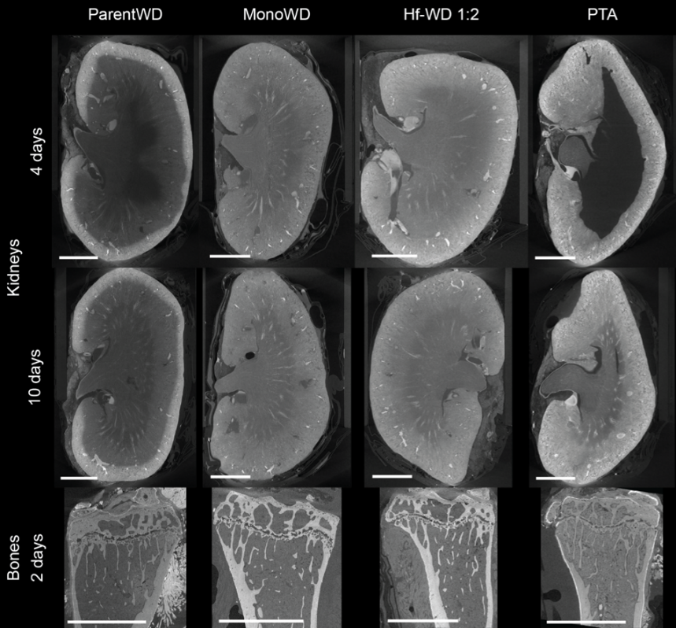
Figure 1: CE-CT images for different POM formulations. Typical longitudinal CE-CT slices for kidneys (row 1 & 2) and tibiae (row 3), stained with different POM formulations (columns: ParentWD (α-/β-K₆P₂W₁₈O₆₂•14/19H₂O), monoWD (α₂-P₂W₁₇), Hf-WD (K₁₆[Hf(α₂-P₂W₁₇O₆₁)₂]•19H₂O), phosphotungstic acid (PTA) (H₃PW₁₂O₄₀)) for different staining times.
Scale bar = 1 mm.

