Erratum to: Comment on “Quantifying the informational value of classification images”: Miscomputation of infoVal metric was a minor issue and is now fixed

Mathias Schmitz¹
Marine Rougier¹
Vincent Yzerbyt¹
Loek Brinkman²
Ron Dotsch²

¹Université catholique de Louvain
²Utrecht University

Erratum to: Behav Res (2019)
DOI 10.3758/s13428-019-01295-1

One of the two miscomputations identified in the infoVal metric, namely the omission of the k constant, turns out not to be a miscomputation since the constant was already taken into account by default in the mad() function from R (see https://www.rdocumentation.org/packages/stats/versions/3.6.2/topics/mad). Therefore, the only miscomputation that remains is the use of the one norm instead of the Euclidean norm. As it can be seen in Table 1 and Figure 1, the impact of this miscomputation is minor. The computation of infoVal has been fixed and can now be computed with the rcicr package. All the computations were performed with the data available in OSF (https://osf.io/fbduk/?view_only=e3c04e549f844facb109200dcba7a0db) from Schmitz et al. (Schmitz, Rougier, & Yzerbyt, 2019).

References
Schmitz, M., Rougier, M., & Yzerbyt, V. (2019). Comment on “Quantifying the informational value of classification images”: A miscomputation of the infoVal metric. Behavior Research Methods. https://doi.org/10.3758/s13428-019-01295-1

Tables
Table 1
Proportions of H₀ rejection (H₀ = CI generated by a random process) out of 1,000 simulation runs per level of P[random] for two different critical values (1.96 and 3) and for the “correct” (Euclidean norm) vs. “incorrect” (one norm) computation of the infoVal metric
 |  | infoVal > 1.96 |  |  | infoVal > 3
P[random] |  | correct  computation | incorrect  computation |  | correct  computation | incorrect  computation
.000 |  | 1.000 | 1.000 |  | 1.000 | 1.000
.125 |  | 1.000 | 1.000 |  | 1.000 | 1.000
.250 |  | 1.000 | 1.000 |  | 1.000 | 1.000
.375 |  | 1.000 | 1.000 |  | 1.000 | 1.000
.500 |  | 1.000 | 1.000 |  | 1.000 | 1.000
.625 |  | .970 | .970 |  | .864 | .866
.750 |  | .555 | .553 |  | .279 | .282
.875 |  | .126 | .125 |  | .028 | .028
1.000 |  | .041 | .041 |  | .005 | .005

Figures

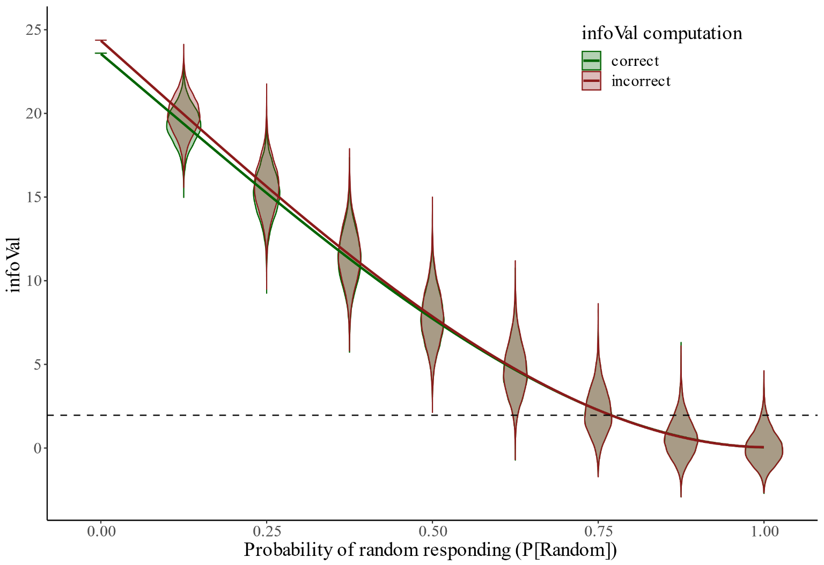
Figure 1. Relationship between the infoVal metric and the probability of random responses, P[random], as a function of the “correct” (Euclidean norm) vs. “incorrect” (one norm) computation of this metric. The dashed line represents 1.96 units of approximated standard deviation

