Opinion Events: Types and opinion markers in English social media discourse
- Barbara Lewandowska-Tomaszczyk , Chaya Liebeskind , Anna Bączkowska , Jurate Ruzaite , Ardita Dylgjeri , Ledia Kazazi and Erika Lombart
From the journal Lodz Papers in Pragmatics
https://doi.org/10.1515/lpp-2023-0022
Cite thisShare this
- Abstract
The paper investigates various definitions of the concept of opinion as opposed to factual or evidence-based statements and proposes a taxonomy of opinions expressed in English as identified in selected social media. A discussion situates opinions in the realm of pragmatics and reaches to philosophy of language and cognitive science. The research methodology combines a thorough linguistic analysis of opinions, proposing their multifaceted taxonomy with the automatically generated lexical embeddings of positive and negative lexicon acquired from the analysed opinionated texts. As proposed, the definition of the concept of opinion is best apprehended when looked upon in terms of an opinion event, with a number of necessary conditions on the one hand, and those that are characteristic of an explicit opinion prototype on the other. Lists of opinion discourse markers show their preferential uses either in positive or negative opinionated texts; however, no sets of necessary and/or sufficient opinion markers properties have been acquired from the analysed texts. The conclusions indicate a polysemous understanding of naturally occurring social media opinionated texts and a definitional flexibility of the boundaries around lexical positive and negative types of opinion markers.
Keywords: belief; evidence; negative; opinion (-event, -marker, -SCHEMA); persuasion; positive; prototype
- 1 Focus of the paper and research question
The present paper focuses on the identification of various approaches to the definition and scope of the concept of opinion, providing an argument toward accepting the definition of opinion embedded in social context in terms of an event rather than as a set of necessary and sufficient markers. A particular emphasis is laid here on similarities and contrasts in positive and negative opinion linguistic markers, opinion taxonomies and schemas.
The second part of the paper refers to the identification of opinion markers in the category of positive and negative opinions, and presents relevant examples with the identification of their relevant parameters.
The main research questions asked in the present study refer to the presence of unique or, minimally, preferred language markers of texts expressing opinion as opposed to those stating facts. The second issue is an attempt to identify unique or preferred contexts and/or language markers for positive and negative verbal opinion expression.
- 2 Multiple outlooks on opinion concept: a literature survey
The field of opinion studies is not a subject of one research domain. Apart from linguistics, which provides insight from phonetics, particularly prosody, as well as lexicon, the field profits from construction grammar and cognitive semantics with the notion of mental models, meaning co-constructions, semantic properties and pragmatically characterised contexts, as well as discourse analysis illuminating the phenomenon of speech events, implicatures and politeness studies. Resort is also made here to some philosophical investigation of truth and judgement, logic of argumentation, and persuasive appeals, social sciences, culture studies, political science, media studies, emotion studies, theory of science, law and other professional fields.
- 2.1 Polysemic character of opinion
Although opinion is a polysemous concept, with a number of senses, which are characterised by varying properties, all of them emphasise subjectivity and agency as characteristic features. Nevertheless, they can differ in their relation to truth (in its Aristotelian, pragmatic, or consensual senses), or to fact, renedered in its diverse ways (scientific, social, etc.).
We propose that there is more to the opinion concept than one prototypical category member. We rather see it as a Lakovian (Lakoff 1987) radial category, in which there are a few prototypical members, all of which are interlinked by family resemblance (Wittgenstein 1953) ties. The family resemblance relies on two criterial properties.
One of the opinion criterial properties is the degree of opinion basis on scientific factual evidence, which provides identification conditions differentiating opinions from factual knowledge.
The other opinion category criterial property refers to the degree of the opinion holder’s (Agent/speaker’s) conviction with regard to the truth/falsity of the proposition expounded. This property aims at differentiating between telling what the speaker considers true and what would be his/her (intentional) lie. The typology of opinions can thus be carried on according to these two different types of differentiation criteria, e.g., scientific/professional hypotheses are typically both based on evidence and their authors believe what they propose to be true, i.e., conforming to facts.
Although immersed in social context and based on social facts on the other hand, fake news, are either not based on scientific proof/evidence or rely on biases or else, on intentionally manipulated data (e,g., by using faulty logic, insufficient evidence, emotive persuasion, etc., cf. Hoehn at al 2023).
A prototypical context of an opinion expression involves a face-to-face interaction and an opinion expressed orally. In the present study, we give a range of opinion texts as used in selected social media website sources (itemized in Appendix 2). While some scholars (e.g., Kumar and Gupta 2021) propose that opinionated texts are restricted to precisely such texts acquired from blogs, social networking sites or any other online portals in which the users have expressed their disposition and point of view towards any particular product or service, we analyse such and similar data in the present study, and we consider opinions in rather wider – general lexicographic – terms as – immersed in a social-cultural context – views or judgements formed about a person, object, property, or an event, not necessarily based on proven fact or evidence.
We do not enter the discussion whether particular opinions are right or wrong as, in general, opinions cannot be classified as such because, apart from the criterial properties discussed above, they are based on personal perspectives and experiences. However, as mentioned before, opinions can be based on factual information or evidence as well, which can make them more or less credible. It is important to note that while opinions cannot be right or wrong, they can obviously be either pleasing, praising (example 1), or else harmful or offensive (example 2).
(1) | EXTREMELY fair teacher. Nice man too. Is enjoyable. Favors weekly online assignments and quizzes (https://www.ratemyprofessors.com/professor/1270844)
(2) | Evil personified!!! Should be strung up and left!! (Fb)
Thus, as proposed in our two criterial properties and the radial category membership of opinion concepts, one can find definitions of opinions as subjective interpretations not necessarily evidence-based, or else facts which are evidence-based or logically derived from evidence. They can be considered statements of belief, attitude, value, judgement, or feeling, as opposed to facts which are statements that can be confirmed by proof.
Subjective statements are often seen in terms of evaluations, which, in simplest terms, are value-laden, personal opinions that something is good or bad (Hunston 2000: 5; Bednarek 2006: 19; Van Linden 2012: 43). The good-bad cline in evaluative language developed in an axiological approach to language and has replaced the long-standing true-false approach typical of truth-conditional semantics. Generally, two strands in the axiological approach can be distinguished. One of them relies on nonveridicality and it revolves around the concept of modality (Taboada and Trnavac 2013: 10), wherein an opinion hinges on the degree of probability when describing an entity. It is often grammar-oriented in the sense that the choices of grammatical categories, such as specific modal verbs, are decisive in verbalizing personal evaluations:
(3) | He's pretty nice, but he's definitely one of the worst teachers I've ever had. He's always extremely vague & unhelpful about his assignments. Personally, he never revised my drafts for my essays even though we were required to turn them in, & then I got bad grades on most of my essays. I emailed him about it several times & he never replied.
The other standpoint is attitudinal, and it encodes evaluations through the choice of adjectives or morphological affixes (usually diminutives to signal appreciation or augmentatives to suggest contempt); thus it is both lexis- and grammar-oriented. There is also an integrative approach, elaborated inter alia by Biber and Finegan (1989) or Thompson and Hunston (2000), which takes into account both options.
Evaluative language is tightly connected and sometimes used interchangeably with stance, yet they are not exactly the same concepts. While evaluative language is associated primarily with implicit meaning, stance is regarded as explicitly expressed lexico-grammatical structures (Biber and Zhang 2018). As a result, evaluative language tends to be examined by describing the contextual information and connotations, whereas stance focuses on recurrent structures appearing in larger datasets, hence corpus-assisted analyses are typically employed to investigate stance (Biber and Zhang 2018). It has been noticed, based on a qualitative analysis (Biber and Zhang 2018), that opinionated texts (unlike persuasive or informative) are marked for stance. In our study, both the implicit and the explicit, the conceptual and the lexico-grammatical aspects will be explored as they are seen as constitutive elements of the prototype of opinions. In example (4), for instance, the stance is expressed very directly by explicitly specifying the speaker’s relation to the object:
(4) | I totally agree! Britain to be 'proper' Britain!
In example (2), meanwhile, the negative emotions expressed can be considered as an example of affective stance, but the speaker provides these strongly attitudinal generalisations without explicitly stating that he/she is taking a stance.
Some other outlooks consider opinions to be subjective conclusions, which might contain preferred (even biased) options, with prototypical opinions that need no verification. On the one hand, opinions can concern choices from logical premises (professional opinions) and on the other, they can be judgments not necessarily based on facts or evidence (e.g., on intuition, on biased preconditions e.g., conspiracy theories). Linguistic bias is referred to by Beukeboom and Burgers (2017) as “a systematic asymmetry in word choice that reflects the social-category cognitions that are applied to the described group or individual(s)”. Bias is often referred to as some vague ideas in which some confidence is placed. Instead, professional opinions are to be considered within the category of Objective opinions - based on facts and evidence, without personal biases or emotions and Expert opinions - based on the knowledge and expertise of a particular field or profession. On the other hand, there should be a distinction made between fact-based professional opinions and language-based professional opinions. Experimental sciences are clearly fact-based, while most humanities, as well as to go further, legal opinions, are all supported by linguistic and discourse analyses.
Opinions can reside in beliefs or sentiments shared by most people, expressing the voice of the people (public opinion), messages expressing a belief about something that can be held with confidence but not substantiated by positive knowledge or proof:
(5) | Drug dealers, rapists, murderous, people who organise grooming gangs when caught and found guilty should be hanged or shot no mercy the only way to stop these hideous crimes.
Such instances as example (5) not only express biased and prejudiced beliefs that lack evidence or grounding, but can also qualify as hate speech in some jurisdictions.
On the other hand, professional opinions indeed indicate (partly) subjective – preferences, albeit immersed again in a larger socio-cultural context. based on or concluded from evidence as in the legal opinion stating the reasons for a judicial decision (Król 2015). Nonetheless, even if a judicial decision is based upon the bounding procedure, the legal argumentation and the legal discourse – it is also given in view of the existing leeways, i.e., freedom to act within certain limits, in the choice of the legal norms to be applied in a given case and moreover the normative leeways inherent in the legal rules. Furthermore, as any judgment expressed in language, is also constrained by the semantic (interpretative) options existing in the determination of the meaning of the chosen rules. All of this may lead to the stance of the “rule-scepticism”, which is coupled with the “fact-scepticism” based on uncertainty of the evidence (compare e.g., Wróblewski 1969; Król 1987).
Considering opinions as legal documents stating the reasons for a judicial decision might somewhat confuse the previous definitions given about opinions as just mere vague ideas and beliefs. These kinds of opinions are to be included into another broad category, that of Informed Opinions – based on research and analysis of available information, and obviously stemming from particular social circumstances.
From all the above-mentioned definitions, it might be concluded that since it is both challenging and interesting to correctly identify and analyse opinions, and since it is important to consider the type of opinion when evaluating its credibility and relevance to a particular topic, a classification of opinions in some rather broad categories might come to the scholars’ help. As such opinions might be broadly classified as: Personal Opinions, Expert/Informed Opinions, and Public Opinions. ^{[2]} A distinction between Biased Opinions and Objective Opinions makes use of an amount of verified background knowledge, which serves as a logical basis for a particular judgement.
- 2.2 Status of truth/fact/evidence/proof and opinion
The act of expressing one’s opinion on a subject is often linked to a discussion of the status of its opposite, i.e., fact, or truth, of a particular assertion. Assertion is considered to be linked to truth, while in expressing an opinion the status of fact or truth seems to be suspended. As we wish to restrain from an ontological discussion of the concept of truth, we resort rather to the idea of evidence and will use the concept of evidence as proofs in discussing opinions.
This approach is connected with a type of semantics that is not synonymous with a truth-conditional specification of a proposition (Lewandowska-Tomaszczyk 1997). As Seuren (1985: 27–29), argues semantics “must primarily define a proposition in terms of what it does to any given discourse domain”. In other words, the meaning of a linguistic unit should be characterized first of all in terms of changes it brings about to a given discourse domain i.e., “a systematic modification, or increment, which it brings about whenever it is added to an appropriate given discourse domain”. The speaker constructs a discourse domain, i.e., in Seuren’s wording, s/he builds “a picture of a partial world” (Seuren 1988: 213) in a semantic space (Langacker 1987: 147).
The understanding of facts and opinions can be influenced by the social and cultural context in which language is used. Social constructivist theories assert that language and meaning are products of social interaction. Societal norms, beliefs and values can shape the categorization of statements as either factual or opinionated. As Searle suggests language is not an automatic system correlating itself to the external world (Searle 1998). More specifically, names do not designate external objects by themselves, and sentences do not describe external states of affairs or facts by themselves. It is human beings, who use a language, that build the bridge connecting a language and the world, and that create the referring (or predicating) relation of names (or sentences) to the corresponding objects (or states of affairs).
As a result, a comment that at first blush seems negative may in fact express a positive opinion and the other way around, which is the case of irony (see below for details). Opinionated statements where an insult is a complimenting remark (as in “You are awful” said to somebody who has passed an examination with the highest mark) or where an apparently positive comment is used ironically, that is to encode criticism (as in “You are an Albert Einstein”), are frequent forms of expressing one’s opinion, in particular when they are burdened with some emotional load. A common practice on social media, in some informal contexts for example, such as X (formerly Twitter), is to resort to vulgarisms in vocatives to signal bonding and in-group identity, as in “How are you bitches”. This is a particularly popular way of communicating among teenagers, and it is not seen as expressing a negative opinion but rather as a compliment or a form of ingratiation, as the social norms valid for social media are much more relaxed and allow one to resort to vulgar language while engaging in positive opinion forming. Expressing positive emotions through swearwords is not uncommon as swearwords have a wide array of functions, even when they sound vulgar and apparently negative they may encode social bonding, group solidarity, flirting, banter, jocularity, etc. (Bączkowska and Gromann 2023). Thus, a negatively-charged lexical marker alone may not do justice to the speaker-intended meaning while signalling opinions implicitly.
Thus, the context in which language is used plays a vital role in discerning between facts and opinions. A series of pragmatic elements such as implicatures, presuppositions and speech acts influence the interpretation and classification of statements as factual or opinionated. Grice’s conversational implicature theory (1975), especially, helps explain how people infer meaning in everyday conversation and how context and cooperation play essential roles in understanding indirect or implied messages. According to Grice, effective communication relies on a cooperative principle, which assumes according to the Grice’s Cooperative Principle that participants in a conversation generally cooperate and make their contributions in a way that is relevant, informative, and conductive to the overall purpose of the conversation (Grice 1975).
Apart from the Cooperative Principle, two other opinion discourse analysis relevant principles to be considered are the Politeness Principle and the Cognitive Change one. The politeness theory follows and enriches to some extent the Cooperative Principle firstly proposed by Grice (1975). Lakoff (1973) and Leech (1983: 132) discussed that politeness and truth are often mutually incompatible (the fact acknowledged as a white lie) and so are politeness and brevity. It seems that the cooperative and politeness principles and the tension between them reflect a dual purpose in human discourse: to act efficiently with other people and maintain social relationships.
The third principle is the principle of a Cognitive Change. Some discourse can be best interpreted as though it followed a maxim “change the receiver”. This fulfils the need to rearrange mental representations, a process that can be best affected in the absence of pressing practical and social constraints. Such can be the case of expressing opinions, personal beliefs and attitudes. This objective is clearly linked to the presence of a persuasive force as part and parcel of opinion defining properties and surface in some cases in the form of linguistic manipulation. Persuasive language often blurs the lines between facts and opinions to influence beliefs and attitudes. The wide and somewhat blurred semantic field of the term “manipulation” includes such key elements as “negative” intention of the speaker (Akopova 2013). Manipulation is a pragmatic aspect that achieves its goals without evident detection of communicative intention: the speaker purposefully chooses such a form of utterance that lacks direct signals of his/her true intentions. It makes use of mechanisms that lead the listener to perceive verbal messages uncritically.
AI and digitalization have given rise to an unprecedented amount of information, some of which may be misleading or false which, on their own, affect our understanding of facts and opinions.
Opinions are often influenced by personal biases, cultural beliefs and emotions. Linguistic bias is defined as a systematic asymmetry in word choice that reflects the social-category cognitions that are applied to the described group or individual(s). Relying on evidence can help mitigate these biases and move towards a more objective understanding of reality. For instance, example (6) expresses biased attitudes towards Muslim migrants through such linguistic/rhetorical choices as the (rhetorical) question, which serves here as an indirect expression of indignation; insult/offensive labelling (“evil cretins”), and the strategy of polarisation between “us” vs. “them” (“they” come to “our” country). Simultaneously, the utterance interrogative form allows the speaker to withdraw from the opinion conveyed, thus functioning as a face-saving device in case of irrefutable verbal attacks from other interactants:
(6) | Why are these evil cretins allowed to come into our country
In a recent paper, Kaiser and Wang (2020: 116) identify an aim of their study as shedding light “on why people struggle with the seemingly easy task of distinguishing facts and opinions.” The authors investigate whether a statement being perceived as fact or opinion is modulated by its, as the authors call it, linguistic packaging. Language in fact provides these multiple “packaging options” for expressing the same basic information (e.g., Chafe 1976; Lambrecht 1996). The authors try to show to what extent the linguistic packaging which contains similar basic information can give us clues as to what extent the statement might be treated as a judgement or belief and where it is more likely to be supported by evidence (facts). They use subjective adjectives (e.g., “important”, “amazing”, “frustrating”, “impressive”, “hideous”, “unclear”, “impossible”) in three positions (as prenominal modifiers, in predicative position, and in appositive roles) to test for the potential effects of linguistic packaging on people’s perception of subjectivity versus factual information. They also consider a lexically based hypothesis, according to which the presence of a subjective adjective should trigger comparable ratings of subjectivity in any structural position. Results suggest that sentences conveying the same core information, using the same words, can receive different subjectivity ratings depending on how those words are put together, thus suggesting that subjective adjectives in different syntactic positions influence people’s subjectivity ratings. Also, when subjective adjectives are in the positions that can be associated with new information (predicative or appositive functions), the text receives higher subjectivity ratings than when the same adjectives are in a position associated with old/already known information (prenominal modifiers of definite nouns).
Overall, it is suggested that linguistic packaging choices can blur the distinction between fact and opinion. If a speaker/writer wishes to present an opinion as an objective fact, they should present the relevant subjective information in prenominal modifier position and not in predicative position. Furthermore, as argued in Hoehn et al. (2023) in an exhaustive analysis of different forms of bias, both lexical choices, grammatical structures, as well as logical argumentation and emotional persuasion can play a vital role in the persuasive strategies identified in opinions.
Apart from subjective adjectives, mentioned before, there also are other linguistic devices that can help distinguish between facts and opinions. Facts are not normally expressed with qualifiers such as: “seems”, “looks like”, “probably”, “possibly”, etc. as is the case of opinions. However, this distinction is not exhaustive since speakers can omit qualifiers when stating an opinion so it resembles a fact and as a result detection remains difficult (Kaiser and Wang 2021).
A good example of such cases are structures typically used to signal negative opinions. In English, personalised negative opinions can be expressed by means of several structures (Culpeper 2011: 135). The personalised negative assertion involves the following elements (words in parentheses are optional elements of a sentence): (you)(be)(so/such a) + Noun (e.g. “You are such a disappointment”). Without the qualifier, the sentence is still an assertion while at the same time being far from an objective fact. This is not valid, however, where the addressee is actually the representative of the name-labelling category, as in “You are (such a) Jew” wherein the recipient can have a Jewish origin, and then it is a fact, or can only have features typically ascribed to Jews (e.g., being mean), and then it is a subjective evaluation/opinion.
Along with personalised negative assertions, vocatives are often employed to express personalised negative opinions by resorting to the following structure: (you) + Adjective + Noun. This structure is typically used in emotional language, e.g. “You (rotten) dickhead”. However, this option need not rely on strong emotional language as apparently neutral statements can also encode negative opinions, as in the vocative “Mr President” when said to somebody who lost in a presidential re-election. This is an obvious irony, and thus a subjective opinion, when the audience knows about the failure in the campaign, or an objective fact if it is a piece of news not yet revealed. Another type of structure proposed by Culpeper (2011) to signal subjective negative opinion is personalised negative reference, which involves (your) + Adjective + Noun, as in “(your) little ass”. Here, the qualifier is required, and the statement is subjective. Finally, personalised third-person negative references are also examples of expressing opinions, even though in a less direct way, as in “(the) (daft) bimbo or prostitute”, especially when uttered in the presence of the target. Theoretically, the “prostitute” example can function as either a subjective negative opinion (if the target is thus compared to a prostitute) or an objective fact (if based on truth). When deprived of modifiers, stand-alone nouns can function as exclamatory expressions, and when offensive language is used, they can have the status of taboo-based secondary interjections (for more details on interjections see the next section).
Reassuming the discussion on the status of (fact) evidence thus, one can try and summarize the evidence-presence scale according to the following criteria:
(a) | No evidence - gossip, hearsay
(b) | Uncertain evidence – beliefs
(c) | Logical fallacies
(d) | Conspiracy theories, fake news; myths, stereotypes, ideology, etc.
(e) | Evidence present
 | (i) | in terms of outside proven facts
 | (ii) | in terms of the logic of discourse [e.g., legal opinions]
 | (iii) | degrees of certainty, though allowing ambiguity in scientific /professional
 |  | opinions
- 3 Opinion schema
Our knowledge is organised into what Lakoff dubs Idealised Cognitive Models (ICMs, Lakoff 1987)), which are referred to as knowledge frames in computational literature (Schank and Abelson 1977) and framing in other subject domains (e.g., media studies). ICMs or frames are relatively stable knowledge structures that represent a given experience. In Cognitive linguistics, they are considered “idealised” because, rather than relating to any specific experience, they incorporate knowledge from various related experiences in order to form a more generalised (or sometimes over-simplified) abstract representation (Lakoff, 1990). Stores of knowledge are built up over time and through repeated exposure to experience. When shaping opinions individuals rely on their existing opinion schemas.
An opinion schema is a cognitive framework that people use to organise and interpret information related, in some part, to external evidence, but primarily to their attitudes, beliefs, and values. It is a mental structure that helps individuals process new information and form judgements about a particular topic or issue. What needs to be added at this point is the role and impact of properties which function as constitutive factors in opinion formation. They include external evidence and logical argumentation on the one hand but also emotional appeals, appeals to authority and other possible shades of Aristotelian persuasive appeals.
Except for those and various other factors, such as personal experiences, cultural background, social norms, and media exposure, opinion schemas can also be shaped by cognitive biases and heuristics, which can affect how people perceive and interpret information.
Opinion schemas can be changed or modified through exposure to new information, persuasive messages, or social influence. However, they can also be resistant to change, especially if they are deeply ingrained or associated with one’s identity or self-concept. These features and characteristics of opinion schemas are to be based on the Cooperative, Politeness and Cognitive Change Principles.
Schematic knowledge can be subverted, exploited, altered or violated in order to create particular effects (Emmott et al. 2014). Schemas can be altered through the process of Accretion, in which new information is added to existing schemas, Tuning in which information within a schema is modified in some way and Restructuring, in which new schemas are created.
Creating opinion schemas is crucial to both Discourse Analysis and AI. AI has demonstrated how schemata are essential to text processing, and this idea has been accepted in discourse analysis as a partial explanation of coherence.
However, at times, Schemata are also considered as a potential barrier to understanding. Since one of the main functions of language is to manipulate the environment and the interlocutors as well as to establish and correctly maintain human and social relationships, the human mind must build new schemata and adjust existing ones if it is to adapt to new experiences it faces.
Agent /Author [Opinion holder] (professional/not, authoritative/not; subjectivity) – Evaluative statement (polarity, emotionality, persuasive appeals) –
Agent: present physically, online, or default
Goal - Object + Channel – Addressee (Receiver) - preconceived beliefs, ideology, preferences, – Effects (persuasion) – Feedback (adopting - rejecting)
Precondition: Agent’s biased/subjective beliefs/judgments/preferences/framing
Channel: acoustic/auditory - visual; direct (face-to-face) – indirect (mail, online)
Addressee: present [synchronous or asynchronous] or default
Receiver: audiences, non-addressed participants
Channel: spoken, written/visual
Expression: explicitly or implicitly evaluative, persuasive force
Explicit: (a) containing mental verbs think/suppose/consider/demonstrate, etc (b) containing evaluative adjective and phrases (c) containing comparative and superlative degrees of adjectives and adverbs, (d) containing comparative numerical values (d) affective/emotional language
Implicit: metaphoric & metonymic language, similes, under- and over-statement, irony, sarcasm, rhetorical question, humorous/jocular, ambiguous, vague
Several researchers have applied the schema theory in the study of the workings of humorous discourse. Raskin (1985) proposes that discourses can be characterized as humorous if they are compatible with two different schemas that are opposed in some way. Thus, a joke typically describes a certain “real” situation and evokes another “unreal” situation which does not take place and is fully or partially incompatible with the former (Raskin 1985: 108). Semino (1997) also suggests that humour can be created by the switching between schemas involved in jokes. Implicit meaning can be conveyed by means of inter alia the following means: (a) similes: e.g., “avoid this guy like the plague”, (b) metaphors: e.g., migrants or refugees represented as venomous animals (“their poison”), as a natural disaster (“another excuse to flood the country with the 3rd world”), or a burden (“we have to pay out to bring them here”), (c) over- and understatement (as in “tons of busy work in the class”) or (d) irony (or its stronger, acerbic form, i.e., sarcasm): e.g. “We should take no more immigrants of any sort. And as for “rescuing” people they mostly went where the money was”.
Irony is hard to identify, though in writing it is sometimes signalled by adding inverted commas, which can serve as a surface-level indicator in automated text analysis.
As already signalled above, negative opinions can predicate on ironic comments. These can be built on the concept of contrast and opposition, also known as the reversal of meaning, which is the most common subtype of irony. A good example to illustrate this type of irony is when the utterance “You are very smart” is said to somebody who has done something evidently stupid.
However, there are more options where irony can be used in either an exaggerated manner (as in the case of the so-called surreal irony) or in a more subtle fashion (as in verisimilar irony). By resorting to absurd ideas, the surreal irony is involved, as in – “I am beautiful, aren’t I?” – “Yes, and I’m Brad Pitt”. The self-praising comment expressed by the first speaker is followed by an obviously unreal situation wherein the interlocutor seems to identify himself with a handsome actor. On the other hand, no contradictory information is built-in a statement in verisimilar irony inasmuch as the speaker expresses a true opinion s/he holds on something, yet it is uttered in a situation where the external circumstances clash with this opinion. The oft-quoted examples to illustrate this option elaborate the so-called “mother scenario”, where the mother says, for example, “I love children who tidy up their rooms” to her son while looking at his room that is in a total mess. Here, the truthful opinion that is generally on the positive note and can be a context-free general opinion indicates a problem existing in a real-life situation at the moment of uttering this opinion.
Needless to say, all the above types of irony can be used for jocular purposes, and perceived as such in a favourable context by the addressee; for example, in a situation where previous utterances involved a sequence of humorous comments and thus a non-offensive meaning is expected or when it can be safely assumed that the interlocutor is sufficiently aware of the speaker’s jocular personality and/or his/her jocular intentions. Opinions can thus be expressed non-explicitly and often by resorting to the opposite of what they manifest on the surface level.
While exaggeration is typical of surreal irony (and occurs in what is dubbed hyperbolic irony), it is not limited to this trope. Non-ironic cases of exaggeration are also common, particularly in statements focusing on minimising the effect (negative exaggeration), and often involving humour. For example, when the captain of a sinking ship informs the passengers about the hopeless situation by saying “We have a bit of a problem”, the opinion he states is an obvious understatement (although it is also an evidence-based fact). The exaggeration aiming at enlarging the situation (positive exaggeration) in turn, as in the case of hyperbolic irony, instantiates overstatement. A comparison, such as a simile or metaphor, may also rely on extreme references, and then they are also illustrative of an overstatement, as in “You are white as a ghost” or “You are an angel”.
(7) | Dr Jeter is the bomb.
The implicit forms show different degrees of vagueness or indeterminateness in revealing the speaker’s opinion that require a cognitive effort on the part of the addressee in order to re-create the speaker-intended conceptual meaning. In other words, understatement, overstatements, as well as other figures of thoughts (such as similes, metaphors) trigger some conceptual-semantic reformulations, i.e., a reconceptualisation (Lewandowska-Tomaszczyk 2010; Bączkowska, 2022). However, a grammatical (-semantic) reformulation is also possible. For example, in the case of indirect speech acts (in the Searlian sense) the structure of a sentence must be transformed from a question into a statement (or request, etc.), as in the rhetorical question “Are you stupid?” Here, the speaker employs an interrogative form while in fact meaning a statement that encodes a strong, negative opinion about the target.
Another group of devices often deployed to signal opinions in a non-explicit way comprises interjections. These involve primarily the so-called secondary, that is word-like interjections, such as the semi-taboo “ghee” (which is a euphemistic form of Jesus) or non-taboo items such as “yuck” and “ugh”:
(8) | Ugh. Skip him.
On the other hand, unless they are used purposefully, cases like ouch are generally not taken into account as means of opinion-forming inasmuch as they are stimulus-bound and, essentially, uncontrolled and involatile vocalizations, i.e., primary interjections. Taboos and semi-taboo interjections, that is expletives to use Biber et al.’s (1999) parlance, largely appear in contexts exhibiting negative opinions (e.g., “Jesus, what are you doing”). Syntactically, they tend to be non-clausal, stand-alone items or loosely attached to larger syntactic units. Due to the laconicism of interjections (as in, say, “wow”), they are potentially subject to multiple interpretations being strongly context-dependent; hence, they epitomise the non-explicit aspect of opinion-forming. To give an example, “wow” can be perceived as an expression of delight such as the following example:
(9) | Wow wow wow wow wow! What an amazing place. Stunning location, fabulous, attentive and wonderful staff …
or contempt, if used ironically; in both instances they reveal the speaker’s opinion.
“Ouch” in turn typically functions as evidence-based statement signalling pain, e.g., when one touches something hot, like a kitchen hob; thus, the vocalization testifies this fact. However, one might easily imagine a situation where “ouch” can be deployed to manifest the speaker’s opinion, i.e., when it is not an uncontrolled reaction to some external pain-inducing stimulus generating involuntary vocal reaction, but a vocal expression triggered by a negative conceptualisation of somebody’s verbal or non-verbal behaviour, uttered with full awareness and will.
Finally, a similar reversal of meaning is observable in im/politeness studies, particularly in what is known in Im/politeness Theories as negative politeness, which “consists in minimizing the impoliteness of impolite illocutions” (Bousfield 2008: 53). An apparently polite structure can in fact signal distance, depersonalisation or disrespect. This negativity is not, however, manifested straightforwardly but in a non-explicit fashion, i.e., by being impolite but in a subtle way inasmuch as it redresses the threat of negative face to the addressee. In case the receiver actually feels a threat to his face and in consequence takes offence, negative politeness, similar to irony, allows immediate cancellability of the actually ill-intended expression of negative opinion, which is not valid for explicitly stated negative opinions. To illustrate this case of mitigated negative evaluation (opinion), one can easily imagine the addressee’s feeling of disappointment, coldness or even exclusion (from a social milieu) when a friend or a colleague the speaker knows well suddenly uses formal language, as in – “Hi, Mary” – “Good morning, Mr Brown”. The more formal the term of address in the reply (e.g., “Mr Brown”, “Mr President”, etc.), the stronger the effect of negative evaluation of the addressee, even though on the surface level the utterance seems perfectly polite. Naturally, depending on non-verbal signals that accompany such a scenario, it cannot be excluded that the person who resorts to the more formal language has the intention to express deference and subordination rather than aloofness, detachment and/or unfriendliness. Alternatively, it can encapsulate ironic jocularity in the case of honorifics (if the addressee is not the President) or non-ironic jocularity (if the person is the President and is being addressed by a befriended colleague). Personal, subjective evaluations mingle here with objective facts. One may really be the President (evidence-based fact) and can be addressed by professional honorifics (such as “Mr President”), by somebody close, e.g., his wife (subjective evaluation/opinion) for humorous purposes, in which case “Mr President” captures a fact and a subjective evaluation at the same time. The myriad of potential options for interpretation an analyst/observer must tackle brings us to the conclusion that analysing communication in its entirety, that is allowing for the interplay of all multimodal resources (gestures, facial expression, eye contact, body posture and movement, etc. and prosodic features), is a crucial step in interpreting opinions expressed by others.
All these types of statements mentioned above (whether involving irony, simile, metaphor, over- or understatement, hyperbole, indirect questions or interjections) represent some form of non-explicit opinion forming. They also highlight the blurred borderline and the gradability existing on the opinion-fact cline: while an opinion is typically subjective and has a strong evaluative function, a fact tends to me more objective and evidence-based, yet the interpretation is context-dependent, and their co-existence cannot be fully excluded. There are a number of cases, as demonstrated above, whose status is not so clear-cut as statements seem to share the features of both categories or have the potential to be deployed in either way.
- 4 Opinion prototype (necessary, typical and characteristic properties) of opinion and opinion peripheral senses (family resemblance types)
PROTOTYPE:
Necessary properties:
Individual judgement or Community judgement
Typical properties:
Reference to proven facts/evidence
Agent’s (speaker’s) [opinion holder’s] conviction as to the truth expressed
Goal: evaluation, persuasion by logic (arguments), emotions, appeal to authority (references) (Aristotelian persuasive appeals)
Characteristic properties: face effects [face maintenance - praising (positive opinion), face threat/losing – criticising, blaming, etc. (negative opinion)]
The process of communication among humans is an intriguing process which allows us to express our opinions, sometimes based on generalisations, which might affect the degree of persuasiveness of an argument or judgement. According to the prototype theory some of the cases that belong to a certain category are more typical members of that category than other cases (Rosch 1975; Lakoff 1987; Langacker 1987; Gärdenfors 2000). Opinions based on uncertain or non-existent evidence are distortions from the prototype.
An opinion prototype, defined as a most representative mental representation of a typical or idealized cognitive opinion model (ICOM) about a particular topic or issue, can be useful in guiding individuals' opinions and attitudes based on their similarity to and departures from the prototype.
However, given the fact that opinions are based on limited or biased information, they can also lead to oversimplification or stereotyping of different facts.
Different contexts in which opinionated discourse takes place, different agents engaged in the discourse and the different individual judgements they make, lead to substantial variations of the characteristics of the typical opinion prototypes. For example, a typical opinion prototype about politics may include beliefs such as "government should provide better basic services to all citizens" or "people should have the right to express their opinions and ideas freely." As stated before, cultural and societal factors play a significant role in shaping the nature of opinionated discourse. These factors can influence the language used, the topics discussed, and the way in which opinions are expressed. Due to the fact that opinions are based on different sources and engage distinct persuasive appeals (Aristotle), logical arguments, emotions, appeal to authority or else are based on rumours or hearsay, they form rather a set of prototypes, i.e., a radial category of prototypical concepts (Lakoff 1987), linked by a family resemblance (Wittgenstein 1956) of the presence of (incomplete) knowledge, and varying framing, defined as “the process of culling a few elements of perceived reality and assembling a narrative that highlights connections among them to promote a particular interpretation” (Entman 2007: 4).
For instance, in cultures that value collectivism over individualism (cf. Hofstede 2011), opinionated discourse may prioritise the group’s interests and values rather than individual perspectives. On the other hand, in cultures that prioritise individualism, opinionated discourse may place more emphasis on personal opinions and experiences.
A study by Dahlman et al. (2016) is concerned with situations where a generalisation is used in argumentation to make an audience agree with a certain judgement. The authors investigated to what extent the agreement is influenced by prototype effects. They conducted two experiments that investigated how the activation of the prototype affects the persuasiveness of the argument. This prototype effect increases the persuasiveness of the argument in situations in which the audience finds the judgement more warranted for the prototype than for the actual case (positive prototype effect) but decreases persuasiveness in situations where the audience finds the judgement less warranted for the prototype than for the actual case (negative prototype effect).
- 5 Proposed typology of opinions
POSITIVE – NEGATIVE …HUMAN – AI- BOTS
biased vs unbiased
argumentative
non-argumentative:
appealing to
emotions
authority
repeated (by many)
subjective – objective
emotional – less/un-emotional
polite- impolite [>offensive]
Individual vs Communal (public)
Explicit vs Implicit
Intuitive (experience) vs Evidence-based [type of evidence]vs Fake data
Lay vs Expert (Professional)
Opinion contexts
Natural contexts< Conversations, verbal stories
Performing contexts< Advertisements, (ARTS) painting, stage
performances, sculpture etc.
Combined contexts < Social media comments [self-presentation]
- 6 Opinion research methodologies
- 6.1 Opinion linguistic expression
Opinion expression falls into categories of diverse types. It refers both to multi-genre and multi-disciplinary types. It can vary depending on culture types and contexts. The expression of opinion engages different modalities and distinct senses. It can be verbal, visual, tactile, olfactory, gustatory, or else it can engage more than one or all of the senses, making the opinion expression multimodal to different extent.
The language level and both its corresponding linguistic units, as well as particular framing, make opinion expression an element of still another categorial taxonomy, relative to:
Pragmatic framing identifies contextual knowledge and evidence: e.g., We here eat more apples than anybody in the world [may be true upon evidence]
Syntactic framing imposes the order of linguistic elements used an opinion and – together with Semantic framing identifies degrees of certainly and conviction by particular Agents: e.g., My/Our opinion is…./According to me…
Lexical framing is marked by relevant lexical items, as e.g., cognitive verbs (e.g., I think, I believe, I feel), adjectives that express evaluation or judgement (e.g., good/bad, worthy, valuable), and expressions that convey personal feelings or experiences (e.g., I love, I hate, I enjoy).
Opinions may be reinforced with persuasive language, such as rhetorical questions, appeals to authority, and emotional appeals as in:
(10) Why are these evil cretins allowed to come into our country? (Fb)
(11) | Not long enough punishment for the devastation they cause, let them go back to the country of Origin and peddle their poison there.
 | (https://www.facebook.com/britishnationalism)
Those opinionated texts which are introduced by means of unambiguous opinion markers such as “I think/I don’t think/I do not think”, “in my opinion” or “according to me” are Explicit Opinionated Texts, as contrasted which those which are Implicit Opinionated Texts, unaccompanied by any such markers, e.g., “This hall is more crowded than the other”.
In the spoken subcorpus of the British National Corpus (BNC), for example, there are 23,309 utterances introduced by “I think”, identified in an index containing 1,027,432 utterances (http://pelcra.clarin-pl.eu/SpokesBNC/#search/pl/I%20think/-1/0/20/-1/-1/-1/-1/-1/1000/NN.*/-1,1/4/true/0/-1/-1/-1/-1/-1/-1/-1/-1)., e.g.,
(12) | Er, ah, I think he was intending to come in
No data was found in this dataset for the phrase “I don’t think”. And yet, the search for the frequency of the unabridged marker “I do not think” returns 12 utterances, in which the negative opinion element “not” can be regarded as particularly salient and emphasised for their negative force:
(13) | I do not think that that evidence second and third hand as it is, is really enough for me to be confident that the conversion will answer. (http://pelcra.clarin-pl.eu/SpokesBNC/#search/pl/I%20do%20not%20think/-1/0/20/-1/-1/-1/-1/-1/1000/NN.*/-1,1/4/true/0/-1/-1/-1/-1/-1/-1/-1/-1)
(14) | I cannot prove that but I do not think that the tests which have been carried out by the County Council refute that possibility.
In example (14) in particular, the complete phrase “I cannot prove that but I do not think” is an explicit opinion marker, which, additionally, excludes the factual reading (“I cannot prove that”) of the opinionated utterance.
A number of other explicit opinion markers can also be mentioned, some of them identified in the present paper, as in the below example of the negative opinion marker it’s not clear to me that, emphasised by the intrusive say:
(15) | Now, it’s not clear to me at the moment that that is going to be the direction, say, of the Roman Catholic Church, because we seem to have a much more conservative Pope (http://pelcra.clarin-pl.eu/SpokesBNC/#search/pl/there%20are/-1/20/20/-1/-1/-1/-1/-1/1000/NN.*/-1,1/4/true/0/-1/-1/-1/-1/-1/-1/-1/-1)
Implicit opinionated texts are much harder to identify. In spoken datasets in particular, the utterances devoid of any explicit opinion clue, can be considered ambiguous between opinionated and factual readings, as e.g.,
(16) | So he is actually taking some action, and he will come back to us fairly soon he said about the results of the survey
 | (http://pelcra.clarin-pl.eu/SpokesBNC/#search/pl/he%20will%20come/-1/0/20/-1/-1/-1/-1/-1/1000/NN.*/-1,1/4/true/0/-1/-1/-1/-1/-1/-1/-1/-1)
The part of the utterance in (16) invoking the evidence in the form of the “saying” reference is typically probabilistic with reference to the person’s coming back fairly soon, but can be considered factual information regarding the act of “saying”.
Such examples as the ones discussed in the present study indicate a communicative Speech Event status of the opinionated texts. It assumes a structure of the scenario in which a communicator (opinion holder) conveys a message (opinion on a Theme) to an Addressee in a particular context and in terms of a given cultural model.
- 6.2 Computational opinion identification – Vector-space models – Distributed representation
The automatic identification and distinction of opinions as opposed to factual knowledge is not easy. The polysemy of opinion definitions, their multilevel and multidimensional typologies, ambiguities particularly in the case of implicit opinionated texts, make such a goal a genuine challenge. The utterances produced in a context e.g.,:
(17) | He is sick.
(18) | My cat/this program/He is very clever.
(19) | They are ready to attack their neighbours.
(20) | It’s raining outside.
can be considered statements of facts or opinions. In other words, without explicit linguistic opinion markers, the judgement concerning the status of these utterances can be rather hard or impossible to make. The knowledge of the outside and internal discourse contexts will be necessary in most of such cases.
And yet, some of the computational methods that have been proposed are conducive in attempts to perform automatic opinion identification (Wang et al. 2019).
Word embedding is one of the most common methods for representing a document's vocabulary. It can determine the context of a word in a document, its semantic and syntactic similarity, its relationship to other words, and so on. Typically, the word embedding representation is a real-valued vector that encapsulates the meaning of the word in such a way that words that are closer in the vector space are anticipated to be similar in meaning.
Word2Vec (Mikolov et al. 2013) is a well-known neural network prediction model that efficiently computes word embeddings by learning from textual data. The two architectures included are the Continuous Bag-of-Words model (CBOW) and the Skip-Gram model (SG). The Continuous Bag-of-Words (CBOW) model is designed to make predictions about the target word based on its surrounding context words. For example, given the sentence “the girl is _ a banana”, where the underscore represents the target word, the CBOW model aims to forecast the target word “eating”. On the other hand, the Skip-Gram (SG) model operates in the other direction, predicting the context words based on the provided target word. Word2Vec is one of the effective methods that represent aspects of word meaning and aid in enhancing opinion mining and, in particular, sentiment classification accuracy (Al-Saqqa and Awajan 2019).
To generate word embedding using the Word2Vec SG method, we employed a large corpus of 25 datasets focusing on various forms of offensive language and collected by Lewandowska-Tomaszczyk et al. (2023).
We learned 50-dimensional embeddings utilising 5 epochs, a window of 5 words, and a minimum frequency of 2. We used the cosine similarity measure, which employs the cosine of the angle between the two vectors to determine the degree of similarity between two words.
For our word embedding analysis, we used two visualisation methods: T-SNE (t-Distributed Stochastic Neighbour Embedding) and heatMap. T-SNE is a dimensionality reduction technique commonly used for visualising high-dimensional data in a lower-dimensional space. Its primary purpose is to reveal patterns and structures in complex data sets that may not be immediately apparent in the original high-dimensional space. Data points that cluster together in the t-SNE plot are considered similar or related, while those that are farther apart are considered dissimilar or unrelated. For each of the investigated terms, we extracted the top 30 most similar words, excluding words whose substrings are the investigated term, its lemma, or its stem. Then, we applied the t-SNE algorithm to the embeddings of the investigated terms and their top 30 most similar words (with complexity set to 15).
A heatmap word embedding visualisation is a graphical representation that uses colours to display the similarity or relatedness between words in a word embedding space. It calculates pairwise similarity scores between words, assigns colours based on these scores, and creates a matrix where cells represent word similarities. High similarity scores are depicted with warm colours, while low scores use cool colours. The heatmap helps users identify clusters or patterns of similarity among words, making it a valuable tool for understanding the semantic relationships between words in natural language processing tasks.
To clarify the rationale for embeddings application, we first present them in a lower number of words. Four frequent synonymy – antonymy examples were excerpted from opinion texts: intuitive – insightful, stupid – ignorant and their embeddings were generated (Figures 1–2).
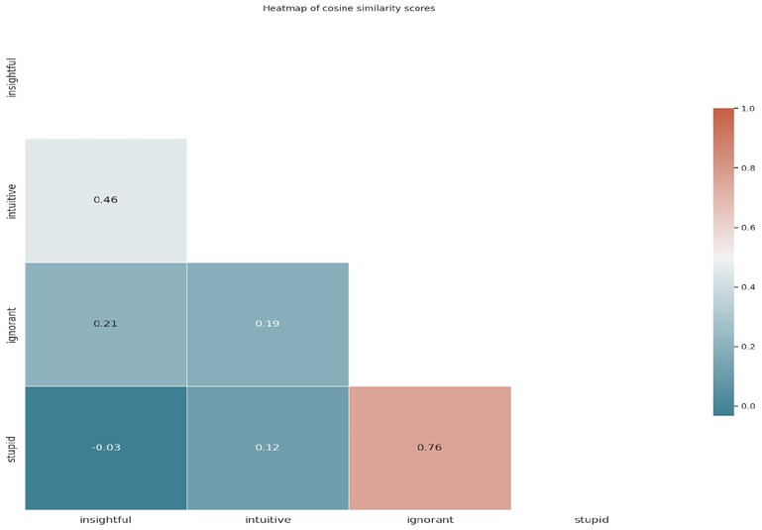
Figure 1
Word2Vec cosine similarity heatmap: intuitive – insightful, stupid – ignorant
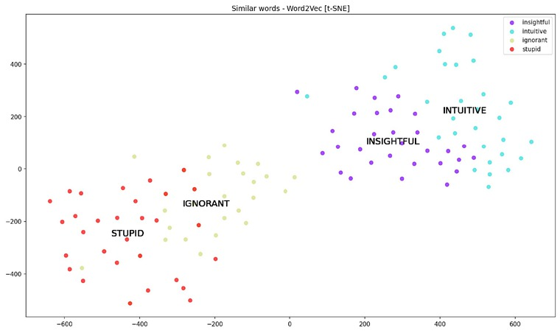
Figure 2
Word2Vec top 30 neighbouring vectors visualization using t-SNE: intuitive-insightful, stupid - ignorant
The embedding results confirm psychological and cognitive linguistic assumptions concerning the close semantic, conceptual, and neural positions not only of synonymic but also antonymous, lexical pairs (for a cognitive-linguistic interpretation of these phenomena consult Lewandowska-Tomaszczyk 1996).
To provide more compelling mental closeness in linguistic results, in the next round we applied the embedding to 5, equally frequent, headwords in opinions, linked by the conventional synonymy - antonymy links: excellent-good-bad, rich-poor (Figures 3–4).
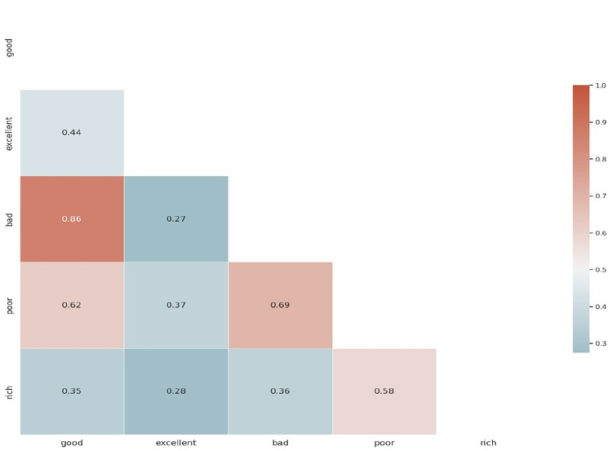
Figure 3
Word2Vec cosine similarity heatmap: excellent-good-bad, rich-poor
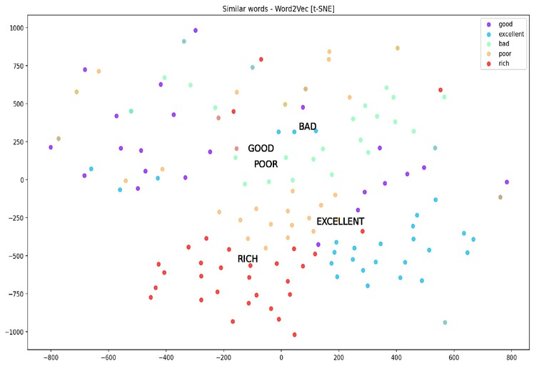
Figure 4
Word2Vec top 30 neighbouring vectors visualization using t-SNE: excellent-good-bad, rich-poor
Both the correlation between synonymy good-excellent reported in the heatmap and that between next synonymous pairs good-bad as well as rich-poor, but also the correlations between the antonymic pairs good-bad, rich-poor in a polysemous (financial and mental) senses are precisely equally high or higher (compare the values for good-excellent 0.35 and for good-bad 0.86). This shows a close conceptual similarity between the two types of lexical semantic relations - synonymy as well as antonymy in particular.
As an example of embeddings, twenty words from the opinionated texts (15 negative and 5 positive) were excerpted as opinion discourse markers and their embeddings presented in Figures 5–6.
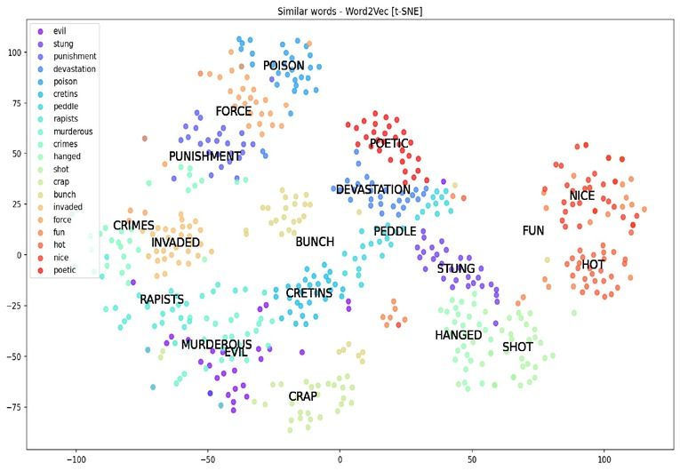
Figure 5
Word2Vec cosine similarity heatmap: twenty words from the opinionated texts (15 negative and 5 positive)
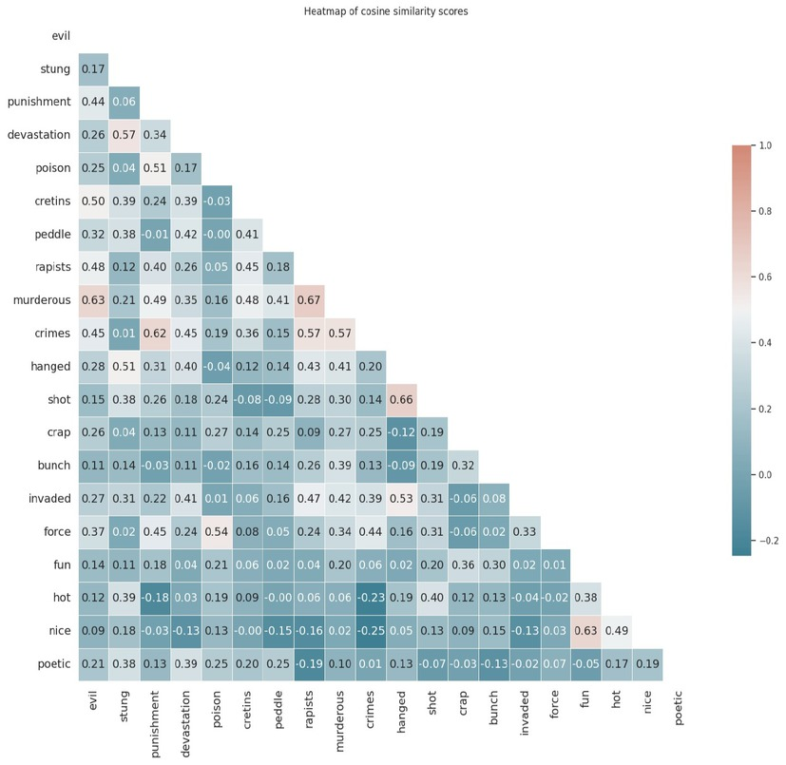
Figure 6
Word2Vec cosine similarity heatmap: twenty words from the opinionated texts (15 negative and 5 positive)
Apart from some obvious examples of words semantically close are e.g., “crimes” and “punishment”, linked by the causative relation, or “shot” and “hanged”, considered as co-hyponymic forms of the same superordinate category, there appear interesting cases of actual ambiguity in this respect e.g., “nice”, “fun” and “hot”, as well as “poetic”, which are all positive in most of the contexts on the one hand, and on the other “hot” has the highest correlation with “shot”, and “nice” correlates with “stung” in the highest degree. These relationships are also represented in the graph, in which the particular cluster shows the same relations visualized as distance representations.
- 7 Discussion and conclusions
Our linguistic and computational analysis of positive and negative opinions makes it possible to propose a general definition of an Opinion Speech Event as a semiotic act, embedded in a social-cultural context, of expressing one’s judgement on a subject, person, property or event.
Opinions are generally identifiable through their characteristic lexical, syntactic, and semantic/pragmatic markers. However, single, separate markers cannot be considered necessary or sufficient. They are rather characteristic, sometimes, as in the case of idioms – typical, but, without additional outside world knowledge and context, they do not exploit a final unique set of opinion distinguishers.
As a semiotic act, opinion expressing can lend itself to a more effective identification in face-to-face contexts in which all signs of body language as well as other modalities can be more easily observed. From a linguistic viewpoint, the presence of paralinguistic signals such as prosody in particular can contribute to a more effective multimodal - verbal, visual, auditory etc., identification of opinionated as opposed to fully factual, evidence-based statements.
To reassume, we might propose that an opinion is a communicative Speech Event which can be defined in the following terms:
Source [Human/Thing/Property/Event] >
Opinion Author/Agent [Opinion Holder] > Affect (Interest/(Dis)pleasantness)) > OPINION (mode) → Communicative Intent [sharing, (mode)→ Persuasive appeal →
➔
Opinion Addressee (default)
Results/Consequences
(if Opinion Addressee > Human Source > [Pragmatics (Face maintenance (praising) & Emotions (joy/satisfaction/happiness/encouragement)
or else
/Face threat (blaming) →
>>Emotion >(sadness/humiliation/anger/discouragement)
➔
Change (for all Sources): individual/public opinion persuasive effects (yes/no effects of varying force with the Addressee(s)
Symbols: >causality; → implication
In other words, an Opinion Speech Event assumes the presence of an Author, i.e., opinion holder, who expresses his/her (positive or negative) judgement/evaluation of a Theme to an Addressee. The Addressee may play either the role of an opinion receiver or an opinion Theme (subject), or else function in both the interactional roles. The term speech event is neutral as to the communicative medium – it can refer either to spoken or written communication. This type of speech event assumes the presence of both a Theme and an Addressee, as well as a transfer medium, together with a persuasive force presence in the Opinion expression act. Effects of such a Speech Event are either positive or negative, embodied in raising the Human Theme, and the Addressee’s emotionality and raising his/her potential of a particular evaluative judgement. Opinions thus are meant to exert a change: both pragmatically (face maintenance or else face threat or loss) and emotionally via their affective impact polarity.
In this study we analysed definitions of the concept of opinion as distinguished from factual or evidence-based statements. On the basis of the literature survey and our own social data excerpts analysis we proposed a taxonomy of opinions expressed in English as identified in selected social media. The taxonomy is based on two criterial properties – the relationship between the opinionated text and facts/evidence and the relationship between the proposition, and on the Agent/Author’s (opinion holder’s) conviction with regard to its truth/falsity to distinguish between truth and lying.
Through a linguistic analysis of opinionated texts that we acquired manually from various social media websites, we proposed lists of positive and negative opinion lexical discourse markers and their taxonomy. Our discussion was confronted with the automatically generated lexical embeddings of these positive and negative opinion markers.
The results did not support a thesis of unique specification of particular positive or negative opinion discourse markers in terms of a syntactic distribution or presence of a single positive or negative marker – as even what seems to be the most insulting lexical offensive markers can be negated in an opinion e.g., “This essay is not stupid, it is rather not completed”, which reverts their sense from the negative to a more positive one. The same initial message conveyed in the sentence though, can strengthen the negativity of the opinion, for example by the use of metalinguistic negation as in “This essay is not stupid, it is appalling”. This is a piece of evidence that even the use of negative markers with the negative opinion sentence, will not always convert it to a positive statement. Nevertheless, what can be obtained via our study is a set of preferential lexical usage types in either positive or negative opinion contexts, as was scrutinised in the analysed texts. The analysed linguistic markers can be proposed to refer not only to explicitly lexical (positive or negative senses), but the relevant polarity judgement is formulated on the basis of a complete collection of morphological, syntactic, and, last but not least, pragmatic markers. This will be particularly evidenced in some cases of implicitly positive or negative senses, in which the whole set of linguistic, paralinguistic and multimodal markers – let alone background knowledge concerning the communicative events and participants – matter. The latter are not considered in this study, especially that in social media communication some of these clues are not available.
Our present conclusions point to a less ambiguous understanding of opinionated texts which is established only by the types of the categorial boundaries of a more advanced syntactic and semantic analysis of the texts both in their pragmatic and cultural settings, but also considering individual identity characteristics of their authors. Furthermore, irrespective of some of these properties, as the present data analysis shows, there exists a definitional flexibility of the boundaries around lexical positive and negative types of opinion expressing markers.
- Acknowledgements
The study was prepared in the Linguistics group of COST Action CA 21129 What are Opinions? Integrating Theory and Methods for Automatically Analyzing Opinionated Communication (OPINION).
- Appendix 1
- Preferred keywords to express opinions
- In opinions based on stronger evidence:
demonstrate, confirm, discover
- Based on weaker evidence
claim, argue, view, suspect
- Emotive/evaluative language in opinions
Praising –
very good, best, excellent, fantastic, superb
Blaming –
poor, weak, unconvincing, unsupported
strong blaming (offensive) - vulgar
- Descriptive:
Use of comparative lexis:
It could be better / It couldn’t be better!
It’s not so good, could be better [negative]
- Explicit/Implicit
It’s awful! I couldn’t look at it
- Ambiguous between positive and negative opinion
extremely, unusually. unexpectedly
I haven’t seen anything like that in all my life
- Appendix 2
- Opinionated exemplar samples.
- Underlined are proposed opinion lexical/phraseological markers

POSITIVE OPINIONS
(1) | Dr. Jeter is the bomb. He’s not real strict, he works with you. He’s definitely fair and treats you with respect. I would recommend him anytime. He is very knowledgable about Criminal Justice issues. He’s certainly a “go-to” guy.
 | https://www.ratemyprofessors.com/professor/1244444
(2) | They’re just the cutest couple ever and you can tell he absolutely loves being a dad. I love watching his pancake videos in IG
 | https://www.reddit.com/r/popculturechat/comments/15yhvey/former_tennis_superstar_serena_williams_and/

(3) | He is so hot. I would bottom for him in an instant
 | https://twitter.com/jw291983/status/1694191915145855114)
(4) | Wow wow wow wow wow! What an amazing place. Stunning location, fabulous, attentive and wonderful staff. And the food, oh my goodness - to die for!!! We went with our two young children (1&amp;7) and they couldn’t have been more accommodating. Best restaurant ever, can’t recommend highly enough!
 | https://www.tripadvisor.com/ShowUserReviews-g4505725-d12658522-r912012364-The_Mussel_House_Restaurant-Ksamil_Saranda_Vlore_County.html#

(5) | i came into #Barbie with HIGH expectations and they still exceeded them. margot robbie was AMAZING as barbie. the whole film was so visually alluring, it was hilarious yet gut-wrenching. i’m definitely going to see it again this weekend
 | https://twitter.com/cambeserious/status/1681847455141310465
(6) | … For the first time, Prince Harry tells his own story, chronicling his journey with raw, unflinching honesty. A landmark publication, Spare is full of insight, revelation, self-examination, and hard-won wisdom about the eternal power of love over grief.
 | https://www.amazon.com/Spare-Prince-Harry-Duke-Sussex/dp/0593593804

(7) | Kadare’s writing is absolutely lyrical. Chronicle of Stone is the story of a city through one imaginative boy’s musings. Physical place is such a large part of history that often goes unobserved. This is a magical book capturing the beauty and opposing rawness of life.
 | https://www.goodreads.com/book/show/708124.Chronicle_in_Stone?from_search=true&amp;from_srp=true&amp;qid=dSezT0IyQs&amp;rank=2
(8) | The casting is also amazing. Cillian Murphy does an outstanding job playing Thomas Shelby. Cant wait for the next season. Definitly give it a try!
 | https://www.reddit.com/r/netflix/comments/auqzfs/is_peaky_blinders_good/

(9) | Great prof, passionate about the subject, cares about student opinions, and really gets you thinking. There is a lot of reading, but that’s just Russian literature for you. Actually, by the end, there were times I found myself wanting to read more.
 | https://www.ratemyprofessors.com/search/professors?q=ani%20kokobobo
(10) | Oh boy, this is obviously going to turn out great for everyone involved.
 | https://www.reddit.com/r/LinusTechTips/comments/15r1pfz/the_problem_with_linus_tech_tips_accuracy_ethics/ )

(11) | Perfect jacket will not s e arrepender.ca SA perfect on the body! I ordered g but the M would be fairer! I still liked
 | https://www.aliexpress.us/item/3256805548166912.html?spm=a2g0o.productlist.main.1.28c1443fZTzymc&algo_pvid=7d038dc0-fed6-43f8-ac26-fbb7c6fd9548&algo_exp_id=7d038dc0-fed6-43f8-ac26-fbb7c6fd9548-0&pdp_npi=4%40dis%21USD%2138.29%2111.85%21%21%21278.45%21%21%402101ea7116952907118767926e2a70%2112000034156325241%21sea%21US%210%21ABS&curPageLogUid=CuzBQAHIOS2X

NEGATIVE OPINIONS
(1) | the guy is impossible to understand and he doesnt understand any questions that you ask him. avoid this guy like the plague. he is also very unclear about what he wants done for the class (Teach Rev)
 | https://www.ratemyprofessors.com/professor/1089225
(2) | Terrible professor. Difficult to understand. For the projects he doesn't explain the directions until the day before it's due. If you ask him any question his response will likely be, "I don't understand" Would not recommend to anyone!!(Teach Rev)
 | https://www.ratemyprofessors.com/professor/1089225
(3) | I wish we could just let them sort their own s**t out, we are not the worlds parents. #Sudan
 | https://www.facebook.com/britishnationalism
(4) | He's pretty nice, but he's definitely one of the worst teachers I've ever had. He's always extremely vague & unhelpful about his assignments. Personally, he never revised my drafts for my essays even though we were required to turn them in, & then I got bad grades on most of my essays. I emailed him about it several times & he never replied. (Teach Rev)
 | https://www.ratemyprofessors.com/professor/1089225
(5) | Ugh. Skip him. (Teach Rev)
 | https://www.ratemyprofessors.com/professor/1089225
(6) | British politicians are destroying our nation. #Sudan
 | https://www.facebook.com/britishnationalism
 | I totally agree! Britain to be 'proper' Britain! (Fb; #Sudan)
 | https://www.facebook.com/britishnationalism
(7) | Vote Reform surely they are better than this bunch who seem to be invaded [i.e., invading] us with Islamics !!
 | https://www.facebook.com/britishnationalism
(8) | We should take no more immigrants of any sort . And as for "rescuing" people , they mostly went where the money was. Now the dream has crumbled we have to pay out to bring them here. And suppose some of these people leaving a conflict are the enemy?
 | https://www.facebook.com/britishnationalism
(9) | Delivered is cheap rag of very bad cotton. Worthless product, scam. Don't buy anything here
 | https://www.etsy.com/uk/listing/892209899/indian-cotton-handmade-summer-women?ga_order=most_relevant&ga_search_type=all&ga_view_type=gallery&ga_search_query=&ref=sc_gallery-7-1&pro=1&frs=1&referrer_page_guid=f6b2872cd42.27e8b29ca76fd982ab42.00&plkey=90ef4edb683c11e9300cbc3c77bdf3c50c4fe385%3A892209899

AMBIGUOUS OPINIONS
Conventional structural ambiguity, i.e., the ambiguity caused by the syntactic relations, is not particularly frequent in opinionated text. An example at from the https://www.quora.com/What-are-some-good-examples-of-ambiguous-phrases can be one such example:
(1) | My mother never made chocolate cake, which we all hated.
The sentence is ambiguous between 3 readings:
(i) reading 1. (negative judgement) We hated the fact that our mother never made chocolate cake for us
(ii) reading 2. (positive judgement wrt mother, negative wrt chocolate cake) We hated chocolate cake and that was why mother never made it
(iii) reading 3. (positive judgement) We loved the fact that mother never made chocolate cake that we would all hate (i.e., would not like).

BALANCED OPINIONS
(1) | Very very slow grader takes up to 4 weeks to return simple assignments. Not that hard to grade math, it's either right or wrong. That being said he is extremely fair but very dull class. I hate math and got a B but I wouldn't want to take another class with him
 | https://www.ratemyprofessors.com/professor/1270844
(2) | The fabric is very, very, VERY thin so I don't think I'll even be able to wear them just to be at home, maybe in the bedroom with my partner but that's about it. The fit is great and they make my butt look good but I just don't see myself exercising wearing them due to how thin the fabric is.
 | https://www.aliexpress.us/item/3256803758682307.html?spm=a2g0o.productlist.main.35.28c1443fZTzymc&algo_pvid=7d038dc0-fed6-43f8-ac26-fbb7c6fd9548&algo_exp_id=7d038dc0-fed6-43f8-ac26-fbb7c6fd9548-17&pdp_npi=4%40dis%21USD%213.44%211.38%21%21%2125.00%21%21%402101ea7116952907118767926e2a70%2112000027528238423%21sea%21US%210%21ABS&curPageLogUid=J6ibSZv9K63g
- List of source websites of opinionated samples:
Rate my professor: https://www.ratemyprofessors.com/
Reddit: https://www.reddit.com/
Twitter: https://twitter.com/
Tripadvisor: https://www.tripadvisor.com/
Amazon: https://www.amazon.com/
Goodreads: https://www.goodreads.com/
Facebook: https://www.facebook.com/
Etsy: https://www.etsy.com/
Aliexpress: https://www.aliexpress.us/?gatewayAdapt=glo2usa
Quora:https://www.quora.com/What-are-some-good-examples-of-ambiguous-phrases

¹The authors wish to express their gratitude for the insightful comments from the anonymous referees of the paper, which provided ground for some new reflections on the theme.

- About the authors
Barbara Lewandowska-Tomaszczyk
Barbara Lewandowska-Tomaszczyk is Professor Ordinarius Dr Habil. in Linguistics and English Language at the Department of Language and Communication at the University of Applied Sciences in Konin (Poland). Her research focuses on cognitive semantics and pragmatics of language contrasts, corpus linguistics and their applications in translation studies, lexicography and online discourse analysis. She is invited to read papers at international conferences and to lecture and conduct seminars at universities. She publishes extensively, supervises dissertations and also organizes international conferences and workshops.
Chaya Liebeskind
Chaya Liebeskind is a lecturer and researcher in the Department of Computer Science at the Jerusalem College of Technology. Her research interests span both Natural Language Processing and data mining. Especially, her scientific interests include Semantic Similarity, Language Technology for Cultural Heritage, Morphologically rich languages (MRL), Multi-word Expressions (MWEs), Information Retrieval (IR), and Text Classification (TC). Much of her recent work has been focusing on analysing offensive language. She has published a variety of studies and a few of her articles are under review or in preparation. She is a member of several international research actions funded by the EU.
Anna Bączkowska
Anna Bączkowska, Dr Habil. Prof. of Univeristy of Gdansk, she holds MA in English Philology, which she received from Adam Mickiewicz University in Poznań, as well as PhD in linguistics and D.Litt. in English Linguistics, which she received from the University of Lodz. Her research interests revolve around translation studies (film subtitles), cognitive semantics, corpus and computational linguistics, and discourse studies (media discourse). She has guest lectures in Italy, Spain, Portugal, UK, Norway, Kazakhstan and Slovakia, and she has also conducted research during her scientific stays in Ireland, Iceland, Norway, Austria and Luxembourg.
Jurate Ruzaite
Jūratė Ruzaitė is Professor at the Department of Foreign Language, Literary and Translation Studies and a senior researcher at the Centre of Intercultural Communication and Multilingualism at Vytautas Magnus University, Kaunas, Lithuania. She holds a Doctor of Philosophy (PhD) focused in Linguistics from the University of Bergen, Norway. She has rich experience in (inter)national research projects, including a national project (Semantika-2, 2018-2019) in the framework of which a software for automated detection of offensive online comments in Lithuanian was created. She is also the Associate Editor of the Lithuanian Applied Linguistics Journal and a board member of the Lithuanian Association of Applied Linguistics. Her research interests include sociolinguistics, pragmatics, discourse analysis, language and ideology, hate speech, propaganda, and disinformation.
Ardita Dylgjeri
Ardita Dylgjeri is professor of Stylistics and Text linguistics at the Department of Foreign Languages, Faculty of Human Sciences, University of Elbasan ‘Aleksandër Xhuvani’, in Albania. She holds an MA in World Literature and a PhD in Linguistics (Pragmatics and Critical Discourse Analysis). In the framework of her PhD thesis and not only, she has shown deep and special interest in Political Discourse Analysis and all its main linguistic peculiarities. Her other research and academic interests include Psycholinguistics, Sociolinguistics, Linguistic Diversity, Second Language Acquisition and Cognitive Linguistics.
Ledia Kazazi
Ledia Kazazi is a professor of English Language and Linguistics at the Department of Foreign Languages at the University of Elbasan “Aleksander Xhuvani” in Elbasan, Albania. She holds a PhD in Cognitive Linguistics. Her research focuses on all aspects of Cognitive Linguistics, especially Conceptual Metaphor and Conceptual Metonymy but also expands to Cognitive Semantics, Cognitive Narratology, Multimodal Discourse Analysis and Critical Discourse Analysis. She has published several articles and given several conference talks on topics related to the aforementioned disciplines.
Erika Lombart
Erika Lombart is a research associate at UCLouvain's Language and Communication Institute. After spending five years at CENTAL, the Centre Traitement Automatique de la Langue, she defended her doctoral thesis in September 2001. Her thesis was centred around "the non conventional implicit in discussion forums". In addition, she authored a book titled "Entre les lignes des réseaux sociaux" (Between the lines of social networks) published by Editions L'Harmattan. Her research currently centres around investigating the application of metaphors in political discussion as well as examining the formal indicators of implication in discourses on social networks. She is actively participating in the COST Opinion Action.
- References
Akopova, Asya. 2013. Linguistic manipulation: definition and types. International Journal of Cognitive Research in Science, Engineering and Education (online only). 1(2).Search in Google Scholar
Al-Saqqa, Samar & Arafat Awajan. 2019. The use of word2vec model in sentiment analysis: A survey. In Proceedings of the 2019 international conference on artificial intelligence, robotics and control, 39–43. New York, NY: Association for Computing Machinery.10.1145/3388218.3388229Search in Google Scholar
Bączkowska, Anna. 2022. Explicit and implicit offensiveness in dialogical film discourse in Bridgit Jones films. International Review of Pragmatics 14(2). 198–225.10.1163/18773109-01402003Search in Google Scholar
Bączkowska, Anna & Dagmar Gromann. 2023. From Knobhead to Sex goddess: swear words in English subtitles, their functions and representation as Lingusitic Linked Data. Rasprave 491(1). DOI: https://doi.org/10.31724/rihjj.49.1.4.10.31724/rihjj.49.1.4Search in Google Scholar
Dahlman, Christian, Farhan Sarwar, Rasmus Bååth, Lena Wahlberg & Sverker Sikström. 2015. Prototype Effect and the Persuasiveness of Generalizations. Review of Philosophy and Psychology 7. 163–180.10.1007/s13164-015-0264-1Search in Google Scholar
Davison, W. Phillips. “Public opinion”. Encyclopedia Britannica, 7 Nov. 2023. Available at: https://www.britannica.com/topic/public-opinion (accessed 12 November 2023).Search in Google Scholar
Emmot, Catherine, Marc Alexander & Agnes Marszalek. 2014. Schema theory in stylistics. In Michael Burke (ed.) The Routledge Handbook of Stylistics, 130–134. Abingdon: Routledge.Search in Google Scholar
Entman, Robert M. 2007. Framing bias: Media in the distribution of power. Journal of Communication 57(1). 163–173.10.1111/j.1460-2466.2006.00336.xSearch in Google Scholar
Gärdenfors, Peter. 2000. Conceptual spaces. The geometry of thought. Cambridge: MIT Press.10.7551/mitpress/2076.001.0001Search in Google Scholar
Grice, Herbert Paul. 1975. Logic and conversation. Reprinted in H. P. Grice. 1989. Studies in the way of words, 22–40. Harvard: Harvard University Press.Search in Google Scholar
Grice, Herbert Paul. 1978. Further notes on logic and conversation. Reprinted in H. P. Grice. 1989. Studies in the way of words, 41–57. Harvard: Harvard University Press.Search in Google Scholar
Grice, H. Paul. 1989. Studies in the way of words. Harvard: Harvard University Press.Search in Google Scholar
Hoehn, Sviatlana, Barbara Lewandowska-Tomaszczyk, Sjouke Mauw & Dove Gabbay. 2023. Dripping the poison: The instruments of bias. Journal of Applied Logic 10(4). 555–585.Search in Google Scholar
Hofstede, Geert (2011). Dimensionalizing Cultures: The Hofstede Model in Context. Online Readings in Psychology and Culture 2(1). DOI: https://doi.org/10.9707/2307-0919.1014.10.9707/2307-0919.1014Search in Google Scholar
Kaiser, Elsi & Catherine Wang. 2020. Distinguishing fact from opinion: Effects of linguistic packaging. Papers of the Cognitive Science Society. Available at: https://cognitivesciencesociety.org/cogsci20/papers/0028/0028.pdf (accessed September 11 2023).Search in Google Scholar
Kaiser, Elsi & Catherine Wang. 2021. Packaging Information as Fact versus Opinion:Search in Google Scholar
Consequence of the (Information-) Structural Position of Subjective Adjectives in Discourse Processes 58(7). 617–641.10.1080/0163853X.2020.1838196Search in Google Scholar
Król, Małgorzata (ed.). 2015. Opinie prawne w praktyce [Legal opinions in practice]. Warszawa: C. H. Beck.Search in Google Scholar
Król, Małgorzata. 1987. Concept of Normative Leeway in an Application of Law, Studies in the Theory and Philosophy of Law 3. 19–35.Search in Google Scholar
Kumar, Akshi & Divya Gupta. 2021. Sentiment Analysis as a Restricted NLP Problem. In Fatih Pinarbasi, Faith & M. Nurdan Taskiran (eds.), Natural Language Processing for Global and Local Business, 65–96. Hershey, PA: IGI Global.10.4018/978-1-7998-4240-8.ch004Search in Google Scholar
Available at: https://www.igi-global.com/dictionary/sentiment-analysis-as-a-restricted-nlp-problem/89393 (accessed 28 October 2023).Search in Google Scholar
Lakoff, Robin. 1973. The Logic of Politeness, or Minding Your P’s and Q’s. Chicago Linguistics Society 9. 292–305.Search in Google Scholar
Lakoff, George. 1990. Women, fire and dangerous things: what categories reveal about the mind. Chicago: University of Chicago Press.Search in Google Scholar
Langacker, Ronald. 1987. Foundations of cognitive grammar. Stanford: Stanford University Press.Search in Google Scholar
Leech, Geoffrey. 1983. Principles of Pragmatics. London: Longman.Search in Google Scholar
Lewandowska-Tomaszczyk, Barbara. 1996. Depth of negation - A cognitive semantic study. Lodz: University of Lodz Press.Search in Google Scholar
Lewandowska-Tomaszczyk, Barbara. 2010. Re-conceptualization and the emergence of discourse meaning as a theory of translation. In Barbara Lewandowska-Tomaszczyk & Marcel Thelen (eds.), Meaning in translation, 105–148. Frankfurt am Main: Peter Lang.10.3726/978-3-653-00940-8Search in Google Scholar
Lewandowska-Tomaszczyk, Barbara, Anna Bączkowska, Chaya Liebeskind, Giedre Valunaite Oleskeviciene & Slavko Žitnik. 2023. An integrated explicit and implicit offensive language taxonomy. Lodz Papers in Pragmatics 19(1). 7–48.10.1515/lpp-2023-0002Search in Google Scholar
Mikolov, Tomas, Kai Chen, Greg Corrado, & Jeffrey Dean. 2013. Efficient estimation of word representations in vector space. arXiv preprint arXiv:1301.3781.Search in Google Scholar
Preece, Jennifer, Yvonne Rogers & Helen, Sharp. 2002. Interaction Design: Beyond Human-Computer Interaction. New York: John Wiley & Sons.Search in Google Scholar
Raskin, Victor. 1985. Semantic mechanisms of humor. D. Reidel Publishing Company.10.1007/978-94-009-6472-3Search in Google Scholar
Rosch, Eleanor. 1975. Cognitive representations of semantic categories. Journal of Experimental Psychology 104. 192–233.10.1037/0096-3445.104.3.192Search in Google Scholar
Schank, Robert C. & Robert P. Abelson. 1977. Scripts, plans, goals and understanding: An inquiry into human knowledge structures. New York: Lawrence Erlbaum.Search in Google Scholar
Searle, John. 1969. Speech acts: An essay in the philosophy of language. Cambridge: Cambridge University Press.10.1017/CBO9781139173438Search in Google Scholar
Searle, John. 1998. Mind, Language and Society. New York: Basic Books.Search in Google Scholar
Semino, Elena. 1997. Language and World Creation in Poems and Other Texts. Abingdon: Routledge.Search in Google Scholar
Wang, Rui, Deyu Zhou, Mingmin Jiang, Jiasheng Si, & Yang Yang. 2019. A survey on opinion mining: From stance to product aspect. IEEE Access 7. 41101–41124.10.1109/ACCESS.2019.2906754Search in Google Scholar
Wittgenstein, Ludwig. 2001 (1953). Philosophical Investigations. Oxford: Blackwell Publishing.Search in Google Scholar
Wróblewski, Jerzy. 1969. Legal reasoning in legal interpretation. Logique et Analyse 12(45). 3–31.Search in Google Scholar
Published Online: 2023-12-12
Published in Print: 2023-12-15
© 2023 Walter de Gruyter GmbH, Berlin/Boston

