a geometric-based method for the perceptive design of hyperstatic rigid frames
Shuyuan HAN*, Denis Zastavniª
* Louvain research institute for Landscape, Architecture, Built environment [LAB]
Place du Levant 1 (L5.05.02) – B 1348 Louvain-la-Neuve
shuyuan.han@student.uclouvain.be
*Year of the first thesis registration：2018
Abstract
This research seeks a perceptive design approach for hyperstatic rigid frames which can provide more insights into the relations between form and inner forces. This approach is based on the historical graphical analysis methods for the hyperstatic rigid frames. This method is further developed and parameterized to overcome its shortcomings and better serve as an intuitive, interactive, and chronology-free design approach.
Hyperstatic rigid frames are one of the most used structural types in the building industry. Bending moment is often the major dominant factor that governs the design of sections of structural members. Simultaneously, the sections of members also affect bending moment distribution by determining bending stiffness and the balance of forces.
The current design practices of frame members are often material-inefficient because they usually respond to a localized peak of loading with constant section dimensions. Although the frames with constant sections may be more economical to fabricate and construct, their material-inefficiency can lead to excess carbon footprint. Besides, the aesthetic value of varying sections is often unexploited. Frames are unthinkingly designed as faceless supports by default instead of an element of architectural expression.
To settle the terms and parameters of such structural problems requires the coordination of form (global geometry + varying section dimensions which dictates bending stiffness) and bending moment, and higher level of involvement of architects in sections dimensioning. Current numerical methods provide not enough insights into the relation between moment of inertia and resulting bending moment. The resulting approaches are not so intuitive and interactive; this results in a guess-and-check process with poor understanding of the reciprocal influences of involved parameters. Moreover, they often deter architect with their demand of a structural experience hard to acquire.
Graphical method, in particular Graphic Statics, is potential to express structural relations more intuitively and provide insights into the structural problems, as geometry can describe forms, forces AND magnitudes more intuitionally, Hence, it could facilitate smart design and it is more comprehensible to architects.
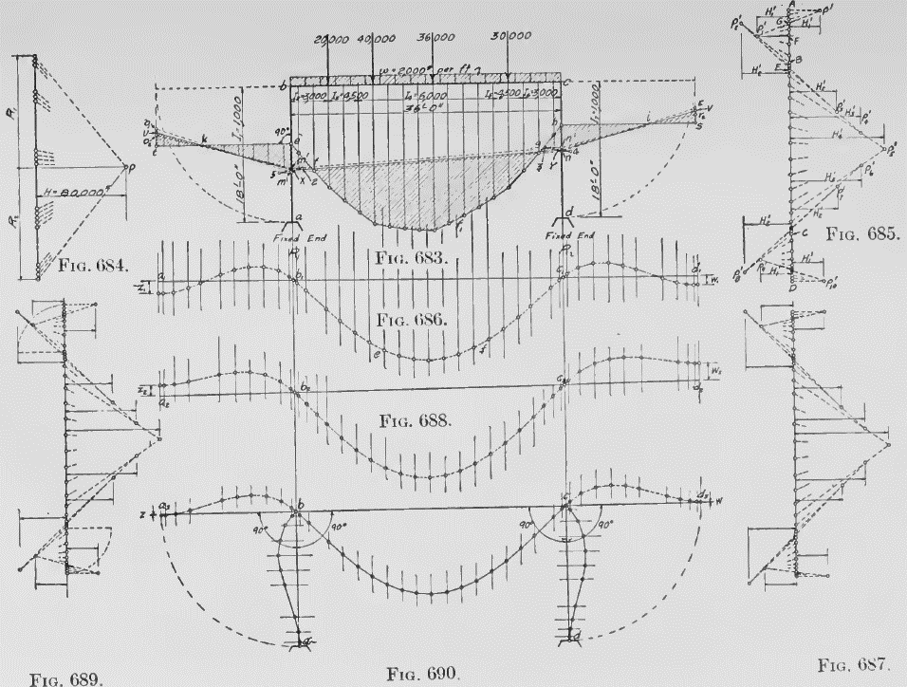
This research starts with an in-depth historical review of the analysis methods for rigid hyperstatic frames using Graphic Statics. This review reveals that statically indeterminate rigid portal frames under vertical loading can indeed be solved – and was solved – with Graphic Statics [figure 1]. This method is potent in analyzing frames with varying sections, and thus could be However, the historical method of hyperstatic rigid frames was limited to orthogonal portal frames under vertical loading. The result can also be rather cumbersome due to the limit of hand-drawing. The error can be significant for frames with static indeterminacy of more than one degree, partly Moreover, this is an one-way chronology approach which is not efficient for design.
Figure 1. historical methods of analyzing a portal frame with graphic statics (W. Wolfe 1921)
To overcome these limits, this research presents a solution for portal frames under horizontal loading using Graphic Statics. The portal frames with oblique members are also explored. In addition, a technique is proposed to address the static indeterminacy more precisely. Furthermore, this research parameterizes such a graphical environment to enable an analysis and design approach that is more intuitive, interactive, and chronology-free: The method is intuitive because all the relations are expressed explicitly on diagrams. Interactive because form and bending moment are simultaneously and dynamically steered by designers. Chronology-free because the deductive process undertaken by the designer can be switched whenever desired. This integrated method can facilitate designers to balance space and structural needs and render structural forms both innovative and structurally efficient.

