advanced characterization of the 3D morphology of the BONE-TENDON INTERFACE

Arne Maes (1), Lisa Leyssens (2), Greet Kerckhofs (1,2,3)

1. Dept. Materials Science and Engineering, KU Leuven, Belgium 2. Biomechanics Lab, Institute of Mechanics, Materials, and Civil Engineering, UCLouvain, Belgium; 3 Prometheus, Division of Skeletal Tissue Engineering, KU Leuven, Belgium

Introduction
The bone-tendon interface or the enthesis, is a highly specialized tissue connecting tendon to bone. Despite its effectiveness in reducing interfacial stress concentrations, injuries at the bone-tendon interface are still relatively common. These injuries are often induced by tissue degeneration related to aging or pathologies but can also be caused by overuse or trauma [1]. Surgical reattachment is characterized by very poor outcomes due to the inability of reconstituting the original tissue, and results most often in re-tearing of the bone-tendon interface. This renders the bone-tendon interface an important research topic. In order to address this clinical issue, it is necessary to regenerate a tissue, which closely resembles the original structure. However, an incomplete understanding of the complex, multi-tissue morphology found at the bone-tendon interface, hampers significant break-throughs in the field of regenerative medicine [2]. This study aims to develop and optimize advanced techniques in order to characterize the microstructural properties of the murine Achilles bone-tendon interface.

Materials, methods and results
Achilles bone-tendon interfaces were extracted from 8-weeks old mice, 30-weeks old lean mice and 30-weeks old diet-induced obese mice (induced by a 22-weeks long high fat diet). High resolution X-ray microfocus (microCT) allowed the characterization of the 3D morphology of the mineralized tissues at the bone-tendon interface. Contrast-enhanced microstructure (CE-CT) was applied in order to study the soft tissues near the bone-tendon interface, including the collagen fiber orientation. A voxel size of 1.25 µm was applied, and samples were stained with Lugol’s iodine for CE-CT.
MicroCT revealed differences between the lean and the obese mice concerning the volume of the mineralized fibrocartilage layer and the surface of the connection between the mineralized and unmineralized fibrocartilage. The increase in volume of the mineralized fibrocartilage observed in the obese mice was caused rather by a broader connection surface, instead of an increase in thickness. The structural differences between obese and lean mice were explained through biological and physical effects: a delay in chondrogenesis and mechanobiology. Ageing, on the other hand, did not have a significant effect on the aforementioned properties. CE-CT allowed the observation of the collagen fiber orientation within the unmineralized fibrocartilage and the connecting tendon (Figure 1). Quantitative 3D analysis is ongoing, as well as further optimization of the contrasting method.

Conclusion
The goal of this study was to develop and optimize microCT and CE-CT for the 3D structural characterization of the murine Achilles bone-tendon interface. MicroCT allowed highly detailed 3D visualization and quantification of the architecture of the mineralized structures at the interface. CE-CT allowed the visualization and the tracking of the collagen fiber orientation both in the unmineralized cartilage and in the tendon. Further research will involve the analysis of a larger set of samples to obtain more statistically reliable results. Furthermore, efforts are currently made to develop novel contrasting methods.

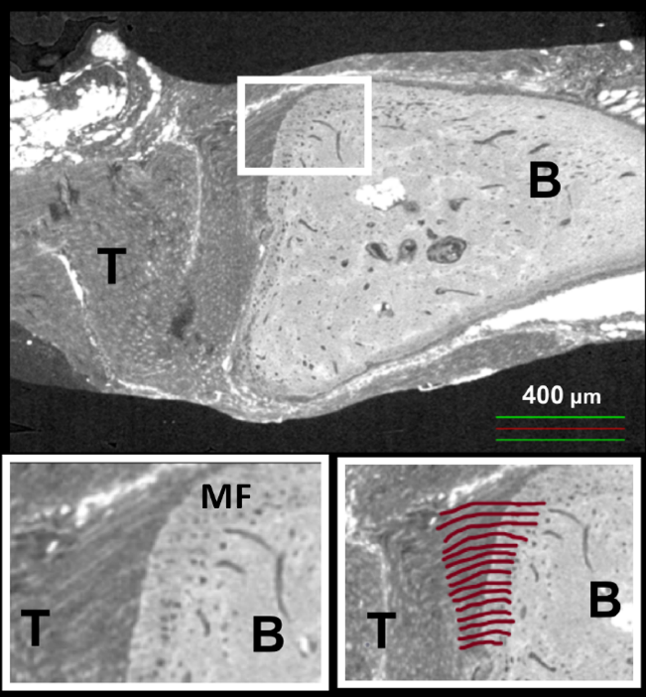
Figure 1: Sagittal view of the bone-tendon interface of a murine Achilles tendon (30 weeks old lean) obtained through CE-CT. The insets show the magnified image indicated by the white rectangle. The red lines indicate collagen fibers running from the tendon (T) through the mineralized fibrocartilage (MF) and ending at the bone (B).

References
[1] Apostolakos, J. et al. (2014). The Enthesis: a Review of the Tendon-to-Bone Insertion. Muscles, ligaments and tendons journal, 4(3), 333-42.
[2] Derwin, K. et al. (2018) Enthesis Repair: Challenges and Opportunities for Effective Tendon-to-Bone Healing. The Journal of Bone and Joint Surgery, 100(16):e109

