Review
Recent advances in pure MOF membranes for gas separation and pervaporation
Xiao Xu ^{a,b}, Yusak Hartanto ^{a,b}, Patricia Luis ^{a,b}
Citation: Lastname, F.; Lastname, F.; Lastname, F. Title. Membranes 2022, 12, x. https://doi.org/10.3390/xxxxx
Academic Editor: Firstname Lastname
Received: date
Accepted: date
Published: date
Publisher’s Note: MDPI stays neutral with regard to jurisdictional claims in published maps and institutional affiliations.

Copyright: © 2022 by the authors. Submitted for possible open access publication under the terms and conditions of the Creative Commons Attribution (CC BY) license (https://creativecommons.org/licenses/by/4.0/).
¹ ª Materials & Process Engineering (iMMC-IMAP), UCLouvain, Place Sainte Barbe 2, 1348 Louvain-la-Neuve, Belgium
² ^{b} Research & Innovation Centre for Process Engineering (ReCIPE), Place Sainte Barbe, 2 bte L5.02.02 - B-1348 Louvain-la-Neuve (Belgium)
* Correspondence: xiao.xu@uclouvain.be; patricia.luis@uclouvain.be
Abstract: Metal–organic frameworks (MOFs), a sub-group of porous crystalline materials, have been receiving increasing attention in gas separation and pervaporation because of their high thermal and chemical stability, narrow window sizes, as well as tuneable structural, physical and chemical properties. In this review, we discuss the formation developments of pure MOF membranes in gas separation and pervaporation comprehensively. Additionally, the application performance of pure MOF membranes in gas separation and pervaporation are analysed. Lastly, some perspectives for the future application of pure MOF membranes in gas separation and pervaporation are given.
Keywords: Metal-organic frameworks, pure MOF membranes, formation developments, gas separation, pervaporation

1. Introduction
The demand for sustainable and energy-efficient separation and purification technology is growing in order to achieve carbon neutrality. Compared with other traditional separation processes (including amine adsorption, pressure swing adsorption and cryogenic separation), membrane separation has gained more and more attention from different realms, namely from energy, water, chemical, healthcare, and food areas, because it has unique merits, such as energy efficiency, high separation efficiency, small carbon footprint, low cost, easy operation and scalability, etc [1-3]. Among a variety of membranes, semi-permeable membranes serve as the heart of gas separation and pervaporation to separate or remove angstrom-scale gas or liquid molecules[4].
Metal-organic frameworks (MOFs) have gained more attention in gas separation and pervaporation because MOFs are a class of porous materials with unique merits, including large surface areas, uniformly adjustable sized pores, high void volumes, and hybrid organic-metal nature[5, 6]. Membranes on the basis of this kind of materials generally have an asymmetric structure with a molecular sieving layer positioned on inorganic supports [7]. Up to now, gas separation and pervaporation using pure MOF membranes are mainly achieved by exploiting the molecular sieve effects of the MOF. In this mechanism, certain gas or liquid molecules with larger kinetic diameters are blocked outside of the pores of the MOF while other molecules with smaller kinetic diameters can pass through the pores of the MOF [6].
Although there have been several excellent review articles on the application of MOF membranes in gas separation and pervaporation [5, 6, 8], only pure MOF membranes applied in gas separation or pervaporation have been summarized. In this work, recent developments of pure MOF membranes in gas separation or pervaporation have been systematically summarized and analysed. Moreover, the application performance of pure MOF membranes in gas separation and pervaporation are evaluated and analysed, respectively. In addition, major challenges and future perspectives of pure MOF membranes in gas separation and pervaporation are presented.

2. Developments of MOF-based membrane
As a type of porous material, metal–organic frameworks (MOFs), because of large surface areas, good stability and well-defined pore structures with molecule-scale pore size, show great potential for energy-efficient separations of gas or liquid mixtures [9, 10]. Since most MOFs are in the form of either microcrystalline powders or submillimetre crystals, it is difficult to use widely them in the field of separation. To improve the situation, a variety of MOF-based membranes have been prepared. These membranes can in general be classified into two types: pure MOF-based membranes and MOF-based mixed matrix membranes. In this review, pure MOF-membranes are only discussed.

2.1. Pure MOF-based membranes
This kind of MOFs-based membranes are a class of continuously grown membranes which are mainly prepared by growing uninterrupted polycrystalline or epitaxial layers on substrates. In this type of membranes, pure-MOFs layers have selectivity to different feed components because the pores of MOFs are the only permeation channel through the entire layers, while substrates as a support offer mechanical strength for the MOFs layers. Since the first attempt on continuous MOFs membranes was reported by Fischer et al. in 2005[11], there have already been a variety of approaches developed to fabricate the pure-MOFs films, including in-situ growth[12-14], secondary growth[15-17], interfacial diffusion[18-22], liquid phase epitaxy[23-26], vapor deposition[27-32] and electrodeposition method[33-35].

2.1.1. In-situ growth
In-situ growth is to fabricate the pure MOF-based membranes on the substrates by soaking the substrate in the solutions of inorganic precursors/ organic precursors, as illustrated by Fig. 1. The whole process is mainly divided into two steps: the first step is to induce MOF crystal nucleation on the substrate surface under certain conditions, and the second step is to promote the continuous growth of MOF crystals until the substrate surface is completely covered with a pure MOF layer [36].
However, it is difficult to achieve sufficient density of nucleation sites on unmodified substrates. To solve this difficulty and at the same time strengthen the adhesion MOFs layers and substrates, supporting substrates are modified. A modification of the substrate surface is sometimes crucial to form crack-free MOFs membranes. In summary, in-situ growth can be further classified into two routes: in-situ growth on unmodified support and in-situ growth on modified support [6].
Despite many attempts, the fabrication of the defect-free MOF layer on the unmodified substrate remains a challenge to date. To obtain a defect-free pure MOF layer while enhancing the adhesion of the MOF layer and the substrate, the substrate usually needs to be modified. According to the difference of the support substrates, in situ growth can be divided into: (1) in situ growth on unmodified supports, and (2) in situ growth on modified supports.
As the name suggests, in-situ growth of the MOF on unmodified support is to grow a MOF layer on the unmodified support. The first example of a continuous and well-intergrown MOF-5 membrane was demonstrated by Lai and co-workers[37]. A porous alumina disc was soaked into the mother solution of MOF-5, and then the solution was heated to 105℃ under sealed conditions to prepare pure MOF-5 membranes. The tested results showed that the diffusion of H₂, CH₄, N₂, CO₂, and SF₆ through the MOF-5 membrane followed the Knudsen diffusion behaviour. It was reported by Jürgen et al that by replacing the dimethylformamide (DMF) as the solvent and aqueous methanol with absolute methanol, a crack-free, dense and polycrystalline ZIF-8 layer was synthesized on a titania support using in situ microwave-assisted solvothermal method [38]. The as-synthesized MOF membrane showed a fine balance between permeance and selectivity for the separation of H₂/CH₄. To enhance the adhesion between the MOF layer and the substrate, Chen and Wang et. al. demonstrated the in-situ growth of ZIF-8 layers on tubular substrates using a concentrated synthesis gel with a molar composition of Zn, 2-methylimidazole (Hmim) and methanol of 1:8:700 by dip or slip casting[39]. The hollow substrates were first dried at 80℃ overnight and then being placed vertically in an autoclave. Subsequently, ZIF-8 synthesis solution was slowly poured into the autoclave and heated under given conditions. The crystalline ZIF-8 layers on the substrates were compact and continuous with a thickness of 6 μm. The EDX elemental mapping suggested that some ZIF-8 crystal might exist in the pores of the supports. The prepared ZIF-8 exhibited strong CO₂ adsorption properties. For the enhancement of Interfacial adhesion, Kang and co-workers used ‘single metal source’ to generate a homochiral MOF membrane [40]. In this report, the substrate not only played the role of supporting the MOF layer, but also involved in the MOF growth process as the sole nickel source. The obtained thin and crack-free Ni₂(L-asp)₂(bipy) exhibited a comparable ee value of 32.5% for the pervaporation separation of pure racemic mixtures.
As stated-above, how to enhance the interfacial adhesion is an urgent problem for the preparation of pure MOF membranes, the modification of the substrate has been considered as an effective strategy to solve this problem. The substrate surface can be modified physically or chemically. Zhang et al. first reported the growth of low-defect ZIF-8 membranes on tubular α-alumina substrates that were modified by coating a layer of ZnO, and then 2-methylimidazole was used to activate and react with ZnO layers[41]. The resulting ZIF-8 layers on physically modified supports exhibited excellent separation performance. These ZnO layers have an important role in promoting the synthesis of ZIF-8 membranes since ZnO can be utilized as the secondary metal source for the preparation of MOF membranes. The obtained low-defect membrane exhibited higher permeances for small gas molecules of H₂, N₂, and CH₄, while large molecules of C₃H₈, n-C₄H₁₀, and SF₆ permeated significantly low through ZIF-8 membranes. For the preparation of defect-free MOF membranes, Tan and co-workers prepared thin uniform ZIF layers on physically modified supports[42]. Firstly, they covered the surface of polypropylene (PP) supports with the metal-chelating polyaniline (PANI) layers by in-situ deposition technique. Subsequently, ZIF-7 and ZIF-67 membranes with controllable thicknesses were produced on the PP supports. ZIF-7-NH₂ membrane with gate-opening and flexibility showed H₂ permeance of 4.9 × 10⁻⁶ mol m⁻² s⁻¹ Pa⁻¹ and an ideal H₂/CO₂ separation factor of 10.6. Using the physically modified concept, Wu et al. deposited 50 ~ 200 nm thick polydopamine (PDA) layers on the α-Al₂O₃ disks before the in-situ solvothermal synthesis of MIL-160 membranes[43]. The obtained high-crystallinity MIL-160 membrane showed the high flux of 467 g m⁻² h⁻¹ and the selectivity of 38.5 from the pervaporation separation of p-xylene from its bulkier isomer o-xylene. Another example of the preparation of HKUST-1 membrane on the chemically modified support via the ‘twin copper source’ technique was reported by Guo and co-workers[44]. In their report, the copper net as both copper source and support for the pure MOF membrane first went through a series of treatments to reach oxidation, and then HKUST-1 membrane was synthesized on the oxidised support that was placed vertically in an autoclave full of a solution of HKUST-1. The resulting membrane demonstrated higher permeation flux of H₂ (∼1 × 10⁻¹ mol·m⁻²·s⁻¹) than other gas components in the separation of H₂/CO₂, H₂/N₂, and H₂/CH₄ mixtures.

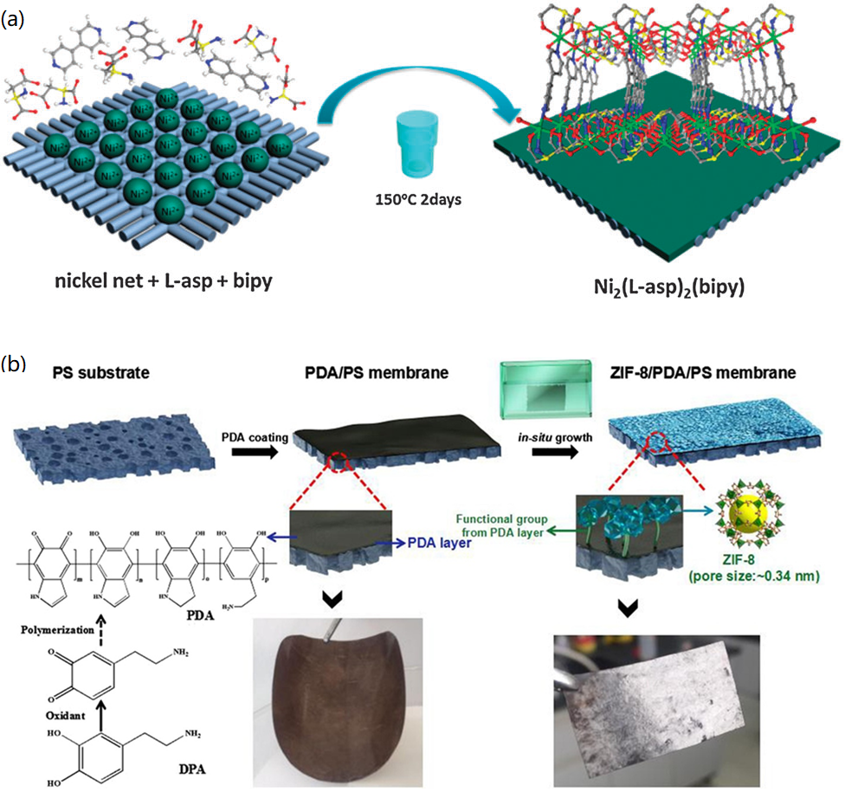

Figure 1. Schematic illustrations of the in-situ synthesis of pure MOF membranes: (a) the growth of Ni₂(L-asp)₂(bipy) on unmodified nickel support and (b) the growth of ZIF-8 membrane on modified PS support. Reprinted with permission from Refs. [12, 40].

2.1.2. Secondary growth
Secondary growth (also called seeded-secondary growth) of MOF membranes involves the seeding of crystal nucleus on the support, followed by the growth of MOF membranes on the seeded support, as illustrated in Fig. 2. For the fabrication of MOF membranes, secondary growth has been proved to be more likely to obtain thinner and less defective MOF membranes[45]. Although the crystal nucleation and growth steps of secondary growth can be independently controlled, the control of the final thickness and orientation of MOF membranes can be achieved by controlling the thickness and orientation of the seeded layer[46].The key step for the secondary growth of MOF membranes is the seeding. Up to now, a variety of seeding techniques has been developed including rubbing[47], dip-coating and slip-coating[48], electro-spinning[49], microwave radiation[50], spin coating[51], reactive seeding[52] and thermal seeding[53], which can be classified into physical seeding and chemical seeding.
In 2009, Tsapatsis et al. synthesized the microporous MOF membrane by manual assembly using a seeded solvothermal growth on the α-alumina support coated with polyethyleneimine (PEI)[54]. In this report, the seeded support was vertically placed in the autoclave containing a mother solution of microporous MOF membrane at 150℃ for 12 h, producing an oriented membrane with the pores aligned preferentially perpendicular to the support surface. Such MOF membranes exhibited low H₂ permeances with ideal selectivity for H₂/N₂ of 23. Lai and co-workers also reported on the preparation of continuous ZIF-8 membrane[55]. The seeds were first attached on the hollow yttria-stabilized zirconia (YSZ) fibre support by dip-coating and drying, and then the seed support was placed vertically in the glass vial filled with a secondary solution. Subsequently, the glass vial was heated under certain under some conditions, finally producing a continuous ZIF membrane with a thickness of about 2μm. In single-component permeation studies, the membrane exhibited a superior performance with H₂ permeance of ∼15×10⁻⁷ mol/m² s Pa and an ideal selectivity of H₂/C₃H₈ of more than 1000 at room temperature. Wang et al. used a wet-rubbing method to coat Ni₂(l-asp)₂bipy crystals on the top surfaces of SiO₂ discs[56]. After this operation, a solvothermal reaction was carried out to prepared continuous grown Ni₂(l-asp)₂bipy membrane. To apply this membrane for the pervaporation separation of ethanol from ethanol/water mixture, a PDMS layer was subsequently coated on Ni₂(l-asp)₂bipy layer to switch the wettability of the MOF membrane to the hydrophobicity. The prepared membrane was utilized to separate the water/ethanol mixture with 50 wt% ethanol at 30 °C, exhibiting a remarkably high flux of 27.6 kg·m⁻ ² h⁻ ¹ and a separation factor of 73.6. For high reproducibility, Jürgen Caro’s group used an automatic dip-coating device to attach ZIF-8 seeds on α-Al₂O₃ supports before the secondary growth in solvothermal conditions[57]. Supported polycrystalline ZIF-8 membranes still did not display a clear cut off in the pervaporation separation of n-hexane, benzene and mesitylene.
In addition to physically seeding, chemically seeding have been gradually introduced to deposit MOF crystals on the porous substrates. ‘’Thermal seeding’’ was first reported to anchor MOF seeds on porous substrates by Jeong et al. [53]. In this research, the solution containing HKUST-1 crystals as well as unreacted HKUST-1 precursors was dropped on hot porous α-alumina supports followed by repeating this process until support surface was covered sufficiently with seed crystals. The resulting seeded support was placed in the autoclave, into which the solution containing HKUST-1 precursors was then filled. Under appropriate synthesis conditions, the continuous HKUST-1 membrane without cracks and fractures grew on the chemically seeding support. The prepared HKUST-1 membrane showed moderate ideal selectivity of H₂ over N₂, CH₄, and CO₂ for the gas separation, also exhibiting greater affinity to CO₂ over CH₄ and N₂ with the temperature. Another chemically seeding method is a facile reactive seeding (RS)[52]. In this method, a porous substrate also played dual roles, one as the support to hold the selective layer, and the other as the inorganic source to engage in the growth of MIL-53 seeds on the support. The as-synthesized MIL-53 membrane displayed a sharp separation for the pervaporation separation of H₂O from ethanol, t-butanol and ethyl acetate, respectively. At 60 ℃, when H₂O-ethyl acetate solution (7 wt.% H₂O) passes through the MIL-53 membrane, H₂O concentration in the permeate increased to 99 wt.% with the flux of 454 g·m⁻² h⁻¹.
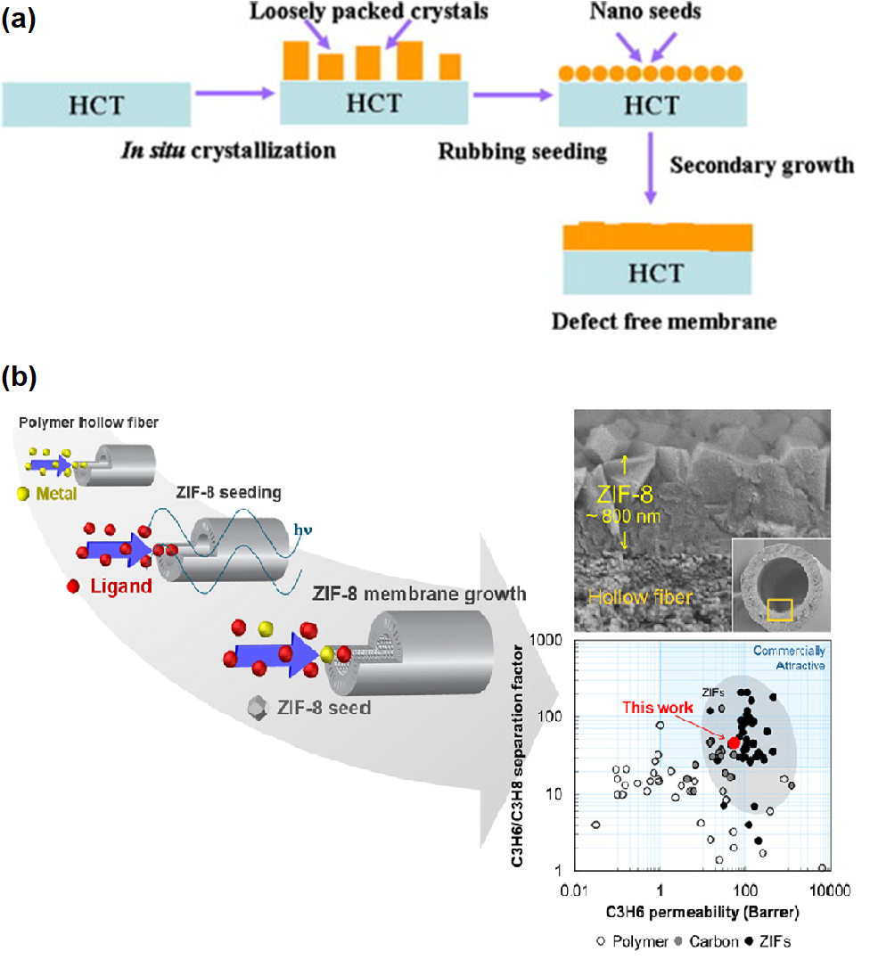

Figure 2. Schematic representations of the secondary growth of MOF membranes: (a) physical seeding and (b) chemical seeding. Reprinted with permissions from Refs. [58, 59].
Lee et al. used a combination of microwave-assisted seeding and microfluidic secondary growth to fabricate well-intergrown ultrathin ZIF-8 membranes with a thickness of ~ 800 nm deposited on porous Matrimid® polymer hollow fibres, which was the first time that the ZIF-8 membranes via secondary growth were grown on bore side of polymeric hollow fibres[59]. They tested binary gas separation performance of the membranes using propylene/propane, showing a separation factor of about 46 and propylene permeance of ~ 55 GPU (gas permeation unit, 1 GPU = 3.348 × 10⁻¹⁰ mol m⁻² s⁻¹ Pa⁻¹). Using a covalent-assisted seeding method, well-intergrown ZIF-8 membranes were prepared on polyimide substrate[60]. For the successful fabrication of a MOF layer on the polymeric substrate, the imidazole-2-carbaldehyde (ICA) molecules as the covalent agent were first grafted onto the polyimide substrate cross-linked with ethylenediamine (EDA), which offered the reaction sites for anchoring ZIF-8 seeds on polyimide substrate. By this method, a well-grown ZIF-8 layer was firmly coated on polyimide substrate. The prepared ZIF-8 membrane showed further elevated separation factor compared to polyimide membrane for the pervaporation dehydration of isopropanol at 40°C.

2.1.3. Interfacial synthesis
So far, various methods of interface synthesis have been developed and have been successfully used in the facile manufacture of MOF membranes. According to the fluid properties of the precursor solution, interface synthesis could be divided into static and dynamic interface synthesis methods (Fig. 3) [61].
2.1.3.1 Static interfacial synthesis
Static interfacial synthesis used for obtaining continuous MOF layers can be classified into the following two routes: 1) interfacial diffusion synthesis[62], 2) contra diffusion synthesis (counter-diffusion synthesis), as shown in Fig. 3a and 3b [63]. In the interfacial diffusion synthesis, two precursors (e.g., the metal ion and the organic ligand) are usually dissolved in two immiscible solvents separately. When two precursor molecules independently in two incompatible solvents meet at the interface, the crystallization that only occurs at the liquid/liquid or liquid/solid interface leads to the formation of the MOF membrane. Similarly, contra-diffusion synthesis has two precursor solutions as well. What is different from the former route is that two precursor solutions in contra-diffusion synthesis are separated by a porous substrate, two precursor molecules diffuse in opposite directions through the porous channels of the substrate.
Zhu et al. used interfacial diffusion method to synthesize free-standing pure MOF membranes[64]. To grow the MOF membrane, the reactant concentration region needed to be identified, since a MOF layer only was able to be prepared in the region of high molar ratio of Zn(NO₃)₂ to terephthalic acid (H₂BDC) and low triethylamine (TEA) concentrations, in which TEA was utilised as a catalyst to improve the coordination reaction between Zn(NO₃)₂ and H₂BDC. The resulting membranes were found to be asymmetric including 3 layers by SEM and XRD, the composition of the surface layer is 3D Zn₄O(BDC)₃ (MOF-5) with a particulate morphology, the bottom layer had a sheet-like morphology, and its component is 2D ZnBDC·DMF (MOF‐2), and in between are transitional zinc-carboxylate structures, viz. Zn₃(OH)₂(BDC)₂ (MOF‐69c) and Zn₅(OH)4(BDC)₃. Due to the poor mechanical stability, free-standing pure MOF membranes have been not widely used in gas separation and pervaporation [6]. Chen et al. prepared ZIF-8 membrane on porous α-Al₂O₃ disks via interfacial synthesis[65]. In this report, the pre-treated α-Al₂O₃ disk was soaking into inorganic precursor solution in an Erlenmeyer flask. In order to fully fill the pores of the disk with zinc nitrate, the flask was connected with a vacuum. After 30 minutes, the disk was taken out, and then the excess solution on the disk surface was wiped out using a rubber wiper. Subsequently, the disk was gently soaked into the pre-heated organic precursor solution for the desired time to prepare ZIF-8 membrane. The obtained ZIF-8 membrane exhibited a CO₂/N₂ separation factor of 5.49 and CO₂ permeance of 0.47 × 10⁻⁷ mol·m⁻²·s⁻¹·Pa⁻¹ in single-gas permeation experiments of CO₂ and N₂.
Similar to interfacial diffusion synthesis, contra-diffusion method has been developed to construct ultrathin MOF membranes. Wang and co-workers successfully prepared ZIF-8 films on flat nylon substrates with the contra-diffusion synthesis method in 2011[63]. In their research, the zinc nitrate methanol solution and 2-methylimidazole (Hmim) methanol solution were separated by the porous nylon membrane with a pore size of 0.1 μm. After a certain period of crystallization, the ZIF-8 films were prepared with under ambient temperature and deployed to separate the H₂/N₂ gas mixture. The gas permeation results of a H₂/N₂ ideal selectivity of 4.3 with H₂ permeance of 1.97 × 10⁻⁶ mol m⁻² s⁻¹ Pa⁻¹ and N₂ permeance of 0.46 × 10⁻⁶ mol m⁻² s⁻¹ Pa⁻¹ confirmed that the ZIF-8 layers were continuous and compact. In 2013, the same group extended the contra-diffusion synthesis method to synthesize continuous and compact ZIF-8 layers on nylon membranes by using an aqueous solution with a Zn²⁺:Hmim stoichiometric ratio of 1:2 [66]. A 2.5 μm thick ZIF-8 layer was formed on hmim side, exhibiting H₂/N₂ ideal selectivity of 4.6 in the gas permeation tests.
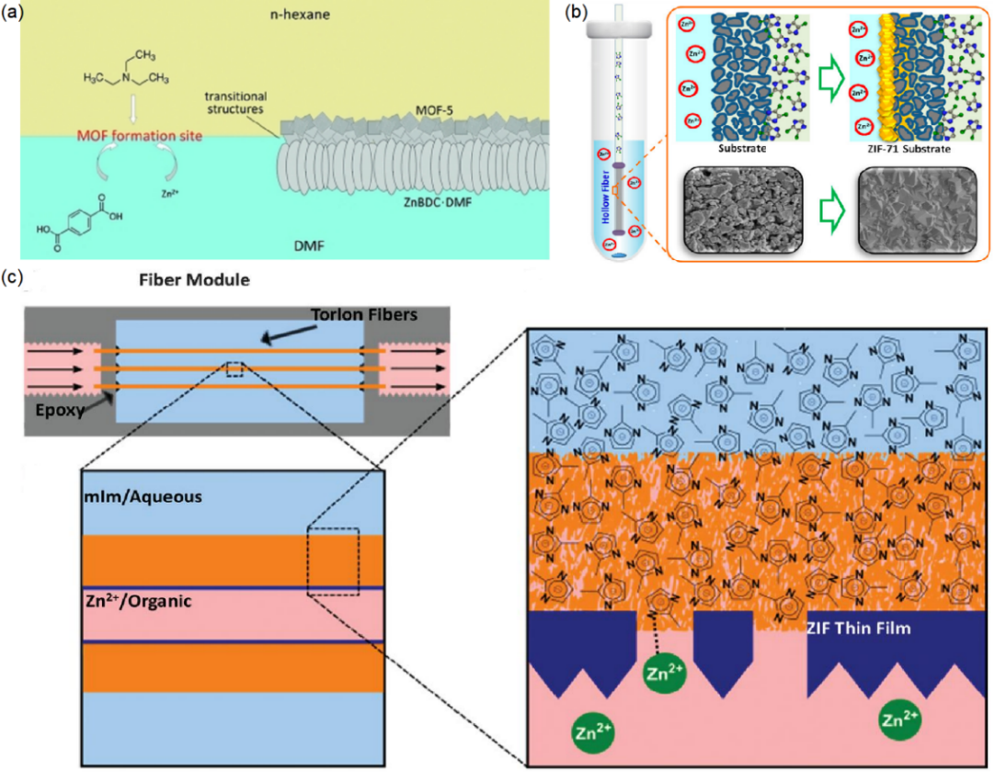

Figure 3. Schematic representations of the interfacial synthesis of MOF membranes (a) interfacial diffusion synthesis,[64] (b) contra-diffusion and (c) dynamic interfacial synthesis. Reprinted with permissions with Ref. [64, 67, 68].
In contra diffusion reaction, the substrates used as porous supports were usually commercial microfiltration membranes with large pores (pore diameter > 100 nm) and long channels (over tens of microns). In these cases, the diffusions of metal ions and organic ligands inside these membranes were quite fast and difficult to control, which resulted in the formation of MOFs films with defects and/or relatively thick layers[51, 69-71]. Considering such problems, a method of fabricating ultra-thin and continuous MOF membranes, a spatially confined contra-diffusion synthesis process, has been reported by Zhang and co-workers[71]. In this process, the difference from the previously reported contra-diffusion processes was that an ultra-thin nano-porous membrane made of polydopamine-coated single-wall carbon nanotube (PD/SWCNT) network with small pores or channels of 5-10 nm was deployed as the porous substrate at the liquid-liquid interface instead of commercial microfiltration membranes. By a spatially confined contra diffusion process, an ultra-thin continuous ZIF-8 film with a thickness of about 550 nm was formed. When applied to hydrogen separation, the membrane showed a high H₂ permeability of up to 6.31×10⁻⁷ mol·m⁻²·s ⁻¹∙pa⁻¹, while maintaining a high ideal selectivity of 43 for H₂/CO₂. Contra-diffusion method was also utilized to fabricate ZIF-71 membrane for the pervaporation recovery of ethanol from H₂O[67]. At 25 ℃, the synthesized ZIF-71 hollow fibre membrane displayed a comparable performance with a flux of 2.601 g/m² h and a separation factor of 6.88.
2.1.3.2 Dynamic interfacial synthesis
Dynamic interfacial synthesis mainly refers to interfacial microfluidic membrane processing (IMMP). Prior to IMMP, microfluidic processing has been deployed to grow continuous MOF membranes on the substrates by flowing mixed precursors in the hollow fibre. Huang and co-workers successfully deposited the ZIF-8 film with a thickness of 2.0 μm on the inner surface of a ceramic hollow fibre by microfluidic processing[72]. The as-synthesized ZIF-8 film on the inner-side of the ceramic hollow fibre was used to recover H₂, displaying good performance with H₂ permeance of 4.324 × 10⁻⁷ mol⁻²s⁻¹Pa⁻¹ and H₂/CH₄ ideal selectivity of 12.13. Using a similar method, the ZIF-93 membrane[73] and the defect-free ZIF-8 membrane[59] were fabricated on the inner surface of the co-polyimide P84 hollow fibre and the Matrimid hollow fibre, respectively. To avoid the occurrence of bulk MOF crystallization during microfluidic processing, Nair and Jones et al., combining microfluidic processing and interface synthesis, proposed interfacial microfluidic membrane processing (IMMP) for the production of ZIF-8 membranes on torlon hollow fibres[68]. Distinguished from the microfluidic synthesis with mixed precursor solution, a Zn²⁺/1-octanol solution was passed through the bore of the hollow fibre, while a 2-methylimidazole (2-mIm)/H₂O solution maintained stationary on the shell side. A continuous and thin ZIF-8 membrane was synthesized on the inner surface of the hollow fibre, due to the relatively fast diffusion of reactants to the water-oil interface under continuous flow. By contrast, under static growth conditions, dense and noncontinuous layers of ZIF-8 particles were produced owing to the insufficient supply of Zn²⁺ ions to maintain the growth of the film after the initial nucleation and growth of ZIF-8 crystals on the inner surface of the fibre. The prepared ZIF-8 membranes with a thickness of 9 μm were used to distinguish H₂ from C₃H₈ and C₃H₆, exhibiting moderate and efficient selectivity. From the above example we can conclude that the so-called IMMP involves the combination of membrane module construction and the crystallization mechanism of interface diffusion synthesis or contra diffusion synthesis. The two non-mixed precursors flow on the tube and shell sides of the hollow fibre respectively. The MOF film is deposited on the surface of the hollow fibre by the flowing precursors. Employing the same concept, Marti et al. synthesized continuous defect-free ZIF-8 thin films on the outer surface of the polymeric hollow fibre using continuous precursor flow, in which Zn²⁺/H₂O solution was flowed on the shell side of hollow fibre, and at the same time 2-methylimidazole (MeIm)/H₂O was passed through the bore of the hollow fibre [74]. The prepared ZIF-8 membrane was applied to capture CO₂, demonstrating a CO₂ permeability of 22 GPUs and a highest reported CO₂ / N₂ selectivity of 52.

2.1.4. Liquid phase epitaxy (LPE)
For liquid-phase epitaxy (LPE, also known as layer-by-layer) growth, also referred to stepwise layer-by-layer (LBL) assembly, a substrate is exposed to one type of MOF precursor component (typically two types) at a time and repeatedly cycled between organic secondary building units (SBUs) and inorganic SBUs by manual immersion[75], dipping[76], spraying[77], or spin coating[78]. In which unreacted components are usually removed by rinsing a solvent between successive deposition steps, as illustrated in Fig. 4. The orientation and the thickness of MOF membrane in the vertical direction to the substrate (out-of-plane) can be precisely controlled by LPE. Moreover, the sequential and stepwise method gives each kind of precursor component the opportunity to saturate all the possible deposition sites without forming new nucleus on the surface or in the solution, thereby forming the low-defect membrane. The layer-by-layer growth mode for the fabrication of MOF membranes can be traced to the pioneering work of Wöll and co-workers[79]. They grew MOF layer on a COOH-terminated self-assembly monolayers (SAM) using layer-by-layer approach in which SAM was repeatedly manually immersed in a solution of metal precursor and in the organic precursor solution. While there is no doubt that the manual immersion technique used in LPE applications can result in smoother MOF membranes, called surfaced-attached MOFs (SURMOFs), there is one major drawback: it is not efficient to prepare SURMOF membranes. Some improved strategies, based on the manual liquid-phase epitaxy synthesis route, are emerging to design SURMOF membranes on the substrate. For example, an automated, computer-controlled dipping robot has been deployed for the preparation of SURMOF membranes of ZIF-8 on Au-coated α-Al₂O₃ supports by Valadez Sánchez and co-workers[80]. The obtained ZIF-8 SURMOF membranes exhibited higher hydrogen and ethene permeances due to their smaller molecular sizes.
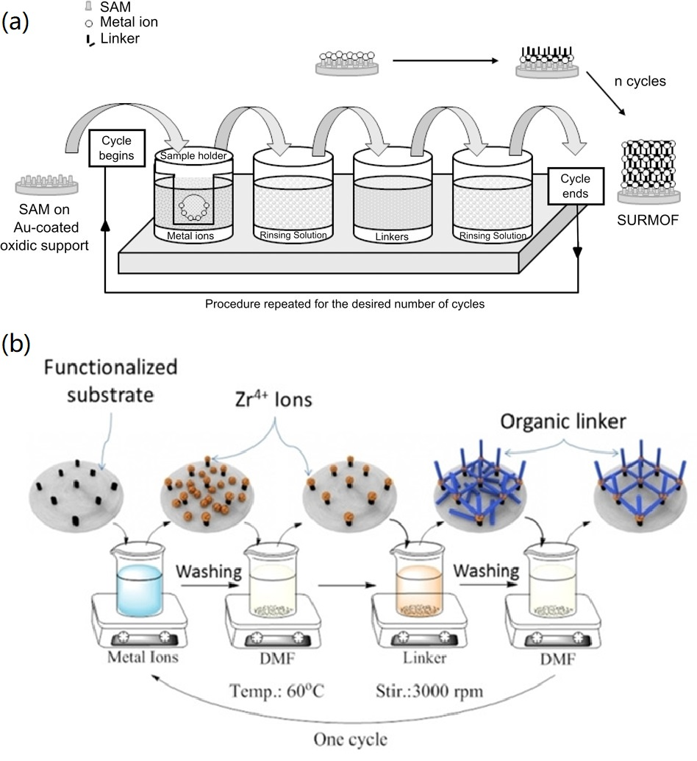

Figure 4. Schematic diagrams for the LPE growth of MOF membranes: (a) ZIF-8 SURMOF membrane deposited on an Au coated alumina support and (b) UiO-66-NH₂ SURMOF membrane deposited on a flat gold-coated substrate. Reprinted with permissions from Refs. [80, 81].
ln 2014, Eddaoudi and co-workers reported the assembly of ultra-thin and defect-free ZIF-8 selective layers on porous aluminate supports by precisely controlling the epitaxial growth[76]. In the single-gas permeation tests of He, H₂, CO₂, O₂, N₂, CH₄, C₂H₄, C₂H₆, C₃H₆, C₃H₈ and n-C₄H₁₀, the resultant ZIF-8 membranes were observed to have a cut-off of diffusion coefficient between C₂ and C₃ because of the relatively small window size of ZIF-8. Although the ZIF-8 membranes fabricated by LPE exhibited ca.100 times lower permeance but with good ideal selectivites of 5, 11, 12, and 60 for H₂-CO₂, H₂-N₂, H₂-CH₄ and H₂-C₃H₈, respectively at 308 K, suggesting the synthesized ZIF-8 membranes with minimal grain boundary micro-defects.
Recently, Léon group used LPE method and in-situ growth method to prepare UiO-66-NH₂ SURMOF membrane and UiO-66-NH₂ membrane, respectively[82]. In the equimolar case, the UiO-66-NH₂ SURMOF membrane exhibited a higher H₂/N₂ separation factor of 3.02 because of LPE method generating continuously and highly oriented MOF membrane.

2.1.5. Vapor deposition
For the MOF membranes by chemical solution deposition (CSD) typically involving reacting metal salts and organic ligands in solutions, the advantages provided are generally simplicity and effectiveness, low capital cost of laboratory implementation, compatibility with conventional wet chemical operations, and high chemical flexibility. However, the reactant transport and fluid dynamic processes of CSD are usually complex and of great difficulty to be controlled carefully, especially on an industrial scale. In contrast to CSD, vapor deposition of MOF films can facilitate their implementation in lab-scale research and industries. Generally speaking, each vapor deposition process includes three steps: 1) evaporation, 2) the transportation of the vaporized material, 3) deposition of the film on the substrate. As of now, while there are many variations of vapor deposition, the processes can typically be divided into two categories: physical vapor deposition (PVD) and chemical vapor deposition (CVD), as shown in Fig. 5a and 5b [83].
PVD is a purely physical process in which the target material is evaporated into the gas phase and deposited onto the substrate for the preparation of the thin films without any chemical reaction taking place. The most critical step in the entire process is the initial evaporation of the target material, which can be achieved by various methods, such as conventional thermal evaporation, ion plating, sputtering, or pulsed-laser deposition (PLD). However, it is quite difficult to apply PVD to the fabrication of the MOF due to low vapor pressure and thermal decomposition or amorphization of MOFs from thermal stress, ion bombardment, or laser irradiation[84, 85]. To remedy those limitations, femto-PLD technique was utilized to fabricate porous ZIF-8 membranes for the first time[85]. To prevent its structural degradation and decomposition, polyethylene glycol 400 (PEG-400) was deployed as a ‘’vehicle’’ to impregnate with ZIF-8, and then hybrid ZIF-8 soaked with PEG-400 was ablated in the ultrahigh vacuum chamber, finally forming membranes with approximate composition Zn(C₃N₂H₂−CH₃)2·¹/₆PEG-400 through femto-laser technique. The PEG additive in the membranes could be removed by washing with ethanol. However, MOF membranes prepared by PVD for gas separation and pervaporation have not reported so far.
In contrast to PVD, CVD typically involves the chemical reaction between solid and gas phases. In other words, this deposition method is based on the reaction of vaporized substances with the substrate, with the growing layer and/or with each other to form a uniform layer. Up to now, several different routes have been explored to CVD of the preparation of the MOF films, mainly including atomic layer deposition (ALD) and molecular layer deposition (MLD). ALD is a vapor-phase thin layer deposition method based on alternating surface reactions between two precursor gas pulses. This self-limiting growth mechanism well controls the conformal deposition of the layers with nanometre precision thickness [86]. MLD is a method similar to ALD. In MLD, a layer of molecules is deposited during one self-limiting surface reaction step instead of the deposition of monolayer of atoms. In 2013, Salmi and co-workers deposited MOF-5 films from vapor phase by ALD[87]. In their study, it was found that the as-deposited layers were amorphous and nonporous. For forming porous MOF-5 thin membranes, the as-deposited membranes also required a two-step post-deposition crystallization treatment. In 2018, the smooth, pinhole-free ZIF-8 thin layers were deposited uniformly on porous substrates using ALD[88]. In one ALD cycle, a ~5-μm γ-alumina mesoporous layer with pores in the 2 to 5 nm range was first coated on α-Alumina macroporous substrate, and then diethylzinc was deposited on the γ-alumina mesoporous layer using ALD, diethylzinc layer was finally exposed to water vapor to yield hydroxylated zinc oxide. This ALD cycle was repeated for up to 50 times for the preparation of an impermeable zinc oxide layer coated on γ-alumina layer. This impermeable material can be transformed into a porous ZIF-8 membrane by exposure to vapours of 2-methylimidazole. For the separation of propylene/propane, the resultant porous ZIF-8 membrane enabled a propylene/propane selectivity over 100 with a propylene permeance as high as 114 GPU.
Nilsen and co-workers reported that the film of amino-functionalised UIO-66 was deposited through an all-gas-phase ALD/MLD[89]. ZrCl₄ and 2-amino-1,4-benzene dicarboxylic acid (2-amino-1,4-BDC) were utilized as precursors to perform the ALD/MLD depositions in an F-120 Sat-type ALD reactor. The as-formed films could be crystallized by post-deposition treatment. In 2020, Lausund et al. reported on MOF thin films with bi-aromatic linkers deposition by MLD[90]. Although some progress for the fabrication of MOF membranes using MLD has been made, there are no reports on the application of MOF membranes prepared via MLD for gas separation and pervaporation because MOF membranes fabricated using this method generally require a postdeposition treatment to convert amorphous MOF layers into crystalline MOF layers[91].
To produce easily the MOF membrane with large effective membrane areas, Li and co-workers developed a gel-vapour deposition (GVD) method for preparing ultrathin ZIF-8 membranes by combination of modification-free sol-gel coating and solvent-free vapour deposition (Fig. 5c)[92]. In this method, the Zn-based gel, composed of zinc acetate dihydrate and ethanolamine, was firstly coated on ammoniated polyvinylidene fluoride (PVDF) hollow fibres by heat treatment. Then, the organic groups of the gel were substituted through ligand vapour deposition by heat treatment, forming the ZIF-8 membrane. Due to the smaller kinetic diameter of H₂, H₂ permeance through the resultant ZIF-8 membrane was up to 215.4 × 10⁻⁷ mol m⁻² s⁻¹ Pa⁻¹ with a H₂/C₃H₈ selectivity of as high as 3400.
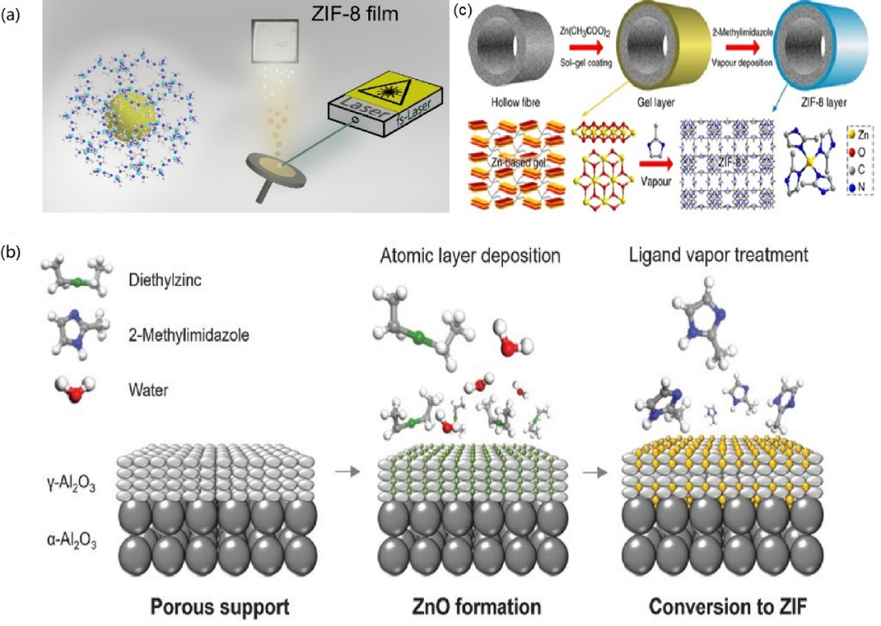

Figure 5. Schematic of MOF membrane formation processes using vapor: (a) ZIF-8 membrane deposition via PVD, (b) ZIF-8 membrane deposition via CVD and (c) ZIF-8 membrane deposition via GVD. Reprinted with permissions from Refs. [85, 88, 92].

2.1.6. Electrodeposition
A major disadvantage of many of these methods described above is that defects are randomly generated during the MOF membrane processing. Although a relatively thick membrane can minimize defects, it inevitably reduces the permeability of the membrane[93]. Moreover, a large amount of waste is produced during the fabrication process, especially given the inorganic salts used and the risks and costs related to anions such as nitrate and chloride ions[94]. The electrochemical deposition stands out among the methods of preparing MOF membranes.
The electrochemical method is advantageous because it requires a relatively minor or non‐pre -treated substrate, shorter growth time, and milder preparation, and is easier to scale up. More importantly, this method allows for controlling the morphology and thickness by altering current. In principle, there are three routes for making MOF thin membranes by the electrochemical method, namely anodic dissolution, cathodic deposition and electrophoretic deposition (Fig. 6)[93, 95]. For anodic dissolution, this route is based on the dissolution of a metal plate used as anode and the inorganic source for the formation of MOF membranes, and subsequently the released metal ions react with the organic ligands in the electrolyte[94]. During the cathodic deposition process of MOF membranes, electrodes is utilized as a chemically inactive spectators and only serve as a source of electrons. Hydroxide formed from the reduction reaction raises the pH of the electrolyte near the cathode and promotes the nucleation and crystal growth of MOFs on the substrate containing the respective organic and inorganic precursor by deprotonating organic ligands[34]. As for electrophoretic deposition, the charged MOF particles (possibly due to missing linkers or missing metal nodes) result in electric field formation in the electrolyte, in practice, which drive the charged particles toward the oppositely charged electrode to form a MOF layer [96].
The HKUST-1 membrane was among the first MOF membranes to be electrochemically fabricated by researchers at BASF, and is also the first MOF membrane reported that has been deposited on the substrate by anodic dissolution[97, 98]. During the process, the solvent was continuously stirred, resulting in the removal of crystals formed from the anode surface, resulting in the continuous production of MOF particles. Since then, MOF layers synthesized on the anode have been used to detect nitro compound explosives[99], glucose[100] and to store charge in the electrical double layer[101], as well as in separation[102, 103]. So far, the development of electrochemical MOF deposition on other conductive substrates (including indium tin oxide (ITO), fluorine tin oxide (FTO), and glassy carbon) by anodic dissolution has been far behind that achieved by cathodic deposition[104]. To open up new possibilities for producing MOF layers on transparent conductive substrates, Oliver group confirmed by a modified scheme that a series of MOF thin layers were deposited on indium tin oxide (ITO) glass by anodic dissolution[105]. Before partial dissolution of the anode and initial nucleation of the MOF crystals, ITO support needed to be electrocoated with either copper or zinc microcrystalline films (Cu-ITO and Zn-ITO, respectively). These metallic coatings served as the metal cation source to grow HKUST-1 and the two-dimensional (2D) cationic framework [Cu(C₁₀H₈N₂)²⁺]Br₂ (CBBr) on Cu-ITO substrates, and Zn₆(OH)₃(BTC)₃(H₂O)₃·7H₂O (Zn-BTC, BTC = benzene tricarboxylate) and the 2D framework [Zn(BPDC)- (H₂O)]·H₂O (Zn-BPDC, BPDC = 2,2′-bipyridine-5,5′-dicarboxylate) on Zn-ITO substrates. In 2009, Ameloot et al. electrochemically deposited the MOF layer on the anodic surface by carefully modification of the conditions used to synthesize bulk MOF material[106]. In their report, by applying an appropriate electrical voltage to the anodic electrode, the electrochemical oxidation of Cu-atoms on the anode led to the dissolution of Cu (II) ions, which were subsequently introduced into the electrolyte containing 1,3,5-benzenetricarboxylic acid (BTC) and methyltributylammonium methyl sulfate (MTBS) as a conduction salt. It was found that densely packed films of [Cu₃(BTC)₂] crystallites with sizes of 2-50 μm could be easily grown by simple alterations of voltage and the composition of the electrolyte. Up to now, there is not practical applications of MOF membranes prepared by anodic deposition for gas separation and pervaporation.
A disadvantage of anodic dissolution is that anode is necessarily corroded during the fabricating process of the MOF membrane which can only apply to a few MOF membranes. To avoid the disadvantage, Dincă et al. illustrated that Zn₄O(BDC)₃ (MOF-5; BDC = 1,4-benzenedicarboxylate) was deposited at ambient temperature by cathodic electrodeposition[107]. Electrodes were used as chemically inert spectators which did not provide metal ions but provided electrons for the MOF membranes in the cathodic deposition process. To eliminate the potential negative effects on the environment caused by organic solvents, Wei and co-workers developed an aqueously cathodic deposition (ACD) approach to prepare the ZIF-8 membranes adopting 100% water as the sole solvent instead of supporting electrolyte or modulator [93]. In the electrolyte cell, anodic aluminium oxide (AAO) with the coating of a conductive layer was deployed as the working electrode, while the counter electrode was graphite paper without any pre-treatment. The two electrodes were parallelly separated by 1.5 cm and soaked in the ZIF-8 precursor solution and zinc cations were driven by electrical field towards the substrate to form the ZIF-8 membrane in only 60 min. The as-formed membrane demonstrated the best combination of 182 GPU permeance and 142 selectivity for the separation of C₃H₆ / C₃H₈ mixtures.
Besides anodic dissolution and cathodic deposition methods, electrophoretic deposition (EPD) method was also used to deposit the MOF membranes[96]. The as-synthesized MOFs displaying net negative charges were first suspended in the toluene solution by sonication, and subsequently two identical fluorine‐doped tin oxide (FTO) glass substrates as transparent conductive electrodes were placed in the MOF deposition solution. Partially charged MOF particles were finally driven towards the oppositely charged electrode to form MOF membranes under 90 V. In 2015, Zhu et al. deposited HKUST-1 membranes on porous stainless steel by EPD method under 100 V for 120 s. In the single gas permeation experiments, the resultant HKUST-1 membrane exhibited the Knudsen separation factors (4.6 for H₂/CO₂, and 3.9 for H₂/N₂)[108].
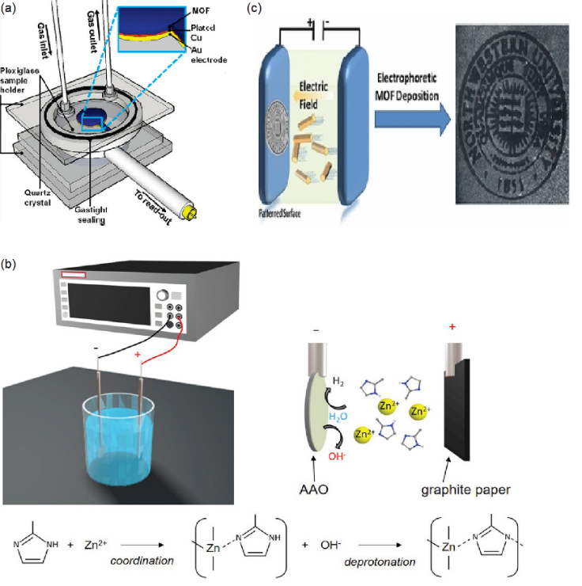

Figure 6. Illustration of electrodeposition of MOF membranes: (a) anodic deposition of [Cu₃(BTC)₂] membrane, (b) cathodic deposition of ZIF-8 membrane and (c) electrophoretic deposition of MOF membranes. Reprinted with permissions from Refs. [93, 96, 106].

2.1.7. Other methods
Recently, some other methods have been developed to fabricate pure MOF membranes for the gas separation and pervaporation. For example, Wang et al. utilized the melting properties of some MOFs including ZIF-62, ZIF-76, and TIF-4, to deposit the molten ZIF-62 phase on porous ceramic aluminate supports[109]. The molecular sieving ability of the as-synthesized ZIF-62 membrane was remarkably enhanced, giving a high separation factor up to 50.7 for H₂/CH₄, 34.5 for CO₂/N₂ and 36.6 for CO₂/CH₄. A new non-conventional approach for the fabrication of a pure MOF membrane was reported[109]. In this report, a high pressure of 10000 psi was utilized to press SIM-1 crystals into a water, and then the pressed wafer was treated with ethylenediamine to generate a free-standing SIM-1 membrane. The resulting SIM was used to separate water form water/ethanol mixtures at room temperature in pervaporation, exhibiting a flux of 460 g/m²·h with no ethanol detected in the permeate.

3. Application of pure MOF membranes
In gas separation and pervaporation, the solution-diffusion mechanism governs transportation permeance and selectivity of molecules across the membrane. However, the membrane is subject to the permeance-selectivity trade-off. The unique pore structures of MOFs (Table 1) offer the possibility to overcome the trade-off effect between permeance and selectivity in gas separation and pervaporation. Among these features, shape-selective window sizes of MOFs determine the diffusion of molecules. Based on it, MOFs are widely used to prepare molecular sieve membranes through different methods.

3.1. Pure MOF membranes in gas separation
MOF name | Metal | Ligand | Formula Composition | Pore volume (cm³/g) | BET surface area (N₂) (m²/g) | Window size (Å) | Ref.
UiO-66 | Zr | 1,4-benzenedicarboxylate (BDC) | Zr₆O₄(OH)₄(BDC)₆ | 0.36 | 970 | 6 | [110]
MOF-5 (Zn) | Zn | BDC | Zn₄O(BDC)₃ | 1.4 | 3800 | 12 | [111]
ZIF-71 | Zn | 4,5-dichloroimidazole (dcIm) | Zn(dcIm)₂ | 0.452 | 1007 | 4.8 | [112]
CAU-10-H | Al | benzene-1,3-dicarboxylate (1,3-H₂BDC) | [Al(OH)(benzene-1,3-dicarboxylate)]·nH₂O | 0.43 | 635 | 7 | [113]
ZIF-7 | Zn | Benzimidazole (H-bIM) | Zn(bIM)₂ | 0.207 | 380 | 3 | [114]
ZIF-8 | Zn | 2-Methylimidazole (Hmim) | Zn(mim)₂ | 0.554 | 1344 | 3.4 | [112]
Sm-DOBDC | Sm | 2,5-dihydroxy-1,4-benzenedicarboxylate (DOBDC) | Sm₆(OH)₈(DOBDC)₆ | 0.263 | 520 | N/A | [115]
SIM-1(ZIF-94) | Zn | 4,5-imidazolecarboxaldehyde | Zn(4-methyl-5-  imidazolcarboxaldehyde)₂ | 0.19 | 471 | 2.6 | [116, 117]
CAU-1 | Al | 2-amino-1,4-benzene dicarboxylic acid (H₂BDC-NH₂) | Al₈(OH)₄(OCH₃)₈ | 0.59 | 1021.7 | 4 | [118]
MIL-100 | In | 1,3,5-benzenetricarboxylic acid (H₃BTC) | In₃O(H₂O)₂OH(BTC)₂ | 0.636 | 1456 | 4.6 and 8.2 | [119]
ZIF-62 | Zn | Imidazole (Im) and benzimidazole (Bim) | Zn(Im)_{1.75}(Bim)_{0.25} | 0.20 | 257 | 1.4 | [120, 121]
Ni₂(L-asp)₂(bipy) | Ni | L-aspartic acid and 4,4′-bipyridine (L-asp and bipy) | Ni₂(L-asp)₂(bipy) | N/A | 247 (CO₂) | 3.8 Å × 4.7 Å | [122]
ZIF-90 | Zn | imidazolate-2-carboxyaldehyde (ICA) | Zn(ICA)₂ | 0.561 | 1360 | 2.86 | [112]
UiO-66-NH₂ | Zr | 2-amino-1,4-benzenedicarboxylic acid (H₂BDC-NH₂) | Zr₆O₄(OH)₄(BDC-NH₂)₆ | 0.48 | 1073 | 7.5 | [123, 124]
MIL-96 | Al | H₃BTC | Al₁₂O(OH)₁₈(H₂O)₃(Al₂(OH)₄) [BTC]₆·24H2O | 0.24 | 629.98 | 3.6 Å × 4.5 Å | [125, 126]
HKUST-1 | Cu | benzene 1,3,5-tricarboxylate (BTC) | Cu₃(BTC)₂(H₂O)₃ | 0.75 | 1663 | 9 | [127]
MOF | Support | Method | Permeance (GPU) |  |  |  |  |  | Selectivity |  |  |  | Ref.
MOF | Support | Method | H₂ | CO₂ | CH₄ | N₂ | C₃H₆ | C₃H₈ | H₂/CO₂ | CO₂/N₂ | CO₂/CH₄ | C₃H₆/C₃H₈
HKUST-1 | N/A | in-situ | 4716.42 | 1149.25 | 1901.49 | 1402.99 | N/A | N/A | 4.10 | 0.82 | 0.60 | N/A | [128]
HKUST-1 | PVDF | in-situ | 6000 | 1044.78 | 1761.19 | 1313.43 | N/A | N/A | 5.74 | 0.80 | 0.59 | N/A | [129]
MOF-5 | alumina | secondary growth | 2388.06 | 746.27 | 1164.18 | 895.52 | N/A | N/A | 3.20 | 0.83 | 0.64 | N/A | [50]
ZIF-8 | TiO₂ | in-situ | 179.1 | 38.81 | 14.93 | 14.93 | N/A | N/A | 4.61 | 2.60 | 2.60 | N/A | [38]
ZIF-7 | alumina | secondary growth | 220.9 | 32.84 | 35.22 | 32.84 | N/A | N/A | 6.73 | 1.00 | 0.93 | N/A | [130]
ZIF-90 | Torlon® fiber | secondary growth | 567.16 | 310.45 | 208.96 | 89.55 | N/A | N/A | 1.83 | 3.47 | 1.49 | N/A | [131]
ZIF-90 | alumina | in-situ | 626.87 | 38.81 | 32.84 | 35.82 | N/A | N/A | 16.15 | 1.08 | 1.18 | N/A | [132]
HKUST-1 | Cu net | in-situ | 379.1 | 83.58 | 47.76 | 83.58 | N/A | N/A | 4.54 | 1.00 | 1.75 | N/A | [44]
ZIF-8 | alumina | in-situ | N/A | N/A | N/A | N/A | 24.15 | 0.59 | N/A | N/A | N/A | 41.00 | [133]
[Ni₂(L-asp)₂(bipy)] | nickel mesh | secondary growth | 3044.78 | 134.93 | 385.07 | 249.85 | N/A | N/A | 22.57 | 0.54 | 0.35 | N/A | [134]
ZIF-8 | Torlon | interfacial synthesis | 1710.8 | N/A | N/A | N/A | 22.9 | 2.5 | N/A | N/A | N/A | 12.00 | [68]
ZIF-8 | alumina | Electrodeposition | 5133 | N/A | N/A | N/A | 386 | 3.22 | N/A | N/A | N/A | 120.00 | [135]
ZIF-90 | alumina | in-situ | 850.75 | 37.61 | 8 | N/A | N/A | N/A | 22.62 | N/A | 4.70 | N/A | [136]
ZIF-94 | P84® | in-situ | 12.54 | 3.5 | 0.1 | N/A | N/A | N/A | 3.58 | N/A | 35.00 | N/A | [137]
CAU-1 | alumina | secondary growth | 1515.5 | 3940.3 | 266.24 | 150.39 | N/A | N/A | 0.38 | 26.20 | 14.80 | N/A | [138]
MIL-100 | alumina | in-situ | N/A | 5283.58 | 4477.61 | 1462.69 | N/A | N/A | N/A | 3.61 | 1.18 | N/A | [139]
UiO-66 | alumina | Liquid phase epitaxy | 313.43 | 1047.76 | 35.82 | 20.9 | N/A | N/A | 0.30 | 50.13 | 29.25 | N/A | [140]
ZIF-62 | alumina | melt-quenching | 56.72 | 35.82 | 1.14 | 1.05 | N/A | N/A | 1.58 | 34.11 | 31.42 | N/A | [109]
ZIF-8 | alumina | interfacial synthesis | N/A | 140.3 | N/A | 25.56 | N/A | N/A | N/A | 5.49 | N/A | N/A | [65]
ZIF-8 | nylon | interfacial synthesis | 3373.13 | N/A | N/A | 746.27 | N/A | N/A | N/A | N/A | N/A | N/A | [66]
ZIF-8 | torlon | interfacial synthesis | N/A | 22 | N/A | 0.42 | N/A | N/A | N/A | 52.38 | N/A | N/A | [74]
ZIF-8 | alumina | liquid-phase epitaxy | 56.72 | 5.97 | 12.24 | 5.67 | 1.79 | 0.51 | 9.50 | 1.05 | 0.49 | 3.51 | [76]
UiO-66-NH₂ | alumina | liquid-phase epitaxy | 35671.64 | N/A | N/A | 8268.66 | N/A | N/A | N/A | N/A | N/A | N/A | [82]
ZIF-8 | alumina | vapor deposition | N/A | N/A | N/A | N/A | 479.4 | 6.48 | N/A | N/A | N/A | 73.98 | [88]
ZIF-8 | PVDF | vapor deposition | 64298.51 | 22568.35 | 3592.1 | 4258.18 | 2498.94 | 56.16 | 2.85 | 5.30 | 6.28 | 44.50 | [141]
ZIF-8 | alumina | Electrodeposition | N/A | N/A | N/A | N/A | 182 | 1.28 | N/A | N/A | N/A | 142.19 | [93]
The intrinsic pore structures of MOFs result in the surge of interest in developing pure MOF membranes for hydrogen purification, CO₂ removal and propylene-propane separation. Table 3 summarizes the gas permeation properties of pure MOF membranes fabricated by different methods. The H₂/CO₂, CO₂/N₂, CO₂/CH₄ and C₃H₆/C₃H₈ separation performance of pure MOF membranes are drawn against the upper bounds in Fig.7.
Table 1. Brief overview of structural parameters of MOFs utilized in gas separation and pervaporation

Table 2. Kinetic diameter for various molecules
Molecule | Kinetic diameter (Å)
H₂ | 2.89
CO₂ | 3.30
N₂ | 3.64
CH₄ | 3.80
C₃H₆ | 3.90
C₃H₈ | 4.30

Table 3. Pure MOF membranes for gas separation
Fig. 7. Selectivity-permeance comparisons against upper bounds [142, 143]: (a) H₂/CO₂ separation, (b) CO₂/N₂ separation, (c)CO₂/CH₄ separation and (d) C₃H₆/C₃H₈ separation.
Pure MOF membranes have mostly been used to act as molecular sieves to separate smaller molecules (H₂, CO₂, and C₃H₆) from larger molecules (CO₂, N₂, CH₄, and C₃H₆). Excellent hydrogen permeance and selectivity over the upper bound has been witnessed in Fig. 7a because the electron-poor H₂ is relatively smaller over CO₂ molecules. However, the performance for the CO₂ separation from N₂ and CH₄ using pure MOF membrane is below or close to the upper bound (Fig. 26b and c), though there is large difference between the kinetic diameters of CO₂ and N₂ or CH₄. Apart from the technical factors of membrane production, the window size of the MOF is another factor that might influence the separation performance of CO₂ from N₂ and CH₄. From Table 1 and Table 2, we can know the window sizes of ZIF-8 and MIL-96 exactly fall between the kinetic diameters of CO₂ and N₂ or CH₄. However, it should be noted that some MOFs have flexible nature and dynamic properties, like the effective aperture size of ZIF-8 between 4.0 to 4.2 Å [144]. That means, the effective aperture sizes of most MOFs in Table 1 are larger than the kinetic diameters of CO₂, N₂ and CH₄, resulting in that most pure MOF membranes cannot exhibit sharp molecular sieving. Furthermore, the interaction, including polarizability, magnetic susceptibility, permanent dipole moment, quadrupole moment, etc. between the gas molecule and the MOF membrane needs to be highly emphasized[145]. From membrane material points, the strong polarizing groups from the MOF ligands such as 1,4-benzenedicarboxylate and imidazolate-2-carboxyaldehyde, and high-valence metal precursors such as Zr⁴⁺, Cr³⁺, Al³⁺ and Fe³⁺ can make MOF membrane show high adsorption to the gas molecule with a great permanent quadrupole moment, like CO₂, but strong adsorption can also result in low diffusion coefficients according to recent researches [145-147]. Promising molecular sieve performances for the separation of C₃H₆ and C₃H₈ have been witnessed using pure MOF membranes (Fig. 7d). Although reports of C₃H₆/C₃H₈ separation have been only limited to ZIF-8, different fabrication methods can lead into different separation performance, such as ZIF-8 [63] and ZIF-8 [128], even different membrane supports using the same membrane fabrication method can have different separation performance, such as ZIF-8 [83] and ZIF-8 [136].

3.2. Pure MOF membranes in pervaporation
Table 4 Physical parameters of liquid solvents in pervaporation
Solvent | Kinetic diameter / Å
Water | 2.65
Methanol (MeOH) | 3.8
Ethanol (EtOH) | 4.3
Isopropanol | 4.6
Thiophene | 4.6
Methyl tert-butyl ether (MTBE) | 6.2
Ethyl acetate | 5.2
N-octane | 4.3

Table 5. Pure MOF membranes for pervaporation
MOF | Support | Method | Mixture (i/j) | Mass ratio (i/j) | T (℃) | Flux (g/m²·h) | i permeance (GPU) | j permeance (GPU) | Separation factor (β_{i/j}) | Selectivity (α_{i/j}) | Ref.
CAU-10-H | alumina | secondary growth | H₂O/EtOH | 10-90 | 40 | 397 | 5391.77 | 12.52 | 324 | 430.61 | [148]
CAU-10-H | alumina | secondary growth | H₂O/EtOH | 10-91 | 65 | 493 | 1914.48 | 10.63 | 148 | 180.09 | [148]
Ni₂(l-asp)₂bipy | SiO₂ | secondary growth | H₂O/EtOH | 50/50 | 30 | 28100 | 373279.57 | 1169.2 | 73.6 | 319.26 | [56]
Sm-DOBDC | alumina | secondary growth | H₂O/EtOH | 5/95 | 50 | 786.4 | N/A | N/A | > 9481 | N/A | [149]
SIM-1 | glass | mechanical press | H₂O/EtOH | 55.82/44.18 | 25 | 460 | 10493.15 | 0.1589 | >10000 | >66036.24 | [150]
UiO-66 | Yttria-Stabilized Zirconia | in-situ | H₂O/EtOH | 5/95 | 50 | 2550 | 8776.12 | 276.85 | 32.9 | 31.7 | [151]
MIL-96 | alumina | secondary growth | H₂O/Ethyl acetate | 4.4/95.6 | 60 | 70 | N/A | N/A | >1279 | N/A | [52]
UiO‐66 | alumina | liquid-phase epitaxy | EtOH/H₂O | 10/90 | 50 | 1490 | N/A | N/A | 4.9 | N/A | [152]
ZIF-71 | alumina | interfacial synthesis | EtOH/H₂O | 5-95 | 25 | 2601 | 17619.83 | 29951.78 | 6.88 | 0.59 | [67]
ZIF-71 | ZnO | secondary growth | EtOH/H₂O | 5-95 | 25 | 322.18 | 1980.52 | 3833.32 | 6.07 | 0.52 | [153]
UiO-66 | alumina | secondary growth | MeOH/MTBE | 5-95 | 40 | 1210 | 2733.36 | 6.92 | 597 | 395.06 | [154]
UiO-66 | alumina | secondary growth | MeOH/MTBE | 15/85 | 40 | 1920 | 2423.83 | 15.35 | 147 | 157.9 | [154]
UiO-66-NH₂ | alumina | in-situ | Thiophene/n-octane | 0.13/99.87 | 40 | 2160 | ∼21000 | ∼4000 | 17.96 (enrichment factor) | ∼5.8 | [155]

There are limited reports on pure MOF membrane applied in pervaporation, though many pure MOF membranes have been successfully used in gas separation. In addition to the high requirements for the integrity of the membrane, there are also higher chemical-stability requirements for the membrane, considering that pervaporation is a liquid-phase process. With continuous developments in the field of MOF-based membranes, more and more attention has been paid to the application of pure MOF membranes in pervaporation. In 2021, Luis et al. published a review on MOF-based membrane in pervaporation[6]. In this review, the design strategies, developments, and performance of pure MOF membranes were discussed in detail. Compared to other types of membranes, especially polymeric membranes, pure MOF membranes showed encouraging performance (Table 5 and Fig. 8). In the dehydration of organics, SIM membrane exhibited the highest selectivity for the dehydration of EtOH. It can be attributed to the small window of SIM. Ni₂(l-asp)₂bipy and UiO-66 had higher water permeances with moderate selectivities because of their larger window sizes. In addition, the hydrophilic surface of Ni₂(l-asp)₂bipy membrane also contributed to this remarkably high water permeance. In the recovery of organics, the hydrophobicity of ZIF-71 did not endow its corresponding membranes with EtOH selectivity because the small difference between the window size of ZIF-71 and the kinetic diameter of EtOH (Table 4). In the separation of organic-organic mixtures, the window size of UiO-66 (0.60 nm) is far larger than the kinetic diameter of MeOH (0.38 nm), close to that of MTBE (0.62 nm), thus UiO-66 membrane exhibited the largest MeOH permeance with a moderate selectivity in contrast with the other types of membranes. As the same series of the MOF as UiO-66, the polarity of UiO-66-NH₂ is switched from the hydrophobicity of UiO-66 to hydrophilicity by grafting amino groups on the organic ligand. The change in the polarity greatly facilitate the adsorption of strongly-polar thiophene[6]. In addition, the kinetic diameter of thiophene (0.46 nm) is much smaller than the window size of UiO-66-NH₂ (0.75 nm), thus it can spread across the membrane by molecular diffusion. That is the reasons why UiO-66-NH₂ membrane showed the highest thiophene permeance and selectivity.
Figure 8. Separation performance of pure MOF membranes in pervaporation: (a) H₂O/EtOH separation, (b) H₂O/Isopropanol, (c) EtOH/H₂O, (d) MeOH/MTBE and (e) Thiophene/n-octane or n-butane. Reprinted with permission from Ref. [6].

4. Conclusions and perspectives
In gas separation and pervaporation, pure MOF membranes have exhibited promising potentials in pushing the polymer upper bounds. The increasing progress in the pure MOF membrane is attracting more and more attention. The following issues are recommended to pay attention in the future research: (1) Exploring the membrane fabrication techniques to obtain defect-free pure MOF membranes; (2) optimizing membrane structures including fabrication parameters, support membrane, and crystal nucleation and growth; (3) selecting the suitable MOF for the target application by computational simulation and calculations, not limited to ZIFs; (4) paying more attention to the application of pure MOF membranes in pervaporation. Although the application of pure MOF membranes for gas separation and pervaporation is still in its infancy, we believe that exciting breakthroughs are on the horizon.

Acknowledgements
Xiao Xu acknowledges the funding from the China Scholarship Council (CSC), grant number: 201906050060.

References
1. Yong, W.F. and H. Zhang, Recent advances in polymer blend membranes for gas separation and pervaporation. Progress in Materials Science, 2021. 116: p. 100713.
2. Baker, R.W., Membrane technology and applications. 2012: John Wiley & Sons.
3. Luis, P., Fundamental Modeling of Membrane Systems: Membrane and Process Performance. 2018: Elsevier.
4. Zeng, H., et al., Emerging nanomaterial incorporated membranes for gas separation and pervaporation towards energetic-efficient applications. Advanced Membranes, 2022. 2: p. 100015.
5. Qian, Q., et al., MOF-based membranes for gas separations. Chemical reviews, 2020. 120(16): p. 8161-8266.
6. Xu, X., et al., MOF-based membranes for pervaporation. Separation and Purification Technology, 2021. 278: p. 119233.
7. Caro, J., Are MOF membranes better in gas separation than those made of zeolites? Current Opinion in Chemical Engineering, 2011. 1(1): p. 77-83.
8. Kang, Z., L. Fan, and D. Sun, Recent advances and challenges of metal–organic framework membranes for gas separation. Journal of Materials Chemistry A, 2017. 5(21): p. 10073-10091.
9. Yang, L., et al., Energy-efficient separation alternatives: metal–organic frameworks and membranes for hydrocarbon separation. Chemical Society Reviews, 2020. 49(15): p. 5359-5406.
10. Xue, D.-X., et al., Topology meets MOF chemistry for pore-aperture fine tuning: ftw-MOF platform for energy-efficient separations via adsorption kinetics or molecular sieving. Chemical Communications, 2018. 54(49): p. 6404-6407.
11. Hermes, S., et al., Selective nucleation and growth of metal− organic open framework thin films on patterned COOH/CF3-terminated self-assembled monolayers on Au (111). Journal of the American Chemical Society, 2005. 127(40): p. 13744-13745.
12. Wang, X.-p., et al., In-situ growth of metal-organic framework film on a polydopamine-modified flexible substrate for antibacterial and forward osmosis membranes. Separation and Purification Technology, 2020. 236: p. 116239.
13. Kwon, H.T. and H.-K. Jeong, In situ synthesis of thin zeolitic–imidazolate framework ZIF-8 membranes exhibiting exceptionally high propylene/propane separation. Journal of the American Chemical Society, 2013. 135(29): p. 10763-10768.
14. Tuergong, M., et al., In situ growth and optical gas adsorption performance of Zn (ii) metal–organic framework membranes at room temperature. Analyst, 2019. 144(16): p. 4887-4896.
15. Zhang, J., et al., In situ secondary growth of Eu (III)-organic framework film for fluorescence sensing of sulfur dioxide. Sensors and Actuators B: Chemical, 2018. 260: p. 63-69.
16. Wu, X., et al., Seeded growth of high-performance ZIF-8 membranes in thick wall autoclaves assisted by modulator. Journal of Membrane Science, 2020: p. 118518.
17. Ma, X., Y. Li, and A. Huang, Synthesis of nano-sheets seeds for secondary growth of highly hydrogen permselective ZIF-95 membranes. Journal of Membrane Science, 2020. 597: p. 117629.
18. Wu, W., et al., Air–water interfacial synthesis of metal–organic framework hollow fiber membranes for water purification. AIChE Journal, 2020. 66(7): p. e16238.
19. Vatanpour, V. and S. Khorshidi, Surface modification of polyvinylidene fluoride membranes with ZIF-8 nanoparticles layer using interfacial method for BSA separation and dye removal. Materials Chemistry and Physics, 2020. 241: p. 122400.
20. Yao, J. and H. Wang, Zeolitic imidazolate framework composite membranes and thin films: synthesis and applications. Chemical Society Reviews, 2014. 43(13): p. 4470-4493.
21. Yeo, Z.Y., et al., An overview: synthesis of thin films/membranes of metal organic frameworks and its gas separation performances. RSC Advances, 2014. 4(97): p. 54322-54334.
22. Zhang, C., et al., Ultrathin metal/covalent–organic framework membranes towards ultimate separation. Chemical Society Reviews, 2019. 48(14): p. 3811-3841.
23. Yu, X.-J., et al., Liquid-Phase Epitaxial Growth of Highly Oriented and Multivariate Surface-Attached Metal–Organic Frameworks. Journal of the American Chemical Society, 2019. 141(48): p. 18984-18993.
24. Liu, J. and C. Wöll, Surface-supported metal–organic framework thin films: fabrication methods, applications, and challenges. Chemical Society Reviews, 2017. 46(19): p. 5730-5770.
25. Eddaoudi, M., O. Shekhah, and Y. Belmabkhout, Fabrication of highly CO2 selective metal-organic framework membrane using liquid phase epitaxy approach. 2019, Google Patents.
26. Chernikova, V., et al., Nanoporous Fluorinated Metal-Organic Framework-Based Membranes for CO2 Capture. ACS Applied Nano Materials, 2020.
27. Boscher, N.D., et al., Metal–organic covalent network chemical vapor deposition for gas separation. Advanced Materials, 2016. 28(34): p. 7479-7485.
28. Li, W., Metal–organic framework membranes: Production, modification, and applications. Progress in Materials Science, 2019. 100: p. 21-63.
29. Betard, A. and R.A. Fischer, Metal–organic framework thin films: from fundamentals to applications. Chemical reviews, 2012. 112(2): p. 1055-1083.
30. Stassen, I., et al., Chemical vapour deposition of zeolitic imidazolate framework thin films. Nature materials, 2016. 15(3): p. 304-310.
31. Liu, X., Metal-organic framework UiO-66 membranes. Frontiers of Chemical Science and Engineering, 2020: p. 1-17.
32. Cruz, A.J., et al., Integrated cleanroom process for the vapor-phase deposition of large-area zeolitic imidazolate framework thin films. Chemistry of Materials, 2019. 31(22): p. 9462-9471.
33. Alizadeh, S. and D. Nematollahi, convergent and Divergent paired electrodeposition of Metal-organic framework thin films. Scientific reports, 2019. 9(1): p. 1-13.
34. Li, M. and M. Dincă, Selective formation of biphasic thin films of metal–organic frameworks by potential-controlled cathodic electrodeposition. Chemical Science, 2014. 5(1): p. 107-111.
35. Liu, H., et al., An electrodeposited lanthanide MOF thin film as a luminescent sensor for carbonate detection in aqueous solution. Journal of Materials Chemistry C, 2014. 2(41): p. 8683-8690.
36. Lin, Y.S., Metal organic framework membranes for separation applications. Current Opinion in Chemical Engineering, 2015. 8: p. 21-28.
37. Liu, Y., et al., Synthesis of continuous MOF-5 membranes on porous α-alumina substrates. Microporous and Mesoporous Materials, 2009. 118(1-3): p. 296-301.
38. Bux, H., et al., Zeolitic imidazolate framework membrane with molecular sieving properties by microwave-assisted solvothermal synthesis. Journal of the American Chemical Society, 2009. 131(44): p. 16000-16001.
39. Xu, G., et al., Preparation of ZIF-8 membranes supported on ceramic hollow fibers from a concentrated synthesis gel. Journal of membrane science, 2011. 385: p. 187-193.
40. Kang, Z., et al., “Single nickel source” in situ fabrication of a stable homochiral MOF membrane with chiral resolution properties. Chemical Communications, 2013. 49(90): p. 10569-10571.
41. Zhang, X., et al., A simple and scalable method for preparing low-defect ZIF-8 tubular membranes. Journal of Materials Chemistry A, 2013. 1(36): p. 10635-10638.
42. Ma, L., et al., In-situ growth of highly permeable zeolite imidazolate framework membranes on porous polymer substrate using metal chelated polyaniline as interface layer. Journal of Membrane Science, 2019. 576: p. 1-8.
43. Wu, X., et al., High‐Flux High‐Selectivity Metal–Organic Framework MIL‐160 Membrane for Xylene Isomer Separation by Pervaporation. Angewandte Chemie International Edition, 2018. 57(47): p. 15354-15358.
44. Guo, H., et al., “Twin copper source” growth of metal− organic framework membrane: Cu3 (BTC) 2 with high permeability and selectivity for recycling H2. Journal of the American Chemical Society, 2009. 131(5): p. 1646-1647.
45. Algieri, C., et al., Preparation of thin supported MFI membranes by in situ nucleation and secondary growth. Microporous and mesoporous materials, 2001. 47(2-3): p. 127-134.
46. Snyder, M.A. and M. Tsapatsis, Hierarchical nanomanufacturing: from shaped zeolite nanoparticles to high‐performance separation membranes. Angewandte Chemie International Edition, 2007. 46(40): p. 7560-7573.
47. Bohrman, J.A. and M.A. Carreon, Synthesis and CO 2/CH 4 separation performance of Bio-MOF-1 membranes. Chemical Communications, 2012. 48(42): p. 5130-5132.
48. Pan, Y., et al., Effective separation of propylene/propane binary mixtures by ZIF-8 membranes. Journal of Membrane Science, 2012. 390: p. 93-98.
49. Wu, Y.-n., et al., Electrospun fibrous mats as skeletons to produce free-standing MOF membranes. Journal of Materials Chemistry, 2012. 22(33): p. 16971-16978.
50. Yoo, Y., Z. Lai, and H.-K. Jeong, Fabrication of MOF-5 membranes using microwave-induced rapid seeding and solvothermal secondary growth. Microporous and mesoporous materials, 2009. 123(1-3): p. 100-106.
51. Hu, Y., et al., Zeolitic Imidazolate Framework/Graphene Oxide Hybrid Nanosheets as Seeds for the Growth of Ultrathin Molecular Sieving Membranes. Angewandte Chemie International Edition, 2016. 55(6): p. 2048-2052.
52. Hu, Y., et al., Metal–organic framework membranes fabricated via reactive seeding. Chemical communications, 2011. 47(2): p. 737-739.
53. Guerrero, V.V., et al., HKUST-1 membranes on porous supports using secondary growth. Journal of Materials Chemistry, 2010. 20(19): p. 3938-3943.
54. Ranjan, R. and M. Tsapatsis, Microporous metal organic framework membrane on porous support using the seeded growth method. Chemistry of Materials, 2009. 21(20): p. 4920-4924.
55. Pan, Y., B. Wang, and Z. Lai, Synthesis of ceramic hollow fiber supported zeolitic imidazolate framework-8 (ZIF-8) membranes with high hydrogen permeability. Journal of membrane science, 2012. 421: p. 292-298.
56. Wang, S., et al., Wettability switchable metal-organic framework membranes for pervaporation of water/ethanol mixtures. Inorganic Chemistry Communications, 2017. 82: p. 64-67.
57. Diestel, L., et al., Pervaporation studies of n-hexane, benzene, mesitylene and their mixtures on zeolitic imidazolate framework-8 membranes. Microporous and mesoporous materials, 2012. 164: p. 288-293.
58. Tao, K., C. Kong, and L. Chen, High performance ZIF-8 molecular sieve membrane on hollow ceramic fiber via crystallizing-rubbing seed deposition. Chemical engineering journal, 2013. 220: p. 1-5.
59. Lee, M.J., et al., Ultrathin zeolitic-imidazolate framework ZIF-8 membranes on polymeric hollow fibers for propylene/propane separation. Journal of Membrane Science, 2018. 559: p. 28-34.
60. Zhao, X., et al., ZIF‐8 membrane synthesized via covalent‐assisted seeding on polyimide substrate for pervaporation dehydration. AIChE Journal, 2019. 65(8): p. e16620.
61. Liu, Y., Y. Ban, and W. Yang, Microstructural engineering and architectural design of metal–organic framework membranes. Advanced Materials, 2017. 29(31): p. 1606949.
62. Ameloot, R., et al., Interfacial synthesis of hollow metal–organic framework capsules demonstrating selective permeability. Nature chemistry, 2011. 3(5): p. 382-387.
63. Yao, J., et al., Contra-diffusion synthesis of ZIF-8 films on a polymer substrate. Chemical Communications, 2011. 47(9): p. 2559-2561.
64. Lu, H. and S. Zhu, Interfacial Synthesis of Free‐Standing Metal–Organic Framework Membranes. European Journal of Inorganic Chemistry, 2013. 2013(8): p. 1294-1300.
65. Chen, S.S., et al., Interfacial nanoarchitectonics for ZIF-8 membranes with enhanced gas separation. Beilstein journal of nanotechnology, 2022. 13(1): p. 313-324.
66. He, M., et al., Aqueous solution synthesis of ZIF-8 films on a porous nylon substrate by contra-diffusion method. Microporous and mesoporous materials, 2013. 179: p. 10-16.
67. Huang, K., et al., A ZIF-71 hollow fiber membrane fabricated by contra-diffusion. ACS Applied Materials & Interfaces, 2015. 7(30): p. 16157-16160.
68. Brown, A.J., et al., Interfacial microfluidic processing of metal-organic framework hollow fiber membranes. Science, 2014. 345(6192): p. 72-75.
69. Peng, Y., et al., Metal-organic framework nanosheets as building blocks for molecular sieving membranes. Science, 2014. 346(6215): p. 1356-1359.
70. Shen, J., et al., Subnanometer two-dimensional graphene oxide channels for ultrafast gas sieving. ACS nano, 2016. 10(3): p. 3398-3409.
71. Zhang, S., et al., Nanoporous film-mediated growth of ultrathin and continuous metal–organic framework membranes for high-performance hydrogen separation. Journal of Materials Chemistry A, 2017. 5(5): p. 1962-1966.
72. Huang, K., et al., Growth of a ZIF-8 membrane on the inner-surface of a ceramic hollow fiber via cycling precursors. Chemical Communications, 2013. 49(87): p. 10326-10328.
73. Cacho-Bailo, F., et al., High selectivity ZIF-93 hollow fiber membranes for gas separation. Chemical Communications, 2015. 51(56): p. 11283-11285.
74. Marti, A.M., et al., Continuous flow processing of ZIF-8 membranes on polymeric porous hollow fiber supports for CO2 capture. ACS Applied Materials & Interfaces, 2017. 9(7): p. 5678-5682.
75. Shekhah, O., et al., Layer-by-layer growth of oriented metal organic polymers on a functionalized organic surface. Langmuir, 2007. 23(14): p. 7440-7442.
76. Shekhah, O., et al., The liquid phase epitaxy approach for the successful construction of ultra-thin and defect-free ZIF-8 membranes: pure and mixed gas transport study. Chemical Communications, 2014. 50(17): p. 2089-2092.
77. Arslan, H.K., et al., High‐Throughput Fabrication of Uniform and Homogenous MOF Coatings. Advanced functional materials, 2011. 21(22): p. 4228-4231.
78. Gu, Z.-G., et al., Transparent films of metal-organic frameworks for optical applications. Microporous and Mesoporous Materials, 2015. 211: p. 82-87.
79. Shekhah, O., et al., Step-by-step route for the synthesis of metal− organic frameworks. Journal of the American Chemical Society, 2007. 129(49): p. 15118-15119.
80. Valadez Sánchez, E.P., et al., ZIF‐8 SURMOF Membranes Synthesized by Au‐Assisted Liquid Phase Epitaxy for Application in Gas Separation. Chemie Ingenieur Technik, 2016. 88(11): p. 1798-1805.
81. Hashem, T., et al., Liquid‐Phase Quasi‐Epitaxial Growth of Highly Stable, Monolithic UiO‐66‐NH2 MOF thin Films on Solid Substrates. ChemistryOpen, 2020.
82. Micero, A., et al., Hydrogen Separation Performance of UiO-66-NH2 Membranes Grown via Liquid-Phase Epitaxy Layer-by-Layer Deposition and One-Pot Synthesis. Membranes, 2021. 11(10): p. 735.
83. Stassen, I., D. De Vos, and R. Ameloot, Vapor-phase deposition and modification of metal-organic frameworks: state-of-the-art and future directions. Chemistry-A European Journal, 2016. 22(41): p. 14452-14460.
84. Bennett, T.D. and A.K. Cheetham, Amorphous metal–organic frameworks. Accounts of chemical research, 2014. 47(5): p. 1555-1562.
85. Fischer, D., et al., ZIF-8 films prepared by femtosecond pulsed-laser deposition. Chemistry of Materials, 2017. 29(12): p. 5148-5155.
86. Ritala, M. and J. Niinistö, Chapter 4 Atomic Layer Deposition, in Chemical Vapour Deposition: Precursors, Processes and Applications. 2009, The Royal Society of Chemistry. p. 158-206.
87. Salmi, L.D., et al., Studies on atomic layer deposition of MOF-5 thin films. Microporous and mesoporous materials, 2013. 182: p. 147-154.
88. Ma, X., et al., Zeolitic imidazolate framework membranes made by ligand-induced permselectivation. Science, 2018. 361(6406): p. 1008-1011.
89. Lausund, K.B., V. Petrovic, and O. Nilsen, All-gas-phase synthesis of amino-functionalized UiO-66 thin films. Dalton Transactions, 2017. 46(48): p. 16983-16992.
90. Lausund, K.B., et al., MOF thin films with bi-aromatic linkers grown by molecular layer deposition. Journal of Materials Chemistry A, 2020. 8(5): p. 2539-2548.
91. Multia, J. and M. Karppinen, Atomic/Molecular Layer Deposition for Designer's Functional Metal–Organic Materials. Advanced Materials Interfaces, 2022. 9(15): p. 2200210.
92. Li, W., et al., Ultrathin metal–organic framework membrane production by gel–vapour deposition. Nature communications, 2017. 8(1): p. 1-8.
93. Wei, R., et al., Aqueously Cathodic Deposition of ZIF‐8 Membranes for Superior Propylene/Propane Separation. Advanced Functional Materials, 2020. 30(7): p. 1907089.
94. Van de Voorde, B., et al., Mechanical properties of electrochemically synthesised metal–organic framework thin films. Journal of Materials Chemistry C, 2013. 1(46): p. 7716-7724.
95. Li, W.-J., et al., Metal–organic framework thin films: electrochemical fabrication techniques and corresponding applications & perspectives. Journal of Materials Chemistry A, 2016. 4(32): p. 12356-12369.
96. Hod, I., et al., Directed growth of electroactive metal‐organic framework thin films using electrophoretic deposition. Advanced Materials, 2014. 26(36): p. 6295-6300.
97. Czaja, A.U., N. Trukhan, and U. Müller, Industrial applications of metal–organic frameworks. Chemical Society Reviews, 2009. 38(5): p. 1284-1293.
98. Mueller, U., et al., Method for electrochemical production of a crystalline porous metal organic skeleton material. 2011, Google Patents.
99. Campagnol, N., et al., Luminescent terbium-containing metal–organic framework films: new approaches for the electrochemical synthesis and application as detectors for explosives. Chemical Communications, 2014. 50(83): p. 12545-12547.
100. Cheng, K.-Y., et al., Electrochemical synthesis, characterization of Ir–Zn containing coordination polymer, and application in oxygen and glucose sensing. Dalton Transactions, 2014. 43(17): p. 6536-6547.
101. Worrall, S.D., et al., Electrochemical deposition of zeolitic imidazolate framework electrode coatings for supercapacitor electrodes. Electrochimica Acta, 2016. 197: p. 228-240.
102. Suttipat, D., et al., Chiral macroporous MOF surfaces for electroassisted enantioselective adsorption and separation. ACS Applied Materials & Interfaces, 2020.
103. Van Assche, T.R. and J.F. Denayer, Fabrication and separation performance evaluation of a metal–organic framework based microseparator device. Chemical Engineering Science, 2013. 95: p. 65-72.
104. Campagnol, N., et al., On the electrochemical deposition of metal–organic frameworks. Journal of Materials Chemistry A, 2016. 4(10): p. 3914-3925.
105. Hauser, J.L., et al., Anodic electrodeposition of several metal organic framework thin films on indium tin oxide glass. Crystal Growth & Design, 2019. 19(4): p. 2358-2365.
106. Ameloot, R., et al., Patterned growth of metal-organic framework coatings by electrochemical synthesis. Chemistry of Materials, 2009. 21(13): p. 2580-2582.
107. Li, M. and M. Dinca, Reductive electrosynthesis of crystalline metal–organic frameworks. Journal of the American Chemical Society, 2011. 133(33): p. 12926-12929.
108. Zhu, H., et al., Preparation of metal–organic framework films by electrophoretic deposition method. Materials Letters, 2015. 142: p. 19-22.
109. Wang, Y., et al., A MOF glass membrane for gas separation. Angewandte Chemie, 2020. 132(11): p. 4395-4399.
110. Wiersum, A.D., et al., An adsorbent performance indicator as a first step evaluation of novel sorbents for gas separations: application to metal–organic frameworks. Langmuir, 2013. 29(10): p. 3301-3309.
111. Furukawa, H., et al., Ultrahigh porosity in metal-organic frameworks. Science, 2010. 329(5990): p. 424-428.
112. Thornton, A.W., et al., Feasibility of zeolitic imidazolate framework membranes for clean energy applications. Energy & Environmental Science, 2012. 5(6): p. 7637-7646.
113. Reinsch, H., et al., Structures, sorption characteristics, and nonlinear optical properties of a new series of highly stable aluminum MOFs. Chemistry of Materials, 2013. 25(1): p. 17-26.
114. Cuadrado-Collados, C., et al., Understanding the breathing phenomena in nano-ZIF-7 upon gas adsorption. Journal of Materials Chemistry A, 2017. 5(39): p. 20938-20946.
115. Zhai, L., et al., Polycrystalline rare-earth metal-organic framework membranes with in-Situ healing ability for Efficient alcohol dehydration. Journal of Membrane Science, 2020: p. 118239.
116. Marti, A.M., M. Van, and K.J. Balkus, Tuning the crystal size and morphology of the substituted imidazole material, SIM-1. Journal of Porous Materials, 2014. 21(6): p. 889-902.
117. Sabetghadam, A., et al., Influence of Filler Pore Structure and Polymer on the Performance of MOF‐Based Mixed‐Matrix Membranes for CO2 Capture. Chemistry–A European Journal, 2018. 24(31): p. 7949-7956.
118. Song, S., et al., Isomerous Al-BDC-NH2 metal-organic frameworks for metronidazole removal: Effect of topology structure. Journal of Solid State Chemistry, 2022. 314: p. 123376.
119. Zhang, F., et al., Microwave-assisted crystallization inclusion of spiropyran molecules in indium trimesate films with antidromic reversible photochromism. Journal of Materials Chemistry, 2012. 22(48): p. 25019-25026.
120. Frentzel-Beyme, L., et al., Quantification of gas-accessible microporosity in metal-organic framework glasses. 2022.
121. Gandara-Loe, J., et al., Molecular Sieving Properties of Nanoporous Mixed-Linker ZIF-62: Associated Structural Changes upon Gas Adsorption Application. ACS Applied Nano Materials, 2021. 4(4): p. 3519-3528.
122. Vaidhyanathan, R., et al., A family of nanoporous materials based on an amino acid backbone. Angewandte Chemie International Edition, 2006. 45(39): p. 6495-6499.
123. Akpinar, I., et al., Exploiting π–π interactions to design an efficient sorbent for atrazine removal from water. ACS applied materials & interfaces, 2019. 11(6): p. 6097-6103.
124. DMello, M.E., et al., An amine functionalized zirconium metal–organic framework as an effective chemiresistive sensor for acidic gases. Chemical Communications, 2019. 55(3): p. 349-352.
125. Abid, H.R., et al., Boosting CO 2 adsorption and selectivity in metal–organic frameworks of MIL-96 (Al) via second metal Ca coordination. RSC advances, 2020. 10(14): p. 8130-8139.
126. Benzaqui, M., et al., Revisiting the aluminum trimesate-based MOF (MIL-96): from structure determination to the processing of mixed matrix membranes for CO2 capture. Chemistry of Materials, 2017. 29(24): p. 10326-10338.
127. Chowdhury, P., et al., Adsorption of CO, CO2 and CH4 on Cu-BTC and MIL-101 metal organic frameworks: Effect of open metal sites and adsorbate polarity. Microporous and Mesoporous Materials, 2012. 152: p. 246-252.
128. Mao, Y., et al., Room temperature synthesis of free-standing HKUST-1 membranes from copper hydroxide nanostrands for gas separation. Chemical Communications, 2013. 49(50): p. 5666-5668.
129. Mao, Y., et al., Pressure-assisted synthesis of HKUST-1 thin film on polymer hollow fiber at room temperature toward gas separation. ACS applied materials & interfaces, 2014. 6(6): p. 4473-4479.
130. Li, Y.S., et al., Molecular sieve membrane: supported metal–organic framework with high hydrogen selectivity. Angewandte Chemie, 2010. 122(3): p. 558-561.
131. Huang, A., et al., Organosilica‐functionalized zeolitic imidazolate framework ZIF‐90 membrane with high gas‐separation performance. Angewandte Chemie, 2012. 124(42): p. 10703-10707.
132. Huang, A. and J. Caro, Covalent post‐functionalization of zeolitic imidazolate framework ZIF‐90 membrane for enhanced hydrogen selectivity. Angewandte Chemie International Edition, 2011. 50(21): p. 4979-4982.
133. Shah, M.N., et al., An unconventional rapid synthesis of high performance metal–organic framework membranes. Langmuir, 2013. 29(25): p. 7896-7902.
134. Kang, Z., et al., In situ confinement of free linkers within a stable MOF membrane for highly improved gas separation properties. CrystEngComm, 2017. 19(12): p. 1601-1606.
135. Wang, J., et al., Ultrathin ZIF‐8 Membrane through Inhibited Ostwald Ripening for High‐Flux C3H6/C3H8 Separation. Advanced Functional Materials, 2022: p. 2208064.
136. Huang, A., et al., Organosilica functionalized zeolitic imidazolate framework ZIF-90 membrane for CO2/CH4 separation. Microporous and mesoporous materials, 2014. 192: p. 18-22.
137. Cacho-Bailo, F., et al., Sequential amine functionalization inducing structural transition in an aldehyde-containing zeolitic imidazolate framework: application to gas separation membranes. CrystEngComm, 2017. 19(11): p. 1545-1554.
138. Yin, H., et al., A highly permeable and selective amino-functionalized MOF CAU-1 membrane for CO 2–N 2 separation. Chemical Communications, 2014. 50(28): p. 3699-3701.
139. Dou, Z., et al., Preparation and Gas Separation Properties of Metal‐Organic Framework Membranes. Zeitschrift für anorganische und allgemeine Chemie, 2015. 641(5): p. 792-796.
140. Wu, W., et al., Polydopamine-modified metal–organic framework membrane with enhanced selectivity for carbon capture. Environmental science & technology, 2019. 53(7): p. 3764-3772.
141. Liu, Y., et al., Carbon nanotube-based three-dimensional monolithic optoelectronic integrated system. Nature communications, 2017. 8(1): p. 1-8.
142. Robeson, L.M., The upper bound revisited. Journal of membrane science, 2008. 320(1-2): p. 390-400.
143. Burns, R.L. and W.J. Koros, Defining the challenges for C3H6/C3H8 separation using polymeric membranes. Journal of Membrane Science, 2003. 211(2): p. 299-309.
144. Xu, X., et al., High-performance ZIF-8/biopolymer chitosan mixed-matrix pervaporation membrane for methanol/dimethyl carbonate separation. Separation and Purification Technology, 2022. 293: p. 121085.
145. Mahdipoor, H.R., et al., Synthesis, characterization, and CO 2 adsorption properties of metal organic framework Fe-BDC. RSC advances, 2021. 11(9): p. 5192-5203.
146. Tovar, T.M., et al., Diffusion of CO2 in large crystals of Cu-BTC MOF. Journal of the American Chemical Society, 2016. 138(36): p. 11449-11452.
147. Yan, T., et al., Large-scale simulations of CO2 diffusion in metal–organic frameworks with open Cu sites. Chinese Journal of Chemical Engineering, 2022. 42: p. 1-9.
148. Jin, H., et al., Preparation and pervaporation performance of CAU-10-H MOF membranes. Journal of Membrane Science, 2019. 577: p. 129-136.
149. Zhai, L., et al., Polycrystalline rare-earth metal-organic framework membranes with in-situ healing ability for efficient alcohol dehydration. Journal of Membrane Science, 2020. 610: p. 118239.
150. Marti, A.M., D. Tran, and K.J. Balkus, Fabrication of a Substituted Imidazolate Material 1 (SIM-1) membrane using post synthetic modification (PSM) for pervaporation of water/ethanol mixtures. Journal of Porous Materials, 2015. 22(5): p. 1275-1284.
151. Liu, X., et al., Novel organic‐dehydration membranes prepared from zirconium metal‐organic frameworks. Advanced Functional Materials, 2017. 27(3): p. 1604311.
152. Miyamoto, M., et al., An Organoselective Zirconium‐Based Metal–Organic‐Framework UiO‐66 Membrane for Pervaporation. European Journal of Inorganic Chemistry, 2017. 2017(14): p. 2094-2099.
153. Dong, X. and Y. Lin, Synthesis of an organophilic ZIF-71 membrane for pervaporation solvent separation. Chemical Communications, 2013. 49(12): p. 1196-1198.
154. Wu, F., et al., Synthesis of stable UiO-66 membranes for pervaporation separation of methanol/methyl tert-butyl ether mixtures by secondary growth. Journal of Membrane Science, 2017. 544: p. 342-350.
155. Wu, F., et al., High-performance UiO-66-NH2 tubular membranes by zirconia-induced synthesis for desulfurization of model gasoline via pervaporation. Journal of Membrane Science, 2018. 556: p. 54-65.

